  Component One:  What are the key skills required when working in the housekeeping team? 750 words (+/- 10%)  Contribution to Overall Module Assessment: 25% | Student No: | 2212423
 | Module Title: | Operating Hotel Facilities
 | Module Code: | BMIH4006
 | Lecturer: | Lola Villard
“The primary role of hotel housekeeping is cleaning and maintenance of hotel units and rooms” (Ivica, 2015). Working in the housekeeping team within the hospitality industry demands a range of essential skills. The housekeeping team's responsibilities varies from cleaning rooms, changing beddings, replenishing toiletries, and providing excellent customer service. I will explore the essential skills required to excel in the housekeeping team and why this topic is important in the hospitality industry.
Attention to Detail:
One of the foundational skills in housekeeping is a keen attention to detail. This involves being meticulous in cleaning, organizing, and maintaining the overall appearance of guest rooms, public areas, and other spaces. Attention to detail ensures that no aspect is overlooked, guaranteeing a consistently high standard of cleanliness. In my personal experience, I have learned that attention to detail is essential when making the bed, which is not only about tucking in the sheets, but it also involves ensuring that the beddings are wrinkle-free and arranged in an aesthetically pleasing manner.

Time Management:
Effective time management skills are vital for housekeeping staff so they shouldn’t have “to choose between doing a great work and finishing up on time” (Duguay, 2018). Prioritizing tasks enables housekeeping professionals to allocate sufficient time for essential duties, such as thorough room cleaning, while still meeting deadlines. In my personal experience, I have learned that managing time effectively involves prioritizing tasks based on their importance and urgency. For example, cleaning the bathroom and changing the beddings may be prioritized over dusting the room.
Communication Skills:
Strong communication skills are essential for housekeeping staff to interact with guests, colleagues, and other departments to make sure that all expectations are met according to Morgan and Mallet International (2022). You need to understand what needs to be done before you begin working. For example, if a guest requests extra towels, the housekeeping team must communicate this to their members to ensure that the request is fulfilled promptly.
Physical Skills:
Housekeeping roles are physically demanding, often involving prolonged periods of standing, bending, and lifting heavy objects. Physical stamina is necessary to perform these tasks efficiently and without compromising on quality. Regular exercise and a healthy lifestyle contribute to increased stamina, enabling housekeeping staff to carry out their responsibilities effectively according to Frost, Watts and Marlow (2017).
Flexibility:
According to Indeed (2022), housekeepers’ working hours are different each day. For example, if there is a sudden influx of guests, the housekeeping team may be required to work longer hours or prioritize tasks based on urgency. In my personal experience, I have learned that being flexible involves having a positive attitude and being open to change.

Theoretical knowledge plays a crucial role in enhancing the performance of housekeeping professionals in the industry. For instance, knowledge of cleaning techniques, safety protocols, and the effective use of cleaning products can significantly improve efficiency and productivity. “Each of the cleaning agents has a specific purpose and it is important to use them as intended. Otherwise, dangerous, and costly mishaps can occur” (Polo and Tweed, 2019).
Moreover, theoretical knowledge also helps housekeeping staff to adapt to evolving industry standards and trends. Staying updated with the latest cleaning technologies and environmentally friendly practices enables professionals to implement sustainable and efficient housekeeping practices. For instance, knowledge of green cleaning practices, such as using eco-friendly cleaning products, clean towel policy, organic washing product and products with less packaging are critical in creating a sustainable hotel according to Thomsen (2018).
The skills discussed above are of utmost importance in the hospitality industry. Cleanliness and guest satisfaction are central to the success of any hospitality establishment. A poorly maintained environment can tarnish the reputation of the property and result in negative guest reviews, affecting business revenue. Maintaining high cleanliness standards enhances the overall guest experience, leading to positive reviews, repeat business, and increased revenue according to Staykeepers (2023).
Furthermore, in the age of social media and online reviews, guest experiences and opinions can quickly spread, impacting a property's reputation. Positive reviews regarding cleanliness and attention to detail can attract new customers and strengthen the property's brand image. The housekeeping team's skills directly contribute to guest satisfaction, making it a vital aspect of the hospitality industry's success.
Working in the housekeeping team within the hospitality industry requires a combination of key skills. Theoretical knowledge complements practical skills by providing a strong foundation and enabling adaptation to industry standards and trends. Understanding the importance of these skills in the hospitality industry highlights their role in enhancing guest experiences, improving business reputation, and ultimately driving success in the industry.

Word Count | 783

Component Two:
Contribution to Overall Module Assessment: 25%
In this scenario – You have just been promoted to team leader for a floor within the hotel. A guest complains that on their arrival, their room had not been properly cleaned. Create an action plan and answer the following questions.

Problem | Why did it happen? | What are you going to do? | How will you prevent this from happening in the future? | What measures would you introduce to improve team effectiveness?
Guest dissatisfaction | Insufficient training  Lack of supervision  High workload or time constraints | Apologize and empathize  Investigate the issue  Rectify the situation: Ensure that the room is promptly cleaned to the guest's satisfaction and address any other concerns they may have  Follow-up with the guest: Contact the guest after their room has been cleaned to ensure their satisfaction and offer appropriate compensation or gestures of goodwill | Enhance training programs  Implement quality control measures  Improve communication channels  Optimize scheduling and workload | Provide ongoing training and development opportunities  Establish performance goals and feedback mechanisms  Recognize and reward excellence  Foster a positive work environment
Loss of repeat business | Competitor offerings: If guests have a negative experience with a hotel's cleanliness or service, they may go to competitors  Cleanliness issues: One of the main reasons guests may be dissatisfied and not return is if their hotel room was not cleaned properly  Inconsistent service quality | Foster a positive and supportive work environment  Regularly communicate cleanliness standards  Conduct training sessions to enhance your team's skills and knowledge  Set up quality control measures  Address guest complaints promptly  Foster teamwork and collaboration for effective communication | Establish clear cleanliness standards  Regularly inspect rooms  Regularly communicate with your team to provide guidance, updates, and feedback  Respond to guest feedback  Regularly assess your team's performance and identify areas for improvement | Clearly define roles and responsibilities  Foster a positive work environment  Provide training  Set performance standards and goals  Implement effective communication channels  Encourage teamwork and collaboration  Implement performance evaluation and feedback  Foster a culture of continuous improvement  Lead by example: As a team leader, set a positive example for your team through your own behaviour
Negative online reviews and ratings | Poor service quality  Cleanliness issues  Maintenance and facility issues  Noise or disturbance  Misleading or inaccurate expectations: This could be related to room size, amenities, location, or any other aspect of the guest experience that does not match what was advertised.  Pricing and value for money | Monitor online reviews  Respond to negative reviews in a timely and professional manner. Apologize for any shortcomings or issues mentioned by the guest, express your concern, and offer a sincere resolution or an invitation to further discuss the matter offline.  Encourage positive reviews: after guests departure, follow up with a personalized email or message requesting their feedback and encouraging them to share their positive experience online  Maintain high standards | Emphasize a culture of exceptional service  Implement rigorous quality control measures  Respond promptly to guest feedback  Proactively address guest concerns  Continuously train and develop your team  Monitor guest feedback to identify areas for improvement.  Celebrate and share positive feedback  Conduct regular team meetings | Training and Development  Clear Expectations and Standards  Feedback and Recognition  Regular Performance Evaluation  Team Building Activities
Damage to the hotel's brand image | Inadequate housekeeping training  Insufficient supervision and monitoring of cleaning activities  High workload and time  Lack of clear processes and guidelines  Inadequate cleaning products  Poor communication between different departments  Lack of accountability and quality control | Comprehensive training programs  Clear processes and guidelines  Regular inspections and quality control  Open communication channels  Guest feedback and responsiveness: Respond promptly to guest concerns and take appropriate actions to resolve any issues raised. | Establish clear cleanliness standards  Emphasize attention to detail  Establish quality control measures  Monitor and address maintenance issues.  Regularly evaluate and recognize performance:  Stay updated with industry best practices  Continuously improve processes: Regularly review and evaluate your team's cleaning processes | Clear Expectations and Standards  Regular Supervision  Quality Control Measures  Team Collaboration and Support  Continuous Training and Development  Guest Feedback and Satisfaction:  Regular Performance Evaluation
Staff performance and training concerns | Inadequate training  Lack of supervision and feedback  High staff turnover  Insufficient staffing levels can lead to excessive workloads for the housekeeping staff  External factors such as unexpected increases in guest occupancy, limited time for room turnovers. | Review and enhance training programs  Strengthen supervision and feedback  Assess the workload and staffing levels in the housekeeping department  Invest in equipment and resources | Evaluate and update housekeeping protocols  Enhance training programs  Implement a mentorship program: Pair experienced and skilled housekeeping staff members with new or less experienced employees as mentors  Regular performance evaluations and give incentives to staff members.  Streamline workload and staffing levels by assessing the workload  Regular quality control checks | Assess and update housekeeping protocols  Enhance training programs  Regular performance evaluations  Mentorship and cross-training  Effective communication channels  Team-building activities  Continuous improvement initiatives  Quality control and inspections  Staff recognition and rewards

Component Three:
Contribution to Overall Module Assessment: 50%
Your task is to create and prepare a presentation following the detailed scenario provided below.

As the floor housekeeping manager and given the recent guest complaints you need to put together a basic training presentation for your colleagues within the housekeeping team to get the best out of them, ensure that brand standard is being achieved and that Health and Safety procedures are also being followed.

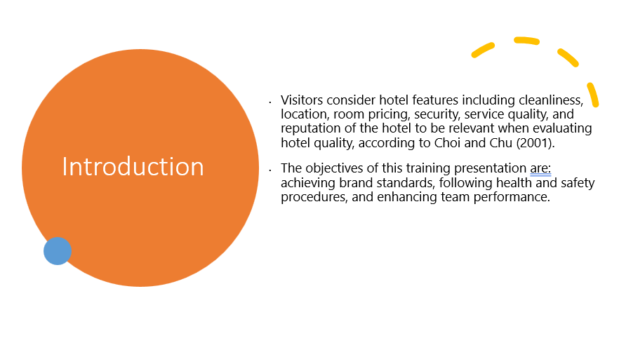

Training Notes: Hello everyone! My name is Andreea Serban and I am the floor housekeeping manager!
Over the past few weeks, we have received several guest complaints regarding the cleanliness of our hotel rooms, which is a matter of great concern for us. It is crucial that we address these concerns promptly and effectively to uphold our commitment to providing exceptional service and ensuring guest satisfaction. Cleanliness is a critical factor in guest satisfaction and plays a significant role in shaping the overall guest experience. Research and industry studies have consistently shown that cleanliness is among the top factors influencing guest perceptions and their decision to return or recommend a hotel. By addressing these recent complaints through enhanced training, we can make a positive impact on our guests' satisfaction levels and ultimately enhance our hotel's reputation.
Visitors consider hotel features including cleanliness, location, room pricing, security, service quality, and reputation of the hotel to be relevant when evaluating hotel quality, according to Choi and Chu (2001).
The objectives of this training presentation are: achieving brand standards, following health and safety procedures, and enhancing team performance.

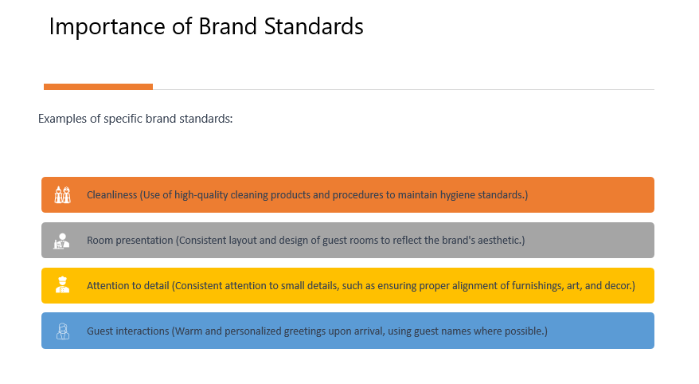

Training Notes: According to Giroti (2020), branding is the process of marketing a concept or image such that it becomes ever more linked to a particular business or good. A company's branding is crucial since it enables businesses to develop their reputations and increase their customer base.
A brand is the consistency, service delivery, and identification of a certain product. Brand Standards set facilities apart from competitors in order to determine their own client preference. Customers might choose well-known hotels and resort brands due to their superior brand standards.
A few examples of specific brand standards would be related to:
- Cleanliness (Use of high-quality cleaning products and procedures to maintain hygiene standards.)
- Room presentation (Consistent layout and design of guest rooms to reflect the brand's aesthetic.)
- Attention to detail (Consistent attention to small details, such as ensuring proper alignment of furnishings, art, and decor.)
- Guest interactions (Warm and personalized greetings upon arrival, using guest names where possible.)

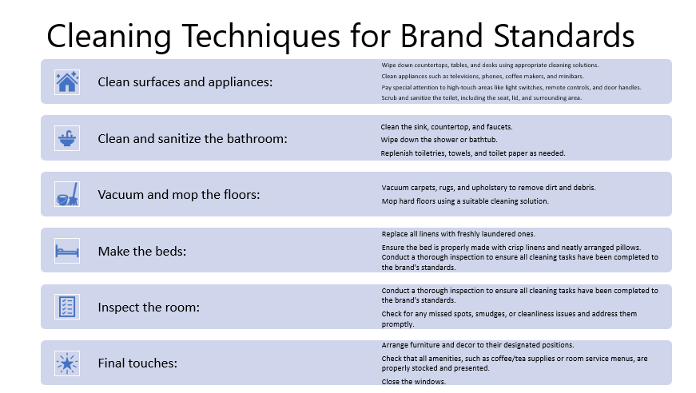

Training Notes: Next, I will present you a guide to the cleaning techniques that align with brand standards:
- Gather the necessary cleaning supplies:
  - High-quality cleaning products.
  - Cleaning tools.
  - Personal protective equipment (PPE).
  - Prepare the cleaning cart:
  - Stock the cleaning cart with all the necessary supplies.
- Enter the guest room and knock on the door and announce yourself as a housekeeping staff member before entering.
- Open the windows to allow fresh air to circulate in the room.
- Strip the beds of linen and mattress protectors.
- Empty and sanitize trash containers.
- Dust all surfaces
- Clean surfaces and appliances:
  - Wipe down countertops, tables, and desks using appropriate cleaning solutions.
  - Clean appliances such as televisions, phones, coffee makers, and minibars.
  - Pay special attention to high-touch areas like light switches, remote controls, and door handles.
- Clean and sanitize the bathroom:
  - Scrub and sanitize the toilet, including the seat, lid, and surrounding area.
  - Clean the sink, countertop, and faucets.
  - Wipe down the shower or bathtub.
  - Replenish toiletries, towels, and toilet paper as needed.
- Vacuum and mop the floors:
  - Vacuum carpets, rugs, and upholstery to remove dirt and debris.
  - Mop hard floors using a suitable cleaning solution.
- Make the beds:
  - Replace all linens with freshly laundered ones.
  - Ensure the bed is properly made with crisp linens and neatly arranged pillows.
- Inspect the room:
  - Conduct a thorough inspection to ensure all cleaning tasks have been completed to the brand's standards.
  - Check for any missed spots, smudges, or cleanliness issues and address them promptly.
- Final touches:
  - Arrange furniture and decor to their designated positions.
  - Check that all amenities, such as coffee/tea supplies or room service menus, are properly stocked and presented.
  - Close the windows.

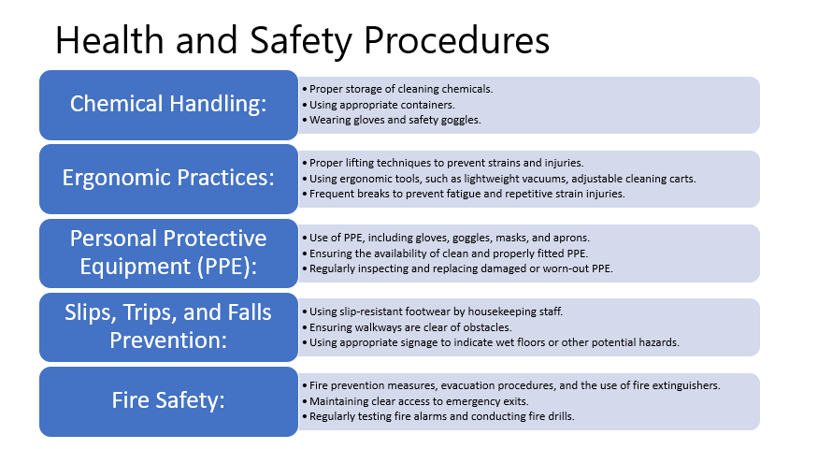

Training Notes: Following health and safety procedures is vital for maintaining a safe working environment in hotels. It protects the well-being of both employees and guests, and enhances the reputation and customer confidence in the hotel. A few examples of specific health and safety procedures relevant to housekeeping would be:
- Chemical Handling:
  - Proper storage of cleaning chemicals.
  - Using appropriate containers.
  - Wearing gloves and safety goggles.
- Ergonomic Practices:
  - Proper lifting techniques to prevent strains and injuries.
  - Using ergonomic tools, such as lightweight vacuums, adjustable cleaning carts.
  - Frequent breaks to prevent fatigue and repetitive strain injuries.
- Personal Protective Equipment (PPE):
  - Use of PPE, including gloves, goggles, masks, and aprons.
  - Ensuring the availability of clean and properly fitted PPE.
  - Regularly inspecting and replacing damaged or worn-out PPE.
- Slips, Trips, and Falls Prevention:
  - Using slip-resistant footwear by housekeeping staff.
  - Ensuring walkways are clear of obstacles.
  - Using appropriate signage to indicate wet floors or other potential hazards.
- Fire Safety:
  - Fire prevention measures, evacuation procedures, and the use of fire extinguishers.
  - Maintaining clear access to emergency exits.
  - Regularly testing fire alarms and conducting fire drills.

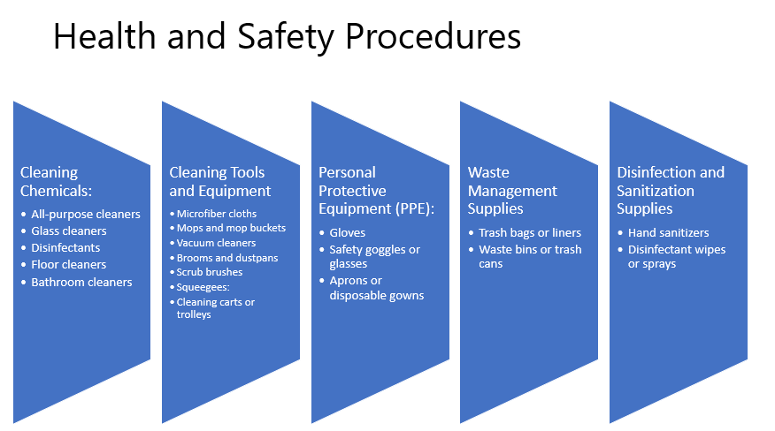

Training Notes: Next, we will discuss about necessary cleaning supplies and equipment required for effective cleaning:
- Cleaning Chemicals:
  - All-purpose cleaners
  - Glass cleaners
  - Disinfectants
  - Floor cleaners
  - Bathroom cleaners
- Cleaning Tools and Equipment:
  - Microfiber cloths
  - Mops and mop buckets
  - Vacuum cleaners
  - Brooms and dustpans
  - Scrub brushes
  - Squeegees:
  - Cleaning carts or trolleys
- Personal Protective Equipment (PPE):
  - Gloves
  - Safety goggles or glasses
  - Aprons or disposable gowns
- Waste Management Supplies:
  - Trash bags or liners
  - Waste bins or trash cans
- Disinfection and Sanitization Supplies:
  - Hand sanitizers
  - Disinfectant wipes or sprays

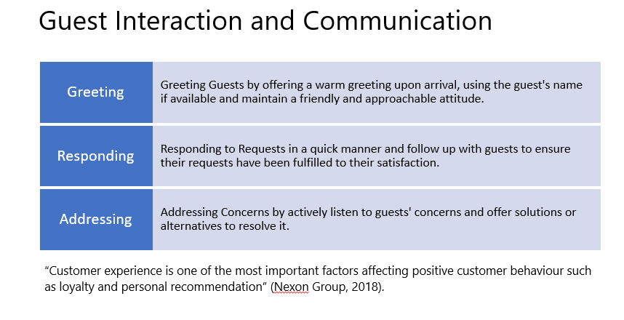

Training Notes: Positive guest interactions and effective communication skills play a vital role in the success of hotels. They contribute to guest satisfaction, loyalty, and overall teamwork.
Here are a few tips on how to interact with guests:
- Greeting Guests by offering a warm greeting upon arrival, using the guest's name if available and maintain a friendly and approachable attitude.
- Responding to Requests in a quick manner and follow up with guests to ensure their requests have been fulfilled to their satisfaction.
- Addressing Concerns by actively listen to guests' concerns and offer solutions or alternatives to resolve it.
“Customer experience is one of the most important factors affecting positive customer behaviour such as loyalty and personal recommendation” (Nexon Group, 2018). Maintaining a respectful and friendly attitude towards hotel guests at all times is vital for guest satisfaction, loyalty, positive word-of-mouth, brand reputation, guest comfort, conflict resolution, employee morale, and cultural inclusivity. It sets the foundation for exceptional hospitality and creates a welcoming atmosphere that distinguishes the hotel from its competitors.

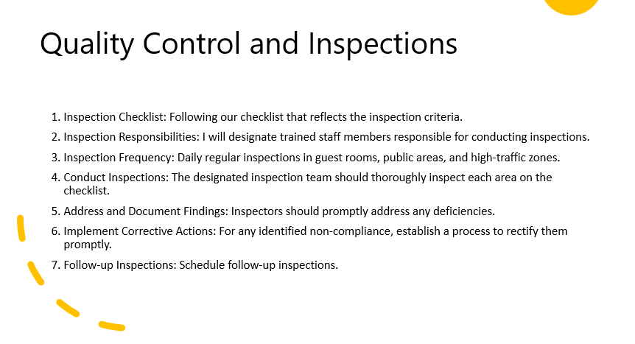

Training Notes: Quality control and inspections are crucial to maintaining hotel brand standards. They ensure consistency, enhance guest satisfaction and protect the brand's reputation.
A few detailed steps for Quality Control and Inspection would be:
- Inspection Checklist: Following our checklist that reflects the inspection criteria.
- Inspection Responsibilities: I will designate trained staff members responsible for conducting inspections.
- Inspection Frequency: Daily regular inspections in guest rooms, public areas, and high-traffic zones.
- Conduct Inspections: The designated inspection team should thoroughly inspect each area on the checklist.
- Address and Document Findings: Inspectors should promptly address any deficiencies.
- Implement Corrective Actions: For any identified non-compliance, establish a process to rectify them promptly.
- Follow-up Inspections: Schedule follow-up inspections.

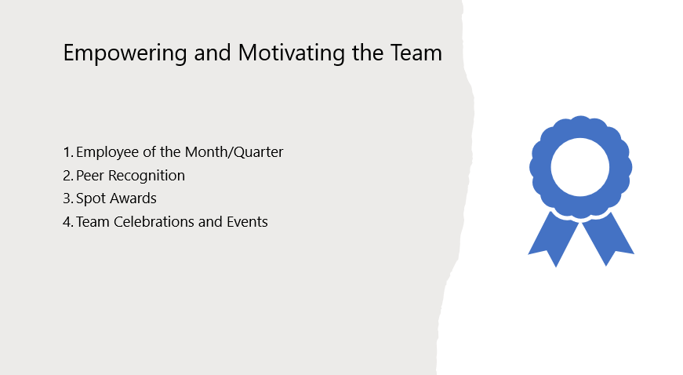

Training Notes: In the next weeks and months we will implement the following rewards and awards within the department:
- Employee of the Month/Quarter: this program is to recognize outstanding performance within the housekeeping team. I will select an employee who consistently goes above and beyond their duties.
- Peer Recognition: I encourage team members to recognize and appreciate each other's exceptional performance through a program where team members can nominate their colleagues for exceptional work.
- Spot Awards: I will also use spot awards to recognize employees who demonstrate exceptional performance on the spot. When I witness a team member exceeding expectations or delivering outstanding service, I will provide immediate recognition and they will receive a meal voucher.
- Team Celebrations and Events: There will be a quarterly team outing to celebrate achieved performances together.

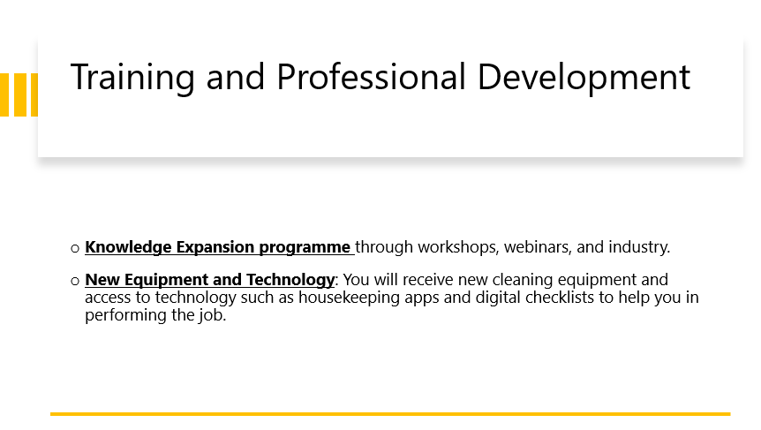

Training Notes: Ongoing training and professional development play a crucial role in continuous improvement within the hotel housekeeping team. They enhance skills, improve efficiency and safety and offer career advancement opportunities.
Also, there will be a Knowledge Expansion programme through workshops, webinars, and industry conferences to bring together industry experts who share their knowledge. By attending these events, housekeeping team can gain valuable information about the latest industry trends, best practices, technologies, and innovative cleaning techniques. This knowledge expansion helps you stay updated and enhances your expertise in the field.
New Equipment and Technology: You will receive new cleaning equipment and access to technology such as housekeeping apps and digital checklists to help you in performing the job.



Training Notes: Thank you very much for your participation and commitment to delivering exceptional housekeeping services!
Now we will have a Q&A session, so if you have any questions, please feel to ask and we will discuss them

References

Reference list Component One:

Duguay, C. (2018) The Secret to Improving Time Management for Hotel Room Attendants Available at: https://lgcassociates.com/2018/03/23/improving-time-management-hotel-room-attendants/ (Accessed: 17 May 2018).
Frost, H., Watts, R., and Marlow, L. (2017) ‘Work-related physical activity among hotel housekeepers’, Journal of Occupational and Environmental Medicine, 59(6), pp. 557-563.
Indeed Editorial Team (2022) Guide to Housekeeping Skills (With Tips and Examples) Available at: https://www.indeed.com/career-advice/career-development/housekeeping-skills (Accessed: 17 May 2023).
Ivica, B. (2015) ‘Organization of business in hotel housekeeping’, Journal of Process Management and New Technologies, Vol. 3, pp. 51-54. Available at: https://scindeks.ceon.rs/article.aspx?artid=2334-735X1501051B (Accessed: 17 May 2023).
Morgan and Mallet (2022) Skills You Need to Develop to Perform as a Housekeeper
Available at: https://www.householdstaff.agency/blog/skills-you-need-to-develop-to-perform-as-a-housekeeper (Accessed: 17 May 2022).
Polo and Tweed (2019) Which Types of Cleaning Agents are Used in Housekeeping? Available at: https://poloandtweed.com/blog/types-cleaning-agents-used-housekeeping (Accessed: 17 May 2023).
Staykeepers (2023) Guest Experiences Available at: https://www.staykeepers.com/communications-experiences (Accessed: 17 May 2023).
Thomsen, F.B. (2018) Talking Point: Why is it important for housekeeping to clean green? Available at: https://www.greenkey.global/stories-news-1/2018/3/12/talking-point-why-is-it-important-for-housekeeping-to-clean-green (Accessed: 17 May 2023).

Reference list Component Two:

Betterteam (2023) Floor Manager Job Description Available at: https://www.betterteam.com/floor-manager-job-description (Accessed: 25 May 2022).
Clark, S. (2021) What To Do if Your Hotel Is Dirty and Unhygienic Available at: https://www.yourtravelrights.co.uk/what-do-if-your-hotel-dirty-unhygienic.html (Accessed: 25 May 2023).
Cvent (2022) Handling Guest Complaints: The Complete Guide for Hotels Available at: https://www.cvent.com/uk/blog/hospitality/handling-guest-complaints (Accessed: 25 May 2023).
Ghebregiorgis, F. (2018) ‘Factors Influencing Employee Performance in Hotel-A Comparative Study of Government and Privately Owned Hotels in Eritrea’, International Journal of Research in Business Studies and Management, Vol 5, no. 11, pp. 1-9. Available at: http://www.ijrbsm.org/papers/v5-i11/1.pdf (Accessed: 25 May 2023).
Karahanian, U. (2022) Online reputation management: 10 Tips on ORM for hotels Available at: https://hotelfriend.com/blogpost/hotel-reputation-management (Accessed: 25 May 2023).
Katz, L. (2022) What To Do If A Hotel Room Is Dirty? Available at: https://www.go4travelblog.com/learn/hotel-room-is-dirty/ (Accessed: 25 May 2022).
Raub, S. (2023) Boosting Employee Performance in Hospitality Available at: https://hospitalityinsights.ehl.edu/hospitality-industry-employee-performance (Accessed: 25 May 2023).
Sawyer, K. (2019) The 20 Most Common Hotel Guest Complaints Available at: https://www.deputy.com/blog/the-20-most-common-hotel-guest-complaints (Accessed: 25 May 2023).
SetupMyHotel (2023) Job Description for Floor Supervisor Available at: https://setupmyhotel.com/job-description-for-hotels/house-keeping/248-floor-supvi.html (Accessed: 25 May 2023).
Shah, M. (2023) How to Respond to Positive and Negative Hotel Reviews? Available at: https://www.ezeeabsolute.com/blog/hotel-review-responses/ (Accessed: 25 May 2023).

Reference list Component Three:

AllianceOnline (2023) Hotel Housekeeping Supplies & Equipment Available at: https://www.allianceonline.co.uk/hotel-and-leisure/hotel-housekeeping.html (Accessed: 26 May 2023).
CCOHS (2023) Occupations and Workplaces Available at: https://www.ccohs.ca/oshanswers/occup_workplace/hotel_housekeeping.html (Accessed: 26 May 2023).
Choi, T. Y. and Chu, R. (2001) ‘Determinants of hotel guests’ satisfaction and repeat patronage in the Hong Kong hotel industry’, International Journal of Hospitality Management, Vol. 20, pp. 277-297. Available at: https://doi.org/10.1016/S0278-4319(01)00006-8 (Accessed: 26 May 2023).
Flexkeeping (2023) Tips for Motivating Your Housekeeping Staff Available at: https://www.flexkeeping.com/tips-for-motivating-your-housekeeping-staff/ (Accessed: 26 May 2023).
Giroti, P. (2020) Hotel / Resort “brand standards” & their significance Available at: https://hospitality.economictimes.indiatimes.com/news/speaking-heads/hotel-/-resort-brand-standards-their-significance/79663108 (Accessed: 26 May 2023).
HotelTutor (2023) How to run a rewards and recognition program in your hotel Available at: https://hoteltutor.com/how-to-run-a-rewards-and-recognition-program-in-your-hotel-when-you-dont-want-to-spend-much/ (Accessed: 26 May 2023).
Indeed Editorial Team (2023) How To Become a Hotel Inspector in 5 Steps (Plus Job Duties) Available at: https://www.indeed.com/career-advice/finding-a-job/how-to-become-hotel-inspector (Accessed: 26 May 2023).
Nexon Group (2018) Do you know the factors that affect guest experience? Available at: https://www.hospitalitynet.org/news/4087829.html (Accessed: 26 May 2023).
Radley, M. (2023) How to maintain brand standards in hospitality Available at: https://trailapp.com/blog/brand-standards-in-hospitality (Accessed: 26 May 2023).
Williams, B. (2023) Hotel housekeeping 101: Tips and tricks for clean hotel rooms Available at: https://www.allianceonline.co.uk/blog/2019/06/hotel-housekeeping-101-tips-tricks-for-clean-hotel-rooms/ (Accessed: 26 May 2023).

