

Subject Name: Marketing Management [LCMB 7001]
Student Name: Dakshesh Raval
Student Id: 2217673
Assignment Name: Assessment 2
Professor Name: Tushara Balendran



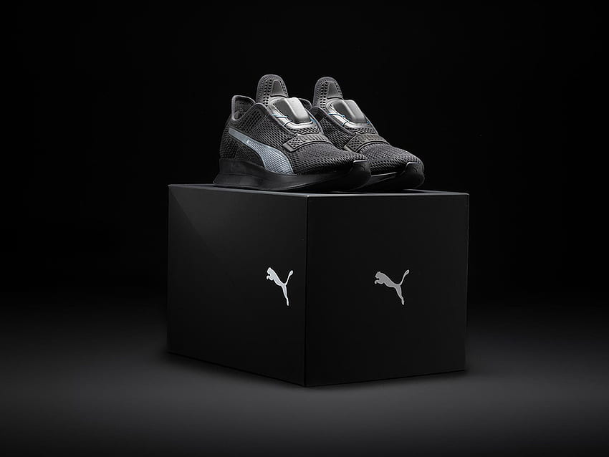

Contents
2 Introduction: 4
3 PESTEL analysis of PUMA: 4
3.1 Political 5
3.2 Economical 5
3.3 Social 5
3.4 Technological 5
3.5 Environmental 6
3.6 Legal 6
3.7 Advantages and disadvantages of PESTEL analysis 6
4 PORTERS 5 FORCES analysis: 7
5 SWOT analysis: 8
5.1 Advantages and Disadvantages of SWOT analysis: 9
5.2 Disadvantages of SWOT analysis 9
6 STP: 9
6.1 Segmentation: 10
6.2 Targeting: 10
6.3 Positioning: 10
7 Marketing Mix Strategy (4Ps): 11
7.1 Product: 12
7.2 Price: 12
7.3 Promotion: 13
7.4 Place: 13
8 Recommendation: 14
8.1 Diversification: 15
8.2 Product development: 15
9 Conclusion: 16
10 References: 17

Introduction:
With a large variety of brands and shops serving a variety of consumers, the shoe market in the UK is a highly competitive and dynamic business. As a Project team member, the author is conducting research on environmental (internal and external) drivers of marketing analysis on PUMA, which is a major player in shoe market in the world. This report demonstrates an internal and external environmental analysis of marketing and how marketing is done by the PUMA. The focus of this report is to identify some major elements affecting marketing strategies such as the political, economic, social, technological, legal, and environmental. Secondly, identify possible threats of the entrance, bargaining power of buyers and suppliers, and threats of substitute by using porters five forces analysis. Some strength, weakness, opportunity, and threats are also mentioned in this study. Apart from this, marketing mix(4ps) of PUMA are also mentioned along with some recommendation for improvement of the organization at the end by using Ansoff Matrix. In-depth study of Puma's marketing environment will be provided in this report, which will aid the company in creating an efficient marketing plan to meet its objectives.

PESTEL analysis of PUMA:
PESTEL analysis is a helpful method for figuring out how external macro-environmental elements might impact a company's performance. (Cipd) An examination of Puma's PESTEL factors is provided here by using some political, economic, social, technological, environmental, and legal dimensions and suggesting advantages and disadvantages (Morrison, 2013). Puma is a German multinational company that creates athletic and non-athletic clothing, accessories, and footwear. This analysis emphasizes on limitations and opportunities of the PUMA by using the above-mentioned factors.

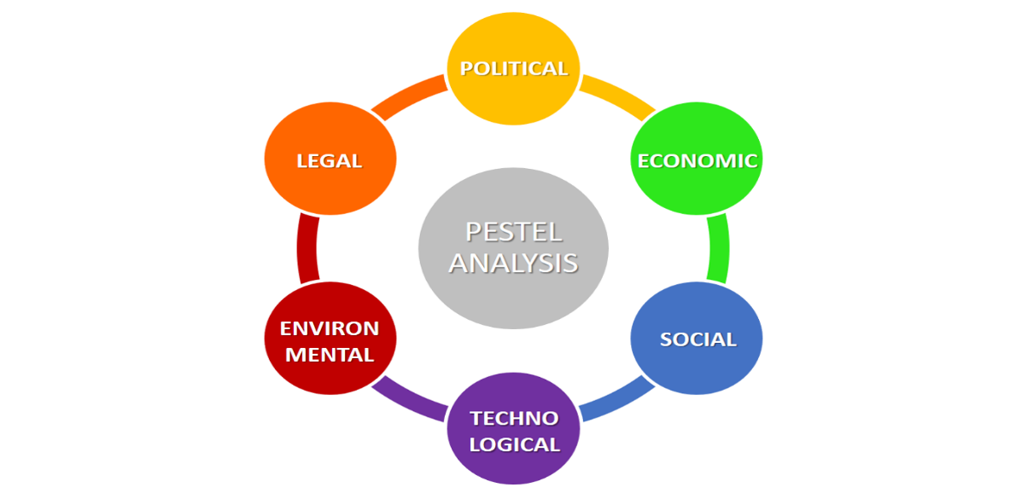
Source: Business to you

Political
- The distribution network and supply chain of Puma may be impacted by trade agreements and regulations. For instance, modifications to trade agreements, such as Brexit(Tony blair institute for global change), may lead to new tariffs and limitations, raising the cost of importing raw materials and exporting completed goods. This element is unfavourable for the company.
- Trade restrictions implemented by nations as a result of political unrest may influence Puma's sales in such areas. For instance, the 2014 US and EU sanctions on Russia led to a drop in Puma's sales in that country. This element is unfavourable for the company.(the guardian,2014)
- 2020 saw additional tariffs placed by the US on footwear imported from China, which had an impact on Puma's supply chain and could raise the price of producing and shipping goods to the US market. This element is also a unfavourable for the company.

Economical
- Consumer expenditure on non-essential commodities like athletics can be impacted by economic downturns, which can harm Puma's sales. For instance, the COVID-19 pandemic saw a decline in consumer purchasing on non-essential commodities like sportswear as a result of global economic anxiety and job losses. This element is a unfavourable for the organization.
- The cost of borrowing for Puma may change as interest rates change. For instance, if interest rates rise, Puma may incur greater borrowing costs, which would lower its net income. This is also a unfavourable for the company.

Social
- Opportunities for Puma's environmentally friendly products may arise as interest in sustainability grows. As an illustration, Puma's "Clever Little Bag" sustainable packaging program has grown in popularity and enhanced the company's brand image. This is a favourable for the brand.(Fuseproject)
- The demand for specific categories of sporting products might change with shifting fashion trends and consumer preferences. For instance, the desire for fashionable and comfortable sportswear that can be worn outside of the gym has increased as athleisure has become more popular. This can be an unfavourable or a favourable depending on how company is adapting with a new trend.

Technological
- The production techniques used by Puma may be impacted by developments in automation and robots. By using robots and other automated equipment, for instance, Puma can produce goods more quickly and effectively while spending less on labour overall. This can be a favourable for the company.
- The development of wearable technologies and 3D printing could open doors for Puma. For instance, Puma and the MIT Design Lab collaborated to develop Bio design products that integrate innovation, performance, and sustainability. This is a favourable for the company.(Hypebeast,2018)

Environmental
- The demand for Puma's sustainable products may rise as environmental challenges become more widely known and felt. Puma, for instance, has introduced "The Puma Sustainability Collection," which consists of goods produced from eco-friendly materials including organic cotton and recycled polyester. This can be considered as a favourable for the organization.
- Climate change and natural catastrophes may have an impact on Puma's business operations and supply chain. For instance, in 2019 the Australian bushfires caused supply chain issues for Puma and raised shipping prices. This can be considered as a unfavourable for the company.

Legal
- Puma's hiring procedures may be impacted by modifications to labour laws and regulations. For instance, modifications to immigration restrictions can make it more difficult for Puma to recruit and keep international staff. This can be considered as a unfavourable for the company.
- The ability of Puma to safeguard its intellectual property may be affected by changes to patent rules. Changes to the patent system, for instance, might make it more challenging for Puma to obtain patent protection for its goods. This can be considered as a unfavourable for the company.(wipo)

Advantages and disadvantages of PESTEL analysis
Advantages of PESTEL Analysis:
PESTEL analysis is a strategic tool that aids organisations in recognising and analysing the external factors that could have an impact on their operations. The fundamental benefit of PESTEL analysis is that it offers an all-encompassing and complete perspective of the external environment. Understanding the larger picture and spotting potential possibilities and dangers helps organisations. PESTEL analysis is useful for strategic planning as well because it aids organisations in creating a plan by identifying external elements that can affect their company's operations. Organizations can improve their decision-making processes and more effectively achieve their strategic goals by analysing external circumstances. PESTEL analysis can also assist organisations in gaining a competitive advantage by foreseeing developments and implementing preventative steps.
Disadvantages of PESTEL Analysis:
While PESTEL analysis offers many benefits, it also has significant drawbacks. One of the key drawbacks is its narrow focus on external issues, which may ignore internal elements that could potentially affect an organisation's performance. Furthermore, PESTEL analysis depends largely on data, which may not always be accurate or current. Due to faulty data, organisations may make wrong assumptions or ignore important factors. Finally, PESTEL analysis may uncover a wide range of external influences, making it difficult to decide which elements are most important to consider. (Ronald buye,2021)

PORTERS 5 FORCES analysis:
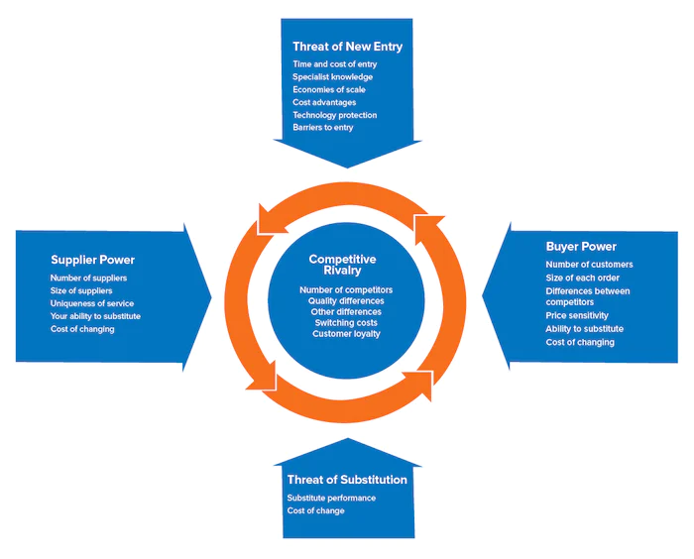
Source: Mindtools
- Threat of New Entrants: Due to Puma's long history in the market and solid brand recognition, it is difficult for new competitors to compete. In addition, the athletic apparel and footwear market is heavily regulated, and new businesses must adhere to stringent safety and environmental requirements, which may be costly and time-consuming. So the threat of new entrants is low.
- Bargaining Power of Suppliers: Due to the variety of Puma's suppliers, each supplier has less negotiating strength. To guarantee continuous quality and prompt delivery of supplies, the corporation must nevertheless maintain close connections with its suppliers. The bargaining power of suppliers may also be increased by growing raw material costs and supply chain interruptions, which means the bargaining power of suppliers is medium in this case.
- Bargaining Power of Buyers: Customers of Puma have strong negotiating power, especially in developed regions like Europe and North America. Customers have several options to pick from, and if they find better quality or cost, they may quickly switch to a rival. In order to keep customers, Puma must continue to offer cutting-edge designs and technologies. Force is high in this case.
- Threat of Substitutes: Alternatives pose a serious challenge to Puma, particularly rival fashion and lifestyle companies that provide athletic-inspired footwear and accessories. To address the expanding athleisure trend, high-end clothing companies like Versace and Gucci have introduced lines of trainers. So, threat of substitute is high.

- Rivalry Among Existing Competitors: Leading companies in the athletic footwear and apparel market Nike and Adidas fiercely compete with Puma. Puma distinguishes itself by emphasising style and design, but in order to remain competitive, it must innovate and differentiate even more. . So, threat of rivalry is medium.
Overall, the athletic footwear and apparel business presents a difficult competitive environment for Puma. While keeping a careful watch on supply chain interruptions, rising raw material prices, and shifting consumer tastes, the corporation must continuously innovate and differentiate to stay ahead of rivals.

SWOT analysis:
An company or business venture's strengths, weaknesses, opportunities, and threats are assessed using the SWOT analysis, a strategic management technique. It offers a well-structured framework for evaluating both internal and external variables that may affect a business's performance and competitiveness. Organizations may use the SWOT analysis to create powerful strategies to solve their weaknesses, build upon their strengths, and seize market chances. ( David,2014)

Strengths |  | Weaknesses
Excellent brand reputation. |  | Market share that is small relative to competitors.
Broad range of products. |  | Dependance on a small number of important markets.
Powerful online presence |  | Little presence in developing markets.
A variety of income sources including cooperation and licencing. |  | Insufficient control over the supplier chain and production processes.
Opportunities |  | Threats
Entering fresh markets, like North America. |  | Extreme rivalry between Nike and Adidas.
Diversifying product lines, such as entering the outdoor and lifestyle markets. |  | Regulations that provide difficulties include environmental and safety regulations.
Improving product design and consumer experience by utilising artificial intelligence and machine learning. |  | The impact of economic downturns on consumer expenditures.
Constructing items using cutting-edge and environmentally friendly materials. |  | Variations in currency exchange rates and international trade regulations.

Advantages and Disadvantages of SWOT analysis:

Advantages of SWOT Analysis
- Businesses of all sizes may utilise SWOT analysis since it is a straightforward and user-friendly technique.
- It may assist in determining the assets and liabilities of a company, allowing for the creation of plans to handle each.
- It can offer perceptions into outside variables like market chances and dangers, which can be utilised to create winning competitive strategies.
- Building agreement on strategic goals and activities may be made easier by facilitating communication and collaboration across organisation stakeholders.
- SWOT analysis is a straightforward yet powerful technique that managers at all organisational levels may utilise with ease.

Disadvantages of SWOT analysis

- SWOT analysis is a flexible instrument that is susceptible to personal biases and preconceptions.
- SWOT analysis is a static technique that does not take into consideration how the external environment evolves over time, which may restrict how beneficial it is for assisting in long-term strategic decision-making.
- SWOT analyses could place too much emphasis on internal issues and not enough on external ones, including shifts in the market's competitive dynamics or macroeconomic developments.
- A SWOT analysis can only be as accurate as the data it is based on. The analysis might be erroneous and provide wrong results and judgements if the data employed is insufficient or inaccurate.

STP:
Segmenting the market into distinct customer segments with comparable needs or characteristics (Segmentation), choosing particular customer segments to concentrate on and develop marketing strategies for (Targeting), and developing a distinct and clear brand image for the company's goods or services in the minds of consumers (Positioning), according to Kotler and Armstrong (2017), are all steps in the STP (Segmentation, Targeting, and Positioning).

Segmentation:
Puma uses a variety of segmentation techniques to separate their target market into several groups according to their traits, requirements, and preferences. Puma use a variety of segmentation techniques, including:
- Demographic segmentation: By segmenting the market according to demographic characteristics like age, gender, income, and education level, companies can target certain demographic groups. For Puma, this may entail concentrating on clients who are between the ages of 18 and 35, lead active lifestyles, and earn moderate to high incomes.
- Geographic segmentation: The process of geographic segmentation entails splitting the market according to location. This can entail Specifically targeting customers according to their nation, state, or city. Puma may, for instance, create marketing plans that are tailored to people in metropolitan or seaside areas.
- Behavioural segmentation: According to consumer behaviour, such as their spending patterns, brand loyalty, and product consumption, the market is divided into different segments. This might involve Puma focusing on clients who are devoted to the brand and frequently buy Puma products. Puma may want to think about creating marketing plans that entice buyers to buy more than one item or explore different product categories.

Targeting:
To appeal to particular client segments, Puma targets customers depending on their age, lifestyle, location, and behaviour. Puma can strengthen consumer ties and boost brand loyalty by customising marketing messaging to the distinct requirements and tastes of each category. Moreover, Puma might make advantage of collaborations, event-based marketing, tailored marketing, influencer marketing, and customised marketing to further set itself apart from rivals. Puma can develop successful marketing campaigns that connect with a wide spectrum of customers by combining classic and cutting-edge targeting tactics.

Positioning:
To market its products and engage with customers, Puma has teamed up with Usain Bolt, Neymar Jr., and Rihanna. Puma has been able to stand out from rivals and build a solid brand identity in the market because to its celebrity endorsement strategy. Moreover, Puma's emphasis on social responsibility and sustainability is a crucial component of its positioning strategy since it appeals to customers who value products that are created ethically and with minimal impact on the environment. Puma has developed a distinct brand identity that distinguishes it from competitors in the market by combining cutting-edge design, celebrity endorsements, and an emphasis on sustainability.

Marketing Mix Strategy (4Ps):
Businesses employ a strategic framework called the 4Ps of marketing, commonly referred to as the marketing mix, to create and carry out their marketing plans. Product, pricing, location, and promotion all fall under the 4Ps. The terms "product," "pricing," "location," and "promotion" all refer to the goods or services being sold, the cost of the product, the channels used for distribution, and the goods or services themselves. In his book "Basic Marketing: A Management Approach" from the 1960s, marketer E. Jerome McCarthy originally suggested the idea. The 4Ps framework is a key idea in marketing education and is widely utilised in the field of marketing.

(Source: created by learner)

Product: 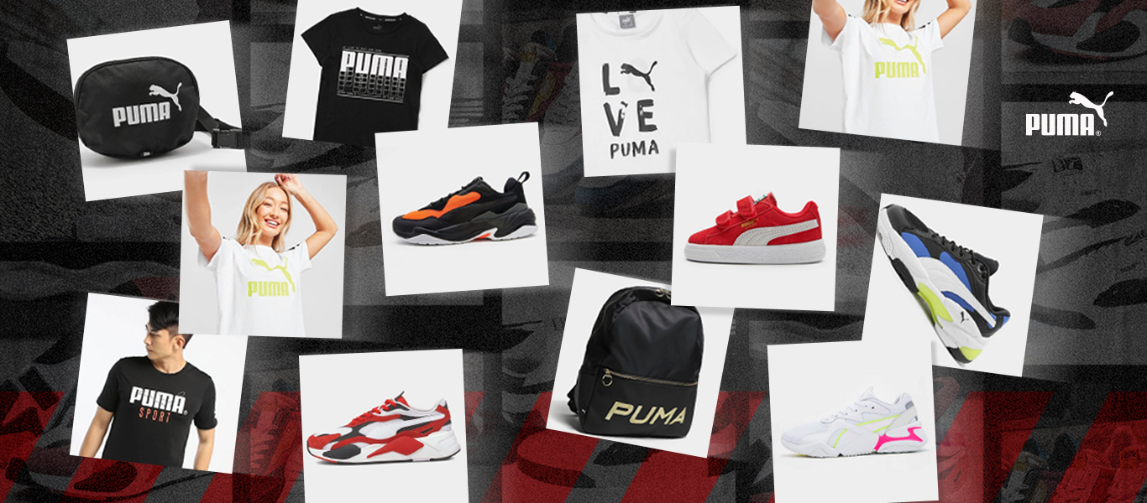

Puma concentrates on providing a wide variety of products for various sports and activities, as well as for casual wear. Puma is able to use family branding to spread the power of their company's name across all of their goods, increasing customer familiarity and trust. Line filling also enables Puma to broaden its product offering and meet a larger range of consumer wants, which helps them to stay competing in the market. Customers can also add their own designs to some of the company's items through customization choices. Also, Puma has created a special approach to product design called "FusionFoam," which mixes various foam layers for better support and cushioning in their golf shoes. (Reference Puma)

Price:
The main objective of Puma's pricing strategy is to provide products at a somewhat cheaper price point than those of its major rivals, like Nike and Adidas. To draw clients, the business occasionally runs promotions and discounts. This tactic, called a "Penetration Price Plan," involves a business setting a lower price than its rivals in order to win market share. (Reference: Forbes)

Promotion:
Puma frequently works with well-known companies or designers in its marketing efforts and uses celebrity endorsers as well. The business has also sponsored well-known sporting events including the Olympics and Formula One racing, as well as teams in such sports. The brand's qualities of uniqueness, inventiveness, and sincerity are frequently emphasised in Puma's advertising. The practice of a business using well-known people to advertise its goods is referred to as a "Celebrity Endorsement Strategy." (Reference: Forbes) Puma has started a number of marketing initiatives to boost brand recognition and promote its goods. They started an advertising campaign in 2021 to advertise their new Mayze shoe line, which included singer Dua Lipa. Social media platforms posts, advertisements, and a commercial with Lipa and other young ladies sporting the Mayze sneakers were all part of the campaign. Puma has also started sustainability-related promotions, such as the "Only See Great" campaign, which highlights the company's initiatives to lessen its environmental effect and produce more sustainable goods (footwearnews,2022).

Place:
Physical retail shops and online sales channels are both part of Puma's distribution plan. Puma is relying on selective distribution. The business has a significant online presence and makes significant investments in e-commerce to meet the needs of online clients. Another innovative retail store concept created by Puma is "Puma City," a mobile container store that visits various cities all over the world, which means Puma is using direct and indirect channel of distribution for its products. The utilisation of numerous channels by a business to reach clients is referred to as a "Omnichannel Strategy." (Reference: Puma)

Recommendation:
Ansoff matrix:
A tool for strategic planning called the Ansoff Matrix aids in identifying and assessing various growth strategies for firms. Igor Ansoff first discussed it in 1965 in his book "Corporate Strategy." Market penetration, product development, market development, and diversification are the matrix's four key growth tactics. By concentrating on current or potential new markets and goods, these techniques can be applied to grow and boost profitability. Igor Ansoff's "Corporate Strategy" is a crucial resource for anyone wanting to comprehend the various growth methods that are available to firms and how to use them successfully.

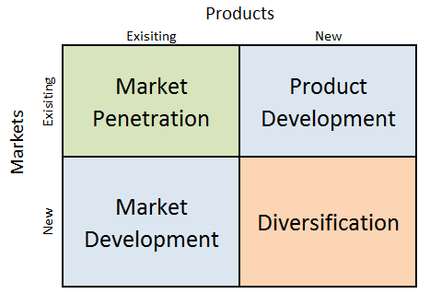
Source: Business research methodology

Diversification:
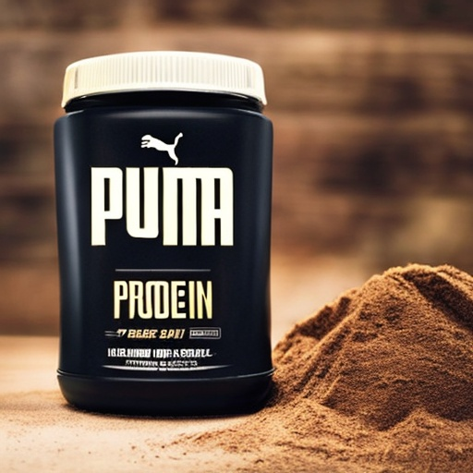

Puma's main line of business is athletic and lifestyle gear and clothing, so expanding into the protein powder market would be a new opportunity for puma. A new revenue stream for the business and a supplement to their current range of goods could be provided by the company's entry into the protein powder sector. A new market for Puma may be opened by the popularity of protein powders among athletes and fitness fanatics. The business must make sure that its protein powder products are of a good standard and priced reasonably in comparison to other brands already on the market. Puma may be able to create a lucrative range of protein powder products by utilizing their already established brand identification and track record for excellence.

Product development:

A growth strategy called "product development" entails developing new items or enhancing existing ones. This could entail creating new footwear or apparel items for Puma, as well as extending into other product categories. Puma's partnership with BMW to create a new line of limited-edition trainers inspired by BMW's vehicles is an illustration of product development. Aimed at automotive aficionados and sneaker collectors, the sneakers have patterns and materials that draw inspiration from BMW's automobiles. Successful product creation can be shown in Puma's partnership with BMW, which allowed the company to design a new product that caters to a specific market and thrill consumers. Overall, product development is crucial to Puma's growth strategy since it enables the company to remain innovative and competitive in market.

Conclusion:

Conducting internal and external analysis of the Puma marketing environment it can be said that some of the points are favourable, however, we cannot ignore unfavourable aspects of the same. Above mentioned recommendations are fruitful for the company to expand its business to another level. Also, it will help customers to complete decision-making for specific products. This knowledge and information will be helpful for the company to create a proper strategy related to its business model and also help them to overcome issues faced in recent years due to internal and external factors affecting the company directly and indirectly.

References:
MORRISON, M. (2013) Strategic business diagnostic tools: theory and practice. CreateSpace Independent Publishing. (Chapter 3: PESTLE).
Kotler, P. T. and Armstrong, G. (2017) Principles of Marketing, Global Edition. Pearson.
Porter, M. E. (2008). The five competitive forces that shape strategy. Harvard business review, 86(1), 78-93.
David, F. R. (2014). Strategic management: concepts and cases, global edition, Pearson.
Ansoff, I. H. (1965). Corporate strategy: An analytical approach to business policy for growth and expansion. McGraw-Hill.
Cipd, PESTEL, Available at, https://www.cipd.co.uk/knowledge/strategy/organisational-development/pestle-analysis-factsheet (accessed on 1/4/2023)
Business to you, PESTEL diagram, Available at https://www.business-to-you.com/scanning-the-environment-pestel-analysis/ (Accessed on 1/4/23)
Tony blair institute for global change, Effect of Brexit, Available at https://www.institute.global/insights/geopolitics-and-security/three-years-brexit-casts-long-shadow-over-uk-economy (Accessed on 1/4/23)

Wipo, Patent, Available at https://www.wipo.int/patents/en/( Accessed on 1/4/23)
Mindtools, Pestel diagram, Available at, https://www.mindtools.com/at7k8my/porter-s-five-forces, (Accessed on 1/4/2023)
The guardian,2014,US and Eu sanction on Russia, available at https://www.theguardian.com/world/2014/jul/29/economic-sanctions-russia-eu-governments (Accessed on 2/4/23)

Hypebeast,2018, Puma and Mit design collaborations, Available at https://hypebeast.com/2018/5/puma-mit-design-lab-self-adapting-microbe-sneaker-technology (Accessed on 3/4/23)
Ronald Buye,2021, critical examination of pestle analysis, Available at https://www.researchgate.net/publication/349506325_Critical_examination_of_the_PESTEL_Analysis_Model (Accessed on 3/4/23)
Fuseproject, Clever little bag, Available at https://fuseproject.com/work/puma-clever-little-bag/ (Accessed on 3/4/23)
Footwearnews,2022, Mayze shoe line with Dua Lipa, Available at, https://footwearnews.com/2022/focus/athletic-outdoor/dua-lipa-puma-mayze-pop-sneakers-release-info-1203268778/amp/ (Accessed on 03/05/2023)
Puma, About Product and place, Available at,https://about.puma.com/ (Accessed on 4/4/23)
Forbes, Price and promotion, Available at, https://www.forbes.com/companies/puma/( Accessed on 6/4/23)
Business research methodology, Ansoff matrix diagram, Available at, https://research-methodology.net/theory/strategy/ansoff-matrix/ (accessed on 2/4/23)

