

Course Title: MBA - International Business
Term 1

Student Name: Shubhamsingh Satyendrasingh Bhadauriya

Student ID: 2510990

Module Name: Human Capital Management

Module Code: LCMB7023_LON

Lecturer’s Name: Dr Gladius Kulothungan

Word Count: 2666

Executive Summary
This report presents, how new technology, changing demographics, and global events affect job market and HR practices, also the Technology like Artificial intelligence (AI) is changing the work style and creating threat and opportunity both by creating new jobs, and making reskilling and upskilling very important. The emerge of gig economy and increase remote work allow companies to hire talent from anywhere in the world, but also creating challenges like job security, implementing and follow the law. Also, Low birth rate, trade policy, global crises, ageing, populations and immigration trends affect workforce planning while political changes influence IHRM decisions. The strategic HRM approaches towards the hiring, training, and retaining employees are important to fill skill gaps and make organizations stronger. The report also reflects on personal skills like technology, communication, teamwork, leadership, and self-learning, which is important for the career growth and helps people adjust to the fast changes in a global working environment, and prepare them to face future workplace challenges successfully.

Contents
Executive Summary 2
Introduction 3
1.Technology & Labour Markets: 4
1.1 The Transforming of Labour Markets: 4
1.2 Implications for HRM/IHRM Strategies: 4
2. Demographic & Geopolitical Factors 5
2.1 Major Demographic Factors 5
2.2 Major Geopolitical Drivers: 6
2.3 Challenges Facing HR Professionals 7
3 Skills Gaps & Strategic HRM 7
3.1 Strategic HRM Strategies: 7
4. Reflective Report on Capabilities 10
4.1 Self-Assessment 10
4.2 Development Plan: 12
Conclusion 12
Referencing 12
Appendix 15
SWOT analysis 15
Demography shift chart 15
UK Skill shortage by manpower survey 16
Gibbs Reflective Cycle 16

Introduction
The transformation of the global labour market depends on demographic, technological and geopolitical factors and the innovations of new technology like Artificial intelligence, automation and digitalization are reshaping the job roles and creating new opportunities while replacing some old skills. Simultaneously, ageing population, low birth rate, migration patterns and demographic trends, influence workforce availability and diversity requiring HR strategies that are adaptable and inclusive. Geopolitical political factors like trade policies, and global crises make it harder to plan the workforce, especially for international companies. Consequently, HRM and IHRM need to focus on the strategic for talent acquisition, reskilling, and retention to meet the skill demands. This report critically analyses these factors and reflects on personal capabilities in this dynamic environment.

1.Technology & Labour Markets:
The rapid development of new technology, effect on global job market and the form of HRM and IHRM practices for multicultural companies are driving changes that are important for decision-making.

1.1 The Transforming of Labour Markets:
The development of news technology comes with threat and opportunity and to adjust in that environment reskilling and leaning is necessary (Shenoi et al., 2024). The use of artificial intelligence comes with a threat of job loss, but it transforms the job and creates new job roles in the future (George, 2024). Also, AI will Advancing the job by reducing work time and increasing the wages of employee by learning new skills. With the advancement of the technology and easy access of online work, people are working from anywhere in the world with any company and work according to their flexibility (Larsson and Teigland (2020, pp. 2013-215)and growth of gig economy provide flexibility but it also comes with challenges of job security and to make safe environment for workers and utilize talent from the world, countries are making law for employment(Espinoza, 2023, p. 6).while HRM and IHRM must ensure that all the employees get equal benefits and opportunities and follow international law to avoid future consequences . Also, the advancement of technology and continuously changes and development of new technology create demand of skill shortage and for that management always provide skill enhancement program to make sustainability of the workforce and to work in the digital environment countries are providing Science, Technology, Mathematics and engineering to improve critical thinking, creativity, problem-solving, and innovation (Bezuidenhout, 2021).

1.2 Implications for HRM/IHRM Strategies:
Companies are now using the AI based software to identify the skill and knowledge of candidates and use of AI based software helps HR professionals to find perfect candidate for the roles by different analysis without any biased decision (Hemachandran et al., 2024).The need for upskilling and reskilling are also important for the employee for their career and individual growth and the new form of individual learning by watching videos and podcast become the new era of learning tool also companies are using AI based software and tools to guide employee by valuable feedback and also indicate management to improvement of the employee(Chacko and Cox, 2025).
According to the World Economic forum, 2025 many jobs are declining and roles like autonomous and electric vehicle specialists and environmental and renewable energy engineers are growing rapidly and increasing demand of artificial technologies emerging skill shortage indicating HR management to make planning accordingly and to complete the demand provide part time and contract based job and freelancing work to professional and make strategy of bland works force and the use of AI based tools in hiring process can indicate and inform and provide guideline to HR managers, related to hiring Process. After Analysis these fact HRM and IHRM need to create environment for self-leaning and reskilling by providing benefits and gift voucher after completing the course.
The IHRM concept is broad and structured, which includes the understanding and implementing of all HR activities according to the culture of the country and affected by the government, religion, belief, and economic conditions, and by analysing these factors, management implements HR policies (Huu, 2022). With the growth of multinational companies' remote jobs increasing and with the concern of the country, companies are following data protection rules and following the gig economy employment rules and regulations, and these factors are analysed in strategic IHRM policies.

2. Demographic & Geopolitical Factors

After considering technology and labour market factors, HR need to analyse the demographic and the geopolitical factors like aging, shifting of migration trend, Immigration policies, Political changes, Pandemic and law and workforce diversification and trade policies for hiring an employee.

2.1 Major Demographic Factors
The increasing age of older people and low fertility rates created gap between the generations and, increasing rapidly, to identify the problem countries are making law and providing benefit to the older generation to stick with the workforce and creating multi culture environment to meet the objectives of organizations by utilise their experience at the work place and these knowledge helps to train new employee related to their work (McKinsey Global Institute, 2025).According to Batista et al. (2025), the countries are facing skill labour shortage and filling it by providing work and employment facilities and fulfil their gap which help them to manage workforce according to requirement.
The major demographic factors are the low birth rate and changes in there generation attitude toward work and to counter this situation easing immigration low for high skilled professional helps and train their people by organising different activities and emerging demand for multi culture environment in new HR practice while Hiring people from the different background comes with challenges and organization must understand about the equal opportunities and communication should be stabilised within and outside of the workplace to established trust within organization culture (Yılmaz, 2024).All of these challenges indicate the HR Professional to act related to the situation. After considering all these facts HRM and IHRM need to make multi culture employment policies and diverse culture within the organization.

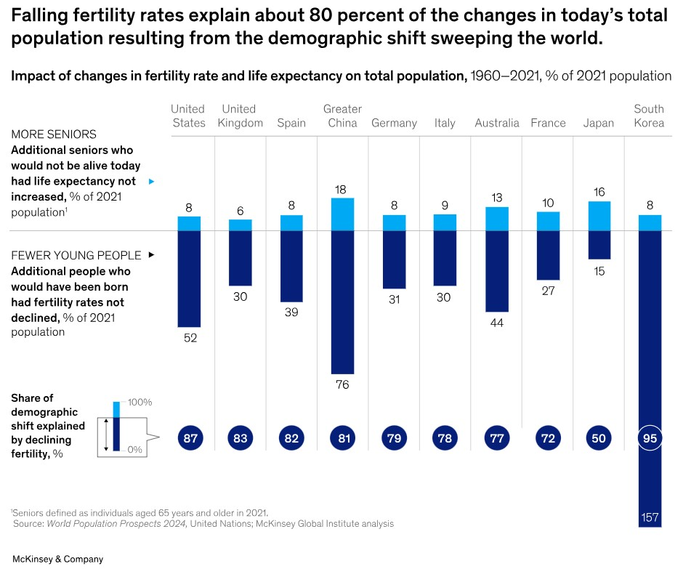
(McKinsey Global Institute, 2025)

2.2 Major Geopolitical Drivers:
HR Management work for the development of the workforce of the company and many factors affect them to change the process of hiring new employees, where the interest shift of government and policy related to the trade and business affect hiring process and create pressure on HR managers. Also, the Political instability creates uncertainty of government policies and relation with the countries which, directly affects hiring process and all these indicators approach the change in HR practices (Salma and Khan, 2016), (Sullivan, 2025).
Kovalenko (2021) analysed the unpredictable economic factors are also create challenges for HR management whether it is an overnight war (Ukraine and Russia) or emergency health crisis (Covid) emerge the requirement of remote work and or contract work according to the management, the fairness with employee rites should be done on the time related to pay and other benefits or provide place for work depends on the management decision. HRM and IHRM must understand these factors and make sure that employee right cannot be violated while staying up to date.

2.3 Challenges Facing HR Professionals
In the present environment HR professionals are facing many challenges while working in the multicultural environment and to remain the sustainability of employee is the most challenging task for HR Management to recruit the employee with long term prospectives, with the changes of visa requirement, to stay in the country and meet skill gap by analysing changes of policies according to the governments. Also, HR Management need to ensure to meet fulfil the compliance on time and make employment contract to ensure the legal record for employment and make sure the changes and new rules should me consider accordingly (Laubscher & Jefferson, 2016). Also, the understanding of the culture communication for making environment are important for multinational companies.

3 Skills Gaps & Strategic HRM
The demand of skill and knowledge of new technology are increasing continuously and constantly, upgradation in technology and working with AI emerging the change of education system and indicating Management to invest on employee’s reskilling and upskilling and make it compulsory to meet the demand of future.

3.1 Strategic HRM Strategies:
According to the briefing Bridging the skills gap (2024) to meet the demand of the companies and understanding of the practical work is most important part of recruiting an employee in an organization and apprenticeships program helps management to produce ready-to-use graduates for industrial needs by providing them vocational training and internships program. The idea of internship makes partnerships with the education institute and with companies to skilling the student for the future employment for example, the countries like Indonesia and turkey and other part of the world making kind of partnerships for upskilling the student.
In the modern time, companies need to understand about hiring process and should not rely on traditional staffing methods and they must be strategic to fulfil the Talend gap of an organization and for that they need to follow the Buying , Borrowing , Building and Binding strategies (Cappelli ,2008).
- Buying strategy - As per the Buying strategy, Companies need to requite employee according to the skill gap and to meet future requirements for example in UK companies are hiring IT and Medical professional to bridge the gap.
- Borrowing strategy - Hiring consultant, freelancer, or give contract work to meet immediate requirement companies need to follow Borrowing strategy for examples, companies in USA hire accounting professional and IT firm in India to run their business without increasing employee cost.
- Building strategy - In the Building strategy, provide training and development program to existing employee, Companies like Deloitte use training and upskilling program to grow in house talent by using coding boot camp for IT and finance analyst tool for finance employee.
- Bind Strategy - The Bind Strategy indicates management to make organization attractive by satisfying their needs and make a favourable place for employees (Cappelli ,2008). Companies like Amazon, Apple and Microsoft provide competitive salary and work life balance and other social benefits to motivate their employees.
According to the Manpower Group talent shortage Surveys (2025), UK is facing skill shortage since 2014, and many employers are struggling to fill talent gap , after declining shortage gap still IT and Data , Operations and Logistics , Engineering , Sales and marketing and Front office are facing problem to fill the gap.

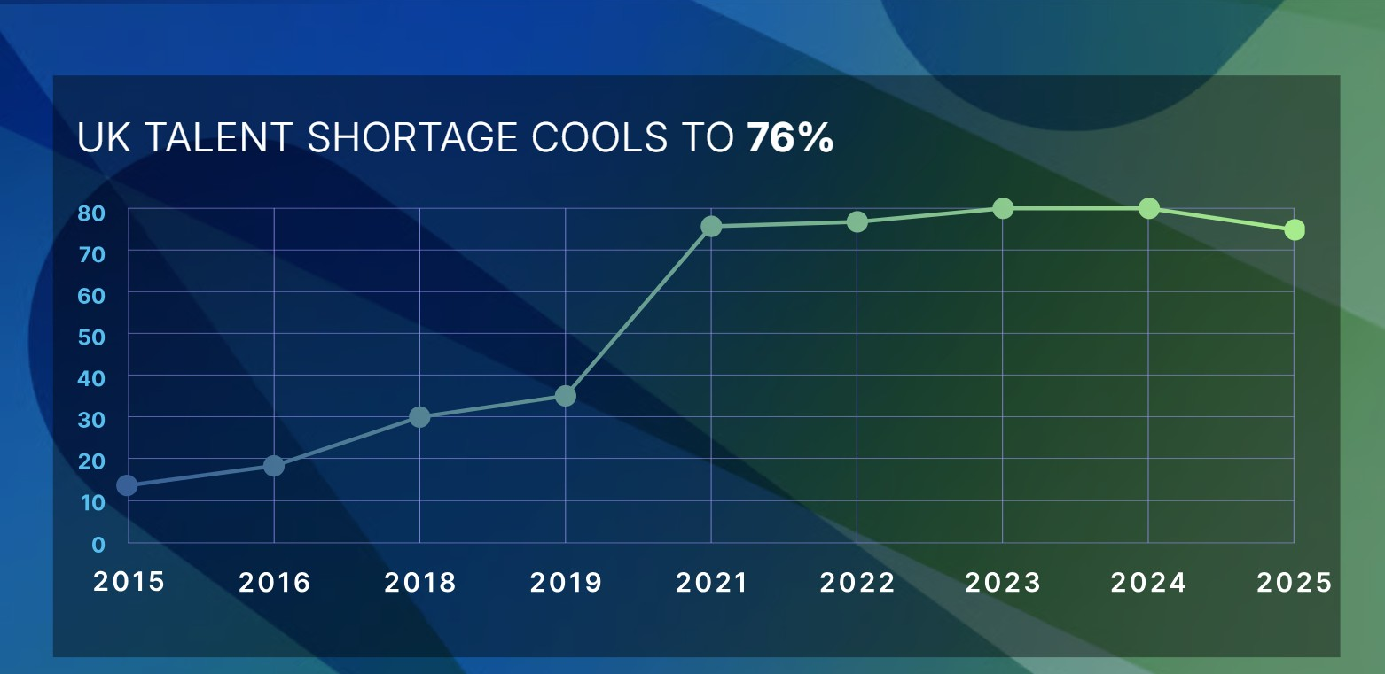(ManpowerGroup, 2025)
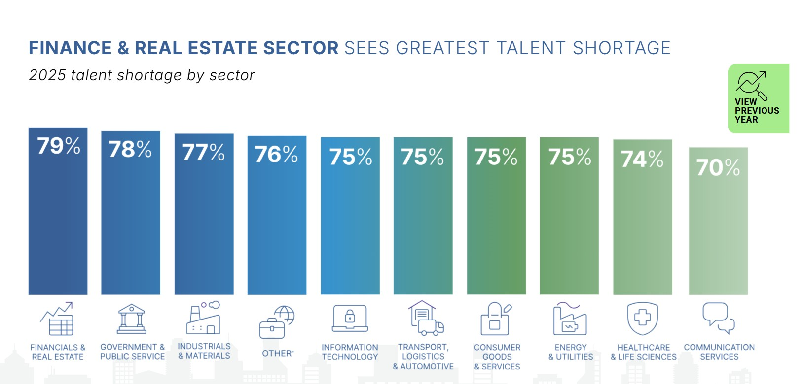(ManpowerGroup, 2025)
Every employee brings unique talent and some also believe that developing talent can help the organisation automatically, but this ideology cannot ensure the requirements are met and for that strategic talent management is needed (Overduin et al., 2018).
The first step of talent management is to make sure that every employee Talent is used and developed but this approach cannot help for specific goal, and it should be quick, flexible and creative and work well in small groups.

4. Reflective Report on Capabilities
Introduction
As an MBA graduate, adjusting to the international environment and respect the beliefs of other is a part of new work culture , Working along does not help candidates to fit in the culture of today’s , they need to adopt other cultures and they have to accept the changes nearby them with that become a creative and problem-solving mindset is important in this globalization.

4.1 Self-Assessment
Technology
After starting the MBA, i have improved the understanding of Microsoft tools like MS word and Excel which are the highly useful in today's world, Now I can create report by using these tools and easily make spreadsheet to present the data. Also, gained the ability to use ChatGPT and other AI tools to summarise and get the information in easy language.
Communication
Everywhere in the world, transferring the information according to others and make sure that other understand the thoughts and feelings are an important part of day life. In my last presentation, I created a product in the classroom and shared that information with my group, whose members were from different countries and backgrounds and i needed to make them understand about it and take their feedback to improve the presentation and this was the first kind of experience i gained.
Teamwork
In my last group presentation, everyone had different opinions related to the product and we need to come with the conclusion with the idea where we can combine idea of all members and we all contribute with same effort to make products unique and different for that we have distributed part of product with all and we all come up with their part and guide everyone related to their thought so we can make good teamwork.
Leadership
Leadership does not mean that you make yourself first in all situations, it means you being a part of team and give you valuable remark or comment related the situation and take position when everyone is facing problem. So, when my one team member stuck in group presentation, I come up with the support without making awkward situations and helped to giving the point so they can continue confidently.
Self-Directed Learning
Living in different county comes with the environmental and geological factor and different leaning methods. During this module, I learned about time management and unique leaning methods, the course is not dependent on a book, we need to read different prospectives from the different writes related to the topic and analyse their though as per the question and write in your word. This method creates a deep understanding of the topic and improves technological knowledge.
To improve ourselves in this corporate world we need to use Gibbs’ Reflective Cycle which helps us to use our experience to create backup plans accordingly. As per Gibbs, what happened, how we felt, what went right or wrong, and what we can do next time to avoid incidence, and all these things help us plan better or make an emergency plan if needed (University of Edinburgh, 2024).
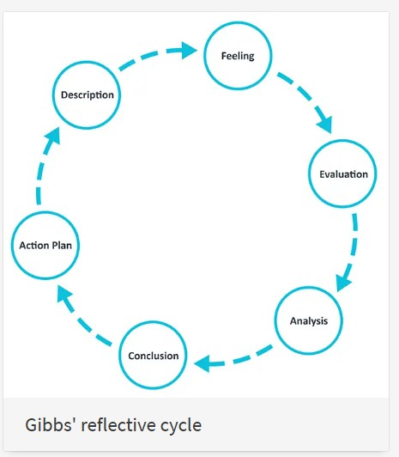
(University of Edinburgh, 2024)

4.2 Development Plan:
My communication and adaptability skills help me to adjust in the multicultural environment and accept the change accordingly and myself motivation skill help me face all the challenges and grow in my field.
The biggest problem i am facing now is time management, and I am working to improve it through my MBA program and online seminars. Also, i want to improve my technical skill and i need to learn AI tools and software to grow in my career for this i will use LinkedIn leaning certificate courses to strengthen my knowledge.

Conclusion
In conclusion, the global job market is transforming rapidly due to technological innovations, demographic shifts, and geopolitical developments. The new era of artificial intelligence, and automation and the growth of gig economy has created both opportunities and challenges for organizations and employees, making continuous reskilling and upskilling essential. HRM and IHRM professionals need to change their strategies and must adopt flexible and fair approaches to hire an employee. Also, low birthrate, aging population and migrant trend, create challenges for HR managers to adopt strategies that promote diversity, and follow compliance related to international labour laws and use Buying, Borrowing, Building, and Binding model to fill the skill gap within the organization.

Referencing

Anthony Larsson, & Robin Teigland. (2020). The Digital Transformation of Labor : Automation, the Gig Economy and Welfare. Routledge.
Batista, C., Han, D., Haushofer, J., Khanna, G., McKenzie, D., Mobarak, A. M., Theoharides, C., & Yang, D. (2025). Brain drain or brain gain? Effects of high-skilled international emigration on origin countries. Science (American Association for the Advancement of Science), 388(6749), eadr8861.https://doi.org/10.1126/science.adr8861
BEZUIDENHOUT, H.S., 2021. An early grade science, technology, engineering and mathematics dialogue reading programme: The development of a conceptual framework. South African Journal of Childhood Education (SAJCE), 11(1),.
Bridging the skills gap in Indonesia: Unpacking a vocational and education training initiative for sustainable workforce development. (2024). Human Resource Management International Digest, 32(4), 26–28. https://doi.org/10.1108/HRMID-03-2024-0062
Cappelli, P. (2008). Talent on Demand: Managing Talent in an Age of Uncertainty. Boston, MA: Harvard Business Press
Chacko M, Cox CB. Learning in the flow of work: Designing person-centric learning experiences with just-in-time microlearning. Industrial and Organizational Psychology. 2025;18(1): 147-150.doi:10.1017/iop.2024.70
ESPINOZA, J., 2023, Dec 15. EU settles on regulations to improve gig economy labour rights: Digital platforms. Financial Times, 6. ISSN 03071766.
Eurostat. (2024) Demography of Europe – 2024 edition: An ageing population. [online] https://ec.europa.eu/eurostat/web/interactive-publications/demography-2024 [Accessed 14 Nov. 2025].
George, T. (2024) Artificial Intelligence and the Future of Work: Job Shifting Not Job Loss. Partners Universal Innovative Research Publication. https:// www.puirp.com/index.php/research/article/view/46
Hemachandran, V. C., Kumar, K. A., Sikanda, S. A., Sabharwal, S., & Kumar, S. A. (2024). A study on the impact of artificial intelligence on talent sourcing. IAES International Journal of Artificial Intelligence, 13(1), 1. https://doi.org/10.11591/ijai.v13.i1.pp1-8
Huu, N. D. (2022). Information Systems In International Human Resource Management (Ihrm)- An Overview. Webology, 19(2), 2912–2929.
Kovalenko, K. V. (2021). Problems of Legal Regulation of Employees’ Remote Work in Terms of Pandemic. Вісник Харківського Національного Університету Внутрішніх Справ, 94(3), 58–65.https://doi.org/10.32631/v.2021.3.05
Laubscher, T., & Jefferson, M. (2016). Employment law update. De Rebus, 2016(560), 51–53.
ManpowerGroup (2025) Talent Shortage Survey 2025 – United Kingdom. [Online]https://www.manpowergroup.co.uk/b_talent-shortage-survey-2025/ (Accessed: 10 November 2025).
McKinsey Global Institute (2025) Dependency and depopulation? Confronting the consequences of a new demographic reality. https://www.mckinsey.com/mgi/our-research/dependency-and-depopulation-confronting-the-consequences-of-a-new-demographic-reality (Accessed: 13 November 2025)
Salma, U. & Khan, M.F.H., 2016. Effects of the Global Political Crisis on Human Resource Management (HRM) in Multinational Companies. IOSR Journal of Business and Management (IOSR-JBM), 18(12, Ver. II), pp.1-5.
Schreuder, R., & Noorman, S. (2019). Strategic talent management: creating strategic value by placing top talents in key positions. Development and Learning in Organizations, 33(1), 1–4.https://doi.org/10.1108/DLO-09-2018-0120
Shenoi, V. V., Sreeram, P., Sai Varma, C. L., Goud, K. R., & Afroz, S. N. (2024). Analysing the Role of Human-AI Collaboration in Workforce Transformation. 2024 International Conference on Advances in Data Engineering and Intelligent Computing Systems (ADICS), 1–7.https://doi.org/10.1109/ADICS58448.2024.10533640
Sullivan, J. (2025) ‘How tariffs and trade wars are impacting recruiting (The top trends to follow)’, Dr John Sullivan Talent Management Thought Leadership, 3 March.
University of Edinburgh, 2024. Gibbs’ Reflective Cycle. Reflection Toolkit. https://reflection.ed.ac.uk/reflectors-toolkit/reflecting-on-experience/gibbs-reflective-cycle?utm_source=chatgpt.com [Accessed 12 November 2025].
Ylmaz, A., 2024. Inclusive Communication Practices: Building Stronger Connections And Embracing Diversity In The Workplace. Journal of Organizational Culture, Communications and Conflict, 28(6), pp.1-3.

Appendix

SWOT analysis

Demography shift chart
https://www.mckinsey.com/mgi/our-research/dependency-and-depopulation-confronting-the-consequences-of-a-new-demographic-reality

UK Skill shortage by manpower survey
https://www.manpowergroup.co.uk/b_talent-shortage-survey-2025/

Gibbs Reflective Cycle
https://reflection.ed.ac.uk/reflectors-toolkit/reflecting-on-experience/gibbs-reflective-cycle?utm_source=chatgpt.com

