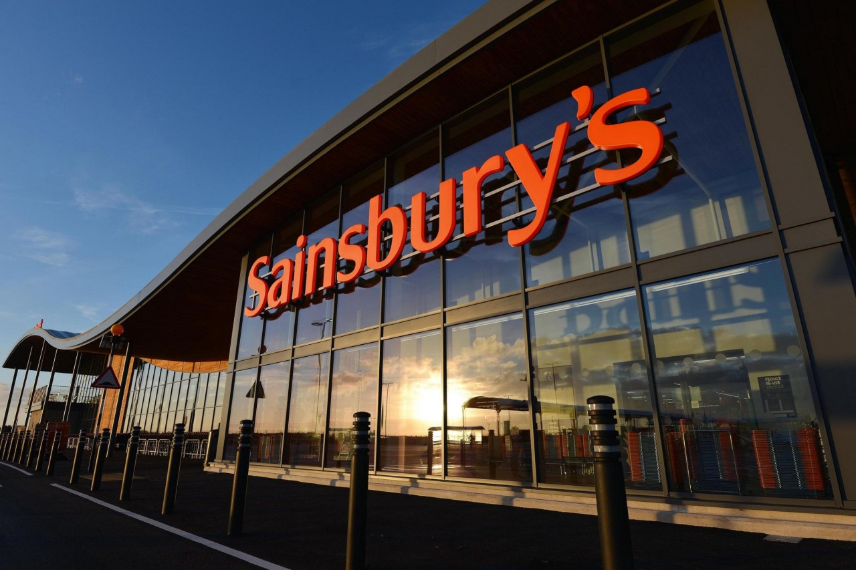

Workplace Culture and Its Impact on Organisational Efficiency at Sainsbury’s

- Table of Contents
- 2
- Introduction 3
- Workplace Culture of The Organisation 4
- Organisational Culture and Performance 4
- Political Factors that Impact Sainsbury (J) Plc 6
- Political Factors 6
- Economic Factors 7
- Social Factors 7
- Technological Factors 8
- Technological 8
- New analytics 8
- Online shopping 8
- Legal Factors 8
- Environmental Factors 9
- Environmental 9
- Carbon footprint 9
- Plastic waste 9
- PESTLE Analysis of Sainsbury’s: Final Thoughts 9
- Organisational Present Culture and Ethical Standard 10
- Conclusion 12
- References 13

Introduction

Sainsbury’s retail established in 1869 by husband and wife John James and Mary Ann Sainsbury, since then Sainsbury’s has gone on to become one of the longest Britain’s standing key food retailing chain. It is held by a parent company J Sainsbury’s. Sainsbury’s retail employs over 153,000 people who serve over 14 million customers a week (Waddock & Leigh, 2006). The retail part of company has a range of products ranging from groceries, meat products, dairy, bakery and other household goods. It is estimated that the company has a turnover of 29.1 billion pounds annually. In addition to retail Sainsbury's has diversified itself into the banking sector, as well as property investment in recent times after margining with British Land Company PLC and Land Securities Group PLC (Bhasin, 2019). Sainsbury’s has merged with other retailers like Argos and Habitat as well as partnering with other businesses.
This report will first of all focus on assessing the workplace culture at Sainsbury's.
The second part of this report evaluates the broader environment which Sainsbury's operates, its organisational culture and performance.
The third part of the report explores the cultural standards and the ethical standards that encompass the company.
The final part concludes findings from this report.

Workplace Culture of the Organisation
Culture is identified as a norm by which individuals and others that can relate. It consists of values, habits, attitudes, beliefs. Individuals identify with culture, as either alike or unlike. If this difference is seen as unlike then the culture is either practiced by individuals or the culture norm is broken. Examples of culture are paintings, art objects, Rap Music or even sports and so on.
However, in an organisation, workplace culture is the way of doing the everyday habits and practises to include norms, practices, and artefacts. (Maund 2018). This could also be the rules or polices of the organisation like Sainsbury’s that would be adhered to when different circumstances arise for example, a uniform is part of Sainsbury’s and all staff below the structure of the chain of command wear as well as the promotions and recruitment of staff in the organisation done internally.
In order for an organisation to succeed, knowledge must be gained and shared in achievement of their goals and this depends on the quality of staff and management altogether. Although the standard of the workforce might be a condition that is essential in the current knowledge economies, however, this is one that is not sufficient. Taking advantage of the talents would develop skills that would be non-substitutable and inimitable by other competitors therefore making it become useful, rare, and priceless. (Greening & Turban, 2000).
Maund (2018), touched upon Peters and Waterman (1982) that managers are in search of a culture of excellence describing the culture of once a famous bank called, Barings, a merchant bank and a first one in the world with a tradition they were very proud off. This bank had a culture of recruiting from the elite, aristocracy from the British society.

Organisational Culture and Performance
This report will measure the performance using the following methods
- Market share
- Swot analysis
- Porters five forces
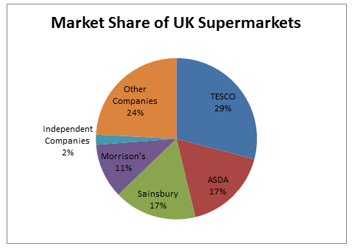
According to Investopedia, Market share is the percentage of overall sales in a sector generated by a specific business. Market share is determined by taking the business's sales over the period and dividing it by the total sales of the sector throughout the same period (Hayes, 2019). The image above outlines the superstores in the UK a market share.
A case study investigated the financial analysis of J Sainsbury PLC and Wm Morrison Supermarkets PLC, both firms are public limited companies trading on the London Stock Exchange. In the retail the two companies operate they are leading companies in the industry. J Sainsbury PLC has approximately 17.7 percent of the market share in the UK superstore. Also, it is the second largest chain of superstores in the sector after Tesco (29%). The business has around 1,106 stores and employs approximately 152,000 employees in their stores (Ivy Panda, 2020).
By comparison, Morrison superstores PLC is fourth amongst the top five superstores in the UK with a market share of 11.3%. with over 600 locations. The company employs around 132,000 workers. (Ivy Panda, 2020)
http://fernfortuniversity.com/term-papers/porter5/lse/477-sainsbury--j--plc.php .
https://myassignmenthelp.com/mah_cms/uploads/2016-10-13_1527q3-1476352754.png

SWOT analysis of Sainsbury's
A SWOT analysis is a tool that is used by the organisation to control and establish their Strengths, Weaknesses, Opportunities, and Threats – SWOT, and this allows the organisation to access their weakness and improve on what has been identified as well as focus on opportunities too.

Strengths | Weaknesses
- Sainsburys is second UK largest supermarket.  - Sainsbury’s has high retention of employee and very diverse  - extremely experienced leadership team  - Excellent brand  - High product availability in stocks  - The company is listed on the London Stock Exchange & FTSE Index  - Sainsbury’s sponsors several events like Paralympics and partnered with organisations to offer charity | - Food prices rising and passing it on to consumers.  - Rising fuel prices impacts on transportation.  - Competitors.
Opportunities | Threats
- Merging with other companies and  - Increasing the machines at Self-checkout to decrease weight times.  - Looking to Expand to other countries.  - community outreach programmes. | - challenges of globalisation  - New competitors  - Sourcing for the best quality and viable products from around the world.

Source: mindtools.
Sainsbury’s is a market leader in the arena it operates, which gives them a competitive advantage over the smaller store. Where growing competition in this retail space demands strategic trends to differentiate itself so, Sainsburys is able to sponsor large events.
One of the strengths of Sainsbury's is its expansion into small retail stores that stock a smaller product range to its bigger stores, which amounts to 800 hundred of its 1400 stores. In doing so, giving the business the ability to compete with the like of Tesco Morrisons and Waitrose,
In terms of weaknesses Sainsbury's must contend with of rising global prices of products from suppliers. This is impacted by the fact that there are more entrants to the market which Sainsbury's retail operates. The competitiveness among the existing companies in the retail sector Sainsburys is activates in, is strong this decreases fees and reduces the overall profitability of the sector. Coupling these two weaknesses together, results in lower margins, take a toll on the overall long-term cost-effectiveness of the business (Bhasin, 2019).

Fig 1: Michael Porter's Five Force
Organisational performance can be measured by Porters 5 forces that can allow the organisation to analyse and understand the elements that are affecting the profitability within the business. Porters 5 force can assist with developing master planning strategies competitively whilst studying the current competitors. Sainsbury’s managers can use the Ports 5 Forces to plan ahead to explore more opportunities that can be of advantage and maintained to Sainsbury’s profitability in the retail service industry

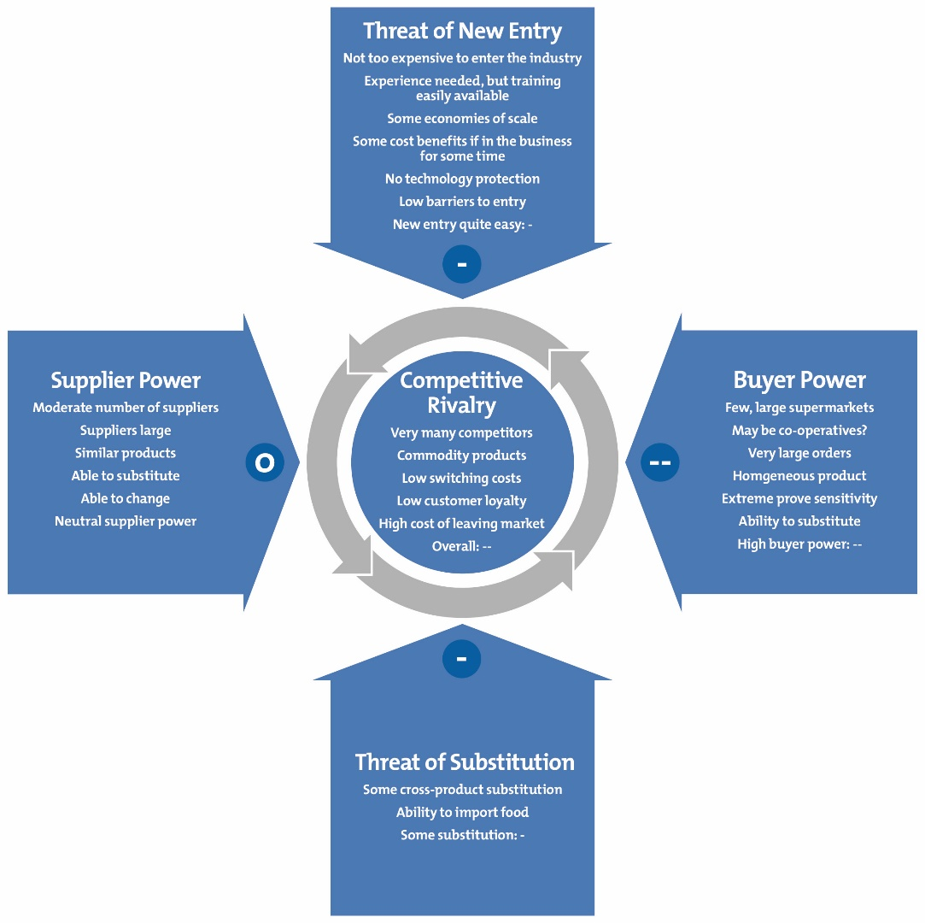https://www.mindtools.com/pages/article/newTMC_08.htm

Political Factors that Impact Sainsbury (J) Plc
Political steadiness is key for stability within a country to avoid meaningfully disruption of business operations. This can particularly be true for businesses that operate globally. For example, a hostile government takeover can result in a situation of looting, riots and disorder within the country. Such circumstances can interrupt business activities, which can have a bearing on its bottom line.

The principal political factor that affects all UK based companies such as Sainsbury’s is the forthcoming Brexit. England will no longer be part of the European Union. Thus, likely result in increased import rates. This would unavoidably increase the product pricing of brands and which could conclude in a loss of a large number of customers to competitors that provide cheaper across-the-board alternatives. As of now the effects of Brexit cannot be measured but it is anticipated to lead to adverse circumstances for the brand.
Another political factor is the connection between Qatar and England in the future. The Sovereign Wealth Fund of Qatar is vital shareholder of the Sainsburys. If any political feud between the Qatar and the UK develop, it would potentially lead to a drop in the market shares of Sainsbury’s. Any political fallouts may by triggered by Brexit.
Foreign Trade Principles – A business has a need to have organic growth with could lead to business expanding operation to other nations. Yet, circumstantial political standing of a country affects the desire for a business to expand its operations. Tax policies controlled by the government can encourage a business to expand operations in different areas while in contrast other tax policies can delay the process of business growth for some industries. Government initiatives designed to prop up local businesses, may well work against international businesses ability to provide competitiveness in a foreign region.

Economic Factors
Sainsbury’s largely depends on transports that is road-based means to move its goods across the UK. The instability of oil prices has a potential to impact increase Sainsburys product pricing. They could possibly lead to a loss of lower-income customers. With major government across the world turning to fossil fuel alternatives, soon will lead to the brand having to look for substitute means of goods transit. High prices of fuel will ultimately make it extra expensive to haul products around the country. This may conclude in a lower profit margins or higher price increase for the consumer; in any case, this is likely to decrease overall viability.

In addition, higher salary expectation of the workforces are the two likely economic issues that are affecting Sainsbury’s. According to ‘’higher wage movement is gaining momentum across the UK and Sainsbury’s is expected to meet the demands of its workers to retain its shareholders’’.

The increase of new Supermarket firms within the UK has always been a strong economic factor that Sainsbury’s has to contend with. Brands such as Asda and Tesco have been long-standing rivals of the firm. Adding to the rivalry are brands such as Lidl and Aldi are demonstrating to be a source of additional competition in this retail sector. This rivalry shows no signs of dropping off, and may well force Sainsbury’s to continually modernise while minimalizing their ability to make profits.

Social Factors
A major driving force of Sainsburys revenue intake, stemmed from the sale of its fast food items in its stores. In recent times, the UK population has continually shifted towards a health-conscious nutrition that does not include fast food products. In order to modernise its current socio-cultural climate Sainsburys will have to change its take-away menu to contain more healthy choices such as salads and organic juices. This is a global movement that has strong presence within the UK and the main fast food brands are affected by this shift in customer behaviour. This trend towards making healthier nutritional changes is a hugely important for superstore chains like Sainsbury’s, since acclimatising to consumers’ demands is imperative to future success. (Pestle analysis.com 2020).
Another trend in consumer behaviour at Sainsbury’s and other superstores is the fair-trade movement. This includes an increase in prices of grains, vegetables, and other farm products; but motivated in support of farmers as a substitute of a profit incentives. Products such as chocolate and coffee are spearheading the fair-trade movement. Brand developers are tasked to certify that they are meeting their consumer behaviour demands. (Marketingtutor.net 2020).

Consumers have become more aware and mindful to the how and where the food and products they buy or consume comes about. This created a movement of Fair Trade which saw the treatment of sweat shop workers mistreated and under paid by the owners of the business. Although the movement has encouraged better wages and better social economics for the workers, but then this was an increase to the price of goods and food that was passed on to the consumers. This movement exposed companies who make chocolate like Cadburys and others that produce coffee and fruits too. You can see products in Sainsbury’s aisle and other supermarkets that now display a fair trade mark on their produce that ensures framers have been assured a fair just price.

Technological Factors
The current generation Z and millenniums are very tech-focused hence the, increased demand and advancement of technology in daily lives and in businesses like Sainsburys. The social environment therefore has seen the introduction of e-commerce across business sectors.
Sainsbury’s as the second leading supermarket has gained an advantage of other supermarkets with their large database of customers and has continued to look for better ways to improve customer experience with the ever-growing demand. This has seen Sainsbury’s introduce the scan and go without tills. However modern technology needs large system to be able to analyse their customers and their behaviour in the example of A1 and big data. This would be of an advantage to Sainsbury’s there is a need to understand customer desires to provide customer satisfaction, this would boost sale and profitability and improved campaigns in marketing. (Marketingtutor.net 2020).

The development and implementation of New Analytics techniques are sure to improve the profitability of Sainsbury’s. Technological advancements in analytics, such as the use of Big Data and Artificial Intelligence principles are allowing companies worldwide In learning more about their operations. Sainsbury’s, can use advancements in analytics to build highly accurate models that describe how much of a given product is expected to sell (preventing waste) and at what price (maximizing profits).

Online shopping-According to Which UK (2020) Sainsbury’s one of the supermarkets that scored high on their survey of best online shopping experience and service. As one of the leading supermarkets brand the service of online one of the options available to consumers and is more in demand than ever before with increased online sales. The advantage of ecommerce being utilized in the food sector.

Legal Factors facing Sainsburys
As a brand, Sainsbury’s does have different layers of decision making applied, to ensure that systemic changes introduced are not delayed by business structure. Any delay in regulatory approval would potentially lead to loss in market shares and competitors being able to provide a better experience to the customers and meet the specific consumer demands. And since the amount of competition faced by Sainsbury’s is absolutely high it needs to ensure that no quarter is given in this aspect.
The legal impacts of post Brexit economy is also a major factor that the brand should be ready to face. It might be required to change many of its policies while running its outlets that will now fall outside the economic and political sphere of Britain.
Sainsburys is focusing its efforts where we can make the greatest difference and believe collective action is the only way to address these global issues at the speed and scale required.

Environmental Factors affecting Sainsbury’s:

Carbon footprint - As environmental concerns mount, companies around the world are expected to reduce their carbon footprint by identifying new ways to become more environmentally-friendly and seriously consider how they can minimize the ecological damage caused by their operations.
Sainsbury’s produces a high level of carbon footprint that is highly adversarial to the current environmental conditions. Currently climate change movement gaining momentum worldwide and throughout the UK, so Sainsburys must take active steps to curb its environmental impact specifically, regarding plastic waste, fossil fuel-based transportation methods, and the high ecological cost of maintenance. Whether it’s transporting goods from one side of the country to the other or keeping huge supermarkets and warehouses lit up around the clock, Sainsburys faces additional pressure on the brand to make quick changes to suit current climate-oriented needs as an industry leader. And apart from being a method of meeting customer demands, catering to environmental impacts is truly the need of the hour for operations as large as Sainsbury’s.

Plastic waste -
Sainsbury’s would also need to follow suit with their shopping plastic carrier bags of which prices have increased from 5 pence to now 10 pence that did not deter customers from not purchasing the carrier bags. Sainsbury’s would need to find better recyclable material to be used instead of plastic like what another supermarket Iceland, they have introduced a large paper bag to be used instead of the former plastic carrier bags Iceland had. Iceland have also launched an initiative to reduce plastic packaging on their range of fresh produce to see a reduction of 93% under the slogan of Doing it right. (Iceland UK, 2020).
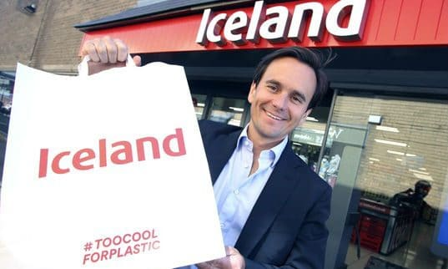
Sourced: Bing.com

According to the Sun News, Sainsbury’s has a scheme which pays money to those that recycle plastic bottles or cans at 5 pence per recycled plastic bottle or can.
Another global organisation Coca Cola has had a summer campaign and strategy pledging to have a world globally without waste. This campaign is encouraging coca cola consumers to recycle their plastic bottles after use at a designated vending machine which would then in return reward the consumer with a 50% off vouchers that can be used at any Merlin entertainment attraction in the United Kingdom. To name a few; this would include resorts such as LEGOLAND, Alton Towers, Chessington as well as Madame Tussauds and London Eye. This is a brilliant idea for Coca Cola as they have a large number of consumers for their brand as well as they are connecting with the environment and reduce and manage their waste. (Coca Cola UK 2020).
Sainsbury’s recently announced that from April 2020 all eggs sold in store and online will be sourced from free range farms in the UK.
Sainsbury’s commitment to sourcing with integrity. In 2004 it launched a partnership with the Woodland Trust to help create and protect the UK’s woodland. To date it has raised more than £8.8 million for the charity and helped to plant 3.6 million native trees with the potential to mitigate the impact of more than 812,000 tonnes of carbon dioxide from the atmosphere.
This was followed in 2009 when the supermarket became the first major retailer to go 100% cage-free for eggs. All of Sainsbury’s own-brand eggs are already from RSPCA Assured UK farms such as The Lakes Free Range Eggs Co and it stocks more RSPCA Assured products than any other UK supermarket.

Organisational Present Culture and Ethical Standard.
Sainsburys is committed to high standards of corporate governance, and apply the main and supporting principles of the UK Corporate Governance Code. This Code emphasises the need for well-balanced, effective boards, strong overseeing of risk management, alignment of remuneration policies with shareholder interests, and sound shareholder relations.
Further information is available in our Annual Report, which includes our Corporate governance statement and Remuneration report.
Modern slavery- Sainsbury’s is devoted to recognising vulnerable workers and does not tolerate any form of slavery or servitude in the business or supply chains. Sainsburys uses a risk-based approach to proactively tackle serious exploitation of workers and provide resources where they are most needed to protect workers.
Further details can be found in 2019 Modern Slavery Statement, which was reviewed by the Corporate Responsibility and Sustainability Committee and is available online (J Sainsbury's plc, 2019).
Diversity and inclusion- The Group’s aspiration is to be the most inclusive retailer, and the Board is highly supportive of the initiatives in place to promote diversity and inclusion throughout the business.
Clear leadership and inclusion agenda are set by Mike Coupe and the Operating Board, with senior management being set annual objectives to drive progress through the business.
The Group Diversity and Inclusion Steering Group is chaired by the Group HR Director and is also attended by three other Operating Board Directors who champion each inclusion stream (gender, ethnicity, LGBT and disability/carers) with other senior leads from the different business units (J Sainsbury's plc, 2019).
The Board believes there is a good balance of diversity amongst our Non-Executive Directors, with several having extensive experience of retail and consumer-facing businesses and other highly relevant skills derived from serving in a range of major executive and non-executive positions throughout their careers. The Board feels that diversity is one of its strengths and endeavours to continue with appointments on merit whilst working hard to broaden the diversity of the talent pool.
Currently, female representation on the Board equates to 30 per cent. Female representation on the Operating Board has increased with the appointment of Clodagh Moriarty and is currently 20 per cent. The representation of female divisional directors and senior management is 31 per cent. (J Sainsbury's plc, 2019)

Covid 2019- Coronavirus disease (COVID-19) is an infectious disease caused by a newly discovered coronavirus. COVID-19 pandemic has had a significant impact on Sainsbury business since early March 2020with three clear priorities keeping customers and colleagues safe; helping to feed the nation and supporting our communities and the most vulnerable in society.
Central teams have supported them, working closely with suppliers to increase orders and to move products quickly through the supply chain and into stores.
Although its early in the financial year it is impossible to predict the full nature, extent and duration of the financial impact of COVID-19 over the course of the year and there is a wide range of potential profit outcomes, both short and medium term.
Sainsburys have modelled a broad range of scenarios only based on assumptions regarding lockdown restrictions, consumer demand, particularly for general merchandise and clothing, will be impacted by weaker economic conditions thereafter.
With the worldwide onset and measures to curb the spread of the disease, Sainsburys has received donations from our customers and colleagues and are overwhelmed by the generosity displayed in these challenging times. Sainsburys matched the £1.5 million already raised in-store and online, bringing the total donated to Comic Relief and BBC Children in Need to over £3 million.
Sainsburys work with Frontline UK charities and projects facing unprecedented demand for their services as a result of Covid-19 via funding from Comic Relief and BBC Children in Need. This includes small grassroots projects at the heart of the Covid-19 response, to larger organisations that have national reach across the UK. Funding are given to charities responding to the immediate impact of the crisis as well as those providing support in the medium or longer term. https://www.sainsburys.co.uk

Since the beginning of April, Sainsbury’s has successfully rolled out Chop Chop service across 20 cities across the country and trialled making deliveries from closed convenience stores bringing fast grocery deliveries by bike to customers outside of London for the first time. The supermarket has already more than doubled the number of customer orders. By bringing the offer to 50 stores across the country Sainsbury’s will increase capacity by a further 400% by mid-June.

Conclusion
Sainsburys boasts that Customers are at the heart of business and their success and future growth is based on ability to anticipate and then deliver customer’s needs.
Sainsbury’s Group leaderships strong sense of social, environmental and economic responsibility and an understanding that depends on society’s success.

Today, with one billion people living in extreme poverty; malnutrition and obesity becoming more prevalent and our planet’s resources being pushed to their limits, Sainsburys values and culture are helping them drive lasting, positive change in the UK and internationally.
Sainsburys supports UN Sustainable Development Goals and want to play our part in tackling climate change, injustice and inequality and ending poverty.

The strong leaderships Goals also offer great economic opportunity and in a highly competitive industry that also make strong commercial sense.
Sainsburys values helps strengthen relationships with all our stakeholders, build trust, reduce operating costs, mitigate risks and attract and retain talent in a crowded marketplace.
The rapid expansion will support Sainsbury’s efforts to increase the total number of online delivery slots for its groceries online service to 600,000 per week. Sainsbury’s is continuing to prioritise elderly, disabled and vulnerable customers for its Groceries Online delivery slots as well as exploring innovative new ways to deliver to more customers.

Fig2
F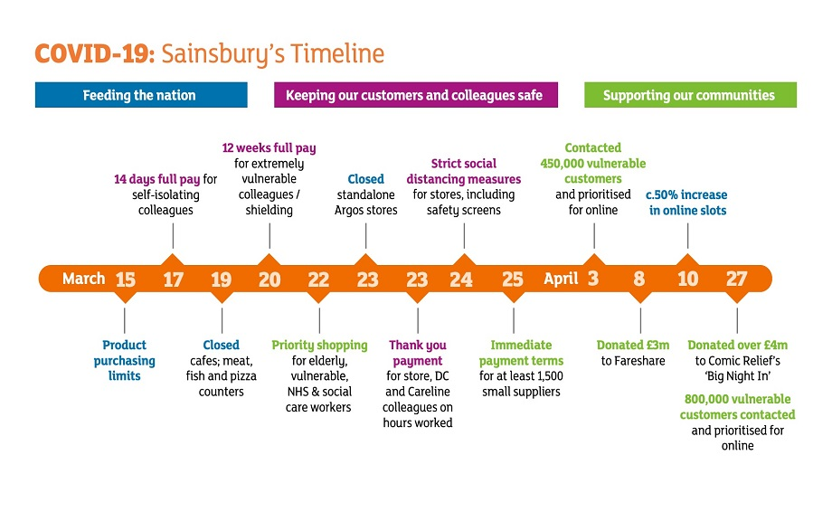IG 2

Fig 3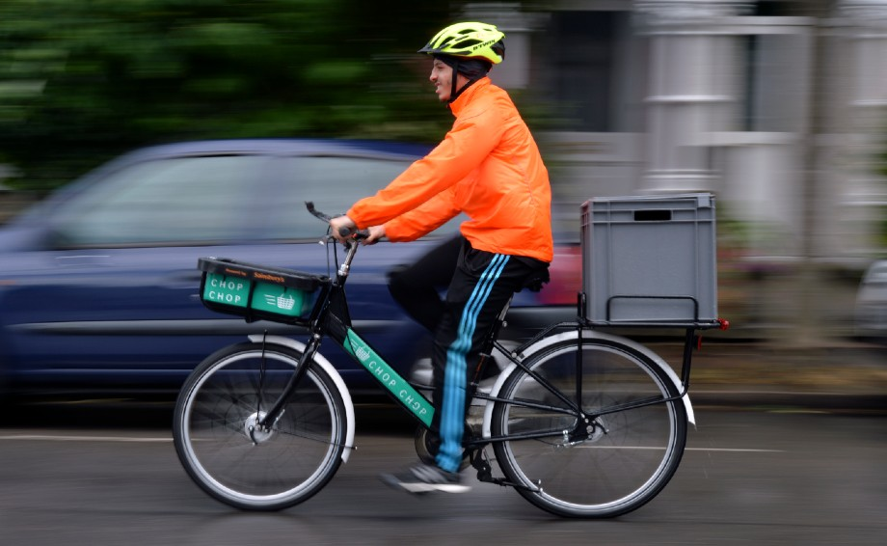

References

- Bhasin, H., 2019. SWOT analysis of Sainsbury. [Online]
Available at: https://www.marketing91.com/swot-analysis-of-sainsbury/
[Accessed 12 05 2020].
- Borland, H. (2019) 'Plastic Fantastic Sainsbury's will pay you 5p for every plastic bottle or drinks can you recycle but its not at all stores', The Sun News, 8th June. Available at: https://www.thesun.co.uk/money/9242681/sainsburys-5p-plastic-bottle-drinks-recycle/
(Accessed 21st May 2020).

Coca Cola Great Britain. How you can recycle your Coca Cola bottles and get 50% off Merlin attractions: Available at: https://www.coca-cola.co.uk/sustainability/packaging-and-recycling/how-you-can-recycle-your-coca-cola-bottles (Accessed: 21st May 2020).

- Greening, D. W. & Turban, D. B., 2000. Corporate Social Performance As A Competitive Advantage In Attracting A Quality Workforce. Business & Society, 39(3), pp. 254-280.
- Hayes, A., 2019. Market Share. [Online]
Available at: https://www.investopedia.com/terms/m/marketshare.asp
[Accessed 13 05 2020].

- Iceland UK. (2020) 'Iceland launches UK first trial to reduce plastic package of fresh produce by 93%' Available at: https://sustainability.iceland.co.uk/news/iceland-launches-uk-first-trial-to-reduce-plastic-packaging-on-fresh-produce-by-93/
(Accessed: 21st May 2020).
- Ivy Panda, 2020. Financial analysis of J Sainsbury PLC and Wm Morrison Supermarkets PLC Report. [Online]
Available at: https://ivypanda.com/essays/financial-analysis-of-j-sainsbury-plc-and-wm-morrison-supermarkets-plc/
[Accessed 13 05 2020].
- J Sainsbury's plc, 2019. Annual Report and Financial Statements 2019. [Online]
Available at: https://www.about.sainsburys.co.uk/~/media/Files/S/Sainsburys/documents/reports-and-presentations/annual-reports/sainsburys-ar2019.pdf
[Accessed 14 05 2020].
- Maund, A. (2018) BA in Leadership and Management: Skills in the Workplace Student Yearbook, 1st Year. London: Sage.

- Waddock , S. A. & Leigh, J., 2006. The emergence of total responsibility management systems: J. Sainsbury's (plc) voluntary responsibility management systems for global food retail supply chain. Business and Society Review, 111(4), pp. 409 - 426.

