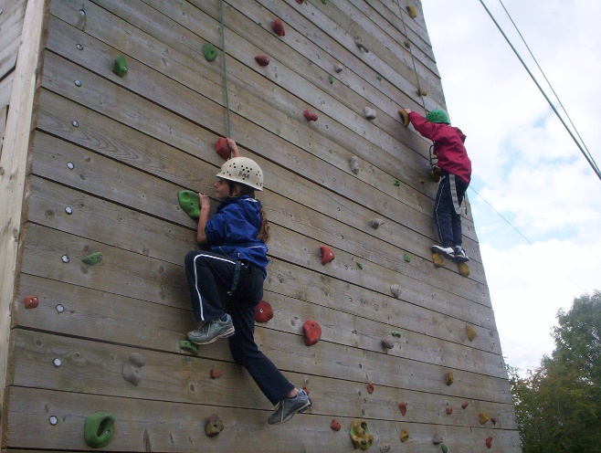
Group 4
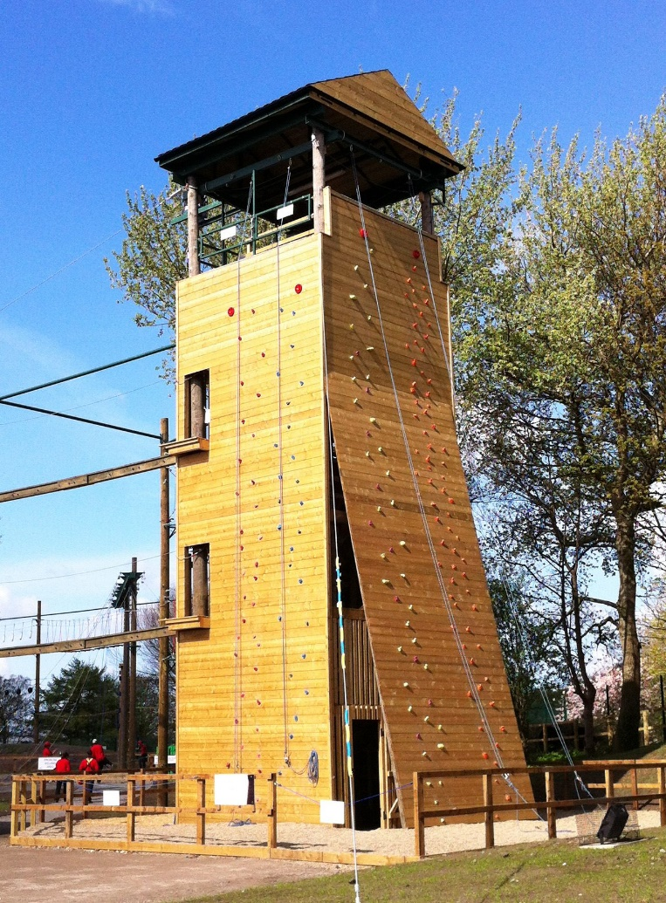

1. Consider the affordances of this environment, what opportunities are provided for…..
  - The development Foundational Movement Competencies
  - Adventurous play
  - Providing a foundation for the development of a life long journey of physical literacy

2. Are there any cultural/social influences on this environment?

