University of Wales Trinity Saint David
BMHP5003_LON
Introduction to Physiology
Name of the lecturer: Adesewa Ajayi
Name of the student: Maria Dandu
Student ID: 1810151

Contents
Introduction 3
Case study 3
Health assessment 4
Recommendations 7
Conclusion 8
References 10
Appendices 11
Appendix I: Poster 11
Appendix I: Health and Lifestyle form 12

Introduction
Human Physiology has been described as the study of the human life. Physiology is the branch of biology which aims at studying the mechanisms of human life and other living things from the functionality of the cells in the molecular and the cellular level all the way to the overall behaviour of the human body as well the impact of the external environment on the human body (Lumen, 2019). This report aims at examining structure ff human body as well as it's functioning. It also aims at analysing the relationship between the function of the human body in relation to detailed anatomy as well as physiology. The report also aims at using that data collected the questionnaire on patient X and the poster to inform the planning of care often the individual. With a recommendation to improve on the health of the individual.

Case study
Patient X born 12 May 1964 is has never smoked in her life but has high blood pressure. Patient X provides from the questionnaire that she has no heart attack and has never suffered from angina too. She never had a stroke herself, however, in her family, she had someone with a heart attack (on her mother side) the mother is aged above the age of 60. Patient X has no trouble with very high cholesterol either.
With a height of1.61cm and weight 103.8kgs, patient x has a BMI of 40, therefore she is obese. Her ethnicity puts her at high risk of health various issues since her BMI is above 27.5. Losing and keeping off 5%of her weight can have health benefits, such as lowering her blood pressure and reducing her risk of developing type 2 diabetes. At the moment she is prediabetic. She aims at losing 5.2kg recommended daily calorie intake: 1716-2207 kcal. To lose 1-2Ibs a week stick to the lower end of the range.
When it comes to exercise, she exercises once a week for about 1h, patient X provides that the reason why she’s not more active is because she is very busy with her job, she cites that her life is very stressful and that she doesn’t have time to exercise.
On her response on diet, she is having pretty much of everything, she doesn’t follow any diets programs, also she doesn’t eat regularly as well. She is a lecturer; therefore, she starts her job early in the morning and finish her work late. Most of the times she skips her breakfast, in the morning and might only have a banana and water. Being an African, most of her meals are very spicy and salted, her meals also contain a lot of red meat. Patient X is a Christian and because of her religion she is usually fast.
She provides that her alcohol intake is less than one units per day. Patient X is suffering from arthritis, she is under hydroxychloroquine sulphate tablets. One of the side effects of this arthritis medication is on eyesight. She ended up having cataract operation, but she is fine now. Her grandmother had arthritis this means that the health issue of arthritis is genetic. When she was a child, she had bonds pain, this was one of the signs, but nobody paid attention to these facts. Patient X is having a high stressful life because of her job, being prediabetic, having one child and being on her menopause.

Health assessment
Physiological conditions simply describe the state or the condition of human body or the state of functioning of the human body, it is also described as the physiological state of the body. The physiological conditions can be normal or abnormal where the normal physiological body conditions are made up of the state in which all the body functions are operating normally; there is normal state of body functioning such as normal temperature, normal pressure, normal breathing, normal digestion, normal weight and other functions are operating normally. On the other hand, the abnormal physiological condition in human body is where the body is not functioning normally; there are defects in the normal body functioning such as high or low body temperature below the optimal levels, high blood pressure, poor or lack of digestion, abnormal body weight and other conditions (WordNet, 2020).
From the assessment basing on the questionnaire of patient X, there are various normal and abnormal physiological conditions identified. One of these physiological conditions is on the body weight. Normal or health body weight is assessed using Body Mass Index (BMI). Body mass index is calculated by dividing the weight of an individual in kilograms by the height of the individual in meters. Using BMI, one can establish if he/she has normal weight, underweight or overweight. Being underweight or overweight puts one into a risk of various health issues (CDC, 2020).
- The underweight range of BMI is 18.5 and below
- The normal or the healthy wight range falls between the BMI of 18.5 to 24.9
- The overweight BMI range falls between 24.9 to 29.9
- The obesity BMI range falls above 30.0 and above
Patient X has a BMI of 40 with a height of 1.61 metres and weight of 103.8 kilograms. Therefore, patient X is obese since her BMI is above 30.0. obesity has major physiological impacts on human body, this includes impact on the normal cardiovascular functioning. Someone with obesity requires an increased supply of intravascular blood and the cardiac output which means that the heartbeat rate must rise above the normal, this has a major impact on the left ventricle which might lead to heart failure. Obesity also leads to obstruction of the airway which directly slows down the blood pressure and have a major impact on the heart having to pump blood beyond the normal functioning (Ortiz and Kwo, 2015). This explains one of the major possibilities why patient X is suffering from high blood pressure.
Obesity has major impairments on organs, body processes and tissues, it has a major impact on the respiratory system. Obesity directly impacts on the mechanical functioning of the respiratory system. Obesity causes deposition of fats in the chest wall, the abdomen as well as the upper airway, it also causes inflammation of the respiratory system which leads to an increased rate of breathing which consequently causes an increase in the neural respiratory drive. The impact of obesity on the respiratory system also causes various respiratory sleep disorders which might eventually lead to hypercapnic respiratory failure. Deposition of fats on the various parts of the respiratory system also increases pulmonary resistance, lowers the strength of the respiratory muscles and lowers the compliance of the respiratory system (Mafort et al., 2016).
With patient A also suffering from high blood pressure, it has many implications on the functioning of the heart. High blood pressure causes the heart over work which might lead to weakening of the heart and eventually heart failure. With high blood pressure, the heart is forced to pump blood so fast beyond the normal rate which might result to heart failure. Over time, the increased blood pressure causes the arteries and other blood vessels. This might cause life threatening complications if action is not taken. Besides that, high blood pressure causes formation of a bulge in the arteries which might cause pain and is deadly if it bursts (Debra, 2018).
The summary of the impact of obesity on the respiratory system in relation to patient X is shown below:
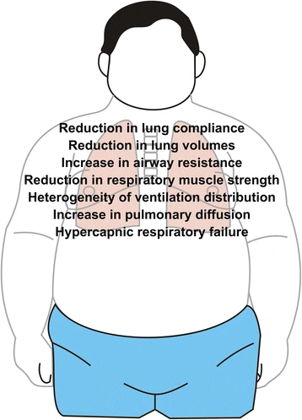
Source:
Obesity has also been associated with various mental impairments and brain functioning. Adiposity caused by obesity causes inflammation of various cells and tissues in the brain and have negative implication on the hormones associated with the brain such as insulin. Adiposity causes inflammation of the brain cells which might affect the stimulation and the functioning of various hormones which are usually stimulated in the brain. Besides that, obesity leads to general inflammation of human brain, the brain being vulnerable to injuries as well as reactive gliosis which majorly occurs in the hypothalamus, this has great impacts on the normal cognitive functioning (Nobuko et al., 2013).
Obesity also has a negative implication on the immune system. Obesity not only weakness the immune system but also lowers the ability of the body to fight the various diseases. Obesity causes the production of inflammatory components in the body originating from the formation of the adipose tissue. which causes impairment on the immune system which causes it to get weaker and weaker. The inflammatory components alter the leucocyte counts besides altering the cell-mediated immune responses. Besides that, the obesity alters the immune system by increasing the circulation levels of the pro-inflammatory proteins. These developments weaken the immune system thereby putting someone suffering from obesity such as patient X at a great risk of contracting various diseases (Gomez et al., 2012).
The medication used by arthritis medication (hydroxychloroquine sulphate tablets) used by patient X also causes various abnormal conditions on her body such as negative impact on her eyesight that she ended up having cataract operation, but she is fine now and has decided to avoid medication and live with her condition. Arthritis also causes pain in her joints, swelling, stiffness as well as loss of various body functions. With the pain, her ability to stretch during exercise might be negatively impacted, however, she should stretch the joints through the various exercises to reduce the pain since it keeps the joints loose (Spineina, 2020).

Recommendations
The health issues that patient X is facing originates from various sources such as genes, lifestyle and other sources. Patient X does not have an eating pattern despite her health issues. Lack of an eating pattern leads one having poor nutrition due to unbalanced diet and intake of food which might contribute to the health issue that one is suffering from (NHS, 2019). As in the case of patient X, she might end up taking food with high cholesterol content, too many fats, sugars, comfortable eating, use of alcohol which contributes to her obesity.
Arthritics have been greatly associated with genetics where some types of arthritis run through the family line. People inherit some genetic composition which puts them at a great risk of contracting arthritis which can be passed through the family line for generations. Some people are a great risk of contracting arthritis if the parents or the siblings has or had the issue (Mayo Clinic, 2020). Therefore, with her mother having suffered from arthritis, the genetic variation of patient X might have contributed to her contracting the disease.
For Patient X and someone suffering from diabetes as from the poster to live a health life, she therefore must take various actions on her lifestyle, eating patterns and other aspects of her life, this includes:
- Having a diet and an eating pattern to follow-patient X should adopt an eating pattern which includes food which less fat and cholesterol content, a lot of vegetables, fruits, starchy foods such as rice, potatoes, bread, dairy foods such as milk, small number of drinks while reducing energy intake and the intake of calories by 600 calories a day. She should adopt a diet plan with a very low content of calories.
- Physical activity and exercise- patient X should participate in light exercises such as cycling, brisk walking, taking part in a sporting activity such as running and others for 30 minutes every day for a start and gradually increase on this pattern to may be one hour every day. This shall help her improve on her immunity towards avoiding many health conditions and losing weight at the same time.
- Goals setting- patient X can set weight losing goals to be achieved on a specified period and work on them such as ‘Lose 5kgs per month,' ‘Avoid chips and fried for a year’ among others.
- Enrolling to weight losing organization such as Rosemary Conley diet- health campaigns have a significant impact on helping people with obesity such as promoting their mental wellbeing, helping them lose weight among other important roles. Since she has little time to exercise, patient X can enrol to the Rosemary Conley diet, an organization which encourage people with obesity on healthy eating. The organization also provides for a web-based work out sessions and videos that guide individuals on working out even at home while providing various psychological, medical and mental advice.

Conclusion
The functioning of human body is affected by so many physical, mental, social, environmental and other factors. This report examined the various normal as well as the abnormal elements of psychology based on patient X from the assessment. Under this report, I analysed the relationship between the detailed anatomy, physiology and body functioning basing the analysis on the findings from the health and lifestyle questionnaire. I then analysed and evaluated the data collected from the health and lifestyle questionnaire with the current recommendations on the health individuals which guided the recommendations which I provided towards promoting the health and wellbeing of patient X.

References
- CDC, 2020. Body Mass Index. [Online] Available at: <https://www.cdc.gov/healthyweight/assessing/bmi/index.html> [Accessed 2nd December 2020]
- Debra, S., 2018. Effects of high blood pressure on the body. [Online] Available at: <https://www.healthline.com/health/high-blood-pressure-hypertension/effect-on-body#Circulatory-system> [Accessed 2nd December 2020]
- Gómez-Martínez, S., Heredia, F.P., and Marcos., A, 2012. Obesity, inflammation and the immune system.
- Lumenlearning, 2019. Introduction to the human body [Online] Available at: <https://courses.lumenlearning.com/nemcc-ap/chapter/1558/> [Accessed 1st December 2020]
- Mafort, T.T., Rufino, R., Costa, C.H. et al., 2016. Obesity: systemic and pulmonary complications, biochemical abnormalities, and impairment of lung function.
- Mayo Clinic, 2019. Arthritis symptoms and causes. [Online] Available at: <https://www.mayoclinic.org/diseases-conditions/arthritis/symptoms-causes/syc-20350772> [Accessed 3rd December 2020]
- NHS UK, 2019. Causes of obesity [Online] Available at: <https://www.nhs.uk/conditions/obesity/causes/. [Accessed 2nd December 2020]
- Nobuko, Y., Goro, K. and Kazuwa, N., 2013. Mental Function and Obesity, Functional Brain Mapping and the Endeavor to Understand the Working Brain, Francesco Signorelli and Domenico Chirchiglia, IntechOpen.
- Ortiz, V.E., and Kwo, J., 2015. Obesity: physiologic changes and implications for preoperative management.
- Spineina, 2020. Exercising and joint pains [Online] Available at: < https://spineina.com/blog/preventing-joint-pain-while-exercising/> [Accessed 2nd December 2020]
- WordNet, 2020. Physiological condition [Online] Available at :<https://www.thefreedictionary.com/physiological+condition> [Accessed 2nd December 2020]

Appendices

Appendix I: Poster
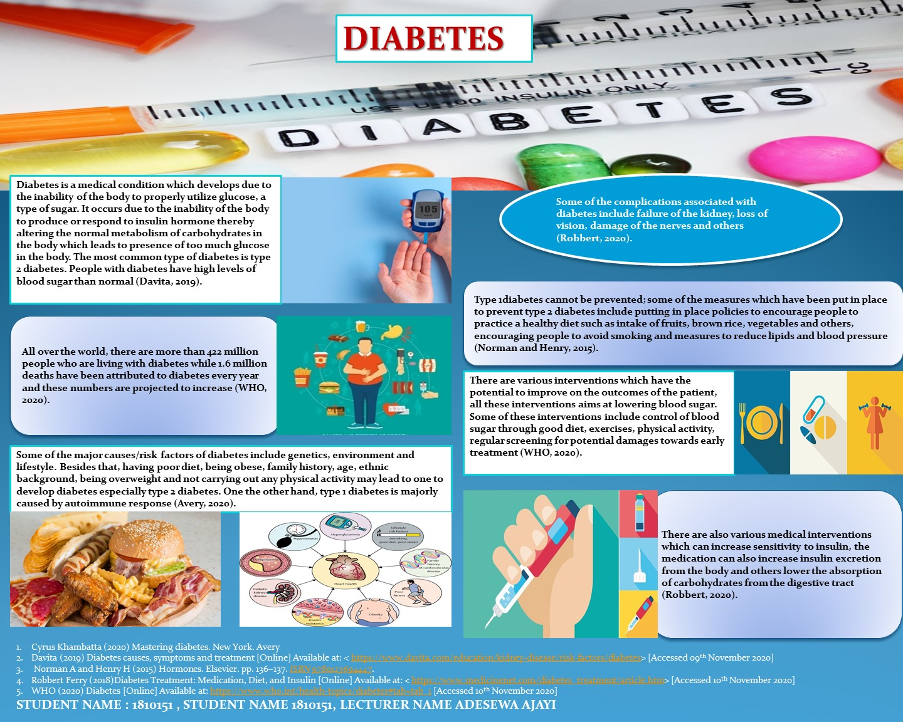

Appendix I: Health and Lifestyle form



