Evidence-based approaches to policing decisions/evidence-based policing and decision making
BMPL4001/ BMPS4008/ BMCP4000

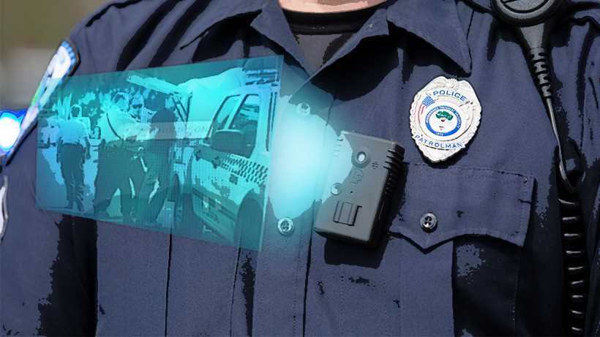

Name: Dorin Sorea
Student number: 2245095

Explore and evaluate the use of body worn cameras in evidence-based policing

INTRODUCTION

The term evidence based policing can be explained as the best available evidence which is
being used to inform and challenge the policies of policing, practices as well as other case
decisions(Weisburd, et al., 2023). This approach can be utilised by the individuals in the policing
system. Under this type of policing, the evidence is given main role. The evidence based policing
mainly deals with the evidence that directly supports the effectiveness of investigation
techniques used by the police officers. This essay will examine the core concept and ideas of the
evidence based policing. It will also outline the use of body worn video cameras in policing. It
will also provide for the strengths, weaknesses as well as ethical limitations of the body worn
cameras in criminal activities.

TASK

The evidence based policing is generally used by the police officers as well as the defence staff in order to create, review as well as utilise the best available evidence for the case. This is done to inform the current policies, practices as well as decisions. This is directly being supported by the collaboration with all the academics as well as other partners of the case. The evidence based policing provides for the best available evidence. These evidence will be used in an appropriate research methods as well as several resources(Kadry and Dodd, 2023). The body worn cameras are those cameras that is fitted in the clothes and other tools such as spectacles worn by an individual. The body worn camera provides for the evidence of real time. It helps in improving the law enforcement practices in the country. These cameras can be worn on an officer’s eyeglasses or under his chest area. It offers the exact real-time information that can be used by the officers on the doing patrolling. The police also has the other assignments which bring them into the contact with members of society. One of the main benefit of the body worn cameras is that it has the ability to render the law enforcement with the cool surveillance tool that will promote the safety of the police officers. It will also help in enhancing the efficiency and prevent crime in the country. In the year 2013, it is used in one third of UK municipal police departments. The members of general public would also tend to embrace the benefits of this technology.
In reference to the non-crime outcomes, an evidence from the core review article suggests that the use of BWCs can help in decreasing the complaints against the police officers. In the terms of several mechanisms, this is being assumed that the procedure of being recorded in the BWC can directly cause the change in police officer as well as the behaviour of the public that directly effects the nature of core interaction between the parties of the case (Gill, 2023). In addition to this, the BWC would also provide the officers with an extra level of information in order to help to recall at the time of writing the statements as well as giving the evidence in the court. Moreover, the implementation of the BWCs is very cost effective in nature.
A large number of police officers are very dedicated, hard-working individuals who are strived out to make up the lives aggrieved party. The evidence based policing has worked in the direction to protect as well as to serve the society in the most effective way. Hence, for rendering these services in the society, the authorities shall provide the tactics and methods in order to do policing. It can be noted that anything which is less authentic is simply unacceptable by the authorities. It will also create the cause to people for re offending at the higher level in the organisation. It also helps in providing the crime control with the less number of officers in the police department (Tomkins and Bristow, 2023). It is the type of information that has to be generated as well as shared across the profession of the policing. This highly shows the evidence based policing work in the society. Further, the concept of evidence based policing mainly explains that the practices of police would be based highly on the scientific evidence about what has worked best. It would also suggests that the best evidence shall be used in order to guide as well as assessing the work of the police department. The evidence based policing movement has explained that there shall be the better way to conduct the overall business of the criminal activity in the society.
The evidence based policing is divided into the two main parts. The first part is that it requires to be an enhancement in the amount of the research which is being conducted in the role of the policing. It is being noted that the police officers generally do not know about how to conduct these scientific rigorous studies, so this area is generally being left to the world of academics. Further, the criminologists would also design the studies about the crime as well as disorder and would publish the results in the academic journals. There area a number of the police officers who has no idea about these studies and would never know about its key results. Hence, for this the police officers would become the key drivers of the research that would partner with the co researchers in order to find the answers to all the questions in order to complete the core missions. The second element of the evidence based policing is mainly based on the translation of the research findings into the core formats which is directly accessible to other parties. It is not so easy for the working police officer to work in this manner. It has to be noted that policing is very different from the academic timelines.
The body worn cameras do has the multiple security functions that works for the public as well as the private sectors in the society. There are many benefits of the body worn cameras. These cameras can be used in any of the setting that will paramount to discourage an anti-social behaviour and crime in the society (Mc Cluskey and Uchida, 2023). The body worn cameras is worn by the door teams in the nightclubs, bars, hotels, retail venues, pubs, schools, hospitals and many more. For instance, the transport for the London staff generally uses these cameras for aiding the authorities to apply the fares as well as to improve its ability to respond with relate to all security incidents very swiftly. Moreover, an emergency sector staff like the ambulance crews would too have initiated it by using the cameras with the rise in assaults as well as violence against the core staff on call outs to the individuals homes in the country.
According to Wil Crisp and Vikram Dodd in 2020, the UK police was the first organisation that has used the body worn cameras while investigating the crime in the society back in the year 2005. From that year, there is more than 26,500 devices which is being given to the Metropolitan Police officers in the London that consists of the 80% of the Met taskforce cameras. Along with this, it will also help to protect the police officers and will also work to improve the public perception of the related police accountability in the society. The Metropolitan Police has explained that there are the guidelines for the police officers to use the cameras at the time of working with these cameras in order to reduce the rate of crime in the society. Initially, the cameras were generally worn by officers are visible to the public. This is because the police officers usually wear it and pinned to their chests. It has to be noted that it is the issue that is non-verbal warning which would be more criminal as well as other act that is very deterrent even if the cameras were not so recording as the work of patrolling by the police officers in the provided period of time. Secondly, the cameras tend to record all the video and audio. Hence, these body worn cameras would render the factual evidence of any kind of incident which is later being challenged in the court of the country. Moreover, the footage is directly being stored in the camera and then it is uploaded to the most secured server of the department. After that, the data where it is being stored for 31 days, then it will automatically be deleted at the end time of that period in the society. It can be used in the court proceedings (Wil Crisp and Vikram Dodd, 2020. Leaked review of Met police body-worn video footage reveals officer errors).
The police can use these evidence with respect to street crime in the society. It can use these cameras to record the on time reality when such street crime is happening in the society. Further, this will aid the police in identifying the criminal in the society. In addition to this, it would also enhance the transparency during the arrests, stop-and-search incidents and at other conditions where the police tend to interact with the public such as by responding to the domestic abuse report like searching any property, etc. The use of these cameras has also resulted into the equipping of the police with all these body cameras in the decrease of the force and very less complaints against the work of the officers. It has severely reduced to 90% in UK. The body worn cameras tend to highly improve the security as well as to deter the crime in the wider range of the authorities (Newell and Koen, 2023).
The body worn cameras too has the ethical consideration. It is ethically worn as the private information of the individuals can also be recorded under the audio and video clip of these body worn cloths which is against the right to liberty of an individual. There are also various demerits of using the body worn cameras. One of its demerit is that it is very expensive in nature. The police body camera is very costly as well as unreliable for a number of police departments (Katz and Huff, 2023). So, by equipping the police departments with these kind of body cameras, it would add up to the total cost of the police departments. It also requires the ancillary equipment like a car charger, proper training, data storage facilities, administration of the video data, and its maintenance cost in the society. Further, the police body cameras would also tend to invade the privacy of several citizens which is very exposing to several victims as well as subjecting to the facial recognition of the individuals. In addition to this, the recording of the police encounters with public can also result to the public exposure of the several private medical conditions like the mental illness of an individual in front of the society. It also decreases the safety of the police officers in long run. Along with this it also negatively effects the physical as well as mental health of the police officers (Choi, Michalski and Snyder, 2023).

CONCLUSION

This essay summarises about the concept of the evidence based policing. It concludes about the pros and cons of the body worn cameras by the police officers. It would also work as to provide the safeguard to the personnel against such accusations of the misconduct in the society. It has provided that the police officers faces so many problems while wearing the body worn cameras in their professional life. Further, the body worn cameras would also tend to improve the security level in the public areas.

REFERENCES
Books and Journals
Weisburd, D., et al., 2023. The Future of Evidence-Based Policing. Cambridge University Press.
Kadry, A. and Dodd, G., 2023. A Qualitative Study into the Success and Challenges in Embedding Evidence-Based Research Methods in Operational Policing Interventions. International Journal of Law and Political Sciences, 17(6), pp.415-422.
Gill, C., 2023. Rethinking the role of the community in proactive policing. The Future of Evidence-Based Policing, p.126.
Tomkins, L. and Bristow, A., 2023. Evidence-based practice and the ethics of care:‘What works’ or ‘what matters’?. human relations, 76(1), pp.118-143.
McCluskey, J.D. and Uchida, C.D., 2023. Video data analysis and police body-worn camera footage. Sociological Methods & Research, p.00491241231156968.
Newell, B.C. and Koen, M.C., 2023. Painting the narrative: Police body-worn cameras, report writing, and the techno-regulation of policework. First Monday.
Katz, C.M. and Huff, J., 2023. The achilles heel of police body-worn cameras: Understanding the factors that influence variation in body-worn camera activation. Justice quarterly, 40(3), pp.315-336.
Choi, S., Michalski, N.D. and Snyder, J.A., 2023. The “civilizing” effect of body-worn cameras on police-civilian interactions: Examining the current evidence, potential moderators, and methodological limitations. Criminal Justice Review, 48(1), pp.21-47.

Online
Wil Crisp and Vikram Dodd, 2020. Leaked review of Met police body-worn video footage reveals officer errors. Online available through <https://www.theguardian.com/uk-news/2020/oct/19/leaked-review-of-met-police-body-worn-videos-reveals-officer-errors>

