
Module Name: Managing Enterprise
Module Code: BMSW4011
Assessment 1: Business Plan and Reflection
Student Name: Pamela Kotseva
Student Number: 2405343
Lecturer: Chris Wilkin

AI Acknowledgement
I acknowledge the use of ChatGPT (https://chatgpt.com/) to create images for the promotional materials used in this work.
All prompts used for the creation of the images are available in the appendices section of this work.
I confirm that I have not presented any AI generated text as my own work. I confirm that I have copies of my drafts, notes, and other resources I used before, and after the use of AI tools which I may be asked to provide in evidence.

Contents
Part 1: Business Plan 4
1. Product/Service Proposition and Company Name 4
2. The Story Behind Your Idea 4
3. Business Ownership Structure 4
4. Mission Statement, Aim, and SMART Objectives 4
5. Location and Rationale 5
6. Human Resources 5
7. Marketing Activities 5
8. Market Research 5
9. Financial Resources 6
10. SWOT Analysis 6
Part 2: Individual Reflection (500 Words) 7
Reference List 8
Appendices 10

Part 1: Business Plan

Product/Service Proposition and Company Name
Beauty Tech is a beauty salon located near the city centre of Swansea, Wales. The main services provided by the business is nail care, manicures, and pedicures. What distinguishes this business from other similar salons is the acquisition of a nail art printing machine – a recently developed machine that operates on a similar basis as a regular printer. This machine allows for the creation and application of extremely complicated designs directly onto the customer nail. The designs printed by the machine are borderline impossible to recreate using traditional methods of manual nail polish application. The printer also drastically cuts down on application time.

The Story Behind Your Idea
I have always enjoyed taking care of my nails. However, I have been impatient during my beaty sessions as the process is lengthy and required patience on both my part and the technician’s since I am keen on more intricate designs. While on a holiday, I attended a recently opened nail salon that offered printed nails. I was a little sceptic at first as I expected that no machine could surpass the abilities of a human being, but I was extremely surprised by the quality of the result. After this, I took it upon myself to enrol in plethora of beauty courses that allowed me to hone my skills and open my own beauty salon.

Business Ownership Structure
I will be registered as the sole owner and trader of the business. This is due to the current scale of the operation and the limited resources available currently. Additionally, according to GOV.UK (2025) this is the simplest type of business that you can open as you are working by yourself for yourself and do not legally need any liability insurance, although Public Liability Insurance is highly recommended in case of accidental injury of a customer (Rose, 2019).

Mission Statement, Aim, and SMART Objectives
When creating the mission statement and aim I was aiming to highlight the technology, inclusivity, and the intricate designs provided by my business (Peek, 2023). /see appendices/
The SMART objectives for the near future of the business are available in the appendices (Makematic, 2023; MacLeod, 2012).
The unique selling proposition of my business is the technology that allows the creation of my designs – “when technology surpasses the human skill” (Frazer, Sheehan and Patti, 2002; Niu and Wang, 2016). This is why I decided on creating a short slogan for my business - “Nail Tech – When beauty meets high-tech” (Petty, Leong and Lwin, 2010).

Location and Rationale
The salon will be a lively area of Swansea city centre to ensure maximum visibility to the locals. Even though my main medium for advertising is social media I believe that the higher rent prices are worth it due to higher traffic and exposure. Additionally, according to Swansea.gov.uk (2024) Uplands, Castle, and Waterfront wards have the highest percentage (70%) of working age population (16-64) which are my main target group (Dooley, 2024).

Human Resources
As a sole trader I will be responsible for all activities carried out including service provision, marketing, and bookkeeping. This will put me in charge of my own business and will allow me to work and develop at my own pace while ensuring that all accountability is on myself. Additionally, this will provide me with more control over my time as I will be employed too in the starting stages of my business (Indeed Editorial Team, 2022). After the business grows, I will employ a family member to supervise my marketing so I can focus on providing better and more adequate services to my clients.

Marketing Activities
Nail Tech will mainly focus on digital marketing; however, I will use some traditional methods too. Researchers suggest that digital marketing is becoming more prevalent especially within the age groups I am mainly targeting (Kotler, Kartajaya and Setiawan, 2017; Jandal, 2024). This is why I will be posting designs and promotions on all the social platforms and engaging with all my followers. As a traditional marketing method, I will create flyers and business cards which I will distribute within my salon and local businesses that want to cooperate. Additionally, I will create promotional material for my vehicle as I use it to travel around Swansea often, to better increase the visibility of my brand. Lastly, I will provide a discount for my first-time customers and introduce a “loyal customer” reward scheme where every 10th visit to the salon will be free (Dowling and Uncles, 1997) /see appendices/.

Market Research
My market research includes both primary and secondary methods. For primary research, I have conducted an interview with my current nail technician /transcript in appendices/, also a sole trader, and a questionnaire distributed locally which yielded 16 answers. My primary research suggests that people are willing to pay £35 on average and usually do their nailcare routines monthly. However, it seems that they are not willing to travel far for their appointment and are mostly willing to keep it within 10miles of their homes. This information proved very valuable for my pricing strategy and proves that I can turn profit on my services as printed nails cost far less than what people are willing to pay for a traditional manicure. Also, my location appears to be extremely suitable for the purpose due to the high density of the population.
My secondary research appears to support my primary findings (Nextstep, 2025). Professionals in the field suggest that more people are willing to use nailcare services and that keeping on top of new trends and technologies is vital for the success of the business (Cummings, 2026).

Financial Resources
The starting capital for the business in £4000 (savings and business grant (Business Wales, 2026)) and the total initial expenses are £1975. Breakdown of the monthly expenses and income is available in the cashflow table in the appendices. Values are based on my research and on average of 5 working days, 8 hours/day, 3 customers daily, average spending of £35pp. Busier months according to research are considered and forecasted accordingly (Personal Beauty, 2019).

SWOT Analysis
I am planning on taking advantage of my strengths to overcome the threats the business faces. Due to my business being one of the first and only to have such technology I will make sure to capitalize on the “hype”. I plan on increasing the scope of my business in the future to include more services so I can diversify my sources of income and appeal to the masses (Kenny, 2024). This will help offset the threats and make the business more likely to succeed.

Part 2: Individual Reflection (500 Words)
Developing the business plan for Nail Tech has proven a very valuable experience as it helped improve my existing entrepreneurial skills and aided me in developing new ones. This helped me put my thoughts for my business on paper and identify areas of a business startup that I have never considered before. I am proud of myself for going through this journey and now I feel far better equipped for the journey of starting my own business. I am content with myself for gaining some crucial entrepreneurial skills that I did not have before. The first one is market research – having to dig deep in the businesses of my potential competitors and researching what worked for them has provided me with the opportunity to learn from their mistakes before I fall in the same traps as them. Creating and distributing a survey and interviewing my own nail technician provided me with valuable insight into the inner workings of this type of business. I am proud of myself for having thought of the idea to implement technology in nail art and I feel confident in the success of my future business. Another valuable skill that I have learned from this was the different aspects of marketing – from physical and digital marketing material distribution to the creation of a loyalty scheme to help keep existing customers. However, after learning what works and how it should work, I found certain areas of my skillset that need improvement. The main area I feel I need to improve is my digital marketing skills. I rarely use social media recreationally and even less so for business marketing purposes. I realize that I need to follow trends and stay on top of the viral content in the field. Additionally, I need to research content creation and ways to make my content more engaging to the demographic that I am aiming at. Also, I need to research Search Engine Optimization (SEO) so I can make my brand more relevant as initially creating a loyal customer base is the most important thing for the survival and longevity of my business.
Since Nail Tech is my personal dream, I am willing to invest in its success should the right opportunity present itself. I understand many businesses fail within the first year of opening, thus I plan on continuing my employment while developing Nail Tech. I will ensure that the potential losses are minimal in case of failure and will not be “putting all my eggs in one basket”. However, I am hopeful that the business will find success in the long run. I find that technological advance is becoming a bigger selling point for many businesses and strongly believe that people will be willing to try this technology and will be left satisfied with the results.
In conclusion I feel that creating this business plan has improved my entrepreneurial skills drastically and has uncovered some issues in my knowledge. I now know what to focus on to maximize my chances to make Nail Tech a successful, sustainable business.

Reference List

- Business Wales (2026). Grants. [online] Business Wales. Available at: https://businesswales.gov.wales/businessfinance/types-finance-and-how-apply/grants.
- Cummings, E. (2026). How to make it as a nail tech: skills, trends, business and growth. [online] Professional Beauty. Available at: https://professionalbeauty.co.uk/nail-tech-career-guide [Accessed 29 May 2026].
- Dooley, D.F. (2024). The Age Group Most Invested in Nail Care, According to Data. [online] NewBeauty. Available at: https://www.newbeauty.com/view/age-group-most-invested-in-nail-care [Accessed 29 May 2026].
- Dowling, G.R. and Uncles, M.D. (1997). Do customer loyalty programs really work? Sydney: Centre For Corporate Change, Australian Graduate School Of Management.
- Frazer, C.F., Sheehan, K.B. and Patti, C.H. (2002). Advertising strategy and effective advertising: comparing the USA and Australia. Journal of Marketing Communications, 8(3), pp.149–164. doi:https://doi.org/10.1080/13527260210147324.
- GOV.UK (2025). Become a sole trader. [online] GOV.UK. Available at: https://www.gov.uk/become-sole-trader.
- Husam Jandal (2024). Generational Marketing: Connecting with Every Age Group. [online] Linkedin.com. Available at: https://www.linkedin.com/pulse/generational-marketing-connecting-every-age-group-husam-jandal-mtulc/ [Accessed 29 May 2026].
- Indeed Editorial Team (2022). The Benefits of Working Alone. [online] Indeed Career Guide. Available at: https://www.indeed.com/career-advice/career-development/benefits-of-working-alone.
- Kenny, G. (2024). 4 Rules for Diversifying Your Business. [online] Harvard Business Review. Available at: https://hbr.org/2024/03/4-rules-for-diversifying-your-business.
- Kotler, P., Kartajaya, H. and Setiawan, I. (2017). Marketing 4.0: Moving from Traditional to Digital. Hoboken, New Jersey: John Wiley & Sons, Inc., Cop.
- MacLeod, L. (2012). Making SMART Goals Smarter. ProQuest, [online] 38(2), pp.68–70, 72. Available at: https://www.proquest.com/docview/1284082621?pq-origsite=gscholar&fromopenview=true&sourcetype=Scholarly%20Journals.
- Makematic (2023). How To Set Goals. [online] alexanderstreet.com. Available at: https://video-alexanderstreet-com.uwtsd.idm.oclc.org/watch/how-to-set-goals/transcript [Accessed 28 May 2026].
- Nextstep (2025). How Much Should I Charge Clients For My Nail & Beauty Services? A Practical Guide for UK Entrepreneurs - Next Step Beauty. [online] Next Step Beauty. Available at: https://www.nextstepbeauty.co.uk/old-blogs/how-much-should-i-charge-clients-for-my-nail-beauty-services-a-practical-guide-for-uk-entrepreneurs/.
- Niu, Y. and Wang, C.L. (2016). Revised Unique Selling Proposition: Scale Development, Validation, and Application. Journal of Promotion Management, 22(6), pp.874–896. doi:https://doi.org/10.1080/10496491.2016.1214209.
- Peek, S. (2023). How to Write Perfect Mission Statement. [online] business.com. Available at: https://www.business.com/articles/the-art-of-words-how-to-write-the-perfect-mission-statement/.
- Personal Beauty (2019). Beauty lovers visit their local salon five times a year, spending £200 on treatments. [online] Professional Beauty. Available at: https://professionalbeauty.co.uk/site/newsdetails/beauty-lovers-visit-their-local-salon-five-times-a-year.
- Petty, R.D., Leong, S.H.S. and Lwin, M.O. (2010). Slogans. International Journal of Advertising, 29(3), pp.473–500. doi:https://doi.org/10.2501/s0265048710201270.
- Rose, B. (2019). What insurance does a small business need? - Companies House. [online] Blog.gov.uk. Available at: https://companieshouse.blog.gov.uk/2019/04/30/what-insurance-does-a-small-business-need/.
- Swansea.gov.uk (2024). Equalities Statistics Review - Swansea. [online] Swansea. Available at: https://www.swansea.gov.uk/article/11014/Equalities-Statistics-Review.

Appendices
- SWOT analysis:
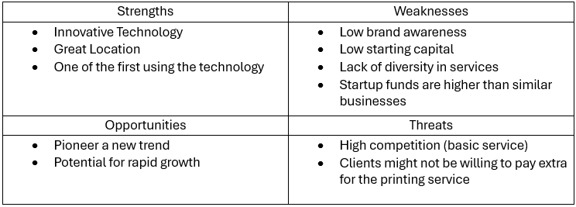
- The mission statement of my business is:
“Nail Tech combines the best nail technicians with state-of-the-art nail printing technology to provide everyone with a unique way to express themselves through their intricate nail designs in a warm and welcoming environment”

- The aim of my business is:
“Nail Tech will continue to provide stunning, innovative, high-tech services to one and all at affordable prices. We will aim to expand our services so we can reach more customers, allowing them to express their unique self with our intricate designs”
- Smart goals:

- To expand my catalogue of designs to 100 by the end of 2026
- To increase my regular costumers (visiting the salon at least once a month) to 50 by the end of 2027
- To employ 2 additional employees by the end of 2027
- To increase the scope of the business by providing hairdressing services in addition to the current services by 2030

Appendix 1. The difference between manual and printed floral art.
Handmade:
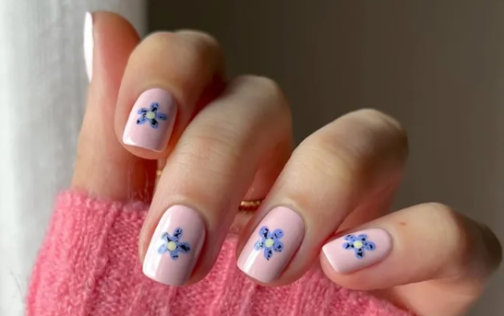
Printed:
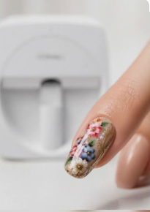

Appendix 2. Location of the Salon:
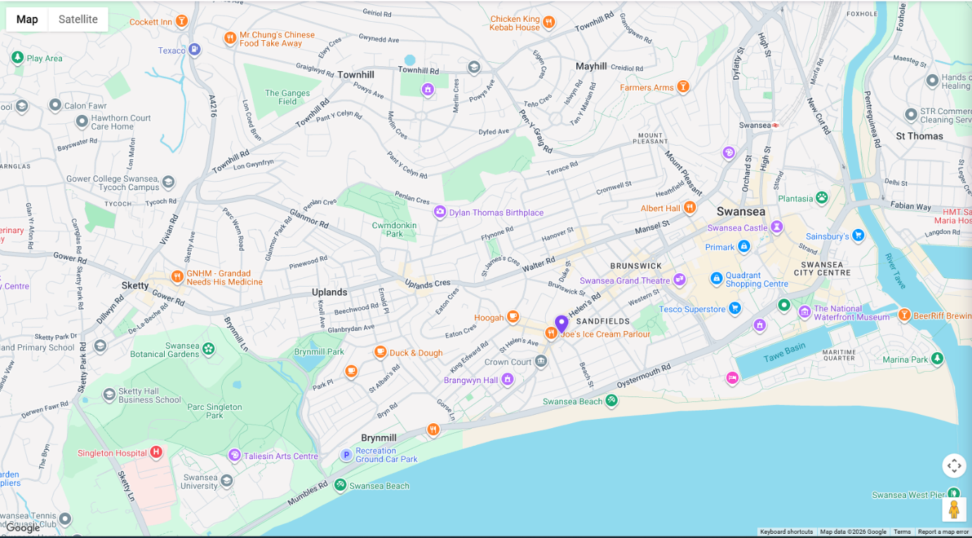

Appendix 3. Flyer, Business Card, Vehicle Design, Loyalty Card (AI Generated)
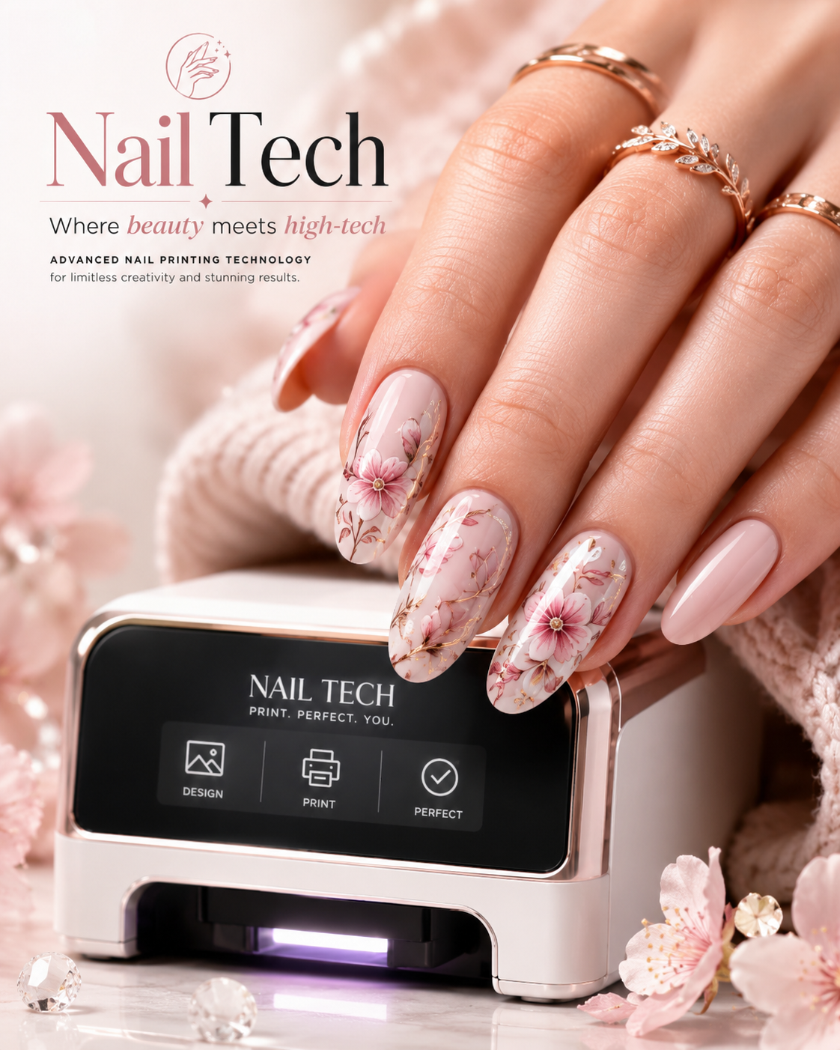
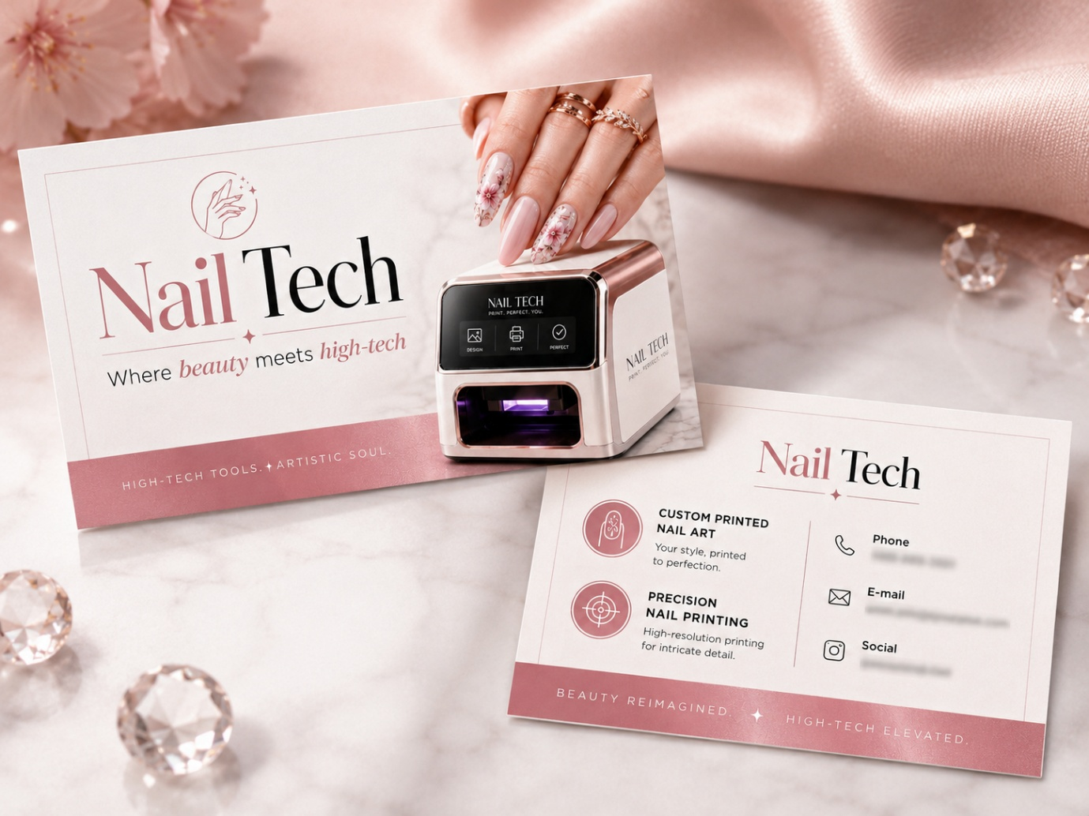
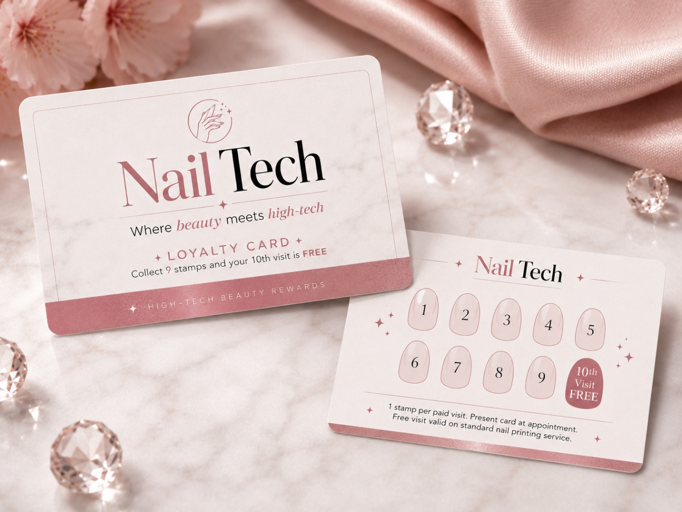
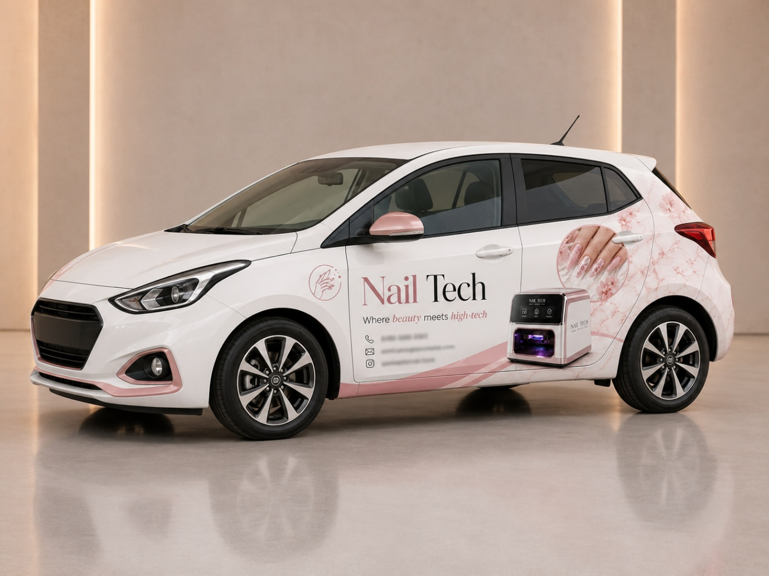

Appendix 4. Questionnaire Results

Appendix 5. Interview Transcript
Q1: Do you think that a nail salon is a viable business option today?
A1: Most definitely! People are taking more and more care of their looks which is great. If your services are adequate, affordable, and you treat your clients with respect, you should have no problem starting a successful nailcare business.

Q2: How much are your clients willing to spend on their nails on average and what distance are your loyal customers willing to travel?
A2: It really depends on the service that they want. Some basic services go as low as £25 while some of the more expensive ones are up to £50. On average I would say that they are willing to send around £35 per visit. I am mostly focusing on the locals here in Gorseinon. Most of my clients live within a 5min drive, although I have some clients that are coming from over 20miles away.

Q3. Do you think that my idea to offer printed nail designs is viable?
A3. Honestly, I have never heard of such machines, but it certainly looks viable. I don’t know of any of my colleagues using such technology so you might be onto something here. My advice is that you make sure to market your idea correctly as I’m willing to bet that the mases haven’t heard of it either

Q4. You work by yourself. What was your starting capital?
A4. I started out very small, in fact, I was doing nails from my own home in the beginning. My starting inventory was less than £1000 but if you are planning on renting a salon, I assume you will need more money.

Q5. How many clients do you get per week on average?
A5. It depends. Some months are much busier than others. For example, in February I notice a peak due to St. Valentine and in December due to the Christmas holidays. In these months I have about 6 clients per day while in other months I get only 2. I would say, on average, I get 4-5 clients per day.

Q6. How do you market your business?
A6. My marketing is done solely on social media websites. I always ask my customers if I can take a photo of their nails when I’m done and post it on my social pages to showcase my work and skills. I strongly suggest that you do the same – and make sure you invest in a nicer camera as the image quality matters a lot online.

Q7. What would you warn me about before I open my salon?
A7. I would suggest that you start creating a potential customer base long before you open the salon. You need people to know about you. Additionally, I strongly suggest that you offer discounts (or even do some manicures for free in the beginning) for your new customers as you build your customer base. Another thing is that you must keep track of your accounts – this will save you a lot of money and time come the end of the [financial] year. Lastly, always stay positive and keep trying and don’t expect many customers in the beginning – you should be happy with 2-3 customers per day. But don’t despair, once you are out there and you do a good job, people will be coming back, and you will build a loyal customer base. What I like about your idea is that you offer something new. This should help you stand out and overcome the competition which is quite fierce.
Appendix 6. Cash Flow Table
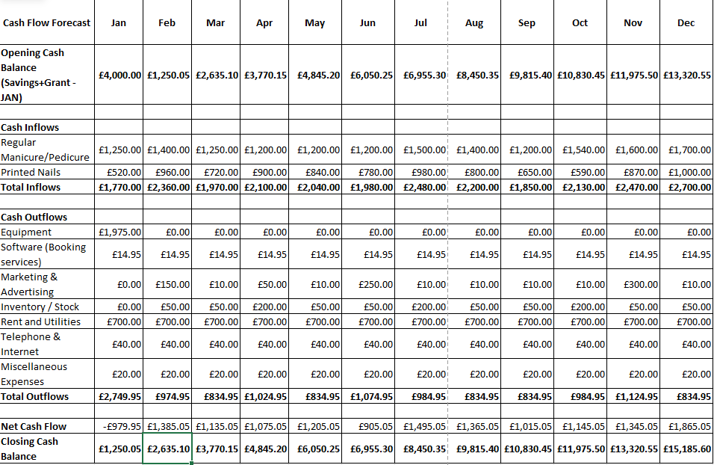

AI Prompts


