Synthesize a solution to a potential real life scenario
Yohannes Zerzghi, Computer Networks; Module: Computer Forensics, Lecturer: Dr. Carlene Campbell
Abstract—Computer forensics plays a major role in the modern world in finding computer related crimes. This field uses different software’s and hardware’s tools to examine by following scientific methodology to find evidences.

Keywords: Message Digest algorithm (MD5); Cyclic Redundancy Check (CRC); Random Access Memory (RAM); Computer Forensic Expert (CFE); Internet of Everything(IoT); Forensic toolkit (FTK); CAINE (Computer Aided Investigative Environment); SANS Investigative Forensics Toolkit (SIFT); Dynamic-link library (DLL).

INTRODUCTION
Nowadays, technology is evolving at a fast pace than ever before. The internet and the growing innovation in the digital industry is constantly changing the daily lives of individuals, organizations and business companies. Thus, the number of devices (IoT) [1], to be connected with the internet is expected to be 75.44 billion in 2025 worldwide. However, digital related crimes are also increasing. In 2017, around 17 million individuals were targeted by cyber criminals
In UK only [2]. Due to this, computer forensics is becoming popular by companies, organizations and individuals.
This paper will explain, the four fundamental methodologies in computer forensics: the collection, preservation, analysis and reporting, as well as the different hardware and software tools available in the computer forensics industry. Moreover, the report looks into real case scenario where crimes related to terrorist activities have taken place and the end destination of the case requires all the evidence found and linked with the terrorist to be documented and reported in the court of law.

Computer forensics tools research and analysis

Computer forensics definition
Forensics is a process of applying scientific methods and techniques for gathering, examining and presenting evidence to the courts [1]. Forensics can be used in various fields of science such as computer, geology, DNA analysis and more.
Likewise, computer forensics is one of the field in forensics. It is mainly used to identify, analysis and investigate on the evidence data found in digital devices such as computers, mobile phones, memory cards, DVD’s, pen drive and more. It uses scientific procedure to acquire, process, examine, present and store digital information which can be presented as an evidence in the court of law [2] [3]. The main aim of computer forensics is to investigate cases involving digital evidence and present the evidence in a manner that is suitable in court after following a structured investigative procedure [4].
According to the concept of Scientific Working Group on Digital Evidence (SWGDE) [5]; there are four common steps in the process of investigating computer forensics. And these are collection, preservation, analysis and reporting, although, there are no standard procedures in computer forensics.

Collection stage
The collection stage [6] is the first phase in computer forensics investigation. This stage involves collecting evidences that are relevant to the case such as taking photos, labeling, and acquiring the evidence data from the targeted device without altering or damaging to maintain the integrity of the original data so that the chain of custody is maintained.

Preservation stage
Following the collection stage is the preservation [7] stage. This stage aims in protecting the collected evidence data from any altering or damage. To do so, the original data must be imaged (copied) using forensic tool to one or more copies. Once imaging process is finished, the copied data should be verified using MD5 and SHA1 values to keep the integrity of data. Moreover, this stage includes recording the device detail, locating the original data in secure location and documenting the process to maintain the chain of custody.

Analysis stage
After the completion of data collection and preservation is data analysis [5]. This stage practices extracting evidence files that are related to the case. To do so, data analysis should be done on the forensic image to keep the chain of custody. Data analysis includes of using forensic tools to examine, identify, recover deleted files, and reveal hidden and decrypted files that are useful information to the crime.

Presentation stage
Presentation [4] is the final phase in computer forensics. It deals with documenting and reporting the whole process of investigation from the start of collecting evidences to the end in a format that is acceptable to the court. In general, the report must provide the authenticity and reliability of the evidence to be admissible in legal proceedings.
Hence, investigators must follow the above four rules and techniques in order to protect the reliability of their work. Evidence data must be collected and examined without tampering it, while preserving the authenticity of the data. Moreover, the evidence must be reported in a format that is appropriate so that it can be admissible for legal proceedings [1] [4].

Figure 1. The four Stages of computer forensics according to SWGDE.
Due to the emerging of new technologies and many different types of digital devices, it is seamless to classify computer forensics. However, based upon the source of evidence computer forensics is grouped into four main categories. And these are computer forensics, network forensics, mobile forensics and database forensics [8].
Besides, there are two types of digital evidences in computer forensics. And these are volatile and non-volatile data. Volatile data [9] is the data that would be lost if the computer is turned off. This type of data contains valuable information in registry, cache and RAM of the computer. Hence, it is important to collect volatile data in real time for forensic investigation. The other type of digital evidence is the data that remains unaffected when the computer is turned off. Non-volatile data is recovered from hard drives, memory cards, USB and more. Moreover, this type of data can also occur in the unallocated file space, file slack and swap file. The reason is, when a file is delete, it is not removed from a hard disk. Instead, the operating system unallocated the space by removing the pointers to it and making the space available for other file. Hence, it is essential that Computer Forensic Expert (CFE) should examine all unallocated file space and the file slack [10].
Nowadays, computer forensics is gaining its popularity due to the increase of crimes related to digital devices and the internet around the world [11]. However, conducting computer forensics can be challenging and risky. Hence, it is good to have certain skills and knowledge in a number of areas. To conduct computer forensics, the expert should have a good understanding of computer hardware and software. Besides, it is recommended to have skills in the fields of law, math, writing, forensic science, criminal justice and linguistics [10].

At present, computer forensics is used by governmental agencies and private companies. It can be used in the military, law firms, criminal prosecutors, academia, insurance companies, government agencies and more. Moreover, it can also be used by individuals to recover deleted files from their computer [12].

Research into computer forensic tools
In computer forensics, the rules and procedures remains the same, but the tools are always changing due to the emerging of new technologies. As previously mentioned, conducting computer forensics need several skills and knowledge.
When it comes to computer forensic tools, some tools are developed to perform specific task while others are designed with more functionality and complexity. For this reason, a computer forensic expert should select a tool that is appropriate for the investigation in hand based on the tool’s capability and functionality. In addition, the tools can be commercial or open source. Commercial tools are under propriety license while open source tools are freely available for everyone [13].
In general, computer forensic tools are classified into two types. And these are hardware and software tools [14].

Hardware forensic tools
Most hardware forensic tools are developed to perform specific task. Due to the emerging of new technologies, these tools are important in computer forensics investigation. These hardware devices have their own built-in software for acquiring image while protecting the original data from any altering. Some of the tools include cloning devices, write-blockers, SIM card readers, digital cameras and more [10].

Software computer forensic tools
There are many software computer forensic tools. These tools can be either commercial or open sources. Moreover, the tools are developed by different companies and individuals with different capability. The tools below are the most frequently used in the computer forensic industry.

Encase
Encase is one of the widely used computer forensic software tool, commonly used with the law enforcement industry. It was developed by Guidance Software Company based on windows operating system. The concept of encase forensic tool is based on the evidence file. The data blocks are copied from the suspect computer bit by bit and store safely to be used as evidence, then verifies the data integrity by generating MD5 hash values and assigning cyclic redundancy check (CRC) values. These values check for any changes, alternation, or errors, helping to keep all the digital evidence is not changed since the drive was acquired. With encase forensic tool, the investigator can gather evidence from volatile memory areas like RAM, cache and so on. The encase tool is used to executes deep analysis to find hidden and deleted data and produces a comprehensive report with the evidence in a format that is applicable to the court law [10], [12].
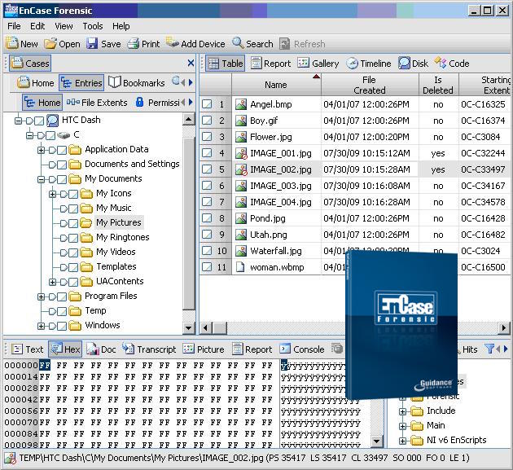
Figure 2: Encase forensic tool work environment [15]

FTK
The Forensic toolkit (FTK) [16], is a powerful digital investigation tool developed by AccessData in 1987. It is one of the powerful digital forensic tool used to extract and examine evidence in windows based operating system by the law enforcement industry. The FTK toolkit uses a separate software called FTK Imager to create a duplicate of a hard disk and generates its MD5 hash value to confirm the reliability of the data [12]. This forensic toolkit is designed with many features, including cracking password toolkit, file decryption, data carving, data visualization, email analysis, web viewer and a comprehensive reporting format that is suitable to the court law [10] [12]. In addition, it is designed to use up to three computers in parallel for processing and analysis to speed up the process of extracting evidence files from the suspect computer or device [12].
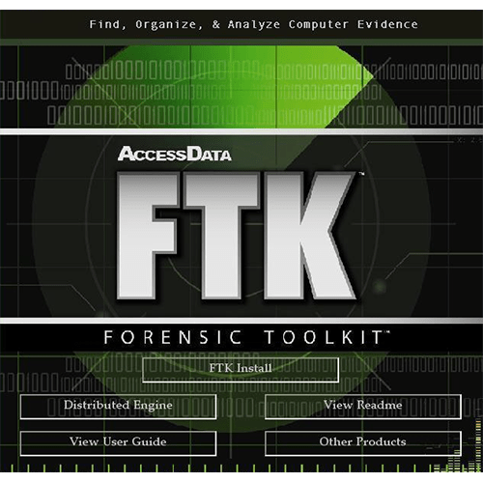
Figure 3: FTK forensic toolkit [17].

CAINE
CAINE (Computer Aided Investigative Environment) [20], is a free forensic tool that contains a variety of digital forensic tools. It is developed based on an Italian Linux live CD. This forensic tool is based on Ubuntu, particularly designed to provide a platform for a collection of many forensic tools in a graphical user interface environment. It is a tool mainly used to examine and collect evidence files for mobile forensics, database forensics, and network forensics and data recovery.
This Ubuntu customized forensic tool has different features. One of its great feature is Guymager, which is a graphical application used to create an image disk in different formats, such as Expert Witness Format (E01), RAW (dd) format and Advanced Forensic Format (AFF) [18]. It can also be used to run live analysis on a Windows OS using the WIN-UFO tool [19]. The latest version CAINE 10 can protect the data on the host device from any data altering or from accident by putting all the devices on to read mode only [20].
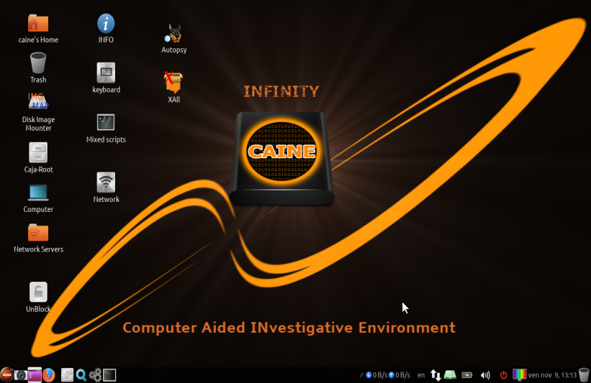
Figure 4: CAINE version 10.0 work environment [20].

SANS SIFT
SANS Investigative Forensics Toolkit (SIFT) [22], is a one of the important commercially free open source in the field of digital forensics developed by Rob Lee. It is a collection of a number of forensic tools built on Ubuntu-based Linux operating system. Some of the digital forensic software’s that are included with SIFT are: The Sleuth kit with its graphical application Autopsy and DFLabs, Wireshark, Hex Editor, ssdeep & md5deep and so on [21]. This toolkit supports evidence image format of Expert Witness Format (E01), RAW (dd) and Advanced Forensic Format (AFF). The latest version SANS SIFT v3.0 contains various new features. This new version gives a platform between Linux and Windows with better memory utilization as well as various file system support and more [22].

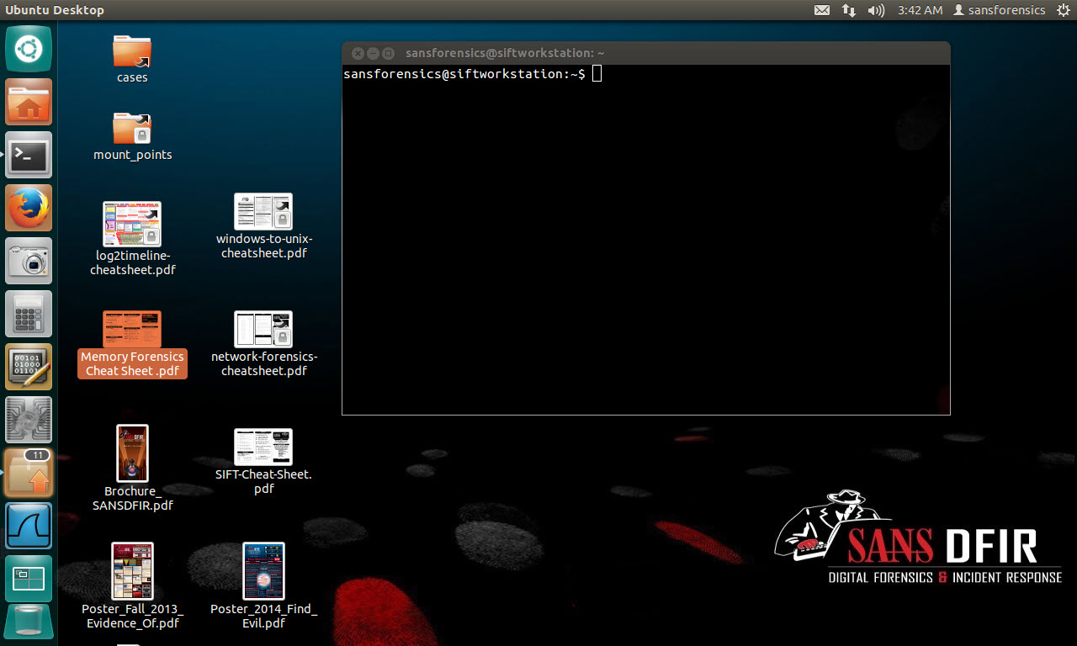
Figure 5: SANS SIFT work environment [23].

The Sleuth Kit
The Sleuth Kit (TSK) [24], is a command line tool founded on Linux that is used in the field of digital forensics. It is known for it’s an in-depth disc images analysis, performing intense analysing of file systems and various different techniques. The tool can be used to find deleted files, hidden files, recover photos from camera’s memory card and for checking the drive image integrity [24]. This toolkit also features a graphical user interface application called Autopsy. Autopsy is a graphical interface to the Sleuth kit that can be used both on Linux and Windows by law enforcement for digital forensic investigation [25].
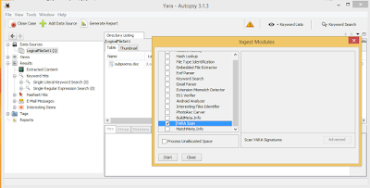
Figure 6: Autopsy work environment [26].

COFEE
Computer Online Forensic Evidence Extractor (COFEE) [27], is a collection of forensic toolkit developed by Microsoft. It is developed as a forensic tool for Windows systems to be used by forensic investigators. This tool is a small plug-in device that contains 150 command tools. Besides, the commands can be installed on any removable media. It is used to perform live analysis by just plugging the USB tool on to the target windows computer [27].
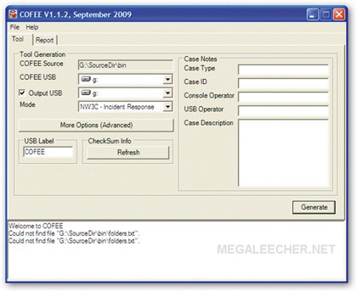
Figure 7: COFFEE work environment [28].

OSForensics
OSForensics [29], is a commercial forensic tool developed by Passmark Software Company. It is best designed to work on Windows based platform [12]. The tool is widely used by forensic experts for performing forensic analysis on emails, files, browsers and more. Furthermore, the tool is designed with easy and user friendly graphical interface to use [29].

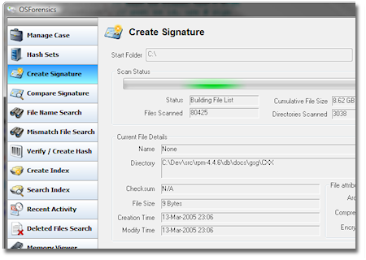
Figure 8: OSForensics work environment [30].

ProDiscover
ProDiscover [31], is a forensic tool used by forensic professionals on Windows Operating system. The product has both commercial and free versions. This tool can recover deleted files, search for hidden contents in the slack space, create image disk and create legal report format of the evidence. Moreover, it allows the forensic expert to preview, search and uncover the Hardware Protected Area (HPA) [31].

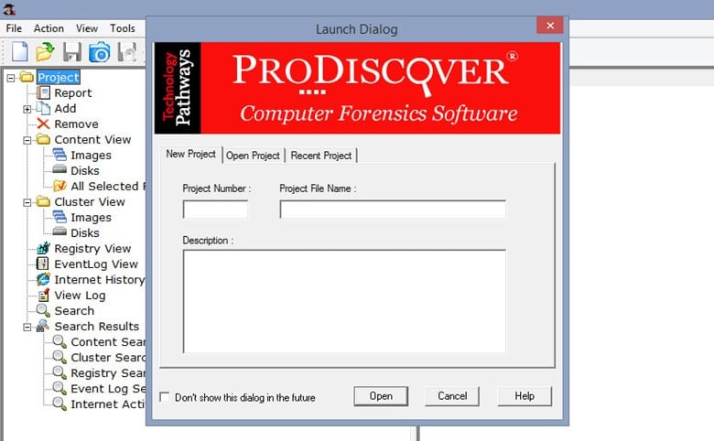
Figure 9: ProDiscover work environment [32].

Xplico
Xplico is a free network forensic analysis tool, which is registered under the GNU General Public License. It was developed on Linux OS using C, Python, PHP and JavaScript programming languages [33]. Xplico is basically used to extract evidence data from network monitoring and analysing tools (e.g. Wireshark, TCPdump, Angry IP scanner). This tool is designed to support the most known network protocols such as TCP, UDP, SMTP, POP, IMAP, HTTP, IPv4, IPv6 and others. Another feature of Xplico is the ability to store the output data in SQLite database of MySQL database [34].

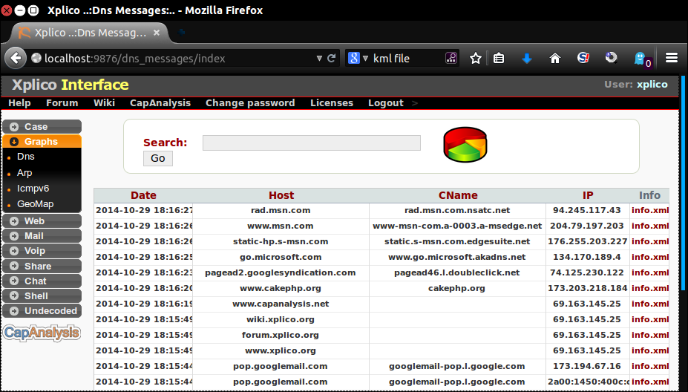
Figure 10: Xplico network forensic tool [35].

X-Ways Forensics
X-Ways [35], is an integrated computer forensics software developed by X-Ways Software technology. X-Ways is able to run on all versions of windows and support various file systems such as FAT32, FAT12, FAT16, exFAT, TFAT, NTFS, Ext2, Ext3, Ext4 and others [36]. It can be helpful for analysing big data file filtering as it is not resource hungry. In addition, this tool provides numerous services to be used by forensic experts. Some of the services are: disk imaging and cloning, memory and RAM examination. Moreover, it can also be used to check integrity using hash calculator, view and edit binary data and many more. Moreover, X-Ways is customized to automatically detect erased or lost partitions [35].

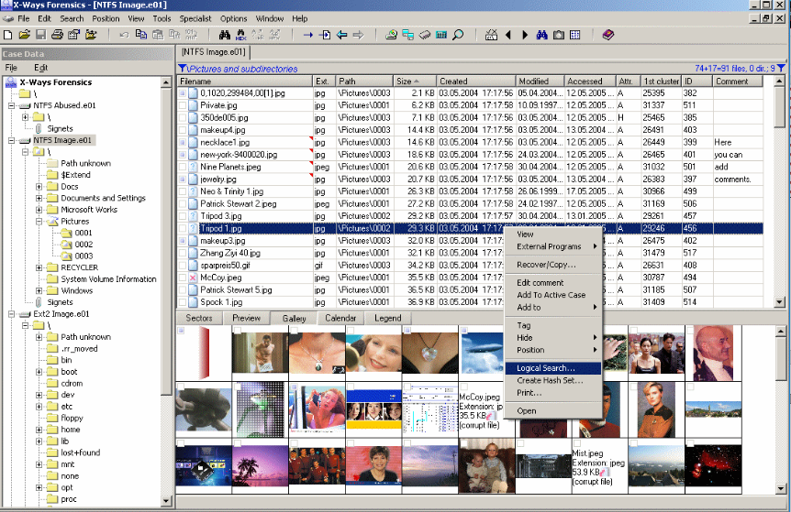
Figure 11: X-Ways forensic tool [35].

Volatility
Volatility [38], is a memory forensic tool, which can be used to collect or analysis on a computer’s volatile memory (RAM). Particularly, it is designed to keep evidence information from memory that would be lost when a computer is shutdown or restarted. Moreover, it can be used to automatically detect and analysis on malware by directly examining the operating system. This tool is registered under the General Public License (GPL) and is able to work on Windows and Linux operating systems [37] [38].

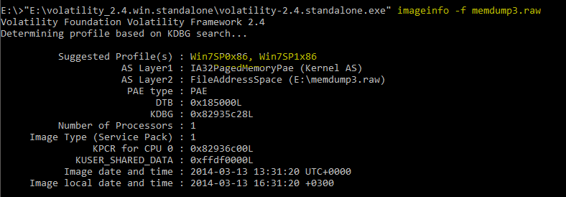
Figure 12: Volatility memory forensic tool [39].

WindowsSCOPE
WindowsSCOPE is another memory forensics that performs reverse configuration technique to examine and acquire on physical volatile memory. It is commonly used for detection of malicious software’s such as rootkits and malwares by using back engineering techniques in windows operating systems. Likewise, it is used to obtain information from registry, DLLs, cache, network connections and others. WindowsSCOPE supports both software and hardware products [38]. The latest version of windowsSCOPE contains a new feature called CaptureGUARD. This new version is a PCI express form factor, which is capable of bypassing the windows login and direct access to the physical memory of the host computer [40]. Moreover, windowsSCOPE can be able to perform live analysis, for incident response, windows memory dump analysis and many others [41].

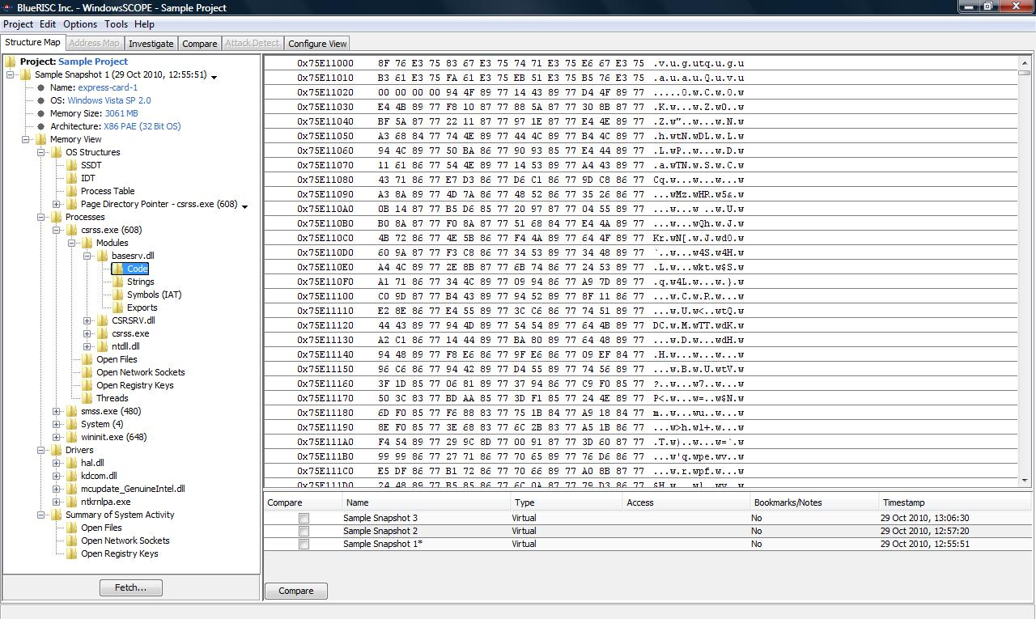
Figure 13: WindowsSCOPE memory forensic tool [40].

WinHex
WinHex is another forensic tool developed by X-Ways Software Technology Company. It is mostly used to edit and examine the contents of the target device in underlying hexadecimal values on Windows systems [42]. It also can be used to create disk image, recover deleted files, find hidden files, wipe hard disks and check for data integrity. Furthermore, this tool can be used by investigators to analysis and recover deleted files of large Microsoft Access database at the hexadecimal level. WinHex can be used to read and examine on FAT12, FAT16, FAT32, NTFS, Ext2/3/4 and many others [43].

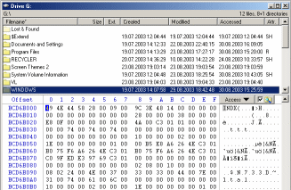
Figure 14: WinHex forensic tool [43].

Classification of computer forensic tools
Based on the above research, computer forensic tools are designed and developed for one or more tasks. The tools are designed with different features and characteristics. The table below categorizes the tools based on type of forensics, operating system and their source.

Tools name | Used for | Platform | Source | Description
Encase | Data recovery | Windows | commercial | GUI
FTK toolkit | Hard disk analysis | Windows | commercial | GUI
CAINE | Live analysis | Ubuntu | free | GUI
SANS SIFT | Data | Ubuntu | free | both
The Sleuth kit | Email, data analysis | Linux | free | Command line
COFEE | Live analysis | Windows | commercial | GUI
OSForensics | Email analysis | windows | both | GUI
ProDiscover | Data recovery | windows | Commercial | GUI
Xplico | Network analysis | Linux | free | Both
X-Ways Forensics | Data analysis | windows | commercial | GUI
Volatility | Memory analysis | Linux/windows | free | both
WindowsSCOPE | Memory analysis | windows | commercial | GUI
WinHex | Edit Hex value | windows | commercial | GUI
Table 1. Classification of computer forensic tools.

Case Study

Terrorist Attack Case
In computer forensics the tools are always changing however, the procedure remains the same. Based on the above research, an investigator should maintain the chain of custody to survive at the court law. Hence, it is important to follow the rules and guidelines of computer forensics.
In this terrorist attack case, John (the incident handler) is a professional investigation service for the case. To maintain the chain of custody, first John should prepare documentation of evidence list offered by Mr. Mark Wales. For this purpose, an evidence form should be prepared with time and date to sign along with signature of the agent in charge for it during the evidence collection. Moreover, the evidence details of the suspected device such as model, serial number, capacity, time, type of device, exact place where it was and people to whom it belongs should all be documented to make sure everything is captured. In addition, data acquisition should be verified using both MD5 and SHA1 values to preserve the authenticity of the original data. And also to keep the chain of custody during the evidence collection. Details about the device is shown below which is taken during the evidence collection.

Device model | Device serial No | Description | Capacity
hp v152w USB Device | EA6B00047010 | Dell Laptop | 16.4GB

Table 2. Evidence detail taken during the identification stage of the case.

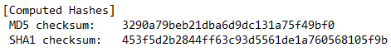
Figure 15. MD5 and SHA1 values taken during the data acquisition stage.
After that, John should quarantine the physical evidence device along with a sticky label on it in a secure location in order to protect the device from physical damage and also to maintain the reliability of the evidence. Afterwards, John should start to verify if there are necessary tools to start the investigation such as high speed computer, forensic tools and secure area lab.
As a forensic expert, John should select the right forensic tools that are suitable for the evidence to be examined. The reason is, most forensic tools are designed with different features and capability of doing specific task, for instance: tools for data recovery, decryption, password cracking, network analysis, database analysis, memory analysis, steganography analysis and more.

Based on the scenario, the suspected DELL Laptop is in standby mode, hence data will be lost when it is turned off. Important data can reside in registry, cache and RAM of the Laptop that are useful for the investigation. Hence, John should use the Volatility forensic tool. As this tool will help the investigator to extract useful information found in RAM, registry, cache, running processes and network connections relevant to the case before the laptop loses its power. At the same time, John should record and compare the time and date on the Laptop with the real time and date to keep the chain of custody.

As a forensic examiner it is not good practice to work on the original evidence data due to the risk of altering or damaging the evidence. Hence, John should use another forensic tool to create the exact copy of the suspected laptop’s hard drive. Based on the investigation case, John should use the FTK Imager to create forensic image of the suspected laptop hard drive by putting as read only. This forensic imaging tool will create an image bit by bit of the entire hard drive including the unallocated space and the slack space. Moreover, the tool will automatically generate MD5 value to verify that the original evidence handed to John during the evidence collection remains the same. When the imaging process is completed, John should document all the processes with time and date and place the target laptop to secure location to maintain chain of custody.

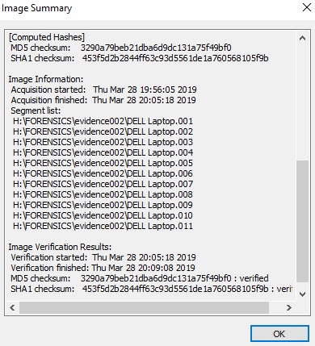
Figure 16.MD5 and SHA1 values generated after the imaging process completed.
In the meantime, John should verify the integrity of the evidence by comparing the values MD5 and SHA1 in figure 2 and figure 3.
Next, John should start analysing on the imaged hard drive. Data analysis is one of the important stages in computer forensics investigations. At this stage, John should also look for a tool that is suitable to the forensic request made by Mr. Mark wales. FTK would be a great tool to find hidden, deleted, encrypted and camouflaged files. When FTK finishes analysing the imaged hard drive, John should start to process on all files including deleted, encrypted and hidden files. Based on this procedure, John should manage to find two password protected files, 9 files with bad extension files, audio files, video files and others that are related to the case. The picture below shows after FTK finishes analysing.
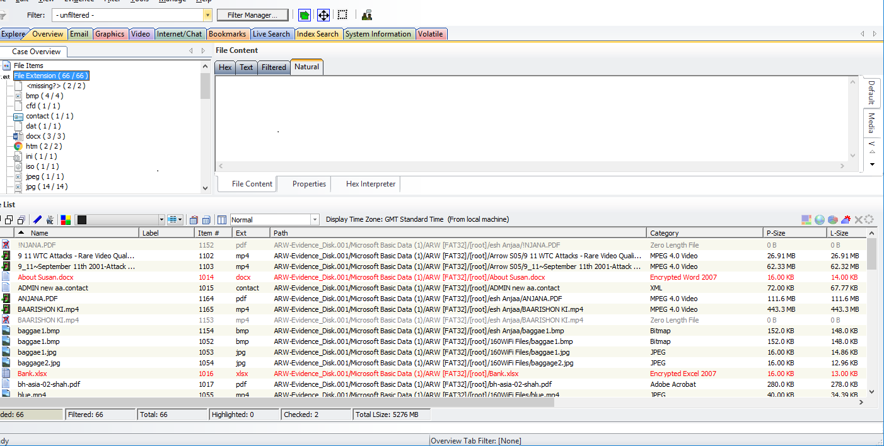
Figure 17: FTK after finishes analysing.
Moreover, John should use keyword text to search and find files based on forensic request by Mr. Mark wales. Furthermore, for more evidence files, John should conduct indexed search using the FTK tool to find files in the unallocated space and the slack space of the computer.
When it comes to the encrypted files, John should export these files and use the FTK password recovery tool to unlock the password-protected files as these files can contain useful information that are related to the investigation. The screenshot below shows the two files with password protected.
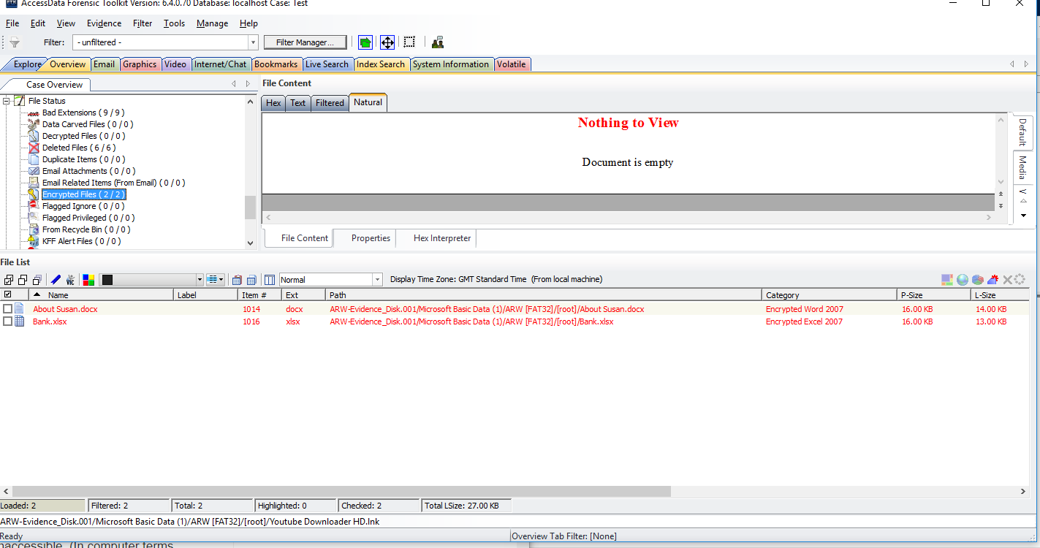
Figure 18: encrypted files found.

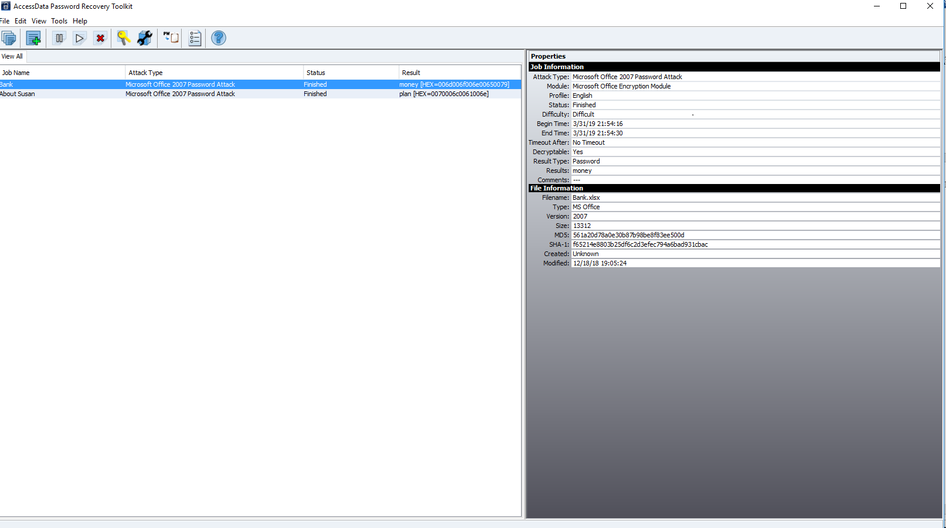
Figure 19: encrypted files unlocked using FTK password recovery tool.
In regards to hidden files, the suspect could change file extension of files to different format to hide files for example from .doc to .jpeg. Hence, it is important for a forensic expert to have good knowledge of different file types such as .doc, .jpeg, .mpeg and more. However, FTK uses a process called file carving to identify files that are hidden through changing file extension technique. To examine those files, John should export these files and change their file extension into the correct format.

The picture below shows files found using FTK file carving.
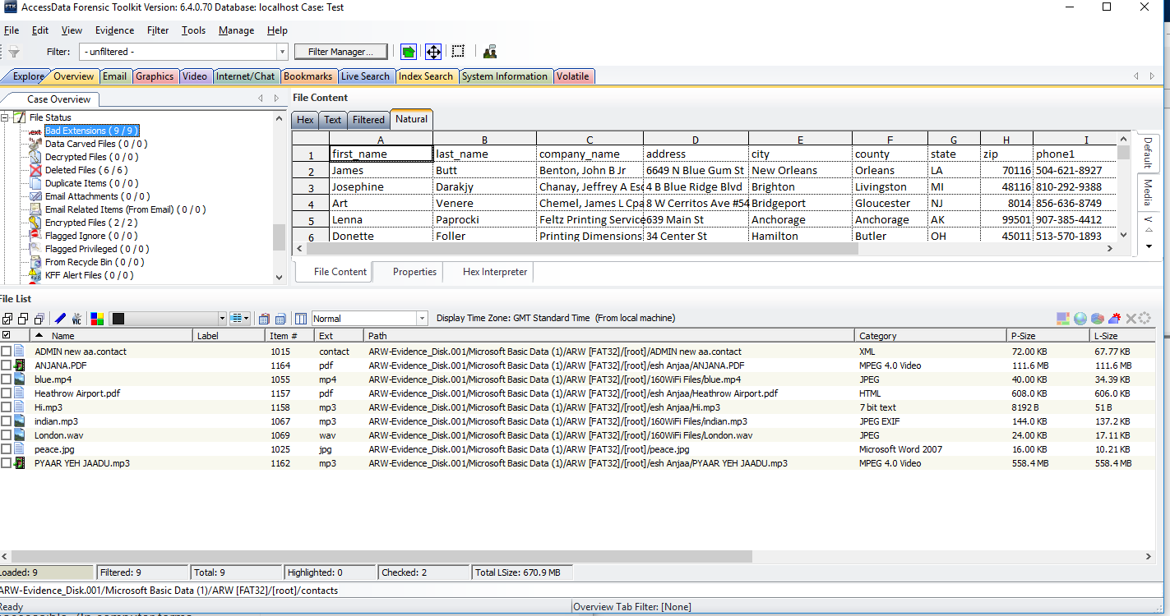
Figure 20: files found with bad extension using file carving.

In addition, the suspect could use steganography technique to hide secret files or messages. Steganography [44]; is technique used to hide secret data within other file. Hence, the investigator should use a steganography tool that can be used to find these hidden files. Moreover, the suspect could use cryptography [12], technique to code secret messages.
The picture below shows a coded message that could be related to the investigation. The message “h3110 80m8 7h3 M@$0n @! rp0r7 @7 f! j! 7h!s $undae” from the picture below could be interpreted using cryptography skill as “hello bomb the mason airport at 7 Fiji this Sunday.”
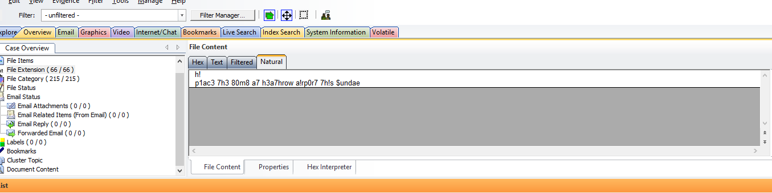
Figure 21: coded message found using cryptography.
As previously said, it is important to have good knowledge of file types and file systems as this will ease to find and search files. To find the MS Word, Excel, PDF, image files, videos and audios that are related to the case, John should use index searching. FTK uses indexing process to search and find files using their file extension name such as .doc, .pdf, .mpeg and more. Moreover, John should use keyword search to find files that are related to the case such as bomb, Heathrow, bank etc. as this would save valuable time.

In connection with MS outlook contacts, email messages, messenger chat history, cache files and temporary files, John should look for an email forensic tool. The reason is, FTK does not have that much capability of examining email files. To do so, paraben e-mail examiner [44]; would be a great tool. This tool can be helpful to read email achieves from MS outlook. Moreover, the tool can be used to read and recover deleted chat history, email messages and more.

A computer forensic expert should follow forensic soundly to survive for legal proceedings. In relation to the videos, John should prepare a document and explain the videos detail as this will help the court to understand the evidence easily. It would be good to include the videos date created, modified and accessed as well as their directory path and so on. Thus, would provide easily understanding to the jury as well as the reliability and authenticity of the evidence to the court.

Report and findings
FTK can generate a full report of the investigation, but it can also generate evidences that are unnecessary for the court. Hence, it would be good for John to prepare a report that is acceptable in the court. The report format should contain the purpose, case information, incident summary, evidence, forensic tools used and conclusion. Moreover, the report should be written using appropriate words to the court. In this scenario, John is the incident handler. An incident handler [6], is a forensic expert whose job is to identify, collect, analysis, preserve, and present the evidence in acceptable format to the court. Hence, John should prepare a report that contains all the records documented and the processes of computer forensics in a way that is easy to understand for the jury.
The table below shows the report format written to Mr. Mark wales. This report format contains the incident handler name, evidence, forensic tools used and at the end conclusion. The report should assist the jury to understand easily.

Author  Date  12/12/2018 | Name | John
Author  Date  12/12/2018 | Email | expert@gmail.com
Author  Date  12/12/2018 | phone | 044786589635156
Evidence
After gathering and analysing all the evidence files on the imaged drive, 18 videos files, 2 encrypted files, contacts, email messages, and 1 secret message, which are related to the case were found. The evidence files should support the judges to make the correct decision. For all the evidence files please follow the link file:///C:/Users/s151368/Desktop/john/Index.html.
Forensic tools used
- AccessData® FTK® Imager 4.2.0.13.
- AccessData® Forensic Toolkit® 6.4.0.70.
- AccessData® Password Recovery Toolkit® (64-bit) version 8.2.0 Build 964.
- Paraben E-mail Examiner.
All the tools are licensed and approved to be used for investigation by the police.
Conclusion
Dear Mr. Mark Wales
This report has stated pieces of evidence files related to the case of the suspected terrorist and his plan to attack the Manson International airport at Fiji. With all the evidence files found, it is now up to the judge to decide regarding the information of this report.
John
Table 3: sample report for the investigation
The screenshot below shows the invoice sent to Mr. Mark Wales.
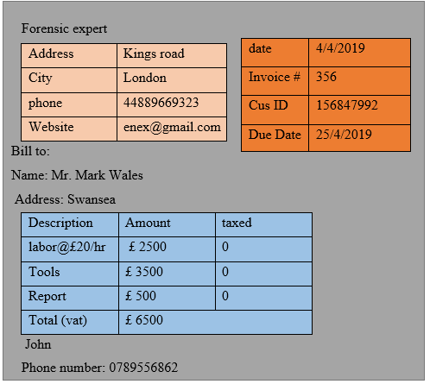
Figure 22: screenshots of invoice

Conclusion
In today’s era, computer forensics is gaining its popularity due to the rise of computer related crime in the world. However, this field is still lacking standard procedures in dealing with crimes due to the differences in policies of different countries. This report discusses the four standard procedures the collecting, acquisition, analysing and reporting in computer forensics. In addition, this report evaluates the most common forensic tools in the world.

References

[1] | P. D. Dixon, "An overview of computer forensics," IEEE Potentials, vol. 24, no. 5, pp. 7-10, 2005.
[2] | M. Reith, C. Carr and G. Gunsch, "An Examination of Digital Forensic Models," International Journal of Digital Evidence, vol. 1, no. 3, pp. 1-12, 2002.
[3] | K. V. N. Rajesh and K. V. N. Ramesh, "Computer Forensics: An Overview," Manager's Journal on Software Engineering, vol. 10, no. 4, pp. 1-5, 2016.
[4] | C. Dr.Cambell, "ACCB5000: Computer Forensics," UWTSD, 22 September 2018. [Online]. Available: https://moodle.uwtsd.ac.uk/mod/folder/view.php?id=138690. [Accessed 24 March 2019].
[5] | SWGDE, "SWGDE Best Practices for Computer Forensics Version: 3.1," swgde, 05 September 2014. [Online]. Available: https://www.swgde.org/documents/Current%20Documents/SWGDE%20Best%20Practices%20for%20Computer%20Forensics. [Accessed 29 March 2019].
[6] | P. Bahadur and D. S. Yadav, "Computer forensics-digitized science," in IEEE, London, 2015.
[7] | C. L. Grande and R. S. Guadron, "Computer forensics," in IEEE, San Jose, 2016.
[8] | infosec, "introuduction," INFOSEC, 2019. [Online]. Available: https://resources.infosecinstitute.com/category/computerforensics/introduction/areas-of-study/digital-forensics/#gref. [Accessed 31 March 2019].
[9] | Linked in, "Collecting Volatile and Non-volatile Data," linkedin, 26 March 2016. [Online]. Available: https://www.linkedin.com/pulse/collecting-volatile-non-volatile-data-vuppala-dhanunjaya. [Accessed 26 March 2019].
[10] | D. R. Dr. Hays, A practical Guide to Computer Forensics Investigations, Indianapolis: Pearson, 2015.
[11] | D. Bern, "Computer Forensics - Past, Present and Future," Journal of Information Science & Technology, vol. 5, no. 3, pp. 43-60, 2008.
[12] | C. Easttom, System forensics, Investigaion, and Response, Burlington: Jones & Bartlett Learning, 2019.
[13] | InfoSec, "Commercial vs. Free/Open-Source Tools," InfoSec, 2019. [Online]. Available: https://resources.infosecinstitute.com/category/computerforensics/introduction/commercial-computer-forensics-tools/#gref. [Accessed 1 April 2019].
[14] | R. Hasan, S. Mahmood and A. Raghav, "Overview on Computer Forensics Tools," Cardiff, 2012.
[15] | Anytech, "EnCase® Forensic," Anytech, 2016. [Online]. Available: https://anytech.ae/product/encase-forensic/. [Accessed 31 March 2019].
[16] | C. A. e. a. Manson D, "Is the Open Way a Better Way? Digital Forensics Using Open Source Tools," in IEEE, Waikoloa, 2007.
[17] | forensicstore, "Forensic Toolkit Suite," Forensic Store, 2017. [Online]. Available: https://forensicstore.com/product/forensic-toolkit-6-2/. [Accessed 31 March 2019].
[18] | C. A. e. a. Decusatis C, "Methodology for an Open Forensics Model Based on CAINE," in IEEE, Liverpool, 2015.
[19] | S. Sharma, "CAINE 8.0 review," techradar.pro, 23 February 2017. [Online]. Available: https://www.techradar.com/reviews/caine-80. [Accessed 24 February 2019].
[20] | Creative Commons License, "CAINE Computer Forensics Linux Live Distro," Creative Commons, 18 December 2018. [Online]. Available: https://www.caine-live.net/page8/page8.html. [Accessed 24 February 2019].
[21] | CyberSecurity Forum, "Review: SIFT Workstation- Digital Forensics Tool Suite," CyberSecurity Forum, 12 December 2017. [Online]. Available: https://cybersecurityforum.com/cybersecurity-tools/reviews/sift-workstation/. [Accessed 24 February 2019].
[22] | SANS Institute, "SIFT Workstaion," SANS Investigative Forensics Toolkit-SIFT, [Online]. Available: https://digital-forensics.sans.org/community/downloads. [Accessed 24 February 2019].
[23] | R. Lee, "SIFT Workstation Version 3.0," SANS™ Institute, 23 March 2014. [Online]. Available: https://digital-forensics.sans.org/blog/2014/03/23/sans-sift-3-0-virtual-machine-released/. [Accessed 31 March 2019].
[24] | C. A. e. a. Manson D, "Is the Open Way a better way? Digital Forensics using Open source tools," in IEEE, Waikoloa, 2007.
[25] | C. B, "Autopsy," The Sleuth Kit, [Online]. Available: https://www.sleuthkit.org/sleuthkit/. [Accessed 24 Februray 2019].
[26] | J. Lukach, "CATEGORY ARCHIVES: SLEUTH KIT," Windows Techs.com, 22 August 2018. [Online]. Available: https://windowstechs.com/wp/index.php/category/sleuth-kit/. [Accessed 31 March 2019].
[27] | S. P, "Popular Computer Forensics Top 21 Tools," INFOSEC INSTITUTE, 17 February 2019. [Online]. Available: https://resources.infosecinstitute.com/computer-forensics-tools/#gref. [Accessed 24 February 2019].
[28] | Plus, PC, "How to create your own free computer forensics kit on a USB drive," techradar, 11 April 2010. [Online]. Available: https://www.techradar.com/news/computing/how-to-create-your-own-free-computer-forensics-kit-on-a-usb-drive-680396. [Accessed 31 March 2019].
[29] | K. M. Bashir MS, "Triage in Live Digtial Forensic Analysis," International journal of Forensic Computer Science, vol. I, no. 1, pp. 35-44, 2013.
[30] | passmark software, "OSforensics," PassMark Software, 2019. [Online]. Available: https://www.osforensics.com/. [Accessed 31 March 2019].
[31] | The ARC Group, "PRODISCOVER FORENSIC EDITION," The ARC Group, 21 March 2016. [Online]. Available: https://www.securitywizardry.com/index.php/products/forensic-solutions/forensic-toolkits/prodiscover-forensic-edition.html. [Accessed 25 Februray 2019].
[32] | "7 Best Computer Forensics Tools [Updated 2019]," INFOSEC RESOURCES, 18 February 2019. [Online]. Available: https://resources.infosecinstitute.com/7-best-computer-forensics-tools/#gref. [Accessed 31 March 2019].
[33] | L. D, "Downloading Xplico," INFOSEC INSTITUTE, 30 July 2014. [Online]. Available: https://resources.infosecinstitute.com/xplico/#gref. [Accessed 27 February 2019].
[34] | K. B. Cankaya EC, "A survey of digital forensics tools for database extraction," in IEEE, San Francisco, 2016.
[35] | X-Ways, "X-Ways Forensics: Integrated Computer Forensics Software," X-Ways, 23 May 2015. [Online]. Available: http://www.x-ways.net/forensics/. [Accessed 4 March 2019].
[36] | P. BV, "Cyber forensic tools: a review," International Journal of Engineering Trends and Technology (IJETT), vol. 41, no. 5, pp. 266-71, 2016.
[37] | The Volatility Foundation, "The Volatility Framework," The Volatility Foundation, 2018. [Online]. Available: https://code.google.com/archive/p/volatility/. [Accessed 4 March 2019].
[38] | A. B. Ahmed W, "A comparison of windows physical memory acquisition tools," in IEEE, Tampa, 2015.
[39] | Ahmed, "How to install and use Volatility memory forensic tool," howtoforge, 18 July 2017. [Online]. Available: https://www.howtoforge.com/tutorial/how-to-install-and-use-volatility-memory-forensic-tool/. [Accessed 31 March 2019].
[40] | WindowsSCOPE, "New WindowsSCOPE Product – CaptureGUARD Gateway," WindowsSCOPE, 25 July 2016. [Online]. Available: http://www.windowsscope.com/new-windowsscope-product-captureguard-gateway/. [Accessed 4 March 2019].
[41] | V. M. e. a. Ghazinour K, "A study on digital forensic tools," in IEEE, Chennai, 2017.
[42] | J. M, "WinHex: A powerful data recovery and forensics tool," TechRepublic, 6 May 2003. [Online]. Available: https://www.techrepublic.com/article/winhex-a-powerful-data-recovery-and-forensics-tool/. [Accessed 6 March 2019].
[43] | X-Ways, "WinHex Hex Editor," X-Ways, 2019. [Online]. Available: http://www.winhex.com/winhex/hex-editor.html. [Accessed 31 March 2019].
[44] | H. Sachdev, H. Wimmer, L. Chen and e. al, "A Digital Forensic Tool for Mobile Devices: Paraben," Management, vol. 18, p. 16, 2018.
[45] | K. B. Cankaya EC, "A survey of digital forensics tools for database extraction," in IEEE, San Francisco, 2016.

