Name | Noreen Shasta
Student Number | 2029247
Module Code | BMSW 4002
Title | Pelsall Hall Care Home – Effective Team Building
Lecturer Name | Joanne Davies
Assignment Title | Pelsall Hall Care Home

Summary (Abstract)
Based on the Case Study for Pelsall Hall Care Home we have been asked to write a report to the management team detailing how management can develop an effective team ensuring all team members are communicating effectively to help the home achieve a high quality of care for residents and help the team develop into a high performing team working collaboratively to produce better results.
It this report, we cover how to develop an effective team, impact effective working can have in a healthcare environment, barriers to effective teamwork and types of roles needed to create cohesive and effective team.

Contents
Page
4 | Introduction
5 | Overview of Team working
7 | Models of Team development
10 | Team Roles
12 | Discussion
14 | Conclusion and recommendations
15 | Reference List

Introduction
This report is based on the Pelsall Hall Care Home case study and has been written for the management team.
Pelsall Hall Care Home has recently appointed a new manager Steve Brookes who is looking to find solutions to help develop a high performing team to work collaboratively as an effective team to produce better results.
The care home has a proactive approach to team building which has seen some great results because of this. The care home has some very dedicated, hard-working individuals but at times do not come together as a team to achieve common goals which leads to misunderstandings and not everyone would have the complete picture when dealing with an issue.
In a healthcare environment it is very important for teams to work together and share knowledge to be able to provide high quality of care, by doing this you can give the right care at the right time, helping to achieve the right results and keep a hold of costs. By giving the care needed first time and getting it right saves money and time.
In this report we will investigate how management at Pelsall Hall Care home can develop an effective team. The impact effective team working can have in a health and social care setting, barriers to effective teamwork and types of roles that are needed to create a cohesive and effective team.
In this report the methods used Tuckman and Belbin
Overview of Team working
What defines a team
A team is group of individuals working towards a common goal, in this case the team are healthcare workers looking to give residents in the care home the correct care they need to have the best experience they can while in care.
The definition of a team is a group of people with different skills and knowledge which together can help achieve a common goal or result.
What contributes to effective teamwork
Druskat and Wolff (2001) identified three essential conditions for team success.
Trust among Members
Trust can be the willingness to rely on others according to Doney, Cannon and Mullen (1998)
To develop an effective team, it is very important to have trust amongst the individuals, without it you may end up with inattention to results which we can see in Pelsall Hall Care home. Even though we have highly committed staff who are hardworking and dedicated we still seem to have misunderstandings amongst the team.
It is important that in a team everyone has the skills and capability to do their job well so that other members of the team can rely on them and be able to trust them. This can be developed through experience and past experiences. So, if people know each other and work well together they will be able to trust each other and achieve common goals.
If someone has had a bad experience with another member of the team, they may need to have a mediator to help repair the relationship so that they can work well together and be more effective team contributors.
A sense of group identity
Teams that spend time together develop a unique identity and are loyal to each other and will try not to let each other down. By developing a team, they soon start to develop normal behaviors and reputations which can separate them from others and others will see them as high performers.
By belonging to a team people will not want to let each other down so will perform better and communicate effectively.

A sense of group efficiency
To be able to be part of a successful team everyone must be confident that they can achieve the common goal.
For teams to be most successful, they need to believe they can accomplish their goals (Porter Gogus & Yu 2011)
Difference between group and team.
Not all groups of people are a team, there is a difference between the two.
A group of people is several individuals working to complete a task with one person in charge not everyone will know each other. All the members in a group are independent and have individual goals to achieve. Once they have achieved their personal goal, they have completed the job at hand
A team however has a common goal and is set up for a reason/ job which is only complete once every task has been completed. A team has more than one leader and each job relies on the other for it to be completed everyone will know each other and what they do. The team has a collective goal to achieve as a team not as an individual and will help each other to complete the job that they are accountable for.

Models of Team development
Which team development model could be considered and why?
Tuckman's theory focuses on the way in which a team tackles a task from the initial formation of the team through to the completion of the project. Tuckman later added a fifth phase; Adjourning and Transforming to cover the finishing of a task.
Tuckman’s theory is successful in the healthcare environment because it recognizes that teams are not complete at the stage of formation they develop as time goes by. This is very relatable to healthcare where teams and needs develop as time goes by.
Tuckman suggests that teams grow through stages from creation as groups of individuals to cohesive and task-focused teams.
At Pelsall Hall Care Home Tuckman’s theory can be used to develop the team and move the team through stages known as forming, storming, norming and performing, and adjourning.
Tuckman’s theory will help target communication which is the problem at Pelsall.
Tuckman’s Theory’s 5 stages are explained below.
Forming – At this stage team members are polite and positive. Some will be anxious as they do not yet fully understand the task at hand. At this stage, it is important for the manager Steve to help others get to know each other and play a dominant role because team member roles and responsibilities are not yet clear.
Storming – this stage can be tricky to manage but is very important where all members must contribute and push against boundaries to help identify different working methods which may have conflict and people work in different ways which cause problems.
At this stage people may resist and conflict with management because they don’t understand the common goal or their responsibilities and may challenge Steve’s authority thinking they know better because they have worked at the care home longer. It is important at this stage that Steve makes it clear what the common goal is and what everyone’s role is otherwise the goal to achieve an effective team can fail at this stage. It is also important to keep an eye on those members who follow instructions and stick with the task in hand. If the members who are contributing feel stressed and overloaded with work because others are not contributing or have not yet formed strong relationships with colleagues this will also impact the teams performance.
Norming – Gradually the team will move into this stage where they know each other better and are able to communicate better asking each other questions and give constructive feedback. People develop stronger commitments with the team goal and you start to see progress within the team and its goal. There may be overlap between Storming and Norming due to new tasks.
Performing – At this stage the team are performing well and Steve will be able to develop the team and delegate most of the work without any friction to achieve the common goal. It should feel easy to lead the team and new members joining or leaving will not cause disruption.
Adjourning – teams reach the end of the journey where they have completed to task such as a project or restructure. People who like routine and find change difficult will not like this stage.

There are other team-building models that can be used such as Belbin’s Team Roles which uncovers the nine-team roles and describes ways of contributing and interrelating in a team.
Belbin suggests that if you understand your role in the team, you can develop your strengths and weakness and so improve your contribution to the team.
Meredith Belbin developed the idea that a team needs a balance of personalities and roles if they are to be successful. There are 9 roles divided into 3 categories.
The nine Belbin Team Roles are: Resource Investigator, Teamwork and Co-ordinator (the social roles), Plant, Monitor Evaluator and Specialist (the Thinking roles), and Shaper, Implementer and Completer Finisher (the Action or Task roles)
Each role has its strengths and weaknesses
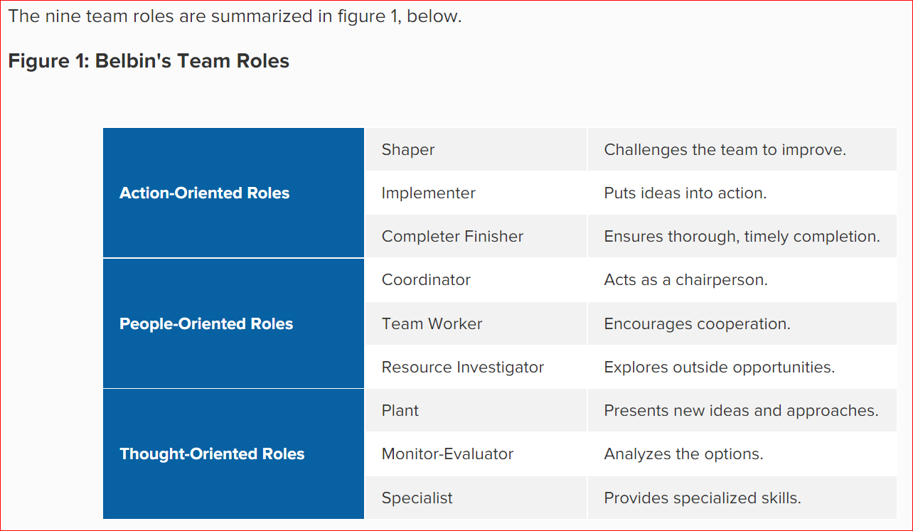
Tuckman’s theory understands that a team is forever evolving so members are joining the team at different times. So, I would suggest this theory is best suited to Pelsall Hall Care home along with Belbin’s theory to help understand the different roles in a team.

Team Roles
The roles that are needed to create a cohesive and effective team can be taken from Belbin’s Theory to identify behavioral strengths and weaknesses in the workplace.
Belbin’s theory helps teams communicate and work together with greater understanding.
There are nine team roles in Belbin’s Theory which are categorized into 3 groups
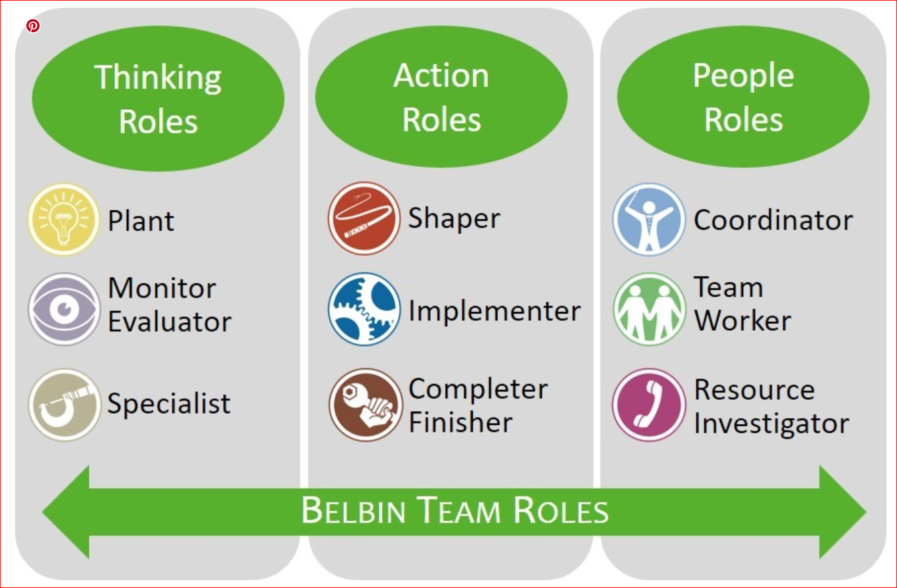
Thinking Roles
Plant – Develop new ideas work alone for the benefit of the team
Monitor -evaluator – Strategic and good analyser but poor in leadership
Specialist – A master in their chosen field may be too focused on technicalities
Action Roles
Shaper – Confident and challenging may cause conflict. Challenges the team to improve.
Implementer – IS a doer gets on with the task but may be resistant to change. Puts ideas into action.
Completer Finisher – Meticulous, meets deadlines and gets the job done but worries
People Roles
Coordinator – Project manager able to delegate and understands the goal but may avoid responsibility
Team worker – Excels in helping others and strives to work as a team but may be indecisive
Resource Investigator – Wealth of contacts knows everyone and good communicator but may be overly optimistic
Steve can use Belbin’s model to create a balanced team with a mix of personalities and skills. Some people may adopt several roles within the team. So the size of the team is important smaller teams are easier to manage within a care home to maximize performance but there are limitations as the team may not fulfil all the roles so some roles may need to be prioritized.
Therefore, using Tuckman and Belbin together is more effective than just one.

Discussion
What makes a successful team?
Teams depend on the style of leadership and the personalities of the team members (which again relates back to Belbin)
A team that is cohesive works better together as they feel part of a team and encourages on open communication. Having mutual respect patience, a common goal and open communication.
A successful team will understand the big picture will be able to communicate transparently. Management should provide training and development where required and ensure all members of team know their responsibilities.
If team members have job satisfaction they will perform better, cohesiveness also allows managers and team leaders to improve their leadership skills and management abilities by encouraging creative thinking and providing opportunities to expand their underrating of how teams work together effectively.
When all clinical and non clinical staff collaborate effectively healthcare teams can improve patient outcomes, prevent medical errors, improve efficiency and improve patient satisfaction.

What are the advantage of effectiveness team working?
Working in a team encourages personal growth, job satisfaction and reduces stress. By using Belbin team roles you select the right people for the right job. Develop and coach existing team members
Highly effective teams are able to achieve goals consistently and eventually have a winning method to follow and achieve their goals, everyone knows who does what best.
There are different models you can use for team effectiveness such as the below.
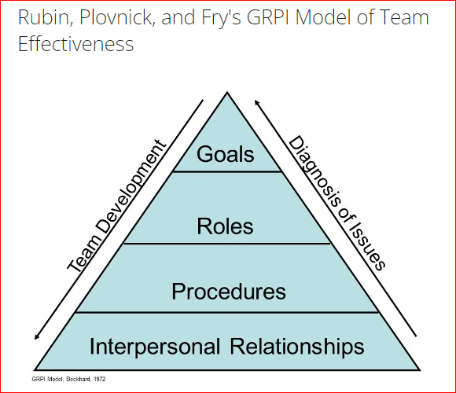

What can the impact be of ineffective or poor teamworking?
In a healthcare environment having ineffective and poor teamworking can lead to inadequate care for residents of Pelsall Hall Care Home.
This can be harmful to the resident’s care and reputation of the home. Let alone lead to additional costs and errors.
This will result in lack of confidence in the team and its abilities and lack use of it’s resources leading to misunderstandings and costly mistakes decreases quality of care.
Bad teamwork can also lead to dividing the team and not working together, lack of cohesive behaviours and delays in meeting deadlines because not everyone will be keeping up with tasks as per the schedules. Some people may not feel that they are valued in the team and may lead to conflict.
Lack of teamwork means there is no clarity in their role or even why they are part of the team. Characteristics of ineffective teams is that they have a low unity of purpose.

Conclusion and recommendations
Steve Brookes has recently been appointed as the manager for Pelsall Hall Care Home. The team at Pelsall Hall are committed and hardworking but sometimes lack of communication between the team members leads to misunderstandings which if left without action can impact the ability to offer consistent high quality care services.
To help rectify this Steve has been appointed to help achieve a high performance team to produce better results.
In this report we have discussed team working and what makes a good team successful. Effective team work has been discussed using references to help understand the need for good communications between team members. How belonging to a team gives staff a sense of belonging so that they are to perform better.
In particular we have discussed models of team development and team roles using Tuckman and Belbins theory which we recommend are used to help develop an effective team.

Reference List
Belbin. “Belbin Team Roles.” Belbin, www.belbin.com, 2022, www.belbin.com/about/belbin-team-roles.
“Building the Emotional Intelligence of Groups.” Harvard Business Review, 28 Dec. 2018, hbr.org/2001/03/building-the-emotional-intelligence-of-groups. Accessed 3 July 2022.
Doney, Patricia M., et al. “Understanding the Influence of National Culture on the Development of Trust.” The Academy of Management Review, vol. 23, no. 3, July 1998, p. 601, 10.2307/259297.
Porter, Christopher O.L.H., et al. “Does Backing up Behavior Explain the Efficacy—Performance Relationship in Teams?” Small Group Research, vol. 42, no. 4, 28 Feb. 2011, pp. 458–474, 10.1177/1046496410390964. Accessed 17 Feb. 2020.
The Team Building Company. “Tuckman; Forming - Storming - Norming - Performing.” Teambuilding.co.uk, 2019, www.teambuilding.co.uk/theory/Forming-Storming-Norming-Performing.html.

