
BMMB7027and BMMB7027D
Strategic and Agile Business Management

STUDENT NAME: MINHAJUR RAHMAN KHAN MISU

STUDENT ID: 2511789
Word Count: 5052
Table of Contents
Executive Summary 4
Introduction 5
Company Background 5
Purpose and Scope of the Report 6
Report Structure 7
Strategic Analysis of Amazon 7
External Environment Analysis 7
PESTLE Analysis 7
Internal Environment Analysis 11
VRIO Analysis 11
Brand Reputation 11
Support Activities 13
Strategic Position 14
Current Customer Care Evaluation 15
Strategic and Agile Business Management Evaluation 15
Strategic Agility at Amazon 15
Agile Culture 16
Innovation Capability 16
Data-Driven Decision-Making 17
Strategic Options for Enhanced Customer Care 17
Option 3: Predictive Customer Service System. 19
Evaluation of Strategic Options Using the SAF Framework 20
Wider Organisational Implications 21
Leadership Implications 22
Organisational Culture Implications 23
Technology and Innovation Implications 23
Ethical and CSR Implications 23
Financial and Operational Implications 23
Conclusions 24
Recommendations 24
References 26

Executive Summary
This report evaluates Amazon's strategic direction with a particular focus on enhancing customer care through strategic and agile business management practices. The report aims to thoroughly analyse Amazon's positioning, understand its challenges and opportunities, understand the expert approaches taken to customer care and give a recommendation on the best approach for Amazon to take that will help achieve sustainable competitive advantage. The analysis revealed a number of strategic points that could impact the future function of Amazon. These include new competition in e-commerce and technology industries, changing customer demands, legal requirements, data privacy, and a constant need for fresh innovations. Meanwhile, there are chances arising with artificial intelligence, predictive analytics, digital transformation, and improved customer experience management. The results reveal that Amazon has several strengths, such as a well-established brand, high-level technological capabilities, highly efficient logistics and a culture that puts customers first, which appears to be effective and successful. The organisation also exhibits a high degree of strategic agility, making innovations, experimenting and making decisions on data. However, ongoing investments in service quality and actively involving customers will be necessary to keep customers loyal. The three options evaluated, with the SAF framework, are hyper-personalisation through Artificial Intelligence, the improvement of the customer testimony by integrating an omnichannel approach and a predictive customer service system. The assessment results indicated that the customer service system with predictive capability is the best strategy as it has the highest suitability, acceptability and feasibility. This strategy expects that customer satisfaction will be enhanced, customer loyalty will be reinforced, the failure rates of services will be lower, and operational efficiency will be higher. Additionally, proactive problem solving will create Amazon's competitive advantage and aid long term organisations resilience in the growing and dynamic business landscape.

Introduction

Company Background

Figure: Amazon
Source: (Das and Hassan, 2022)
Amazon is one of the largest multinationals around the world in the fields of technology and e-commerce. It was started in 1994 by Jeff Bezos, and, originally, it was an online bookstore, but over time it branched out into other products and services (Das and Hassan, 2022). Nowadays, Amazon is present in e-commerce, cloud computing, digital streaming, AI, supply chain and advertising markets. It has a presence in several global markets, including North America, Europe, Asia and other international markets and has millions of customers around the world. Amazon is positioned as a strong and competitive player in the global retail and technology sector, boasting a broad range of products, a robust logistics system, and advanced technological features. Amazon Web Services (AWS) also bolsters its presence in the market with its cloud infrastructure to help businesses around the world.
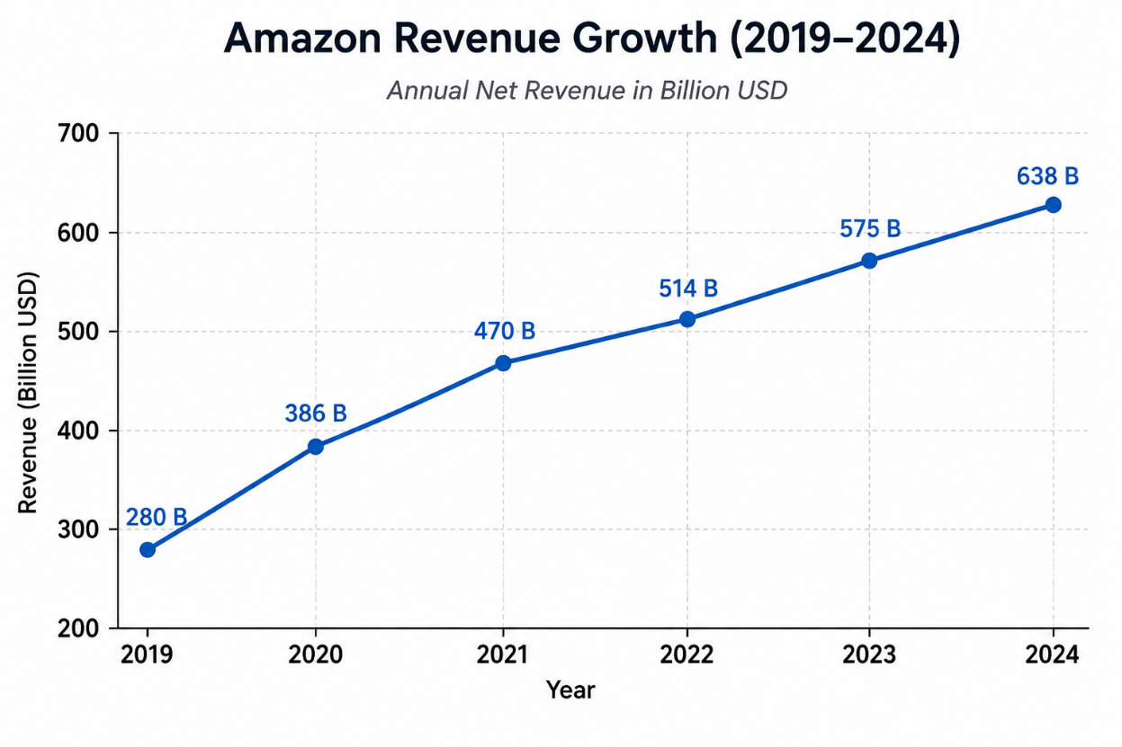
Figure: Amazon Revenue Growth
Source: (Tuncalp, 2026)
The company's innovation and operational efficiency have been key to its continued success and competitiveness. Amazon's goal is to be "Earth's most customer-centric company. As observed in the chart, the annual revenue of Amazon is increasing on a steady pace from 2019 to 2024. During 2019-21 growth was the highest, and in subsequent years revenue growth was steady. The positive trend indicates good sales of Amazon's business and Amazon's strength will lead the company in financing its innovation, customer service and future expansion (Tuncalp, 2026). As shown in the figure, Amazon’s annual revenue increased from $280.5 billion in 2019 to $386.1 billion in 2020, $469.8 billion in 2021, $514.0 billion in 2022, $574.8 billion in 2023 and $638.0 billion in 2024. Revenue grew by 37.6% in 2020, followed by 21.7% in 2021, before moderating to 9.4% in 2022, 11.8% in 2023 and 11.0% in 2024.

Purpose and Scope of the Report
This report is designed to analyse the strategy that is being followed in Amazon and look for better customer service opportunities through strategic and agile business management tactics. Amazon lives in a dynamic and volatile world filled with fast technical advancement, shifting buyer preferences, and severe competition from around the world. As seen by its revenue growth from around $386 billion in 2020 to $638 billion in 2024, its operations are extensive and it has a robust market presence and financial resources to invest in innovation and digital transformation (Lemon and Verhoef, 2016). Con convene easiest, quickest recommendations and services to their mind is critical to Amazon's digital business model; convenience, rapid delivery and personalised suggestions are key factors in pleasing and retaining customers. Hence, the aim of this report is to analyse strategic moves that can improve the relationship with customers and increase the quality of their services with regard to strategic agility. Adopting an agile way is helping Amazon to take advantage of shifting customer needs, technological advances and competitive pressures, which in turn allow the company to remain sustainable and competitive in the long term.

Report Structure
This report is divided into a number of sections. The main body of this introduction will be followed by a detailed strategic examination of Amazon by considering the external and internal business environment. It then investigates and critically examines strategic and agile business management practices and compares and contrasts the different strategies for improving customer care (Mueller-Saegebrecht and Walter, 2025). The wider organisational implications with respect to leadership, organisational culture, technology, ethics and corporate responsibility are then explored.

Strategic Analysis of Amazon

External Environment Analysis

PESTLE Analysis
Amazon is dealing with an extremely dynamic global environment that is affected by politics, ecology, economy, technology, legality and social dynamics. It's essential to be aware of these outside factors so they can be compared to the organisation's strategic position and opportunities.
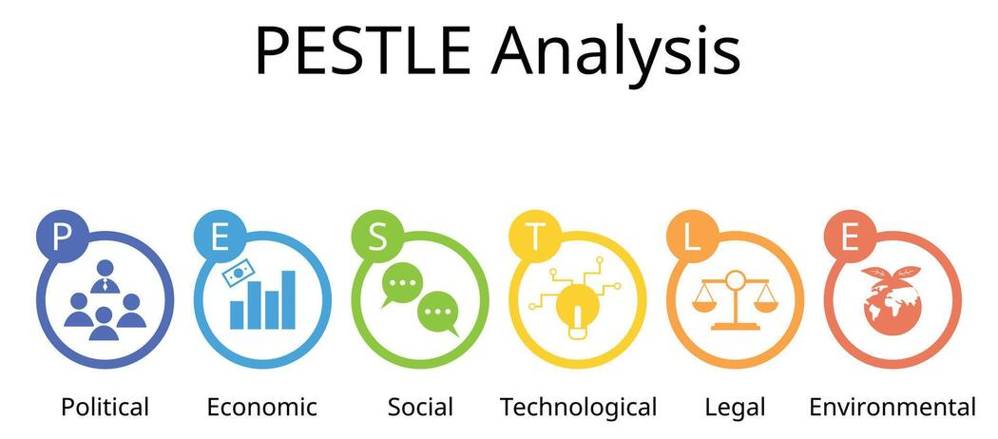
Figure: PESTLE Analysis
Source: (Mueller-Saegebrecht and Walter, 2025)
Political Factors
Amazon's business internationally is greatly affected by its political situation. The company does business in many countries and is thus impacted by laws and regulations of governments in those countries relating to trade, taxation, labour standards and digital regulations. In some markets, government regulation and antitrust action have become more stringent and intense as a result of probing and questioning of major tech firms (Haislip and Richardson, 2017). International trade changes and geopolitical risks could also impact one of Amazon's international supply chains and supply chain efficiency. As a result, Amazon needs to keep adjusting its strategies continuously to meet the evolving regulatory needs.
Economic Factors
The economic condition will directly affect the purchasing behaviour of consumers and organisational performance. Amazon's retail activities are impacted by inflation, interest rates, economic growth and consumer confidence (Coltman et al., 2011). One of the biggest potential downsides when an economy faces uncertainty is that some people will become more sensitive to price and be concerned with what they're buying. But Amazon has a diversified business model of e-commerce, cloud computing, advertising and subscription services. It manages to diversify its revenues, which helps it mitigate the risk from one source and ensure sustainability in economic declines.
Social Factors
Consumer expectations are still increasing in the digital markets. Today, increasingly, customers are expecting to get convenience, speed, customisation, and a smooth customer service experience from modern businesses (Mueller-Saegebrecht and Walter, 2025). In response to Amazon, the company has been putting money into innovations that make customers happy, like same-day delivery, individualised recommendations, and technologies that use voice commands. Amazon's long-term growth is backed by demographic changes, rising use of the internet and growing acceptance of online shopping.
Technological Factors
Technology is one of the most important assets behind Amazon's competitive advantage. Amazon's use of AI, machine learning, cloud technology, robotics, and data analytics ensures its smooth functioning and enhances customer habits (Mihardjo et al., 2019). The company is constantly pursuing innovation in order to help it hold its position in the market and enable strategic agility. New technologies also allow better customer service by using predictive analysis and automation, and customising the delivery of services.
Legal Factors
Amazon Inc. thrives in intricate legal contexts in various jurisdictions. Its organisation is subject to both consumer protection and competition law principles, in addition to requirements for participation in the employment process, data privacy and the protection of intellectual property. The recent legal challenges regarding market dominance and data treatment have led to additional compliance requirements (Arbussa et al., 2017). Noncompliance may lead to monetary fines and damage to its reputation. Hence, legal risk management is still of great strategic value.
Environmental Factors
Customers, governments and investors are now more concerned about environmental sustainability. Amazon is increasingly coming under pressure to further lower carbon emissions, increase the sustainability of its packaging and boost the sustainability of environmental responsibility in its supply chain. The company has undertaken various sustainability measures, such as investing in renewable energy and committing to carbon footprint reduction.
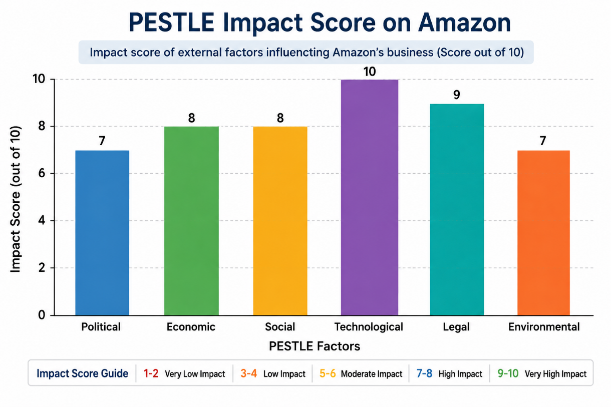
Figure: PESTLE Impact Score on Amazon
Source: (Mihardjo et al., 2019)
The six PESTLE factors have an impact on the Amazon business, however, to different extents. The technological dimension is the most influential of the factors, as it can be seen in the figure, and innovation, the change of business and technological adaptation are fundamental for Amazon. Found to be significant are legal factors, economic factors, and social factors on the contrary variables are having comparatively low level of the influence. The overall results suggest that Amazon should keep an eye on external environment changes and adjust in response to the changes. The ongoing adaptation can keep the company competitive, elastic towards market shifts and promote future development.

Internal Environment Analysis

VRIO Analysis
The VRIO framework assesses characteristics of the resources and capabilities that enable the organisation to sustain a competitive advantage: Value, Rarity, Imitability and Organisational Support. Amazon has several strategic assets which help to reinforce its competitive positioning and help it in the long-term.

Brand Reputation
Amazon has developed one of the most recognised and trusted brands globally. Convenience, reliability and good customer service add to the reputation of the organisation, thus establishing value in the business. It is a relatively rare brand strength because of its long years of customer trust accumulated (Kandampully et al., 2018). However, similar brand value can be attempted by the competitors, but it takes a lot of time and investment to build customers' loyalty for the equivalent brands. Amazon is very well structured in its marketing, service and customer service policies to utilise the brand. Thus, brand reputation offers a competitive edge that is constant.
Technological Capabilities
Amazon's high-tech facilities are an asset to the company's goals. AI, machine learning, cloud computing, and data analytics are among the technologies the organisation uses to enhance both operations and customer experience (Du Plessis and De Vries, 2016). These capabilities contribute to efficiency, creativity, and strategic agility. While companies invest in technology, it is not easy for them to follow the Amazon lead in scale and expertise. The organisation has also been configured in such a way that it benefits as much as possible from technological innovations through constant investments and research. Thus, technological competence plays an important role in competitive advantage.
Logistics and Distribution Network
Amazon's logistics network is a global, critical strategic asset as well. There are many extensive fulfilment centres, transportation networks, and delivery partners that allow for quick and efficient order fulfilment. This feature provides significant value to customers and adds to operational efficiencies. It would be very expensive to duplicate such a network and would take quite a bit of investment. Organisational systems are specially structured to ensure the effort of these resources is most effective.
Amazon Web Services (AWS)
AWS is a significant strategic asset for Amazon and accounted for $107.6 billion in net sales and $39.8 billion in operating income for the company in 2024. It accounts for about 30% of the world's cloud infrastructure market, which represents its market strength in Q4 2024. AWS is valuable from a VRIO point of view 1) it brings in significant revenue and 2) it helps to serve Amazon's technological needs. It operates globally with an advanced technological base and a customer base set up — making it relatively scarce and hard to copy. Amazon's organisation means that they're able to make effective use of AWS, which helps them maintain their competitive edge for the foreseeable future.
Value Chain Analysis
Value Chain Analysis (VCA) looks at the role of organisational activities in contributing to value creation and competitive advantage. Amazon has been very successful in integrating the primary and support functions in its value chain, thereby allowing the organisation to create superior customer experiences.
Inbound Logistics
Amazon has a wide network of suppliers and inventory management systems in various markets around the world. The use of advanced forecasting technologies and data analysis enhances inventory management and minimises inefficiencies in the operation (Homburg et al., 2017). The capabilities help in product availability and stock management effectively.
Operations
Operating at an "operational level" is at the core of Amazon's business model. Using automated fulfilment centres, robotics, artificial intelligence, and cutting-edge warehouse management systems can facilitate efficient order processing (Lemon and Verhoef, 2016). These technologies deliver productivity gains and cut the cost of operation and time to market.
Outbound Logistics
Amazon's distribution capability is one of its biggest competitive advantages. The company has large fulfilment centres and transport solutions and can guarantee faster delivery of products, thanks to its last-mile logistics skill (Verhoef et al., 2015). Prime services improve customer satisfaction and build loyalty of customers.
Marketing and Sales
Amazon uses data to help them customize their marketing efforts and enhance customers' shopping experiences. Purchasing recommendations, promotions, and reviews from customers helps make informed buying decisions. Such activities improve customer connectivity and boost sales productivity.
Service
One of the main values given is customer service. Well-designed returns processes, service and self-service play an important part in customer experiences (Das and Hassan, 2022). The ongoing program of service quality does meet the organisation's philosophy that customers are at the centre of its operations.

Support Activities
The activities of Amazon's value chain outside of their business provide them with three key strength capabilities: technology, human resources, procurement and organisation. Amazon also incurred $88.5 billion in technology and infrastructure costs in 2024, as they continue investing in research and development, technology and infrastructure. The business also keeps on growing and optimizing their supply chain with supplier negotiations and optimisation. The investments are in innovation, employee capabilities and supplier management, and strong leadership and governance enable coordination of Amazon's global operations. So, the support activities play a significant role in operation efficiency, innovations and creating value to the customers for the Amazon.

Strategic Position
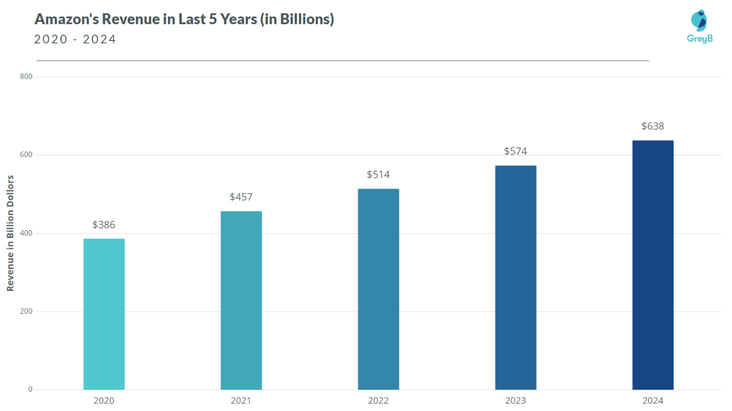
Figure: Amazon’s Revenue Last Year
Source: (Shamout et al., 2024)
Amazon's revenues have been increasing steadily as shown in the chart, from $386 billion in 2020 to $638 billion by 2024. This steady growth is indicative of the company's competitive position in the market and its global operations. Better revenues also mean successful investments in the area of technology, logistics and innovation towards customer. To recap, the week-on-week gains in Amazon's stock price reflect its outstanding financial performance and prospects for expansion. In addition to its stellar standing in the global e-commerce and tech markets, Amazon's strategic analysis helps strengthen its position.Amazon has already established a strong presence in the global ecommerce and tech industry, and this strategic analysis further solidifies its standing. There are many key assets within the organisation, such as the highly recognised brand, its advanced technological resources, and the fact that it has a very sophisticated logistics network, alongside excellent financial resources. They increase operating efficiency, innovation and customer satisfaction and provide significant barriers to the competition. Amazon still had several options available to it in future to grow its capability to do so (Haislip and Richardson, 2017). As AI, automation, and predictive analytics becomes a way of business, these can also be leveraged to enhance the customer experience and performance. Similar to Other Fees and Charges, there are risks associated with the exposition.

Current Customer Care Evaluation
In physical stores, customer care is a key element of the company's operations and is a key objective of the company's business strategy in this regard. The primary attributes through which Amazon will provide a convenient and reliable service experience are: competitive pricing, fast delivery, and personalised service experience. The use of advanced technologies such as AI and data analytics enables personalised product recommendations and customer interaction. There are multiple strengths that result in elevated stages of consumer satisfaction (Coltman et al., 2011). Convenience and customer loyalty are improved by fast shipping (especially Amazon Prime). Easy digital platforms make buying all easier and more convenient, and effective return and refund policies build customer confidence. The wide portfolio of offers and tailored advice enhances the customer experience even more and leads to the right repurchase behaviour. While this is a strong area, there are some areas of customer care that Amazon could do better. With increasingly high expectations of customers, there is a constant need to add value to the service. In some cases, an automated support system can restrict opportunities for human interaction when dealing with intricate issues.

Strategic and Agile Business Management Evaluation

Strategic Agility at Amazon
Strategic agility is the capacity of an organisation to swiftly and effectively adjust to shifting market conditions, customer demand, technology and competition. The company's track record of strategic manoeuvrability remains remarkable, with a customer-centric culture, groundbreaking innovations, and data analytics that guide decision-making (Khan et al., 2021). Amazon's ability to manoeuvre flexibly over the years with its customer-focused culture, constant innovations, and wide implementation of data-driven decision-making has consistently been remarkable. This allows the organisation to be flexible and retain and build a sustainable competitive advantage in a highly dynamic market.
Strategic Agility Dimension | Evidence at Amazon | Strategic Contribution
Agile Culture | Customer obsession, experimentation, and decentralised decision-making | Faster response to market changes
Innovation Capability | AWS, Alexa, Prime, AI technologies | Continuous value creation and growth
Data-Driven Decisions | Customer analytics, predictive systems, machine learning | Improved customer experiences and operational efficiency

Agile Culture
Amazon's culture is very conducive to strategic agility. Leadership standards progress foundation building, experimentation, accountability, and customer fervour. Employees are motivated by the opportunity to recognise opportunities, explore ideas and make decisions to enhance the outcomes for customers (Nurjaman and Dwipriyoko, 2021). This culture is one that is flexible and reacts quickly in the business arena. One standout trait of Amazon's agile culture is that they are willing to try things and learn from them. Many new products and services are experimented with and tuned up before being introduced on a large scale. This allows the organisation to adapt to its customers' needs and the market and makes it more responsive. The structure, where the emphasis is placed on small autonomous teams, also ensures swift decisions and flexibility around measures.

Innovation Capability
Amazon's strategic tremendous success hinges on innovation. The organisation continuously engages in research, technology development and digital transformation activities. This dedication to invention has manifested itself in several hugely successful services, including Amazon Prime, Amazon Web Services (AWS), Alexa, and advanced logistics technologies. Innovation capacity allows Amazon to see and capitalise on emerging opportunities in the market and to stay competitive (Mueller-Saegebrecht and Walter, 2025). The company is constantly innovating in products, services and business model development to create new revenue streams and value for its customers.

Data-Driven Decision-Making
Another critical component of Amazon's strategic agility is decision-making based on data. The organisation gathers and processes vast amounts of customer data, operational and market data for strategic and operational decisions. With advanced analytics and machine learning, Amazon can uncover trends, forecast customer behaviour, and fine-tune business processes. Customer info is especially crucial towards enhancing the quality of service and personalisation. Advanced analytical systems provide support for product recommendations, targeted promotions, inventory planning and forecasting demand (Shams et al., 2021). These capabilities allow Amazon to react swiftly to customer needs and the market. Moreover, data are helpful in decision-making, making organisations more efficient and better managed in terms of risk management. Decision-makers have timely data to guide with, not just their opinions based on past ideas that might not be true in the present.

Strategic Options for Enhanced Customer Care
After the strategic analysis, there are a number of strategic options that can be considered to enhance Amazon's customer care capabilities. These options are most likely around the customer experience, customer satisfaction, and strategic agility and innovations for long-term customer competitive advantage.
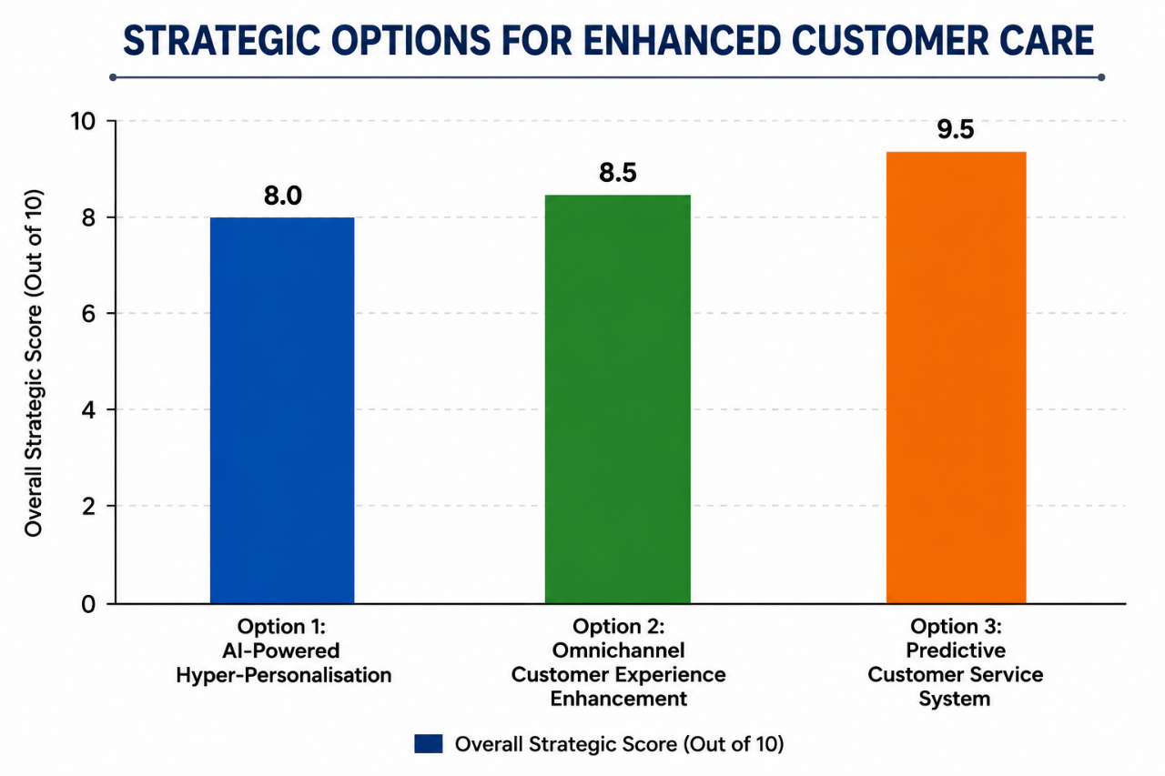
Figure: Strategic Options for Enhanced Customer Care
Source: (Hansen, 2025)
This is a comparison chart of three strategic positions that can aid Amazon's customer care. The Predictive Customer Service System is the one with the highest points as it enables businesses to resolve problems before they even occur, and to work more efficiently. The second one is Omnichannel Customer Experience Enhancement, which provides smooth customer interaction. AI-Powered Hyper-Personalisation also shines in the personalised recommendations and enhanced customer loyalty departments.
Option 1: AI-Powered Hyper-Personalisation
Hyper-personalisation with AI involves a broad range of AI, machine learning and advanced data analysis technologies, all brought together to provide personalized customer interactions. While Amazon already has a system in place to make recommendations, a more intricate personalisation scheme throughout the customer's experience would be possible with greater investments. With this scheme, consumers would be studied in real time, including their interests, shopping behaviour, number of pages visited, socio-demographic characteristics, and shopping trends (Mihardjo et al., 2019).
There are various promising possibilities of benefits in this strategy. Personalised experiences can result in improved customer satisfaction, loyalty and retention. The additional boost can also create additional sales revenue as a result of additional purchases. More is also a reinforcement of the ‘the customer is king' mentality and can help Amazon's competitive edge.
Option 2: Omnichannel Customer Experience Enhancement
Omnichannel customer experience enhancement is the process of orchestrating each customer touchpoint to make them all cohesive. Customers expect a seamless experience with a brand across all channels, including social media, customer support or retail stores, websites and mobile apps, and voice assistants. This approach would entail integrating the information and communication systems with the service processes, both within and between the channels.
This strategic option has a number of benefits. More integration of the channels can offer increased convenience, customer satisfaction and brand cohesiveness. A seamless customer journey could also result in improved interaction with customers and increased loyalty (Tenggono et al., 2025). Also, embedded systems provide employees with more access to customer data, which helps them provide effective services. While these benefits are apparent, significant technology investments and changes in approach and behaviours may be required to implement.

Option 3: Predictive Customer Service System.
Predictive customer service systems are indeed an proactive approach to customer systems. Rather than waiting for a problem to arise, Amazon would use AI, predictive analytics and other machine learning tools to anticipate potential problems before they occur.
It would review all this information on operations, delivery, procurement and the relations with the customers to identify possible issues with service. However if any delays are possible, or a short run/long run production problem, payment problem, or technical problem is encountered, they could be identified prior to the process (Arbussa et al., 2017). This can be a big help in offering customer support advantages. By resolving issues proactively, one can minimise customer frustration, enhance service stability, and boost customer satisfaction. Also, early intervention can help to reduce the amount of customer complaints and support requests, which can help to streamline operations.

Evaluation of Strategic Options Using the SAF Framework
The Suitability-Acceptability-Feasibility (SAF) Framework to Assess Strategic Options for Improving Amazon's Customer Care Model is the main tool that will be utilised for evaluating the options identified for enhancing Amazon's customer care capabilities.
Strategic Option | Suitability | Acceptability | Feasibility | Overall Assessment
AI-Powered Hyper-Personalisation | High | Medium-High | High | Strong Option
Omnichannel Customer Experience Enhancement | High | High | Medium | Strong Option
Predictive Customer Service System | Very High | High | High | Best Option
Suitability Assessment
An important aspect that is addressed at suitability is whether or not the strategy presented is going to do a good job of addressing the strategic challenges and opportunities that are available within the organization. Hyper-personalisation, particularly AI-powered, is the best because it can lead to increase in consumers' engagement through customisation and fit Amazon's customer-centric perspective. The availability is also in line with the growth of consumers' demand for customised services (Doz and Kosonen, 2010). Omnichannel customer experience enhancement is also apt as customers have come to anticipate a seamless customer journey across channels.
Acceptability Assessment
Acceptability includes the responses from the stakeholder group and potential risks and benefits of each option. The advantages of hyper-personalisation are especially significant when it comes to increasing customer satisfaction and loyalty, as well as boosting revenues through an AI-driven hyper-personalisation strategy. However, there is a risk that concerns stakeholders with the privacy of the data and that there is a high amount of customer data, which could restrict acceptability (Clauss et al., 2019).
Feasibility Assessment
Feasibility is concerned with the degree to which an organisation is able to implement the project, as an analysis of its resources, capabilities and competencies. With algorithms, all the information given by the customers is used appropriately and the technological expertise and advanced artificial intelligence (AI) that Amazon has make hyper-personalisation very possible (Wade et al., 2021). Improving the CX for all channels is in the middle range of difficulty to achieve. While Amazon has a range of digital capabilities, the adoption of some (global) customer services channels might represent an investment, coordination and organisational change.

Wider Organisational Implications
A predictive customer service system would go beyond customer service, reaching numerous aspects of the Amazon business. These strategic decisions can impact leadership behaviour, organisational culture, technology, ethical obligations, and bottom-line profitability. Thus, the broader organisational consequence of the proposed strategy must be assessed.
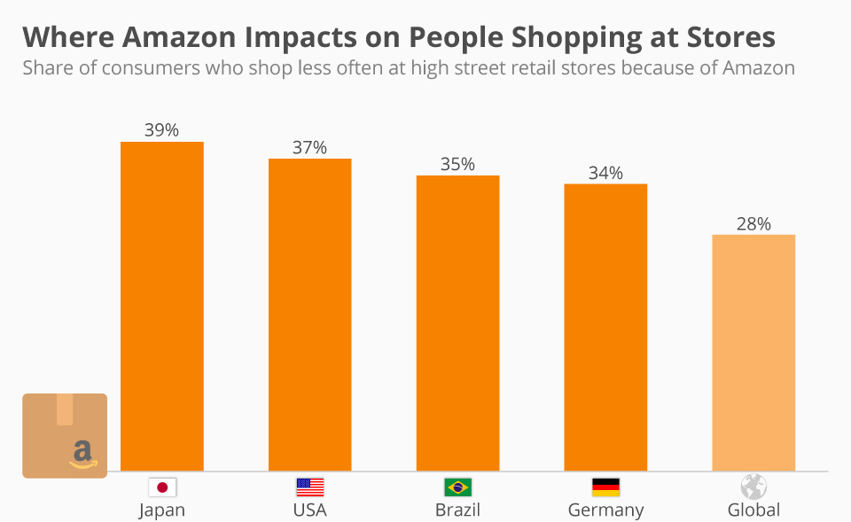
Figure: Wider Organisational Implications
Source: (Grewal et al., 2025)
The graph shows that Amazon is already having a strong influence on the consumer shopping patterns of several countries. The highest impact is in Japan with 39% of consumers reporting a decrease in their shopping frequency in physical stores, followed by the USA (37%), Brazil (35%) and Germany (34%). In the world 28% of consumers have reduced the frequency of their meetings to conventional retail shops and aisles because of Amazon. The results prove the influence of Amazon on the retail markets and urge companies to invest in digitalisation, process optimisation and innovative solutions for customers.

Leadership Implications
Continued Results will depend on effective leadership commitment and direction. Senior leaders would need to champion organization-wide change to be customer-centric - and support the digital transformation that will be needed for the business overall (Slater, 2022). Leadership teams would also be accountable for the provision of resources, staffing, the management of change in the organisation, and the development of working across departments.

Organisational Culture Implications
The new plan will continue to focus on the customer-centric culture with the ultimate goal of creating a proactive customer service. Through predictive functions, the employees would be anticipated to foresee what customers were looking for, ahead of them even recognizing they were dissatisfied (Mason, 2018). This shift could foster an innovative mindset, one that is responsive and continually evolving and improving. However, in the beginning, they may not be keen on embracing new strategies of working practice.

Technology and Innovation Implications
To implement this, more investments need to be made in artificial intelligence, machine learning, predictive analytics, data integration systems, etc. Such innovations would bolster Amazon's ability to reinvent itself and improve efficiency and customer service (Kotter et al., 2021). Better analytics also could pave the way for future strategy efforts in other business functions. Further, constant innovation is needed to make sure the system is accurate and that a competitive advantage remains.

Ethical and CSR Implications
Using predictive customer service systems comes with several ethical issues. Amazon would also have to develop strategies on sensitive data utilization by users and be transparent in the way they gather and analyse data. If the data privacy protection measures are not of good strength, then it would not be possible to ensure the customers' trust and compliance with the regulations. From a CSR (Corporate Social Responsibility) standpoint, the organisation will need to also ensure equitable operation of the AI systems and to avoid any discrimination in their outcomes.

Financial and Operational Implications
Starting up such a plan would require a significant initial investment of technology infrastructure, software development, training personnel and integrating the systems. These expenses may lead to an increase in operating expenses in the short-term (Kern, 2018). Long term, however, the returns to the company may be through greater customer retention, higher LTV of customers, lower cost of dealing with customer complaints and higher operational efficiency. Predictive service capabilities can also contribute to minimising service disruptions and to optimising services.

Conclusions
This report aimed to analyse Amazon's direction and strategic approach to them, focusing on their Customer Care and the ways it can be improved based on a strategic and agile approach. Certainly th,ough, the analysis confirmed Amazon's position as highly competitive in the e-commerce and technology marketplaces around the world. It has very strong assets such as a strong, global brand, sophisticated technological competence, comprehensive logistics networks and innovation capability. Having these resources, Amazon can deliver customer value and a sustainable competitive advantage (Denning, 2019). During the external analysis, several opportunities were identified, pertaining to the digital transformation, customer personalisation and changing consumer expectations, as well as AI. However, the organisation faces some new pressures, too, such as competition, regulatory, data privacy, and changing economic factors. More so, Amazon has demonstrated dynamic resources that are difficult to develop and replicate, which enhance its strategic value in the long term, also by analysing the internal strengths and weaknesses. Amazon's strategic agility was measured in its marketing strategy, the way people worked together across the various departments, how they treated customers and how they used their data and approach to make decisions. These capacities paved the way for future strategic growth and enhancement of customer services (De Smet et al., 2018). The three strategic scenarios analyzed by applying the SAF framework are the implementation of Artificial Intelligence (AI) in hyper-personalization, optimisation of Customer Experience (CE) omnichannel and a predictive system for Customer Service (CS). They all seemed to have merit of being strategic, but this predictive customer service seemed to be the most viable contender. The approach that had the best balance of suitability, acceptability and feasibility was the one that came with the directly voice-to-reel approach relevant to Amazon's customer-centric approach.

Recommendations
Several recommendations are suggested, which are formed on the basis of the findings of this report, to enhance Amazon's capacity related to customer care and to support the long-term strategic success.
Recommendation 1: Implement AI-Driven Predictive Customer Care
Amazon needs to focus on implementing a predictive customer service system for its all-around operations (Whittington et al., 2020).. AI can be leveraged to foresee your customers' problems beforehand. Drivers of proactivity in problem resolution include better customer satisfaction rate, lower number of complaints and customer loyalty (Ahlbäck et al., 2017). This is very similar to what Amazon are trying to achieve with their Customer First and Strategic Verbal Polite.
Recommendation 2: Strengthen Omnichannel Integration
Amazon should also enhance their customer support channels to make its support experience seamless across its website, mobile apps, voice-activated apps, social media, and support channels. Better coordination of channels would make services better for customers and service more uniform (Lynch, 2018).
Recommendation 3: Develop Customer Analytics Capability
The watchword for future investments in advanced customer analytics is a better understanding of customer behaviour and preferences. The improvements in analytical capability could benefit demand forecasting, delivery of personalised services, and strategic decision-making Better data use would also give Amazon the advantage of better predicting the evolution of customer expectations and market trends.

References
- Ahlbäck, K., Fahrbach, C., Murarka, M. and Salo, O. (2017) How to Create an Agile Organisation. McKinsey & Company.
- Amiri, S., & Vida, V. (2023). Analysis of marketing strategic issues at Amazon. SEA: Practical Application of Science, 11(31).
- Arbussa, A., Bikfalvi, A., & Marquès, P. (2017). Strategic agility-driven business model renewal: the case of an SME. Management Decision, 55(2), 271-293.
- Clauss, T., Abebe, M., Tangpong, C., & Hock, M. (2019). Strategic agility, business model innovation, and firm performance: an empirical investigation. IEEE transactions on engineering management, 68(3), 767-784.
- Coltman, T., Devinney, T. M., & Midgley, D. F. (2011). Customer relationship management and firm performance. Journal of Information Technology, 26(3), 205-219.
- Das, S., & Hassan, H. K. (2022). Impact of sustainable supply chain management and customer relationship management on organisational performance. International Journal of Productivity and Performance Management, 71(6), 2140-2160.
- De Smet, A., Lurie, M. and St. George, A. (2018) Leading Agile Transformation: The New Capabilities Leaders Need to Build 21st-Century Organisations. McKinsey & Company.
- Denning, S. (2019). How Amazon Became Agile. Forbes.
- Doz, Y. L., & Kosonen, M. (2010). Embedding strategic agility: A leadership agenda for accelerating business model renewal. Long-range planning, 43(2-3), 370-382.
- Du Plessis, L., & De Vries, M. (2016). Towards a holistic customer experience management framework for enterprises. South African Journal of Industrial Engineering, 27(3), 23-36.
- Foltean, F. S., Trif, S. M., & Tuleu, D. L. (2019). Customer relationship management capabilities and social media technology use: Consequences on firm performance. Journal of business research, 104, 563-575.
- Grewal, H., Dhillon, G., Buddhavarapu, V., Verma, R. K., Munjal, R. S., Sharma, P., ... & Surani, S. (2025). Strategic insights of telehealth platforms and strengths, weaknesses, opportunities, and threats analysis of Amazon's clinical endeavors. World Journal of Methodology, 15(2), 98513.
- Haislip, J. Z., & Richardson, V. J. (2017). The effect of Customer Relationship Management systems on firm performance. International Journal of Accounting Information Systems, 27, 16-29.
- Hansen, T. L. (2025). Amazon Strategic Audit.
- Homburg, C., Jozić, D., & Kuehnl, C. (2017). Customer experience management: toward implementing an evolving marketing concept. Journal of the Academy of Marketing Science, 45(3), 377-401.
- Hwang, J., & Seo, S. (2016). A critical review of research on customer experience management: Theoretical, methodological and cultural perspectives. International Journal of Contemporary Hospitality Management, 28(10), 2218-2246.
- Kandampully, J., Zhang, T., & Jaakkola, E. (2018). Customer experience management in hospitality: A literature synthesis, new understanding and research agenda. International Journal of Contemporary Hospitality Management, 30(1), 21-56.
- Kern, J. (2018) Agile in the Context of a Holistic Approach. InfoQ.
- Khan, S. H., Majid, A., & Yasir, M. (2021). Strategic renewal of SMEs: the impact of social capital, strategic agility and absorptive capacity. Management Decision, 59(8), 1877-1894.
- Kotter, J.P., Akhtar, V. and Gupta, G. (2021) Is Your Organisation Surviving Change—or Thriving in It? Harvard Business Review.
- Lemon, K. N., & Verhoef, P. C. (2016). Understanding customer experience throughout the customer journey. Journal of Marketing, 80(6), 69-96.
- Lynch, R. (2018) Strategic Management. 8th edn. Harlow: Pearson.
- Mason, L. (2018) Amazon Culture: Staying Agile. YouTube.
- Mihardjo, L. W., Sasmoko, , & Rukmana, R. A. (2019). Customer experience and organisational agility-driven business model innovation to shape sustainable development. Polish Journal of Management Studies, 20(1), 293-304.
- Mueller‐Saegebrecht, S., & Walter, A. T. (2025). Strategic agility—an urgent capability for successful business model innovation? A conceptual process model and theoretical framework. Strategic Change, 34(3), 407-428.
- Nurjaman, R., & Dwipriyoko, E. (2021, March). Strategic agility on SME: A case study of the small doll industry in Bandung. In 1st Paris Van Java International Seminar on Health, Economics, Social Science and Humanities (PVJ-ISHESSH 2020) (pp. 392-395). Atlantis Press.
- Shamout, M. D., Alzoubi, H. M., Elrehail, H., Itani, R., Al-Gasaymeh, A., & Farouk, M. (2024, February). Streamlining E-Commerce and Last-Mile Delivery for Enhanced Customer Satisfaction: An In-Depth Analysis of Amazon's Strategies. In 2024 2nd International Conference on Cyber Resilience (ICCR) (pp. 1-8). IEEE.
- Shams, R., Vrontis, D., Belyaeva, Z., Ferraris, A., & Czinkota, M. R. (2021). Strategic agility in international business: A conceptual framework for “agile” multinationals. Journal of International Management, 27(1), 100737.
- Slater, D. (2022). Leading and Innovating with Leadership Principles. Amazon Web Services Executive Insights.
- Tenggono, E., Soetjipto, B. W., & Sudhartio, L. (2025). Navigating institutional pressure: Role of dynamic managerial capabilities and strategic agility in healthcare organisations’ renewal. International Journal of Healthcare Management, 18(3), 502-511.
- Tuncalp, D. (2026). Amazon Corporation: Controlling for Success.
- Ullah, I., & Narain, R. (2020). The impact of customer relationship management and organisational culture on mass customisation capability and firm performance. International Journal of Customer Relationship Marketing and Management (IJCRMM), 11(3), 60-81.
- Verhoef, P. C., Kannan, P. K., & Inman, J. J. (2015). From multi-channel retailing to omni-channel retailing: introduction to the special issue on multi-channel retailing. Journal of Retailing, 91(2), 174-181.
- Wade, M., Joshi, A. and Teracino, E.A. (2021) 6 Principles to Build Your Company's Strategic Agility. Harvard Business Review.
- Whittington, R., Regnér, P., Angwin, D., Johnson, G. and Scholes, K. (2020) Exploring Strategy: Text and Cases. 12th edn. Harlow: Pearson.

