

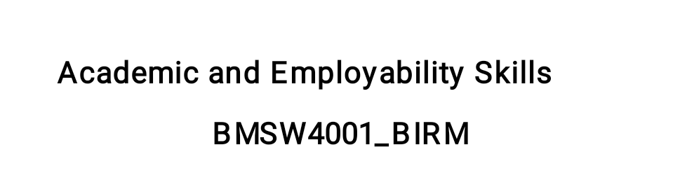
Reflective Report towards the personal experience through Academic and Employability Skills module

Dr. Besty Jose
Stefan Ciprian Petre

April, 2022
Words, 1803
Table of contents
- Introduction
- Gibb’s reflective cycle model of reflection
  - Examination of writing task 1
  - Experience of working as a group
- A personal development plan (PDP)
References

- Introduction
With regard to the current report, a reflective one, where the main goal is to highlight the most important changes, feeling, motivations regarding my experience during the module taken into account, it has to be pointed out that the theoretical model utilised is Gibb’s reflective cycle model of reflection. Moreover, besides the personal perspective, it will be presented the experience regarding the teamwork for the week number eight. It is essential, in our days, to have the skills and knowledge regarding teamwork, one of the most important skills the employers are searching, being essential to be team players and understand, accept, help our colleagues. The UK environment, one characterised by multiculturalism, with people from different cultures, with different backgrounds, is very interesting and challenging, from this perspective. Moreover, another part is represented by a personal development plan, where I will highlight some goals I have and how I’m trying to change, improve some habits, personal issues.

- Gibb’s reflective cycle model of reflection
According to Brown (2018), Gibbs reflective model is based on several levels, where the person has to ask to answer several in-depth questions in order to deepen the reflections as much as possible. Gibbs reflective model is suggesting the following stages, namely, as it follows: description, feelings, assessment, analysis, conclusions and action plan (Gibbs, 1988). However, the main idea of this model is “to systematize the reflections and to isolate the feelings. Usually, the various steps help to slow down the thinking process so that we do not draw conclusions too quickly” (Brown, 2018).
Figure 1. Gibbs Reflective Model (E-learning network)
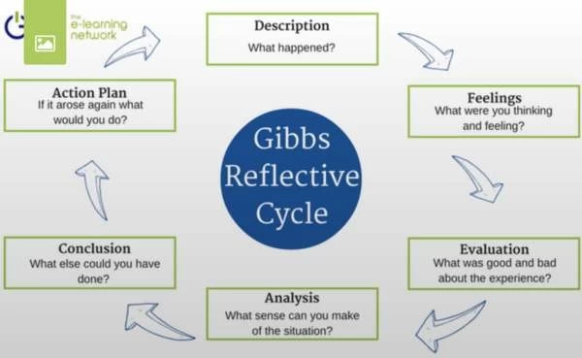
2.1. Examination of writing task 1
In order to offer a holistic perspective, all the stages will be discussed, analysed, with regard to the tasks taken into account.
- Description
In the current scenario, I had to prepare an assignment by myself, so I controlled each stage of its creation and preparation. Considering that I’m having a full-time job, my time management skills are extremely important and I’m using them a lot during my academic projects. I am constantly trying to prepare the assignments in advance, and I’ve succeed to finish my assignment before the deadline.
- Feelings
I was extremely nervous, being one of the first assignments I had to prepare, I consider that I put a lot of pressure on myself in order to deliver a high-standard report. However, some personal issues appeared, and I strongly believe that I didn’t offer my best, I wasn’t focused enough. Anyway, overall, I am pleased with the project, and the idea that I am perfectionist and want to improve myself is positive on medium and long term, in this scenario.
- Evaluation
Considering that is one of my first assignments, I didn’t have plenty of expectations, or, more precisely, I didn’t know what to expect. The UK academia is totally new for me, and I’m amazed that I have the chance to improve my skills, develop myself through these programmes. I do consider positive the fact that I was able to finish the assignment on time, I followed the plan and tried to offer a decent academic work. However, on the other side, the fact that I let some personal issues to affect my work it has to stop on the future, because it will affect my academic results, capacity to work and achieve the desired results.
- Analysis
As it was discussed and presented above, there are pros and cons with regard to my work during this module. Again, it is positive that I prepared a plan, I followed it, I avoided to work under pressure and delivered the assignment before the deadline. However, I’ve lost my interest because of some personal issues, the quality of my work changed, decreased. I will have to maintain a professional attitude in the future, maintain objectivity, in order to achieve my goals. In order to help me achieve my objectives more easily, I consider that a SWOT analysis might be useful, a helpful tool to help me understand better my strengths and weaknesses, constantly.
- Conclusion
There are a few important lessons I’ve learned from this experience. First, I have to clearly separate the personal life and academic one. Even if it’s extremely difficult, an approach where an objective perspective is maintained permanently is appropriate, in this scenario. Also, setting up a coherent plan is desirable, making the work much more pleasant, easy to follow the goals, a structure being always an asset. As well, using properly the digital tools university is offering is representing an advantage, the online library, articles, and for the future I will take advantage on these tools.
- Action plan
For the next assignment I will have a different approach in regards to some points, as it follows. Firstly, I will set up a comprehensive SWOT analysis, highlighting main strengths, weaknesses, opportunities, threats, in order to see what my position is at that specific time. As well, I will separate clearly my personal life with the academic one. Even if such an approach is extremely difficult to be achieved, the desire, in this respect, is relevant, the need to improve and acknowledgement that some issues are raising.

2.2. Experience of working as a group
a. Description
With regard to the group assignment, our group (me and two other colleagues) decided to divide the different sections between us, in order to make it fairer, with each colleague researching only one sector. The plan was to put the task together in the afternoon a day before the deadline, which means we didn't have to schedule time to sit and write it together. But, when we double checked each person’s work, it was obvious that the writing styles were completely different. Therefore, we made the decision to rewrite it in order to make it sound a coherent project. However, we did not took this stuff into consideration, and, as a consequence, two of our team members had to spend extra time working at the project in order to finish it in the deadline.
b. Feelings
Before we started the work I was pretty excited with regard to our project. The idea that we can share together plans, ideas, observe and understand different typologies, new approaches, was extremely interesting from an intellectual point of view. However, the actual result, with the issues presented above, made me to accomplish that uncertainty is always part of our existence, part of the game. If initially I was excited about the idea, the issues bought some frustration, a lack of motivation. However, we managed to sort the things out, and this is a relief, so I’m overall satisfied with our work, results.
c. Evaluation
Considering that we are still at the beginning, we have some circumstances to rely on. However, it has to be pointed out overall we managed to deliver a god project in the current scenario, submitting the work at the proper deadline. My colleagues worked hard, showing an amazing work ethic. However, the communication between members wasn’t extraordinary at the beginning, we didn’t manage to set up a clear set of rules in order to make our life easier.
d. Analysis
As it was stated above, we have to emphasise the work ethics, the fact that we managed to submit on time everything. But, in contrast, a lack of communication, understandable in the current scenario, created some issues with regard to the project’s quality. At this point, it can be pointed out the fact that there is a rich, various literature on the topic. Relevant, in this scenario is Belbin’s team role inventories, with nine team roles, such as: Resource Investigator, Team worker and Co-ordinator (the Social roles); Plant, Monitor Evaluator and Specialist (the Thinking roles), and Shaper, Implementer and Completer Finisher (the Action or Task roles, see Mostert, 2015). Such a test would be suitable mainly because would help us to understand ourselves and our colleagues better, in different environments, with each of us in a proper position, according to his skills and capacities.
e. Conclusion
Most important lesson I’ve learned is that communication is the key. Also, in order to divide the work in a group, it is imperative to set up a clear plan, model, in order to present a cohesive plan, with approximatively the same approach, style. A good idea would be to work together, meet and prepare the work together. As well, utilising Belbin team roles model would be beneficial, helping the team workers to understand and know each other in a comprehensive way. Lastly, in a group is normal to have animosities, people with different views. Again, a clear communication is fundamental in order to overtop them.
f. Action plan
For the next group project, an important point would be to have a clear discussion regarding each colleagues’ strengths (an SWOT analysis, doubled by Belbin’s team roles). Moreover, if we agree to divide the work, I will insist on having a clear plan, along with maybe writing together the introduction and conclusion. Also, I will try to suggest my colleagues that disagreement is not necessarily a problem, but a way to improve ourselves and our work. Hence, a clear approach, a suitable plan, a good communication between members are representing most important elements of a successful team, in this scenario.

3.A personal development plan (PDP)
In order to present a personal development plan, it has to be established that there are several steps to follow, such as:
- Set some goals - on an academic level, my goal is to successfully finish the degree, with distinction.
- In terms of my career, I wan to develop my company, manage to
make a living from this activity.
- Prioritize my goals – on academic level, in order to accomplish, I have to improve my English, improve my time-management skills, improve my academic skills.
- Regarding my career, I have to find some financial support in order
to develop the company.
- Set deadlines – Academia – 3 years time.
- Job/career – 12/24 months is a suitable deadline.
- Recognize threats and opportunities – Academia – Threats might be represented by some poor marks, maybe the fact that I don’t have the necessary skills for this educational programme. Opportunities might be represented by the fact that the skills I’m learning might help me in my career.
- Career – Threats – I am not able to find a partner for the company,
“Brexit” and its implications, Covid-19 pandemic and its impact on automotive industry.
- What skills you need to work on – Academic – English, presentation skills, team skills.
- Career – Management skills, strategic thinking, business skills.
However, it is essential to point out that a continuous development is the key, in this respect, being imperative to genuinely look at ourselves and try to develop on all levels permanently in order to become successful.
References
Brown, N. (2018) Reflective model according to Gibbs. Available from: https://www.nicole-brown.co.uk/reflective-model-according-to-gibbs/ (Accessed at 03/04/2022).
E-learning Network (N/A) Gibbs – Reflective Cycle Model (1988). Available from: https://www.eln.co.uk/blog/gibbs-reflective-cycle-model-1988 (Accessed at 03/04/2022).
Gibbs, G. (1988) Learning by Doing: A guide to teaching and learning methods. Further Education Unit, Oxford Brookes University, Oxford.
Mostert, N., M. (2015) “Belbin – the way forward for innovation teams”, Journal of Creativity and Business Innovation, Vol. 1.

