How much influence does Politics have on the art world and how influential is Art on Politics?

Art is a very influential and highly influenced thing within society, so it comes to no surprise that politics plays a heavy role in many artists pieces and many art movements. But how influential is politics when it comes to art and does art have the same impact on the world as we think it does? Art causes a lot of controversy when used in a political way, however it can be used in both a way that benefits the political parties or can demonise them. This can cause politicians to deem some movements as hateful and offensive but ‘do we trust those in power to decide what is offensive or hateful and what constitutes true information?’(Kuoni, Raicovich, 2022,pg 34).

Propaganda has been a very successful way of influencing the public to stand behind the idea of war. In Germany during the First World War ‘a significant number of female intellectuals and artists were caught up in an initial atmosphere of excitement and support for War’ (Siebrecht, Claudia, 2019, pg.29). One artwork that stood out because of the many death semiotics used within it is Death the Russian Bear by Katharina Heise. She uses a bright red for the sky which alludes to blood and death especially considering the other contextual clues like the slanted gravestones and the hanging hare. This piece is representing the destruction from Russia and she is trying to demonise Russia through her work .

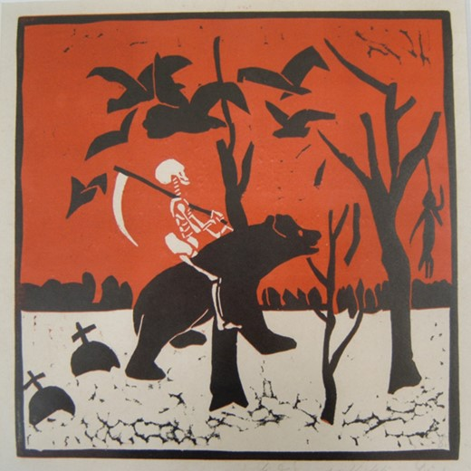

Tod dem russischen Bären (Death to the Russian Bear), 1916.

Semiotics is also used within advertising like it would’ve been used in propaganda years ago , however companies have become a lot more subtle when trying to convince a customer to buy their product over another companies. Semiotics relies on the fact that ‘our subconscious relies interpretations rely on emotions, not information’ (Lesley Vos 2021) so advertising tries to make the consumer feel at the centre of either the company or the choice . This relates to how War propaganda made the public feel like it was their responsibility and up to them to help the country. Most companies within the food and drinks industry use the colour red as it is the most appetising and hunger inspiring colour, the red colour has been used a lot in propaganda as well as it is such a bold and eye-catching colour. ‘War time posters were not just about military recruiting’( Vergun, 2019) they were also trying to attract women to help and join factories that were building bombs and tanks etc., the way they did this was a poster by the artist J.Howard Miller. The semiotics within the poster are the powerful stance with the hand on her bicep, it creates the image of strength and power. The colour yellow promotes optimism which would help get more people involved and would make them feel better about the War going on.
Another propaganda poster that was highly influential was the Uncle Sam recruitment poster by James Montgomery Flagg. The use of red and blue adds to the patriarchal element of the poster making the public feel more inclined to join because of their responsibility to the country. The point towards the viewer is also a tactic of persuasion as it feels very targeted and it is at the viewer. All the semiotics within this propaganda poster leads to the feeling of responsibility and like it is aimed at you. They also use the powerful red colour with the US army text to incite confidence and show the power of the US Army. The stern look on Uncle Sam’s face also creates a sense of responsibility for the viewer because he looks unforgiving.

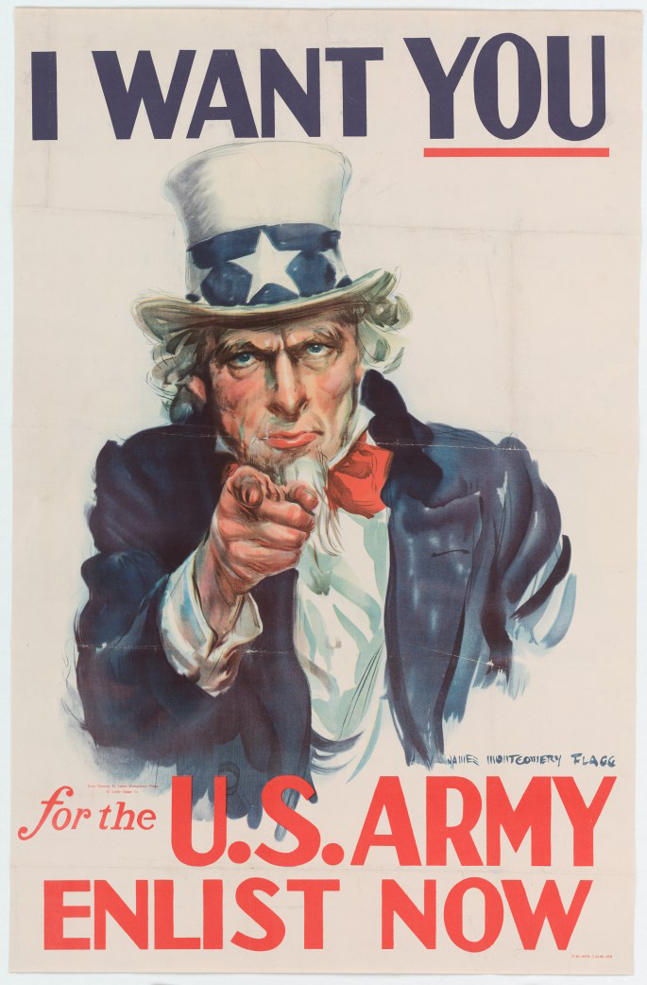

(Uncle Sam recruitment poster, 1942. American artist James Montgomery Flagg)

However not all War propaganda is there to promote, most artists disagree with the idea of war and the trauma war inflicts. ‘Much of today’s most critically lauded contemporary art that deals with war, terror, and political violence speaks the language of empathy, affect, emotion and trauma’ (Čvoro, U., & Messham-Muir, K,2021, pg 26-64). It seems that most art that deals with the trauma of war comes years after the event and throughout history the depictions have become less restrained and have gotten more effective at deterring people from the idea of war. As most people have very set feelings towards war and the people who fight in them, art that is created to either poke fun at the idea or show and emphasise the horror of war can be quite controversial and can spark a lot of conversation. While art influences the conversation around war, war has influenced art by ‘inspiring new movements, reshaping cultural narratives, and reflecting emotional responses to conflict’ (Coates, 2024) . The trauma of war made artists find new ways to explore the ways they can present the atrocities and the harsh realities of conflict, ‘many of the most significant artistic movements, such as Dadaism and Surrealism, emerged in response to the trauma of war’ (Coates, 2024) . Most conflict and war related art has reoccurring themes which reflect the trauma and the hardships of the conflict, however some war art conveys the heroes within the war and are patriarchal pieces. ‘Art during wartime often depicts the pain and suffering of individuals caught in conflict ... Conversely, war art can celebrate acts of courage and patriotism’ (Coates, 2024). Another reoccurring theme can be the healing after a conflict or a war ‘Pablo Picasso’s Guernica (1937) ... is both a condemnation of war and a reflection of its destructive consequences.’(Coates, 2024). The hope for the future that comes from post war art is very beautiful and inspiring because it acknowledges the hardships and horrors of war while also giving faith and confidence e to the public about the future and rebuilding. There is a lot of reassurance in some of the work that responds to conflict.
While war is destructive to the surrounding areas and the population it also has a destructive nature towards the art surrounding it. War has destroyed plenty of cultural symbols and statues, ‘the loss of these cultural symbols can erase crucial aspects of a community’s identity and history’ (Coates, 2024). The damage that wars brings forces people to come together , this leads to artists around the world pulling together to create art to try stop the conflicts and demonise the people behind the wars. Does this conflict and destruction lead to more collaboration and more preservation? ‘Following World War II, significant reconstruction efforts were undertaken to restore damaged monuments and artworks’ (Coates, 2024). Some destructive elements of war cause people in power and the public to band together to reconstruct and reconnect. Art is a highly therapeutic thing which helps a lot of people process the trauma that occurred during conflict and can help them voice the things they don’t want to talk about. People can express the grief they feel and the loss that they have endured.

Are art and war as interconnected as we believe them to be ? It seems like they both influence each other to a certain degree. Art is something that is always adapting and changing because of the world around it . Similarly war is something that is also highly influenced, art has the potential to change how people view a certain politician or person in power which is such a strong tool. It may not be the art and conflict influencing each other but the way they public views it and changes it due to their perception. The evolution of propaganda has both a positive and negative effect on the world around us and has caused many issues for War and conflict, especially when conflict is painted in a positive light. The art world is an ever-changing place and so is the world within Politics, it feels like both fight against one another for power. People in power seem to be afraid of the ways art can demonise them and make the public hate them, whereas artist can be scared of how they can be suppressed and censored by the people ruling over them. In conclusion it seems that art and conflict are both as influential as each other.

Bibliography

Kuoni, C., Raicovich, L., Vera List Center for Art and Politics, publisher, & Vera List Center for Art and Politics, publisher. (2022). Studies into darkness : the perils and promise of freedom of speech (C. Kuoni & L. Raicovich, Eds.). Amherst College Press. https://doi.org/10.3998/mpub.12625211
Siebrecht, Claudia, ‘Female Artists and Cultural Mobilization for War’, The Aesthetics of Loss: German Women’s Art of the First World War (Oxford, 2013; online edn, Oxford Academic, 23 Jan. 2014), https://doi-org.ezproxy.uwtsd.ac.uk/10.1093/acprof:oso/9780199656684.003.0002, accessed 3 Dec. 2024.
Katharina Heise, Tod dem russischen Bären (Death to the Russian Bear), 1916. Coloured lithograph, Kreismuseum Schö nebeck.

Lesley Vos, Semiotics in Marketing: What It Means for Your Brand and Messaging (published 4 June 2021) https://cxl.com/blog/semiotics-marketing/ accessed 7 December 2024
David Vergun, WWII Posters Aimed to Inspire, Encourage Service (published 16 October 2019) https://www.defense.gov/News/Feature-Stories/story/Article/1990131/wwii-posters-aimed-to-inspire-encourage-service/ accessed 7 December 2024

Gavin Coates, The Impact of War on Art: How Conflict Shapes Creativity and Culture (published 17 September 2024) https://naturalist.gallery/blogs/journal/the-impact-of-war-on-art-how-conflict-shapes-creativity-and-culture?srsltid=AfmBOoqHTKI0JwDCcf7EftyQlHl7zZmBD6yg-8hffmXhe_Ch12LTUmme accessed 7 December 2024
(Uncle Sam recruitment poster, 1942. American artist James Montgomery ).

Word Count – 1366 words.

