
Intercultural communication and culture
ASOS Corporation and China


Unit name: International Business Communication
Module code: BMBM6021
Written by: YAN LU
Student ID:2304167
Date submitted:1 December 2023

Table of Contents
Executive Summary 2
1.0 Introduction 4
2.0 Main Findings 6
2.1 International Business Communication 6
2.2 Skills Requirements 6
2.3 Methods of Communication 8
2.3.1 Halls High Low Context 9
2.4 Effective Communication 11
2.5 International Culture 13
2.5.1 Trompenaars 7 dimensions to culture 13
2.6 Importance of Building Relationships 17
2.7 How to Build Trust 18
2.8 Failed Relationships 19
3.0 Conclusion: 21
4.0 Recommendations 23
Appendices 24
1. Trompenaars 7 dimensions to Culture 24
Reference 32

Executive Summary
The purpose of this paper is to discuss how the British fashion retailer ASOS copes with cultural differences in cross-cultural communication with China and expands its business to the Chinese market. It is analysed through intercultural communication theories and methods such as international business communication, international culture, Halls High Low Context, and Trompenaars 7 dimensions to culture, etc.

The study results show that ASOS uses five skills in international business communication: language proficiency, cultural understanding, and business knowledge, etc. The communication approach adopted is the digital communication approach. Use Halls High Low Context, it was learned that China is a high-context culture, and the UK is a low-context culture. Five aspects of effective communication are needed to respect cultural differences and promote cultural exchange, build good interpersonal relationships, and use appropriate language and expressions, etc. Four of these dimensions were applied using Trompenaars 7 dimensions to culture. Building relationships requires four approaches such as understanding the Chinese market and consumers, promoting brand image, and recognition, etc. Building trust requires four methods: respecting Chinese culture and customs establishing、good supply chain relationships, etc. Some of the reasons why conducting cross-cultural communication may fail are differences in language, traditional culture, and social media.

Only by applying these cross-cultural communication theories and methods wisely, as well as solving the cultural differences between the UK and China promptly when encountering problems, can ASOS successfully expand its business into the Chinese market. At the same time, these experiences and lessons can be a reference and inspiration for other Western companies to help them better enter the Chinese market and achieve sustainable development.

1.0 Introduction
ASOS is a British online fashion retailer that has been committed to providing fashionable, high-quality clothing, and excellent customer service since its establishment in 2000.ASOS's product lines cover men's and women's clothing, children's clothing, and accessories, with a global sales network, centered on the UK domestic market (ASOS, 2023).

With the deepening of globalisation, the Asian market is gradually showing great potential and room for growth. Especially China, with its rapidly developing economy and rising consumption level, has become one of the largest consumer markets in the world and has attracted the attention of many companies around the world (Zhang, Van and Leeflang, 2012). Therefore, ASOS has set its sights on China in Asia, hoping to further enhance the company's business scale and brand influence by expanding into the Chinese market.

In the process of entering the Chinese market, cross-cultural communication is particularly important, but there are many different cultural differences between China and the UK. Therefore, understanding and respecting these differences is crucial to the success of ASOS in the Chinese market. Using the British fashion retailer ASOS as an example, this paper examines the skills required to facilitate successful international business communication, the importance of being aware of the different cultural differences, the various skills required to build a relationship with China, the impact that being aware of potential failures in business communication will have on the process of building a relationship, as well as explaining the reasons for the failed relationship and making recommendations, using the theories such as Halls High Low Context and Trompenaars 7 dimensions to culture.

2.0 Main Findings

2.1 International Business Communication
International business communication refers to the exchanges and transactions that take place between participants in business activities in different countries or regions. This communication involves differences in cultures and languages and therefore requires some specific skills and knowledge from the participants (Malyuga and Orlova, 2017).

2.2 Skills Requirements
The skills and knowledge required for ASOS to communicate with China in international business are:
1. Having language skills. Knowledge of the language of the target country is the basis for international business communication, which not only avoids misunderstanding and communication barriers but also enables a better understanding of the needs and cultural context of the target country (Verluyten,2020). Therefore, ASOS needs interpreters with bi-directional language skills in English and Chinese to be able to communicate and interact effectively with customers, partners, and employees in China.

2. Possess cultural understanding. Understand the cultural background and customs of the target country, respect the concepts and values of the target country, and avoid using words and behaviors that offend or disrespect the culture of the target country in communication (Stahl and Tung, 2015). Therefore, ASOS needs to have a deep understanding and respect for Chinese culture, values, business practices, and social etiquette to better adapt and integrate into the local market.

3. Possess business knowledge. An in-depth understanding of the target country's industry market, consumer needs, and trends, as well as relevant business regulations and policies, etc., is needed to better conduct business (Buckley, Doh and Bunischke, 2017). Therefore, ASOS needs to understand the demand characteristics, consumer psychology, and competitive landscape of the Chinese market.

4. Have the ability of flexibility and adaptability. Due to the uncertainty and change in international business communication activities, participants need to have the ability to quickly adapt to new environments and situations (Myers, Gailliard and Putnam, 2013). Therefore, ASOS needs to have a flexible decision-making mechanism and resource deployment ability, the ability to quickly adapt to the changes and uncertainties in the Chinese market, and the ability to flexibly respond to various challenges and problems.

5. Ability to build trust. Building trust is one of the keys to the success of international business communication activities, and participants can build and maintain trusting relationships with partners and customers through honest, transparent, and responsible communication behaviors (Gerbasi and Latusek, 2015). Therefore, ASOS needs to build trusting relationships with its Chinese partners, customers, and employees by focusing on honest business practices, complying with local regulations, and protecting and safeguarding the interests of its partners, etc.

2.3 Methods of Communication
MNCs' methods of communication are crucial to their successful operations, with digital communication methods becoming increasingly important in today's globalised business environment. Common digital communication methods include email, video conferencing, instant messenger, etc. Digital communication can greatly improve the efficiency of communication and the accuracy of information transfer and reduce the cost of communication and misunderstanding (Nevalainen et al., 2014).

Therefore, ASOS can adopt a variety of digital communication methods: 1. It can use email to communicate with China, checking and replying at any time. 2. It can use video conferencing to communicate with China by video, showing products, presentations, and other contents in video conferencing. 3. It can use online collaborative tools to collaborate with China in real-time, e.g., sharing documents, editing documents, discussing issues, etc.

2.3.1 Halls High Low Context
Halls High Low Context theory was proposed by Edward Hall in 1976, which refers to the differences in communication styles across cultures, with high-context cultures emphasising the communication of non-verbal symbols, such as emotions, attitudes, values, etc., while low-context cultures focus more on the communication of verbal symbols (Aladwani,2013).

The cross-cultural communication between ASOS and China needs to consider the contextual characteristics of the Chinese market. China is a high-context culture, whereas the UK is a low-context culture (Broeder, 2021). Therefore, ASOS needs to pay attention to the emotions and values of Chinese consumers and convey its brand culture and values through emotional marketing and brand storytelling, for example, images, colors, music, and other elements in advertisements can convey emotions and values, so ASOS needs to focus on the application of these elements in its advertisements in the Chinese market to better communicate with Chinese consumers.

There is also a need to focus on different communication styles:
1. For direct versus indirect communication styles: British culture tends to express ideas and opinions directly and clearly (Corbett, 2022). Chinese culture, on the other hand, prefers to use indirect and euphemistic styles (Lee,2020). Therefore, ASOS needs to focus more on using indirect and euphemistic expressions when communicating with Chinese employees or consumers to avoid being too direct and rigid.

2. For surface versus in-depth: British culture usually focuses more on surface information and direct expression, while Chinese culture focuses more on in-depth thinking and comprehensive understanding (Zheng,2018). Therefore, when ASOS communicates with Chinese employees or consumers, it needs to focus more on in-depth thinking and comprehensive understanding of their needs and expectations, rather than just on surface information and direct expression.

3. For individual versus collective: British culture emphasises individualism and self-actualisation, whereas Chinese culture focuses more on collectivism and teamwork (Sun, Horn and Merritt, 2004). Therefore, ASOS needs to focus more on highlighting the themes of teamwork and personal growth rather than just individualism and self-actualisation when communicating with Chinese employees or consumers.

2.4 Effective Communication
Effective communication between multinational corporations has become crucial, not only affecting the company's day-to-day operations but also playing a decisive role in the realisation of long-term strategic goals (Abugre, 2018).

For ASOS to communicate effectively with China can be achieved through the following methods:
1. Respecting cultural differences and promoting cultural exchange: China has a long history and unique cultural traditions that have had a profound impact on fashion and culture around the world (Barron, 2021). ASOS needs to recognize the cultural differences between China and the West and respect these differences. This includes understanding Chinese history, culture, and values as well as accepting the high-context cultural characteristics of China. Although there are differences between Chinese and Western cultures, some common values can be established. ASOS can communicate with Chinese consumers to understand their values and concerns and try to reflect these common values in its brand image and products, bringing more opportunities and space for the company's development.

2. Building good relationships: Building and maintaining relationships is very important in China (Javidan et al.,2016). ASOS can strengthen mutual trust and cooperation by building good personal relationships with Chinese employees and consumers. This can be achieved through regular communication, participation in social events, etc.

3. Use of appropriate language and expressions: ASOS needs to understand and use localised Chinese language expressions to better communicate with Chinese consumers. This includes using appropriate vocabulary, expressions, and tone of voice. At the same time, avoid using offensive or taboo language.

4. Conduct cross-cultural training: To better adapt to the Chinese market, ASOS can conduct cross-cultural training to help employees understand and adapt to Chinese cultural characteristics. This includes knowledge of Chinese social etiquette, language habits, and cultural values to better communicate effectively with Chinese consumers.

5. Focus on product design and promotion: In China, product design and promotion also need to consider the characteristics of high-context culture. ASOS needs to understand and respect the aesthetics and cultural preferences of Chinese consumers and can better adapt to the characteristics of the Chinese market using Chinese social media and e-commerce platforms and other promotions.

2.5 International Culture
International culture is to build bridges of friendship, carry forward the inheritance of the world's outstanding national cultures, promote cultural exchanges between countries, and enhance mutual trust and understanding to achieve a more harmonious world. International culture is composed of various cultures, which include material culture, language, body language, aesthetics, education, religion, social organisation, values, traditional habits, and so on (Tung and Stahl, 2018). Among these cultures, body language and non-verbal communication are very important in international business communication.

2.5.1 Trompenaars 7 dimensions to culture
Trompenaars 7 dimensions to culture was proposed by culture were proposed by Fons Trompenaars and Rudolf Hampel in 1993. The theory proposes seven dimensions of culture, and they are more often used in international businesses (Covas and Pirlog, 2019). These seven cultural dimensions are explained specifically in Appendix 1.

When ASOS is on the dimension of Universalism versus particularism, the balance between universalism and particularism may be more complex in China, where there is a certain tension between traditional Chinese culture and modern social change (Patapan,2015). Therefore, ASOS needs to understand and respect the reality of China's cultural traditions and modern social changes, and when promoting and communicating its brand and products, ASOS can apply the principle of universalism, i.e., emphasise that its products and services are for all people, irrespective of ethnicity, gender, age, cultural background, etc. This will allow it to better integrate into the Chinese market and attract a wider group of consumers. Secondly, it is important to respect and adapt to the specificities of the Chinese market, which has its unique peculiarities, including consumption habits, aesthetic concepts, market environment, etc. ASOS needs to understand and respect these peculiarities when it enters the Chinese market and try to adapt its products and services to the needs of the Chinese market.
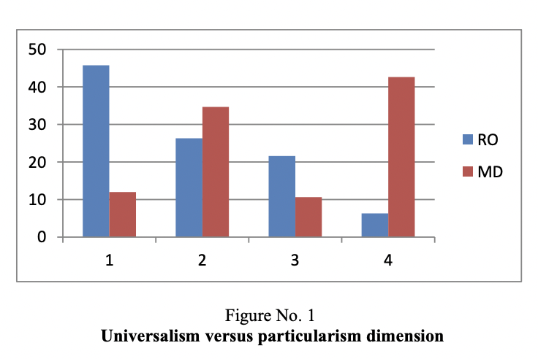

When ASOS is on the dimension of Neutral versus emotional, emotional expressions are more common in China, especially in dealing with interpersonal relationships and social interactions (Allen, Diefendorff, and Ma,2014). Therefore, ASOS needs to understand and respect these emotional needs when entering the Chinese market and try to adapt its products and services to the emotional needs of the Chinese market. Secondly, to better adapt to the Chinese market, ASOS can provide cross-cultural training to its employees to help them better understand Chinese culture and Chinese consumers. This includes training in understanding Chinese emotional culture, language communication skills, and marketing strategies.
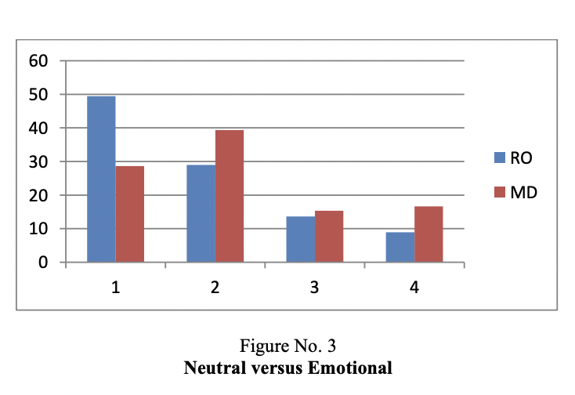

When ASOS is Defuse versus specific cultures, a cultural dimension, diversity, and richness of culture are more prominent in China (Crane,2016). Therefore, ASOS companies need to respect China's cultural diversity, focus on communication and cooperation with specific cultures in each region of China, and promote mutual understanding and integration between different cultures.
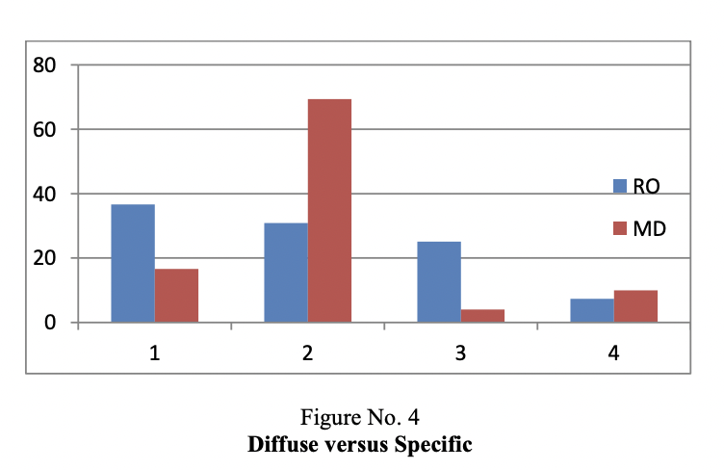

When ASOS is in the dimension of the Human-Time relationship, in China, the concept of time is relatively flexible, and people pay more attention to "time management" and "timesaving" (Castelli, 2015). Therefore, ASOS needs to understand and respect the human-time relationship in China, rationalize production and sales plans, improve operational efficiency, and flexibly respond to time changes and emergencies in the Chinese market.
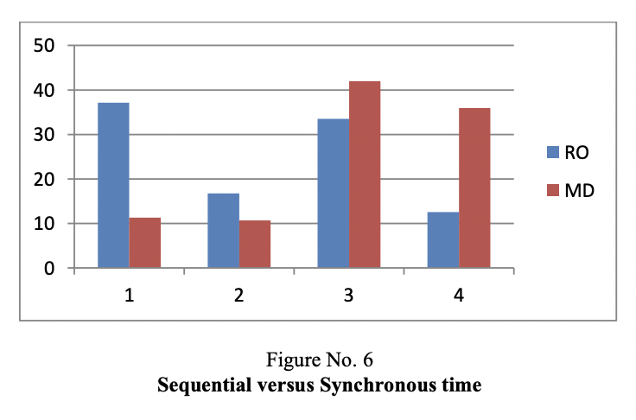

2.6 Importance of Building Relationships
The importance of building relationships between ASOS Clothing and China is mainly reflected in the following aspects:
Firstly, it can gain a deeper understanding of the Chinese market and consumers, through cross-cultural communication, ASOS can better understand the needs, preferences, and cultural background of Chinese consumers, so that it can better position its products and services and adapt to the development of the Chinese market. Secondly, it can promote brand image and brand identity. Through effective cross-cultural communication with Chinese consumers, ASOS can better convey brand image and values, and build brand identity and loyalty.

Secondly, it can optimize product design and R&D. Through cross-cultural exchanges with Chinese designers and R&D teams, ASOS can better understand the aesthetics and needs of Chinese consumers, optimize product design, and improve R&D efficiency.

Finally, China is a leader in new technology and innovation (Huang and Sharif, 2015), through cross-cultural exchanges, ASOS can absorb the innovative elements and cultural wisdom of the Chinese market and enhance the competitiveness and innovation of the company.

2.7 How to Build Trust
ASOS can build trust with China in the following ways:
1. Respecting Chinese culture and customs: ASOS should deeply understand and respect Chinese culture and customs, and fully consider the special needs and characteristics of the Chinese market in product design, marketing strategy, staff management, etc., to avoid misunderstandings and conflicts caused by cultural differences.
2. Establish a good supply chain relationship: ASOS can establish a long-term, stable relationship with high-quality suppliers in China to build a good supply chain system, ensure product quality and delivery time, and improve the transparency and sustainability of the supply chain.

3. Strengthen brand cooperation and public welfare activities: ASOS can enhance its brand awareness and influence in China by cooperating with Chinese fashion brands, celebrities, and opinion leaders, etc., and at the same time, actively participate in public welfare activities and social responsibility practices in China to establish a positive and responsible corporate image.

4. Maintain transparent and honest communication: ASOS should maintain transparent and honest communication with Chinese partners, government departments, etc., respond to and deal with relevant issues promptly, and work together to address market challenges and risks, and establish a long-term and stable cooperative relationship.

2.8 Failed Relationships
The reasons why ASOS may fail to expand its business to China and engage in cross-cultural communication include the following points:
Firstly, there is the language difference. China is a country with rich language and culture, and different regions have different dialects and language habits. ASOS is a British company that mainly uses English as its working language, so there may be a language barrier when communicating with Chinese employees or partners.

Secondly, there are traditional cultural differences. China has a long traditional culture, including traditional festivals such as Chinese New Year and Mid-Autumn Festival, as well as traditional customs such as tea culture and wine culture. Britain also has its own traditional culture, such as Christmas, afternoon tea, and so on. These cultural differences may lead to misunderstandings or conflict in communication between the two sides.

Finally, there are social media differences. There is a big difference between China's social media market and the UK's. Chinese social media users are more inclined to use platforms such as WeChat and Weibo, while the UK is more inclined to use platforms such as Facebook and Twitter. This difference may lead to divergence in marketing and branding between the two parties.

3.0 Conclusion:
The findings of the theories related to cross-cultural communication between ASOS and China are concluded:
ASOS needs to better adapt to the Chinese market, conduct effective cross-cultural communication, and achieve more business success by continuously improving the skills and knowledge required for international business communication.

ASOS has adopted a digital approach to communication, which not only speeds up the decision-making process with China and improves efficiency, but also provides a richer way of presenting information to better analyze and solve problems and achieve better business results.

ASOS has learned that China is a high-context culture, and the UK is a low-context culture by utilizing Halls' theory of high and low context. ASOS needs to pay special attention to the characteristics of high-context cultures when communicating cross-culturally with China so that it can communicate its brand culture and values using non-verbal signifiers and adopt the appropriate strategies and techniques to better adapt to the Chinese market and achieve success.

Effective communication between ASOS and China is critical to the success and growth of the company. Efforts are needed to respect cultural differences and promote cultural exchange, build good interpersonal relationships, use appropriate language and expressions, etc. Effective communication with Chinese consumers can only be achieved through comprehensive strategic adjustments and staff training, leading to sustainable growth.

By applying these dimensions from Trompenaars 7 dimensions to culture to understand and respond to cross-cultural communication issues, ASOS can better adapt to the Chinese market and cultural environment and promote mutual understanding and cooperation.

ASOS needs to fully understand the cultural differences with China and take appropriate measures and approaches to minimize communication barriers and cultural conflicts. At the same time, ASOS needs to respect the characteristics of the Chinese market and seek opportunities for win-win cooperation.

4.0 Recommendations
Recommendations on why ASOS may fail to communicate cross-culturally with China: Firstly, regarding language differences, ASOS could recruit staff or partners with Chinese language skills to assist in communication with China. At the same time, the company can provide language training to help employees and partners better understand Chinese culture and language.

Secondly, about traditional cultural differences, ASOS can learn about traditional Chinese culture and customs and respect Chinese festivals and celebrations. The company can learn about the preferences and habits of Chinese consumers to better meet their needs and adapt to the market.

Lastly, regarding social media differences, ASOS can focus on the development and trends of the Chinese social media market and choose social media platforms for brand promotion and marketing that are suitable for local users. At the same time, the company can recruit local staff or partners with social media marketing experience to help the company better interact and communicate with local users on social media.

Appendices

1. Trompenaars 7 dimensions to Culture
Universalism versus particularism is about the rules versus relationships. This dimension is about the difference between the cultures in which it is considered that the ideas and techniques can be applied in any conditions without modification and those in which it is considered that the circumstances dictate the way in which ideas and techniques must be applied.
The results for each dimension are the following (Figure 1):
1. is a full universalist answer;
2. is a full particularist answer;
3. is a particularist answer doubled by an universal orientation;
4. is a universalist answer but recognizing the importance of particular relationships.
The conclusions that must be derived from these data are that young people from Romania tested proved to be rather universalist but also with particularistic tendencies while Moldovan students have shown more particularism with universalist direction.

Communitarianism versus individualism is the dimension about the group versus the individual relationship. In individualist cultures people consider themselves independent persons, while in the collectivist people are defined as members of a group.
The answers denote the following (Figure 2):
1. is a radical individualist answer,
2. affirms competitive individualism, but reconciles it with communitarian cooperation;
3. asserts the preeminence of the group, but also allows the existence of competing individuals;
4. is a radical communitarian answer.
Specific competitive individualism with collective cooperation is specific in the both societies, as well as the group importance allowing the existence of competitive individuals.
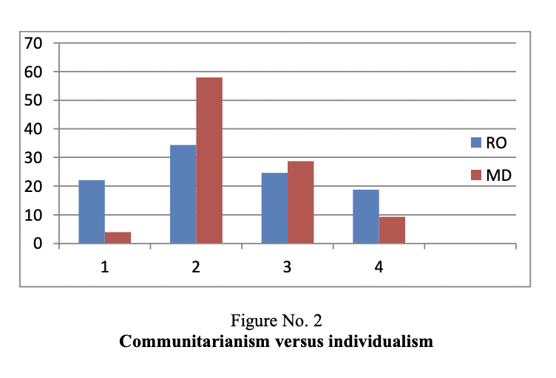

Neutral versus Emotional shows the range of feelings expressed. A neutral culture is the one where people hide their feelings, while an affective culture is characterized by the fact that emotions are natural and open.
The results for each dimension are the following (Figure 3):
1. is a radical option for neutral orientation;
2. starts from the neutral point of view, but acknowledges the importance of emotions for a good future relationship;
3. represents an affective orientation, aimed at bringing under control of future affective interactions;
4. is a radical option for the affective orientation.
The individuals in Moldavian and Romanian societies have a neutral orientation with taking into consideration the personal relations importance for growing.

Diffuse versus Specific indicates
the range of involvement. Specific relationship is seen as one very impersonal based only on contracts and agreements. Diffuse refers to relationships on a human level. The diffuse culture prefers a more human relationship and values this over impersonal, logical relationships often seen in specific cultures.
The answers denote the following (Figure 4):
1. is an option for diffuse orientation;
2. is a compromise between the two, based on a diffuse point of departure;
3. is a compromise between the two, based on a specific point of departure;
4. is an option for specific orientation. Analyzing specific versus diffuse dimension we can see a compromise of both with the diffuse starting point.

Achievement versus Ascription dimension demonstrates how status is attributed. In cultures with the achievement dimension the status is gained, individuals are treated equally, so that they can be evaluated according to their merit. The cultures in which the superior levels have full decision-making authority and establish the social-professional status of individuals according to criteria like age, political affiliation, membership to a clan, etc.
In this dimensions the answers denote the following (Figure 5):
1. is a radical option for ascribed status;
2. represents the belief that socially ascribed status will lead to achievement and success;
3. represents the belief that achieved status will lead to social ascription;
4. is a radical option for achieved status.
In Moldova people are convinced that the ascribed status helps them in their personal and professional life, in Romania the ascribed option is in balance with achieved one.
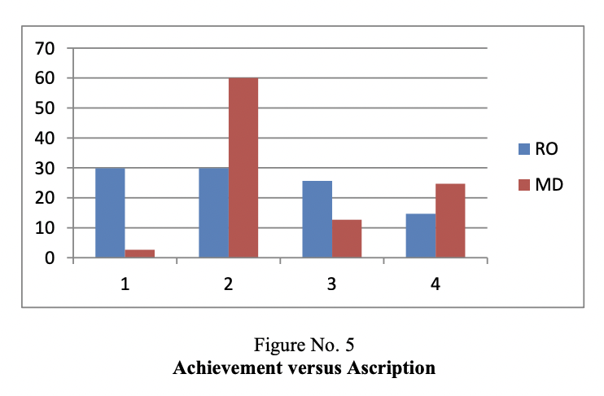

Sequential versus Synchronous time dimension describes how the time is managed. This dimension focuses on time and how a culture relates to it.People in sequential cultures try to do a single task in a given period; they are punctual and strictly follow work plans.In synchronous cultures people tend to do more things in a given period of time, the dates of meetings may be changed at the last minute and plans are generally subordinate to interpersonal relationship.
In this dimensions the answers denote the following (Figure 6):
1. is a radical option for sequential orientation;
2. represents an option for sequential orientation, but connects it to synchronic managed processes;
3. represents an option for synchronous orientation, but connects it to high-speed sequential managed processes;
﻿﻿﻿4. is a mdical option for synchronous orientation.
Republic of Moldova is a synchronous-time country. People can have several activities in the same time while in Romania the society is more sequential, they are more are punctual and try to do a single task in a given period.

Inner direction versus Outer direction shows how people relate to nature). In external-oriented cultures individuals consider that they control the environment,while internal-oriented cultures individuals believe the environment is the dominant factor.
In this dimensions the answers denote the following (Figure 7):
1. is a radical option for an outer-directed Strategy/orientation;
2. represents an option for outer-directed orientation, but connects it to inner-directed strategy
3. is a radical option for an internal-directed strategy/orientation;
4. represents an option for internal-directed orientation, but connects it to an outer-directed strategy.
More internal direction than that external represent the situation for the individuals in Moldova, external direction with elements of internal is more representative for the students from Romania.
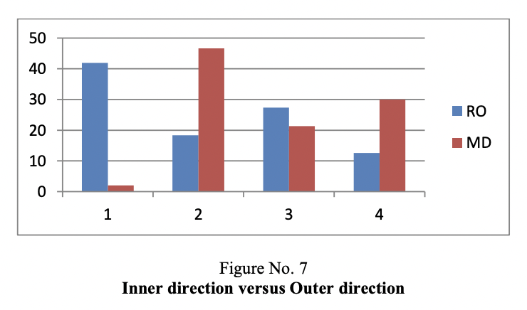

Reference
ASOS. (2023).The ASOS Brands.ASOS Online,[online].Available at:https://www.asos.com/about/asos-brands/?ctaref=aboutus|asosbrands [Accessed 15 November 2023].

Abugre, J. B. (2018). Cross-cultural communication imperatives: Critical lessons for Western expatriates in multinational companies (MNCs) in sub-Saharan Africa. Critical Perspectives on International Business, 14(2/3), pp.170-187.

Aladwani, A. M. (2013). A cross-cultural comparison of Kuwaiti and British citizens' views of e-government interface quality. Government Information Quarterly, 30(1), p.76.

Allen, J. A., Diefendorff, J. M., and Ma, Y. (2014). Differences in emotional labor across cultures: A comparison of Chinese and US service workers. Journal of Business and Psychology, 29, pp.21-35.

Bartlett, C. A., and Ghoshal, S. (2017). Managing across borders: new strategic requirements. In International Business.Routledge.pp.295-305.

Barron, L. (2021). The creative influence of history in fashion practice: The legacy of the silk road and Chinese-inspired culture-led design. Fashion Practice, 13(2), pp.275-295.

Broeder, P. (2021). Informed communication in high context and low context cultures. Journal of Education, Innovation, and Communication, 3(1), p.15.
2.4 Effective Communication

Covas, L., & Pirlog, A. (2019). The importance of national culture dimensions on intercultural competence development of future managers. Cross-cultural Management Journal, 21(2), pp.111-119.

Crane, D. (2016). Culture and globalization: Theoretical models and emerging trends. Global culture, pp.1-25.

Castelli, A. (2015). On Western and Chinese conception of time: A comparative study. Philosophical Papers and Review, 6(4), pp.23-30.

Corbett, J. (2022). An intercultural approach to English language teaching (Vol. 36). Multilingual matters.pp.5-20.

Gerbasi, A., and Latusek, D. (2015). Trust-building in international business ventures. Baltic Journal of Management, 10(1), pp.30-51.

Huang, C., and Sharif, N. (2015). Global technology leadership: The case of China. Science and Public Policy, 43(1), pp.62-73.

Javidan, M., Dorfman, P. W., De Luque, M. S., and House, R. J. (2016). In the eye of the beholder: Cross-cultural lessons in leadership from Project GLOBE. Readings and cases in international human resource management. Routledge, pp.119-154.

Lee, H. Y. (2020). Linguistic politeness in the chinese language and culture. Theory and Practice in Language Studies, 10(1), pp.1-9.

Malyuga, E. N., and Orlova, S. N. (2017). Linguistic pragmatics of intercultural professional and business communication. Springer.pp.1-26.

Myers, K. K., Gailliard, B. M., and Putnam, L. L. (2013). Reconsidering the concept of workplace flexibility: Is adaptability a better solution?. Annals of the International Communication Association, 36(1), pp.195-230.

Nevalainen, M., Sisko Maarit Lipiäinen, H., and Ensio Karjaluoto, H. (2014). Digital channels in the internal communication of a multinational corporation. Corporate Communications: An International Journal, 19(3), pp.275-286.

Patapan, H. (2015). Towards a cosmopolitan constitutionalism: on universalism and particularism in Chinese constitutionalism. The Chinese Journal of Comparative Law, 3(1), pp.78-96.

Stahl, G. K., and Tung, R. L. (2015). Towards a more balanced treatment of culture in international business studies: The need for positive cross-cultural scholarship. Journal of International Business Studies, 46, pp. 391-414.

Sun, T., Horn, M., and Merritt, D. (2004). Values and lifestyles of individualists and collectivists: a study on Chinese, Japanese, British and US consumers. Journal of consumer marketing, 21(5), pp.318-331.

Tung, R. L., & Stahl, G. K. (2018). The tortuous evolution of the role of culture in IB research: What we know, what we don’t know, and where we are headed. Journal of International Business Studies, 49, pp.1167-1189.

Verluyten, S. Paul. (2020). Cultural biases in intercultural business communication courses and how to avoid them. Exploring the Rhetoric of International Professional Communication. Routledge.pp.191-209.

Zhang, S., Van Doorn, J., & Leeflang, P. S. (2012). Changing consumer markets and marketing in China. International Journal of Business and Emerging Markets, 4(4), pp.328-351.

Zheng, X. (2018). The Influence of the Difference between Chinese and Western Culture on Advertising Translation and Strategy. Theory and Practice in Language Studies, 8(3), pp.331-339.

