University of Wales Trinity Saint David
Institute of Science and Art



Risk Assessment Technical Report
Workshop and Practice (ACHA4011)

Stephen White
2003889
March 2021
Contents
1 Introduction 2
2 Research 3
3 Initial FEMA 5
3.1 Pre-mitigation FMEA 5
3.2 Incorrect Brake Calliper Bolts Torque 5
3.3 Incorrect Brake Disk Size 6
3.4 Incorrect Brake Pad Orientation 7
3.5 Brake Line Fitting Not Fully Tightened 8
4 Post Mitigation FEMA 9
4.1 New FMEA Rankings 9
4.2 Incorrect Brake Calliper Bolts Torque 9
4.3 Incorrect Brake Disk Size 10
4.4 Incorrect Brake Pad Orientation 10
4.5 Brake Line Fitting Not Fully Tightened 10
5 Conclusion 11
6 References 12

Introduction
Risk is an inherent part of any action we take, no matter how big or small. For engineers, it is important to understand the risks involved and recognise the consequences they incur. It is crucial that engineers realise that these implications can extend much further than the end of the assembly line and can affect customers too. To assess and reduce these risks, Failure Mode and Effect Analysis (FMEA) tests are carried out, identifying how likely, severe and detectable each risk is. These are used to calculate the Risk Priority Number (RPN).
This report aims to identify all potential failure modes of the brake component installation process, rank them appropriately and introduce mitigation methods to reduce the RPNs.

Research
FEMA is an engineering technique designed to reduce and eliminate modes of failure in both product and process design (Semp, Pathan and Dessert, 2006) and is used throughout multiple engineering disciplines, with mechanical and automotive being two prominent examples. First used in the late 1940s (Kiran, 2017), FEMA allows for failure modes of individual processes to be recognised, thus reducing their risk and potentially eliminating it (Semp, Pathan and Dessert, 2006).
However, FEMA is not a perfect method of failure mode analysation. One of its drawbacks is there is no set methodology for analysing the risks (Semp, Pathan and Dessert, 2006), leaving it very much up to the interpretation of the person carrying out the FEMA assessment. This is an issue as different people will have different views on what is a major or minor risk.
It is important to realise that errors made in the manufacturing and assembly process can have repercussions outside of the factory floor, affecting customers themselves. For example, a problem within the braking system that went unnoticed during design and testing could become apparent during real world usage, causing the system to fail. It is clear that the life and safety of customers are in the hands of engineers, therefore they need to recognise this and take it into account during every stage of the design process.
Mistakes made in the assembly plant can have a massive impact on perception of the vehicle make and/or model, as a vehicle with no problems from the factory will be received better than one that has issues. Additionally, if the issue affects a large number of vehicles, recalls will have to be given, potentially costing millions and harming the brands reputation. For example, in 2013, airbags manufactured by Takata were fitted with faulty inflators, causing them to expand with too much force and explode (NHTSA, 2021), costing the company roughly $24 billion. This shows just how important an effective FMEA of every product and process is.

Risk Priority Number (RPN) is a metric used to rank multiple processes by risk. The higher the RPN number, the higher risk it represents and more immediate attention it requires (Kiran, 2017). RPN is determined using the factors listed below:
- How likely is the risk to occur?
- How severe is the risk?
- How likely is the risk to be detected?
The above bullet points are then each given a ranking between 1-10, with 1 being the least severe and 10 being the most severe. These numbers are then multiplied together to give the RPN (Kiran, 2017).
It is imperative that engineers act with thorough competence and care throughout all work-related activities (IMechE, 2018), as carelessness or complacency about procedure could lead to a fatal accident.

Initial FEMA

Pre-mitigation FMEA
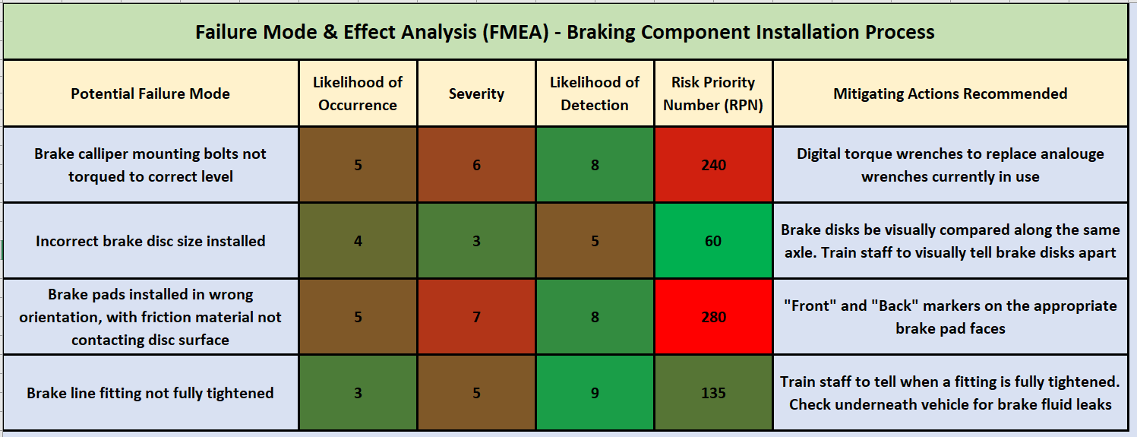
Table 3.1.1: FMEA of braking component installation process.
The above table shows an FMEA analysis for the installation of braking components. 4 potential modes of failure were detected and given suitable rankings. They are listed below in order of highest RPN:
- Brake pads installed in the wrong orientation.
- Brake calliper mounting bolts torqued incorrectly.
- Brake line fitting not fully tightened.
- Incorrect brake disk size installed.

Incorrect Brake Calliper Bolts Torque
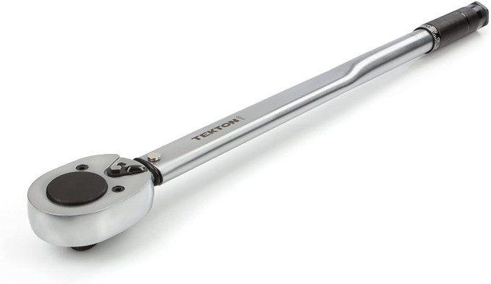
This was given the likelihood of occurrence of 5, as it is possible that the torque wrench is not calibrated correctly or that the wrench itself is set to the wrong torque. Analogue torque wrenches need to be calibrated after a certain period, potentially resulting in the torque wrench being set correctly but torquing incorrectly. Alongside this, new and inexperienced members of staff may not know how to properly use a torque wrench, causing them to set it at the wrong torque or be unable to tell when the specified torque is reached.
Figure 3.2.1: Analogue “click” type torque wrench.
Severity has been given a 6 because it is possible that the callipers can have more free movement on the wrong torque, therefore not gripping the brake disk as effectively, hampering braking performance. Additionally, if the torque is too low, then the bolts could come loose and cause the calliper to come away from its position, again affecting braking performance.
The likelihood of detection is 8, as once the bolts have been tightened initially, it is highly unlikely that they will be checked again because as the vehicle continues along the assembly line, more parts will be added that will be in the way of the calliper bolts, such as wheels and tyres. Additionally, it might take a while for the bolts to loosen to the point where they hamper braking performance, due to factors such as vibration from the road surface.
This gives an RPN of 210, the second highest of all FMEA. This means that it should be tackled immediately after the first most severe RPN (Semp, Pathan and Dessert, 2016).
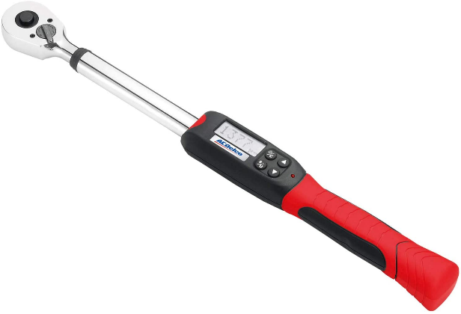
To mitigate this issue, it is recommended that the torque wrenches used for this process are changed from analogue to digital. Digital torque wrenches use strain gauges to measure how much torque a bolt has, whereas analogue wrenches use spring loaded levers that make a ‘click’ sound when the set torque is reached, which may not be heard on the assembly line due to other noise. Additionally, analogue torque wrenches need to be calibrated after a certain time or amount of uses, whereas digital torque wrenches do not need to be calibrated due to the inherent accuracy of their strain gauges (Floorjacked, 2017). Staff will also need to be trained in how to use the new equipment efficiently and effectively, otherwise new failure modes may arise from improper usage.
Figure 3.2.2: Digital torque wrench, the digital display is clearly visible.

Incorrect Brake Disk Size
The likelihood of occurrence for incorrect brake disc size installed is 4, as after installing the same disks all day, a technician is likely to recognise a discrepancy in brake disk size. If the disk is too big for the calliper, it is likely not to fit in such a way that the calliper no longer fits into its mounting bolts.
Severity has been given a 3. Whilst the braking performance will be affected, it will not cause total brake failure.
Likelihood of detection has been rated 5 because, depending on the size difference between the correct and incorrect brake disk, it would be obvious to see the difference in size when comparing them along the same axle. A comparison between the front and rear brakes would not be possible as on the majority of road vehicles, the front and rear brakes are of different sizes and potentially a different type altogether.
This gives an RPN number of 60. This is the lowest out of the 4 FMEA conducted for the installation of braking components. Therefore, this is the one that should be delt with last as it poses the least risk.
To mitigate this issue, it is recommended that staff be better trained to be able to tell brake disks apart from each other. Once the disks are fitted, a comparison between both sides should be made visually along the same axle, for the aforementioned reason.

Incorrect Brake Pad Orientation
Likelihood of occurrence is 5, as it is unlikely that an experienced technician will install a brake pad the wrong way. However, mistakes through human error are still possible and new staff will likely not have seen a brake pad before.
The severity has been given a 7, as a brake pad the wrong way round will not provide sufficient friction, drastically hampering braking performance.
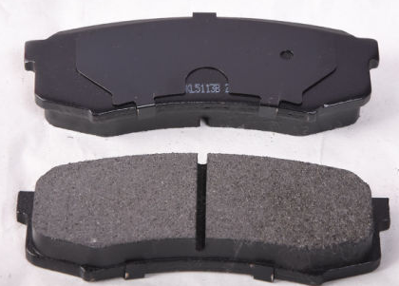
Likelihood of detection has been given an 8. This is because it is practically impossible to tell if the brake pads are orientated correctly due to multiple other parts obstructing them, rendering visual checks ineffective. However, it would be noted that something is wrong with the brakes as they will not operate in the correct manner, but this could be too late, endangering the end user. It would also be noted that a metal-on-metal grinding sound can be heard when applying the brakes.
Figure 3.4.1: Example of brake pads, with back (top) and front friction surface (bottom).
These number give an RPN of 280, the highest out of the 4 potential failure modes. As it is the highest, it presents the most risk and therefore should be delt with first (Semp, Pathan and Dessert, 2016). Whilst it has a relatively low likelihood of occurrence, the severity and likelihood of detection are high.
To mitigate this failure mode, “front” and “back” markers should be placed on the appropriate sides of the pads themselves, as this will make it more obvious which side is which, reducing confusing and errors made during installation. Alongside this, all staff involved in the installation process should be retrained in brake pad installation.

Brake Line Fitting Not Fully Tightened
Brake line fittings are used as unions between two brake pipes. They allow for the shortening of brake pipes, replacing one long pipe with multiple shorter sections, which also makes manufacturing and replacement costs considerably cheaper.
Likelihood of occurrence has been rated as a 3. Brake line fittings are straightforward to install correctly, however inexperienced/new staff could have difficulty knowing when one is correctly tightened.
Severity has been given a 5, as a brake line fitting that is incorrectly tightened will not be sufficient to hold the increase in pressure when under braking. The harder the brake pedal is pushed, the more pressure there is in the brake lines, meaning that a fitting might be tightened enough for regular braking use, however, may fail once above average pressure is applied, i.e. emergency braking.
Likelihood of detection has been rated as a 9, the highest of all failure modes. This is because brake lines are hidden throughout the car even more so than brake calliper bolts and because they are more numerous.
To mitigate this, staff should be better trained to know when a brake line fitting is fully tightened. In order to tackle the high likelihood of detection, visual checks to fittings that can be easily seen and a look underneath the vehicle to check for any leaked brake fluid should be undertaken to check that they are not leaking.

Post Mitigation FEMA

New FMEA Rankings
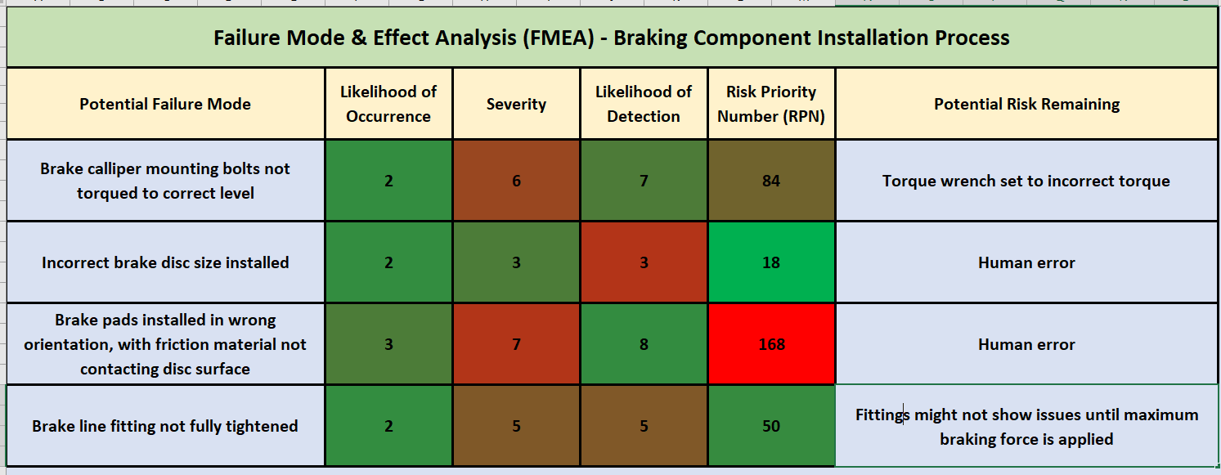
Figure 4.1.1: Post-mitigation FMEA
It is interesting to note that despite mitigating actions being implemented, the order of the RPNs remains unchanged, which is listed below:
- Brake pads installed in the wrong orientation.
- Brake calliper mounting bolts torqued incorrectly.
- Brake line fitting not fully tightened.
- Incorrect brake disk size installed.

Incorrect Brake Calliper Bolts Torque
The implementation of digital torque wrenches has had a drastic impact on likelihood of occurrence, due to the increase in accuracy and no need for recalibration. It has had the largest impact on the RPN, a reduction of 156.
The torque wrench could still be set incorrectly, resulting in the bolts being torqued incorrectly. The likelihood of this happening has been reduced because digital torque wrenches are easier to set up than analogue ones, however the risk is not eliminated completely.
Severity and likelihood of detection remained unchanged as there is no reasonable way to reduce either. Rechecking the torque of the bolts will require removal of the wheels, slowing down the production line drastically. The RPN is simply not high enough to warrant this.

Incorrect Brake Disk Size
Training staff better and introducing a visual check of the disks after installation has affected both likelihood of detection and likelihood of occurrence.
Human error is a remaining risk, as the difference in disk sizes could be hard to tell apart once on the vehicle. Another method of increasing detection is measuring the diameter of the disks once assembled, however this would not have much of an impact as the RPN is already very low.

Incorrect Brake Pad Orientation
The introduction of “front” and “back” markers on the brake pads has helped reduce likelihood of occurrence from 5 to 3, bringing the RPN down from 280 to 168, the second highest reduction.
Despite the large reduction, human error is still a possibility, and given that it still has the highest RPN, more mitigating actions are needed.
Reducing likelihood of detection would be difficult due to reasons mentioned in section 3.4; there is no feasible way of checking pad orientation without the removal of multiple parts, slowing down the production line in a similar fashion mentioned in section 4.2.

Brake Line Fitting Not Fully Tightened
Additional staff training has had a notable impact on likelihood of occurrence, as they now have a better understanding of when a fitting is fully tightened.
The visual checks introduced have had a positive impact, bringing likelihood of detection down from a 9 to a 5. This is a massive increase in detection, going from near impossible to check to being fairly easy.
The RPN has been reduced from 135 to 50, a considerable reduction, mainly due to the increase in detection.
A potential remaining risk is that fittings might not show signs of being loose until maximum braking force is applied, resulting in it being undetected.

Conclusion
The mitigating actions put in place have had a drastic impact on likelihood of occurrence and detection, having a knock-on effect on RPN.
Likelihood of occurrence was reduced for all 4 failure modes, which will ultimately result in less chance of them happening and therefore will affect less end users. Likelihood of detection has followed a similar trend, however, has only been increased for 3 failure modes. Severity has not changed post-mitigation as no measures were made to reduce it. Despite this, RPN has been noticeably reduced for all failure modes.
In the future, mitigation measures targeted specifically at reducing severity should be implemented because likelihood of detection and occurrence are already very low. Methods to reduce occurrence and increase detection should not be ignored if they will have a big impact however.
The effectiveness of the FMEA process is clear, as it has had a drastic impact on all recognised failure modes, making them safer for both staff and the end users.

References
Semp, B, Pathan, A and Dessert, P (2006). The Role of Automated FMEA in Automotive Reliability Improvement. SAE International, Michigan. (Accessed 13 February 2021).
NHTSA (2021). Takata Recall Spotlight. Available at: https://www.nhtsa.gov/equipment/takata-recall-spotlight (Accessed 17 February 2021).
Kiran, D (2017). Total Quality Management. Accessible at: https://www.sciencedirect.com/topics/engineering/risk-priority-number (Accessed 17 February 2021).
IMechE (2018). Code of Conduct Regulations. Available at: https://www.imeche.org/docs/default-source/governance-documents/code-of-conduct-regulations-(5-12-18).pdf?sfvrsn=2 (Accessed 26 February 2021).
Floorjacked (2017). Click Type Versus Digital Torque Wrenches: Advantages and Disadvantages. Available at: https://floorjacked.com/click-type-versus-digital-torque-wrenches-advantages-and-disadvantages/ (Accessed 5 March 2021).

