Name: Gheorghe Alui-Gheorghe
Student number: 2018577
Module code and title: Developing Innovation and Creativity for Business Advantage
Lecture’s name: Piyumika K. Gamage
Assignment title: Development of innovative product OR unique service proposition

Executive Summary
EcoWear is a new online business that will change the ecologically conscious clothing industry by selling eco-friendly clothes to people who care about the earth. EcoWear wants to set itself apart from rivals like Patagonia and Everlane by offering a wider range of goods made from new, eco-friendly materials. At first, the company focuses on the United Kingdom and Canada, but it plans to grow internationally. Using the Shopify platform as the foundation for its internet shopping site, EcoWear will ensure customers have a smooth and safe shopping experience by offering several convenient payment methods. The company's marketing plan is based on digital channels, focusing on focused advertising, social media interactions, and working with influencers to raise brand knowledge and encourage community. EcoWear is dedicated to being open and teaching, so they will also emphasise material that shows how important it is for fashion to be sustainable. EcoWear will protect customers' privacy and security by following GDPR and additional data protection rules. This is important for building long-term relationships with customers.

Table of Contents
Executive Summary 2
1.0 Introduction 4
2.0 Business Proposition of EcoWear 5
2.1 Target Market 5
2.2 Product Offering 5
2.3 Competitive Landscape 6
2.4 E-commerce Strategy 6
3.0 E-Commerce Considerations 8
3.1 Content Creation and Engagement 8
3.2 Multiple methods of payment 8
3.3 Prioritising Security in Transactions 9
4.0 Digital Marketing 10
4.1 Comprehensive Digital Marketing Strategy 10
4.2 Building Customer Persona 11
4.3 Leveraging a Pre-Launch Email Marketing Campaign 11
5.0 Privacy and Data Protection Policy 13
5.1 Commitment to Data Protection Compliance 13
5.2 Ensuring Customer Rights and Security 13
6.0 Conclusion 15
References 16
Appendix 18

1.0 Introduction
As people learn more about the environment and push for sustainability, fashion is at a crossroads. They need to discover a way to simultaneously be stylish and good for the world. In order to fill this gap, EcoWear is a new type of web-based store that sells a wide range of durable, eco-friendly clothes (Daniel, Wilson and Myers, 2002). EcoWear is beyond being a name as it grows. It is a trend that encourages using eco-friendly products and methods in fashion.
At its foundation, EcoWear is designed to cater to an expanding population of users who care about the environment and want to find alternatives to fast fashion’s waste culture. This group, mostly millennials and Gen Z, seeks style and quality. They additionally desire their apparel to show that they care about making clothes in a way that is good for people and the earth (Daniel, Wilson and Myers, 2002). EcoWear uses natural fibres such as bamboo, cotton, and fabrics that have already been used to make apparel that is additionally stylish and beneficial for the environment.
Beyond the goods they use, EcoWear cares about the earth. People can learn from the site how essential it is for clothing manufacturers to use eco-friendly methods such as reducing their carbon footprint and water use. Customers can make smart decisions because each piece of clothing will be able to demonstrate how it impacts the environment, for example, by showing how much freshwater it saves and carbon dioxide it gives off (Fichter, 2002).
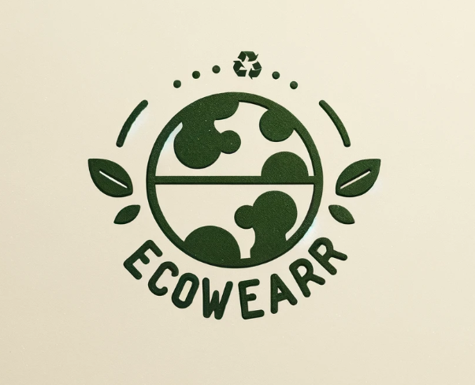
Fig 01: Logo of EcoWear

2.0 Business Proposition of EcoWear

2.1 Target Market
Millennials and Gen Z, who care about the environment, are growing quickly, and EcoWear is in a great position to meet their needs. This group of people cares about the environment, using fair work, and the impact of the products they buy on the world. They are really into social media because they grow up immersed in it. They buy things that are in style but are picky because they require companies to appear real and serve a purpose (Hur and Faragher- Siddall, 2022). These ideas match what EcoWear sells, which is not only clothes but also a way of existence that aligns with its eco-friendly values. This group is important to EcoWear because it is big, cares greatly about the environment, and can spend money on things that show they care.

2.2 Product Offering
EcoWear is unique in the marketplace for eco-friendly clothes because it has many styles. This company will make many kinds of clothes and accessories, ranging from everyday casual clothing to eco-friendly sportswear and a lot more. Bamboo is soft and lasts a long time; organic cotton, which does not need as much water and does not have any harmful chemicals; and recycled materials, which reduce the amount of trash that ends up in dumps, will be used to make each item (Hur and Faragher- Siddall, 2022). EcoWear can meet various needs of an ecological way of life thanks to this all-around method. This makes it a great place for individuals who want to buy green clothes.
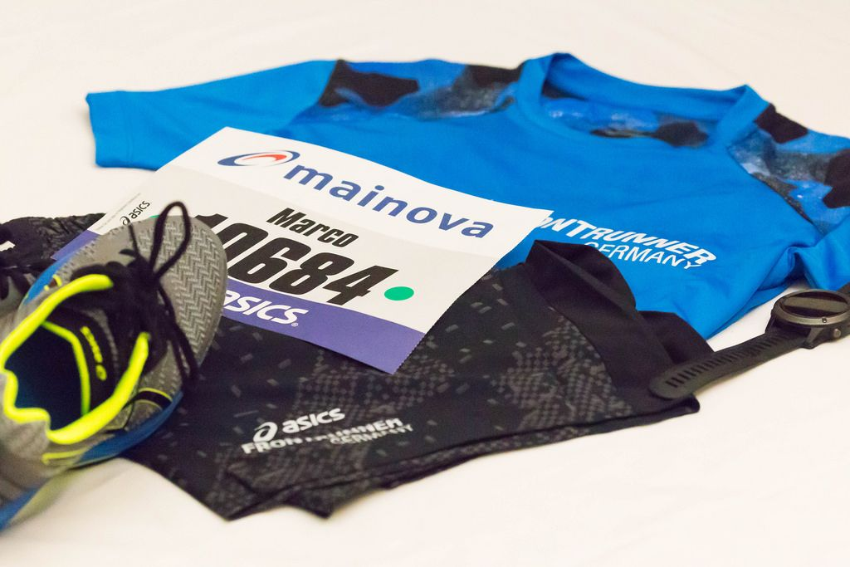
Fig 02: Eco-friendly Sportswear and Casual Apparel (Source: Google Image)

2.3 Competitive Landscape
EcoWear has to contend with strong rivalry from well-known brands, including Patagonia, Ever Lane, and Tentree. The field of environmentally friendly clothing is growing quickly. These competitors have set ambitious goals and built strong customer bases through their websites regarding being environmentally friendly (Oláh et al., 2023). EcoWear, on the contrary, is poised to carve out its own space by offering a bigger range of products while focusing on new styles and materials. However, EcoWear will do beyond simply selling clothes. A place where individuals may discover and take part in eco-friendly dress will also be created. Being truthful and forthright about the supply chain and how every item impacts the environment is part of this (Oláh et al., 2023). This will change how people in the business are responsible and learn about their purchases.

2.4 E-commerce Strategy
The online store, which Shopify runs brings in most of the money for the business. The people who buy this brand are tech-savvy, eco-friendly, and like how easy it is to shop online, so this choice makes much sense (López and Alejandra, 2023). Shopify is great for EcoWear since it is very flexible, can grow alongside the company, and works with many payment and marketing tools. This tool will help EcoWear make shopping easy and safe as individuals look around and check out (López and Alejandra, 2023). This way, it will be simple for customers to find garments that benefit the environment. Shopify's strong tracking features will assist EcoWear in learning more about how customers act, what they like, and what is popular. This will help them decide how to grow their business best.

3.0 E-Commerce Considerations

3.1 Content Creation and Engagement
Nowadays, content is very significant. This idea lies at the core of how EcoWear does business online. It talks about the importance of making interesting, high-quality material that does more than show off products; it tells a narrative. This is not solely concerning the clothing; it is also about the journey of making them, from using eco-friendly materials to ensuring that workers are treated fairly. EcoWear employs professional pictures and videos to get people's attention and show off its good and eco-friendly products (Puspita and Chae, 2021).
EcoWear aims to provide people with more than just pictures about the significance it is for clothes to be eco-friendly. The brand will use eco-friendly posts and reports to talk about how the system works, how ethical behaviors affect the world, and how people can live in an improved eco-friendly way (Puspita and Chae, 2021). This method also helps EcoWear get to know its customers better and renders the company a leader in eco-friendly fashion. A smart way to build a group of individuals concerned about the brand's goals and ideas is to get them interested in what the brand stands for.

3.2 Multiple methods of payment
Because EcoWear knows that the people it wants to sell to have a lot of different tastes, it plans to give them a lot of different ways to pay. The usual options will be there, like credit and debit cards, and PayPal. Cryptocurrencies might be added (Puspita and Chae, 2021). As digital payments change and more people want alternate currencies, this way is ahead of its time, and that is taken into account. This is especially true for EcoWear's younger, technologically savvy target group.

Fig 03: Cryptocurrency as a method of payment procedure (Source: Google Image)
It is nice to give different pay methods, but it is also smart to eliminate any problems that might stop people from buying by rendering the checkout process as simple as possible. This makes EcoWear more appealing to a restricted number of people searching for ways to use their digital currencies (Puspita and Chae, 2021). It also helps the brand build an image of being innovative and receptive to new ideas. With so many ways to pay, the brand should appeal to a wider range of people, which might result in more sales.

3.3 Prioritising Security in Transactions
Security is essential in eCommerce companies when people are worried about hacks and scams that happen online. Clients can trust EcoWear with their private financial information because they know how important it is to them. The brand says it will do this by adding SSL keys to each website. This will safeguard all the information that is sent. This makes people feel better and safer while they shop at EcoWear.
It is also important for EcoWear to follow the Payment Card Industry Data Security Standard (PCI-DSS). Following these rules ensures that EcoWear meets international safety standards for card payments and lowers the chance of data breaches, which is good for the brand's reputation (Rao et al., 2021). These safety steps are important to EcoWear because they want their customers to feel safe and secure when they shop online. This will help customers believe and feel safe, which is important for any online store that wants to stay in business (Soliman and Youssef, 2003).

4.0 Digital Marketing

4.1 Comprehensive Digital Marketing Strategy
EcoWear wants to reach its target audience in several different ways through its digital marketing plan. These include social media, built-in relationships with celebrities, web optimisation (SEO), and targeted ads. The EcoWear group can grow on social media, which is an excellent method (Wang and Ahmed, 2009). Around 72% of millennials and Gen Z work for firms that share their values. Collaborations with important people will be carefully picked, focusing on those with values that align with the brand. This will include the 60% of consumers who rely on those they follow on the internet to tell them about products. SEO will also be essential for getting more people to see EcoWear in their country. The goal is to be among the first ten search results for "eco-friendly clothing" because 75% of people skip past the first few results.
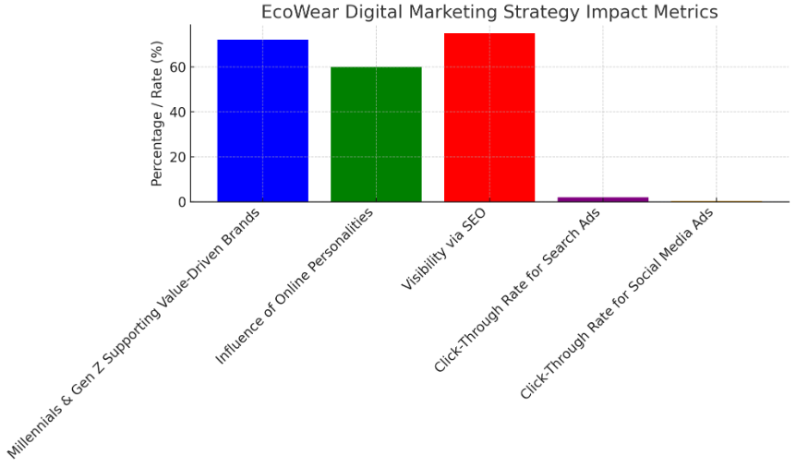
Fig 04: EcoWear's Digital Marketing Strategy Impacts
Paid web and social media ads will reach people passionate about fashion and the environment. There is a 1.9% click-through rate for search ads and a 0.35% click-through rate for social media ads in the fashion business (Wang and Ahmed, 2009). The company, EcoWear, wants to get the most out of its advertising budget so that people will visit its online store.

4.2 Building Customer Persona
In order to sell its products, EcoWear likes to get to know its buyers. A lot of market research and data analysis will be used to make thorough customer models to show the target market's different desires, requirements, and tendencies (Lewis and Cockrill, 2002). There will be information about the individual's chronological group (primarily 18–34 years old), their enthusiasm for spending money in a way that is good for the environment and people, and their electronic habits (85% of individuals in this age bracket find new products on social media).
These people's qualities will help EcoWear ensure that all of its ads and campaigns are beneficial and intriguing to all of its intended demographic groups. For example, people who like exercise might talk about how EcoWear's line is good for fitness and the environment. The goal is to get 30% of those listening to buy again in the first year after the line comes out (Lewis and Cockrill, 2002).

4.3 Leveraging a Pre-Launch Email Marketing Campaign
A campaign of advertising emails will be sent out in the weeks leading up to EcoWear's launch. The objective is to get people excited and interested. The effort will focus on getting people to sign up early. Those who do will get special deals before the products even come out before anyone else does, and they will also learn about the company's goal (Kazan et al., 2018). Email marketing makes an average of £42 for every pound spent, so this method ought to not solely get people excited but also get a lot of them to buy for the first time.
At least 5,000 people should get texts before the start date, and 10% of these individuals should buy something in the initial month. EcoWear wants to build a loyal customer base and brand advocates who will tell those closest to them how passionate they are about eco-friendly fashion by taking charge of these early contacts (Kazan et al., 2018).
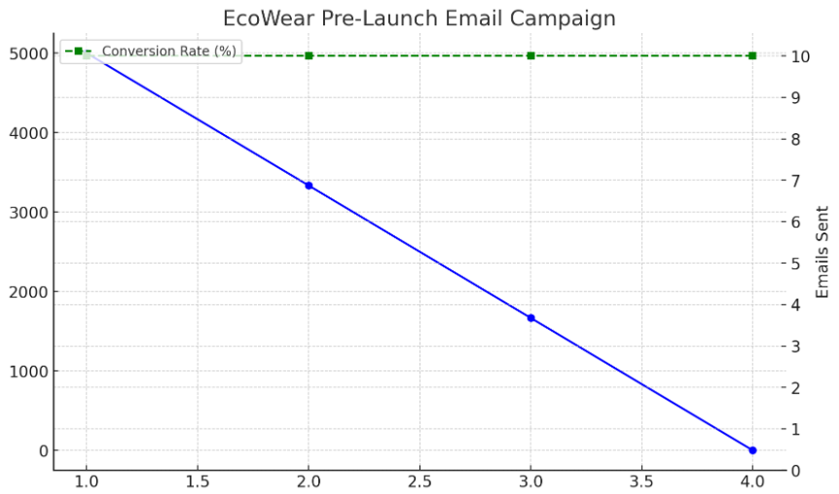
Fig 06: EcoWear Pre-Launch Email Marketing Campaign

5.0 Privacy and Data Protection Policy

5.1 Commitment to Data Protection Compliance
Regarding its customers' info, EcoWear cares a lot about their privacy and safety. The company has always said it would follow all the General Data Protection Regulation (GDPR) rules, the Data Protection Act 2018, and the Privacy and Electronic Communication Regulations (PECR) (Keserwani and Rastogi, 2021). Since this promise was made, strict rules on data security will be implemented to keep personal data safe from those who should not view it, use it, or even share it. Trust and honesty are important to EcoWear because they recognise how important it is to protect customer data—88% of consumers say that the safety of their personal information is crucial to their brand trust.
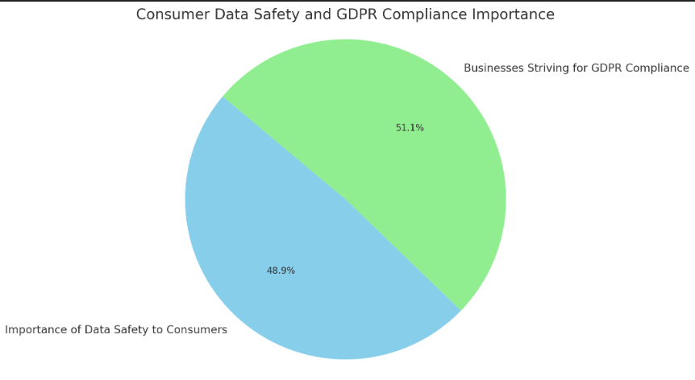
Fig 07: Consumer Data Safety and GDPR Compliance Importance
EcoWear's approach will depend on straightforward authorisation methods to ensure customers know what is occurring and have accepted that their data can be collected and used (Keserwani and Rastogi, 2021). This means giving customers clear, detailed privacy notices before they give their data and attempting to make it easy for them to change their minds about giving consent. According to GDPR, these are the rules that 92% of businesses are trying to follow.

5.2 Ensuring Customer Rights and Security
EcoWear's plan for keeping data safe goes beyond just following the rules. People have the right to privacy and control over their private data, so the business makes it simple to stop getting marketing texts (Daniel, Wilson and Myers, 2002). With just one click, one should be able to remove 74% of people who do not want to receive marketing emails. This will help to keep their confidence and happiness.
EcoWear often looks at and changes its information security policies and processes to ensure it still follows new laws and rules. Not only does this method try to stop database hacks, which happen to 30% of companies worldwide, but it also wants to ensure customers that their information is always safe (Daniel, Wilson and Myers, 2002). This will help EcoWear's reputation as a trustworthy brand in ecologically friendly clothing.

6.0 Conclusion
As EcoWear gets primed to enter the tough market for sustainable clothing, it stands out with its distinctive combination of new ideas, care for the environment, and education. People concerned about the earth can get a lot of clothes from EcoWear that are made from materials that can be used repeatedly (Kazan et al., 2018). EcoWear also seeks to educate people about the significance of staying healthy in fashion. Because the brand wants to use new products and make its vendor network more open, it is a strong force in its field. EcoWear also has an established clientele because it uses creative digital advertising methods and cares a lot about customer privacy and data security (Keserwani and Rastogi, 2021). Anyone can buy clothes at EcoWear, but the company also encourages people to live more sustainably and wants people to join an association that cares about fashion and the earth.

References
Daniel, E., Wilson, H. and Myers, A. (2002) "Adoption of E-commerce by SMEs in the UK: Towards a stage model," International small business journal, 20(3), pp. 253–270. doi: 10.1177/0266242602203002.
Fichter, K. (2002) "E‐commerce: Sorting out the environmental consequences," Journal of industrial ecology, 6(2), pp. 25–41. doi: 10.1162/108819802763471762.
Hur, E. and Faragher- Siddall, E. (2022) "Young consumer perspectives on government policy interventions for sustainable fashion consumption in the UK," Fashion practice, 14(3), pp. 405–427. doi: 10.1080/17569370.2022.2125149.
Kazan, E. et al. (2018) "Disentangling digital platform competition: The case of UK mobile payment platforms," Journal of management information systems : JMIS, 35(1), pp. 180–219. doi: 10.1080/07421222.2018.1440772.
Keserwani, D. R. H. and Rastogi, D. R. H. (2021) "Green E-commerce: An assessment of market readiness & movement to a new competitive landscape," Journal of contemporary issues in business and government, 27(3), pp. 1437–1441. Available at: https://cibgp.com/au/index.php/1323-6903/article/view/1753 (Accessed: March 30, 2024).
Lewis, R. and Cockrill, A. (2002) "Going global—remaining local: the impact of e-commerce on small retail firms in Wales," International journal of information management, 22(3), pp. 195–209. doi: 10.1016/s0268-4012(02)00005-1.
López, A. and Alejandra, E. (2023) Green Marketing in UK: The sustainable digital advertising as an influence of customer purchase decision.
Oláh, J. et al. (2023) "Sustainable e-commerce and environmental impact on sustainability," Economics & Sociology, 16(1), pp. 85–105. Available at: https://www.ceeol.com/search/article-detail?id=1169739 (Accessed: March 30, 2024).
Puspita, H. and Chae, H. (2021) "An explorative study and comparison between companies' and customers' perspectives in the sustainable fashion industry," Journal of global fashion marketing, 12(2), pp. 133–145. doi: 10.1080/20932685.2020.1853584.
Rao, P. et al. (2021) "The e-commerce supply chain and environmental sustainability: An empirical investigation on the online retail sector," Cogent business & management, 8(1). doi: 10.1080/23311975.2021.1938377.
Soliman, F. and Youssef, M. A. (2003) "Internet‐based e‐commerce and its impact on manufacturing and business operations," Industrial management + data systems, 103(8), pp. 546–552. doi: 10.1108/02635570310497594.
Wang, Y. and Ahmed, P. K. (2009) "The moderating effect of the business strategic orientation on eCommerce adoption: Evidence from UK family run SMEs," Journal of strategic information systems, 18(1), pp. 16–30. doi: 10.1016/j.jsis.2008.11.001.

Appendix

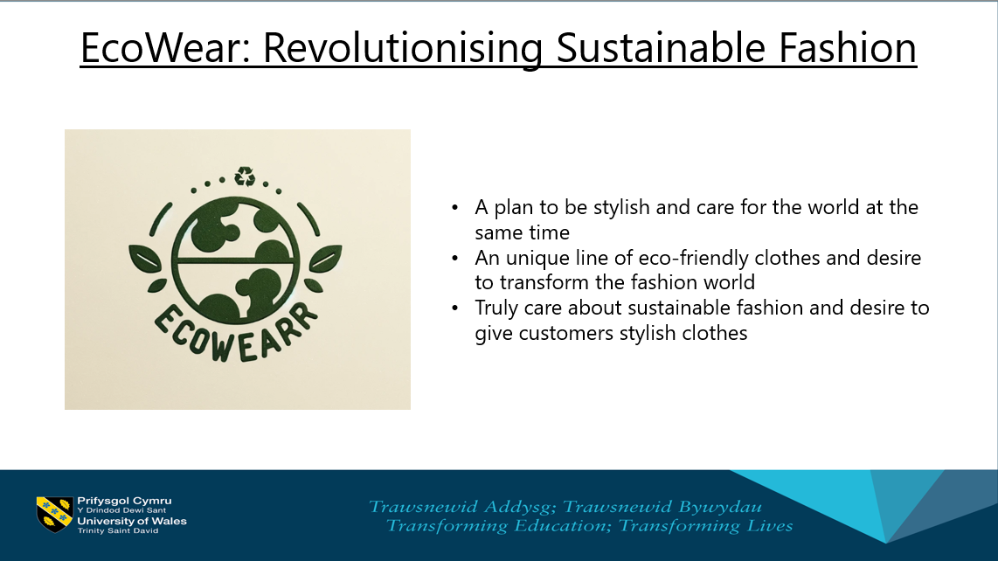
EcoWear is an online shop that combines style and morality. The company wants to change the fashion industry by making high-quality and eco-friendly clothes that look great.
The eco-friendly clothing line is at the heart of the plan to be stylish and care for the world at the same time. They care about sustainable fashion and desire to give the customers stylish clothes that are additionally good for the earth. EcoWear is not just a name. The company want to pioneer eco-friendly fashion by making new rules for getting materials and decently making clothes. People who adopt EcoWear help make the world healthier and better for the environment. EcoWear is excited to show off its brand-new, unique goods and services today. This is what EcoWear is really about. With their unique line of eco-friendly clothes, they desire to transform the fashion world one look at a time. It is important to them that fashion and ecology can live in harmonious peace.
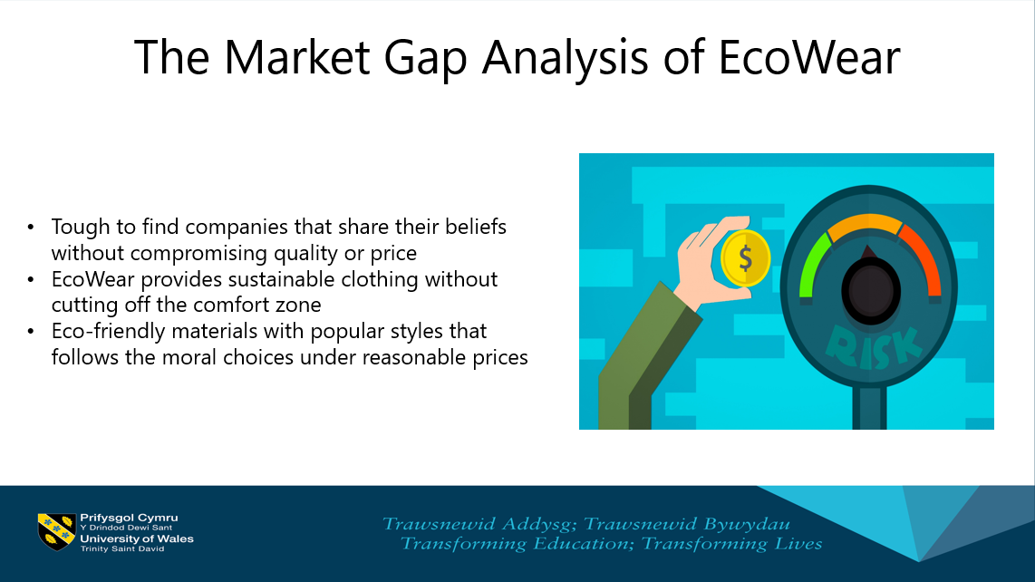
When the company initially looked into sustainable fashion, it saw a big hole in the market. People want cheap, stylish clothes that are sustainable. It is tough for people to find companies that share their beliefs without giving up style or price. They are also more cognizant of and stressed about how the items they buy impact the world. They fill this need with EcoWear, which has many stylish, sustainable clothes that do not sacrifice comfort. EcoWear uses a mix of new, eco-friendly materials and popular styles to give clients the moral choices they want at prices they can afford it.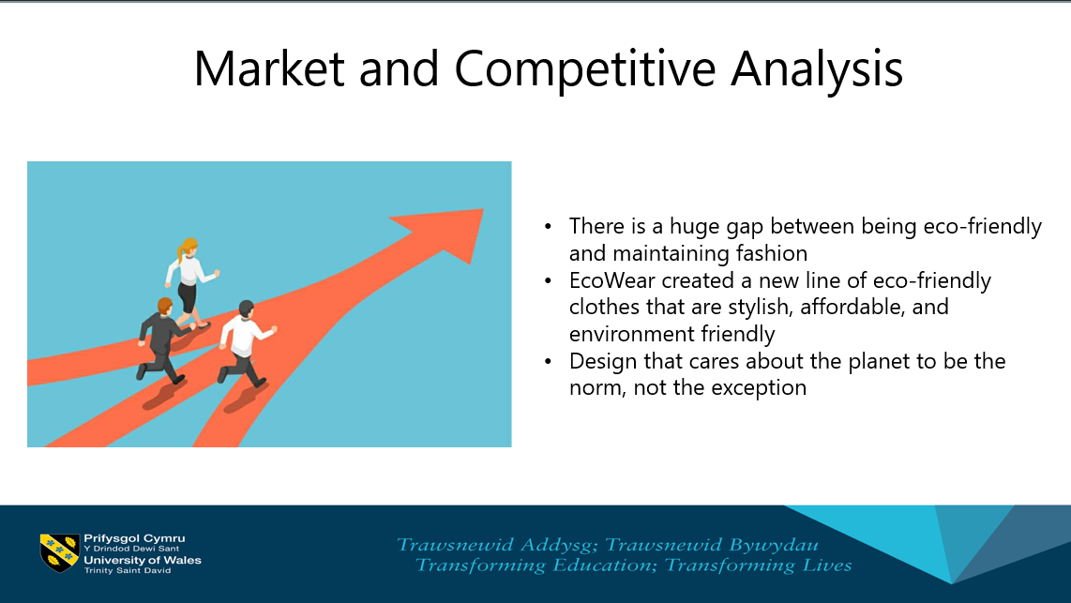
When it comes to fashion, there is a big gap between being eco-friendly and looking good. EcoWear is eager to fill in the blank. More and more people want to buy responsible and good clothes for the environment without sacrificing style or price. EcoWear sees all this and has made a new line of eco-friendly clothes that look good, do not cost a lot, and are good for the world. When the firm makes clothes, they use materials that are sustainable and fair work practices. This gives people a stylish alternative to fast fashion. EcoWear wants a design that cares about the earth as the norm, not the exception. They want to immediately give people on the market real, eco-friendly clothes options.
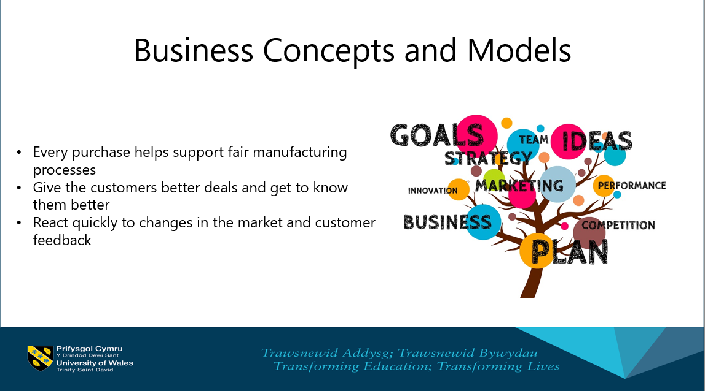
EcoWear's company strategy is built on being good to the earth, coming across new ideas, and acquiring individuals involved. The business has less effect on the earth, and the goods are easier for more people to get by using a web-based store. Because their products are good for the environment, every purchase helps support fair manufacturing. EcoWear's company strategy also involves a direct-to-consumer way. Since they do not have to go through intermediaries, they can give their customers better deals and get to know them better. This method demonstrates that they care about their surroundings and lets them react quickly to changes in the market and customer feedback, which keeps the business busy and adaptable.
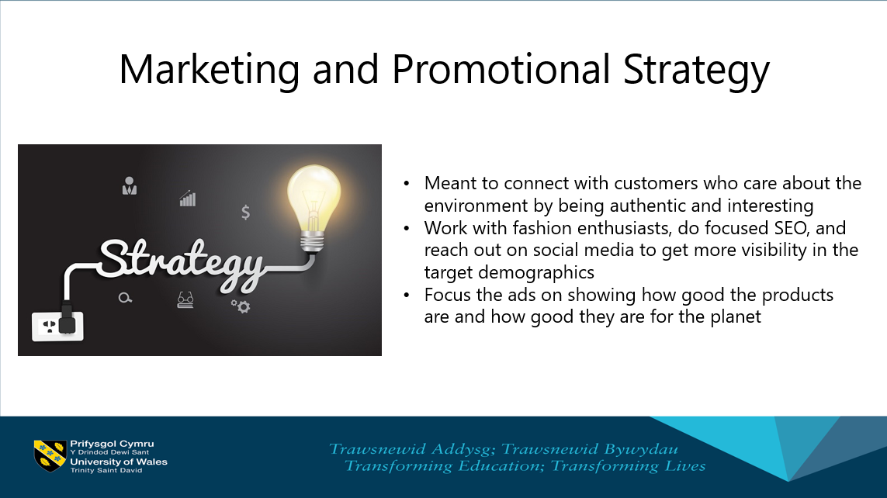
EcoWear's advertising strategy is meant to connect with customers who care about the earth by being honest and interesting. The firm works with fashion leaders focused on SEO (search engine optimization) and reaches out on social media to get more visibility in the community of people who wear clothes that are better for the environment. To get customers who will stick with us, they must show that they are concerned about the surroundings and honest in their work. To make EcoWear stand out in the marketplace, the company focuses their ads on showing how good its products are and how good they are for the environment. This plan makes sure that as many individuals as possible hear about and are interested in eco-friendly fashion, which boosts both understanding and conversion.
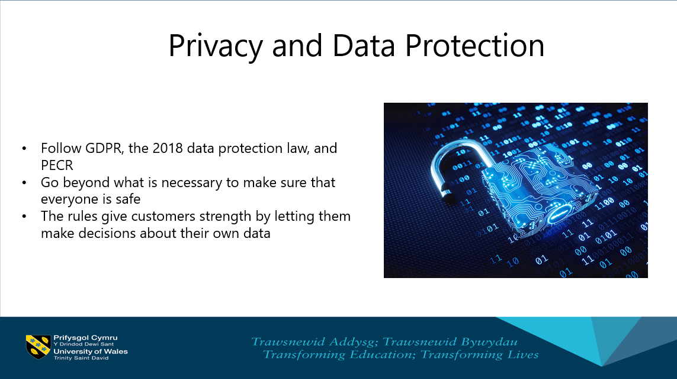
At EcoWear, they value the trust their customers put in them regarding their personal information. To follow GDPR (General Data Protection Regulation) the 2018 data protection law, and PECR (Privacy and Electronic Communications Regulations), they have set up strict data security and privacy rules. These steps not only follow the law, but they also go beyond what is necessary to make sure that everyone is safe and that everything is open. The rules are giving customers strength by letting them decide about their own data and ensuring that their shopping experience is safe, private, and risk-free.
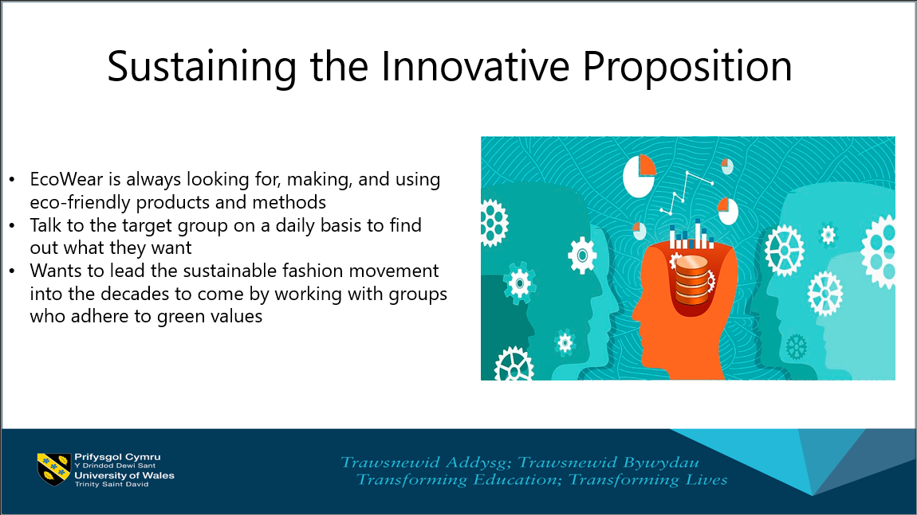
EcoWear is always looking to make and use eco-friendly products and methods because it wants to be ahead of the curve in the sustainable fashion business. As part of the plan, the company talks to their target group daily to find out what those individuals want and guess what they might want. This helps them think of novel concepts before the consumers do. Even though EcoWear wants to grow and add more items, it continues to be good for the planet. EcoWear wants to lead the sustainable fashion movement into the decades to come by working with groups that adhere to its values and follow the newest green fashion trends.

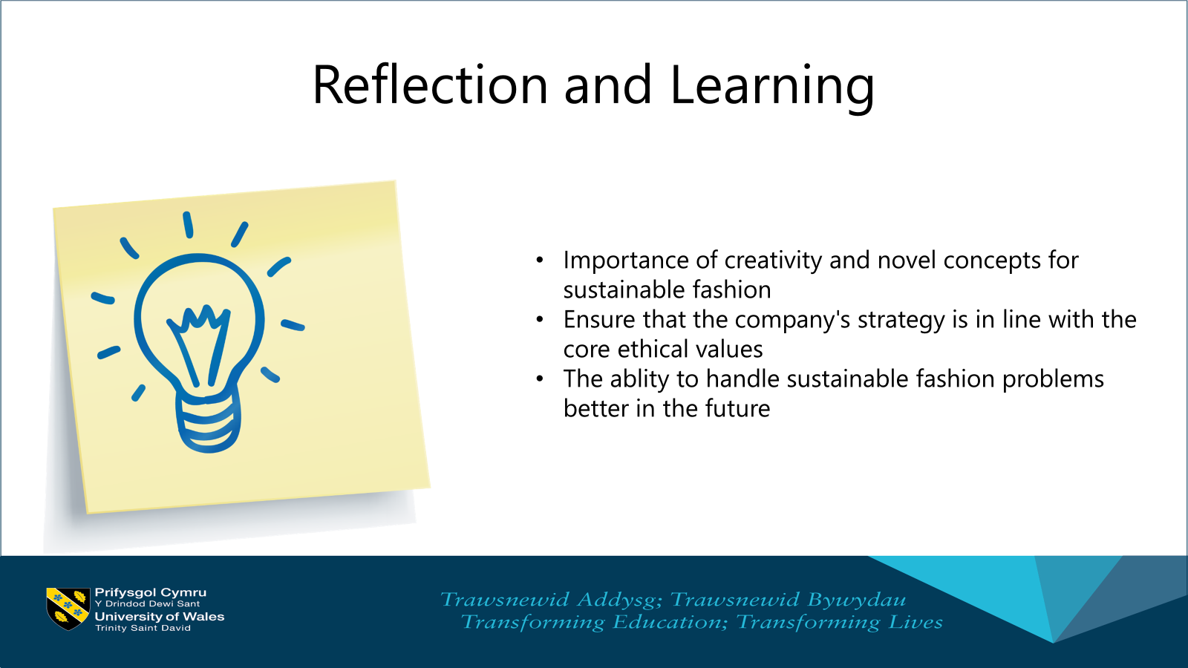
When thinking back on making EcoWear, I realize that the things I learned were very important. Realising creativity and novel concepts are important for making company procedures last longer, which is one of the most important things. I learned on this trip how essential it is to ensure that the company's strategy aligns with the core values of ethics and the environment. I will be able to handle problems better in the future thanks to the lessons learned. I learned new things from these events, inspiring me to keep seeing what is possible in an eco-friendly fashion.
In the final analysis, EcoWear is a star in eco-friendly fashion because it cares about the earth, new ideas, and quality. That is how much they desire to transform the fashion sector so that it does good things and looks good. Thanks for embracing the ecological future and making it the new thing to do in style.



