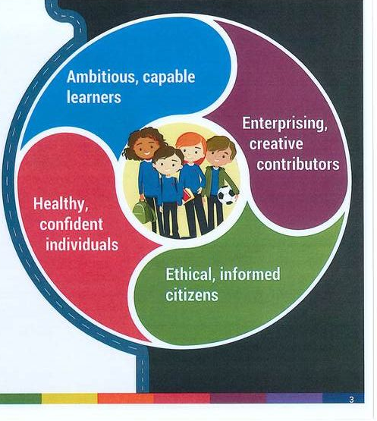    Wales’s new curriculum has been passed to be carried out in all schools as the beginning of the 2021/2022 academic year, The new curriculum is a modern way of learning with majority of it using new technology and online work and apps, children will be using the internet more than ever and its important we make sure the children no how to use it safely and securely. |  | UNCRC Article 13-  “I have the right to find out and share information.”  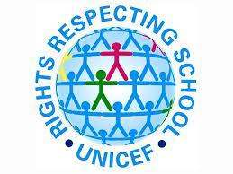
 |  |  |  | E’Safety and Bullying

“1 in 5 children between 9 to 15 have experienced some form of these online bullying in last 12 months.”  (Sophie sanders national statistics for crime and justice) |  | Impacts of online bullying  Low Self Esteem  - Social withdrawal  - Change of personality.  - Change of Appearance.  - Exclude them selves  - Affect on mental health  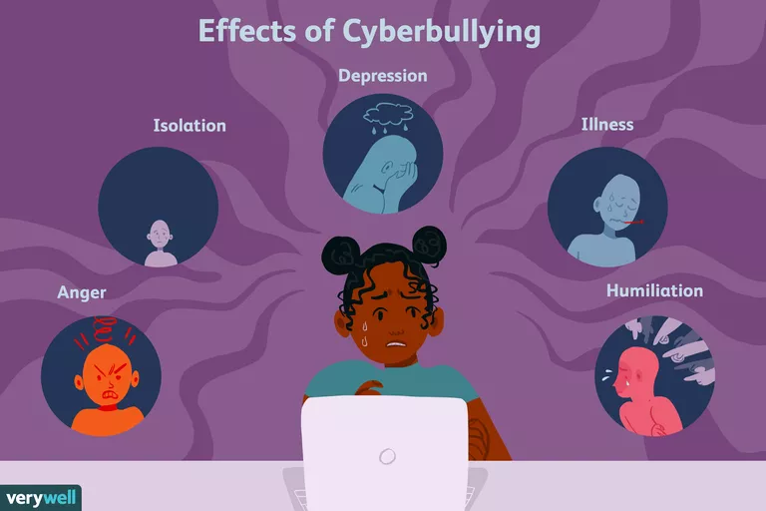 |  | “Cyber bullies can hide behind a mask of anonymity online and do not need direct physical access to their victims to do unimaginable harm” (Anna maria Chavez)
How to stay safe online  - All social media apps have age restrictions.  - Regularly check your children’s social media accounts.  - Encourage your child to speak to you or another adult if anything happens on while they are on or using the internet.  - Make sure they have a strong Password that you are aware of and make sure the know not to tell anyone this password.  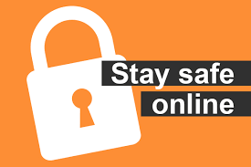  - Teach them how to safe browse online. |  |  |  | Further Advice and support  - Visit child net online for more information https://www.childnet.com/  - Call bullying UK on 0808 800 2222  - Speak to your family support officer in your child’s school.  - Also, if your child has been a victim and needs support the following offers more information and advice on mental health in children https://youngminds.org.uk/find-help/your-guide-to-support/guide-to-camhs/  
 |  | 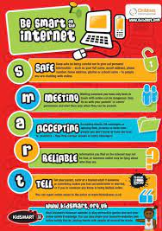

Reference list for Leaflet
- Issuu. 2021. E-safety Leaflet. [online] Available at: https://issuu.com/olchs/docs/parents-leaflet-e-safety [Accessed 20 March 2021].
- Childnet. 2021. Be SMART online. [online] Available at: https://www.childnet.com/resources/be-smart-online [Accessed 20 March 2021].
- The Children and Young People's Commissioner Scotland. 2021. UNCRC Article 13 - I have the right to find out and share information - The Children and Young People's Commissioner Scotland. [online] Available at: https://cypcs.org.uk/rights/uncrc/articles/article-13/#:~:text=Everyone%20has%20the%20human%20right,in%20the%20way%20you%20want. [Accessed 21 March 2021].
- Brighouse.calderdale.sch.uk. 2021. E-Safety. [online] Available at: https://www.brighouse.calderdale.sch.uk/About-Us/E-Safety-2 [Accessed 20 March 2021].
- Tes.com. 2021. Diamond 9 For The UNCRC (United Nations Convention on the Rights of the Child)= Rights Respecting | Teaching Resources. [online] Available at: https://www.tes.com/teaching-resource/diamond-9-for-the-uncrc-united-nations-convention-on-the-rights-of-the-child-equals-rights-respecting-12075636 [Accessed 21 March 2021].
- Childline.org.uk. 2021. Staying safe online | Childline. [online] Available at: https://www.childline.org.uk/info-advice/bullying-abuse-safety/online-mobile-safety/staying-safe-online/ [Accessed 20 March 2021].
- manager, G., 2021. Helping your company to stay safe online - Companies House. [online] Companieshouse.blog.gov.uk. Available at: https://companieshouse.blog.gov.uk/2019/02/04/helping-your-company-to-stay-safe-online/ [Accessed 20 March 2021].
- Verywell Family. 2021. Learn to Recognize the Real-Life Effects of Cyberbullying on Children. [online] Available at: https://www.verywellfamily.com/what-are-the-effects-of-cyberbullying-460558 [Accessed 20 March 2021].
- Familylives.org.uk. 2021. Parentline family support and bullying helpline | Family Lives. [online] Available at: https://www.familylives.org.uk/how-we-can-help/confidential-helpline/?_ga=2.178784802.78845645.1616796848-926885023.1611739579 [Accessed 20 March 2021].
- YoungMinds. 2021. Guide to CAMHS. [online] Available at: https://youngminds.org.uk/find-help/your-guide-to-support/guide-to-camhs/ [Accessed 22 March 2021].
- Baras, R., 2021. How to Help Bullying Bystanders | Family Matters. [online] Family Matters. Available at: https://www.ronitbaras.com/emotional-intelligence/personal-development/how-to-help-bullying-bystanders/ [Accessed 21 March 2021].
- Georgetown Primary School. 2021. The new curriculum for Wales. [online] Available at: https://www.georgetownprimary.co.uk/the-new-curriculum-for-wales.html [Accessed 21 March 2021].
- Thenationalcollege.co.uk. 2021. Remote video CPD to empower school leaders | The National College. [online] Available at: https://thenationalcollege.co.uk/webinars/the-welsh-curriculum-an-exclusive-review-with-prof-graham-donaldson [Accessed 20 March 2021].

SJIE5006 Rationale
During the following rationale I will be looking at safeguarding and child protection for our young people and children and how we keep them safe. I will then be talking about my leaflet above, discussing a very relevant topic at the moment E-safety and how parents, adults and schools can help inform children and young people how to stay safe online, the affects of online bullying and who and where to get advice or support.
Safeguarding is where we protect young people and children from abuse and neglect and try and stop this affecting their health and development making sure the environment in school and at home are safe and effective for them to learn and develop, this then gives the children the best opportunity in life. It is a statutory duty for schools to safeguard all the pupils who attend the school and help promote a positive and healthy set up and welfare for all pupils. Safeguarding includes up to date relevant training opportunities for all staff with a good management of all staff with positive safe staff recruitment. Staff also must arrange and meet the needs of children with medical conditions. A elected safeguarding team in responsible for over seeing and carrying out the correct procedures for safeguarding however everyone has a responsibility to make sure all children and young people are safeguarded. Staff can do this by creating and maintain a safe learning environment, while making sure they can see when there are child safeguarding and welfare concerns and making sure they do something about it efficiently and appropriately. Teachers can also help children understand safeguarding and resilience through the use of the curriculum in class. Staff promote this by making sure all pupils have good self-esteem, confidence, communication and a ethos where children feel safe and know they can speak up and trust staff at any time and staff will listen and help for example school A’s ethos where I work is “striving for success for all” (school A 2018) this means no matter who or where the pupil has come from we will help them develop the mentality they can be successful in life. Our school creates a safe environment by making sure the staff in our school are all suitable and will help get the best out of the pupils whilst promoting safe practice and making sure they challenge poor and unsafe practice. Every school must have certain policies in place, in my school we have a safeguarding policy, child protection policy, whistleblowing policy, acceptable use policy, positive handing policy and we make sure all staff have regular essential training across all these areas. Child protection is a part of safeguarding but comes under a different heading it is about what is undertaken to make sure we are protecting specific children who may be at risk of suffering abuse or neglect. The system has failed a few young people and children in recent times for example in 2003 Victoria Climbies death rocked the UK people and lord laming reported in 2003 108 recommendations for government and from this health services and social services where installed to help prevent this happening to another children and young people. However, in 2004 we were hit with another horrible story of the girls Holly wells and Jessica Chapman where Bichard filed a report on is and what came from that was information need to be shared better between authorities and DBS (Disclosure and Barring Service) started where all staff had to pass a DBS to be able to work with children. Also in 2004 Wales appointed their first children’s commissioner Peter Clarke, He recommended child protection training for all staff with designated teacher and governor in each school. Each school should have the opportunity for counselling for all pupils and making sure information is available for children from companies such as NSPCC and child line. Welsh government also brought in the 3P’s for all children which are the right to provision, right to protection and the right the participation this came in along side the seven core aims for all children across the country which are having a flying start, making sure children have a wide range of leaning opportunities, making sure they are free from abuse, victimization and exploitation while having access to play, leisure, sporting and culture activities, children also should be listened to and treated with respect and have their race and culture recognized, they should all have a safe home and live in a community that supports them with there well being and no child should be disadvantaged because of poverty. My school is a right respecting school where we make sure the UNCRC rights are embedded through out the school and the children are ware or their rights and make sure they know if they feel one of their rights are not being met they can seek help support and advice. The most recent policy we have brought in to our learning environment is the acceptable use policy and online safety policy this is because children are online and using the internet more than ever and its becoming a big factor for the decline children’s mental health and wellbeing and due to COVID 19 the children have been online more than ever and this was the only way they could communicate with friends and family for a long time.
My leaflet above is one I feel really strongly about due to being on the receiving end of online bullying and about E-safety, this means electronic safety, it concerns about young people and children in the digital world and help making sure they feel they are safe when accessing technology, its aim is to stop children and young people from unsuitable material and stop them from taking part in activities which are dangerous and prohibited. I think its important for parents to understand the risks of using the internet, how they can help their child stay safe online and the signs to look out for if their child is being bullied online and the impacts it may have. “one in five children between nine and fifteen have experienced some form of online bullying in the last twelve months” (sophie sanders national statistics for crime and justice) This is a big increase due to children being on it more than ever due to COVID 19 and having to work from home. There are many different types of online bullying but the main ones we hear off and see are exclusion from games and groups, gossiping, harassment and keyboard warriors who write mean comments to other people. Online bullying can have big impacts on children but some of signs of online bullying are low self-esteem, low confidence, their personality might have changed, they might change their appearance, they might have withdrawn them selves from social events with friends etc and it could eventually have a negative impact on their mental health. We have seen a rapid growth in young people and children who mental health is being affected, a modern example of this is tv presenter Caroline Flack who had so much abuse online that it led to a massive deterioration of her mental health which led to her taking her own life because she did not have the help and support, she needed. As parents and guardians, you can help your child be safe online by making sure they are the correct age when downloading and crating accounts with apps such as you should thirteen to have a Facebook account. You should regularly check your child’s social media accounts making sure your aware of anything they could be hiding and making sure their posts and comments are appropriate, encourage your child to speak to your or another trusted adult if something happens online straight away, making sure they have a strong password which no one can guess easily and make sure your aware of it for security reasons and teach them how to be safe when using the internet. There are also so many companies and organizations where you can seek help, advice and support some of these are Child net and bullying UK, these offer phone numbers to ring and chat to a professional, online chat rooms or just information on things you can do to help your child. A problem we have now is the welsh government have just announced that Graham Donaldson new curriculum has been passed and schools will start this in the 2021/2022 academic year, this Is excellent news for the children and teachers to be teaching a new curriculum focusing on the future and making sure the children have the best start to life, however the new curriculum is very modern based and the four areas of learning will involve a lot of technology and devices to help them achieve this.
Child protection policies and safeguarding polices are developing strongly and are being updated to make them better all the time. The welsh government (2016) have made changes and recommendations to internet safety they have said people need to be more educated on how to keep young people and children safe online. This seems to be the case as its now compulsory that children should be taught in school on how to be safe online and there is more information’s help and advice for parents and adults everywhere. However, there is still so much risk online and children need to be so careful and make sure they show empathy to each other. I also feel there still can be miss communication from different organizations due to people having different policies and rules so I feel it would be good if everyone policy was the same.

Referencing Rationale
- Childline.org.uk. 2021. Staying safe online | Childline. [online] Available at: https://www.childline.org.uk/info-advice/bullying-abuse-safety/online-mobile-safety/staying-safe-online/ [Accessed 20 March 2021].
- Childnet. 2021. Be SMART online. [online] Available at: https://www.childnet.com/resources/be-smart-online [Accessed 20 March 2021].
- GOV.UK. 2021. About us. [online] Available at: https://www.gov.uk/government/organisations/disclosure-and-barring-service/about#:~:text=Safeguarding%20is%20at%20the%20heart,with%20vulnerable%20groups%2C%20including%20children. [Accessed 20 March 2021].
- Unicef UK. 2021. UN Convention on the Rights of the Child (UNCRC) - UNICEF UK. [online] Available at: https://www.unicef.org.uk/what-we-do/un-convention-child-rights/ [Accessed 21 March 2021].
- Downloads.unicef.org.uk. 2021. [online] Available at: https://downloads.unicef.org.uk/wp-content/uploads/2019/10/UNCRC_summary-1_1.pdf?_adal_sd=www.unicef.org.uk.1616848589259&_adal_ca=so%3DGoogle%26me%3Dorganic%26ca%3D(not%2520set)%26co%3D(not%2520set)%26ke%3D(not%2520set).1616848589259&_adal_cw=1616848566823.1616848589259&_adal_id=3dad78bf-7968-46cf-a643-e3521cfab283.1610904830.3.1616848567.1610904830.08e51f45-81c4-4bcf-86f5-e5d5f224338b.1616848589259&_ga=2.87462232.1354518915.1616848567-142787739.1578171955 [Accessed 24 March 2021].
- Ihasco.co.uk. 2021. What is the Children Act 2004? | iHASCO. [online] Available at: https://www.ihasco.co.uk/blog/entry/2508/what-is-the-childrens-act-2004 [Accessed 23 March 2021].
- Pembrokedockcommunityschool.co.uk. 2021. Home | Pembroke Dock Community School. [online] Available at: https://www.pembrokedockcommunityschool.co.uk/ [Accessed 23 March 2021].
- NSPCC Learning. 2021. Safeguarding children and child protection | NSPCC Learning. [online] Available at: https://learning.nspcc.org.uk/safeguarding-child-protection [Accessed 23 March 2021].
- 2021. [online] Available at: https://www.frg.org.uk/ypa/need-help-or-advice/child-protection [Accessed 23 March 2021].
- NSPCC. 2021. Online safety. [online] Available at: https://www.nspcc.org.uk/keeping-children-safe/online-safety/ [Accessed 23 March 2021].
- Verywell Family. 2021. Learn to Recognize the Real-Life Effects of Cyberbullying on Children. [online] Available at: https://www.verywellfamily.com/what-are-the-effects-of-cyberbullying-460558 [Accessed 20 March 2021].

