Name: Sumaira shah
Student no :2421021
Module: Online Portfolio of Set Exercises
Module code: BMHP5014
Assignment Title: Component 1: Online Portfolio of Set Exercises
Lecturer Name: Parese Ahmed

Task 1 – Concept Map
Create a concept map that outlines the relationship between creativity, value creation,
and health and social care improvement. Within the concept map explains how these
concepts interact in a health and social care context (250 words)
Response/Analysis:
Creativity is at the heart of diagramming out how to use creativity effectively. Creativity can be thought of as a conceptual skill that allows a person to generate new ideas or ideas of worth/value in a wide range of contexts from solo problem-solving to innovating the way things work as an entire system of systems (Boden, 1994, as cited in Carile and Jordan, 2012).
Many benefits to creativity come through the key enabling factors listed below, which include Motivation, which exists on a continuum ranging between Extrinsic Motivation (external rewards producing motivation) and Intrinsic Motivation (motivated because of enjoyment from performing a task and having the freedom to make one's own choices), (Ryan and Deci, 2000; Pink, 2011); another enabling factor to Creativity is Wellbeing; complete mental and social well-being (WHO, 1948) can provide a basis for fostering creativity, at the same time being involved in Creative Activities like Community Arts can both increase one's Wellbeing and provide a means for (Coulton et al., 2015; Mental Health Foundation, 2020).
Enabling factors help create the process of Value Creation. In this case the creative process is guided by the structured methodologies of models for harnessing Creativity, such as the Osborn-Parnes Creative Problem-Solving Process, creating the bridge between conceptualisation and execution of Value Creation, defined as achieving the best possible results at the lowest possible costs for the Health and Social Care Sectors (Porter, 2010). Value is multi-dimensional, having allocated, technical and personal characteristics.
In conclusion, this generation of creative value creation leads directly to Health and Social Improvement. With various ways these improvements can happen, developing new and innovative person-centered resources such as Premed Prep toys to reduce patient anxiety; tackling systemic challenges such as A&E waiting times and health inequalities (Nuffield Trust, 2023; The King's Fund, 2023); and enhancing the overall population wellbeing through providing more effective and equitable services. The map is cyclical; with each new improvement creating new challenges that require further creative and value-based solution development, with creativity being the vehicle for continuous progressive change within care systems.
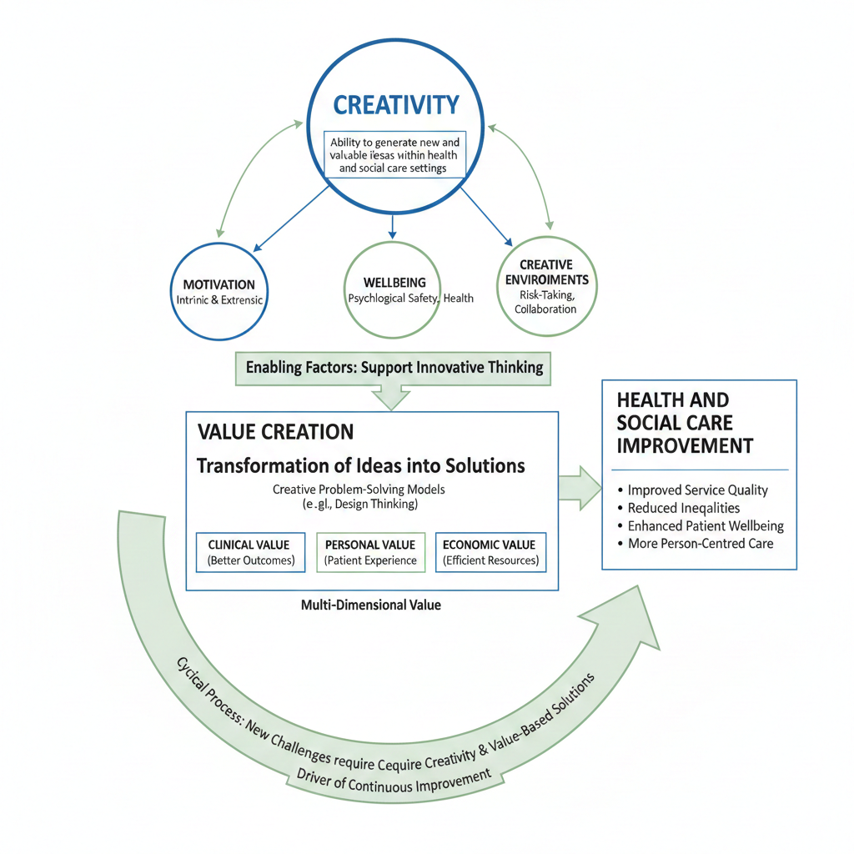
Fig 1. A cyclical concept map illustrates how creativity and enabling factors drive value creation to achieve continuous health and social care improvement.
Task 2 - Self-Reflection of Group Activity
Complete a self-Reflection on the Convergent/Divergent paperclip thinking class activity
using a reflective model (250 words, 1 source)
Response/Analysis:
In this analysis of the paperclip activity, I will be using the What? So What? Now What? reflection model by Borton (1970).
So What?
The paperclip activity was a practical application of two cognitive processes, divergent thinking (where we brainstormed uses for a paperclip) and convergent thinking (where we evaluated each of those ideas based on feasibility, safety, and resource use).
Divergent thinking involved initially trying to generate as many ideas as possible. This process allowed me to generate 27 different uses for a paperclip in just 10 minutes, where I suggested therapeutic uses (e.g., being used as a fidget tool for anxiety).
Once we moved on from divergent thinking to convergent thinking, I began to evaluate some of the ideas generated regarding the risks associated with those ideas. For example, I disagreed with the use of a paperclip as a lock pick for both ethical and practical reasons.
What?
The paperclip activity provided an experiential understanding of two different types of thinking needed to be innovated. The divergent phase required participants to suspend their judgement about the quality of the ideas being generated so that they could achieve a high number of ideas, which is the creativity component defined by Guilford (1967). The transition from divergent thinking to convergent thinking occurred quickly, simulating the reality of how quickly an idea may go from being an innovative possibility in health/social care to a viable and safe alternative to use. In addition, I found I am naturally inclined toward convergent thinking, which can be very helpful when it is time to implement an idea, but, if unmanaged, can reduce the number of ideas generated during the divergent phase of the process.
What's Next?
This insight will assist with the development of my Component 2 innovation. Therefore, I will intentionally divide my creative process into two phases: (1) unrestricted divergent brainstorming to explore every possibility; and then (2) applying convergent criteria (e.g., clinical safety, cost-effectiveness and the World Health Organization's (2016) goal of distributing resources equitably among all populations) to narrow down those ideas into a feasible, effective solution. This methodical approach provides for both an unrestricted environment for creative thinking and practical outcomes which will have a positive impact on already strained healthcare systems.
Task 3 - Case Study of a UK innovation
Write a concise case study analysis of an innovative project or initiative within the NHS
or UK social care. Focus on how creativity was used to drive change and the value it
created for patients or service users (400 words, 2 sources).
Response/Analysis:
NHS at Home is a groundbreaking project that has revolutionized the way healthcare is delivered in the United Kingdom. This project was developed because of creative solutions to the insupportable burden placed on healthcare resources due to the growing number of patients who have chronic conditions. The primary source of creativity in the NHS at Home program was not using technology but through the conceptualisation of the patient-care environment by moving advanced clinical care facilities from hospitals into homes. This change required the combination of new technologies with redesigned services and the active engagement of patients.
Creativity was apparent in the way in which divergent thinking was used to address the issue of hospital admission. Rather than only working to enhance inpatient throughput, the innovators began to ask how care could be provided outside the traditional institution. This question prompted the integration of portable; home-based diagnostic devices (such as portable ECGs) with wearable technology, and predictive statistical models powered by artificial intelligence into one package of remote patient care (NHS at Home, n.d.). Another key element of this initiative is that it embodies a patient-centered approach to innovation by training the patient to interpret their own data, effectively changing the patient-provider dynamic from that of a passive recipient of care to that of an active participant in managing their own health—this creative transformation of the patient-provider relationship (Bajwa et al., 2021).
Value creation is multidimensional and aligned with Porter's (2010) Value-Based Healthcare Framework. For service users, value is personalised by enhancing their autonomy, reducing their travel time and providing them with the psychological benefit of managing their conditions in an environment they know, ultimately increasing their wellbeing. For service users, clinical value is created through technical achievements by allowing for proactive interventions based on real-time data, thereby enabling prevention of crisis situations and improving health outcomes. For the NHS as a Service Provider, significant allocative values are produced through this type of service provision as well as allowing for early discharge and reducing unnecessary admissions. This type of opportunity for increased efficiency across the whole system, from reduced admissions and increased number of early discharges, produces cost savings within the system. An example is represented by the heart attack remote monitoring programme at Imperial College Healthcare NHS Trust and its ability to demonstrate tangible evidence of value through significantly reduced 30-day readmission rates, and clinical outcomes contrast as well as resource utilisation (Imperial College Healthcare NHS Trust; 2024).
In conclusion, NHS at Home demonstrates that monumental advancements in care delivery stem from innovative encouragement of existing technologies through the creative assembly of these technologies into a novel, patient-empowering model. The value generated through this approach is not either but a synergistic relationship, where improved patient experience, better clinical outcomes and increased sustainability of the system are achieved at the same time and therefore providing a replicable model of what future integrated preventative care should look like.
Task 4 – Research Task
Identify a current issue in health and social care (e.g. e.g., mental health stigma, access to care for vulnerable populations). Find two pieces of academic research (journal articles) that explain the reason for this problem. Paraphrase the findings of each article (300 words, 2 sources).
Response/Analysis:
Identified Issue: Low uptake of cervical screening among ethnic minority women in the UK, particularly those of South Asian heritage, which contributes to persistent health inequalities.
Article 1 Findings:
Marlow, Forster, Wardle & Waller (2015) conducted a survey examining the barriers to access for minority ethnic women in London. This research uncovered both cultural and practical intersections that resulted in significant barriers to screening for these women. A lack of targeted, linguistically relevant information resulted in many women being unaware of the purpose and significance of the screening. Modesty and embarrassment were also very prominent barriers to women attending screenings, with many women indicating they would be uncomfortable with an aspect of an intrusive medical procedure. This research also indicated how critical the gendered congruence is to attendance at a screening – in that the availability of a female screener is a significant factor for women attending screening. This highlights that the issue of access to screening is not simply an individual issue with choice but rather is a structural issue that is embedded within a service that does not account for the cultural specificities or needs of communication.
Article 2 Conclusion
Exploring this issue through a socio-ecological lens, Akbar et al. (2022) completed a systematic review of the literature that consistently focused on British Bangladeshi and British Pakistani women's health. In their study, the authors identified multiple layers of reasons for the low rates of uptake of cervical cancer screening that are rooted in community and systemic levels of influence. At the community level, Akbar et al. (2022) identified stigma, fear of a cancer diagnosis, and the lack of discourse about women's health within families as major barriers to accessing cervical cancer screening. Systemic barriers included a lack of pro-active engagement by general practitioners in their respective communities, and a failure of health promotion materials to resonate with the cultural and religious values of the specific populations. Akbar et al. (2022) also found that current public health messages conflict with strongly held community beliefs surrounding concepts of modesty and fate (kismet), leading to standard campaigns being ineffective. As such, this study indicates that the low rates of uptake of cervical cancer screening are a result of a service model that is not culturally competent and not due to a deficit or absence of want from the respective communities.
Task 5 - Podcast

Task 6 - NHS Leadership Framework Analysis
Write a short summary (200 words) explaining the key components of the NHS Leadership Framework. Then, choose one component and describe (150 words) how a leader might use it to encourage creativity and improve care in the NHS (2 sources)
Summary of the NHS Leadership Framework
The Healthcare Leadership Model (previously known as the NHS Leadership Framework) offers an overarching organisational structure for developing leaders across all levels and roles in the United Kingdom's health system. The model comprises seven different leadership domains, including: 1. Leading with Care — which includes a focus on treating others with compassion and respect; 2. Sharing the Vision — where strategic direction is communicated; 3. Engaging the Team — where collaboration and developing talent are emphasised; 4. Evaluating Information — which enables evidence-based decision making; 5. Connecting Our Service — focusing on working in partnership across the entire system; 6. Influencing for Results — which includes motivating people to achieve desired outcomes; and 7. Inspiring Shared Purpose — where members of a group develop mutual trust and commitment to achieve a common aim (NHS Leadership Academy 2013). Therefore, the model is a broad-based framework and focuses on identifying the specific behaviours required to encourage the provision of high quality and compassionate service.
Applying 'Engaging the Team' to Foster Creativity
Leading teams to think creatively begins with creating a safe space where team members can freely share their ideas – a place where they do not worry about being punished for suggesting something new. In order to achieve this, leaders can use regular innovation huddles, an example of which may be a paperclip exercise that allows staff to re-think care pathways; lead to new ideas by assigning staff to try out small-scale innovations like using a digital tool to monitor patients that may empower them; develop greater efficiencies and job satisfaction; create efficient delivery of care by using frontline staff's feedback to develop solutions for hands-on problems; and inspire a resourceful and value-based leadership style.
Response/Analysis:
After completing this module, I believe that I have a new understanding of creativity.
I don’t think of creativity as a limited and artistic characteristic anymore but rather as a structured and cognitive means of enabling system-wide improvement in Health and Social Care (HSC). Creativity is now viewed by me as the power behind value creation, which I now define as a complex outcome that has three (3) dimensions: improved patient experience; effective clinical practice; and efficient use of resources (Porter, 2010).
A major significant change in my use of creativity is being able to intentionally distinguish divergent from convergent thinking. I have become much more resourceful using a disciplined process of first generating ideas via free flow (brainstorming), and then carefully evaluating those ideas with a focus on feasibility.
My professional practice is very much influenced by this new and improved framework. When solving a service challenge, I now use these creative processes to generate quantifiable value for HSC through equitable and patient-centered outcomes rather than simply saving money.
Reference
Borton, T. (1970) Reach, touch, and teach. New York: McGraw-Hill.
Boden, M. A. (1994) What is creativity?’, in Dimensions of creativity. Cambridge, MA: MIT Press. [Cited in Carlile, O. and Jordan, A. (2012) Approaches to creativity: a guide for teachers. Maidenhead: Open University Press].
Coulton, S., Clift, S., Skingley, A. and Rodriguez, J. (2015) ‘Effectiveness and cost-effectiveness of community singing on mental health-related quality of life of older people: randomised controlled trial’, British Journal of Psychiatry, 207(3), pp. 250-255.
Mental Health Foundation (2020) Creativity and innovation: Findings from the Mental Health Fellowships. Available at: https://www.mentalhealth.org.uk/sites/default/files/2022-06/MHF-Winston-Churchill-Memorial-Trust-Creativity-Innovation-Findings.pdf (Accessed: 4 January 2025).
Nuffield Trust (2023) A&E Waiting Times. Available at: https://www.nuffieldtrust.org.uk/resource/a-e-waiting-times (Accessed: 3 January 2024).
Pink, D. H. (2011) Drive: The surprising truth about what motivates us. New York: Riverhead Books.
Porter, M. E. (2010) ‘What is value in health care?’, New England Journal of Medicine, 363(26), pp. 2477-2481.
Ryan, R. M. and Deci, E. L. (2000) ‘Intrinsic and extrinsic motivations: Classic definitions and new directions’, Contemporary Educational Psychology, 25(1), pp. 54-67.
The King's Fund (2023) Key facts and figures about the NHS. Available at: https://www.kingsfund.org.uk/audio-video/key-facts-figures-nhs (Accessed: 3 January 2024).
World Health Organization (WHO) (1948) Constitution. Geneva: World Health Organization.
Borton, T. (1970) Reach, touch, and teach. New York: McGraw-Hill.
Guilford, J. P. (1967) The nature of human intelligence. New York: McGraw-Hill.
Li, X., Theisen, A., Seo, C. and Sibley, S. D. (2018) ‘Resourcefulness: Current Insights and Future Directions for Family Scholars and Clinicians’, The Family Journal, 26(4), pp. 1-11.
World Health Organization (WHO) (2016) Global strategy on human resources for health: Workforce 2030. Geneva: World Health Organization.
Bajwa, J., Munir, U., Nori, A. and Williams, B. (2021) ‘Artificial Intelligence in healthcare: Transforming the Practice of Medicine’, Future Healthcare Journal, 8(2), pp. 188-194. Available at: https://doi.org/10.7861/fhj.2021-0095.
Imperial College Healthcare NHS Trust (2024) Remote Monitoring of Heart Attack Patients Significantly Reduced Hospital Readmissions. Available at: https://www.imperial.nhs.uk/about-us/news/remote-monitoring-of-heart-attack-patients-significantly-reduced-hospital-readmissions (Accessed: 20 September 2024).
NHS at Home (n.d.) *Case Study 1: "NHS at Home" -- Remote Monitoring to Reduce Hospital Admissions* [Unpublished module material]. University of Wales Trinity Saint David.
Porter, M. E. (2010) What is value in health care?’, New England Journal of Medicine, 363(26), pp. 2477-2481.
Akbar, N., Hossain, M. M., Huda, M. N. and Khan, H. T. A. (2022) ‘Barriers to cervical cancer screening among ethnic minority women in the UK: a systematic review and meta-synthesis’, Ethnicity & Health, 27(8), pp. 1914-1935.
Marlow, L. A., Forster, A. S., Wardle, J. and Waller, J. (2015) ‘Ethnic differences in human papillomavirus awareness and vaccine acceptability’, Journal of Epidemiology & Community Health, 69(12), pp. 1190-1196.
NHS Leadership Academy (2013) Healthcare Leadership Model: The Nine Dimensions of Leadership Behaviors. Leeds: NHS Leadership Academy.
West, M., Eckert, R., Steward, K. and Pasmore, B. (2017) Developing Collective Leadership for Health Care. London: The King's Fund. Available at: https://www.kingsfund.org.uk/publications/developing-collective-leadership-health-care (Accessed: 1 February 2024).
Porter, M. E. (2010) What is value in health care?’, New England Journal of Medicine, 363(26), pp. 2477-2481.

