ASSIGNMENT 2: DATA HANDLING AND ANALYSIS
By (Student’s Name)

Course Number:LCBB5000
Professor’s Name: Amati Banik
Student name:Desislav Dyankov
Student ID:2132880

Table of Contents
Introduction 3
Part 1 4
1.1 Changes in annual average price 4
Summary and Interpretation 5
1.2 Microsoft Excel for data preprocessing and analysis 6
1.2.1 Pivot tables and charts 7
1.2.2 IF function 8
1.2.3 LOOKUP 9
1.3 Data Visualization in Excel 10
Part 2 12
2.1 Frequency distribution of genders 12
2.2 students who qualified or did not qualify for reduced/free lunch 12
2.3 The mean and median of students who qualify or do not qualify for reduced/free lunch 13
2.4 K-Means Clustering 14
2.5 common data mining and text mining methods in today’s business 16
2.6 advantages and disadvantages of using SPSS and Excel 17
Conclusion 19
References 20

Introduction
The business environment is increasingly becoming competitive due to the increased number of enterprises offering similar goods and/or services. This growth, while considered beneficial in different economic systems, has forced business owners to adopt a data-driven approach to operations, especially during decision-making (Brynjolfsson et al., 2011). According to Alsghaier et al. (2017), this adoption has resulted in businesses embracing the collection of data on internal operations and other market-related variables. An analysis of this process shows that it has been accompanied by the adoption of unique data analytics procedures to ensure meaningful insights are obtained from the data. An example of this adoption has been continuous access to a firm’s revenue and sales information that determine its profits and overall market position (Alsghaier et al., 2017).
While focusing on the need to determine the firm's or businesses' overall market decision, Alsghaier et al. (2017) recognize that the data-driven approach tends to be adopted as a way of identifying key bottlenecks in business operations. For instance, gaming companies have adopted data analytics to set reward schedules as a way of ensuring that their target market continues to be engaged with their product (Richards et al., 2019). A similar example has been the adoption of data-driven approaches by content companies to boost their online traffic, hence higher revenue (Alsghaier et al., 2017). Furthermore, these companies tend to summarise the voluminous dataset using different data visualisation tools and techniques (Alsghaier et al., 2017; Richards et al., 2019) — based on such adoptions and operations, this analysis was aimed at exploring the experience behind data analytics and visualisation using Microsoft Excel and IBM’s Statistical Package for Social Sciences (SPSS).

Part 1

1.1 Changes in annual average price
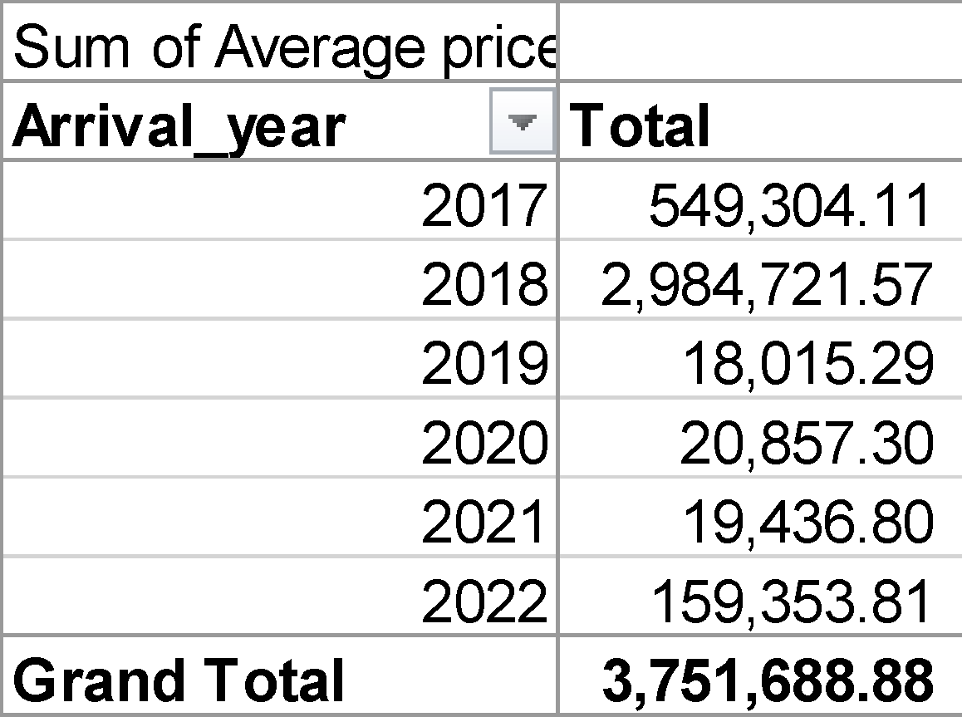
Figure 1: Pivot tables showing changes in the annual sum of the average price
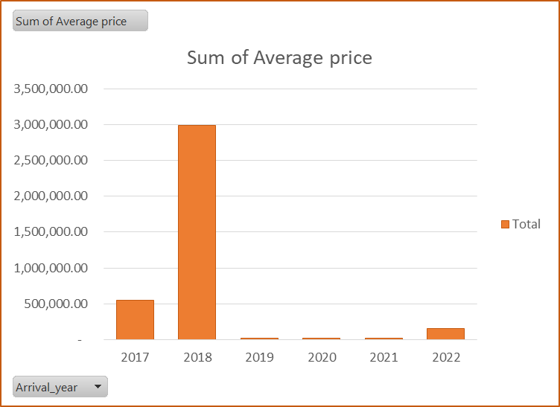
Figure 2: Bar chart showing the difference in the annual sum of the average price

Summary and Interpretation

Summary
In summary, the provided dataset is significantly large— it contains a total of 36,276 records associated with hotel reservations and other performance metrics. Based on such diverse variables under observations, the most notable metric has been that of average price for individual bookings. An analysis of the metric shows that there has been a general downward trend in terms of the annual total average price of the booking associated with the hotel. While the trend shows a general decline (see Figure 2 above), it is vital to acknowledge notable variations within the datasets. These variations have even been highlighted by the rapid increase in the total average price in 2018, accompanied by a rapid decline before a steady rise beetle 2020 and 2022.

Interpretation
Hotel prices do not change randomly; they occur due to the presence of numerous changes that may result in significant shifts in operations, thus a change in the pricing model. In the case of the provided reservation data, there are several factors that could have resulted in the rapid rise of the total average annual price of the bookings. For instance, an increase in the number of adult customers, a reduction in lead time, and increased capabilities to take in special requests. The presence of other external factors such as changes in tourism season and the capacity of the hotel to offer high-quality products and services to their guests could also be vital in shaping the increased demand for the hotel services in 2018.
While focusing on the rapid rise between 2017 and 2018, it is vital to recognize that the rise was not sustained in the subsequent year. This was characterised by the total value declining below those observed in 2017. This aspect of the result can be attributed to a wide range of factors, including sudden changes in the type of products, closure of critical hotel services, or a drop in the quality of the products. Similarly, the inability of the hotel to account for its diverse customers may result in a rapid decline. However, not all facets of the decline can be attributed to internal business operations; some of them have been due to external market characteristics. For instance, the increase in the presence of alternatives in the market may result in high competition— as such customers may be tempted to choose alternatives that offer services of similar quality at a relatively low cost. This explains the rapid decline in the number of reservations between 2018 and 2022.

1.2 Microsoft Excel for data preprocessing and analysis
So far, the need to collect data related to business operations and performance has been established and justified. However, the collected data cannot be sufficiently used for the decision-making process— this is due to the presence of different variations and potential errors or incomplete records that may be misleading (Nisbet et al., 2016). Based on this potential challenge, data preprocessing must be conducted to ensure all errors associated with the data are removed and the underlying dataset is presented in an understandable format (Paczkowski et al., 2021). According to Paczkowski et al. (2021), data preprocessing involves data cleaning, reduction, integration, and transformation for an error-free and effective analytics process. Given the observed importance of data pre-processing, it is vital to acknowledge that Microsoft Excel has unique tools and features that aid this process by removing incomplete, accurate, and inaccurate data values from business-related datasets (Lee & Peters, 2015). At the same time, the software has the potential to identify missing values for removal or replacement via various imputation techniques. Such capabilities have been known to leverage key Excel-based functions such as COUNTBLANK and IFERROR— these functions are used to play a critical role in the pre-processing process, especially data cleaning.
Upon completion of data preprocessing the analytic processes commences. In Microsoft Excel, this process is known for a high level of dynamism due to the presence of multiple functions and features that encourage multidimensional data analysis. According to Lee and Peters (2015), these tools are useful in creating accurate reports from a relatively large dataset. Based on this recognition, it is vital to acknowledge that the provided dataset is relatively large (More than 36,000 records), hence key summaries are essential for the data analysis and reporting processes. Despite their relative importance, they may not offer full insight into the specific variations in the datasets; hence the need to utilize other functions for better insights into the dataset. In this case pivot tables and charts, IF, and LOOKUP functions were used for the analysis.

1.2.1 Pivot tables and charts
Pivot tables are known for their simplicity and capability to provide key summaries from a large dataset. An analysis of their overall output shows their emphasis on providing a grid-like matrix with key classification of variables based on selected criteria. While focusing on the criteria of selection, it is vital to acknowledge the presence of pivot charts, whose function is to complement the developed pivot tables. Specifically, they provide a graphical representation of the data in pivot tables, thereby improving the decision-making process through visualisation. An analysis of their development shows that they take different forms ranging from bar charts to pie charts— their utilisation, therefore, varies with user preferences/ amidst these preferential variances, it is vital to acknowledge their capability to save time by allowing one to simultaneously analyse and visualise data based on the needs of the business.
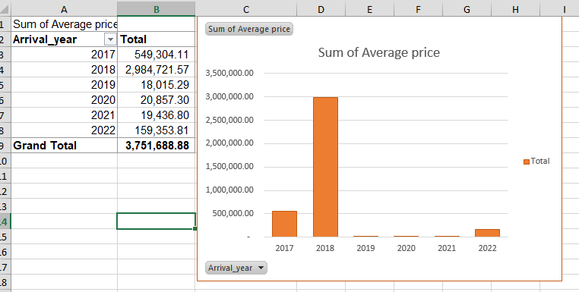
Figure 3: Pivot table and Chart in MS. Excel
As one focuses on the simplicity of pivot tables and charts dyeing data analysis, it is vital to recognize that not all facets of their use have advantages. According to Lee and Peters (2015), using pivot tables tends to be time-consuming, especially for first-time users. This disadvantage is often accompanied by the absence of automatic updates, especially in a system where new data is collected regularly. Regardless of these disadvantages, pivot tables are known to work well with database management systems, with emphasis on the segmentation of datasets based on specified categories. When combined with the underlying data visualisation elements, their benefit to data-driven decision-making is significant.

1.2.2 IF function
The dynamism behind pivot tables and charts indicates faster analyses and comparisons of specific variables in the dataset. This aspect of data analysis in MS Excel can also be achieved by using the IF function. The function is mainly designed to provide a comparison between two values if either of them is true or false— this comparative analysis is essential in data classification. Further analysis of its application shows that the function is highly flexible, hence can be used with various operations and other Excel functions for more dynamic insights into the dataset. Therefore, the specific variations of the function include the COUNTIF, SUMIF, and AVERAGEIF.
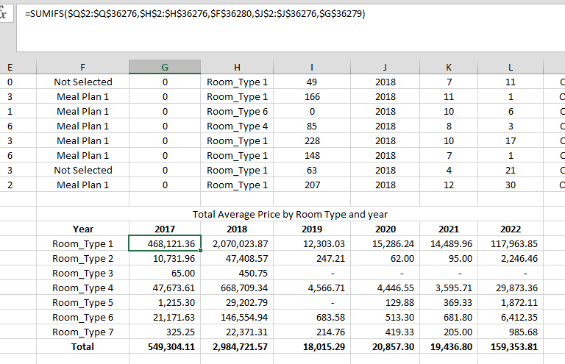
Figure 4: Example of it and sums if in data analysis

1.2.3 LOOKUP
Over the years, the LOOKUP function has been popular due to its dynamism in identifying specific features within a given dataset. According to Lee and Peters (2015), the LOOKUP function allows one to obtain a count or a specific value based on a specified array or vector in a dataset. An example of this application is where one needs to identify the average price based on a given Booking ID; as such the syntax =LOOKUP (BOOKING ID Value, the lookup vector, result vector) will be used (see figure 4 below). In this case, the function was tested in obtaining the unit price for booking ID INN03500, where a united price of 266.67 was obtained. Similarly, the function can be changed to determine the year and the date associated with the same booking ID— in this case, it was determined that the booking was done on 26th September 2018 (see figure 5 below).
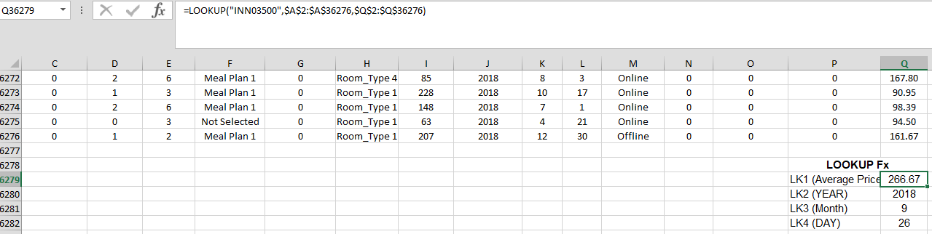
Figure 5: Basic data extraction using the LOOKUP function
The dynamism of the LOOKUP function, while critical, does not fully address all facets of the analysis. As a result, it was vital to resort to other variations of the function such as the HLOOKUP. HLOOKUP and VLOOKUP. The HLOOKUP focuses on identifying values within specified rows (H stands for horizontal) while VLOOKUP is known to identify values within a specified set of columns (V stands for vertical). XLOOKUP on the other hand, focuses on both rows and columns, regardless of the position of the result array or vector; hence a highly dynamic approach to data extraction and classification.

1.3 Data Visualization in Excel
While focusing on the different functions associated with Microsoft Excel, its data visualisation capabilities were observed. These capacities tend to be reflected when there is a need to summarise the dataset using different charts. In this case, there was a need to determine the variation in sales based on the types of rooms offered by the hotel. As a result, it was determined that room type 1 reached more processes across all years. The rest of the rooms had notable variabilities, depending on other dimensions of the business—this variation is indicated in Figure 6 below
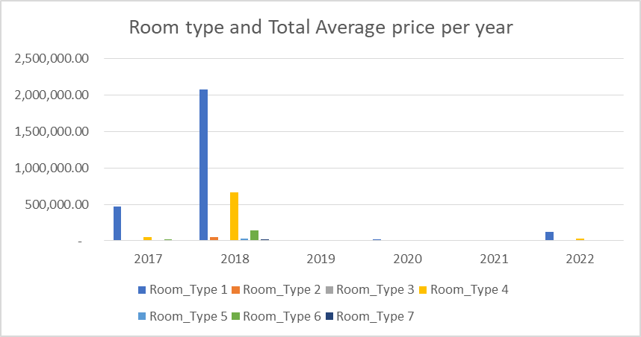
Figure 6: Variation in total annual average price based on room type

Part 2

2.1 Frequency distribution of genders
The dataset contained a total of 2133 records, reflecting the total number of participants in the test. Of the 2133 students, 50.5% were female (n=1077) and the remaining 49.5% were female (n=1056). This variation is how in the table below,
Table 1: Frequency distribution of gender
Gender
 |  | Frequency | Percent | Valid Percent | Cumulative Percent
Valid | Male | 1056 | 49.5 | 49.5 | 49.5
Valid | Female | 1077 | 50.5 | 50.5 | 100.0
Valid | Total | 2133 | 100.0 | 100.0

2.2 students who qualified or did not qualify for reduced/free lunch
As one focuses on gender distribution, it is critical to recognize that records on whether students qualified or did not qualify for reduced or free lunch were also collected. In this case, it was established that the majority of students who did not qualify for reduced/free lunch accounted for 57% of the total participants (n=1215). Where those who qualified for free/reduced lunch were concerned, they accounted for 43% of the total students (n=918). These variations are indicated in Figure 7 below.
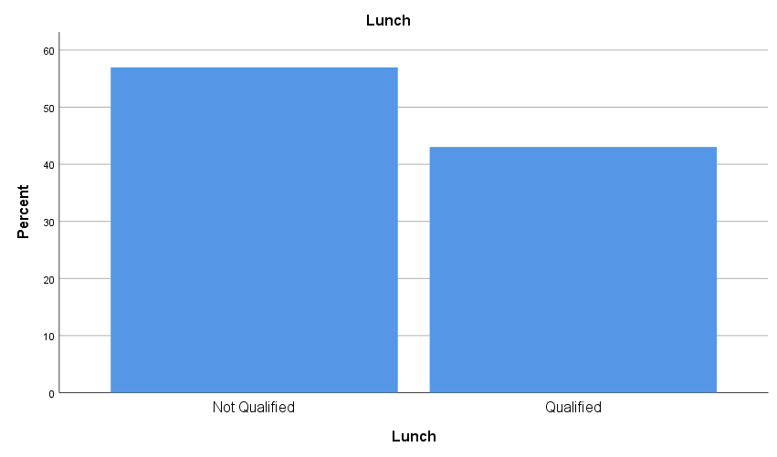
Figure 7: Variation in the number of students who qualified or did not qualify for reduced/free lunch

2.3 The mean and median of students who qualify or do not qualify for reduced/free lunch
An analysis of these variables shows that they are not numerical— they are categorical variables, hence one cannot obtain their mean using Microsoft Excel. Where SPSS is concerned, such variables can be coded using numerical values, thereby providing statistical summaries such as mean and median. In this case, the mean of the variable was found to be 0.43, and a median of 0.00 was recorded.
Table 2: Mean and Median
Statistics
Lunch
N | Valid | 2133
N | Missing | 0
Mean |  | .43
Median |  | .00

2.4 K-Means Clustering
K-means clustering is primarily based on the idea that observations do not occur in isolation; rather they belong to a group or cluster that is of the nearest mean. Such observation cannot be made using the traditional data analysis techniques— often it is done using machine learning algorithms are not the only approach to performing K-Means clustering; In SPSS one can achieve this objective by selecting the classify option in the analyze menu. Prior to selecting this option, it is vital for one to obtain a descriptive dataset and the underlying standardized values. In this case, the key values that were standard include the lunch variable, pretest, and posttest scores.
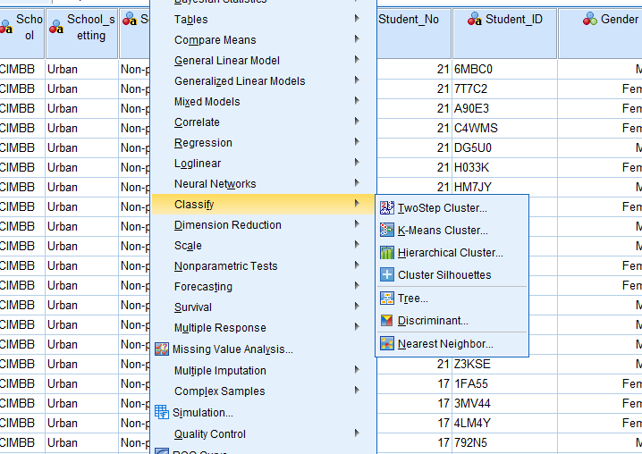
Figure 8: Selecting the K-Means clustering
Once the standardised values have been obtained, one selects the K-Means option, separates the variables based, using the obtained Z-scores (standardised values), and defines the number of clusters— in this case, 3 clusters were selected. Under the options sub-menu, ANOVA is selected for more insights into the variations in the dataset.
Based on the obtained process, the data showed that the first cluster had a total of 687 cases, with the second and third clusters having 961 and 485 members respectively. Each of these clusters had significant variables, especially where the pretests and post-test scores were concerned. In the first and third clusters, the pretests and posttests were significantly lower compared to the second cluster. These variations were accompanied by changes in student numbers and their qualification for reduced lunch. In the case of the ANOVA model, the differences in the observed clusters were found to be statistically significant.
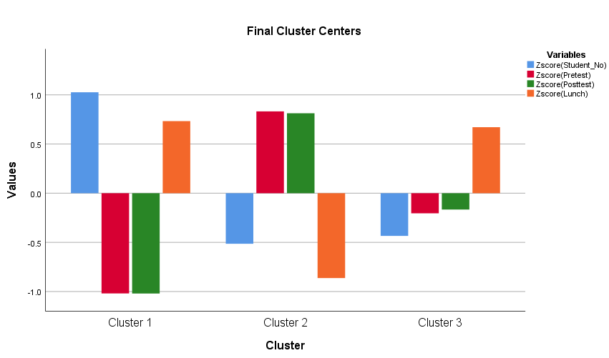
Figure 9: K-Means clusters
Table 3: ANOVA for the difference in Clusters
ANOVA
 | Cluster |  | Error |  | F | Sig.
 | Mean Square | df | Mean Square | df | F | Sig.
Zscore(Student_No) | 534.409 | 2 | .499 | 2130 | 1070.644 | .000
Zscore(Pretest) | 699.586 | 2 | .344 | 2130 | 2033.384 | .000
Zscore(Posttest) | 681.608 | 2 | .361 | 2130 | 1888.472 | .000
Zscore(Lunch) | 651.409 | 2 | .389 | 2130 | 1673.338 | .000
The F tests should be used only for descriptive purposes because the clusters have been chosen to maximise the differences among cases in different clusters. The observed significance levels are not corrected for this and thus cannot be interpreted as tests of the hypothesis that the cluster means are equal.

2.5 common data mining and text mining methods in today’s business
Decision tree: this is a data mining technique commonly studied and adopted when utilising machine learning algorithms. It focuses on the interaction between a given input and its output by deploying the noted IF rules. Through this approach, the influence of specific inputs on specific results or business-related variables can be identified (Fuller et al., 2011).
Sequential patterns: this approach has significant similarities with the decision tree method of data mining. However, it focuses often on patterns or sequences taking place within a given dataset. Based on its interactive model, it has been widely adopted in mining for transactional data, especially where customer expenditure and product are concerned (Fuller et al., 2011)— consider the underlying recommended systems for e-commerce platforms to aid in maximising sales.
Long-term memory processing: similar to the decision tree method, this approach to data mining has had numerous applications in situations where machine learning has been adopted. The main purpose of this adoption has often been to analyse data over long periods of time, thereby allowing businesses to account for time-based patterns in their sales or operations (Fuller et al., 2011). For instance, a fashion store may utilise this approach to identify the changes in sales based on climate and type of clothing. At the same time, it provided key probabilities associated with the observations, hence crucial for integrating predictive analytics.
Outlier Detection: this data mining method allows the business to move away from generalised patterns in the dataset by accounting for discrepancies in the collected data. Specifically, it is often utilised to identify key anomalies in the dataset, thereby allowing one to derive accurate predictions for the business (Gaikwad et al., 2014). An example of its use is when there is a sudden spike in monthly sales without any possible cause; this approach can be used to determine whether such a sudden change can be replicated in the future.
Association: this is a data and text mining technique that focuses on determining key patterns in a given data with special attention to the attributes that connect such occurrences. It has been commonly used in e-commerce platforms to determine the likelihood of a customer purchasing two related products based on their history and existing market trends (Gaikwad et al., 2014).

2.6 advantages and disadvantages of using SPSS and Excel
The provided dataset has been key to identifying data processing capabilities associated with SPSS and Microsoft Excel. During this process, the uniqueness of each software was identified based on its capacity to create a visual representation and handle different facets of the dataset. While focusing on such variations, it was vital to acknowledge the different advantages and disadvantages associated with each software (see the table below).

Table 4: Advantages and Disadvantages of using Excel and SPSS:
SPSS | Microsoft Excel
It has the capacity to store datasets within a specific environment. Similarly, it has the potential to access data remotely, making it possible for business to achieve their objective, with minimal potential for data corruption | The software is designed to ensure that data can be stored and managed within the same computer or connected environment. However, the approach tends to be prone to data corruption, especially in areas where multiple personnel are allowed to edit the data.
The software is primarily oriented towards data analytics. As such its capacity to accommodate data entry is highly limited by the need to define different characteristics of the data. Nevertheless, it ensures accuracy in data presentation and analysis. | Microsoft Excel is popular for its simplicity in data entry, storage, and management. There is no need to provide additional information associated with the values, hence easy to use, especially in small to medium-scale business settings.
SPSS is known for its fast approach to data manipulation, especially where complex analytic processes such as K-Means, ANOVA, and Regression are needed. As a result, it adheres to general guidelines associated with statistical analysis as defined by IBM. | Excel is known for its dynamism, in the manipulation of both financial and non-financial data. This implies that it is guided by the principles behind different data analysis processes. However, its approach to advanced analytics is rather time-consuming,

Conclusion
Data analytics is increasingly becoming essential in modern business due to its potential to aid in the decision-making process. This need has seen more companies collect voluminous data through different approaches. While focusing on the presence of data, it is vital to acknowledge the presence of key software that can aid in data manipulation (analysis) and interpretation. In this case, it was found that Excel and SPSS have unique functions and formulas that have eased the analytical process. However, each software is efficient in different facets of analysis, hence the need to account for the specific type of information before deploying them in a business setting.

References
Alsghaier, H., Akour, M., Shehabat, I. and Aldiabat, S., 2017. The importance of big data analytics in business: a case study. American Journal of Software Engineering and Applications, 6(4), pp.111-115.
Brynjolfsson, E., Hitt, L.M. and Kim, H.H., 2011. Strength in numbers: How does data-driven decision-making affect firm performance? Available at SSRN 1819486.
Fuller, C.M., Biros, D.P. and Delen, D., 2011. An investigation of data and text mining methods for real-world deception detection. Expert systems with applications, 38(7), pp.8392-8398.
Gaikwad, S.V., Chaugule, A. and Patil, P., 2014. Text mining methods and techniques. International Journal of Computer Applications, 85(17).
Lee, N. and Peters, M., 2015. Business statistics using EXCEL and SPSS. Sage.
Nisbet, R., Miner, G. and Yale, K., 2016. Handbook of Statistical Analysis and Data Mining Applications.
Paczkowski, W.R. and Paczkowski, W.R., 2021. Basic Data Handling. Business Analytics: Data Science for Business Problems, pp.57-83.
Richards, G., Yeoh, W., Chong, A.Y.L. and Popovič, A., 2019. Business intelligence effectiveness and corporate performance management: an empirical analysis. Journal of Computer Information Systems, 59(2), pp.188-196.

