Software Solutions for Business
Component 1 Coursework Portfolio
Business Scenario Corner Cup Café
Programme | CertHE Computing Skills for Workplace
Module | Software Solutions for Business
Module code | ACCA4026
Lecturer | Dr Anum Paracha
Assessment | Component 1 Coursework Portfolio
Submission deadline | 3 December 2026, 2 pm
Student name | Faiza Zarroug
Student ID | 2609359
Campus | University of wales st trinity david
Word count | 4000 words

Table of Contents
Introduction 3
Task 1. Website Builders for Ecommerce 4
1.1 Wix 4
1.2 Square Online 4
1.3 Comparison in a Business Context 4
Task 2. Mind Mapping 6
2.1 The Mind Mapping Technique 6
2.2 Mind Map for Launching Corner Cup Café 6
Task 3. Office Applications 9
3A.1 Microsoft Word 9
3A.2 Microsoft PowerPoint 9
3A.3 Microsoft Access 10
3B.1 Practical Test One. The IF Function 10
3B.2 Practical Test Two. The VLOOKUP Function 11
Task 4. Communication and Collaboration Applications 14
4.1 Communication Application. Slack 14
4.2 Collaboration Application. Trello 14
4.3 Practical Test Three. Slack Channels and Threads 14
4.4 Practical Test Four. Trello Boards, Due Dates and Checklists 16
Conclusion 18
References 19

Introduction
This portfolio evaluates a range of software applications through the lens of Corner Cup Café; a small independent café used as one consistent business scenario across all four tasks. Small businesses now rely on digital platforms to sell products, organize and plan their workforce, and it has been proven that the percentage of SMEs surviving thanks to the implementation of e-commerce increased during the Covid pandemic [1]. Team messaging also defines how coordination takes place each day, as the set-up of common channels is going to determine how employees share information and how they can accomplish project work [2]. Task 1 involves comparing two freely available website builders and evaluating their appropriateness to a start-up food business that has a low budget. Task 2 describes the mind mapping technique and goes ahead to apply it to the opening of a cafe using an original mind map. Task 3 reviews Microsoft Word, PowerPoint and Access before presenting practical evidence of the Excel IF and VLOOKUP functions. Task 4 evaluates Slack as a communication tool and Trello as a collaboration tool, supported by simulated practical tests using invented data. Throughout the portfolio, each application is evaluated in relation to productivity, workflow, communication, decision-making, and information management instead of being a description of the application.

Task 1. Website Builders for Ecommerce

1.1 Wix
Wix was launched in 2006 in Tel Aviv by Avishai Abrahami, Nadav Abrahami and Giora Kaplan, with the aim of letting people without coding skills build websites. Its target market comprises both sole traders and expanding companies, and they provide more than 2,000 templates, a drag-and-drop editor and in-built SEO features. Integrations are supported via the Wix App Market, which allows a business to add bookings, reviews or email marketing without any programming. According to the usability testing, a Wix store was rated most accurate in accomplishing tasks, but it was the least satisfying, with a score of three builders, due to their rich design features that created cluttered pages [3]. This finding matters for a café, since customers ordering a lunchtime coffee need fast navigation rather than visual complexity. The decisive limitation for selling lies in the free plan, which carries Wix branding, uses a wixsite.com address and blocks every form of online payment [4]. Accordingly, Wix provides good customization and scalability with paid plans, but a cafe will be able to accept online orders only on a Core plan or beyond.

1.2 Square Online
Square Online was based on Weebly, which was a builder developed in 2006 by David Rusinko, Chris Fanini and Dan Veltri and later acquired by Square to integrate online and in-store sales. Its clients are small stores and food establishments already accepting card payments via square point-of-sale terminals at the checkout. In contrast to Wix, the free option allows selling online with Square charging a processing fee on every card transaction in place of a monthly subscription [5]. The store developed with the help of Weebly demonstrated high accuracy of the tasks performed and got the augmented satisfaction score as compared to the store developed using Wix as a part of the same comparative usability study [3]. Nevertheless, free sites display Square advertising, use a Squaresite address and offer fewer templates and layout controls than Wix. Payments must also run through Square, which limits flexibility for a growing business that later wishes to compare payment providers.

Square Online is my choice over Wix because Square Online matches the needs of a café. Square Online offers an clear way to sell items online. Unlike Wix Square Online lets a business take payments on its free plan. This means a new café can start selling without paying a fee. That helps a café with a budget. Square Online also works with Square’s point‑of‑sale system. Because of this a café can handle online. Store sales together making order handling easier and cutting down on paperwork. A usability study found that customers were more satisfied with the Square Online store than with a Wix store. That suggests Square Online gives a shopping experience. Square Online has design choices and shows Square branding on the free plan but those limits are okay. For a café how it works, how cheap it. How easy it is matter more, than fancy design. Therefore, Square Online lets the café start taking orders with little upfront cost while giving the essential tools to serve customers well.

1.3 Comparison in a Business Context
For a startup café, the stronger business argument favors Square Online, because it allows revenue from the first day without fixed monthly costs [5]. The pandemic demonstrates that SMEs using third-party platforms have survived, in contrast to companies that used self-built websites, which cost a significant amount [1]. Square Online is not an exception to this trend, because the café does not outsource developers, but instead provides hosting and security, which it manages itself. In contrast, Wix has better design freedom and an app ecosystem, which is better suited to a café that focuses on brand image or further growth [4]. Its free plan works well as a marketing brochure, yet paying for a Core plan becomes unavoidable once online orders begin. Thus, Square Online represents the better low-risk entry point, whereas Wix becomes preferable when customization and scalability outweigh short-term cost.

Task 2. Mind Mapping

2.1 The Mind Mapping Technique
A mind map is a visual note-making technique that places one central idea in the middle of a page and radiates related ideas outward. The main idea is the key problem or objective, and primary branches illustrate key themes, while sub-branches refine each theme into further detail. The short keywords used in every branch instead of a sentence make the map very succinct and encourage the thinker to think associatively and organize ideas better. The ability to visualize the topic by color, spacing and bundling enables a reader to visualise an entire topic at a glance, and this aids in planning as well as brainstorming. The radial layout can be used in problem solving so that one can follow a case of a solution and the options to use without pushing the ideas into early order. A randomized trial using students in respiratory therapy observed that mind mapping effectively increased the scores of critical thinking, but standard notetaking had no significant increase [6]. This fact indicates that the method not only reinforces memory but also reason-making, hence its increasing application in planning at the workplace. Digital mind mapping tools now extend the paper method, allowing branches to be moved, color-coded, and shared with colleagues working in different locations. The key strengths are accelerated idea generation, better views of complex projects and increased recall of information in varied learning conditions. Mind maps are also applicable in group workshops, as each member is able to add branches and view, in real time, relationships among personal ones. However, the method has evident drawbacks when applied in business, especially when a plan needs to be sequenced accurately, or is costly or held accountable. Branches are associated without being ordered, so a mind map cannot substitute a timeline, a budget or an official project schedule. Large maps also become cluttered quickly, and their meaning can stay unclear to readers who took no part in creating them. Furthermore, the respiratory therapy evidence came from students over fifteen weeks, so results from education can not transfer directly to commercial teams [6].

2.2 Mind Map for Launching Corner Cup Café
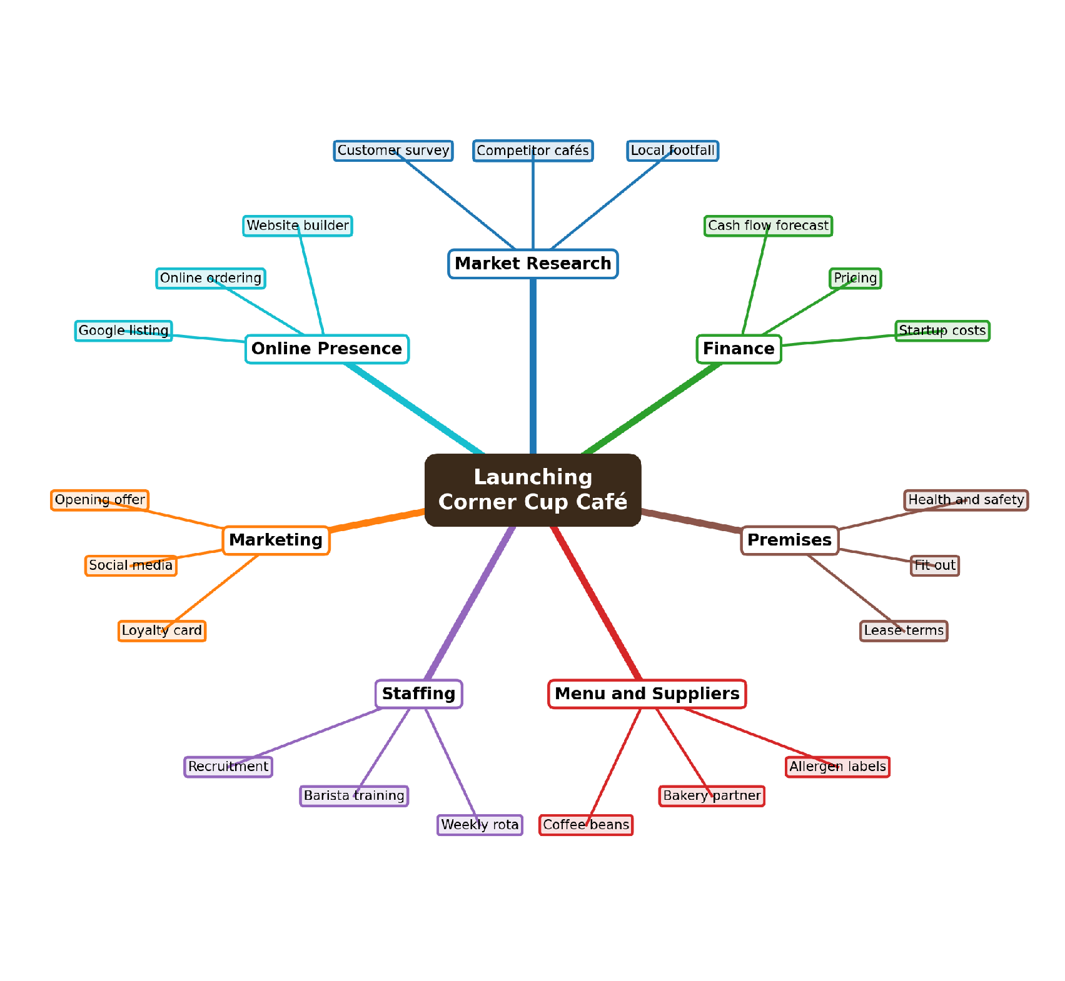
Figure 1: Mind map for launching Corner Cup Café, a small independent café
The central topic, Launching Corner Cup Café, represents the single goal that every planning decision in the plan must ultimately support. Seven key divisions were chosen since these divisions reflect the fundamental operations of any new food enterprise, i.e. market research, finance, premises, menu and suppliers, staffing, marketing and online presence. The branch of finance is connected to the start-up costs and the price and a cash flow projection, which an owner would typically form in Excel. Spreadsheet models frequently contain faults that distort decisions, so the map flags this branch as needing careful checking before any figures are trusted [7]. This online presence branch is directly related to Task 1, since deciding on a website builder is a necessary aspect of the launch plan. Sub-branches under staffing and marketing can then be translated into specific tasks, which a team can put on a Kanban board to track. The number of keywords was limited to two or three words in each sub-branch, meaning that the owner can easily scan the entire plan in a matter of seconds in the middle of a working day.
The map, as a planning tool, provides the owner with one overview of the interdependent decisions; thus, the risk of missing areas, like allergen labelling, is minimal. It also gives a point of reference to a small stock, as every individual can see the branch that he/she has got and that which connects to the objective. Accountability in a group can then be enhanced by translating the branches into allocated tasks done on a collaborative board. However, the map is an immutable snapshot which displays no deadlines, no costs or dependencies between multiple branches. Therefore, the mind map is best suited as the initial phase in the planning and the café would require a budget, a schedule and a risk register prior to opening. For this reason, the café owner should treat the map as a living document and revisit it whenever research findings or costs change.

Task 3. Office Applications

3A.1 Microsoft Word
The Microsoft Word program can be used to prepare documents with templates, styles, tables, references and mail merge, which would enable a cafe to create menus, contracts and letters with a similar professional look. Styles and automatic tables of contents save time, because a change to one heading style updates every matching heading across the whole document. Changes and comments tracking leave an audit trail of edits that allow an owner and an accountant to verbally agree on contract terms, without losing previous versions. In Microsoft 365, subscribers are able to collaboratively work in real-time and view co-workers editing documents, unlike those using older versions who had to save their work to share the changes [8]. Such a difference is critical in the case of a small business, as it is possible to experience real-time collaboration only when having to pay a subscription, but not when having a single licence. Coauthoring also requires files stored in OneDrive or SharePoint, and it remains unavailable for documents protected by rights management. Word stays weak for numerical analysis or structured records, so tasks such as stock control belong in Excel or Access instead. A more efficiency benefit, though, is provided by mail merge, where a single letter template can be used in combination with a customer list to personalise hundreds of loyalty offers within minutes. However, merged mailings require clean source information, and thus, duplicate or misspelt records on the list would be repeated in all printed letters. Altogether, Word is an excellent business writing tool, yet its collaborative feature depends on cloud storage and licensing options. Therefore, in the case of a cafe, Word is recommended for the menu, in the staff manuals and in the letter to the suppliers, and the current operational information would be in the tools that can be used to calculate and store it.

3A.2 Microsoft PowerPoint
Microsoft PowerPoint enables businesses to communicate ideas visually through templates, charts, multimedia, animations and speaker notes within a single file. In the case of a cafe, a short deck can be given to employees to work with a seasonal menu or offer to a bank manager to provide funds. Presenter View shows the current slide, the next slide and private notes on the speaker's screen while the audience sees only the slides [9]. This makes it easy to deliver and provides confidence, as the presenters can use prepared notes but do not have to read the text on a projected slide. Cloud storage also enables multiple personnel to make amendments in a single deck, a factor that minimises version mix-ups just before a crucial communication with investors or suppliers. However, template bullet point defaults promote text-rich slides, which can undermine clarity on the part of the presenter and the audience. A study among engineering students discovered that students who have designed assertion evidence slides have experienced reduced cognitive workload when compared to students who have depended on traditional PowerPoint templates [10]. Hence, PowerPoint is most useful when users create deliberate default override layouts, and its advantage should rely on the design ability rather than the programme itself. For a small café with no design specialist, using a few strong images and short sentence headlines would communicate a menu launch more effectively than dense bullet lists. In larger organisations, brand templates protect visual consistency, although they can also lock staff into the same text-heavy layouts.

3A.3 Microsoft Access
Microsoft Access is a relational database management system whereby data are stored in interconnected tables, can be accessed using queries, as well as be displayed using forms and reports. Relationships between tables, such as customers, orders and products, prevent the duplication that occurs when one large spreadsheet holds every record. Forms simplify data entry and improve data accuracy for staff, and transform unstructured records into printable options for managers. In the case of a small cafe, it is possible that Access would be able to track the deliveries of suppliers, stock levels and people with loyalty cards in a single structured and searchable file. The structure provides a more secure option compared to a spreadsheet, which, according to a large review of the literature, is often flawed when applied in making business decisions [7]. However, Access databases cannot exceed 2 GB, and Microsoft has placed a limit of 255 parallel users [11]. Building a sound database also requires design knowledge, including normalisation and relationship rules, which many small business owners lack. Therefore, Access will be a great fit in a one-site venture where the data will be modest, but an expanding chain would be better served by a cloud database or a specific stock system. Access is also only available as part of some Microsoft 365 business plans, an additional cost to license which is unnecessary since the café could already use free spreadsheet tools. Based on the above information, an Access adoption choice must be based on the level and quantity of records and not on knowing or using Microsoft products. A sensible path for a new café would start with a well-structured spreadsheet and move to Access only once customer and stock records grow beyond easy manual checking.

3B.1 Practical Test One. The IF Function
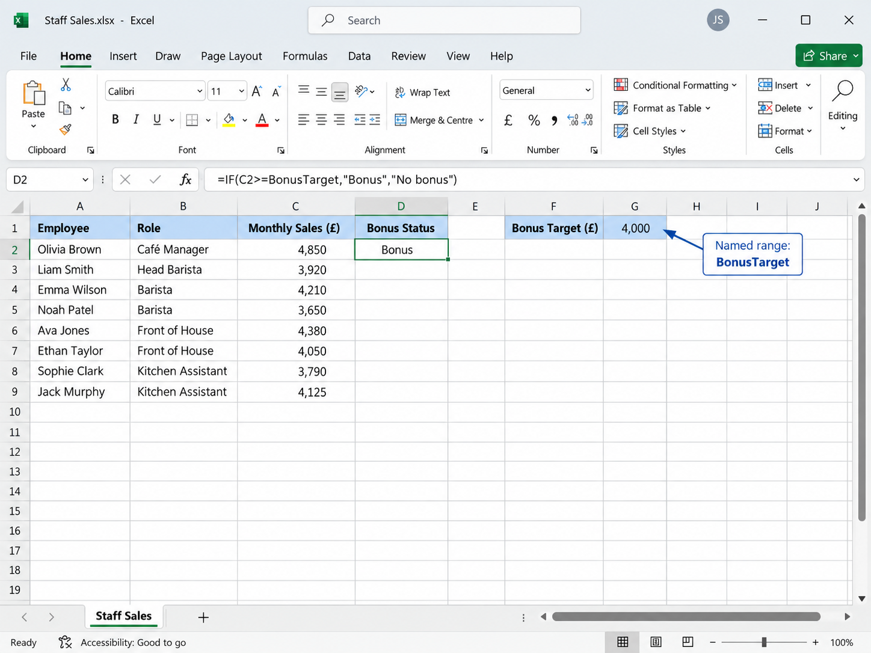
Figure 2: Staff sales data with the IF formula entered in cell D2
For the first practical test, I created a simulated staff sales sheet for Corner Cup Café containing eight invented employees, their roles and monthly sales. I stored the monthly bonus threshold of £4,000 in a separate cell and named it BonusTarget, so the rule could change without editing any formula [12]. In cell D2, I entered an IF formula that compares each employee's sales with Bonus Target and returns Bonus when the target is met. The IF function performs a logical test and returns one value for a true result and a different value for a false result [13]. I chose this feature because bonus decisions follow a clear yes or no rule, which makes manual checking slow and inconsistent across a team. Figure 2 shows the starting data together with the formula in the formula bar, which provides evidence of the logical test being applied. Using a named cell rather than typing 4000 inside the formula follows good spreadsheet practice, because every assumption remains visible and editable in one place. This design choice also supports decision making, because the owner can test a higher or lower target and instantly see the effect on the number of bonuses paid.
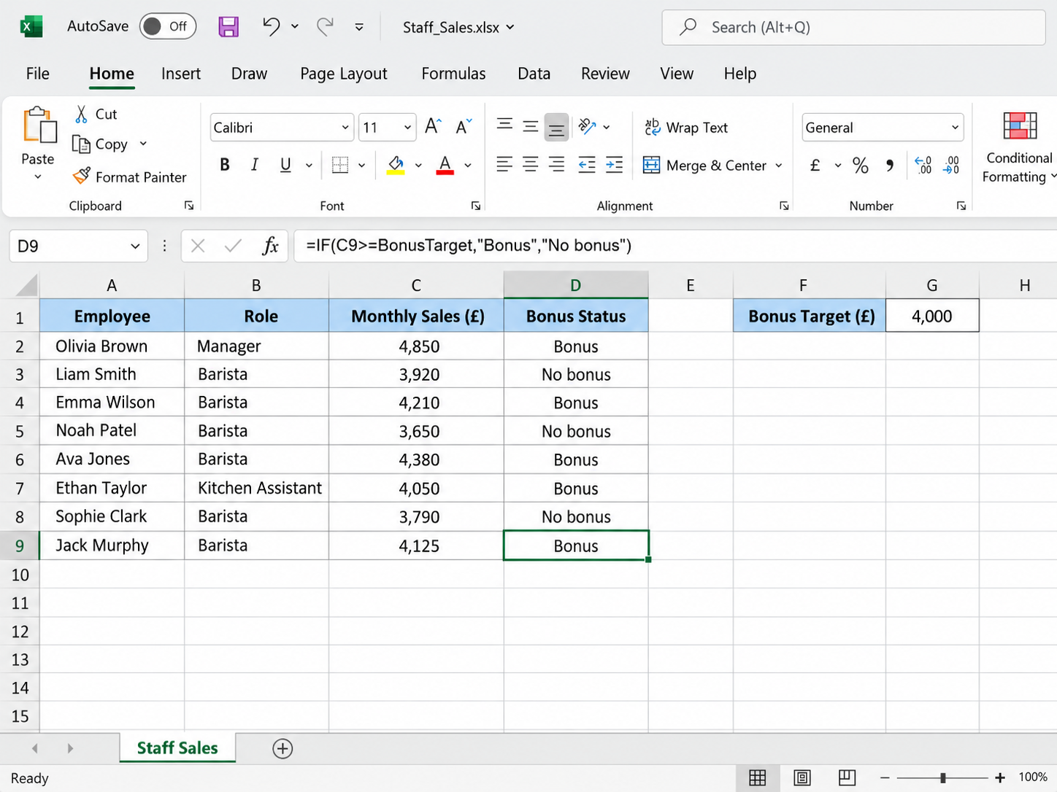
Figure 3: Bonus results after copying the IF formula down column D
For the first practical test, I created a simulated staff sales sheet for Corner Cup Café containing eight invented employees, their roles and monthly sales. To enable the rule to be varied without altering any formula, I put the monthly bonus threshold of £4,000 in a different cell and labelled it Bonus Target [12]. I entered an IF formula in cell D2 and compared sales of each employee with Bonus Target and provided a bonus when the target is achieved. The IF function performs a logical test and returns one value for a true result and a different value for a false result [13]. The reason why I selected this feature was that bonus decisions are made based on a definite yes/no principle, and it becomes tedious and inaccurate to do this by hand, especially within a team. An example of evidence of the logical test being used can be seen in Figure 2, where the starting data are known, and the formula in the formula bar gives evidence of a logical test being performed. Using a named cell rather than typing 4000 inside the formula follows good spreadsheet practice, because every assumption remains visible and editable in one place. The design option is also helpful to decision-making, as the owner has the opportunity to experiment with a higher or lower target and immediately see what happened to the number of bonuses paid.

3B.2 Practical Test Two. The VLOOKUP Function
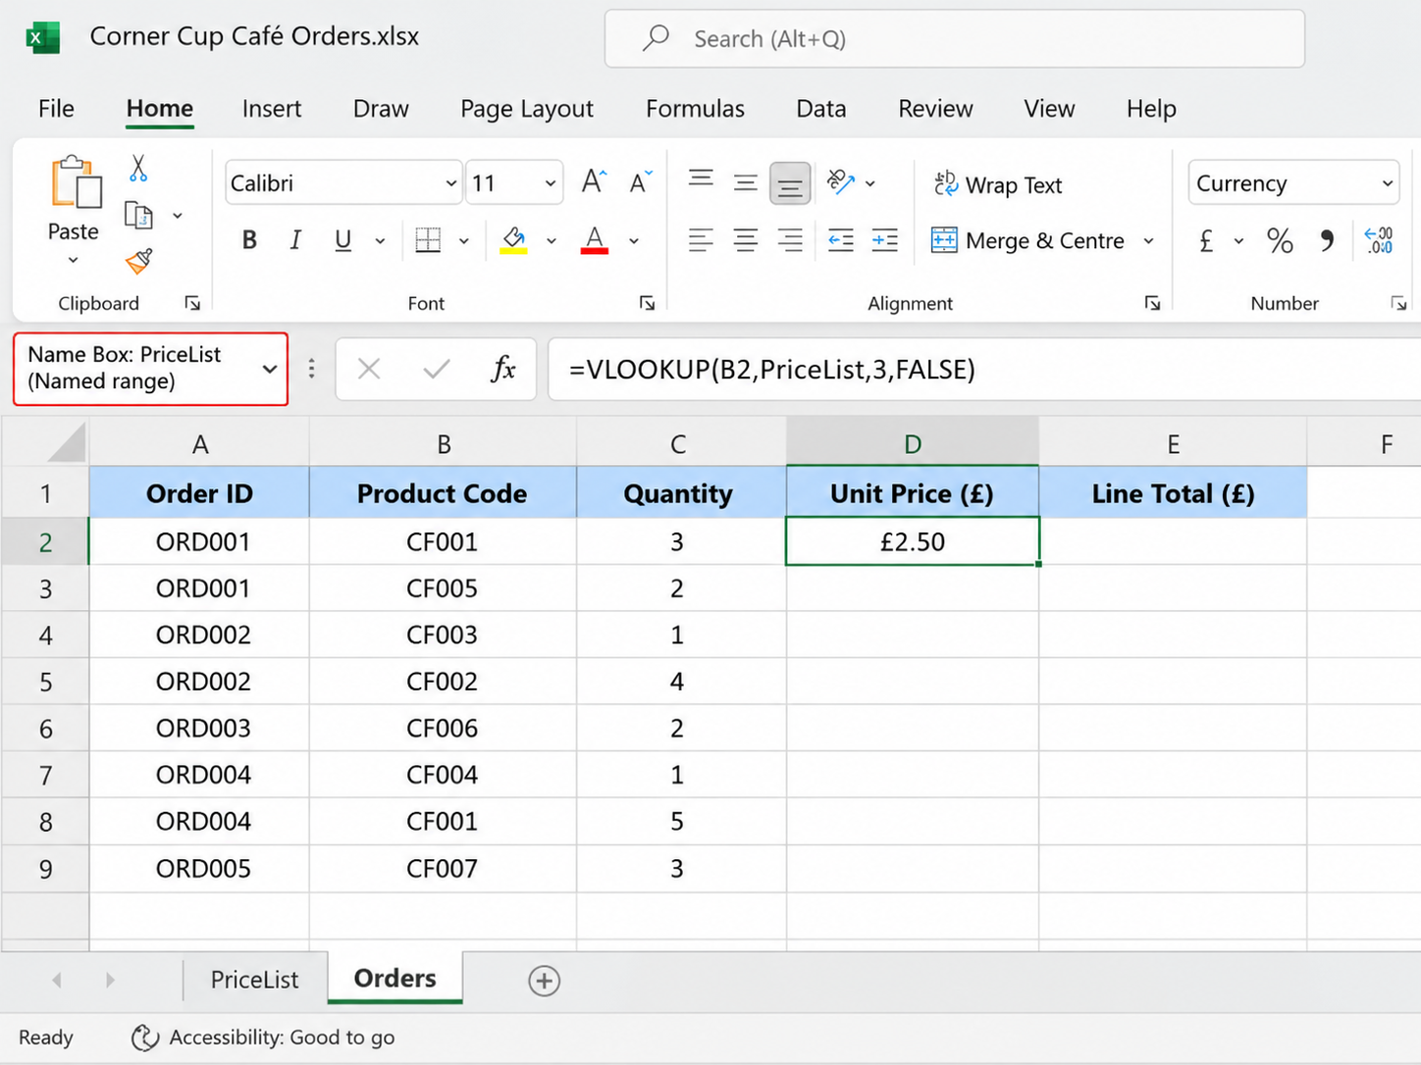
Figure 4: Order sheet with the VLOOKUP formula referencing the PriceList named range
For the second test, I built a simulated price list of eight café products and a separate order sheet listing product codes and quantities. I selected the price list and typed PriceList into the Name Box, which created a named range that reads more clearly than cell addresses [12]. I typed a VLOOKUP formula in D2 of the order sheet, which would search the PriceList for the product code and the unit price corresponding to the code. I assigned the last argument a value of FALSE, as Microsoft recommends this to ensure an exact match each time the first column in the lookup table is not sorted [14]. Fig. 4 illustrates the order data along with the formula; column E is the product of quantity and unit price to create each line total in column E. I chose VLOOKUP because retyping prices for every order wastes staff time and creates avoidable keying errors at busy periods. It is also a good design principle to keep the price list and the orders apart, as the reference data and the transaction data are useful fields of different types and have different change rates. Since the named range includes the columns with the product code, the product name and the unit price, the column index three makes Excel find the price instead of the product name in the specified columns.
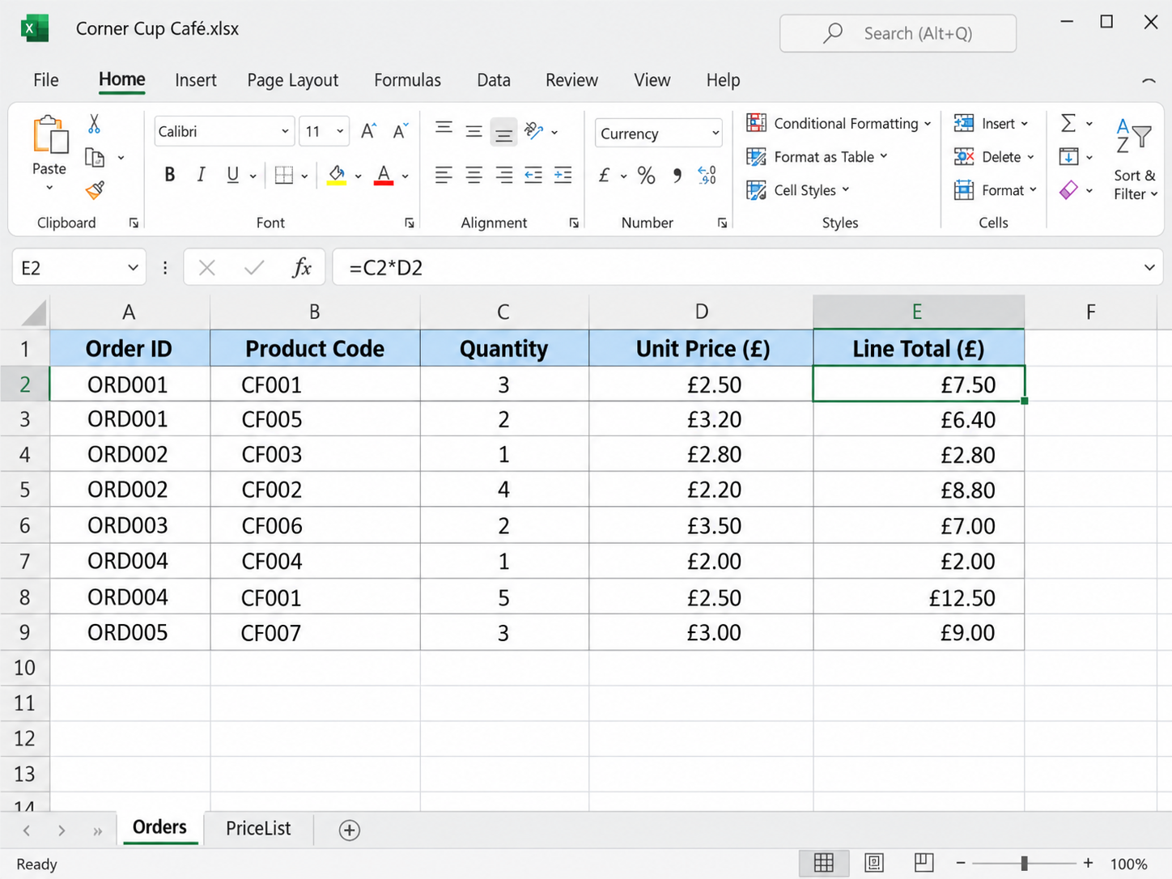
Figure 5: Completed order sheet showing unit prices and line totals
After copying the formula down, every order line displayed the correct unit price and line total, as Figure 5 confirms. An example of suppliers who could have their invoices done using this approach would be a cafe that has menu costing or loyalty discounts, as a single central price list will be used to supply all the calculations. When a price is changed, the manager only needs to edit one cell, and all associated orders are changed, which enhances both speed and accuracy. Storing the workbook in OneDrive would also allow staff to coauthor it, so a shared price list stays current across several devices. However, when typed-in code is incorrect, VLOOKUP would report an error, and it would only look at the first column of the chosen range [14]. These limitations imply that lookup formulas still need some data validation and low-frequency analysis, particularly where target pricing decisions are made using the results. Overall, both tests show that Excel functions automate routine judge ments, yet their reliability depends on careful design and testing. To test robustness, I entered an invalid product code in a row and received the error message, which proved that in the exact match setting, the wrong price does not show up without any error message. In practice, adding a drop-down list of valid codes through data validation would stop such mistakes at the point of entry.

Task 4. Communication and Collaboration Applications

4.1 Communication Application. Slack
Slack, released publicly in 2014, is a cloud-based communication platform which displays messages by channel (by topic), by project or team and direct messages and file sharing. A study of over four thousand Slack channels in a multinational firm identified distinct channel types, such as project, support and event channels, and linked communication styles to team performance [2]. In the case of a café, changes of rote, supplier problems and daily specials could be channel led, and this minimizes the use of dispersed personal text messages. The notifications in the form of integration with calendars and file storage (as well as other applications) also enable receiving a notification in a single place, instead of a collection of open inboxes. However, the free plan will automatically delete all messages and files older than one year as well as restrict an individual workspace to ten apps that can be installed [15]. Therefore, Slack would be an excellent tool to use in quick daily coordination, but it should not be set as the permanent record of key decisions made in the cafe. In comparison to email, Slack makes life less formal and reduces time-to-response, which is a sound approach among shift-based teams that spend little time at a desk. In contrast, constant notifications can interrupt staff during service, so the café would need clear rules about urgent and non-urgent channels.

4.2 Collaboration Application. Trello
Trello is a web-based collaboration tool built on the Kanban method, in which cards representing tasks move across lists such as To Do, Doing and Done. All cards can be described and include checklists, attachments, comments, labels and due dates, helping the entire team have a visual representation of progress. In the case of a cafe, a launch plan generated in Figure 1 can be handled by a board that can transform every branch of a mind map into activity that can be followed by the staff. The free version is only appropriate with extremely small teams, since Atlassian limits the number of people that should collaborate in a free workspace [16]. Therefore, Trello is fit to be used in a cafe with a small core team, but a bigger company will require a paid plan or a higher-level project tool. Trello is also compatible with mobile devices, which is important to staff members of the cafe who look at their tasks in between serving a customer instead of at a computer. Its simplicity remains both its strength and its weakness, because it lacks the budgeting and resource planning features found in dedicated project software.

4.3 Practical Test Three. Slack Channels and Threads
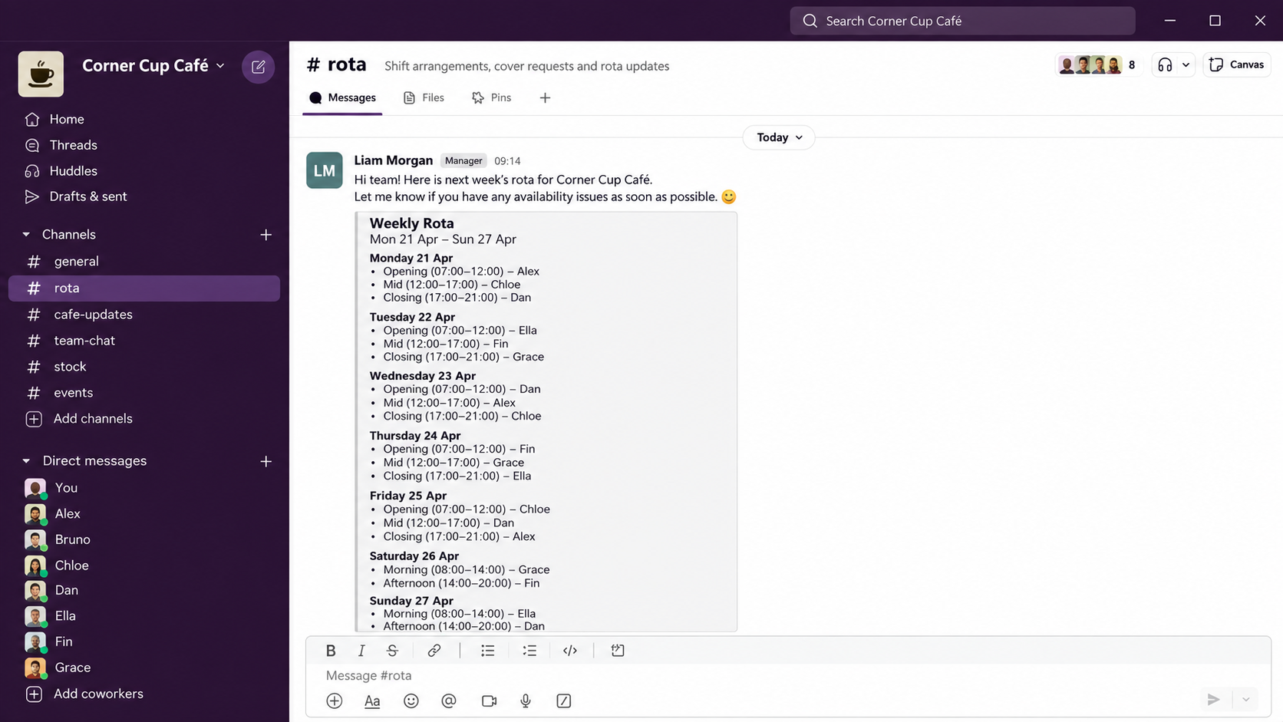
Figure 6: Corner Cup Café Slack workspace showing the rota channel and posted rota message
For the first practical test, I made a free Slack workspace, which I named Corner Cup Café and a public channel, where I will arrange shifts, named rota. I wrote out an imitation weekly example rota using fictitious staff names, therefore, no authentic, personal or business confidential data was present in the test. As can be seen in Figure 6, the rota channel has been posted, and the message displayed in the channel proves that the schedules are displayed in one consistent location to all the staff employees. Creating the channel took less than two minutes, which suggests that a small business could adopt the tool without formal training or specialist support.

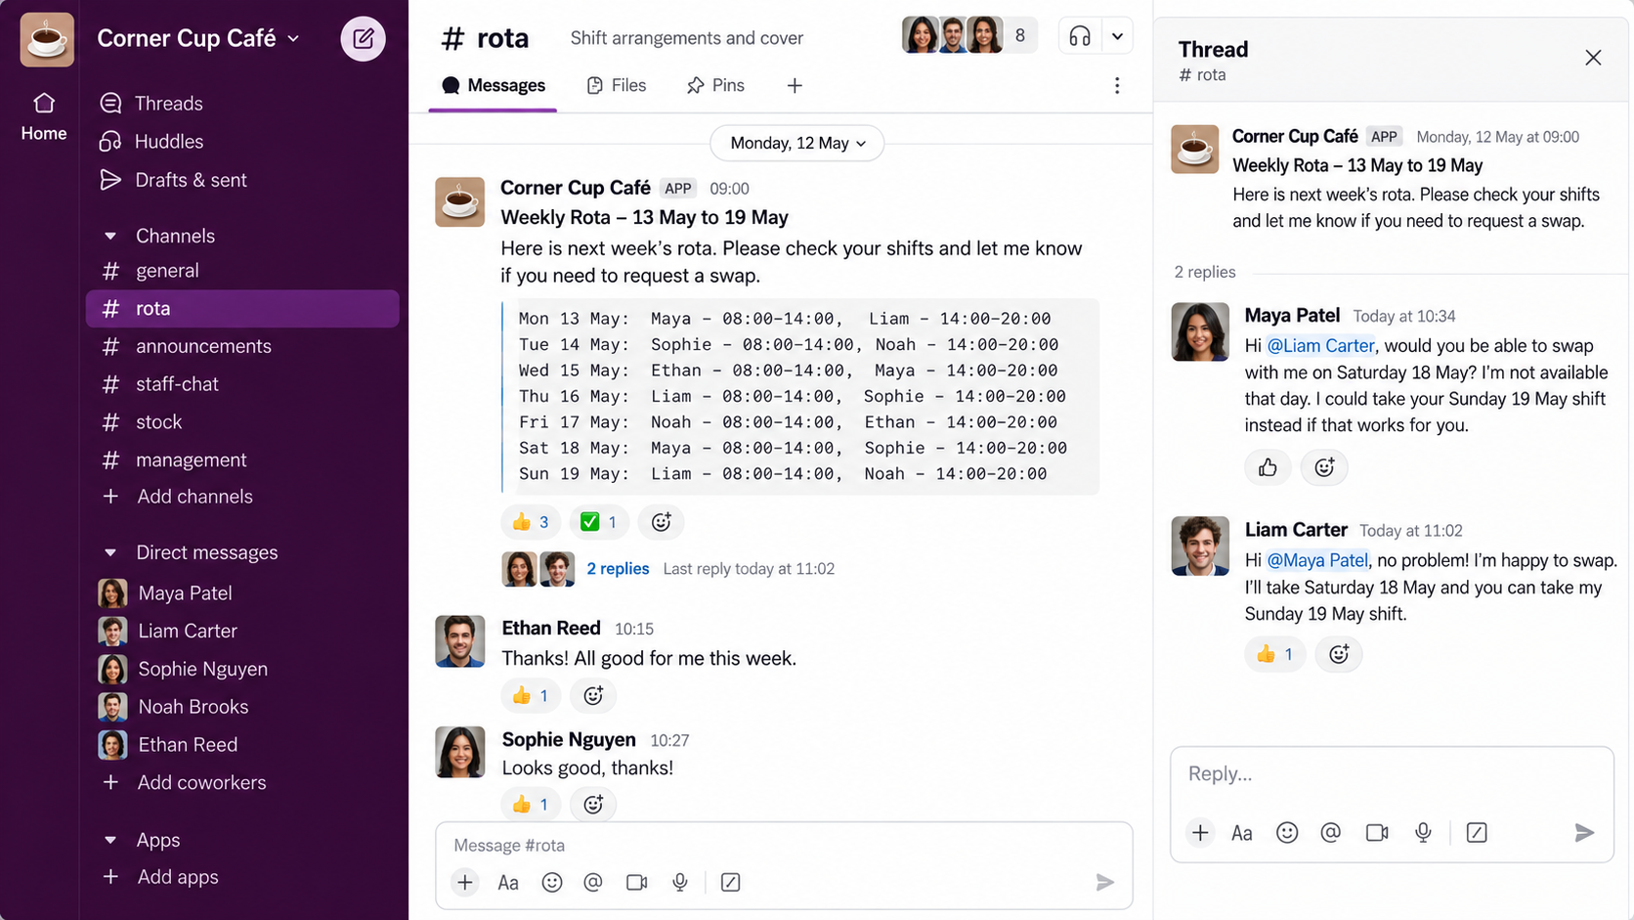
Figure 7: Threaded discussion resolving a simulated shift swap request
Next, I tested threaded replies by responding to the rota message with a simulated request from one barista to swap a Saturday shift. I then responded within the same thread as the manager to accept the swap, which had left the main channel free to accept other notices. The output, which appears in Figure 7, retains the entire decision, as a by-product of its original message, which enhances traceability with a small group. It is also a method of minimising the chances of a request not being responded to amid unrelated discussions during a busy trading week. A limitation emerged because the free plan hides messages older than 90 days, so approved rote changes should also be recorded in payroll records [15].

4.4 Practical Test Four. Trello Boards, Due Dates and Checklists

Figure 8: Café Launch Plan board in Trello with cards drawn from the mind map
In the second practical test, I made a free Trello board called Café Launch Plan with three lists called To Do, Doing and Done. I picked up five cards that were directly part of the mind map in Figure 1, such as Register food business, Order coffee machine, and Recruit two baristas. I then moved Order coffee machine to Doing and assigned it a due date, and hence the status and urgency were displayed on the board at a glance. Trello cards have colored badges, wherein they become yellow at the approaching date of a task within a period of 24 hours, and red when the task becomes overdue [17]. The projected board in Figure 8 represents the result and illustrates how a small group can visually observe tasks at a glance. Linking the board to the mind map shows that the two tools complement each other, since one generates ideas and the other manages their delivery.

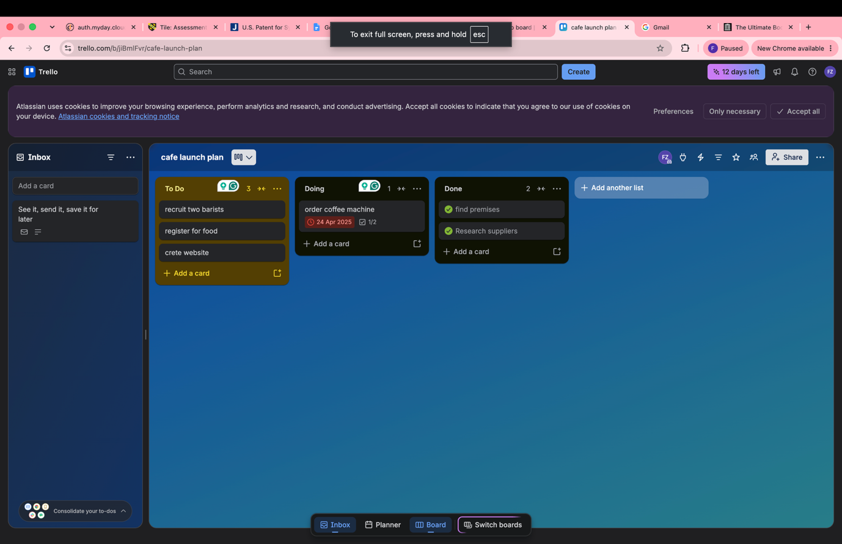

Figure 9: Checklist and due date inside the Order coffee machine card
Then I opened the Order coffee machine card and put a checklist that had three tasks, that is, compare suppliers, approve the budget and place the order. The completion of the first item on the card changed the progress bar on the card, providing a manager with indications of some progress, yet without holding a meeting. Figure 9 shows the checklist and the due date together, demonstrating that responsibilities and deadlines sit beside the task itself. This structure in a workplace minimizes the use of memory and verbal reminders, which can be unreliable in the busy periods of service. However, a free workspace only admits ten collaborators and adding to it makes each board in the workspace a view-only resource [16]. The use of due date reminders also relies on an individual member opting to get notices thus, a board cannot be assured that employees are going to work on due dates [17].

Conclusion
This portfolio shows that everyday software can strengthen a small business, but only when each tool matches a clear operational need. Square Online presents the most secure path to initial online earnings, whereas Wix compensates companies ready to pay for increased design and scalability. Mind mapping can aid in early planning and understanding, however, the end result will be, at a later point, transformed into budgets, schedules and task boards. In Microsoft 365, the Word application has a collaborative value based on subscriptions and cloud storage, as opposed to operating the application per se. Likewise, the communicative strength of PowerPoint relies on premeditated design of the slides, as the default layouts can add to the effort that presenters will need. Excel tests proved that IF and VLOOKUP can be used to automate the process of making everyday decisions, but named ranges, exact matching, and validation are also necessary protective elements. Slack and Trello improved the visibility of simulated café communication and tasks, while their free plans imposed limits on history and team size. Overall, the strongest business value comes from combining tools within a coherent workflow and recognizing the point at which free versions no longer suffice.

References
[1] Z. Cao, Q. Tu, and N. Williams, “E-commerce, pandemic shock, and the survival of small and medium enterprises,” China & World Economy, vol. 32, no. 5, pp. 113–139, 2024. Accessed: Oct. 5, 2026. [Online]. Available: https://shura.shu.ac.uk/34259/
[2] D. Wang, H. Wang, M. Yu, Z. Ashktorab, and M. Tan, “Group chat ecology in enterprise instant messaging: How employees collaborate through multi-user chat channels on Slack,” Proc. ACM Hum.-Comput. Interact., vol. 6, no. CSCW1, Art. no. 94, Apr. 2022. Accessed: Oct. 5, 2026. [Online]. Available: https://arxiv.org/abs/1906.01756
[3] A. H. Kusumo, “Has website design using website builder fulfilled usability aspects? A study case of three website builders,” in Proc. 4th Int. Conf. Informatics, Technology and Engineering (InCITE 2023), Atlantis Highlights in Engineering, vol. 21, 2023, pp. 545–557, doi: 10.2991/978-94-6463-288-0_45.
[4] R. Tomasis, “Is Wix really free? Yes, and here’s how,” Wix Blog, Jul. 26, 2026. Accessed: Oct. 5, 2026. [Online]. Available: https://www.wix.com/blog/is-wix-free
[5] Square, “Square Online plans,” Square UK. Accessed: Oct. 5, 2026. [Online]. Available: https://squareup.com/gb/en/online-store/plans
[6] F. A. Turkestani et al., “Mind mapping to enhance critical thinking skills in respiratory therapy education,” J. Educ. Health Promot., vol. 13, no. 1, p. 198, 2024, doi: 10.4103/jehp.jehp_1816_23.
[7] P.-L. Poon, M. F. Lau, Y. T. Yu, and S.-F. Tang, “Spreadsheet quality assurance: A literature review,” Front. Comput. Sci., vol. 18, no. 2, Art. no. 182203, 2024, doi: 10.1007/s11704-023-2384-6.
[8] Microsoft, “Collaborate on Word documents with real-time co-authoring,” Microsoft Support. Accessed: Oct. 5, 2026. [Online]. Available: https://support.microsoft.com/en-gb/word/training/collaborate-on-word-documents-with-real-time-co-authoring
[9] Microsoft, “Start the presentation and see your notes in Presenter view,” Microsoft Support. Accessed: Oct. 5, 2026. [Online]. Available: https://support.microsoft.com/en-us/office/4de90e28-487e-435c-9401-eb49a3801257
[10] M. A. Alzayed, “Assertion evidence versus traditional PowerPoint: An investigation of the impact of slide structure on engineering students’ cognitive load, motivation, and performance,” J. Eng. Res., May 2022. Accessed: Oct. 5, 2026. [Online]. Available: https://journals.ku.edu.kw/jer/index.php/JER/article/view/16963
[11] Microsoft, “Access specifications,” Microsoft Support. Accessed: Oct. 5, 2026. [Online]. Available: https://support.microsoft.com/en-gb/access/access-specifications
[12] Microsoft, “Define and use names in formulas,” Microsoft Support. Accessed: Oct. 5, 2026. [Online]. Available: https://support.microsoft.com/en-gb/office/define-and-use-names-in-formulas-4d0f13ac-53b7-422e-afd2-abd7ff379c64
[13] Microsoft, “IF function – nested formulas and avoiding pitfalls,” Microsoft Support. Accessed: Oct. 5, 2026. [Online]. Available: https://support.microsoft.com/en-gb/excel/if-function-nested-formulas-and-avoiding-pitfalls
[14] Microsoft, “VLOOKUP function,” Microsoft Support. Accessed: Oct. 5, 2026. [Online]. Available: https://support.microsoft.com/en-us/Excel/vlookup-function
[15] Slack, “Usage limits for free workspaces,” Slack Help Center. Accessed: Oct. 5, 2026. [Online]. Available: https://slack.com/help/articles/115002422943
[16] Atlassian, “Collaborator limit for free Workspaces,” Trello Support. Accessed: Oct. 5, 2026. [Online]. Available: https://support.atlassian.com/trello/docs/workspace-user-limit/
[17] Atlassian, “Add a due date or start date to a card,” Trello Support. Accessed: Oct. 5, 2026. [Online]. Available: https://support.atlassian.com/trello/docs/adding-dates-to-cards/

