Email: rohidhussain1805526@gmail.com
Password: dob28.02.93

QUESTIONAIRRE PAGE
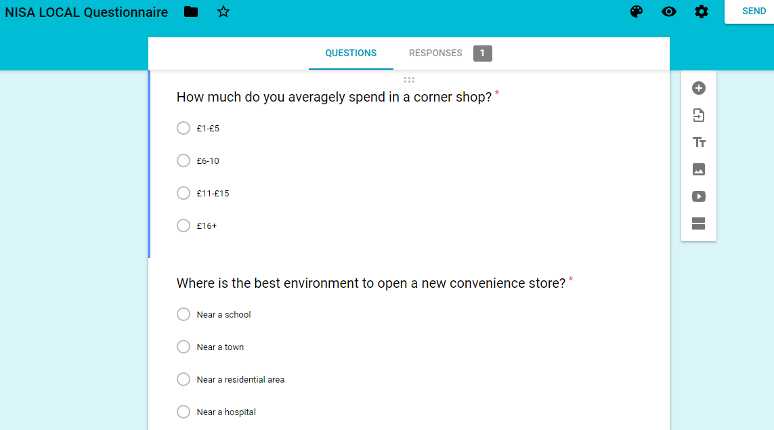
The first question was to find out how much the average customer usually spends in a local corner shop and the next question was to get an idea of where it is more of a necessity to open up a local corner shop.

MENU PAGE
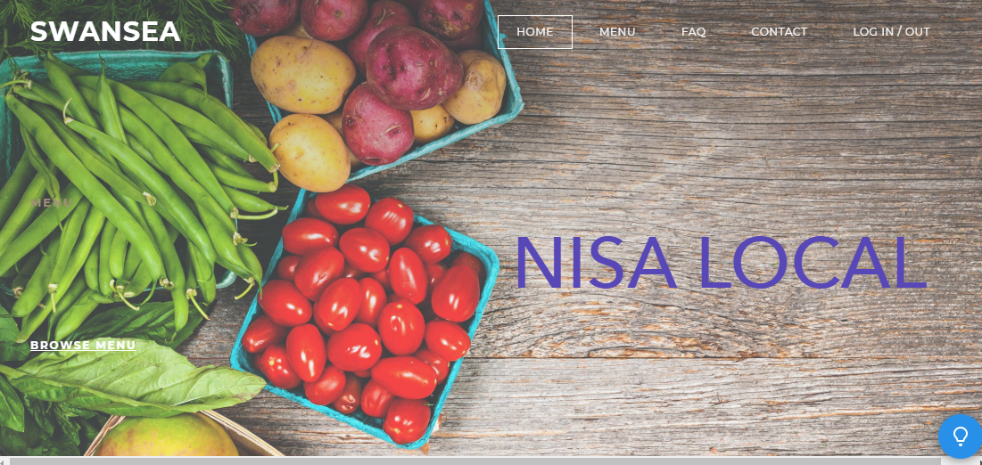

MENU PAGE
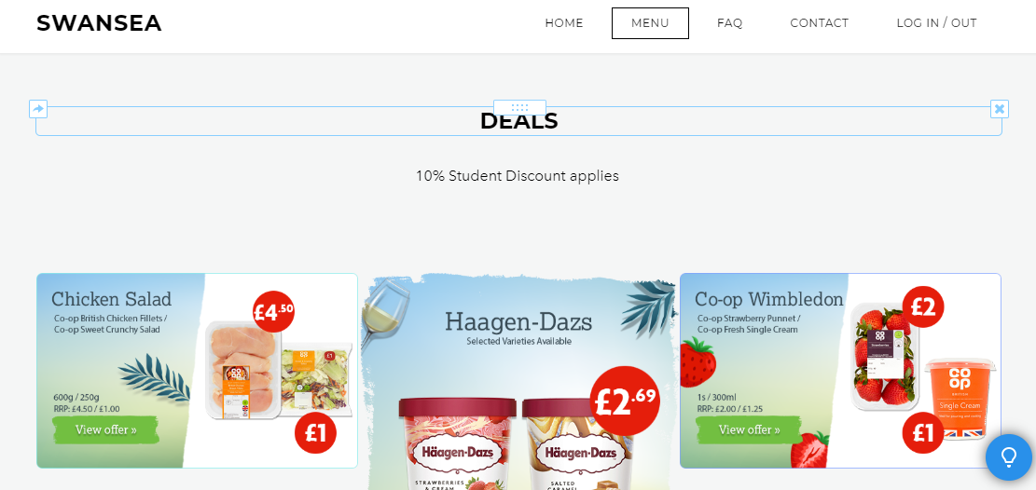

FAQ PAGE
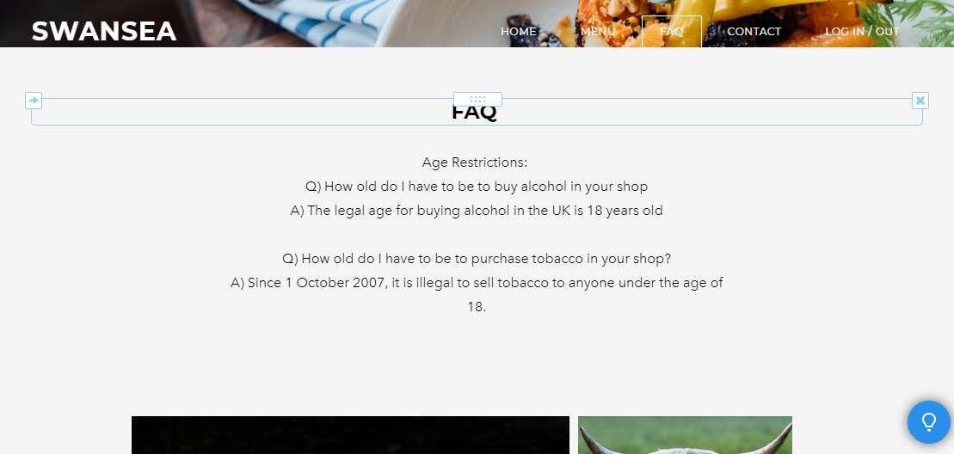

CONTACT PAGE
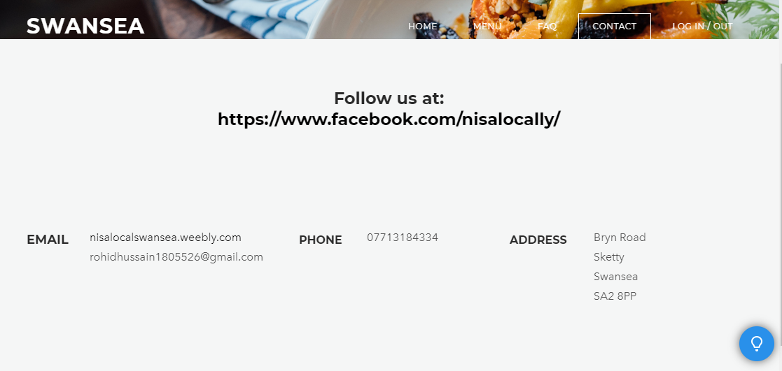

For the website I first designed a home page with a title of ‘NISA LOCAL’ and hyperlinks of menu on the page. The second page was ‘MENU’ which advertised 10% student discount to market to the students. I also added promotional offers in the menu page to cater for the average spending customers. I added a FAQ page which answered questions of the legal ages to purchase alcohol and tobacco. Furthermore, I added a contact page which gives customers access to contact via email and telephone along with the address of our store.

