
Data Analysis & Visualisation
Assessment 2
Denis Gori (2030117) | 5/6/22 | Koushik Modak

Table of Contents
Introduction 2
Description of the DATASET 2
Analysis & Practical Application and Deployment 4
T-TEST: TWO-SAMPLE ASSUMING EQUAL VARIANCES 4
Factors that affects hypothesis power: 8
What are outliers in a data set? 8
Conclusion 9

Introduction
In this report we propose to analyze the results of class tests that teach math concepts in a local primary school. Although here a local company developing an online learning application wants to analyze the success of this application as a learning tool, and after the results of this application to think about the further development of this application in practice, we propose the results of students when using traditional materials and the results obtained after using the online application. Thus, for a more efficient understanding we analyze the data in Excel.

Description of the DATASET
The application was offered to a class of 40 students where the table shows the results of traditional lessons and after using the online application to test its effectiveness compared to traditional learning.
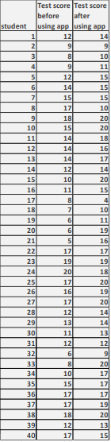
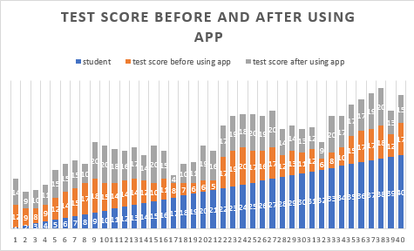
For better image it is necessary using charts to help with understanding and communication of a data collection. A chart can create a clearer picture of a set of data values than a table with rows of numbers, allowing users to incorporate this information into analysis and future planning.

Analysis & Practical Application and Deployment

T-TEST: TWO-SAMPLE ASSUMING EQUAL VARIANCES
The t-Test Paired Two-Sample for Means device plays out a matched two-example Student's t-Test to determine if the invalid speculation (method for two populaces are equivalent) can be acknowledged or dismissed. This test doesn't accept that the fluctuations of the two populaces are equivalent. Matched t-tests are normally used to test the method for a populace when some treatment, for example two examples of math scores from students before and after score.
This hypothesis will determine the students score before and after using the application. In the analysis of our case we will use in part the t test which can have 2 types (one tiled and two tiled).
- If t < 0, P(T <= t) the possibility of observing an t-Statistic value that is more negative than t is known as one-tail.
- If t >0, P(T<=t) the possibility of observing an t-Statistic result that is more positive than t is known as one tail.
- P(T <=t) the possibility of observing an t-Statistic value that is bigger in absolute value than t is called two tail.
T-test process is used because we have similar change in which we go to have an effect when the application was utilized all the more effectively and had an outcome. This large number of examinations are given to us in succeed which permits us to compute and focus on the progressions made. These information are comparative just to the various information in the collected outcome we can do investigations when this application has been utilized better.
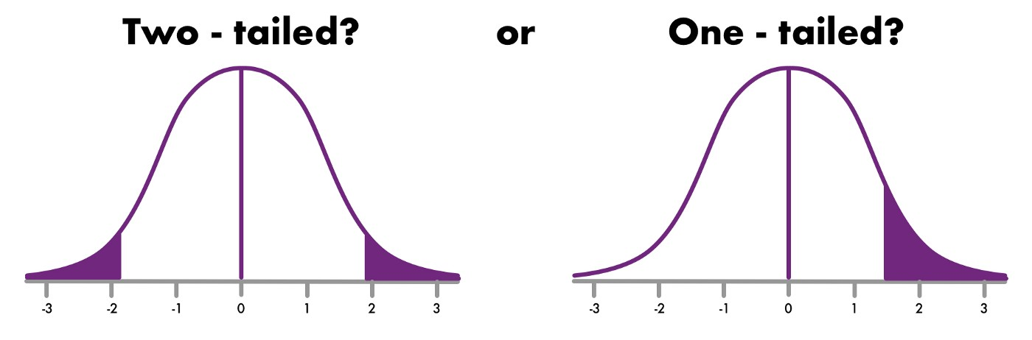
Null Hypothesis and Alternative Hypothesis
The null hypothesis and the alternative hypothesis are two types of estimates used in factual tests, which are formal methods for arriving at conclusions or making decisions based on data. The theories are educated estimates regarding a factual model of the populace based on a populace example. The tests are key components of quantifiable deduction, and they are heavily used in the translation of logical trial information in order to separate logical instances from factual chaos.
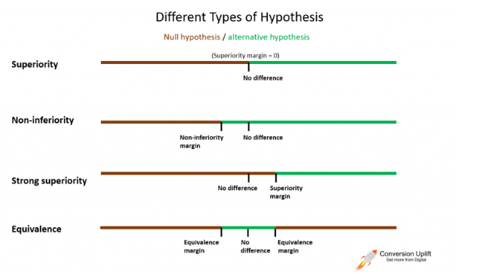
The null hypothesis - default assumption that there is no relationship between two observed events or phenomena. Thus, the null hypothesis is considered true until the opposite can be proven. The refutation of the null hypothesis, that is, the conclusion that there is a connection between two events, phenomena, is the main task of modern science. Statistics as a science gives clear conditions under which the null hypothesis can be rejected.

Often, the null hypothesis is the assumption that there is no relationship or correlation between the variables under study, that there are no differences (homogeneity) in the distributions (distribution parameters) in two and/or more samples. The symbol H0 is used to denote the null hypothesis.
The alternative hypothesis - is one of the ideas proposed during the speculation test. As a general rule, the motivation behind a speculation test is to show that, under a given condition, there is adequate proof to help the validity of the alternative hypothesis rather than the avoidance provision in the test (the null hypothesis). It is normally predictable with the exploration speculation since it is based on writing survey, past examinations, and so on. Notwithstanding, at times the research hypothesis is consistent with the null hypothesis. The symbol Ha or H1 is used to denote the alternative hypothesis.
Next it is necessary to test the hypotheses at different levels.
For testing p = 0.05 we will check if it is rejected. Thus, we will initialize with the T-state value to observe the approach of two critical queues. The value p = 0.05 shows that the value of t-State -2.8465 is less than 1.990, so the null hypothesis is alone and cannot be rejected.
When the p with two tails is greater than the value, it is clear that the null hypothesis is not rejected because 0.005 is less than 0.05 and can reject the null value in this situation. The result p = 0.05 cannot be rejected.
t-Test: Two-Sample Assuming Unequal Variances
 | test score before using app | test score after using app
Mean | 12.75 | 15.3
Variance | 16.80769231 | 15.29230769
Observations | 40 | 40
Hypothesized Mean Difference | 0
df | 78
t Stat | -2.846542418
P(T<=t) one-tail | 0.002822714
t Critical one-tail | 1.664624645
P(T<=t) two-tail | 0.005645427
t Critical two-tail | 1.990847069
When testing p = 0.01 we must apply the same method. We must first observe whether the t-state value is lower or higher than the t-critical. Using the value p = 0.01 we can see that the T-state -2.8465 is lower than the T-critical 2.6403, so the null hypothesis cannot be rejected.
Also the result p of the value with two tails 0.005 is less than 0.01, so the null hypothesis is false and can be rejected.
t-Test: Two-Sample Assuming Unequal Variances
 | test score before using app | test score after using app
Mean | 12.75 | 15.3
Variance | 16.80769231 | 15.29230769
Observations | 40 | 40
Hypothesized Mean Difference | 0
df | 78
t Stat | -2.846542418
P(T<=t) one-tail | 0.002822714
t Critical one-tail | 2.375110958
P(T<=t) two-tail | 0.005645427
t Critical two-tail | 2.640340015
The importance level is given to test hypothesis for each worth to consider which is less or equivalent and are measurably huge. The testing hypothesis is that interaction which the objective is:
To reach an inference in the perceptions made. For this situation we need to make an inference for an organization that might want to be aware of the application that the tried to know when they more prevail previously or later.In this case we will apply the value p = 0.10 and we will notice that the null value can be accepted or rejected.The result shows that t-state is smaller than t-critical, so t-state -2.8464 is less than t-critical 1.664 and the null hypothesis cannot be rejected. We can also explain that the value of the tail 0.005 is less than the alpha value 0.10 and the null hypothesis also cannot be rejected.

t-Test: Two-Sample Assuming Unequal Variances
 | test score before using app | test score after using app
Mean | 12.75 | 15.3
Variance | 16.80769231 | 15.29230769
Observations | 40 | 40
Hypothesized Mean Difference | 0
df | 78
t Stat | -2.846542418
P(T<=t) one-tail | 0.002822714
t Critical one-tail | 1.292499597
P(T<=t) two-tail | 0.005645427
t Critical two-tail | 1.664624645

Factors that affects hypothesis power:
- • The number of samples (n). If all other variables remain constant, the larger the sample size, the better the test's power.
- • Significance level (). As the significance threshold is reduced, the test's power diminishes. As the significance level is decreased, the tolerance zone widens (for example, from 0.05 to 0.01). As a result, the null hypothesis has a lower chance of being rejected. This means that if you don't reject the null hypothesis when it's false, you're more likely to make a Type II mistake. In other words, reducing the significance threshold reduces the power of the test, and vice versa..
• The "true" value of the parameter under study. As the discrepancy between the "true" value of a parameter and the value stated in the null hypothesis widens, so does the test's power. In other words, the more powerful the test, the higher the effect size.

What are outliers in a data set?
An outlier is a number that is considerably higher or lower than most of the values in your data. Outliers can distort the findings when using Excel to examine data. The mean average of a data collection, for example, may accurately reflect your values.
An outlier is a value that is significantly higher or lower than most of the values in your data. Outliers can distort the findings when using Excel to examine data. The mean average of a data collection, for example, may accurately reflect your values.
An outlier is a value that differs significantly from other values in a population's random sampling. In some ways, this definition delegated the decision of what constitutes abnormality to the analyst.
To avoid these issues, we must pay close attention to the data from the start to ensure that it is accurately prepared and free of mistakes. We do not have any outliers in our data set because the range of numbers starts at 4 and ends at 20, and there is no smallest or largest number that can affect our data set.
How to remove outliers?
1. Using Excel Function to Calculate Average without Outliers
Succeed TRIMMEAN capacity can be utilized to ascertain the normal of a given dataset while barring anomalies. The information focuses to reject is provided as a rate. The rate worth can be input as a decimal arrangement or percent design.
2. Using alternative analytic methods-In this scenario, we may examine the data using other statistical sets, such as the median, to see whether there are any outliers.
3. Calculating the Z score—When calculating the Z score, we know that the center is 0.



Conclusion
In this report, we first got acquainted with the online application which according to the mentioned calculations can make the students' teaching more effective, thus the results of 40 students in a class were offered using the traditional educational materials, and with the help of the online application. To analyze the difference we used the excel diagram which visually showed the difference between them and showed that the online application can really bring success in education. After that to determine the speculations we used T tests which are suitable normally used to test the method for a canteen of people (in our case students), examples of scores in mathematics before and after the score. For these results I have attached the tables with results and some images suitable for the subject.

References

[1] | B. R. U. S. R. K. a. A. T. .C. Olston, Pig latin: a not-so-foreign language for data processing.",, 2008.
[2] | .. P. a. S. Card., The sensemaking process and leverage points for analyst technology as identified through cognitive task analysis., 2005.
[3] | ,. O. A. K. a. K. E. W. G. Chin, Exploring the analytical processes of intelligence analysts., 2009.
[4] | P. Christen, Proceedings of the 14th ACM SIGKDD international conference on Knowledge discovery and data mining KDD, 2008.
[5] | ,. F. B. V. M. W. a. J. K. C. M. Danis, Your place or mine?: visualization as a community component, 2008.
[6] | P. G. I. a. V. S. V. A. K. Elmagarmid, Duplicate record detection: A survey, 2007.

