
AN ANALYSIS OF THE PROBLEM AT ASDA


GABRIELA CIUBA
1806307

12.07.2020
UNIVERSITY OF WALES TRINITY SAINT DAVID

Executive Summary
ASDA has financial problems after the new entry of the discounter retailers. It has led to the loss of sales and cost-cutting to be able to meet the finances. It has been fined with the court for polluting the environment and its merger with Sainsbury blocked. The analysis done suggested that the retailer should consider exploring new markets to counter their competitors. ASDA should shift its approach to concentrate more on sustaining its supply chain, which may rely on the United Kingdom’s food and goods. It set up a Green policy to guide in protecting the environment. To ensure easy assimilation of the recommendation, ASDA has to communicate with its shareholders and employees. Monitor the agreed strategy by either benchmarking with other companies and observing to be adopted fully. Evaluation and assessment should be done frequently to determine if it is meeting the target.

Table of Contents
Executive Summary 2
An Analysis of the Problem At ASDA 4
Introduction 4
Findings 4
Overview 4
History 4
Products and services 5
Investigating ASDA 5
Description 6
SWOT Analysis 6
Strengths 6
Weaknesses 7
Opportunities 7
Threats 8
PESTEL Analysis 9
Economic factors 9
Environmental 10
Conclusion 11
Options 11
Action Plan 12
Communicated 12
Monitored 12
Reviewed 12
References 13

An Analysis of the Problem At ASDA

Introduction
There have been several problems facing ASDA as a limited company, like the loss of sales to the fast-growing stores in the market. The court has also fined it for polluting the environment, and its merger with Sainsbury blocked, leading to a financial crisis. It has forced the company to find ways of cost-cutting. Below is a report that was done to provide the analysis on the cause of loss of sales by ASDA using SWOT AND PESTEL as tools. This report will review secondary sources from popular new media, and interviews will be used to conduct research and conclude the problems and give recommendations on solving the problem.

Findings

Overview
In 1949 the British supermarket was established. It was later acquired by an American retail company Walmart to become the largest retailer chain in Britain. In 2018 the company announced its merger with Sainsbury to create the largest chain of supermarkets in the United Kingdom. However, the movie was stopped by the British court. ASDA has different formats of their shops, for example, supercentres who are offering a range of foodstuffs, George clothing, and decathlon sports retailers. Superstores provide fresh food, pharmacy, optician. Moreover, the company is also providing mobile services, ASDA logistics, and financial services (ASDA, 2020).

History
The organisation was established in 1949 when the supermarket ownership of the Asquith family combined with the Yorkshire Associated Dairies Company. ASDA is a Britain grocery chain headquartered in Leeds. Until the year 1999, when the American company Walmart acquired, and it was included in the London Stock Exchange (Stanton, 2018).
The advertising ventures in ASDA appear to be price dependent only, and ASDA has marketed itself under the slogan of “Save Money. Live Good” since 2015, like its parent company, Walmart (Stanton, 2018). A joint retail venture was revealed in April 2018 by Sainsbury and ASDA, which would have formed a merger of the UK grocery market. However, the process was stopped by the British government.
There has been a threat to redundancies of over 2,800 ASDA workers as Britain’s the retailer tries to reduce costs. The Guardian has learned that the company has pushed staff into a divisive, more flexible contract of employment to avoid a financial crisis (Wood, 2020).

Products and services
ASDA has a different store format to facilitate its accessibility to customers acquiring its products and services. Supermarkets are offering nonessential food items and ASDA living that provides clothing, entertainment, and home equipment (Stanton, 2018). ASDA also provides petrol stations, mobile, and banking services.

Investigating ASDA
Based on the recent articles by the Guardian Magazine, ASDA is facing financial problems caused by loss of sales from the market share after entry of a new retail company providing its services at discounted prices. It has been fine by the British court for polluting the environment after spillage of fuel into the river that is a source of water for the citizens. The merger between Asda and Sainsbury stores was stopped by the competition and market authority, forcing them to find a way to cost-cut (Wood, 2020).

Description
The value proposition of Asda is challenged by the rapid growth of the Aldi and Lidl discount pair. Still, the retailers are more and more looking to close the price gap, retain their relevance in an increasingly educated customer base, and preserve market share. However, the discounting retailer has acquired a large market share leading to Asda losing its sales and profits. The financial constraint faced by Asda as a company is also due to its merger with Sainsbury blocked. The organisation considering selling its share to the public to acquire money to sustain the company, but the stock market flotation may take up to two years to be available (Wood, 2020).
Over 2800 workers are facing the threat of losing their work as the company is trying its way in cost-cutting. The company pressured workers to enter into a contentious, more flexible employment arrangement. And informed other staff in the administrative, cash, and personnel departments that their jobs are in jeopardy. Both employees and the shareholders have been affected by the entry of the retailer (Wood, 2020). It has led to the loss of sales and profits and employment.

SWOT Analysis

Strengths
As one of the leading sectors, ASDA has several strengths that help it thrive on the market. Such attributes not only protect the market share in developed markets but also contribute to the penetration of new markets.
ASDA offers a wide range of products, including financial services. Moreover, Asda has departmental centers in the United Kingdom, spread over the shop network. Its online websites www.asda.com and www.george.com, serve millions of consumers covering 98 percent of UK consumers as compared to other brands. It has a different format on stores that have allowed it to provide a wide range of services.

Weaknesses
The constant card glitch when paying bills and even poor hygiene when doing home delivery, which provoked the customer to consider another service provides hence losing their loyal customers. Customers have argued the goods are not of good quality as those of competitors, for instance, Sainsbury. Moreover, discounters like Aldi and Lidl are cheaper than them.
Asda’s net sales declined by 5,8% between three months and reportedly also decreased operating profits, although the retailer provided no figure. It was due to the constant card glitch when paying bills and even poor hygiene when doing home delivery, which provoked the customer to consider another service provides hence losing their loyal customers. ASDA has troubles with positioning. Customers have argued that ASDA’s goods are not of good quality as those of similar brands, for instance, Sainsbury. Moreover, discounters like Aldi and Lidl are cheaper than them. For many customers, that certainly does not convince them to shop or get services from, thus considering other brands (Fern, 2020). ASDA and a few other retailers admitted on price-fixing for the dairy products. It led to the loss of the consumers because of the price-fixing operation, affecting the brand. This reflected on the organisation losing its sales and profits and leading to financial problems due to the restriction of higher-values items (Fern, 2020).

Opportunities
Increasingly, customers shop online in Great Britain and therefore provide ASDA with an excellent opportunity to ensure a more significant share. Opening new stores and taking control of smaller retailers and merging with others, the company can continue to grow. In the same way, it’s worth looking internationally outside the UK. A new ASDA market will open up new behaviour patterns for customers. The organisation has a tremendous opportunity to build new sources of sales and to diversify into new types of goods (Fern, 2020).
Asda can capitalise on its capabilities, being the largest supermarket in the UK with a huge market share (Kantar, 2020). Its excellent management has been established, and over the years, it has been employing people from other major global names like Carrefour to fulfil several of its strategic positions. It provides clients with a variety of goods and services (Fern, 2020). It provides financial services, and several services like Asda Mobile, Asda Smart Price, George Clothing, and pharmacy are amongst their various services. Its online website www.george.com and www.asda.com, serve millions of consumers covering 98% of UK consumers as compared to other brands. It has a variety of formats on stores that have allowed it to provide a wide range of services, i.e., superstores, George Stores, Asda Living, and petrol stations (ASDA, 2020).

Threats
ASDA, as a company, has had different threats from its competitors, the recent one being the price war with other global retailers like Aldi and Lidl. They are discounting their products and services, posing a significant challenge for the group (Ruddick, 2020). It has led to ASDA losing its customers to the retailer. With the discovery of the online platform, competitors are now getting websites set up to allow their customers to shop easily. Moreover, with the redundancies happening in the company, there will be a shortage of professional labour force in the organisation, leading them to be poached by competitors (Fern, 2020).
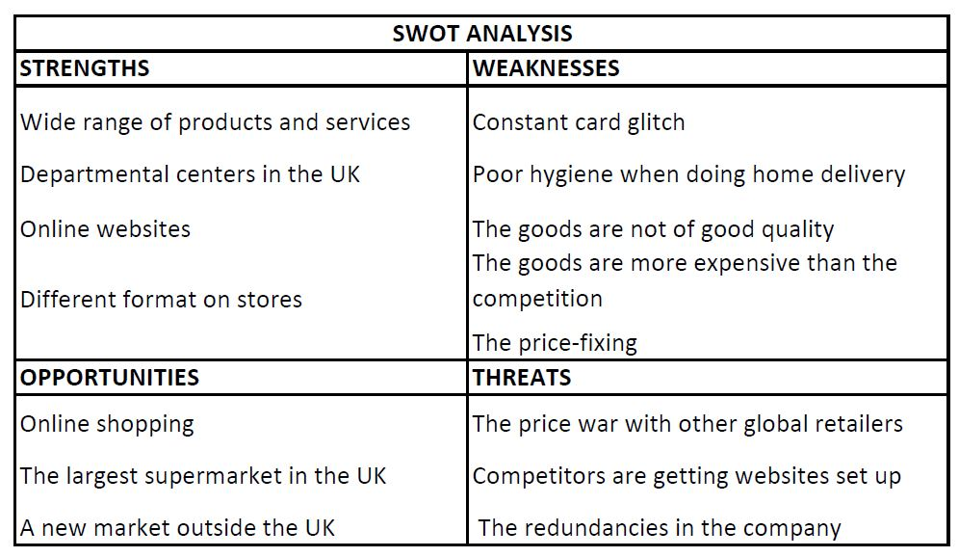

PESTEL Analysis
There are many factors in the macro-environment that will affect the organization. To help analyze these factors, directors can categorize them using PESTEL analysis.

Economic factors
The economic factors is consists of many factors such as inflation, unemployment and interest rates. Inflation rate means increasing level of prices of goods and services.
Asda is affected by inflation rate when prices of products and services increase and products are cost more, wages of employees don’t increase meaning customers have less money to spend.
Public transport is about how many local buses, taxis and cars there are in the area or next to business. This affects Asda as if there is less transport this will mean there will be fewer customers coming to Asda, so less money will be made by the business. Asda can get its own bus service out if there is less service. The lack of competition is that if Asda’s competitors have the similar product or cheap price would affect the business were as the customer would go to where it is cheaper and better product and Asda will have to compete with the other retailers to keep the customers coming in. (UK Essays, 2016)
With the entry of the discounter retailer, ASDA will be forced to take account of economic factors such as wages, competitive conditions, supply, and demand for jobs. It has a significant effect on the company’s price strategies.
It has reorganized itself to compete favorably with Aldi and Lidl since they have their prices cheap and discounted hence attracting more customers. (Gale, 2018)
This is reflected in ASDA when consumers turn around and consider the discount Aldi and Lidl.

Environmental
The problem affecting the retailer is the environmental factor, recently the company pleaded guilty to spilling fuel into the nearby river. The magistrate fined the supermarket £7500 for polluting a river that is highly dependent on the community. The government was forced to use the Environment Agency to contain the pollution later to have ASDA contractors to join in cleaning up. ASDA has to ensure a green economy, avoid carbon emissions, hazardous waste, and organic food. Citizens are now aware of the environmental effects of companies, and all organisations are forced to work in an environmentally sustainable manner. ASDA must also show that it is an organisation that values the environment. (Macauley, 2019)
At Asda, the approach to sustainable development is based on the belief that environmental protection and saving go hand in hand. The goal is to reduce the environmental impact of ASDA's operations, the goods and services sold, and the suppliers who manufacture them.

Conclusion
Based on the analysis done, SWOT, and PESTEL tool, several weaknesses were highlighted. One, the environmental factor, the company pleaded guilty to spilling fuel into the nearby river, leading to the magistrate fining the supermarket £7500 for polluting a river that is highly depended by the community. Its merger with Sainsbury’s was also blocked, leading to financial glitch.
The entry of the new discounters Aldi and Lidl led to Asda’s net sales declining by 5,8% between three months and reportedly decreased operating profits. Moreover, the constant card glitch when paying bills and even poor hygiene when doing home delivery provoked the customer to consider another service provides hence losing their loyal customers. ASDA has troubles with positioning. Customers have argued that ASDA goods are not of good quality and continuously involved in price-fixing for dairy products. It has led to the loss of the consumers because of the price-fixing operation, affecting the brand. It has reflected on the organisation losing its sales and profits and leading to financial problems.

Options
ASDA should shift its approach to concentrate more on sustaining its supply chain, which may rely on the United Kingdom’s food and goods, leading to the emotional attachment for customers. ASDA has a chance of diversifying its product portfolio to include a “premium” area: whether it extends its “Extra Special” portfolio or adds local brands and products. The emphasis on UK goods could give ASDA a “special point of sale,” which could justify higher prices for the company. Improve the technology of their card services to avoid card glitch when customers are paying.
The company should consider setting up their Green policy to guide them in maintaining the environment (Goodman, Dingli, 2017). Set up environmentally friendly shops, 40% more energy-sensitive as a standard new physical shop, and a good drainage system that does not release waste into the river.
Managers must rapidly search and generate information on Simple screening to the problem arising (Goodman, Dingli, 2017). They should find fairways of laying off an employee to avoid the fight between employees and the company.

Action Plan

Communicated
The recommendations should be presented to the management, who will share it with the shareholders to decide on the best way to apply it.

Monitored
The decision made by the administration should be adopted and assessed if it is working or solving the problems designed to tackle it. Respective managers appointed by the administration should continuously monitor the strategy put in place. It can be done through benchmarking or observation.

Reviewed
Constant analysis and evaluation should be done to review the options to identify if they are helping to resolve the problem. The use of both SWOT and PESTEL marketing tools should be adopted to assess in a market survey.

References
ASDA (2020) Company facts. [Online] Available at: https://corporate.asda.com/our-story/company-facts [Accessed: 27.06.2020]
Stanton, J.L. (2018) A brief history of food retail. British Food Journal.
Wood, Z. (2020) Cost-Cutting At Asda Supermarket Chain Puts 2,832 Jobs At Risk. [Online] the Guardian. Available at: https://www.theguardian.com/business/2020/jan/10/cost-cutting-at-asda-supermarket-chain-puts-2832-jobs-at-risk [Accessed: 29.06.2020]
Fern, F. (2020) ASDA SWOT Analysis Matrix [Step By Step] Weighted SWOT. [Online] Fern Fort University. Available at: http://fernfortuniversity.com/term-papers/swot/1433/1162-asda.php [Accessed: 01.07.2020]
Ruddick, G. (2020) It May Already Be Too Late For Tesco And Sainsbury’s, The Rise Of Aldi And Lidl Looks Unstoppable. [Online] Telegraph.co.uk. Available at: http://www.telegraph.co.uk/finance/newsbysector/retailandconsumer/10974773/It-may-already-be-too-late-for-Tesco-and-Sainsburys-the-rise-of-Aldi-and-Lidl-looks-unstoppable.html [Accessed: 29.06.2020]
Kantar Worldpanel (2020) UK Grocery Market Share. [Online] Available at: http://www.kantarworldpanel.com/global/grocery-market-share/great-britain, [Accessed: 30.06.2020]
UK Essays (2016) The Business Environment Of Asda. [Online] Available at: https://www.ukessays.com/essays/economics/the-business-environment-of-asda-economics-essay.php [Accessed: 07.07.2020]
Gale, A. (2018) How long will Aldi and Lidl’s onslaught last? [Online] Available at: http://www.managementtoday.co.uk/long-will-aldi-lidls-onslaught-last/future-business/article/1386497, [Accessed: 07.07.2020]
Macauley, C. (2019) Asda fined £7,500 for polluting County Antrim river. BBC News.
[Online] Available at: https://www.bbc.co.uk/news/uk-northern-ireland-50649354
[Accessed: 30.06.2020]
Goodman, M., and Dingli, SM (2017) Creativity and strategic innovation management: Directions for future value in changing times. Taylor & Francis. 2nd edn. New York: Routledge.

