Name of the Team: Team Coffee
Student Name | Student ID
mARK WILLIAMS | 2022279
ASHLEY REES | 2009258
TIRION WALL | 2023509
JOSH archer | 2011907
Team Evaluation
 | Mark | Ashley |  | Tirion |  | Josh
Mark | 5 |  | 5 |  | 5 |  | 5
Ashley | 5 |  | 5 |  | 5 |  | 5
Tirion | 5 |  | 5 |  | 5 |  | 5
Josh | 5 |  | 5 |  | 5 |  | 5
Team’s Contribution with a scale of 1 to 5 (1 No Contribution and 5 Excellent Contribution)
Ashley: Once again our team worked very well together, Mark and I went through the worksheet together and Tyrion and Josh took screenshots, then went away and wrote the descriptions of each step. The team has grown closer much closer this time, I believe it has helped us to complete the work to an excellent standard.
Tirion: By collaborating closely, our team worked really well. Mark and Ashley (who study Cyber Security, and therefore have a better understanding on the topic) troubleshooted the issues we came across as we went through the worksheet, and Josh and I provided the screenshots and detailed descriptions. Our ability to communicate well as a team helped us complete the work to a high standard.
Josh: As before the team worked well together. With Mark and Ashley providing valuable support to myself and Tirion. I found personally, this assignment more difficult however with Mark and Ashley supporting me throughout I was able to fully understand the fundamentals of what the assignment was trying to get us to understand.

Mark: Our team once again worked extremely well together each brining in their own unique skills and abilities to this assignment, for example I went through the Worksheet with help from Ashley while Tirion and Josh took screen shots and wrote the descriptions of what each of the stages was. Our team have grown close and worked exceptionally hard to make sure the work is to the highest quality possible.

Tirion Wall
Student number: 2023509
Software Engineering
Network Operating Systems and Services
06/04/2023

Contents
Abstract 4
Introduction 5
Task 1: Managing and maintain network resources using network policy and security practices 6
2.1 Configuring User Environment and Computer Environment, ‘Network Group Policy Objects’ 12
GPO 1: Moderating Access to the Control Panel 12
GPO 2: Removing Access to the Command Prompt 17
GPO 3: Restricting Access to Removable Media Drives 19
GPO 4: Restricting Software Installs 21
GPO 5: Enforcing Password Policy in the ‘accatask.msft’ domain 23
Task 2: Routing and packet filtering within core TCP/IP services and critical failover/redundancy policies 25
Task 3: Observation tasks – Individual Task 43
1) On a SOHO (Small Office/ Home Office) Network, if you want to consider enhancing security, what actions could you do? 43
2) Failover Clustering for high availability systems/services 45
3) Draft a network policy for an Enterprise Network which operates in multiple locations 47
Brief reflection 49
Conclusion 50
References 51

Abstract

In the first two tasks of this assignment, a team of four will be closely working together to create local drive/ file folder permissions, and using Group Policy objects to modify network environment settings and security policies. In the third task of the assignment, team members will be individually explaining how security can be enhanced in Small Office/Home Office networks and discuss failover clustering for high availability systems. The assignment will finish with a draft network policy for an Enterprise Network that operates in multiple locations. Screenshots will be provided throughout task one and two to demonstrate key points.

Introduction

In task one and two of this assignment, the team will work together to create local drive/ file folder (NFTS) permissions, and will learn how sharing permissions work for network deployed access control to these resources. Additionally, the team will use Group Policy Objects to modify network environment settings and security policies. This will be demonstrated via screenshots.
In task three, the team members will work individually to explain how security can be enhanced in a Small Office/Home Office (SOHO) network, and discuss failover clustering for high availability systems. Finally, a draft will be created for a network policy for an Enterprise Network that operates in multiple locations.

Task 1: Managing and maintain network resources using network policy and security practices

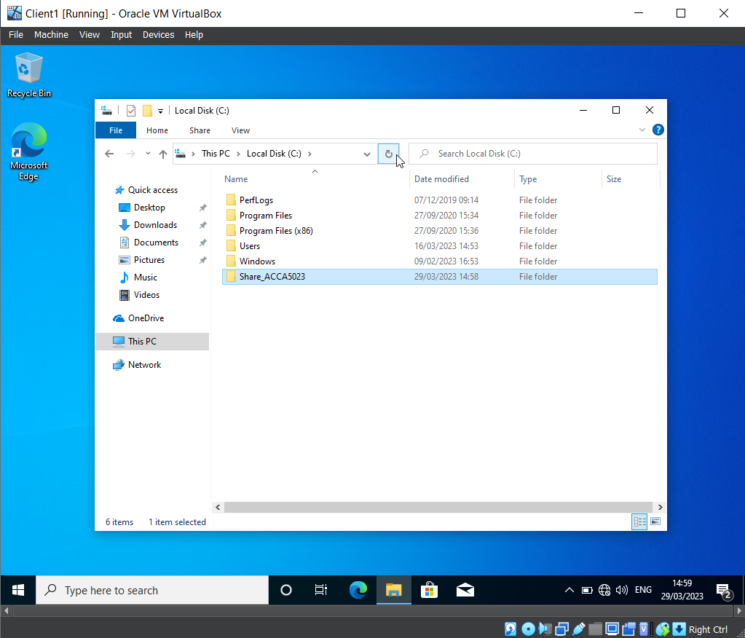
A file has been created within the Local C drive called ‘Share_ACCA5023’. NTFS (local) permissions have been set so that the network user has Full Control permissions, and the other network users have read only access. This helps protect the contents of the file.

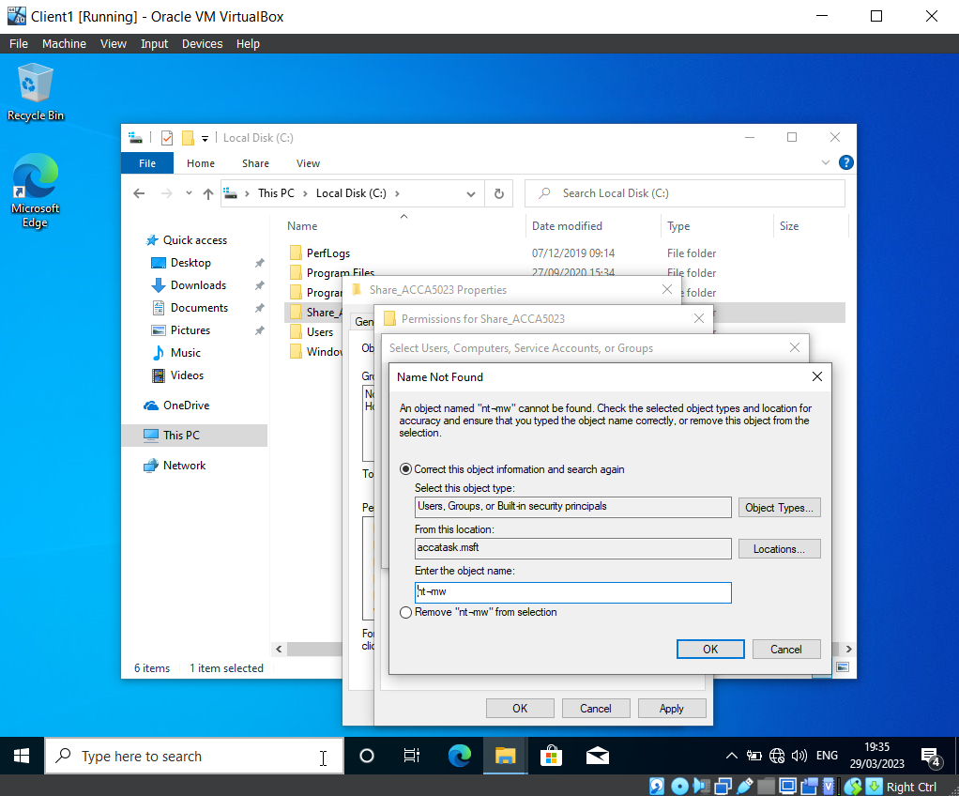
When using the username ‘nt-mw’ to search for the admin login for ‘Mark Williams’, the group encountered the error message in the screenshot above, which indicated that the account could not be found. To resolve this issue, the group retraced their steps, repeating the previous actions. This resolved the problem, as depicted in the next screenshot.

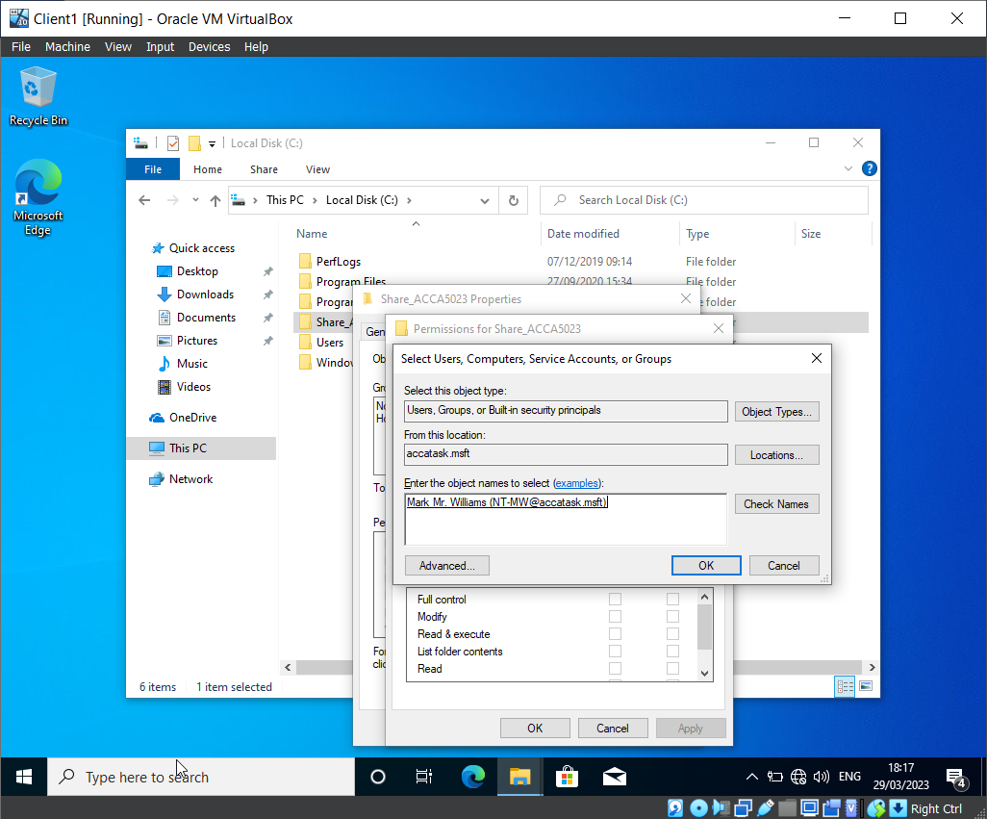

The username has successfully been added to the group, which allows the team to modify the permissions of this user’s access within the file ‘Share_ACCA5023’.

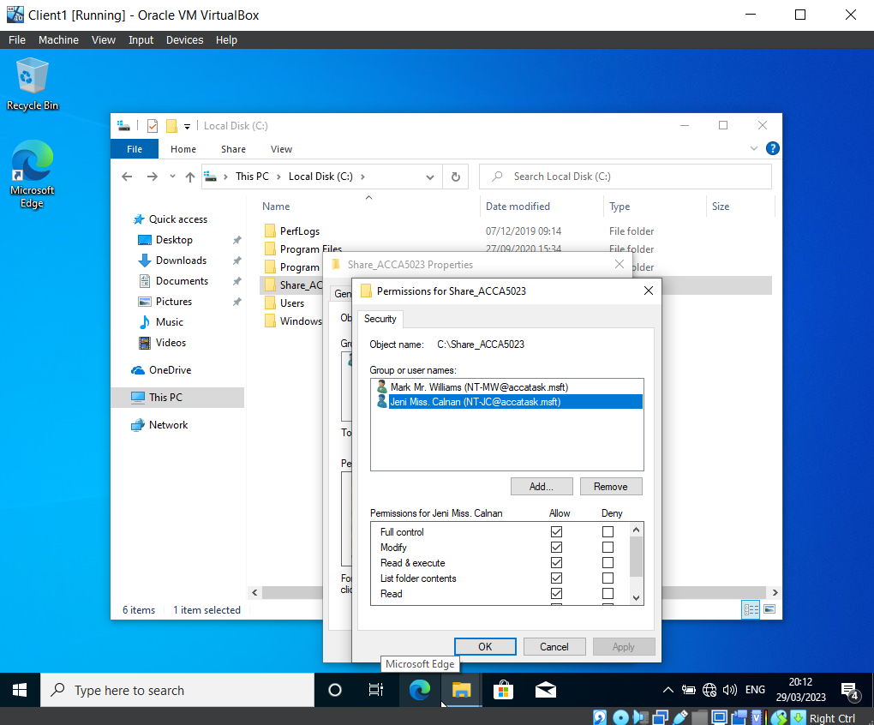
Two users were added to the permissions group for the folder ‘Share_ACCA5023’.

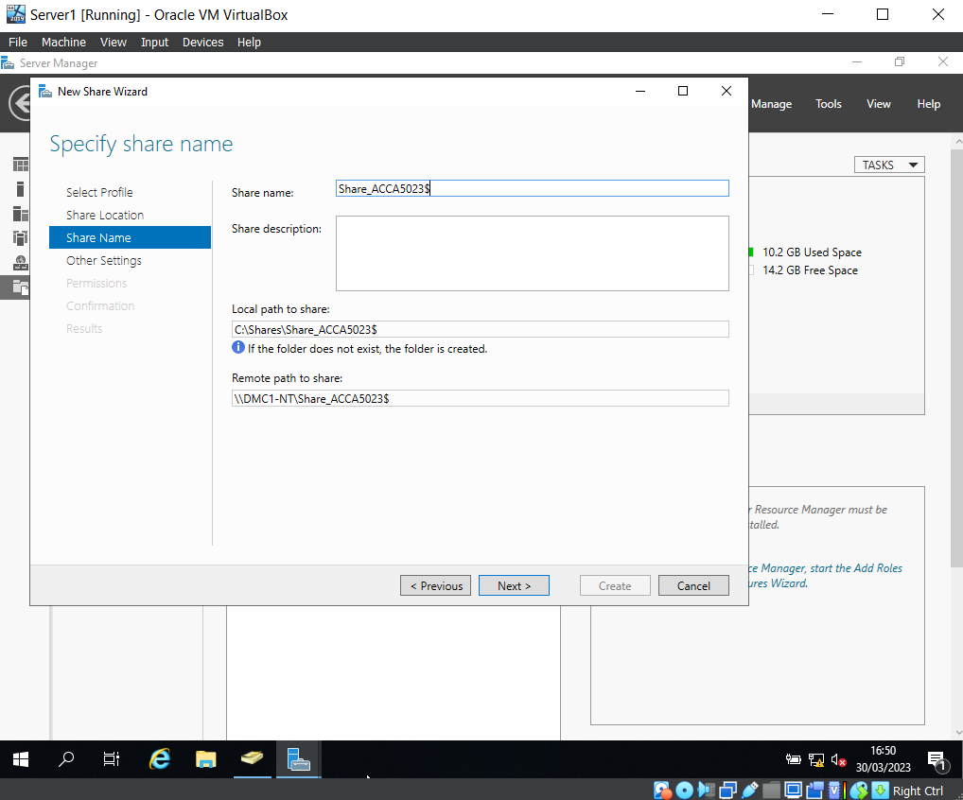

A folder share has been created on the ‘Share_ACCA5023’ server. This shows the local path to share, and the remote path to share. These options have been noted for later use, as they will be needed when the group access the files over the network from a different machine. Additionally, they will be needed to map a network drive to the file server.

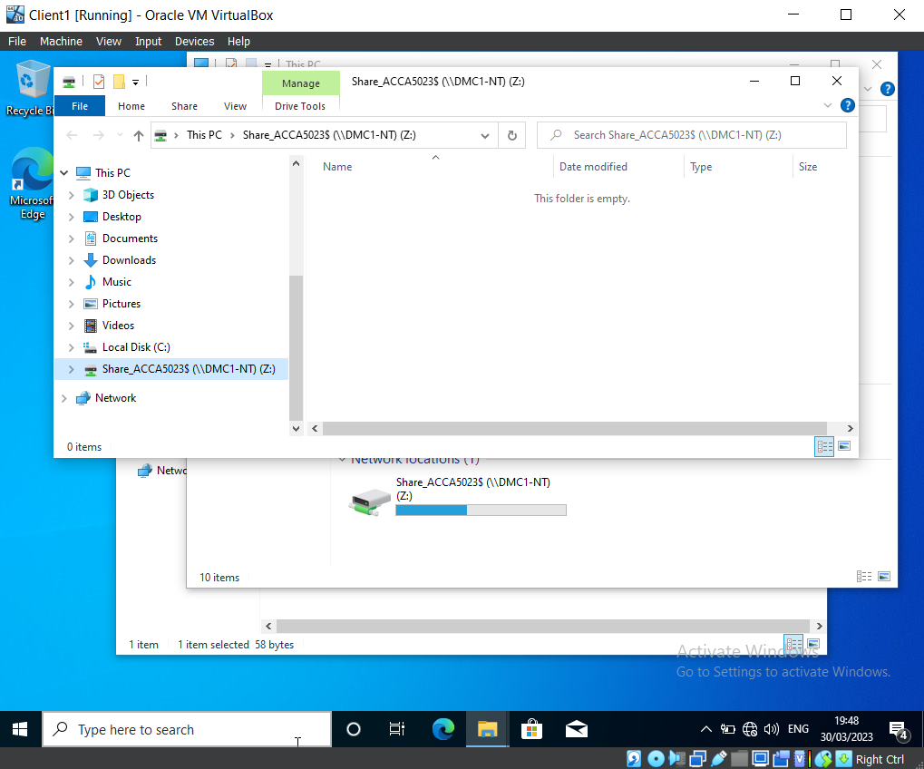

This screenshot shows that the mapped shared network drive is set to drive Z.

2.1 Configuring User Environment and Computer Environment, ‘Network Group Policy Objects’

GPO 1: Moderating Access to the Control Panel

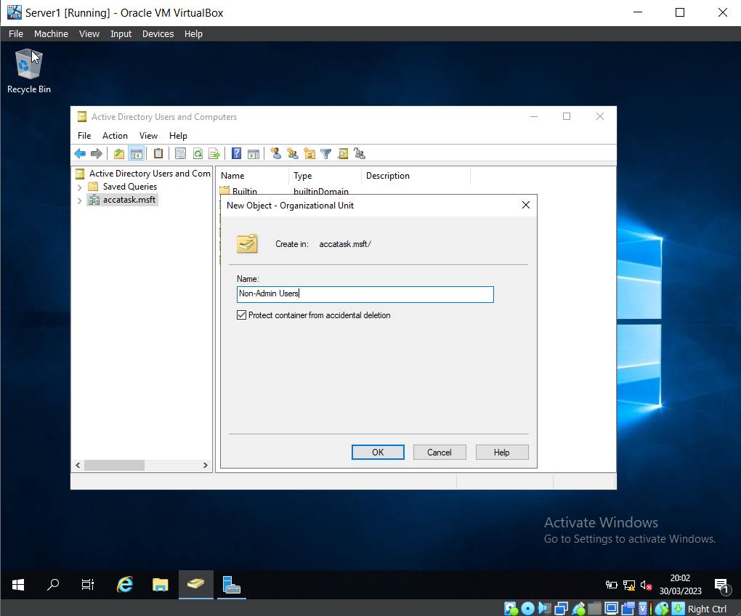

A new Organisation Unit has been created on Virtual Machine Server 1, named ‘Non-Admin Users’.

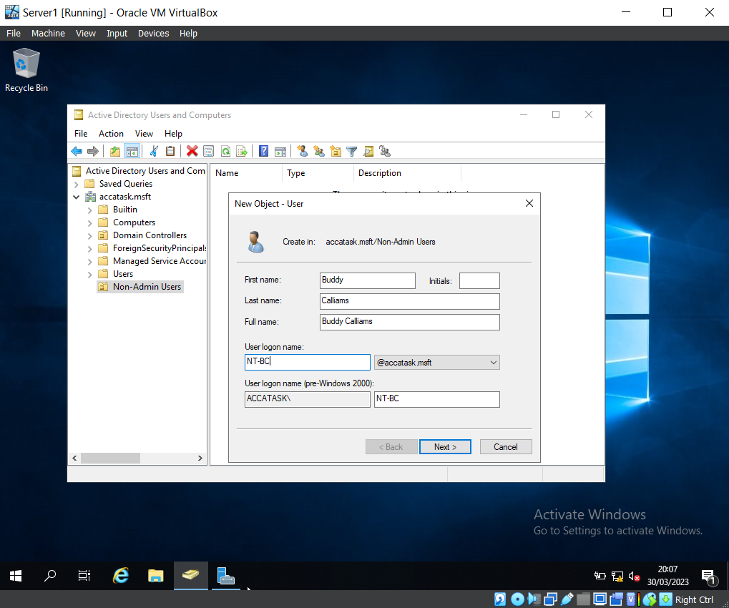

Using Active Directory Users and Computers, a new user has been created within the Non-Admin Users OU. (New user: ‘Buddy Callams’)

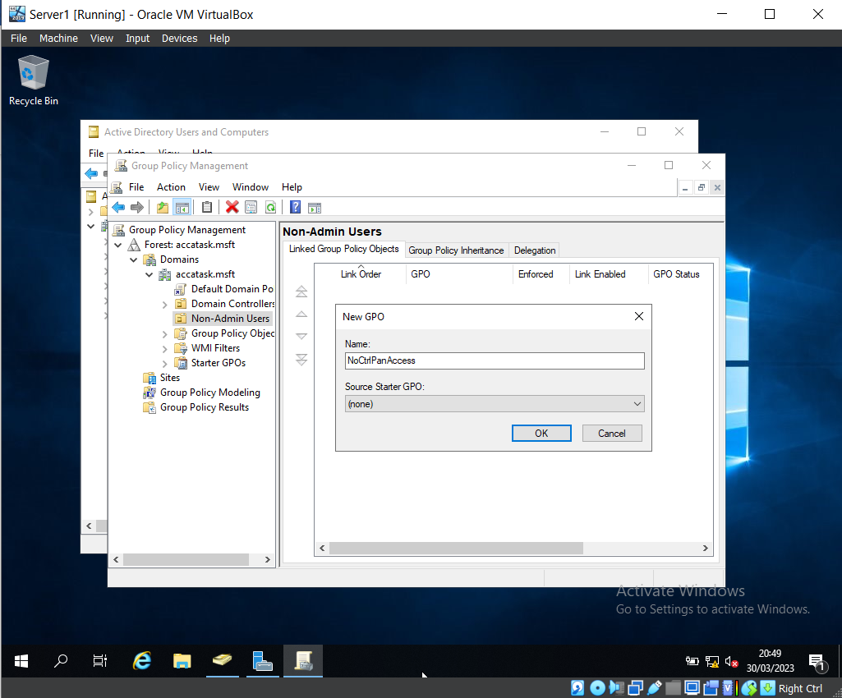

The Group Policy Management Console program was loaded to create a Group Policy Object (GPO). This GPO was named ‘NoCtrlPanAccess’.

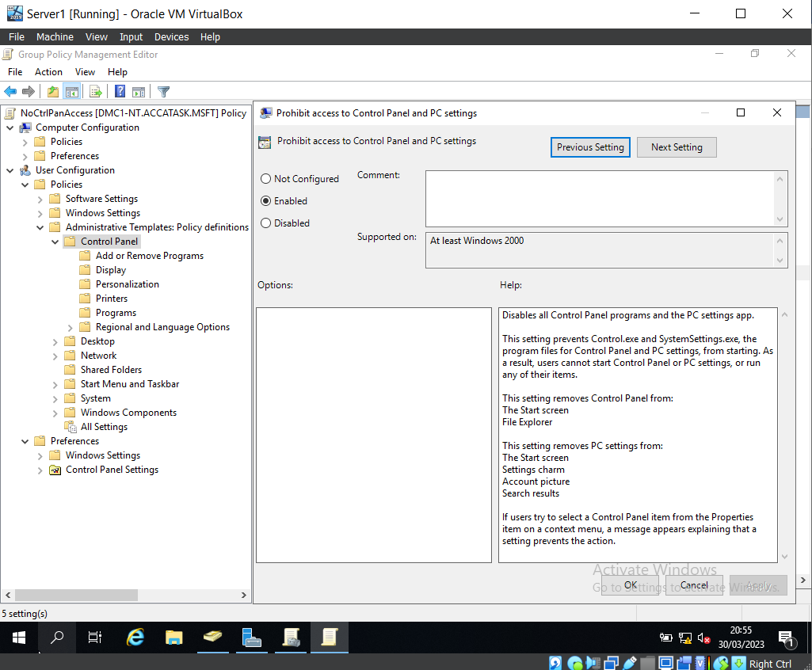

Here you can see that the ‘Prohibit access to Control Panel and PC settings’ policy has been enabled.

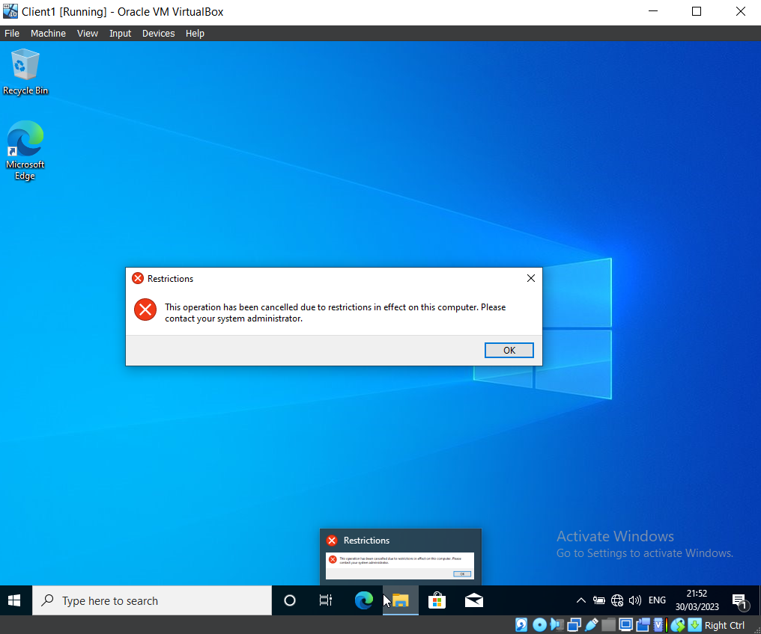

Once logged into Buddy Callams’ account (which was intentionally created with no access to the Control Panel), the group verified that the account could not access the Control Panel.

GPO 2: Removing Access to the Command Prompt

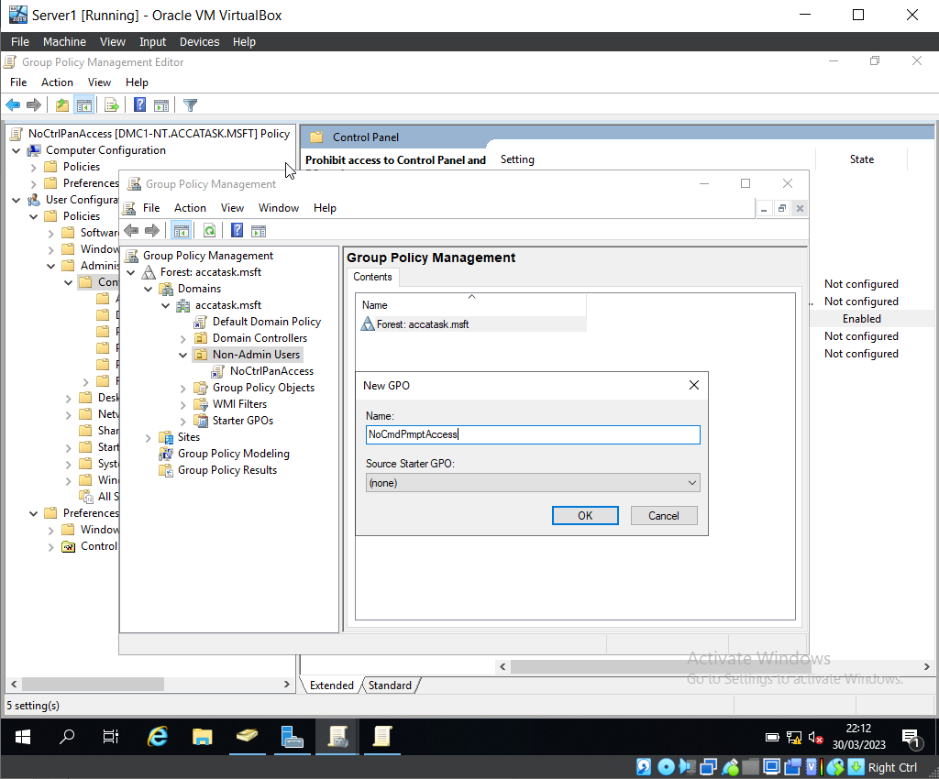

After loading the Group Policy Management Console program, expanding the domain and finding the Non-Admin Users OU, the team created a new GPO named ‘NoCmdPromptAccess’.
The team then edited the GPO to prevent Buddy Callams from access to the Command Prompt.

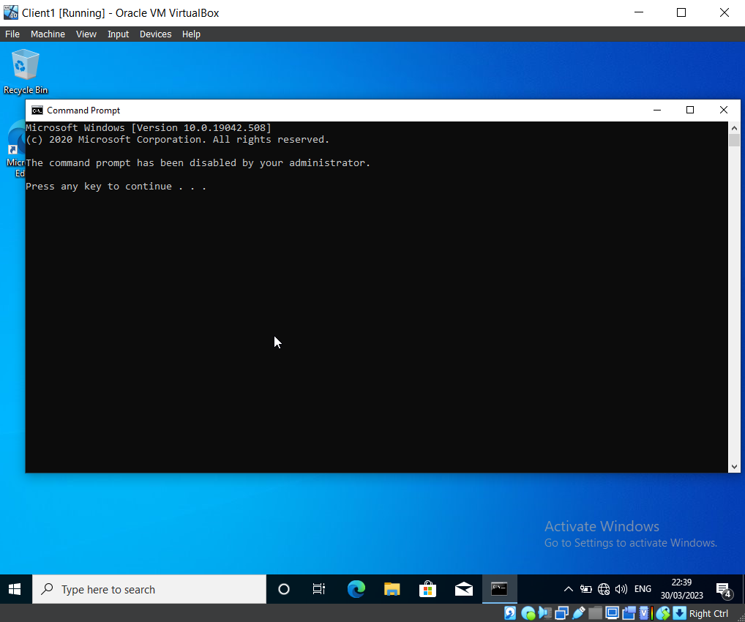

Using Buddy Callam’s account, the team tested that the Command Prompt could not be accessed. This screenshot confirms that the policy created in the GPO is working as expected.

GPO 3: Restricting Access to Removable Media Drives

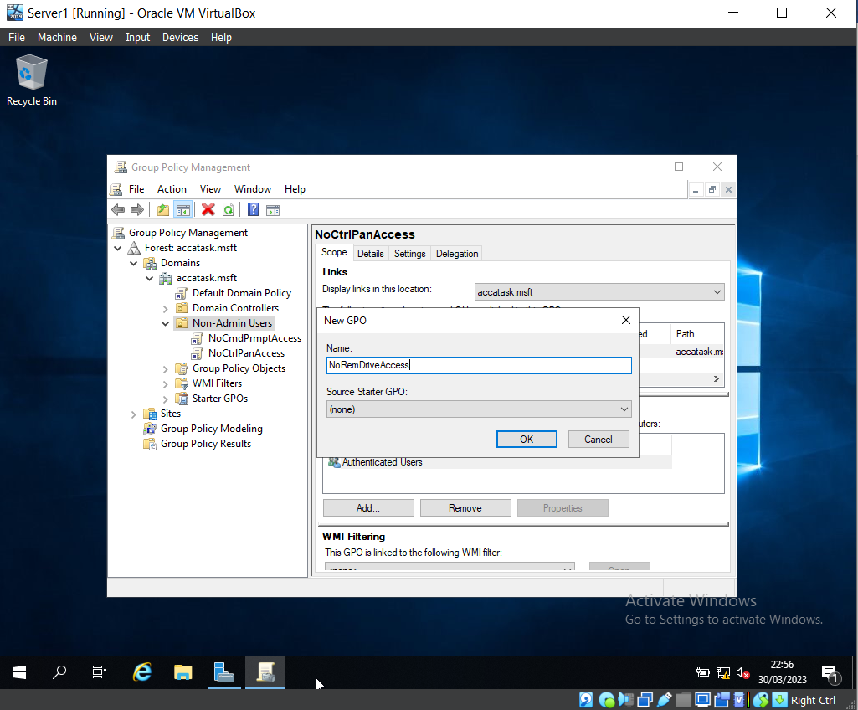

Another Group Policy Object has been created within the Non-Admin Users OU, named ‘NoRemDriveAccess’.

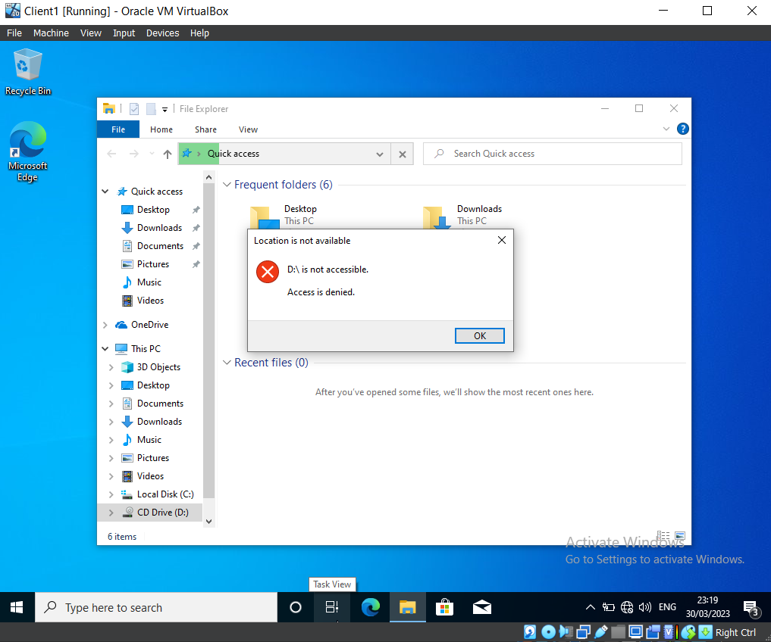

A USB has been attached to the Virtual Machine. This screenshot demonstrates that due to the policies now in place (i.e., access to Removable Storage is disabled), the USB is not accessible, and the error message is displayed to inform the user.

GPO 4: Restricting Software Installs

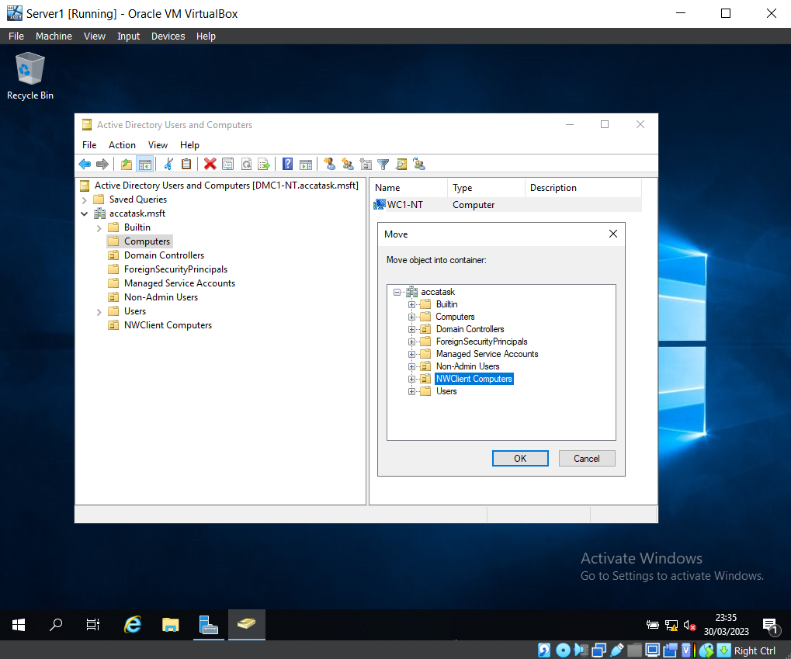

This screenshot displays the relocation of the client computer from the ‘Computers’ folder to ‘NWClient Computers’, enabling the policies specifically designed for computers within that particular Active Directory.

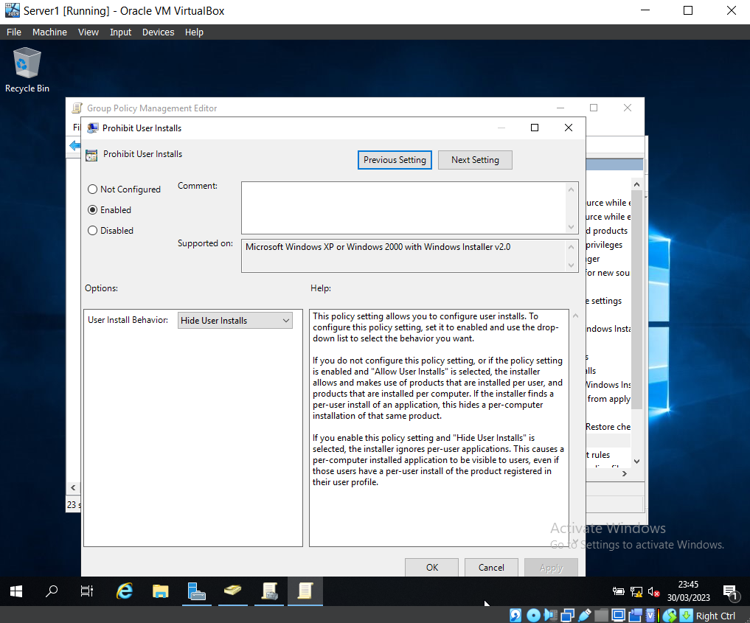

A policy has been created to stop users from performing installation on the client computer.

GPO 5: Enforcing Password Policy in the ‘accatask.msft’ domain

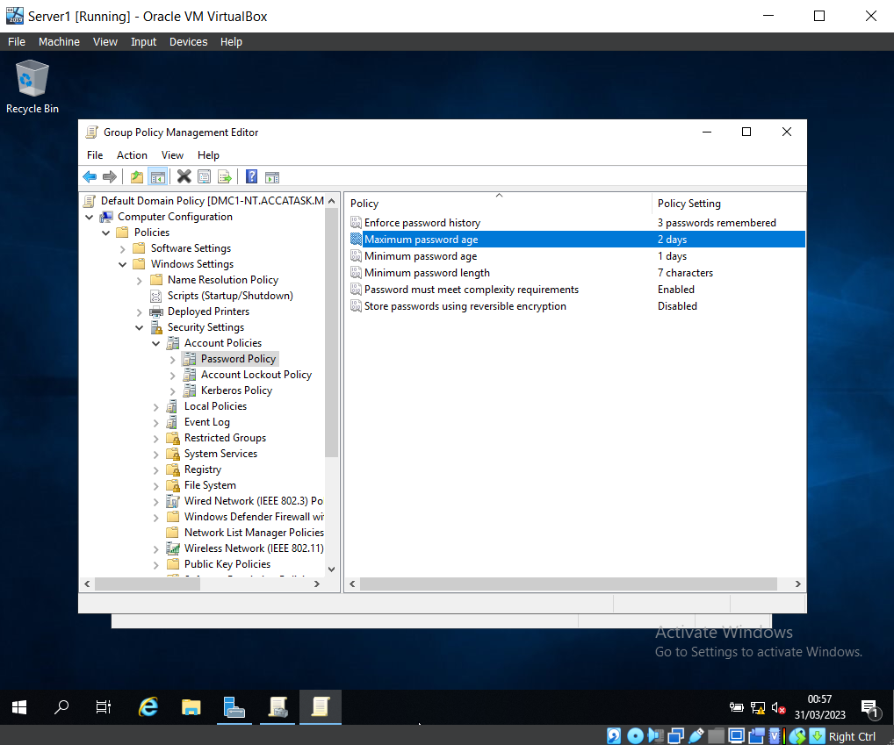

The password policy has been edited to fit the new requirements (e.g., the password must be a minimum of seven characters, and passwords using reversible encryption have been disabled).

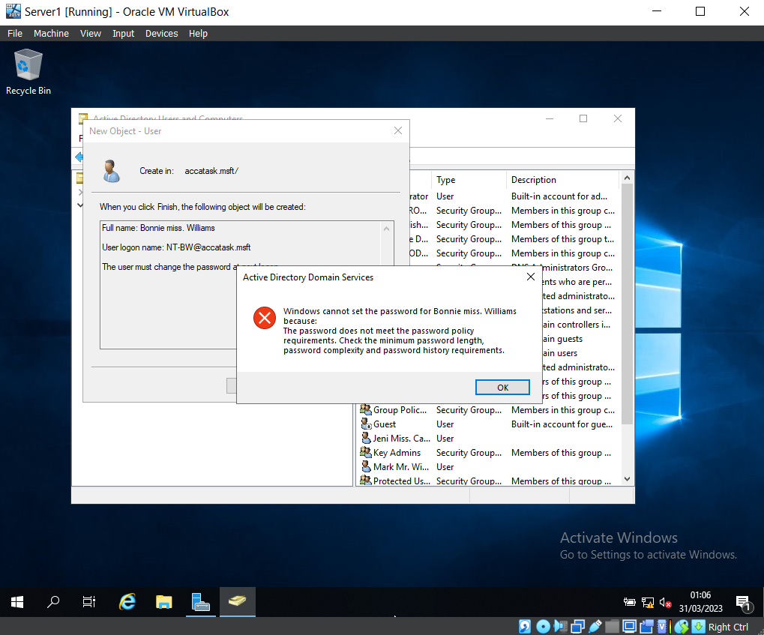

Here is evidence that the password policy is working as expected.
The team set a user’s password that was only four characters long, as this did not meet the criteria of the Password Policy, the password was not updated and an error message appeared.

Task 2: Routing and packet filtering within core TCP/IP services and critical failover/redundancy policies

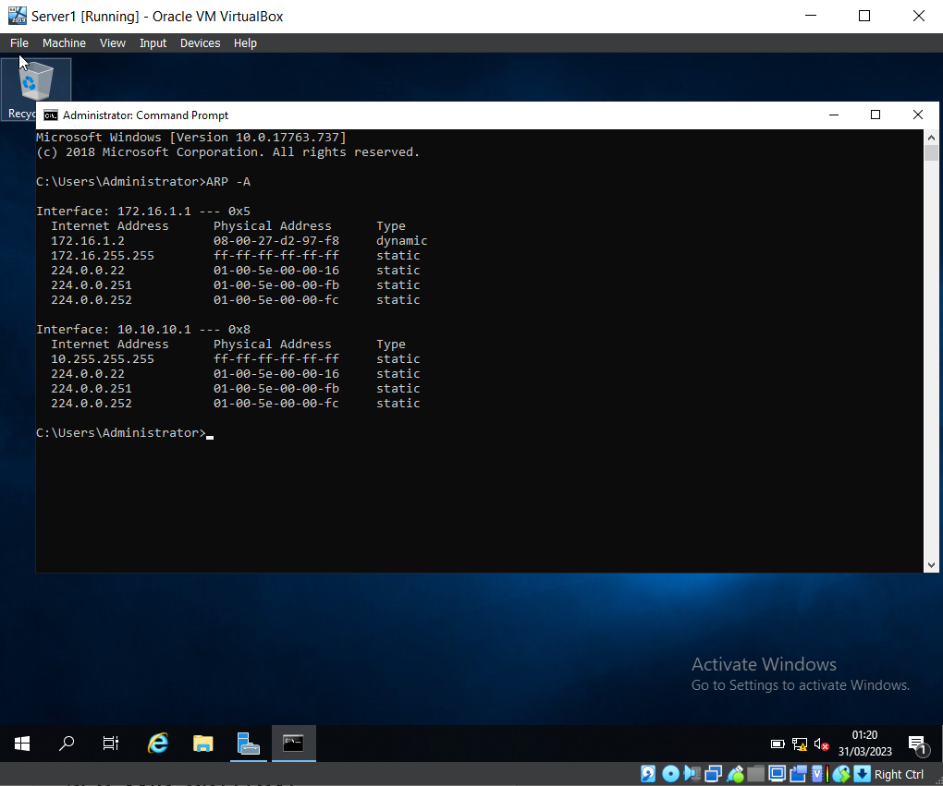

‘ARP – A’ has been entered into the Command Prompt, this shows the Interface (NIC’s), the Physical (MAC) address, and internet address of this NIC.

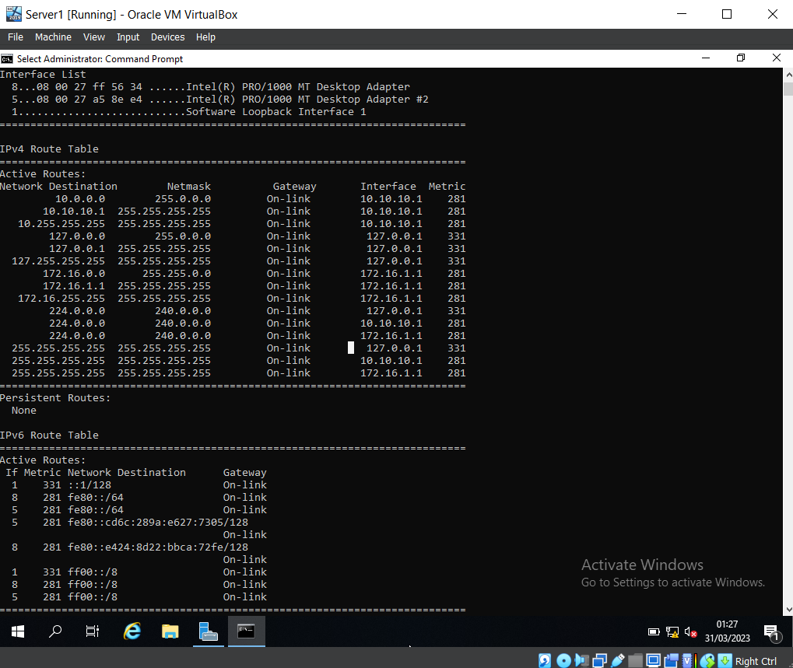

‘route print’ was entered into the Command Prompt to show the current IP routing table, which displays the following information: Netmask, Gateway, Interface, and Metric.

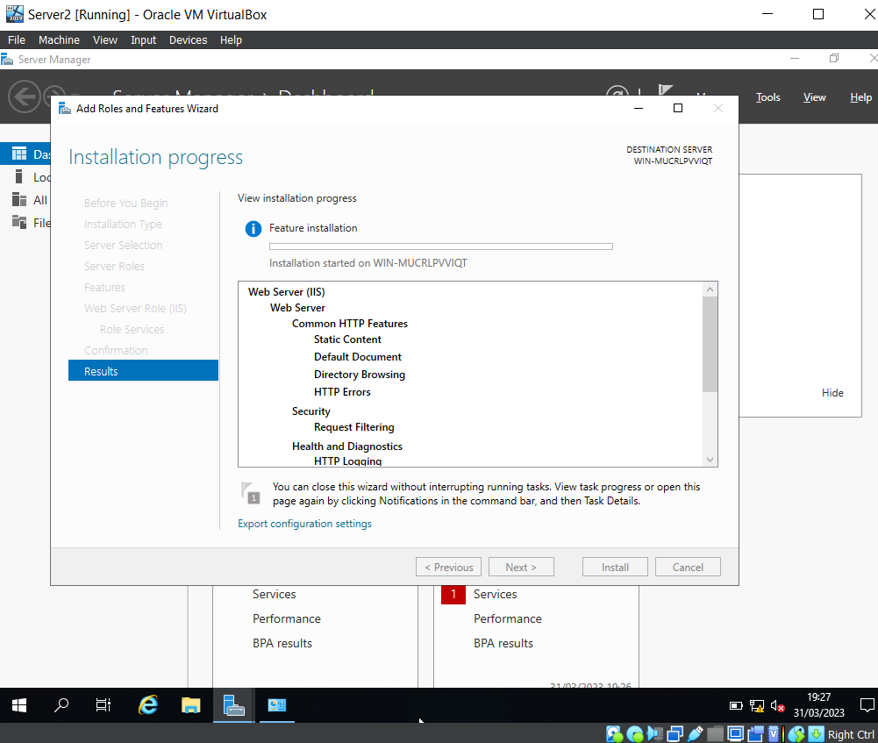

After launching the Server Manager, the FTP Server (IIS) Role has been configured and the FTP User Account has been created.

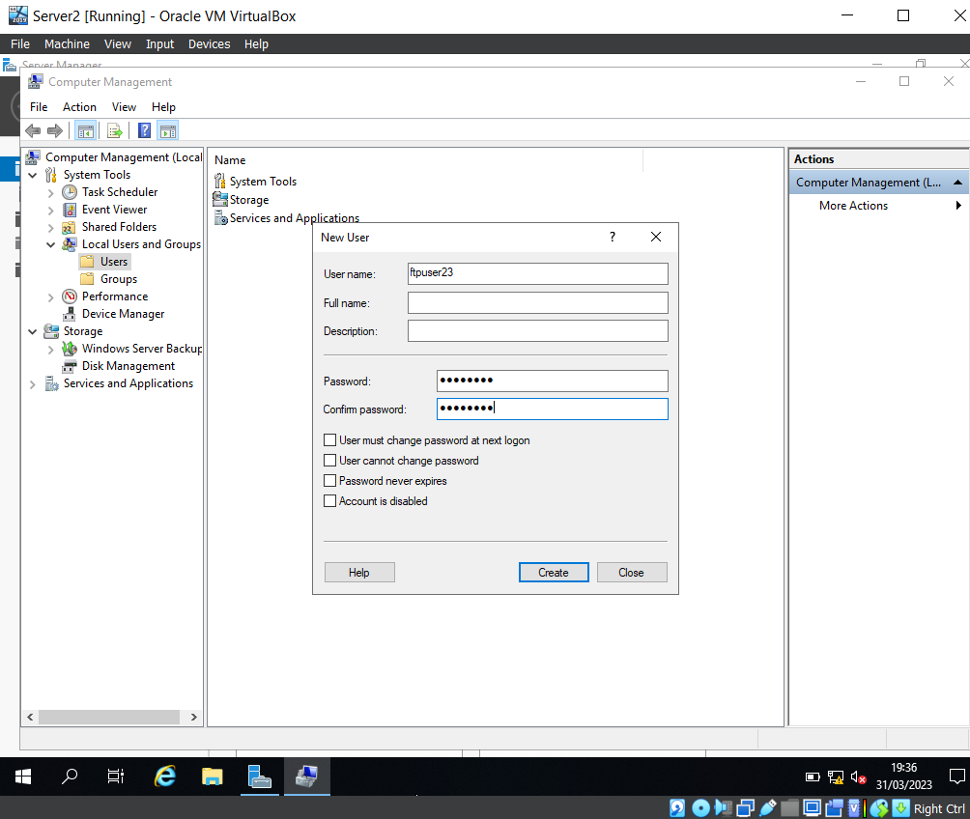

A new user was created, the username was set to ‘ftpuser23’ and the password ‘P@55word’.
The team manually unticked ‘User must change password at next logon’ before creating the user.

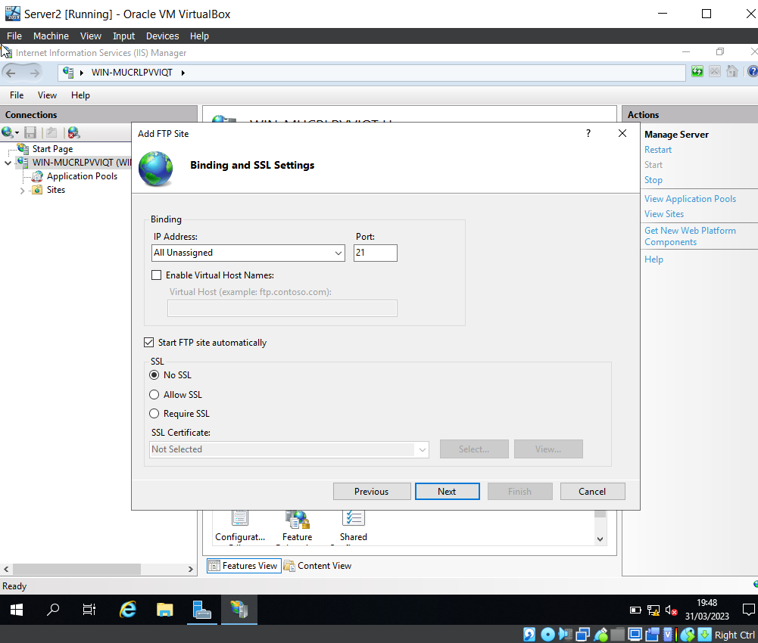
The team then opened the IIS Manager within the Sever Manager Tools and changed the binding and SSL settings to ‘No SSL’, and made a note of the Port Number (21), as this is the port used for FTP (File Transfer Protocol).

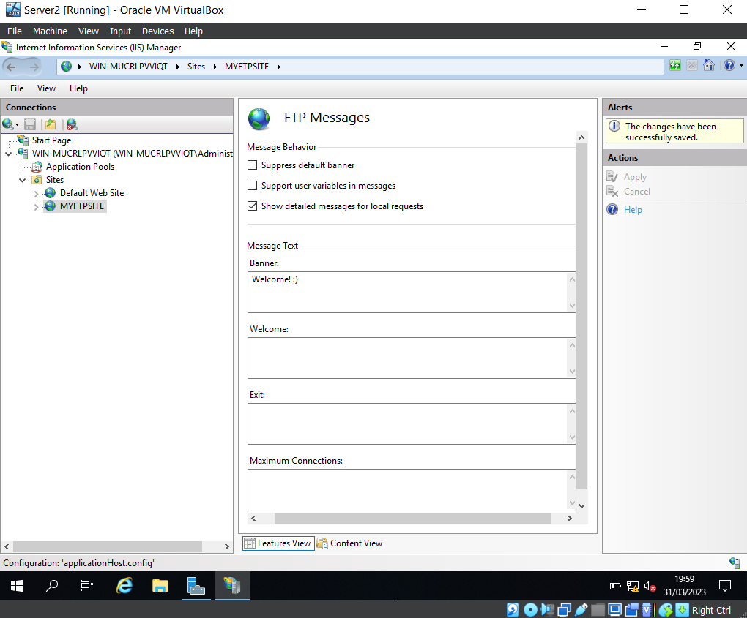
This screenshot displays the set-up of a banner message within the ‘MYFTPSITE’ site.

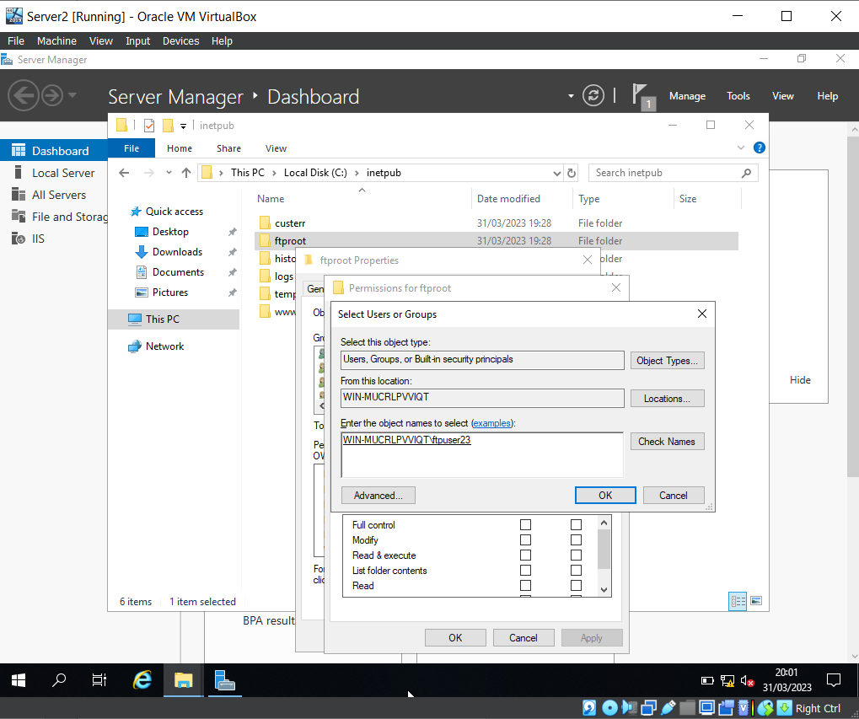

The newly created user, ‘ftpuser23’, has been added to ‘ftproot’ users group.
To confirm that the new user could be found, the team entered ‘ftpuser23’ and clicked ‘Check names’. The account is underlined, confirming that is has been found.

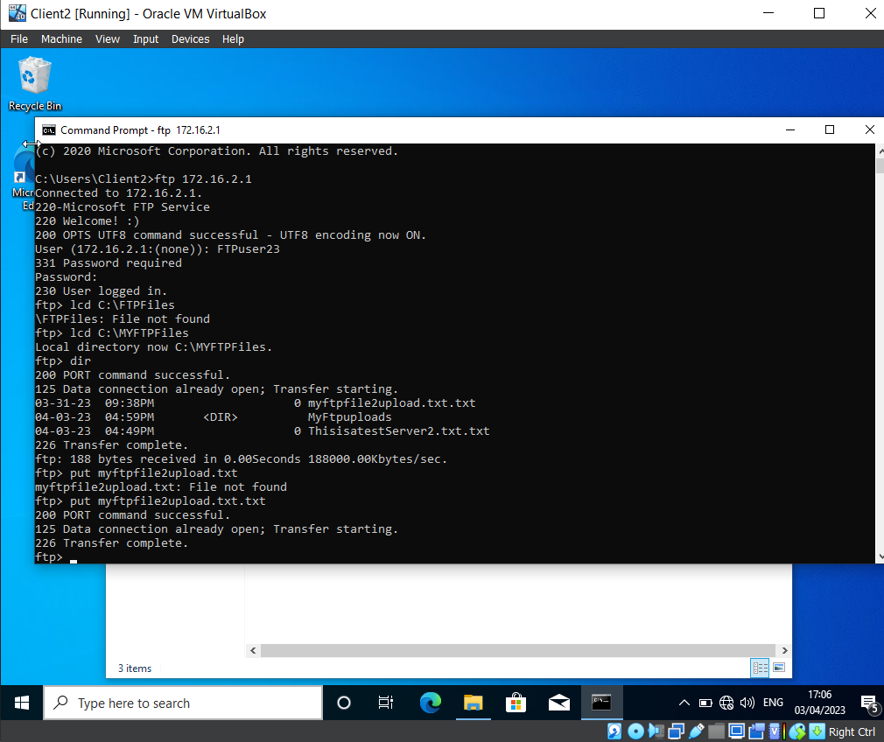

Using the command ‘ftp 172.16.2.1’ granted access to the FTP Service and prompted the ‘Welcome :)’ banner that was set up previously in the desk. This then prompted a login which was for the ‘Ftpuser23’ account. After the successful login, the command ‘lcd C:\MYFTPFiles’ proceeds to the directory of ‘C:\MYFTPFiles’. The command ‘dir’ brings up the files within the directory and the command ‘put myftpfile2upload.txt.txt’ transfers the document within ‘C:\MYFTPFiles’.

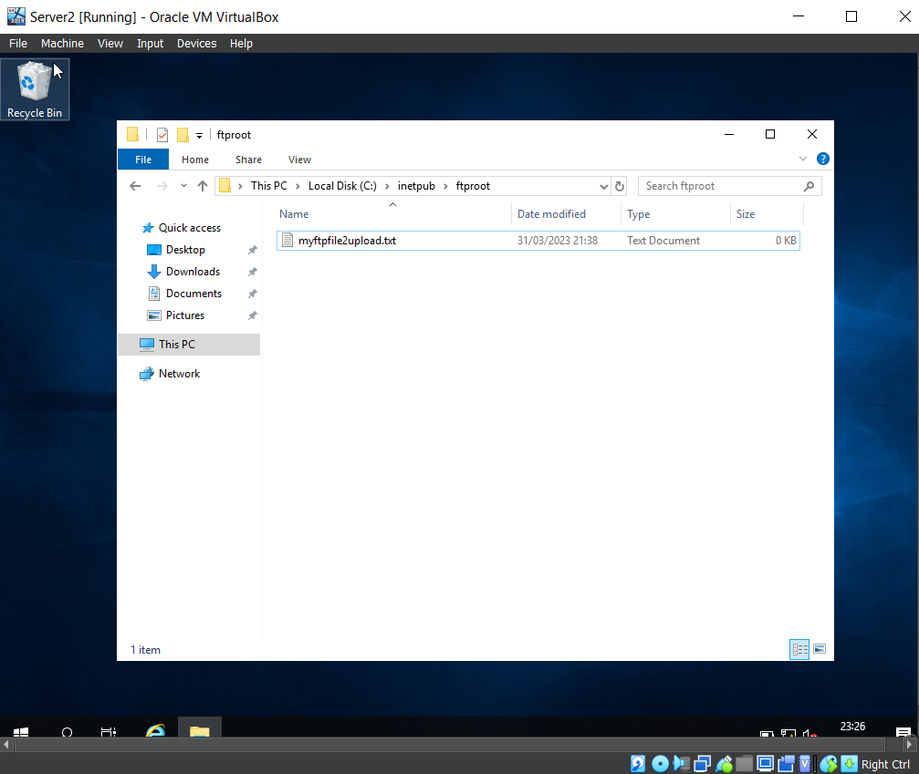
In the C:\directory of Client 2, the team created a new folder, and within this folder, a text file was created, named ‘myftpile2upload.txt’.
Prior to this, the team logged in as a domain administrator level account, and confirmed that the firewall on the Windows 10 client machine was disabled.

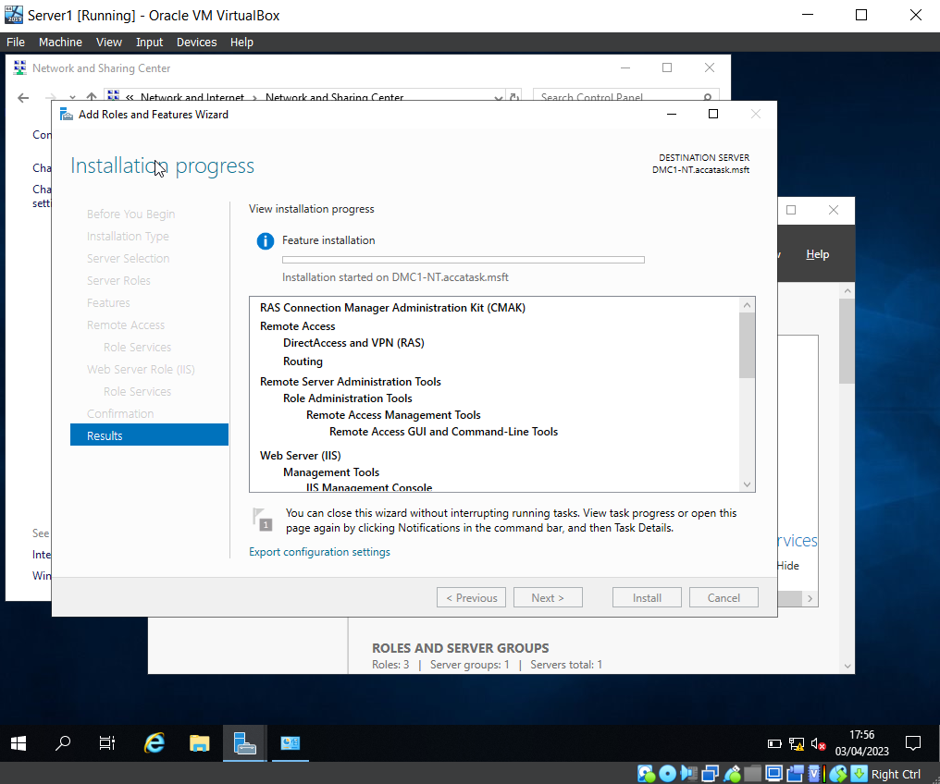

This screenshot displays the installation stage of adding roles and features for DirectAccess, VPN, and Routing Services.

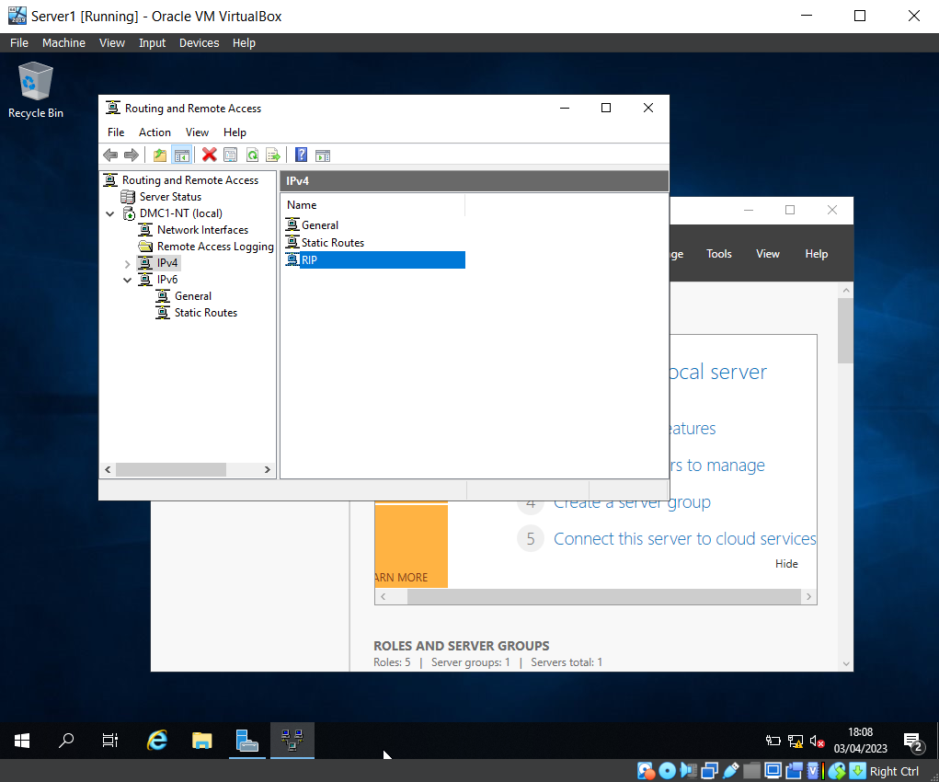

The team opened Routing and Remote Access and selected ‘RIP V2’ as the IPv4’s New Routing Protocol.
As you can see, ‘RIP’ is listed as an available protocol on the IPV4 stack.

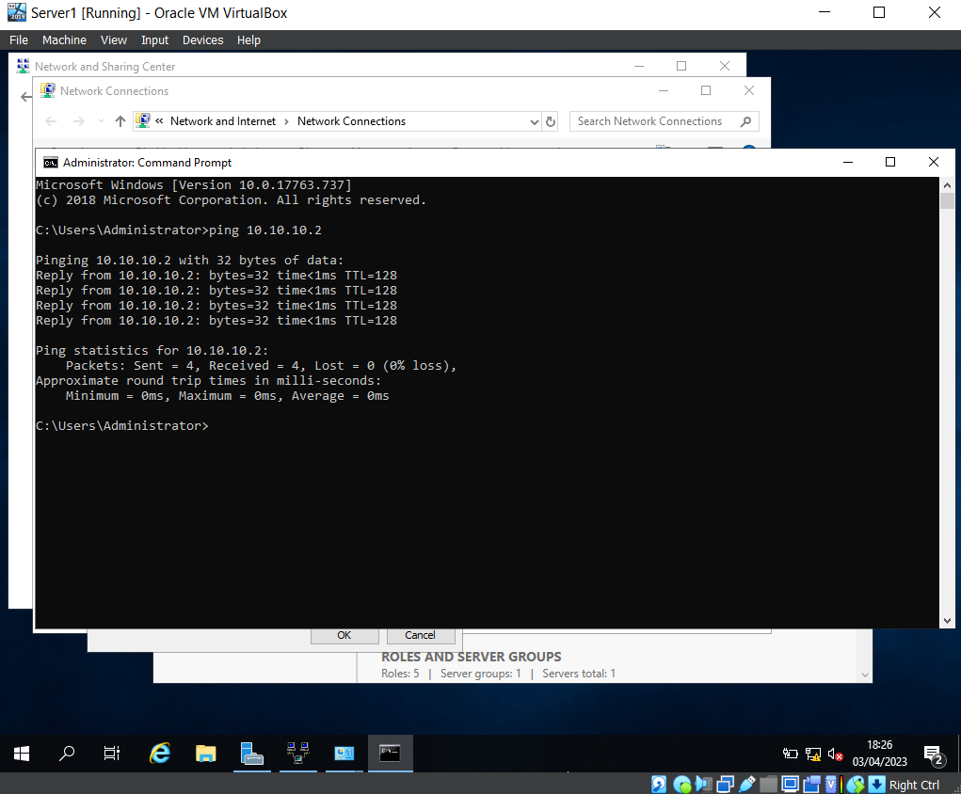
Pinging the PublicNet IP address for Server 2 from Server 1 and receiving a response.

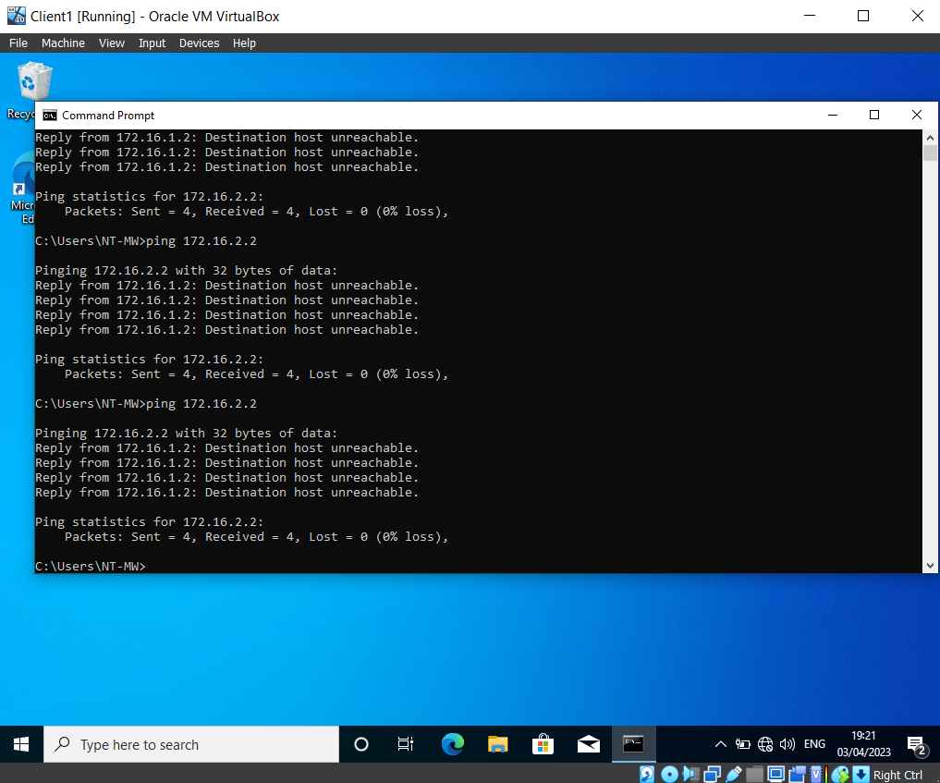

Here you can see the team are unable to ping Client 2 from Client 1.

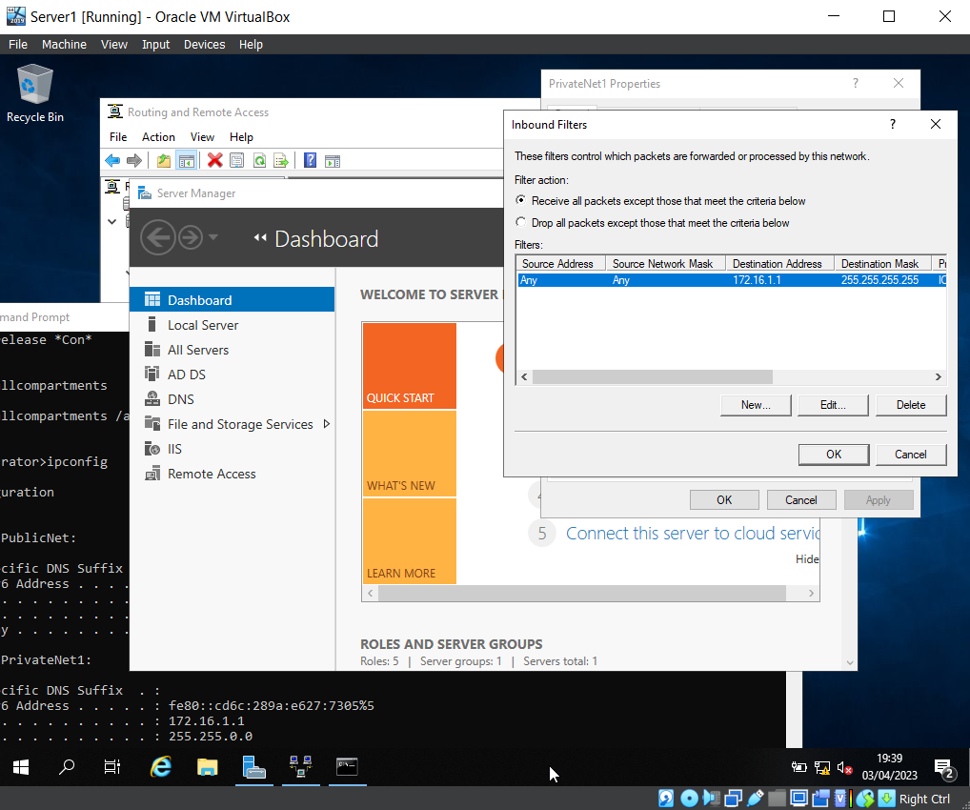

The Inbound filter for PrivateNet1 within Server1.

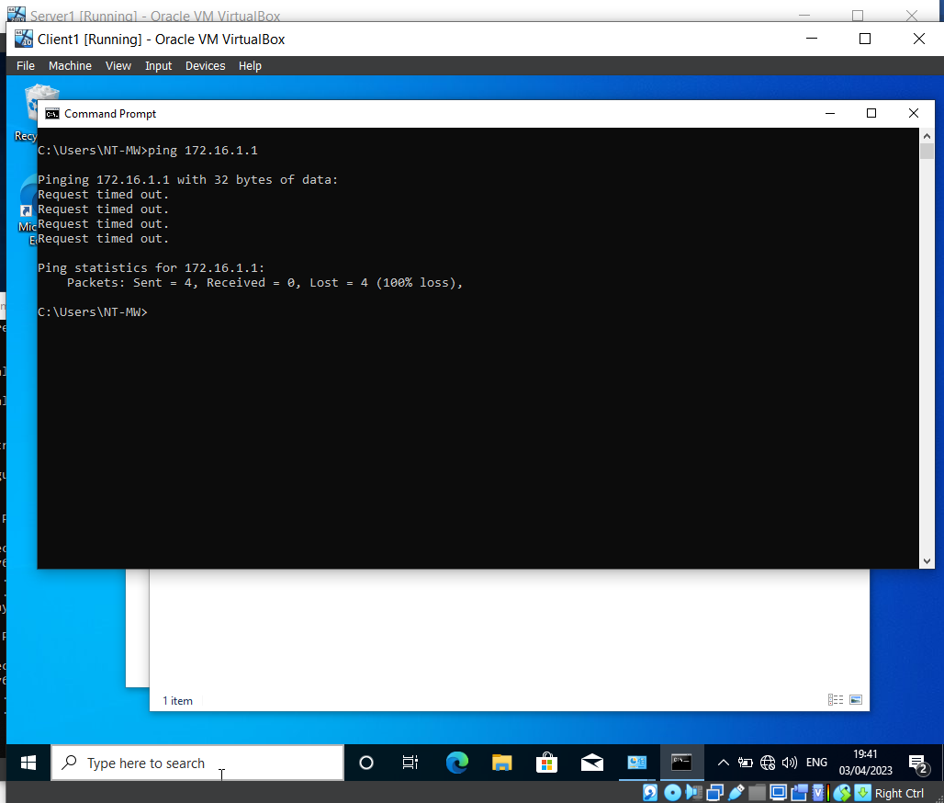

Here the team have attempted to send a ‘ping’ to PrivateNet1 from the Client, this currently results in a timeout error, as the new inbound filter is blocking ping requests.

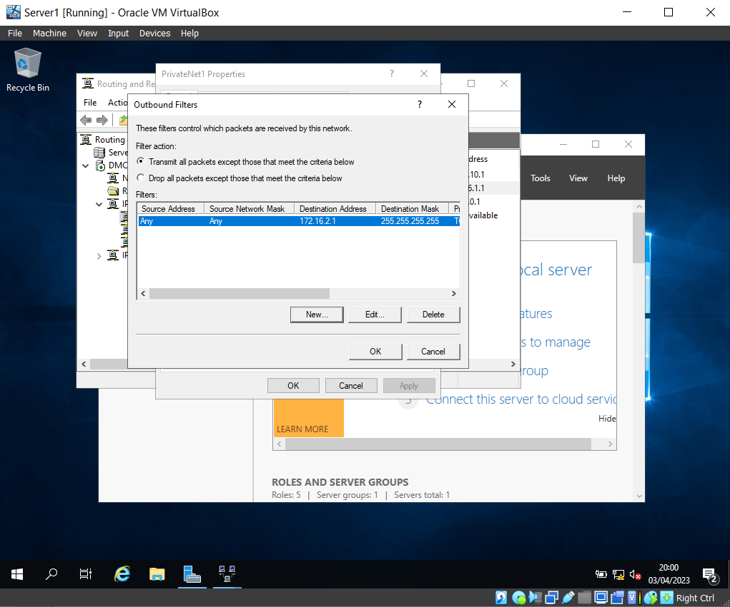

The outbound filter on Server 1 for PrivateNet1 is configured to restrict access from PrivateNet1 to the FTP running on Server 2.

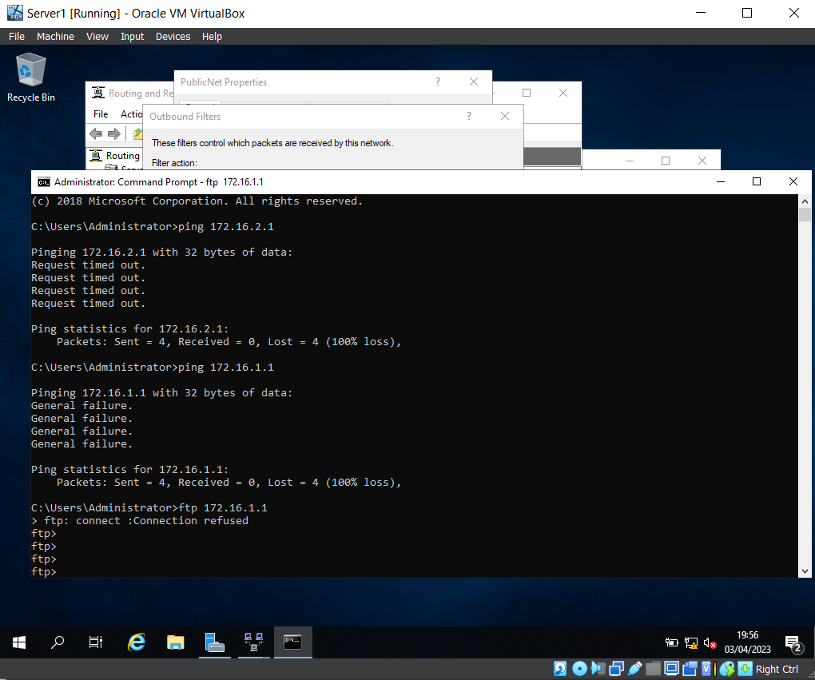

This screenshots shows the connection to ‘FTP 172.16.1.1’ has been blocked, due to the filter.

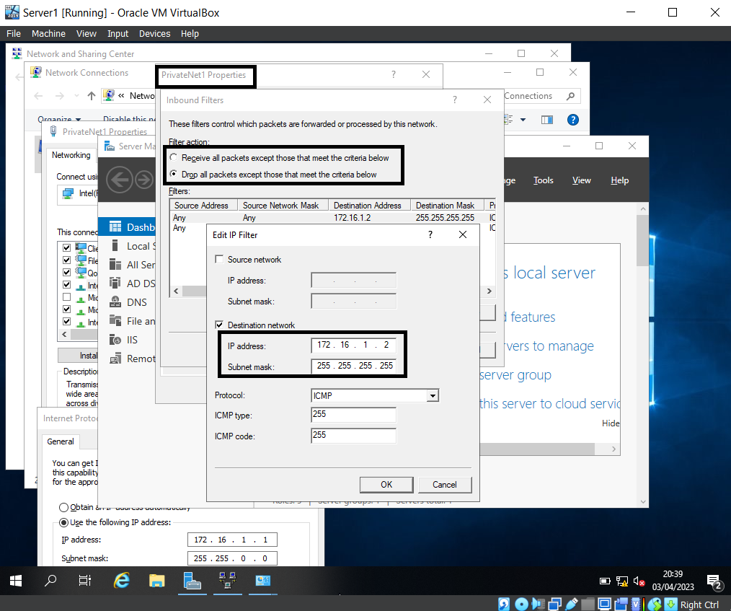

The set inbound rule above shows that the IP is set for Client1, and the middle box shows the filter action ‘Drop all packets except those that meet the criteria below’, which means Client 1 will have FTP access, but all other IP addresses will be denied access.

Task 3: Observation tasks – Individual Task

On a SOHO (Small Office/ Home Office) Network, if you want to consider enhancing security, what actions could you do?
There are many ways in which you can enhance security in a Small Office/ Home Office (SOHO). These include, but are not limited to:
- Ensure the building is secure e.g. install surveillance cameras, alarm systems and make sure that doors, locks and windows can withstand any physical attacks. Additionally, to prevent unauthorised people from entering the building, install a badge system
- Prepare a recovery plan so that the network is prepared for any incidents. This is also beneficial in the event of a breach (which are undoubtfully stressful events with lots going on) as you are legally required to report them to the ICO within 72 hours
- Ensure security measures are in place:
- Make sure staff regularly update their passwords and ensure they are strong
- Use firewalls and up to date antivirus software
- Restrict user’s access to unnecessary resources via Group Policy Management, this will help protect sensitive information from being viewed by unauthorised users, and also reduce the attack surface
- Educate staff through awareness training e.g. phishing training, which will help staff to recognise and report phishing emails, which is vital as phishing emails make up “33% of all cyberattacks” [1] and “an estimated 74% of US organisations fell victim to at least one phishing attack in 2020” [1]
- Ensure that sensitive data is encrypted and stored safely, for example, the data can be stored in a data centre or on the cloud
- Back up data regularly in the case of data loss or breach
- Perform penetration testing to check for any vulnerabilities
- Monitor internet traffic (this can be done through network tools such as ‘Wireshark’, which will analyse the internet traffic and report any suspicious activity)
- Use multi-factor authentication to ensure only authorised people can access the systems
- Remove data when it’s no longer needed to help reduce the amount of data leaked in any potential breaches
- Change the Service Set Identifier (SSID) or disable the SSID Broadcast. “Every wireless network must have an SSID, and by default, WAPs and wireless routers typically use the manufacturer’s name or the device’s model number as the default SSID.” [2] By changing the default SSID, cyber attacks are reduced as it is harder for attackers to identify the network
- Regularly release new patches to ensure that software is up to date and bug fixes are deployed
- Enable mac address filtering to prevent unauthorised access on your network (by enabling mac address filtering, only devices with this filtering can connect to your network). Additionally, enable IP filtering to block traffic
- Set NFTS (local permissions) on folders/files so that certain users have read only access to help protect content of files
- Create a Group Policy Object (GPO) within the Non-Admin Users Organisation Unit to enable settings such as ‘Prohibit access to Control Panel and PC settings’, which will restrict user’s access to the Control Panel. In the screenshot below you can see that during the workshop activities, the team prevented a user in the Non-Admin Users OU from accessing the Command Prompt via their GPO, 'NoCmdPromptAccess'. There are many advantages of blocking users from using Command Prompt, for example, this can prevent users from making any malicious or accidental changes to the system. There are many GPOs you can create to enhance security, another example would be to restrict access to removable media drives. An advantage of this would be that users would be unable to use USBs to transfer sensitive data, and this would also help prevent malware.

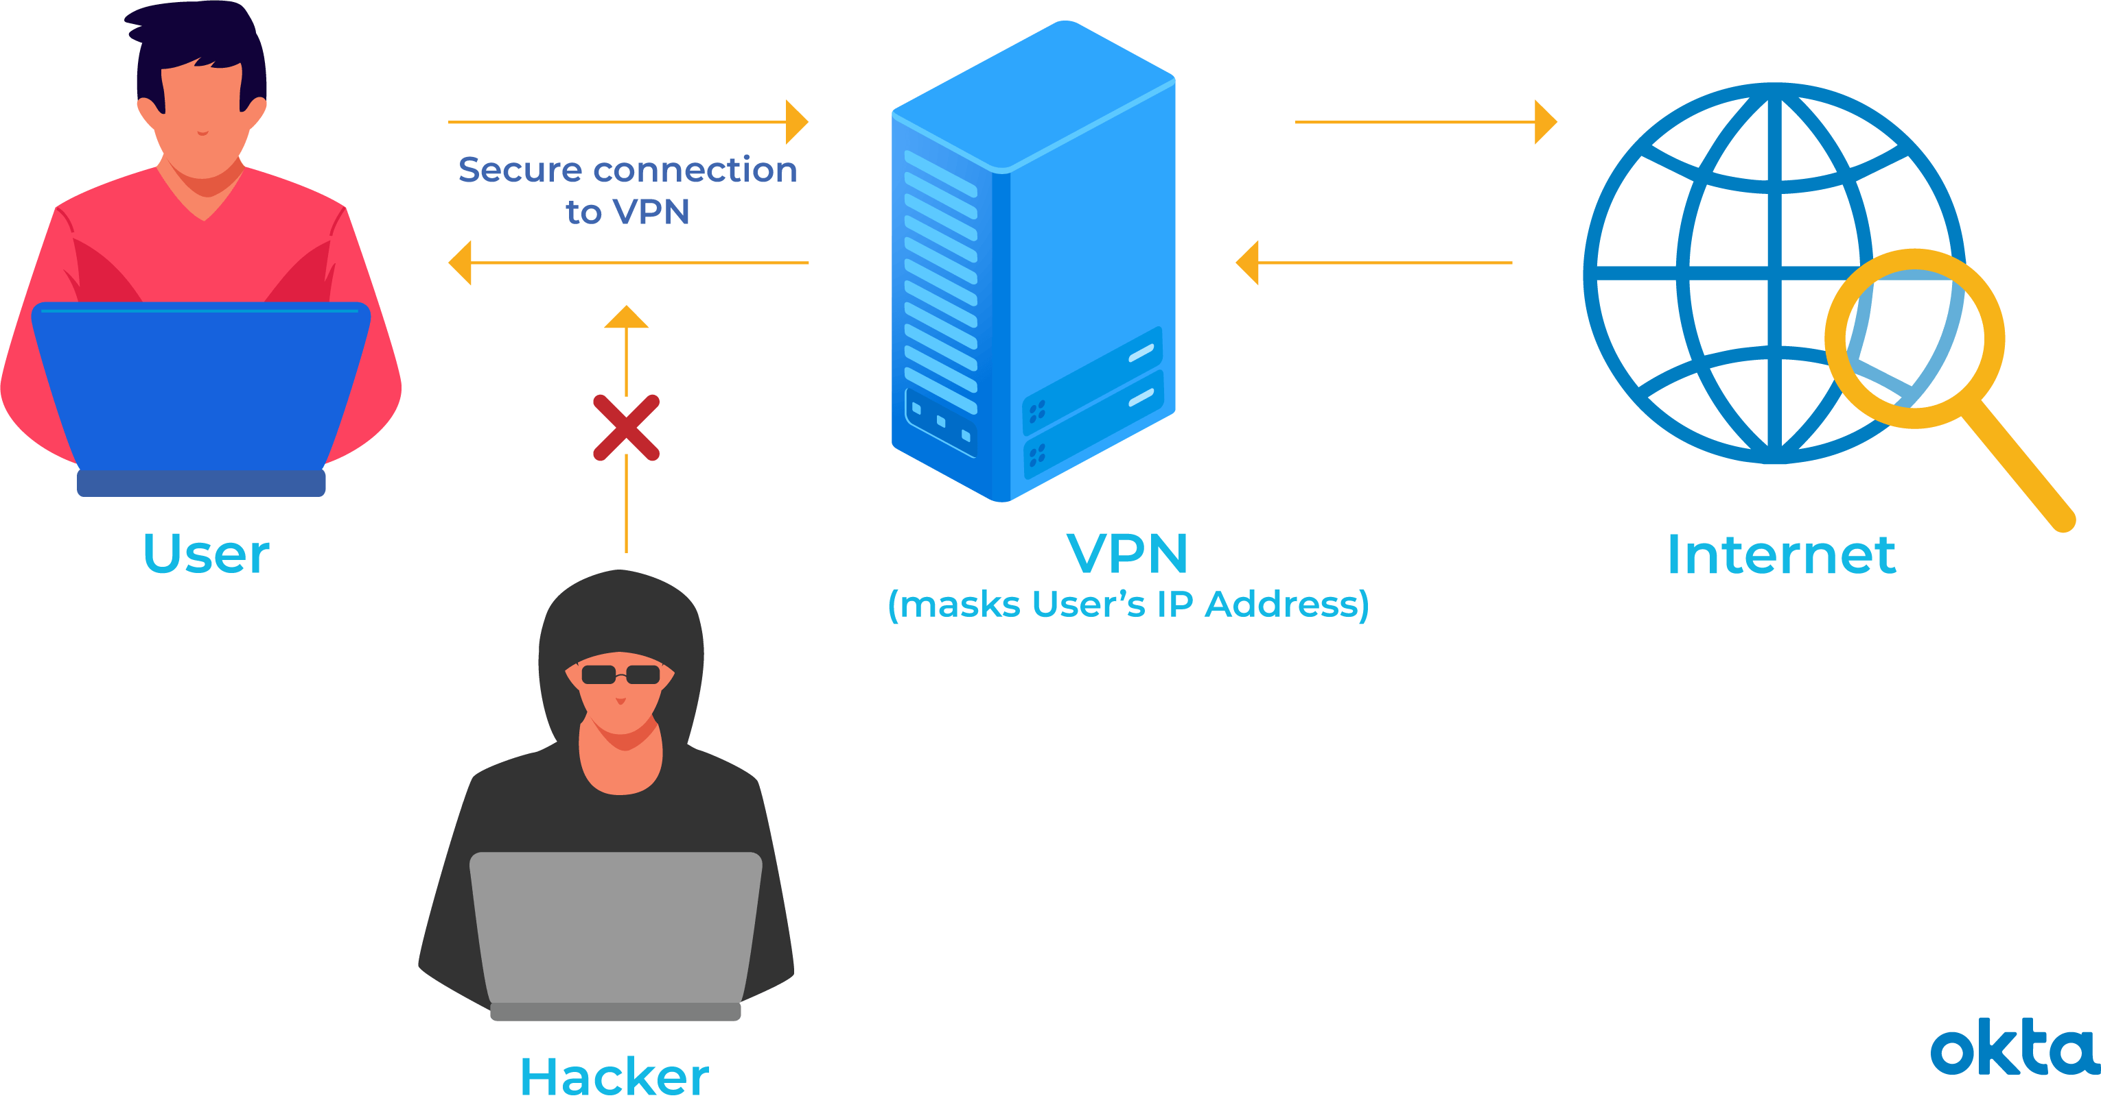
- Finally, as many people now work remotely, a Virtual Private Network (VPN) should be used to encrypt remote staff’s connection from their device and company’s network

How a VPN works [3]

Failover Clustering for high availability systems/services

“A failover cluster is a group of independent computers that work together to increase the availability and scalability of clustered roles (formerly called clustered applications and services). The clustered servers (called nodes) are connected by physical cables and by software. If one or more of the cluster nodes fail, other nodes begin to provide service (a process known as failover).” [4]
When attempting to deploy failover cluster, there are concepts that need careful consideration. Below are some examples:
- Servers: Microsoft recommend that when creating a failover cluster, you use a set of matching computers that have the same/similar components [5], as this allows you to distribute resources evenly, and spot any issues with performance.
- Disaster Recovery Plan (DRP): a plan needs to be put into place in the event of any disasters/emergencies (e.g. natural disasters, ransomware, data breach/loss, power outages, and server failure). A DRP allows organisations to continue business after a disaster. There are many goals for a DRP, to name just a few, they should identify potential threats and identify priorities, and state roles and responsibilities.
- Configuration: when using network configuration for the failover cluster, it is vital that the configuration is correct. For example, all of the clustered servers should have their own unique IP address. Duplicate IP addresses can otherwise disturb the cluster. Encryption and firewalls should also be installed to block access from unauthorised users.
- Scalability: scalability is crucial as it allows systems to handle more work, and it is a must in agile environments where demands are always changing.
- Testing: the failover cluster will need to be tested often to ensure that it is working as expected.
- Monitoring: this is another crucial concept to consider, as it will allow you to detect any (potential) problems, and review the performance of the clustered servers, and resource groups.

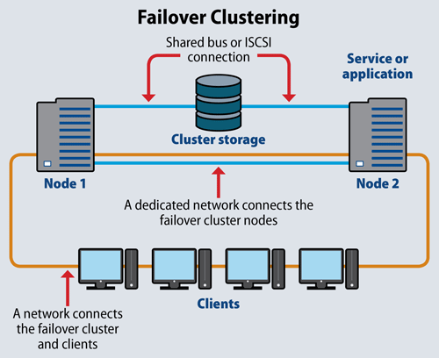
Additionally, a possible role within the Window Server OS environment that could provide these requirements is the Hyper-V role. On a Windows Server host, the Hyper-V role gives you the ability to create and manage Virtual Machines (VMs). If a server fails when failover clusters are used in this way, the VMs are highly available.

How Failover Clustering works [6]

To configure failover cluster, the following steps would be taken:
1) Confirm that all servers are running on the same Windows Server version, and that they are linked to the same Active Directory (AD) domain, so that the computers can collaborate
2) Install the Failover Clustering feature on each server
3) Use Cluster Validation Wizard to confirm the configuration
4) Click Create Cluster
A screenshot is provided below to demonstrate installing Failover Clustering Tools.
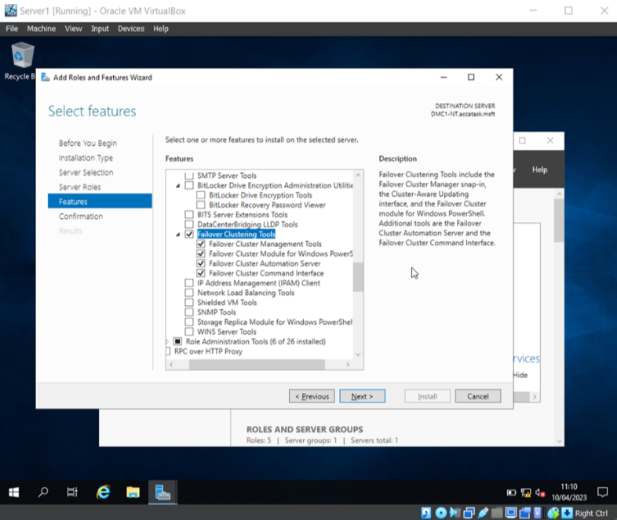

In conclusion, failover clustering is hugely important in facilitating a HA and CA environment for applications and services that work within enterprise networks as it prevents downtime by providing backup when clustered servers fail, ensuring users are not affected.

Draft a network policy for an Enterprise Network which operates in multiple locations
Network policies are a set of “rules and guidelines on what network users can and cannot do” [8].
It is vital to create a network policy for an Enterprise Network that operates in multiple locations to ensure high availability and security of critical business applications.
There are many advantages of network policies, these include the following: they provide consistency across different locations, security measures are easier to enforce, performance can be monitored, and it can make automating network devices easier by providing a standard [7].
A network policy has been drafted below, specifically designed for this type of network.
Overview:
This network policy provides a set of rules and guidelines for this enterprise network which operates in multiple locations, considering critical business application, high availability and security practices.
Assumptions:
- The network is used in multiple locations with a large number of staff
- Staff work in offices and remotely, and therefore use VPN to securely use the company’s network
- Role-based policies are in place to offer more flexibility
- The enterprise’s application require high and continuous availability
- Security practices are in place
Architecture:
- Network Topology: show the layout of network devices and connections (physical and virtual)
- Use Dynamic Host Configuration Protocol (DHCP) to change the default IP addresses within the network to prevent hackers from identifying the network
- Scalability: make sure the network can be changed as demands will always be changing e.g. show how to add new locations to the network
- Monitor the network e.g. via penetration testing to identify any potential weaknesses, and network traffic analysis to spot suspicious activity
Network Access:
- All users must sign into the VPN, ‘Cisco AnyConnect’, where all connections will be encrypted
Enforcement of security policies:
Security policies will be in place and regularly reviewed. These include GPOs, firewalls, and monitoring tools. The GPOs will enforce password policies, block unauthorised software deployment, prevent unauthorised users accessing sensitive data, and disable apps such as command prompt, and restrict access to removable media drives
Analysis of security risks:
Risk assessments will regularly be taken (every six months) to identify any vulnerabilities within the network
Mitigations in the event of violations:
A Disaster Recovery Plan (DPR) will be put in place, and in the event of any violations e.g. data breaches, the company will follow the guidelines within the DPR. All data breaches will be reported to the ICO within 72 hours
- Provide mandatory staff training e.g. cyber security awareness training, and educate them on phishing emails
- Monitor the network
- Encrypt all sensitive data
- Use GPOs to prevent unauthorised access e.g. password policies to enforce strong passwords
- Use audit logs via the Active Directory to view any suspicious activity and prevent issues from occurring
Conclusion:
This network policy applies to all staff and covers the key guidelines and rules for the network, including its architecture, network access, enforcement of security policies, analysis of security risks, and mitigations in the event of violations

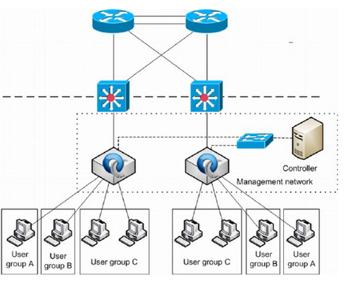
Network Topology [9]

Brief reflection

Completing task one and two of this assignment as part of a team again was really beneficial as issues were quickly resolved and lessons were learnt through discussion. Again, the team evenly contributed to the assignment and got on well. Everyone brought different strengths to the work.
In task three of the assignment, a lot was learnt regarding network security, especially the ways in which security can be enhanced in SOHO networks. To improve the assignment, more technical detail could be given.

Conclusion

In conclusion, it is vital to manage and maintain network resources using network policy and security practices to ensure the security of networks. By properly configuring settings using Active Directory, unauthorised access and attacks are prevented. An additional method to help secure networks is by implementing Routing and packet filtering, as this can help prevent attacks and block dangerous packets.

Additionally, failover clustering is hugely important as it prevents downtime by providing backup, and network policies are vital so all staff are aware of the guidelines and can follow them.

It is important to remember that are many ways to help protect networks, however, this can never be guaranteed, so network policy and security practices must be regularly reviewed and updated where necessary, and staff must be regularly trained.

References

[1] M Butavicius, R. Taib, S. J. Han, “Why people keep falling for phishing scams: The effects of time pressure and deception cues on the detection of phishing emails”, Computers & Security, vol. 123, Dec. 2022. [Online]. Available: https://doi.org/10.1016/j.cose.2022.102937 [Accessed May 3, 2023].
[2] R. McDonald, CompTIA A+ Core 1 (220-1001) and Core 2 (220-1002) Cert Guide, 5th ed., Person IT Certification, 2019
[3] “What Is a VPN & How Does It Work?”, Okta, Feb. 14, 2023. [Online]. Available: https://www.okta.com/uk/identity-101/what-is-a-vpn/ [Accessed May 3, 2023].
[4] S. Gerand et al. “Failover Clustering in Windows Server and Azure Stack HCI”, Microsoft, Feb. 11, 2022. [Online]. Available: https://learn.microsoft.com/en-us/windows-server/failover-clustering/failover-clustering-overview [Accessed: May 5, 2023].
[5] S. Gerand et al. “Failover clustering hardware requirements and storage options”, Microsoft, Mar. 29, 2022. [Online]. Available: https://learn.microsoft.com/en-us/windows-server/failover-clustering/clustering-requirements [Accessed: May 3, 2023].
[6] J. Emigh, “Failover Clustering”, ServerWatch, May. 15, 2019. [Online]. Available: https://www.serverwatch.com/servers/failover-cluster/ [Accessed: May 3, 2023].
[7] “What Is Network Policy?”, Cisco. [Online]. Available: https://www.cisco.com/c/en/us/solutions/enterprise-networks/what-is-network-policy.html [Accessed: May 3, 2023].
[8] "Identifying and preventing vulnerabilities", BBC. [Online]. Available: https://www.bbc.co.uk/bitesize/guides/zj89dxs/revision/3 [Accessed: May 3, 2023].
[9] V. Dangovas, F. Kuliesius, “SDN-Driven Authentication and Access Control System”, The International Conference on Digital Information, Networking, and Wireless Communications (DINWC2014), Ostrava, Czech Republic, June 2014. [Online] Doi: 10.13140/RG.2.1.3739.3129 [Accessed: May 3, 2023].

