University of Wales Trinity Saint David

Effective Team Working and Communication

Student Name: Tatyana Volchevska
Student ID: 1921380
Lecturer name: Prof. Saqib Shamim

Contents
Introduction 3
Explaining different theories of group dynamics and the impact of effective team working in the organisations 4
Group dynamics 4
Features of group dynamics 4
Demonstrating different theories of group dynamics 5
Describing different team working skills and real-life example of teamwork 7
Analysing the impact of efficient teamwork in an organisation 7
Demonstrating effective communication skill and the impact of proper communication skill in the organisation 9
Competent Communication skill 9
The communication model of an organisation 9
The necessity of efficient communication within an organisation 10
A real-life example of poor communication system 10
Conclusion 12
References 13

Introduction
Effective communication skill is the most required talent that is searched in an employee by an organisation. Strong communication process boosts the speed of performance and ensures accuracy. Through an effective communication process, the organisations can build effective teams and can assure proficient teamwork. Proper communication system ensures a positive and healthy working environment (Locker and Kaczmarek, 2019). Teamwork is another effective approach to gain success in the business. In any teamwork, communication is the most important element. Efficient communication system eases the tasks of teamwork and enables to take challenges. An organisation needs to hire efficient employees and engage in their jobs with effective communication skill training to ensure improved performance.

Explaining different theories of group dynamics and the impact of effective team working in the organisations
Teamwork is mainly the concept of working two or more people collaboratively to achieve a common goal. In every organisation, there work many groups at a time. It may be a group of managers working together to manage the overall operations or maybe a group of supervisors operate the activities and monitor them (Tarricone and Luca, 2012). For making the teams of the organisations more effective, the organisations need to control the team with proper group dynamics.

Group dynamics
Group dynamics refers to a set of behavioural pattern and attitudes to manage and control the activities of a team. Any sort of small changes in a team or group brings an overall change in the group bonding or group structure (Mascarenhas, 2019). For controlling the changes, group dynamics plays the role of a disseminator. The elements of group dynamics control the behaviour and actions of the team to avoid any kind of change or conflict.

Features of group dynamics
Group dynamics are designed according to put some unique factor in the organisations’ team to work effectively. For this reason, the dynamics must contain some specific characteristics. Those are-
- Group dynamics should describe the way of operations and the actions of the particular groups.
- Group dynamics must contain the wy of leadership and the behavioural pattern of the team members as well as the team leaders.
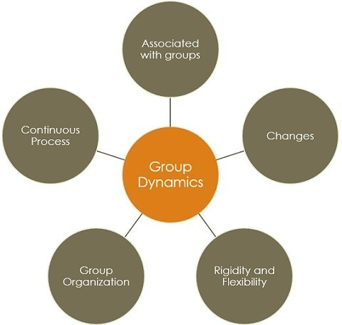
Figure: Characteristics of group dynamics (Mascarenhas, 2019)
- Group dynamics must have the formation process of the group in general and for the need for special purposes to avoid any kind of hassle in the critical moments.
- Group dynamics must clarify the jobs and responsibilities of each team members.
- Group dynamics is a continuous process that remains as long as the organisation runs and the group sustains (Mascarenhas, 2019).

Demonstrating different theories of group dynamics
Different people have given different theories of group dynamics. Some of the theories are described below:
The Tuckman Theory of Group Dynamics
Tuckman has introduced five stages of group formation and maintenance to ensure effective teamwork and avoid any kind of conflict. The stages are:
Forming: This is the initial stage of group building. The people of similar thoughts and similar goal of an organisation tries to build a group to accomplish their tasks easily and effectively to ensure maximum success of the organisation (Maples, 2018). The most crucial task of this stage is to choosing the members of the group to match the behavioural pattern of each of the team members.
Storming: This is the stage where conflicts can arise while performing the duties of the group. The team members need to be compatible to avoid any kind of conflict. The members can find flaws in any of the members and they might have problems in their activities which can create conflict. So, here they need a good range of collaboration.
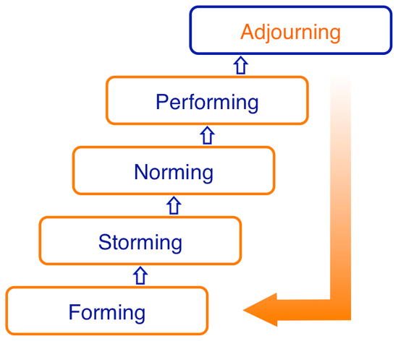
Figure: Tuckman’s model of team development (Maples, 2018)
Norming: This stage is the time when the team members become more cooperative and understanding to other team members. They know the pattern of their work and the way how to communicate effectively within the team in this stage. The tasks become easier for the team at this stage.
Performing: In this stage, the performance level goes on the highest point with the help of maximum collaboration and the use of resources. The team members become acquainted with the ways of actions and the ways of problem-solving which help the employees to perform effectively and efficiently (Maples, 2018).
Adjourning: In this stage, the team works as a part f the organisation after completing the specific project for which the group was formed. This stage is an optional section. If the group performs well and gains success then the organisation can utilise it as a strength. On the other hand, if the group fails then the group is dismissed (Maples, 2018).

Five Factors’ Model of Richard Hackman
Richard Hackman has described five factors model to describe the effectiveness of the group and how to make a team effective. The factors are described below:
Being a real team: The key factor of being a real team is clarity of tasks. The team members need to know their tasks clearly and must have the dedication to fulfil the activities collaboratively. A dedicated and real team can achieve the goal of the team easily and without any conflict. Stability among the team members is a must (Hackman and Katz, 2011).
Compelling direction: The members must have a clear goal that helps them to get a clear direction of their actions. The team members can be compatible with their work if they know where to reach (Hackman and Katz, 2011).
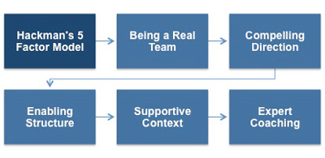
Figure: Five factors’ model of group development (Hackman and Katz, 2011)
Enabling structure: the team should have an efficient structure according to the purpose of the team. A large team having no skills at all is not a compatible team. On the other hand, a small team having skilled members huge potentialities.
Supportive context: The group and the group members must be benefited with the facilities of required resources. Such as skill development training, required information to perform the actions effectively and motivation through reward. The employees can be motivated to speed up their performances through reward systems (Hackman and Katz, 2011).
Expert coaching: the team should be updated with new demand and the wants of the organisation. For this, they need to be trained by the experts, which should be managed by the organisation. This approach improves the performance of the teams (Hackman and Katz, 2011).

Describing different team working skills and real-life example of teamwork
Building and managing an efficient team is not an easy task. The employees must have some skills to perform teamwork properly. Some of the teamwork skills are described below:
Proper communication skill: The team members must have efficient communication skill to communicate effectively within the team and the outside parties. The information must be communicated properly to achieve the flawless result in the teamwork (Baker and Salas, 2012). They should also know the use of communication medium such as e-mail, direct communication, phone calls etc.
Efficient listening skill: The employers search listening skill to build an effective team. The members can communicate properly and share the actions and required information when they listen to the instructions properly. Proper eye contact and attentiveness are the key element of listening power (Baker and Salas, 2012).
Trustworthiness: The team members must have trust among them to increase reliability and bonding among them. Without trust, the team cannot be strong. The team members need to be faithful to each other to perform their duties properly.
Efficient decision-making: In any teamwork, the proper and efficient decision-making process is a must. The team members need to take a sudden decision when needed. For this reason, employees need to be innovative in the decision-making process (Baker and Salas, 2012).

Analysing the impact of efficient teamwork in an organisation
Teamwork is a must needed element for the success of an organisation. Teamwork has lots of positive impacts on the organisation. The impacts of teamwork are described below:
Improving the efficiency of work: Teamwork enables the employees to gather different types of skills from different members. This approach increases the efficiency of the overall organisation. The employees apply their skills in the different sectors of the organisation (Leonard and Frankel, 2011).
Improving the relationship of employees: The employees of an organisation can increase the range of communication and connection. The bonding among the employees increases the productivity of the organisation by building a healthy working environment (Leonard and Frankel, 2011).
Improving employee morale: Teamwork improves the morale of the employees. Teamwork requires to maintain several cultures at a time. For this reason, employees can improve their morale by working with different types of people.
Increasing productivity: Teamwork increases productivity by using the talent of several employees at a time. The efficient decision-making process and productivity increase the performance level of the employees as well as the organisation (Leonard and Frankel, 2011).
A real-life example of poor teamwork
Poor teamwork can hamper the productivity and image of an organisation. One of my friends worked as a supervisor in a retail company named Bestway. They need to build several teams for the supervision of the distribution of their product. Their teams failed to achieve the goal. One of the scenarios of poor teamwork is described below:
The pharmacy chain of Bestway got a large order from a hospital to some medicine and health care essentials. The production team was supervised by a team to get maximum efficient output where my friend was included. The communication process of the team was weak. The supervising team could not share properly the requirements of the hospital within the team as well as to the production workers (Leonard and Frankel, 2011). As a result, could not serve the products according to the demand of the hospital and the organisation lost the client and did not get any order further.
Here, poor teamwork resulted in the loss of the organisational image, failure of the team and hamper in productivity. They can improve their team building and team working skills through improving communication skill, listening skill and employee relationship through training and consultation (Leonard and Frankel, 2011).

Demonstrating effective communication skill and the impact of proper communication skill in the organisation
Proper and efficient communication is the major element to achieve the expected result in the teamwork as well as in the overall performances of and organisation. The use and impact of effective communication skill are described below:

Competent Communication skill
Efficient communication is the process of sharing any information clearly to the potential receivers at the shortest possible time. The key element of effective communication is the clarity of the message to make the message useful (Huseman, Lahiff and Penrose, 2018). The organisation, which have potential employees having efficient communication skill can make deals with different types of companies and customers.

The communication model of an organisation
In an organisation, the top-level managers plan the actions and decisions. The messages and the plans need to be delivered to every employee and the departments according to the need. The continuous process of communication is described below:
The sender of the message: The planners of the organisation make the message or operational plan to run the organisation properly. The planners need to be careful about their decision-making process to make the communication process successful (Griffith and Harvey, 2011).
Encoding: The sender gives the message a form of written, verbal or pictorial content to share with the potential receiver. Proper encoding is needed to ensure clarity of message.
The medium of communication: The sender selects the proper medium of communication such as face to face contact, contact over phone calls, e-mails and so on.
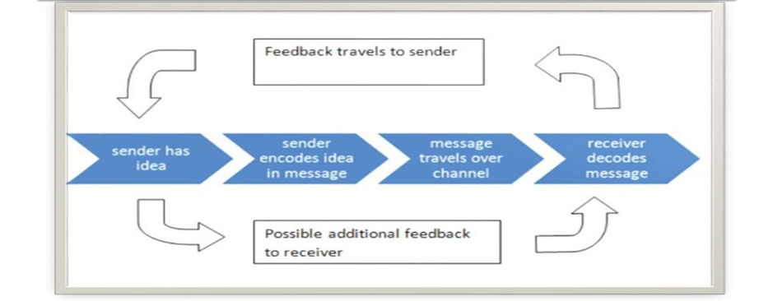
Figure: The basic model of communication (Griffith and Harvey, 2011)
Decoding the message: The receiver decodes the message according to his or her convenience to use them properly. Such as the executive chef of a restaurant takes the message of order in a written form and translate the message according to his convenience and transforms that verbally and share that with the other chefs and helpers (Griffith and Harvey, 2011).
Feedback: The receiver gives the reply according to the message after getting and understanding the message.

The necessity of efficient communication within an organisation
Effective communication is the first and foremost need of the fluency of an organisation. The importance of efficient communication skill is described below:
Fluency in the work: Efficient communication process brings fluency in the actions and eases the process of transaction and communication. Fluency in the workplace increases productivity and ensures profitability (Muscalu, Todericiu and Fraticiu, 2013).
Eases the decision-making process: Proper communication system makes the decision-making process easier. The organisational actions are done easily and the employees can easily decide if they have connection and communication with all departments at a time.
Improves the teamwork: The organisation can make efficient teams if it has potential employees with efficient communication skill. Proper teamwork ensures maximum productivity and skill development which helps to achieve the goal of the organisation (Muscalu, Todericiu and Fraticiu, 2013).
Ensures healthy working environment: The working environment can be developed through the proper communication system. A fluent communication system can erase any kind of flaws in the organisation. It can create strong bonding among the employees and the managers by avoiding every kind of conflicts.
An organisation must have an efficient communication system in overall activities and the employees as well to gain progress.

A real-life example of poor communication system
British Airways is an efficient airline. The company has efficient employees who have proper training in communication skill as it is a service company. But, they also face some problems in their communication system sometimes. One of the cases that had been faced by one of my friends who worked in the service counter is described below:
Once a passenger of British Airways came to the counter and asked for a window seat in sign language as the passenger was disabled in saying anything. That friend of mine was unable to understand the requirement of that passenger, which took much time and other passengers complained about the delay in the queue. This incident resulted out as an ignorance case of disable customers and hampered the image of the company.
To avoid this situation, the organisation could improve their communication system by giving training about sign languages as they have to handle different kinds of customers for being a service company (Muscalu, Todericiu and Fraticiu, 2013).

Conclusion
Communicating proficiently within and outside the organisation is the key element to ensure efficiency and success of the business. Efficient communication process ensures transparency, fluency and integrity in the organisation. This approach increases connection and bonding among the employees and the employers as well. Effective communications skill also benefits the teamwork activities. The team members can easily communicate and share information through proper communication system (Leonard, Graham and Bonacum, 2014). The organisation can get benefit grom external stakeholders like competitors and suppliers through making the best use of communication skills and efficient teamwork. The models of communication can help organisations to train their employees to improve communication skill.

References
Baker, D.P. and Salas, E., 2012. Principles for measuring teamwork skills. Human factors, 34(4), pp.469-475.
Griffith, D.A. and Harvey, M.G., 2011. Executive insights: an intercultural communication model for use in global inter-organizational networks. Journal of international marketing, 9(3), pp.87-103.
Hackman, J.R. and Katz, N., 2011. Group behaviour and performance.
Huseman, R.C., Lahiff, J.M. and Penrose, J.M., 2018. Business communication: Strategies and skills (Vol. 38). Chicago: Dryden Press.
Leonard, M., Graham, S. and Bonacum, D., 2014. The human factor: the critical importance of effective teamwork and communication in providing safe care. BMJ Quality & Safety, 13(suppl 1), pp.i85-i90.
Leonard, M.W. and Frankel, A.S., 2011. Role of effective teamwork and communication in delivering safe, high‐quality care. Mount Sinai Journal of Medicine: A Journal of Translational and Personalized Medicine, 78(6), pp.820-826.
Locker, K.O. and Kaczmarek, S.K., 2019. Business communication: Building critical skills. New York, NY: McGraw-Hill Higher Education.
Maples, M.F., 2018. Group development: Extending Tuckman's theory. Journal for Specialists in Group Work, 13(1), pp.17-23.
Mascarenhas, B., 2019. Strategic group dynamics. Academy of Management Journal, 32(2), pp.333-352.
Muscalu, E., Todericiu, R. and Fraticiu, L., 2013. Efficient organizational communication-A key to success. Studies in Business and economics, 8(2), pp.74-78.
Tarricone, P. and Luca, J., 2012. Employees, teamwork and social interdependence–a formula for successful business?. Team Performance Management: An International Journal.

