CAD & FEA Analysis of a suspension going over a speed bump.

University of Wales Trinity Saint David
School of Engineering
Motorsport engineering
Oliver gordon
P150782
15/1/20
CAD & FEA
Andrew Harrison

Table of Contents
1 Introduction 4
2 Background Research 5
3 Methodology 6
4 FEA motion study results 9
4.1 Test 1 original part 9
4.2 Test 2 modified 1 strengthen 9
4.3 Test 3 modified 2 lightening 10
5 Further work 11
6 Conclusion 12
7 References 13
8 CAD File Link 13

Figure 1- spring mate in motion study 6
Figure 2- road speed bump direction 7
Figure 3- motion study constraints 7
Figure 4- design history graph 8
Figure 5- VON Mises Stress graph 8
Figure 6- example from the testing of the VON Mises Stress veiw in results 8
Figure 7- tes 1 design history graph 9
Figure 8- test 1 original wishbone results 9
Figure 9- fillet changes/ modifications to the lower wishbone 9
Figure 10- visual representation of where the fillets are made 9
Figure 11- stress guage for test 2 10
Figure 12- design history graph test 2 10
Figure 13- test 2 results 10
Figure 14- showing the change for the 3rd test, 5mm thickness 10
Figure 15- design history graph test 3 10
Figure 16- visual representation of fail component from test 3 11

Introduction
For this report, measuring, modelling and motion studies have been conducted to create a simulation of a wheel and suspension system going over a speed bump, using a vehicle of our individual choice, the formula ford was a suspension system that was accessible and that could be taken apart simply, measured accurately and then modelled. Then made to simulate how the suspension system reacts when it comes into contact with the speed bump. To perform a motion study and analyse the results and look into wether strengthening or lightening the component is the right thing to do.
Background research and methodology has been conducted and a brief insight to what a plan would be for further work on this assignment if allowed.

Background Research
When looking into the materials used in formula ford, found that the suspension components could be any alloy steel, “The following parts must be of alloy steel or other ferrous material: wishbones, rockers, push and/or pull rods. All other stress bearing components must be metallic with no composite materials allowed.” (Company, 2018). This prompted the choice of alloy steel as the chosen material in the cad work.
Von mises stress is used during this assignment as a guideline as weather the part will fail during testing, as if the yield strength is lower than the von mises stresses experienced then its assumed that the part would fail, “Von Mises stress is considered to be a safe haven for design engineers. Using this information an engineer can say his design will fail, if the maximum value of Von Mises stress induced in the material is more than strength of the material. It works well for most cases, especially when the material is ductile in nature.” (Mathew, 2012).
The solidworks system is very user friendly, “With powerful and intuitive SOLIDWORKS® Simulation solutions, product engineers can virtually test new ideas, quickly and efficiently evaluate performance, improve quality, and get the knowledge for product innovation.” (Tech, 2020). There are a few different motions that could have been used depended on the depth of analysis/ simulating process you would want to go. The three being animation, basic motion and motion analysis,
- “Animation: If you simply wish to create some nice visuals for presentation or marketing without consideration of mass and gravity effects, then animation is for you.
- Basic Motion: For an extra layer of complexity that takes into consideration the effects of mass, springs, gravity and physical collision detection, then a Basic Motion study is more suited for your requirements.
- Motion Analysis: This is the top tier of motion study and takes into account a wider range of physical interactions such as impact effects, damping, force, momentum, etc.” (Keane, 2016).

Methodology
For the cad motion study, a suspension set that as students we had access too that was picked was, the formula ford front end from the university workshop.
Picking the front left corner of the setup, the wheel was taken off and the suspension components were disassembled and measured which included;
- Upper wishbone
- Lower wishbone
- Rocker
- Suspension linkage (from lower wishbone to rocker)
- Steering linkage
- All rose joint’s
- Wheel
- Tyre
- Hub in 2 parts
- Spacer
- Road with speed bumps
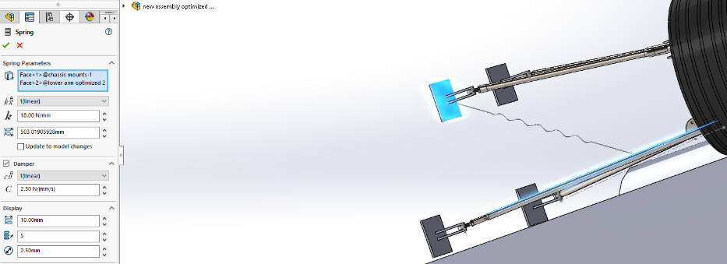
Also include in the assembly on solidworks were two parts not from the formula ford, this was the shock absorber, made from a You tube tutorial (tutorials, 2017) just to help show the suspension system working whilst the wheel goes over the speed bump, also included in the assembly was a bearing (Chakraborty, 2019) used inside the wheel hub which was adapted to work with the hub. When it came down to assembling the parts the damper was simply left out because of complications with the dimensions and mates used. This is because of complications that came up during motion study testing, with multiple attempts at fixing it, the idea was then scraped. Opting instead to apply a spring mate in motion analysis, as shown below, 18 N/mm set as the spring constant & 2.5N/(mm/s) set as the damping constant.
Figure 1- spring mate in motion study
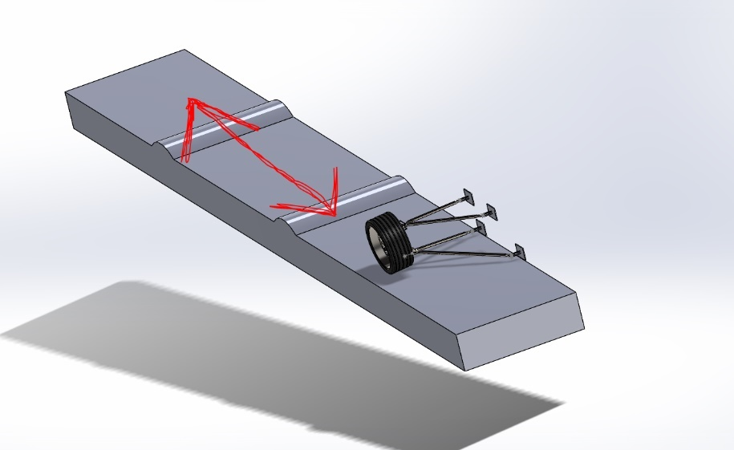
Onto the assembly, the wheel, tyre and spacer were put into a pre-assembly, this was so the tyre and wheel would rotate together. With the two-hub parts house the bearing assembly which will allow the wheel to spin. Then adding in the four chassis mountings, once mated in place, they wee then fix in space and the rose joint ball then mated and fixed to them. This then allowing the upper and the lower wishbone to be concentric mated to the rose joint ball, and attached at the other to the hub. Then the speed bump gets added in so it can only move in a singular direction as displayed on the right in figure 2.
Figure 2- road speed bump direction

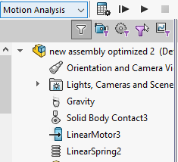
Then it comes to setting up the motion study, making sure that the motions add in is selected, then using the drop-down menu as seen on the right, select motion analysis. Add in gravity and make sure it’s working in the correct direction, then add a solid body contact input clicking on the tyre and road and setting the input material as dry rubber and dry steel respectively, these how are the real selected materials for these parts, those are already set and the ones selected for the solid body contact are just a representation. Then add in the spring mate like previously stated.
Figure 3- motion study constraints
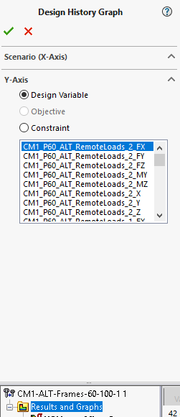
Run the motion by clicking calculate, once the motion has completed its run, pick a time just before the wheel goes over the bump and just after. Go to the top bar and click the simulation button and then click on import motion loads, and select the part that the test is being conducting on and go to multiple frame study and type the frame tat lines up with the wheel just before and after the bump with the start and end respectively. Click okay and save, then double check all the load bearing faces are selected, rerun the motion sim b selecting calculate again, now open the part that the test is conducted on, in this case the lower wishbone. click the tab with the test scenarios on and press run and wait for the simulation to take place, this may take some time depending on the number of frames.
Figure 4- design history graph
Now this has completed, you’ll be able to view the design history graph by right clicking the results and graphs tab on the left, then click constraint and press the tick.

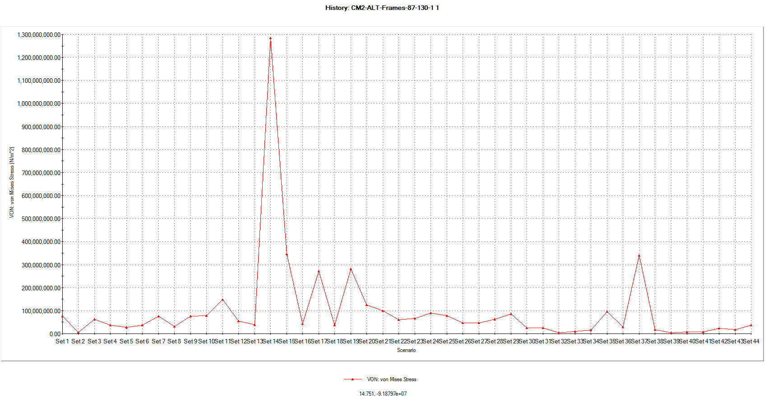
This will show the graph on the right, and you’ll be able to see a spike on the line graph at scenario 14, this is where the part (lower wishbone), has picked in the amount of von mises stress it’s had to go through during the test.
Figure 5- VON Mises Stress graph
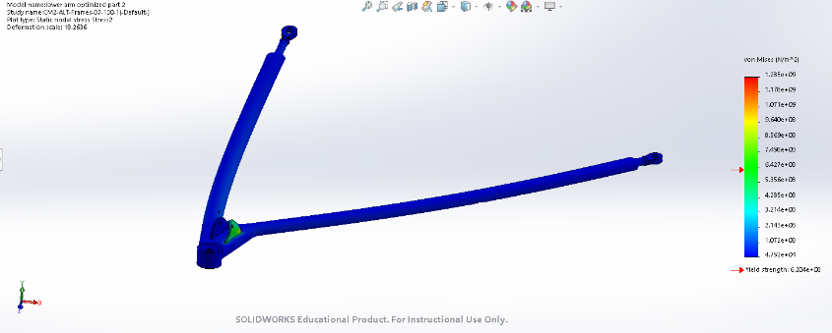
You’d then be able to view the optimized part like so on the right, the number on the bar on the right of the image, being the maximum VON Mises Stress experienced during the test, and the number by the red arrow being the yield strength which is also the maximum Von Mises Stress the component will be able to handle, so the aim is to have the top number being a lower figure than the yield. This would then bring you onto the test results and depending on those is weather the part needs strengthening or not.
Figure 6- example from the testing of the VON Mises Stress veiw in results

FEA motion study results
For this section, analysis will be conducted on three test results, the first being for the original lower wishbone, the second test being on the first of two modified versions of the lower wishbone. the first modified part having added strengthening, with the reason being that the first was to see if that strengthening it in the right areas could reduce the maximum stress experienced during testing and then once that’s achieved the focus could then be turned onto making the component lighter.

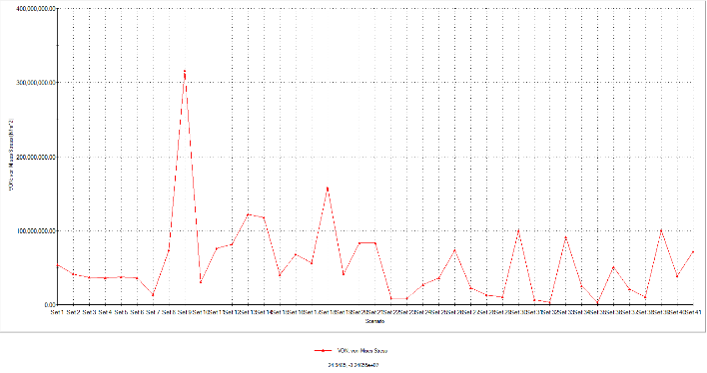
Test 1 original part
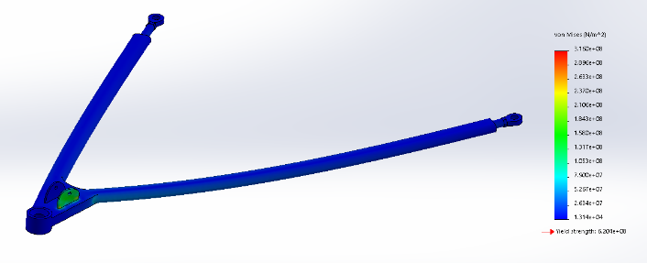
this test being on the original formula ford lower wishbone, the graph on the right showing where the peak of the Von Mises stress was experienced. Scenario 9 being where the wishbone with stands 3.160e+08 N/m^2 and this happens on the face of the push rod (suspension linkage), the yield strength of this part is 6.204e+08 N/m^2, the first thing that was wanted to be achieved after this test was that the strength could be increased, and we would see this if in the next test the max stress experienced is lower than the figure from this test.
Figure 7- tes 1 design history graph
Figure 8- test 1 original wishbone results
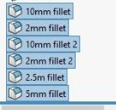
Figure 9- fillet changes/ modifications to the lower wishbone

Test 2 modified 1 strengthen
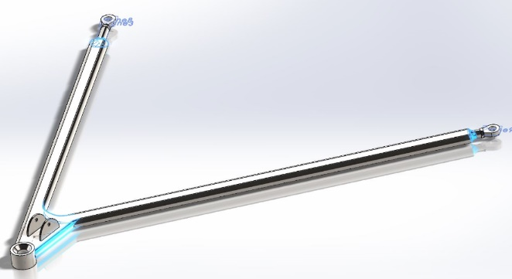
For this test run the modification that was decided on was adding on some fillets, including 2x 10mm, 2x 2mm, 1x 2.5mm and a 5mm fillet. All of these are positioned on the sharp edges, the fillets will act as if they’re spreading loads. As an initial thought, the idea was that these would reduce the stress by around 10-15%.

Figure 10- visual representation of where the fillets are made
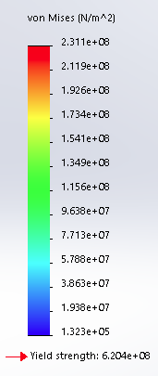
On the right is the Von Mises stress experienced by the modified lower wishbone in the second test, and as you can see the yield stress is the same because is no different in size and the material is the same but the max stress that the part with stands is 2.311e+08 n/m^2 which is a stress reduction of 26.8% which is double what was the prediction. This achievement from adding six fillets to the part is an excellent result, this gives a very good foundation to reduce the weight as the next modification.
Figure 11- stress guage for test 2
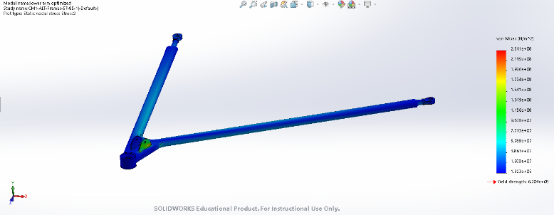
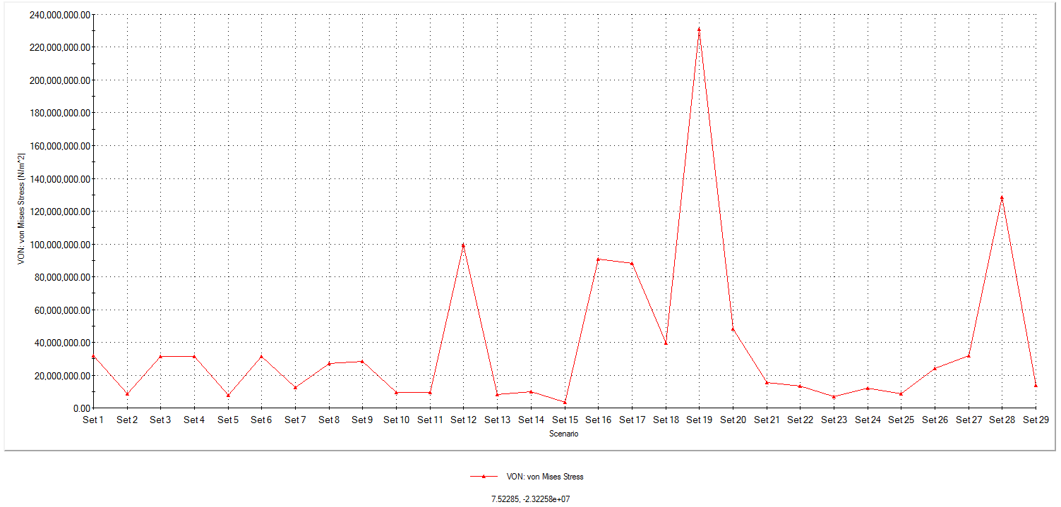
on the left is the design history graph showing which scenario has the peak stress. In this test it was scenario 19.
Figure 12- design history graph test 2
This a full representation of the stress & displacement and to show that the push rod mountings again withstand the most stress.
Figure 13- test 2 results

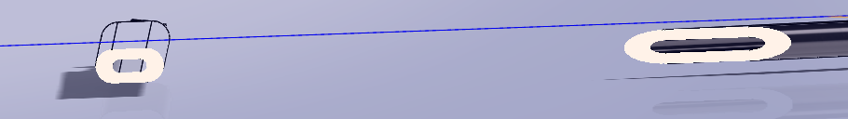
Test 3 modified 2 lightening
Figure 14- showing the change for the 3rd test, 5mm thickness
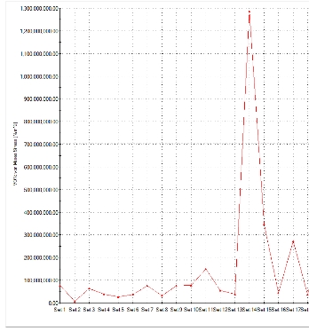
in this test the idea was to lighten the wishbone by applying a material thickness and that the arms of the wishbone will hollow and the wall thickness was set to 5mm.
below is the result of the test and what happened to he push rod mounting point, this point now known for distorting under load, something that would need to be addressed in further work. On the right it shows the max stress is experienced in scenario 14.
Figure 15- design history graph test 3
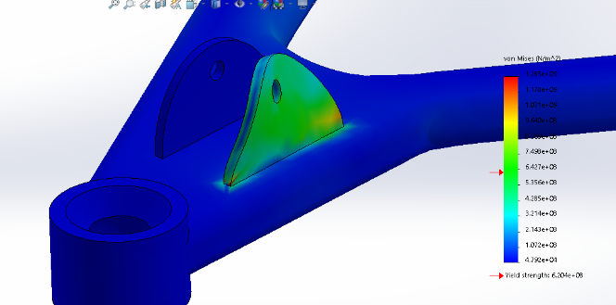
Figure 16- visual representation of fail component from test 3
The yield still being 6.204e+08 N/m^2 and the max stress experienced is 1.285e+09 N/m^2, well over the yield, further work needed.

Further work
In this assignment, further is required because of the second modified change failed in a scenario during testing. Consideration to take away is that the material thickness could be thicker than 5mm, that may work. The main thing would be to try alternative materials. Like aluminium or titanium alloys. Which could have its own benefits on the strength of the component. Preferably 3 more test would be run, one to save weight but the part not fail like test 3 and then alternative material and look through results and then rather alter shape or material depending on the results of the extra tests.

Conclusion
To conclude in this report,3 tests were performed correctly and up to standard with good reliable results, including the original and two modifications, ideas for further work conducted. Good level of understanding for the background research into the different types of studies that can be performed. In conclusion for the test results, successfully reduce the stress that goes thought the lower wishbone by 26.8%, which was double hat of the prediction made beforehand. The 3rd test may have failed but it gives good parameters for further work and shows the limitations of the material.

References
Chakraborty, S., 2019. Ball Bearing. [Online]
Available at: https://grabcad.com/library/ball-bearing-284
Company, F. M., 2018. 2018 Technical Regulations Formula Ford 1600 Kent, s.l.: Ford 2018.
Keane, P., 2016. Enigineers rule. [Online]
Available at: https://www.engineersrule.com/motion-studies-and-how-to-do-them/
[Accessed 17 January 2020].
Mathew, S., 2012. learn engineering. [Online]
Available at: https://www.learnengineering.org/what-is-von-mises-stress.html
[Accessed 16 1 2020].
Tech, J., 2020. javelin tech. [Online]
Available at: https://www.javelin-tech.com/3d/technology/solidworks-simulation/
[Accessed 18 January 2020].
tutorials, S., 2017. You Tube. [Online]
Available at: https://www.youtube.com/watch?v=VGE6P5d_dds

CAD File Link

https://uowtsd-my.sharepoint.com/:f:/g/personal/ogordon_150782_student_uwtsd_ac_uk/Esn5730uOvZFu5gL25InzIAB9zlDW9K3ooDKYY_ZQjHggQ?e=0CDzOU

