Yohannes Zerzghi (P151368)

The papers is a proposal for developing a Converged network SMEs.

Project Proposal
Developing a Converged Network For SMEs.

Table of Contents
Introduction 1
Project title 1
Background Literature 1
VoIP protocols 2
Quality of Service (QoS) in VoIP 4
Security issues of VoIP 6
Aims and Objectives 6
Research Methodology 8
Development Methodology 10
Risks 12
Analysis and Deliverables 13
Resource and Planning 14
Resources 14
Planning 15
Conclusion 22
References 23

Introduction
This report explains a proposal for developing a converged network of small to medium enterprises. The report contains three sections. In the first section, the report introduces the background of the subject area through conducting a research based on which area it will take. It will provide the current literature review that relates to the project. In addition, it will introduce the aims and objectives that are expected at the end of the project.
In the second part, the paper explains the different research and development methodology that are applicable to the project. Moreover, the report looks into the ethical and legal issues as well as risks that can affect the project. Finally, it clarifies on how to evaluate the aim and objectives of the project are reached. And, the final section presents the resource and skills required for the project. In addition, it introduces the schedule of the project using different project management tools such as Gantt chat and PERT analysis.

Project title
The title of the project is developing a Converged Network for small to medium enterprises.

Background Literature
Converged network is a transmission of data, voice and video within a single network. It is also called voice over internet protocol abbreviated as (VoIP). VoIP was first introduced in 1996 by the VOIP Association group. The idea of VoIP is to transmit voice, data and video applications by using different protocols via the internet. In other words, it is the transmission of voice over the internet protocol (IP) which actually is a substitute of the old-style public circuit-switched telephone network (PSTN) system [1]. But how is the VoIP different from a circuit switched traditional communication system? The PSTN communication system has been for almost a century in the world. In PSTN, in order to transmit voice over a committed channel, first the voice is changed into analogue signals. Then, the signals are conveyed onto the dedicated medium to reach out on the other end for a duration of the call [2]. The PSTN is known as circuit switching network as the signal may traverse across several switches before a connection is established [3]. Therefore, in circuit switched a dedicated cable is needed in order to establish a connection between the two endpoints (Telephones). In other words, in PSTN a fixed size of 64kbps channel is reserved to connect to a phone line. Thus, PSTN is not cost efficient [4].
But VoIP operates differently comparing to PSTN. In VoIP, first voice signals are converted into small packets of digital format that can be sent over Internet Protocol (IP). Then, the digital format is reassembled into the original message at the receiver end [5]. In other words, the message is transmitted like the normal data packets over the IP. Thus, VoIP is called Packet switching telephony. Therefore, using VoIP technology users can make calls using the internet (IP) instead of using a dedicated cable of a phone line. Consequently, business companies and individuals are moving into VoIP due to its lower cost than the circuit switching telephony. Moreover, VoIP is more reliable and scalable. Furthermore, it gives flexibility to users as it provides multimedia connection (voice, data and video) in a single network [6]. Nowadays, VoIP is gaining popularity than the traditional telephone system (PSTN) however, it has some drawbacks. One of the main drawbacks comparing to PSTN is its security. Comparing to PSTN, VoIP is more vulnerable to security attacks. The reason is, VoIP relies on the internet for transmission, unlike the PSTN which uses a permanent cable [7]. Moreover, the quality of service (QoS) is not guaranteed in VoIP comparing to PSTN communication. Because, in VoIP, there could be a delay, packet loss, latency and jitter due to the nature of the internet connection. However, PSTN uses a dedicated cable of capacity 64kbps [8]. In general, with VoIP, there are many benefits than the traditional communication (PSTN).

VoIP protocols
But how does VoIP works? According to Mehta et al. [9] , there are four steps to transmit a voice message using the internet protocol (IP). And these are: signalling, encoding, transport and gateway control. Raheja et al. in 2015 [10], identified the key signal protocols, security, Quality of Service (QoS), benefits and drawback of VoIP. According to the authors, the key steps of signalling protocols are categorized into four sections: session establishment, user location, call participant management and session negotiation. In the literature, the two common protocols in the field of VoIP: H.323 and Session Initiation Protocol (SIP) are also discussed. In the paper, the H.323 contains four parts to create communication using the VoIP technology, and these are Multipoint control units (MCUs), gateways, terminals and gatekeeper. In general, the H.323 protocol is developed with a set of standards for audio and video codecs to transmit multimedia across internet-based network (IP). Based on the paper, the G.711 audio codec which runs at a rate of 64 Kbits/ sec, is the lowest prerequisite for audio applications. However, the paper does not identify which of the standards is the weakest or strongest to transmit a multimedia (audio or video) application. Moreover, the literature does not identify which protocol (H.323 or SIP) is more acceptable to use in implementing VoIP technology.
According to Shaw et al. [5], in VoIP network, there are three commonly used protocols, and these are the family of H.323 protocol, SIP and Media Gateway Control Protocols (MGCP). The H.323 protocol is an application layer in the TCP/IP model which uses either TCP or UDP for connection. This protocol is developed by the International Telecommunication Union (ITU) with a set of standards. Based on the paper, there are four standard sets in the H.323 of family protocols, where the T.120 is used for data application, G.7xx series is used for audio application, H.26x is used for video application, H.245 and H.225 are used for controlling and signalling respectively. In addition, this protocol utilises the Real Time Protocol (RTP) and Real-Time Control Protocol to transmit multimedia applications (audio or video) over the internet. And, it is mostly used for real-time applications [7].
Session Initiation Protocol (SIP) is an open source protocol developed by the Institute of Electronics and Telecommunication Engineering (IETE). According to the work [7], SIP is the most common and resourceful protocol in VoIP technology. Moreover, this protocol is text based and easily available. This protocol contains proxy server, location server, registrar and endpoints. According to the literature, this protocol is a signalling protocol that operates similar to the HTTP of a web browser protocol. Similar to the H.323 family protocol, it uses TCP and UDP as transport protocols. However, SIP uses another transport protocol called Stream control transmission protocol abbreviated as (SCTP) to protect the packet when it is traveling across the network from denial of service (DOS) attacks. Hence, this protocol is the most secure to use in VoIP technology.
MGCP [11], is another text based protocol used in the field of VoIP. It is developed by the Internet Engineering Task Force (IETF) that is used as a gateway to manage a disintegrated VoIP gateway. Similar to the H.323 protocol, it is made up of standard sets. The MGCP contains two different components. And, these are call agent (MGC) and media gateway (MG). Within MGCP, the MGC is the server that controls calls and establishes a connection with the endpoints (MG), whereas the MG is the endpoint that executes the commands given by the MGC. In MGCP protocol, the MGC is the master that enables to create, delete and modify connections on the endpoints without knowing the MG. Hence, this protocol is known as master/slave protocol, where MGC is the master and MG is the slave [5]. And this protocol is designed to support both SIP and H.323 protocols.

Quality of Service (QoS) in VoIP
VoIP is designed to transmit voice, video and data over the internet protocol (IP) through a single network. Hence, it is very difficult to manage these different applications due to the nature of the internet. However, VoIP utilises Quality of Service (QoS) as a tool to manage these different network traffics. According to work [12], QoS is the most commonly used tool to measure the quality of service in a network. This tool creates priorities for certain types of traffic such as voice and video over non-time-sensitive applications such as email and chatting. Hence, utilising QoS is a significant factor in VoIP calls in order to improve the quality of service. There are many QoS issues that affect VoIP calls. The main QoS issues are latency, jitter, packet loss, bandwidth and throughput. Latency (delay) represents the time taken to transmit a voice or video from the source to destination. According to Cisco networking academy notes [13], the latency of voice should be ≤ 150 ms, whereas for the video it should be ≤ 200-400 ms. Jitter represents the time differences between the arrival of each packets. It is mainly caused due to network congestion, improper configuration, route changes and more. And packet loss characterises to packets dropped due to network congestion. Packet loss usually happens when the network becomes congested (busy). The table below shows the minimum requirements of voice and video traffics taken from the cisco networking academy.

QoS metrics | Voice | Video
Latency (delay) | ≤ 150 ms | ≤ 200-400 ms
jitter | ≤ 30 ms | ≤ 30-50 ms
Packet loss | ≤ 1% | ≤ 0.1-1%
Bandwidth | 30-128 Kb/s | 384Kb/s – 20 + Mb/s
Table 1: minimum requirements for voice and video traffics.
Gupta et.al, [13] identified delay, jitter, packet loss, bandwidth and selection of codec as the main reasons that affect the QoS for VoIP calls by comparing from different literature. The authors compared the performance of codecs such as G.729A, G.711, G.723.1 and G.726 based on different environment scenarios by evaluating various QoS parameters such as delay, jitter and Mean Opinion Score (MOS), where MOS is an assessment scale in the range 1-5 defined by the ITU-T, where 1 represents the lowest quality, and 5 represents the highest quality. According to the paper, G.711 codec is the best to use due to its high MOS value. In another study, Dhar et al. [15] investigated the performance of different voice codecs (G.711, G.726ar24, G.726ar32 and G.729) over IEEE 802.11n using simulation software. The authors measured the average MOS, jitter and delay by carrying out three simulations. The results of the experiment show that G.711 with a high value of MOS, minimum delay and jitter value. Hence, G.711 is the suitable voice codec to utilise for VoIP over IEEE 802.11n situations. In [16], Researchers have compared the performance of various QoS policy models such as Differentiated Services (DiffServ), Integrated Services (IntServ) and best-effort service for VoIP traffics in IPv4 and IPv6, where DiffServ model is a QoS based on classifying different traffic classes, and IntServ model is defined by IETF that delivers end to end QoS by signalling process and the best-effort model [13], is utilise when QoS is not essential. In the paper, six scenarios are created and simulated using OPNET simulation software. In the paper, the performance of DiffServ model was compared against IntServ over both IPv4 and IPv6 scenarios. On comparison, DiffServ QoS model over IPv6 network is the most appropriate for VoIP technology. Mohammed et al [17], present a simulation of various voice codecs ( G.711, G.723, and G.729) for both FDDI and WiMAX networks. The authors created six different scenarios for simulations by using OPNET 14.0 to evaluate VoIP performance, by utilising different QoS metrics such as delay, jitter, throughput and MOS. The results show that G.711 is the best VoIP codec to use for WiMAX network. And in FDDI network, both G.711 and G.729 are appropriate VoIP codecs to utilise. Besides, G.729 is the best to use in terms of throughput comparing to G.711 and G.723 for FDDI network.

Security issues of VoIP
VoIP utilises a shared network to transmit voice, video and data by using the internet. Hence, security is an important issue in VoIP due to the internet is an open standard. Thus, VoIP is vulnerable to security attacks. According to work in [5], there are various attacks on VoIP such as Denial of Service (DoS) attack, network sniffing, spoofing, toll fraud, Spam over Internet Telephony (SPIT) and Eavesdropping. DoS attack is an attack that prevents a device from accessing its service. In VoIP, this can be achieved by flooding the network with traffic to interrupt or drop the calls by overwhelming its bandwidth. Another security threat for VoIP is eavesdropping. It is an attack, where someone listen in on any call made and collects information from the network traffic. Toll fraud is one of the main security risks for VoIP technology. It is also called call fraud. Toll fraud can occur when an attacker is able to control the transmission medium or the framework of the VoIP elements.
But what are the most common security techniques for VoIP? Surasak et al [18], identified and analysed the key security techniques for VoIP such as SIP-Proxy, Server, SRTP and VPN. The authors evaluated and compared the performance of VPN and SRTP by developing an android application that supports VoIP. The authors found VPN is the most secure for VoIP.

Aims and Objectives
The main aim of the project is to develop a converged network that can be used by small to medium enterprises. However, in order reach this purpose, the following objectives must be reached.
- To conduct survey on the current VoIP technology.
- To analyse and evaluate the current VoIP protocols.
- To analyse and evaluate security protocols of VoIP
- To evaluate the performance of VoIP
- To design and build a converged network

Research Methodology
It is good practice to follow a structured methodology in order to produce a project with high validity. To achieve this, the research onion is the best approach as a research philosophy. As it can be seen in figure 1, the research onion classifies and relates the different elements of the research philosophy.
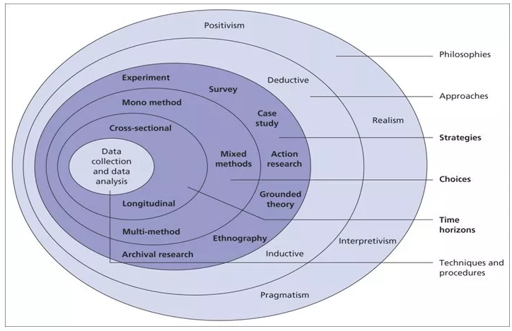
Figure 1: the research onion [19]
For this project positivism is selected as the best philosophy. It is a philosophy that depends on scientific justification through observing, measuring, data collection and interpretation. In positivism philosophy, the results of research studies are mainly visible and measurable and the research of this project is based on experiment and facts [19].Another philosophy is phenomenography. This philosophy is based on people’s ideas that is intended to discover different experiences from people’s perception or understanding on a particular thing. It is a qualitative research approach that aims to analyse from individual experiences [20]. However, this philosophy does not reflect to this project. Hence, the author will not consider of utilising it.
In addition to selecting the right research philosophy to this project, it is also good practice select the proper research approach. There are two research approaches; and these are inductive and deductive. Inductive approach is a qualitative research that is based on collecting and analysing data. In inductive approach, a researcher can formulate a theory based on observation and analysis of the collected data. In other words, it is a process of developing theory from collected data. Inductive approach is related to phenomenography [21].
Another research approach is deductive which is based on quantitative research. It is a research methodology that develops a hypothesis from an already existing theory. In other words, it is a research that constructs a new theory from general to specific level. This research method is most associated with scientific investigation. Deductive approach is linked to positivism philosophy. It can be used to evaluate on the existing theory quantitatively [22]. Hence, this project will utilise the deductive research approach. Because, this project approaches mathematical and scientific investigation on the already existed VoIP technology. In summary, the author will use both positivism and deductive approaches for this project.
A research strategy is an essential part of the research methodology that provides direction of the research. According to [23], there are five common research strategies in the computer science : experiment, software development, document review, case study and survey. The aim of the project is to develop a VoIP for small to medium companies. Hence, the author will use simulation software to analyse the various network parameters in VoIP such as protocols, network algorithms and so on. Thus, experiment research strategy has been chosen as the best to use for the project. Moreover, software development is also chosen as another applicable research strategy as the project will encompass design, development and testing. The project will also use case study as a research strategy, although it is linked to phenomenography philosophy. This strategy will be used to get better understanding by collecting data using different methods such as interview with senior managers of a company that utilises VoIP. Thus, will help to produce with high standard VoIP system.

Development Methodology
The main target of the project is developing a converged network (VoIP). Hence, it is important to utilise a development technique which is based on software. This software based process is called software development methodology. It is used to enhance the development of the software by dividing it into parts such as design, implementation, testing, planning and analysis. Nowadays, there are various software development methodologies for example agile, object-oriented, waterfall and so on. Hence, the author has chosen to utilise feature-driven development (FDD) approach. This approach is an interim between the traditional waterfall and the modern agile. The FDD [25] ,is based on the agile procedure that is used to develop a specific requirement by iterative and incremental software development process based on feature, where a feature represents a small function. This model is divided into 5 classes: develop overall model, build feature list, plan by feature, design by feature and build by feature. Each feature has a definition they are:
Develop overall model: it creates a model based on requirements of the services.
Build feature list: identifies a list of features that are collected during the develop overall model stage.
Plan by feature: develops the plan and design based on a list of features
Design by feature: design documentation for each feature are produced, examined and completed.
Build by feature: then the completed feature is added to the main build after the design is enhanced.
In FDD, the tasks that include modelling, programming, testing and building the system are related to both the design by feature and build by feature. Hence, the project fits to these two features of FDD as it will need to be tested, configured and designed.

Iteration

Requirement
Theory
Deliver
Release
Build

Design and build Iterations

Test

One time phases Iterative approach
Figure 2: FDD system development lifecycle [25].

Risks
There are several factors that can affect the project. Hence, it is good practice to identify and analyse the risks using risk assessment for the project. Risk management includes risk identification, risk analysis, risk planning and risk monitoring. One of the main risks for the project is, there is no enough time to construct the project. In addition, overloading from other works such as assignments, exams will also affect the project. Moreover, the network devices are restricted to cisco property. Other risks that are identified for the project are listed below.
- Not able to get the right simulation software for the project
- Lack of skills and knowledge in certain areas of the project such as configuring audio and video protocols
- Lack of time management

Based from the above, the key risks are related to time management. However, there are tools that can help to manage these risks. The use of project planning tools will help to identify, examine and monitor the risks of the project. The main tools that are going to be used for the project are Gantt chart with PERT. The Gantt chart can be used to identify the critical path (the most important) for the project and the PERT will help to examine the time required to complete each task. At the moment, these are the only risks identified that can affect the project.
The project is based on experiment which will be held inside the cisco lab. Hence, it is good to identify the legal and ethical issues of the project. As far as to the knowledge of the author the only legal and ethical issues is data protection and storage. Therefore, it is necessary to follow the rules and regulations of the Data Protection Act (DPA). But for more information about the legal and ethical issues a separate paper will be handed to the supervisor of the project.

Analysis and Deliverables
During the development of the project, data will be collected from different sources, in order to get ultimate data. The data will be evaluated at the completion to the project by using different methods. However, for the project the only way of collecting data is by using a simulation software. Hence, the collected data will be tested by comparing to benchmark or standards of voice and video. Finally, the project will provide a converged network (VoIP) that is suitable to small and medium enterprises. The deliverables at the completion of the project are listed below.
- It will provide the physical and logical network design.
- It will provide documentation of the network topology
- It will provide service report
- It will provide screenshots and video recording of the experiment.

Resource and Planning

Resources
The following resources will be required in order to complete the project effectively.
- Four desktop and one laptop will be required to build the VoIP system.
- Access to library and books in order to research and study on the system.
- Access to internet
- Four routers, two switches, one access point to build the network topology
- Two phones with VoIP capabilities (IP telephone)
- Network cables
- Simulation software’s like packet tracer, Matlab and Netsim
- IT staff members from UWTSD

Planning
The development plan for the project is divided into seven parts: determining the services required, study and research on literature, planning, design, implementation, testing and documentation. The proposed development structure is shown below.

Fig 3: development planning.
A Gantt chart is constructed based on Fig 3 in order to plan and manage each task for the project (see fig 4-9). The project will contain three different parts. The three parts are project plan, design and implementation where each part contains sub section. Each task is listed under its right section.
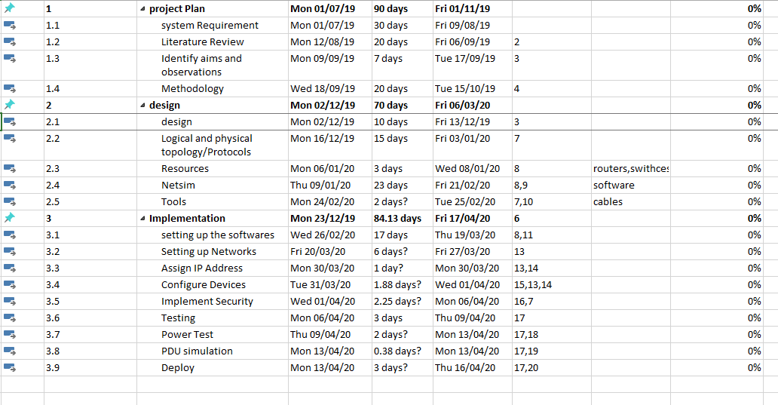
Fig 4: Gantt chart for the proposed project (1).


Fig 5: Resource sheet (2).

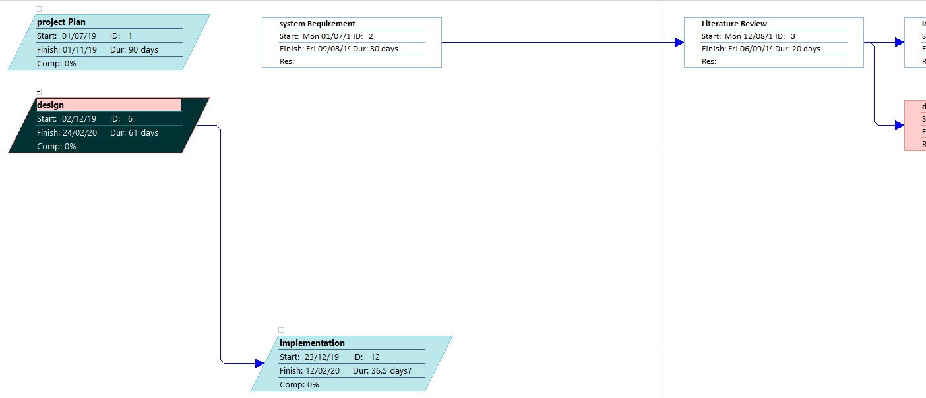
Fig 6: network diagram (3)

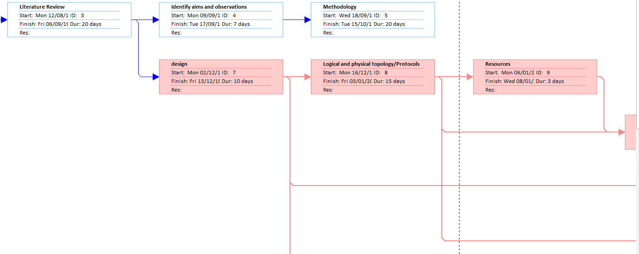
Fig 7: network diagram (4)
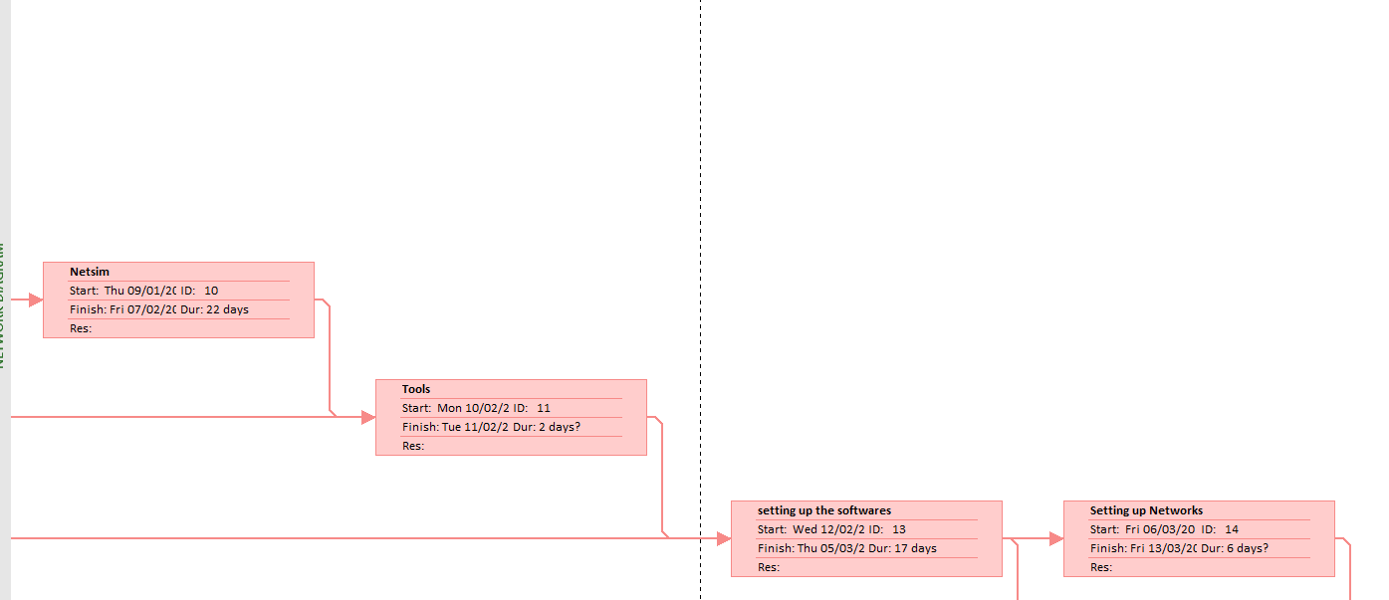
Fig 8: network diagram (5)
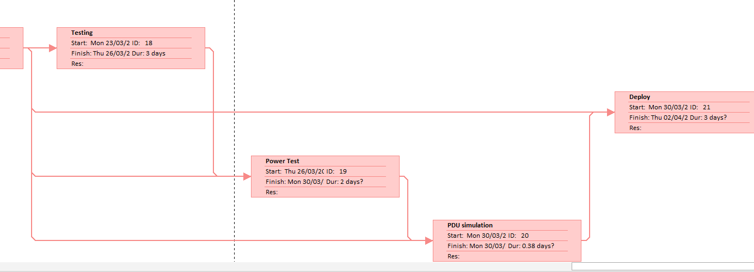
Fig 9: network diagram (6)

Conclusion
The primary goal of the project is to develop a converged network (VoIP) that is suitable for small to medium enterprises. This paper identified and outlined the different research methods that are applicable to design and develop VoIP. And, it also identified five objectives that are needed through the development of the project. In addition, the potential risks, limitations, ethical and legal issues that can affect the project are identified. Moreover, the procedures on how to analyse and evaluate the data for the project are outlined. In addition, the time plan and the resources needed are also explained. However, there is more chance of resources needed for the project during the development of the project which hasn’t been taken into consideration. Another problem for the project is time management as there is high chance of overloading from the real life such as assignments and exams.

References

[1] | J. Pourqasem, S. Karimi and S. Edalatpanah, “A Survey of Voice Over Internet Protocol (VOIP) Technology,” IJCMSA, vol. 6, no. 3-4, pp. 53-62, 2012.
[2] | C. Johnson, “What Is PSTN and How Does It Work?,” nextiva, [Online]. Available: https://www.nextiva.com/blog/what-is-pstn.html. [Accessed 26 April 2019].
[3] | D. Roos, “How Telephone Country Codes Work,” howstuffworks, [Online]. Available: https://electronics.howstuffworks.com/telephone-country-codes1.htm. [Accessed 26 April 2019].
[4] | ramcomminc, “RAM Communications Telecom Services 101,” ramcomminc, [Online]. Available: https://www.ramcomminc.com/ram-telecom-101/. [Accessed 27 April 2019].
[5] | u. Shaw and B. Sharma, “A Survey Paper on Voice over Internet Protocol (VOIP),” International Journal of Computer Applications (0975 – 8887), vol. 139, no. 2, pp. 16-22, 2016.
[6] | Q.-V. Ly, H. Nguyen and V. Nguyen, “Vulnerability Analysis and Defense of Voice-over-IP,” BDU Journal of Science & Technology, vol. 7, no. 1, pp. 1-8, 2019.
[7] | M. Hasan and M. Hussain, “Collective Study On Security Threats In VOIP Networks,” INTERNATIONAL JOURNAL OF SCIENTIFIC & TECHNOLOGY RESEARCH, vol. 6, no. 1, pp. 20-23, 2017.
[8] | M. Miraz, M. Ganie, S. Molvi and M. Ali, “Simulation and Analysis of Quality of Service (QoS) Parameters of Voice over IP (VoIP) Traffic through Heterogeneous Networks,” (IJACSA) International Journal of Advanced Computer Science and Applications,, vol. 8, no. 7, pp. 242-248, 2017.
[9] | P. Mehta and S. Udani, “Voice over IP,” IEEE Potentials, vol. 20, no. 4, pp. 36-40, 2001.
[10] | t. Raheja and D. Munjal, “A Comprehensive Survey on Voice over Internet Protocol (VoIP),” International Journal of Advanced Research in Computer Engineering & Technology (IJARCET), vol. 4, no. 4, pp. 1552-1557, 2015.
[11] | Cisco, “MGCP and H.323 Voice Gateway Protocol Comparison,” cisco, 4 August 2006. [Online]. Available: https://www.cisco.com/c/en/us/support/docs/voice/gateway-protocols/70628-h323-mgcp-compare.html. [Accessed 26 April 2019].
[12] | M. Yang, S. Wang, R. Calheiros and F. Yang, “Survey on QoE Assessment Approach for Network Service,” IEEE Access, vol. 6, pp. 48374-48390, 2018.
[13] | cisco networking acadamy, “Connecting Networks,” cisco, 2019. [Online]. Available: https://static-course-assets.s3.amazonaws.com/ConnectNet6/en/index.html#6.1.2.4. [Accessed 27 April 2019].
[14] | N. Gupta, N. Kumar and H. Kumar, “Comparative Analysis of Voice Codecs Over Different Environment Scenarios in VoIP,” in IEEE, Madurai, 2018.
[15] | S. Dhar and S. Chatterjee, “A study of VOIP codecs performance over IEEE 802.11n,” in IEEE, Kalyani, 2017.
[16] | H. Al-Fayyadh and M. Koyuncu, “Comparison of QoS architectures for VoIP traffics in IPv4 and IPv6,” in IEEE, Bku, 2016.
[17] | M. Mohammed and W. Abdullah, “PERFORMANCE ANALYSIS OF VoIP OVER WIRED AND WIRELESS NETWORKS : NETWORK IMPLEMENTATION IN ADEN,” International Journal of Research in Engineering and Technology, vol. 5, no. 2, pp. 325-330, 2016.
[18] | T. Surasak and C. Scott Huang, “Enhancing VoIP Security and Efficiency using VPN,” in IEEE, Honolulu, 2019.
[19] | allassignmenthelp, “Research Onion – Made easy to understand and follow,” allassignmenthelp, 14 July 2017. [Online]. Available: https://www.allassignmenthelp.co.uk/blog/research-onion-made-easy-to-understand-and-follow/. [Accessed 24 April 2019].
[20] | research-methodology, “Positivism Research Philosophy,” Research-Methodolgy, 2019. [Online]. Available: https://research-methodology.net/research-philosophy/positivism/. [Accessed 25 April 2019].
[21] | M. Khan, “Phenomenography: A qualitative research methodology in Bangladesh,” International Journal on New Trends in Education and Their Implications, vol. 5, no. 2, pp. 34-43, 2014.
[22] | esearch-methodology, “Inductive Approach (Inductive Reasoning),” research-methodology, 2019. [Online]. Available: https://research-methodology.net/research-methodology/research-approach/inductive-approach-2/. [Accessed 25 April 2019].
[23] | research-methodology, “Deductive Approach (Deductive Reasoning),” research-methodology, 2019. [Online]. Available: https://research-methodology.net/research-methodology/research-approach/deductive-approach-2/. [Accessed 26 April 2019].
[24] | A. Dr.Mabrouka, “Project Management and Research Methods,” UWTSD, 24 September 2018. [Online]. Available: https://moodle.uwtsd.ac.uk/course/view.php?id=2284. [Accessed 26 April 2019].
[25] | A. Razzaq, S. Hasan and et.al, “Evaluation for Feature Driven Development Paradigmin in Context of Architecture Design Augmentation and,” International journal of advanced computer science and applications , vol. 9, no. 3, pp. 236-247, 2018.
[26] | agilemodeling, “Feature Driven Development (FDD) and Agile Modeling,” agilemodeling, 2019. [Online]. Available: http://agilemodeling.com/essays/fdd.htm. [Accessed 23 April 2019].

