William Baker
1703131

Programming I

Programming I (ACCA4004)

Mike Dacey, Tim Bashford

March 23th 2017

Contents
Part A (Understanding) 3
Variables 3
For-Loops 4
Arguments 5
Classes 5
Part B (Interpretation) 7
Part C (Implementation) 7
Exercise 1 8
Exercise 2 8
Exercise 3 8
Exercise 4 9
Exercise 5 9
Exercise 6 9
Exercise 7 10
Exercise 8 11
Appendices 12
Exercise 1 12
Variables.cpp 12
Exercise 2 12
ShapeArea.cpp 12
Exercise 3 13
GravelDiscounts.cpp 13
Exercise 4 13
Shape.cpp 13
Exercise 5 14
ProductTax.cpp 14
TaxCalculator.h 15
TaxCalculator.cpp 15
Exercise 6 16
Menu.cpp 16
Main.h 20
Exercise 7 20
Main.cpp 20
FruitMachine.h 20
FruitMachine.cpp 21
Exercise 8 23
Main.cpp 23
Player.h 23
Player.cpp 24
Battleships.h 27
Battleships.cpp 27
References 31

Part A (Understanding)

Variables

A variable is a way of storing data in a program, Variables are used to create and read data that is stored in the RAM, they supply a simple way for the programmer to access the data without using the memory address. Variables have a type, a name, and a value. There are many different types of variables that are used within software, these include:
- Booleans – These variables store a True/False value.
- Integers – An Integer is a whole number.
- Floats – A Float, also known as a Floating Point is a numerical value that uses a decimal point. It provides 32bit precision.
- Doubles – Doubles, like floats, store a numerical value with a decimal point. The difference is that they store twice as much after the decimal point, using 64bit precision.
- Char – Used to store a single character.
Naming is one of the most important steps in creating a variable. Using a meaningful name makes it easier for developers to understand what the variable is being used for. For example, you may store the height of a person in a float variable, named float1. This is not a good name as it gives no indication of what the variable is being used for. Instead, naming it height would be very useful as it tells you exactly what is stored.
The value of a variable will depend on its type. As shown above there are different types depending on what you need. The value of a variable could be set in the code before the program is run, or it could be a user entered value.
Variables are important in writing programs because storing data is needed in just about every type of program. They allow the programmer to easily store, read, and write data. To make variables easy to for the developer, within the code they have a variable type, a name, and a value.
Below is an image showing different variables. It shows their type marked in red, the name marked in green, and the value marked in blue.
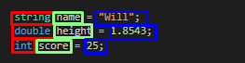

For-Loops

A for-loop is an iterative tool used in programming. They can be used to repeat a piece of code a set number of times. They are sometimes known as a counting loop because generally they count from an initial value to a set limit.
A for-loop can be especially useful for looping through an array. This can be easily done by setting the initial value to zero, and the upper limit to the length of the array. The counter in the for-loop can be used as the index of the array. On each iteration, the counter will increase by one, giving you the next entry. This allows you to easily modify the array and search for certain criteria in each entry.
Below is an image showing the use of a For-Loop to iterate through an array. It shows how the counter(marked in green) of the loop is used as the index of the array.
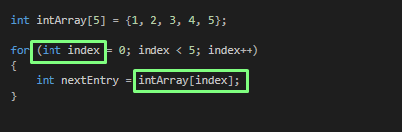

Arguments

Arguments are a way of passing a variable into a function. Using arguments in a function allows you to pass variables in which can be read and edited within the function. This is incredibly useful for programmers as it means they can create functions that can be used with many different values, instead of creating a function for each variable the is needed. One place arguments are often used is in the constructor of a class. The constructor is called when the class is created. Using arguments here is very useful as you can provide vital information to the class. For example, if you a class called ‘Car’, in your constructor you could input the engine size and the cost. Within the function, the variable that is passed as the argument is called a parameter. Editing the variable in the function will not edit it outside since it is its own variable.

Below is an example of a method that has a parameter called cost. The parameter is marked in red where it declared and being used.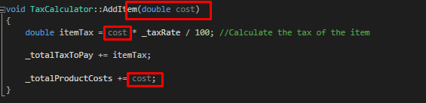
Below is the same method being called using arguments. The argument is in green and the method call is in red.
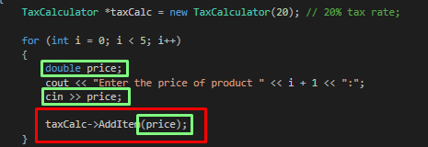

Classes

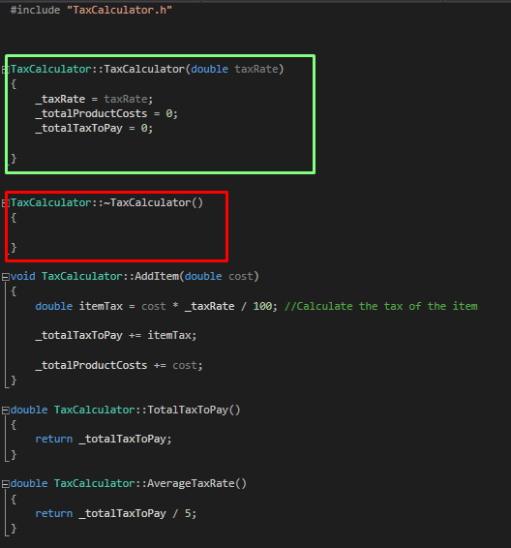
A class is a template for creating objects. A class contains a mixture of methods and variables related to the class. An object created from a class contains all the data that was added in the class. A class can be stored as a variable when created as an object. A class can store public and private data, public data can be accessed from outside of the class itself, by other methods. Private data can only be accessed from within the class. When a class gets created, a method is called inside the class called the constructor, this is used to initialise and setup variables within the class. A class also have a destructor which is called when the object gets deleted, a programmer can use this to ensure that all data created within the class gets deleted along with it. The constructor and destructor can have arguments like any other method, however, by default they have none.
To the right is an example of a class, highlighted in green is the constructor and highlighted in red is the destructor. As you can see, the constructor has a few arguments which can be used to initialise variables.

Below is an example of the header file of the class, this shows public and private data.
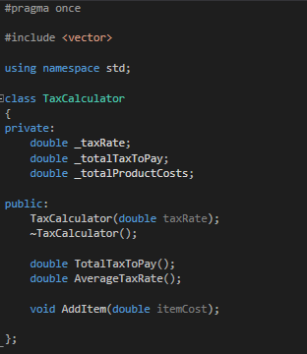

Part B (Interpretation)
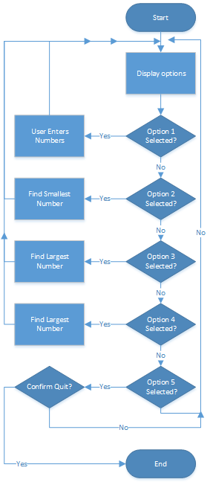
The code provided works by displaying a set of options to the user. The user can select an option by entering a number into the console. The code checks the number and chooses the desired option. The first issue with the code is that the option is incorrect for number four. Instead of displaying all the numbers like it should, it jumps to the quit option. To the right is a flow chart to show how the options should work. As you can see, there are different processes depending on the number selected.
If the user selects option one, the code should prompt the user to enter five numbers. This is where the second issue is, when entering the numbers, the line does not clear correctly which in turn causes the numbers to not enter correctly.
If the user were to select option two, the code should find the smallest number that had been entered.
Option three is very similar to option two, but instead of finding the smallest, it finds the largest number.
The fourth option is to display all numbers. This simply loops through all the displayed numbers and prints each one to the console. However, like mentioned, in the code there is an error and it is set to quit instead.
The final option is to quit the program, when selected this asks the user if they would really like to quit, if they write ‘Yes’, it will quit. If they write ‘No’, it will return to the beginning.

Part C (Implementation)

Exercise 1

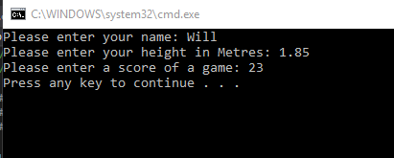
In this exercise, the task was to show how different variables store different types of data. As you can see in the code, there are three variables, a string, a double, and an int (Integer).
The program asks the user to enter their name, this gets stored in the variable called ‘name’, as a string. It then asks the user to enter their height in metres, which gets stored in a variable called ‘height’, as a double. Finally, the program asks the user to enter the score a game – any game, this gets stored in an int variable called ‘score’.

Exercise 2

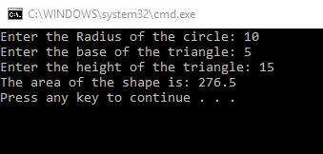
In the second exercise, two shapes were given, a triangle inside of a circle. The task was to get the shaded area of the image. To do this, the program had the user enter the radius of the circle, the base of the triangle, and the height of the triangle. It then calculated the area of the triangle (base multiplied by height, divided by two), and the area of the circle (pi multiplied by the radius squared). To calculate the area of the shaded area, the area of the triangle was taken away from the area of the circle.

Exercise 3
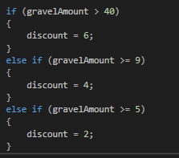
The next exercise was to calculate a discount based on the amount of gravel purchased. This was solved by having the user enter the amount they would like to purchase, and the cost. The program checked the amount they purchased against certain bounds to work out the discount.
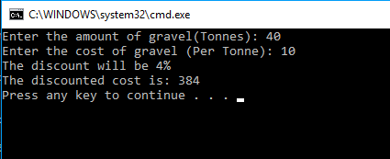

Exercise 4
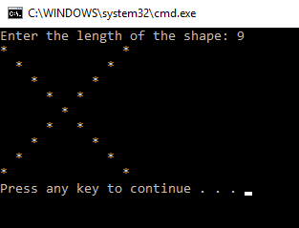
The next task was to draw an ‘X’ using started in the console. To achieve the correct result, the program had the user enter the length of the shape. It used two for loops to create the rows and columns of the star.

Exercise 5
The fifth exercise was to create a class to be used as a tax calculator. It was supposed to take in the prices of five products and calculate the amount of tax to be paid, and the average amount of tax paid per item. This was done by having the user enter the values, the program then calculated the tax of each item at 20% and added it to a total. To get the average tax, the total tax was divided by 5.
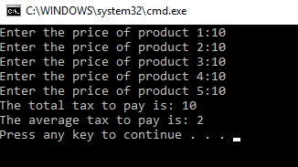

Exercise 6
For the sixth exercise, code was provided which contained errors. It was required that the errors be identified and fixed. The first error that was found was that the fourth option in the code was set to quit the program rather than displaying the numbers. This was fixed by creating a new method to loop the array of numbers and print them. 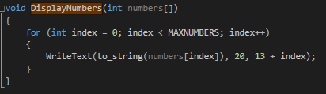

Exercise 7
The next program had to emulate a Slot Machine / Fruit Machine. To do this, the program asked the user if they would like to play. If the user typed ‘No’ the program would simply end. If the user typed ‘Yes’, the program would generate three random numbers between 0 and 5. The numbers were then used as the index of a string array which contained the text for each of the fruit. If the user matched two fruits, they would get 10 points. If they matched 3, they would get 20 points. If they matched two Cherries they’d get 100 points, and if they matched three cherries they would get 1000.
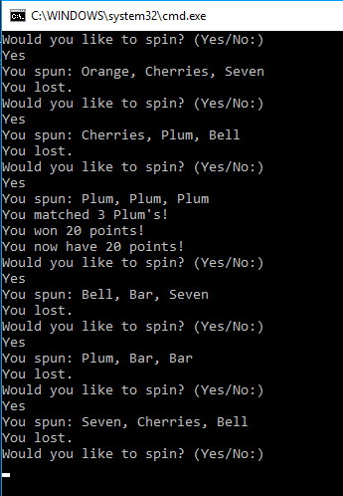

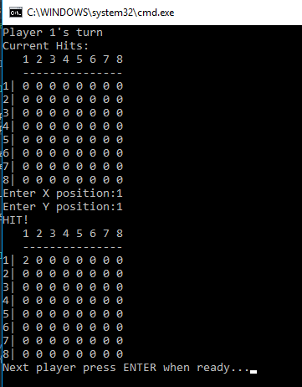
Exercise 8
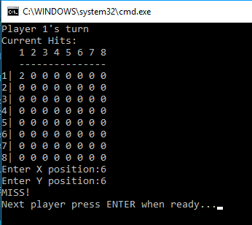
The next exercise was to re-create the battleships board game using command line. The program achieved this by using a multi-dimensional int array as a grid for the game. The player was given 15 points to be used to place ships. Each co-ordinate a ship took up would cost the player 1 point. The user was asked to answer they Start X and Y positions of the ship, then whether they would like it to face up, down, left, or right. The user could then enter the size of the ship. The program checked if the size of the ship would fit on the grid or if it was overlapping, if it was, they program would return saying there’s an error and ask the user to place it again. Once both players had placed their ships, they were given the option to attack their opponent. This was done by having them enter an X and Y co-ordinate and comparing it to the enemy players grid.

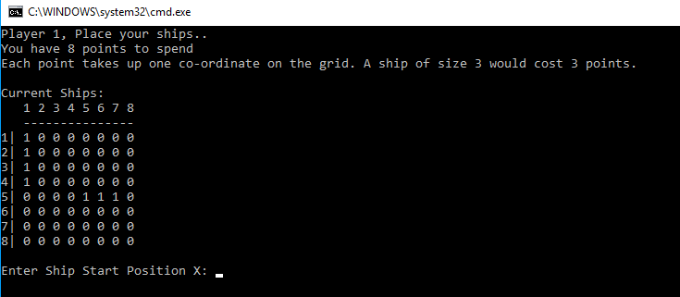

Appendices

Exercise 1

Variables.cpp
// Variables.cpp : Defines the entry point for the console application.
//

#include "stdafx.h"
#include <string>
#include <iostream>

using namespace std;

int main()
{
string name; //Example of a name in a variable
double height; //Example of length in a variable
int score; //Example of score in a variable

cout << "Please enter your name: ";
cin >> name;

cout << "Please enter your height in Metres: ";
cin >> height;

cout << "Please enter a score of a game: ";
cin >> score;

return 0;
}

Exercise 2

ShapeArea.cpp
// ShapeArea.cpp : Defines the entry point for the console application.
//

#include "stdafx.h"
#include <iostream>

using namespace std;

int main()
{
double triangleBase, triangleHeight, circleRadius, triangleArea, circleArea, shadedArea;

cout << "Enter the Radius of the circle: ";
cin >> circleRadius;

cout << "Enter the base of the triangle: ";
cin >> triangleBase;

cout << "Enter the height of the triangle: ";
cin >> triangleHeight;

triangleArea = (triangleBase * triangleHeight) / 2;
circleArea = 3.14 * (circleRadius * circleRadius);
shadedArea = circleArea - triangleArea;

cout << "The area of the shape is: " << shadedArea << endl;

return 0;
}

Exercise 3

GravelDiscounts.cpp
// GravelDiscounts.cpp : Defines the entry point for the console application.
//

#include "stdafx.h"
#include <iostream>

using namespace std;

int main()
{
double gravelAmount, gravelCost, totalCost, discountedCost, discount;

cout << "Enter the amount of gravel(Tonnes): ";
cin >> gravelAmount;

cout << "Enter the cost of gravel (Per Tonne): ";
cin >> gravelCost;

totalCost = gravelAmount * gravelCost;

if (gravelAmount > 40)
{
discount = 6;
}
else if (gravelAmount >= 9)
{
discount = 4;
}
else if (gravelAmount >= 5)
{
discount = 2;
}

discountedCost = totalCost * (1 -(discount / 100));

cout << "The discount will be " << discount << "%" << endl;
cout << "The discounted cost is: " << discountedCost << endl;

return 0;
}

Exercise 4

Shape.cpp
// Shape.cpp : Defines the entry point for the console application.
//

#include "stdafx.h"
#include <iostream>

using namespace std;

int main()
{
int length;

cout << "Enter the length of the shape: ";
cin >> length;

for (int i = 1; i <= length; i++)
{
for (int j = 1; j <= length; j++)
{
//Checks if the correct amount of spaces have been put at the start and middle of each row
if ((i == j) || (j == (length + 1) - i))
{
printf("%s", "*");
}
else {
printf("%s", " ");
}
printf("%s", " ");
}
printf("\r\n");
}
return 0;
}

Exercise 5

ProductTax.cpp
// ProductTax.cpp : Defines the entry point for the console application.
//

#include "stdafx.h"
#include <iostream>
#include"TaxCalculator.h"

using namespace std;

int main()
{
TaxCalculator *taxCalc = new TaxCalculator(20); // 20% tax rate;

for (int i = 0; i < 5; i++)
{
double price;
cout << "Enter the price of product " << i + 1 << ":";
cin >> price;

taxCalc->AddItem(price);
}

cout << "The total tax to pay is: "<< taxCalc->TotalTaxToPay() << endl;
cout << "The average tax to pay is: " <<taxCalc->AverageTaxRate() << endl;

return 0;
}

TaxCalculator.h
#pragma once

#include <vector>

using namespace std;

class TaxCalculator
{
private:
double _taxRate;
double _totalTaxToPay;
double _totalProductCosts;

public:
TaxCalculator(double taxRate);
~TaxCalculator();

double TotalTaxToPay();
double AverageTaxRate();

void AddItem(double itemCost);

};

TaxCalculator.cpp
#include "TaxCalculator.h"

TaxCalculator::TaxCalculator(double taxRate)
{
_taxRate = taxRate;
_totalProductCosts = 0;
_totalTaxToPay = 0;

}

TaxCalculator::~TaxCalculator()
{

}

void TaxCalculator::AddItem(double cost)
{
double itemTax = cost * _taxRate / 100; //Calculate the tax of the item

_totalTaxToPay += itemTax;

_totalProductCosts += cost;
}

double TaxCalculator::TotalTaxToPay()
{
return _totalTaxToPay;
}

double TaxCalculator::AverageTaxRate()
{
return _totalTaxToPay / 5;
}

Exercise 6

Menu.cpp
// AssignCode_Menu.cpp : Defines the entry point for the console application.
//

#define _CRT_SECURE_NO_WARNINGS

#include "stdafx.h"
#include <conio.h> // For pause
#include <string>
#include <stdarg.h>
#include <Windows.h> // To change cursor position
#include <iostream>

using namespace std;

#include "Main.h"

int main()
{
int theNumbers[MAXNUMBERS];
int chosenOption = 0;
bool quit = false;

InitialiseNumbers(theNumbers, MAXNUMBERS);

while (quit == false)
{
DisplayHeader();
DisplayMenu();
chosenOption = ReadNumber("Please choose an option: ");
quit = ProcessMenu(chosenOption, theNumbers);

ClearConsole();
}

return 0;
}

void InitialiseNumbers(int numbers[], int size)
{
for (int index = 0; index < size; index++)
{
numbers[index] = 0;
}
}

void DisplayHeader(void)
{
WriteText("*******************************************************************************", 0, 0); // Top left hand corner of screen is x = 0, y = 0
WriteText("* This application is designed to allow you to choose numbers *", 0, 1); // Next line down is x = 0, y = 1, etc
WriteText("* and finds the biggest and the smallest value *", 0, 2);
WriteText("*******************************************************************************", 0, 3);
}

void DisplayMenu()
{
WriteText("Select an option", 20, 8); // Display menu at at x = 20, y = 8
WriteText("1. Enter the numbers", 20, 9);
WriteText("2. Find the smallest", 20, 10);
WriteText("3. Find the largest", 20, 11);
WriteText("4. Display all numbers", 20, 12);
WriteText("5. Quit", 20, 13);
}

int ReadNumber(string prompt)
{
int number = -1;
int inputCharCount;

WriteText(prompt, 20, 14);
inputCharCount = scanf("%i", &number);
if (inputCharCount == 0) // Wasn’t a number, so ignore what they typed in!!
{
IgnoreInput();
}

ClearText(20, 14, prompt.length() + inputCharCount); // Clear the text at this line

return number;
}

void IgnoreInput(void)
{
char ch;
while ((ch = getchar()) != '\n' && ch != EOF);
}

void ClearText(int x, int y, int length)
{
// Write space ' ' characters starting at x, y for 'length' times
string spaces(length, ' ');
WriteText(spaces, x, y);
}

bool ProcessMenu(int option, int numbers[])
{
string message;
bool quit = false;

switch (option)
{
case 1:
GetNumbers(numbers);
break;
case 2:
WriteText(FormatText("The smallest value is %i", FindSmallest(numbers)), 20, 15);
Pause();
break;
case 3:
WriteText(FormatText("The largest value is %i", FindLargest(numbers)), 20, 15);
Pause();
break;
case 4:
//quit = IsQuitting();
DisplayNumbers(numbers);
break;
case 5:
quit = IsQuitting();
break;
default:
WriteText("Unknown option value entered", 20, 15);
Pause();
break;
}

return quit;
}

void DisplayNumbers(int numbers[])
{
for (int index = 0; index < MAXNUMBERS; index++)
{
WriteText(to_string(numbers[index]), 20, 13 + index);
}
}

void GetNumbers(int numbers[])
{
for (int index = 0; index < MAXNUMBERS; index++)
{
numbers[index] = ReadNumber("Enter number: ");
}
}

int FindSmallest(int numbers[])
{
int smallest = numbers[0];

for (int index = 0; index < MAXNUMBERS - 1; index++) // <-- subtract 1
{
if (numbers[index + 1] < smallest)
{
smallest = numbers[index + 1];
}
}

return smallest;
}

int FindLargest(int numbers[])
{
int largest = numbers[0];

for (int index = 0; index < MAXNUMBERS - 1; index++) // <-- subtract 1
{
if (numbers[index + 1] > largest)
{
largest = numbers[index + 1];
}
}

return largest;
}

bool IsQuitting()
{
char input[100];
string response;

bool quit = false;

WriteText("Do you really wish to quit? ", 20, 13);
scanf("%99s", input);

response = input;
WriteText(response, 20, 13);

if (response == "YES")
{
quit = true;
}

return quit;
}

void WriteText(string text, int x, int y)
{
SetCursorPosition(x, y);
printf(text.c_str());
}

// JUST USE THIS FUNCTION
// This function positions cursor in Console window,
// and you DON'T need to understand it!!!
void SetCursorPosition(int x, int y)
{
static HANDLE handle = NULL;
if (!handle)
{
handle = GetStdHandle(STD_OUTPUT_HANDLE);
}
COORD coords = { x, y };
SetConsoleCursorPosition(handle, coords);
}

// JUST USE THIS FUNCTION
// This function does creates a string
// using a format string and values i.e.
// FormatText("Number is %i", 5) returns "Number is 5",
// and you DON'T need to understand it!!!
string FormatText(const char *c_format, ...)
{
char ch[100];
va_list args;
va_start(args, c_format);
vsnprintf(ch, 100, c_format, args);
va_end(args);
return string(ch);
}

// JUST USE THIS FUNCTION
// This function clears the screen,
// and you DON'T need to understand it!!!
void ClearConsole(void)
{
system("cls");
}

void Pause(void)
{
// Pause
while (1) { if (_kbhit()) break; }
_getch(); // Clear the keypress
}

Main.h
#pragma once

const int MAXNUMBERS = 3;
const int MAXINPUTCHARS = 100;

using namespace std;

void InitialiseNumbers(int numbers[], int size);
void DisplayHeader(void);
void DisplayMenu(void);
int ReadNumber(string prompt);
void IgnoreInput(void);
void ClearText(int x, int y, int length);
bool ProcessMenu(int option, int numbers[]);
void GetNumbers(int numbers[]);
int FindSmallest(int numbers[]);
int FindLargest(int numbers[]);
bool IsQuitting();
void WriteText(string text, int x, int y);
void SetCursorPosition(int x, int y);
string FormatText(const char *format, ...);
void ClearConsole(void);
void Pause(void);
void DisplayNumbers(int numbers[]); //New Method

Exercise 7

Main.cpp
#include "stdafx.h"

#include "FruitMachine.h"

int main()
{
FruitMachine *fruitMachine = new FruitMachine();

fruitMachine->Play();

return 0;
}

FruitMachine.h
#pragma once

#include <random>
#include <time.h>
#include <iostream>
#include <string>

using namespace std;

class FruitMachine
{

private:
time_t theTime;

int _points;

bool _quit;

string textDisplay[6] = { "Seven", "Bar", "Bell", "Plum", "Orange", "Cherries" };

public:
FruitMachine();
~FruitMachine();

int GetPoints();

int CalculatePoints(int matches, int matchedNum);
void Spin();
void Play();
int RandomValue(int maxValue);
};

FruitMachine.cpp
#include "stdafx.h"
#include "FruitMachine.h"

#include <map>

FruitMachine::FruitMachine()
{
srand((unsigned)time(&theTime));
_points = 0;
_quit = false;

}

FruitMachine::~FruitMachine()
{
}

int FruitMachine::GetPoints()
{
return this->_points;
}

void FruitMachine::Play()
{
while (!_quit)
{
string spin;

cout << "Would you like to spin? (Yes/No:)" << endl;
cin >> spin;

if (spin == "Yes")
{
Spin();
}
else if(spin == "No")
{
_quit = true;
}
else
{
cout << "Invalid Entry." << endl;
}
}
}

void FruitMachine::Spin()
{
int nums[3];

nums[0] = RandomValue(5);
nums[1] = RandomValue(5);
nums[2] = RandomValue(5);

int matches = 1;
int matchedNum = 0;

for (int i = 0; i < 3; i++)
{
for (int j = 0; j < 3; j++)
{
if (i == j)
continue;

if (nums[i] == nums[j])
matches++;
}

if (matches > 0)
{
matchedNum = nums[i];
break;
}
}

cout << "You spun: " << textDisplay[nums[0]] << ", " << textDisplay[nums[1]] << ", " << textDisplay[nums[2]] << endl;
if (matches > 1)
{
int wonPoints = CalculatePoints(matches, matchedNum);
_points += wonPoints;

cout << "You matched " << matches << " " << textDisplay[matchedNum] << "'s!" << endl;
cout << "You won " << wonPoints << " points!" << endl;
cout << "You now have " << _points << " points!" << endl;
}
else {
cout << "You lost." << endl;
}
}

int FruitMachine::CalculatePoints(int matches, int matchedNum)
{
if (matches == 3)
{
if (matchedNum == 5)
{
return 1000;
}
return 20;
}
else if (matches == 2)
{
if (matchedNum == 5)
{
return 100;
}
return 10;
}
return 0;
}

int FruitMachine::RandomValue(int maxValue)
{
return rand() % (maxValue + 1);
}

Exercise 8

Main.cpp
#include "Battleships.h"

int main()
{
new Battleships();
return 0;
}

Player.h
#pragma once

#include <string>
#include <iostream>

using namespace std;

class Player
{

private:
int _playerGrid[8][8];
int _enemyGrid[8][8];
int _shipPoints;
int _playerId;
int _health;

string _letters[8];

public:
Player(int playerId, int shipPoints);
~Player();

enum Direction
{
UP, DOWN, LEFT, RIGHT, UNKNOWN
};

int GetPoints();
int GetPlayerId();
int GetHealth();

bool AddShip(int startX, int startY, Direction direction, int size);
bool CheckHit(int x, int y);

int GetHitCount();

void RecordEnemyHit(int x, int y);
void PrintGrid(int grid[8][8]);
void InitialiseGrids();
void PrintPlayerGrid();
void PrintEnemyGrid();

};

Player.cpp
#include "Player.h"

Player::Player(int playerId, int shipPoints)
{
_playerId = playerId;
_shipPoints = shipPoints;
_health = shipPoints;

InitialiseGrids();
}

Player::~Player()
{
}

bool Player::AddShip(int startX, int startY, Direction direction, int size)
{
int realStartX = startX - 1;
int realStartY = startY - 1;

int coordsToAdd[8][8];

if (_shipPoints >= size)
{
//Generate the coords needed, check in bounds of array and not used already.
for (int i = 0; i < size; i++)
{
bool breakLoop = false;

switch (direction)
{
case UP:
if (realStartX - size < -1 || _playerGrid[realStartX - i][realStartY] == 1)
{
return false;
}

coordsToAdd[realStartX - i][realStartY] = 1;
break;

case DOWN:
if (realStartX + size > 8 || _playerGrid[realStartX + i][realStartY] == 1)
{
return false;
}

coordsToAdd[realStartX + i][realStartY] = 1;
break;

case RIGHT:
if (realStartY + size > 8 || _playerGrid[realStartX][realStartY + i] == 1)
{
return false;
}

coordsToAdd[realStartX][realStartY + i] = 1;
break;
case LEFT:
if (realStartY - size < -1 || _playerGrid[realStartX][realStartY - i] == 1)
{
return false;
}

coordsToAdd[realStartX][realStartY - i] = 1;
break;
}
}

//Draw in the coords
for (int i = 0; i < 8; i++)
{
for (int j = 0; j < 8; j++)
{
if (coordsToAdd[i][j] == 1)
{
_playerGrid[i][j] = 1;
}
}
}

_shipPoints -= size;
}
return true;
}

bool Player::CheckHit(int x, int y)
{
return _playerGrid[x - 1][y - 1] == 1;
}

void Player::InitialiseGrids()
{
for (int i = 0; i < 8; i++)
{
for (int j = 0; j < 8; j++)
{
_playerGrid[i][j] = 0;
_enemyGrid[i][j] = 0;
}

}
}

void Player::PrintPlayerGrid()
{
PrintGrid(_playerGrid);
}

void Player::PrintEnemyGrid()
{
PrintGrid(_enemyGrid);
}

void Player::PrintGrid(int grid[8][8])
{
cout << " 1 2 3 4 5 6 7 8" << endl;
cout << " ---------------" << endl;

for (int i = 0; i < 8; i++)
{
cout << i + 1 << "|";
for (int j = 0; j < 8; j++)
{
cout << " " << grid[i][j];
}
cout << endl;
}
}

void Player::RecordEnemyHit(int x, int y)
{
_enemyGrid[x - 1][y - 1] = 2;
}

int Player::GetHitCount()
{
int count = 0;
for (int i = 0; i < 8; i++)
{
for (int j = 0; j < 8; j++)
{
if (_enemyGrid[i][j] == 2)
{
count++;
}
}
}
return count;
}

int Player::GetPoints()
{
return _shipPoints;
}

int Player::GetPlayerId()
{
return _playerId;
}

int Player::GetHealth()
{
return _health;
}

Battleships.h
#pragma once

#include "Player.h"

#include <stdlib.h>
#include <conio.h>

class Battleships
{

private:
Player * playerOne;
Player * playerTwo;

Player *activePlayer;
Player *enemyPlayer;

int _activePlayer;

bool _quit;

public:
Battleships();
~Battleships();

void StartGame();
void Turns();
void PlaceShips();
void SwitchActivePlayer();
Player::Direction StringToDirection(string str);

};

Battleships.cpp
// Battleships.cpp : Defines the entry point for the console application.
//

#include "Battleships.h"

Battleships::Battleships()
{
playerOne = new Player(1, 15);
playerTwo = new Player(2, 15);

activePlayer = playerOne;
enemyPlayer = playerTwo;

_quit = false;

StartGame();
}

Battleships::~Battleships()
{

}

void Battleships::StartGame()
{
while (!_quit)
{
if (playerOne->GetPoints() == 0 && playerTwo->GetPoints() == 0)
{
if (playerOne->GetHitCount() >= playerTwo->GetHealth())
{
cout << "Player One Wins!" << endl;
_quit = true;
}
else if (playerTwo->GetHitCount() >= playerOne->GetHealth())
{
cout << "Player Two Wins!" << endl;
_quit = true;
}
else
{
Turns();
}
}
else
{
PlaceShips();
}
}
}

void Battleships::PlaceShips()
{
while (activePlayer->GetPoints() > 0)
{
cout << "Player " << activePlayer->GetPlayerId() << ", Place your ships.." << endl;
cout << "You have " << activePlayer->GetPoints() << " points to spend" << endl;
cout << "Each point takes up one co-ordinate on the grid. A ship of size 3 would cost 3 points." << endl;

cout << endl << "Current Ships:" << endl;
activePlayer->PrintPlayerGrid();

int x, y, size;
string enteredTxt;
Player::Direction direction;

cout << endl << "Enter Ship Start Position X: ";
cin >> x;

cout << "Enter Ship Start Position Y: ";
cin >> y;

cout << "Enter Ship Direction (UP, DOWN, LEFT, RIGHT): ";
cin >> enteredTxt;

direction = StringToDirection(enteredTxt);

cout << "Enter Ship Size: ";
cin >> size;

if (!activePlayer->AddShip(x, y, direction, size) || direction == Player::UNKNOWN)
{
system("CLS");
cout << "Failed to place ship. Please try again." << endl;
}
else
{
system("CLS");
}
}
SwitchActivePlayer();
system("CLS");
}

void Battleships::Turns()
{
int x, y;

cout << "Player " << activePlayer->GetPlayerId() << "'s turn" << endl;

cout << "Current Hits: " << endl;
activePlayer->PrintEnemyGrid();

cout << "Enter X position:";
cin >> x;

cout << "Enter Y position:";
cin >> y;

if (enemyPlayer->CheckHit(x, y))
{
cout << "HIT!" << endl;
activePlayer->RecordEnemyHit(x, y);
activePlayer->PrintEnemyGrid();
}
else
{
cout << "MISS!" << endl;
}

SwitchActivePlayer();

cout << "Next player press ENTER when ready...";

//if (cin.get() == '\n')
if(getch() > 0)
{
system("CLS");
}
}

void Battleships::SwitchActivePlayer()
{
if (activePlayer == playerOne)
{
activePlayer = playerTwo;
enemyPlayer = playerOne;
}
else
{
activePlayer = playerOne;
enemyPlayer = playerTwo;
}
}

Player::Direction Battleships::StringToDirection(string str)
{
if (str == "UP")
{
return Player::UP;
}
else if (str == "DOWN")
{
return Player::DOWN;
}
else if (str == "RIGHT")
{
return Player::RIGHT;
}
else if (str == "LEFT")
{
return Player::LEFT;
}
return Player::UNKNOWN;
}

References

[1] | J. Bruce, “The Basics Of Computer Programming 101 – Variables And DataTypes,” 23 October 2011. [Online]. Available: https://www.makeuseof.com/tag/basics-of-computer-programming-variables-datatypes/.
[2] | M. Rouse, “What is a variable?,” September 2005. [Online]. Available: http://whatis.techtarget.com/definition/variable.
[3] | “What Is a For Loop?,” Techopedia Inc, [Online]. Available: https://www.techopedia.com/definition/19415/for-loop.
[4] | “What's A Class?,” [Online]. Available: http://guyhaas.com/bfoit/itp/JavaClass.html.
[5] | Y. Agrawal, “Paramaters & Arguments,” Codeburst, 23 August 2017. [Online]. Available: https://codeburst.io/parameters-arguments-in-javascript-eb1d8bd0ef04?gi=9a8a2f9512b1.

