Portfolio of Evidence & Reflective Commentary
Alina Lis

Table of Contents
Reflective Commentary…………………………………………... 3 References…………………………………………………………10
Evidence
Photograph of my work placement………………………...….…12
Mission Statement…………………………………………………14
Job Description…………………………………………………….15
Completed Trainings………………………………………………17
Supervision…………………………………………………………19
Example of my placement diary…………………………………..20
Appendix
Email to Module Lead about work Placement....………………..25
Placement information form ……………………………………..26
Record of hours………………………….…………………….…...27
Placement attendance form ………………………………………27

Reflective Commentary

Using Gibbs' Reflective Cycle (Gibbs’ Reflective Cycle, 2020)
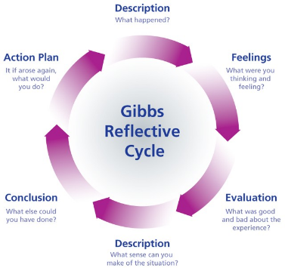
to reflect on the application of counselling skills in daily activities with residents, I realised the significant therapeutic potential these interactions contain. To promote the residents' emotional and psychological development, as a support worker, I integrated techniques like active listening, empathy, and positive reinforcement into regular activities like cooking, painting, gardening, farm, and disco events. I did not realise how much of an impact these activities would have at first, but as time went on and I saw the residents grow and express themselves, I felt both happiness and pressure to make sure every contact was therapeutic. The assessment showed that the advantages—such as improved interpersonal connections and more community involvement—far exceeded the difficulties. This is consistent with ideas from nature-based therapies and expressive arts, which contend that these kinds of activities enhance mental and emotional health by fostering situations in which residents feel respected and understood. The procedure served as a reminder of how crucial it is to deliberately include counselling approaches into everyday encounters to support residents’ personal development and enrich their daily lives. My action plan is honing these techniques, getting input, and expanding my knowledge to increase my efficacy and validate the game-changing potential of therapeutic integration in everyday caregiving.

It has been a learning and discovery process for me to consider how counselling approaches may be included into regular contact with people in a caring setting. I had not completely appreciated the extent of therapeutic potential inherent in everyday interactions until I started this trip. These days, I view farm work, gardening, painting, weaving, going to discos, and cooking as profound chances for emotional and psychological development in addition to being fun and instructive activities. I have personally seen how these routine activities may become therapeutic sessions that promote growth, healing, and connection by incorporating counselling skills into them. My contacts with the residents have much improved as a result, transforming ordinary conversations into worthwhile therapeutic chances. Additionally, it has improved our interpersonal ties and made our community more sympathetic and caring.
Gardening and contact with farm animals offer therapeutic environments where the practices of active listening and empathy are crucial for enhancing residents’ well-being. The rhythmic nature of gardening tasks like planting and watering facilitates reflective conversations, creating a space for residents to share emotions and experiences. My approach to support and therapy has changed activities like gardening and taking care of farm animals, demonstrating the significant influence of incorporating these activities into our everyday interactions. This environment enables to engage deeply with residents through active listening and empathetic responses, significantly impacting mental health outcomes as highlighted by Manusov et al. (2018) and Jones et al. (2016). Furthermore, studies by Andzaurova and Оаpтова-бочавер (2023) and Koay and Dillon (2020) demonstrate the important potential of nature-based therapies, such as gardening, to improve psychological well-being. Active listening and sympathetic interactions combine with a naturally restorative and soothing environment to create a powerful therapeutic blend. People's tension and anxiety levels can be lowered by engaging their senses with their surroundings—touching the earth, smelling the flowers, and seeing the colours. They also engage in thoughtful talks while tending to plants in a peaceful and focused manner. This method promotes a special kind of healing and connection that is based on growth and care. According to Berget et al. (2008), residents' lives are enhanced by the physical touch and responsibility that come with caring for farm animals, which also helps them develop better coping mechanisms and self-esteem. My awareness of the therapeutic potential of commonplace activities has been enhanced by these experiences, which have also reaffirmed the importance of nurturing, empathy, and active listening in fostering emotional well-being and connection.
I learned in the painting and weaving sessions how acknowledging even the little accomplishments might make a big difference in our residents' moods and inspire them to pursue their artistic endeavours. This strategy is consistent with what I discovered from Gladding (2016), Leone (2020) and De Witte et al. (2021), who highlight the value of positive reinforcement and expressive arts therapy as transforming tools. Providing constant encouragement, I observed clearly how it improved the residents sense of self and participation in activities. These workshops developed into more than just platforms for artistic expression; they became centres for fostering self-assurance, drive, and a sense of community. This experience has made me realise how important a supportive environment is for promoting healing and personal development.
The disco events gave residents a vibrant platform for self-expression and emotional release, and they opened my eyes to a new kind of therapeutic expression through dance and music. It was quite unexpected and eye-opening for me to see how these modalities allowed residents to interact and engage with each other on a deeper level than just verbal communication. This experience confirmed research by Horwitz et al. (2022) and Mino-Roy et al. (2021) that shows how dance and music therapy can help people express their emotions and connect with others, especially those who struggle with learning. Disco parties turned into lively places where people could freely express themselves, bringing to light facets of their personality that might have stayed hidden in traditional therapy settings. This unique platform for self-expression served as a further reminder of how crucial it is to investigate various and innovative methods for boosting residents' emotional wellbeing and developing deep relationships.
By integrating counselling approaches into the cooking sessions, I saw that these activities were evolving into more than just preparing meals; they were becoming platforms for improving social skills, emotional intelligence, and problem-solving abilities. This method was difficult for me at first because I had to teach the residents not just the practical aspects of cooking but also how to connect with them emotionally. Nevertheless, it was very fulfilling to see how their emotional and cognitive growth continued as they became more proficient in the kitchen. Asher et al. (2020) and Farmer and Cotter (2021) have highlighted the therapeutic benefits of cooking for improving social skills, emotional intelligence, and personal development. My experience is consistent with their perspectives on culinary therapy. During these sessions, I helped create deeper connections and promoted holistic growth by encouraging residents to communicate their thoughts and feelings. During this trip, I was able to see firsthand the positive effects of incorporating counselling techniques into regular activities. This enhanced the residents' lives and confirmed the therapeutic benefits of these group projects.
The nutrition training emphasized how diet affects both mental and physical health, changing how I think about meal preparation and food activities. It is fascinating to see how discussions about nutrition can lead to broader conversations about overall wellbeing.
The food hygiene training was particularly enlightening, reinforcing its role in our comprehensive care strategy. This training provided essential knowledge for ensuring the residents safety and well-being, enhancing my understanding of food safety. I learned about various contaminants, conditions that encourage bacterial growth, and important safety practices, significantly improving my ability to manage food-related risks.
Workplace supervision meetings have been crucial for my professional and personal growth. They provide a space for introspection, learning, and support, enhancing my skills in working with residents. These meetings have deepened my understanding of my own emotions and reactions, improving my empathetic and sympathetic responses. Supervision has also been vital in balancing support with allowing residents the independence to explore and grow independently.
Starting to use counselling skills in daily activities with residents has been a transformative experience, extending beyond formal meetings to our everyday interactions. The supervision sessions, along with nutrition and hygiene training, have highlighted the importance of a holistic approach to care that addresses both physical and mental health, as well as the environment.
Working in this role has been incredibly rewarding. It involved overcoming challenges like learning the best ways to interact with residents, managing group dynamics during events, and addressing my own feelings of dissatisfaction or inadequacy. Each challenge helped me grow and find innovative solutions. I am deeply satisfied watching residents thrive, develop new skills, and form relationships. This experience has affirmed the transformative power of integrating counselling techniques into everyday interactions and the therapeutic value of activities. I have learned the importance of patience, adaptability, and continual self-reflection. I have experienced a range of emotions, from joy at residents’ successes to empathy for their struggles, and I am grateful for the opportunity to contribute to their holistic development. This journey has not only enhanced my professional skills but also deepened my commitment to fostering their growth, reinforcing my belief in the potential for recovery and growth through our daily interactions.

References
Andzaurova, P. O., & Нартова-бочавер, С. К. (2023). Gardening and Garden therapy as a resource for Human Psychological Well-Being. Vestnik Rossijskogo Universiteta Družby Narodov, 20(2), 331–351. https://doi.org/10.22363/2313-1683-2023-20-2-331-351
Asher, R. C., Jakstas, T., Wolfson, J. A., Rose, A., Bucher, T., Lavelle, F., Dean, M., Duncanson, K., Innes, B., Burrows, T., Collins, C. E., & Shrewsbury, V. A. (2020). Cook-EDTM: a model for planning, implementing and evaluating cooking programs to improve diet and health. Nutrients, 12(7), 2011. https://doi.org/10.3390/nu12072011
Berget, B., Ekeberg, Ø., & Braastad, B. O. (2008). Animal-assisted therapy with farm animals for persons with psychiatric disorders: effects on self-efficacy, coping ability and quality of life, a randomized controlled trial. Clinical Practice & Epidemiology in Mental Health, 4(1), 9. https://doi.org/10.1186/1745-0179-4-9
De Witte, M., Orkibi, H., Zarate, R., Karkou, V., Sajnani, N., Malhotra, B., Ho, R. T. H., Kaimal, G., Baker, F., & Koch, S. C. (2021). From Therapeutic Factors to Mechanisms of Change in the Creative Arts Therapies: A scoping review. Frontiers in Psychology, 12. https://doi.org/10.3389/fpsyg.2021.678397
Farmer, N., & Cotter, E. W. (2021). Well-Being and Cooking Behavior: Using the Positive Emotion, Engagement, Relationships, Meaning, and Accomplishment (PERMA) model as a theoretical framework. Frontiers in Psychology, 12. https://doi.org/10.3389/fpsyg.2021.560578
Gibbs’ reflective Cycle. (2020, November 11). The University of Edinburgh. https://www.ed.ac.uk/reflection/reflectors-toolkit/reflecting-on-experience/gibbs-reflective-cycle
Gladding, S. T. (2016). The creative arts in counseling. In Wiley eBooks. https://doi.org/10.1002/9781119291961
Horwitz, E. B., Korošec, K., & Theorell, T. (2022). Can dance and music make the transition to a sustainable society more feasible? Behavioral Sciences, 12(1), 11. https://doi.org/10.3390/bs12010011
Jones, S. M., Bodie, G. D., & Hughes, S. D. (2016). The impact of mindfulness on empathy, active listening, and perceived provisions of emotional support. Communication Research, 46(6), 838–865. https://doi.org/10.1177/0093650215626983
Koay, W. I., & Dillon, D. (2020). Community Gardening: Stress, Well-Being, and Resilience Potentials. International Journal of Environmental Research and Public Health (Online), 17(18), 6740. https://doi.org/10.3390/ijerph17186740
Leone, L. (2020). Craft in art therapy. In Routledge eBooks. https://doi.org/10.4324/9781003050513
Manusov, V., Stofleth, D., Harvey, J., & Crowley, J. P. (2018). Conditions and consequences of listening well for interpersonal relationships: modeling Active-Empathic listening, Social-Emotional skills, trait mindfulness, and relational quality. International Journal of Listening, 34(2), 110–126. https://doi.org/10.1080/10904018.2018.1507745
Mino-Roy, J., St-Jean, J., Lemus-Folgar, O., Caron, K., Constant-Nolett, O., Després, J., & Gauthier-Boudreault, C. (2021). Effects of music, dance and drama therapies for people with an intellectual disability: A scoping review. British Journal of Learning Disabilities, 50(3), 385–401. https://doi.org/10.1111/bld.12402

Photograph of my work placement
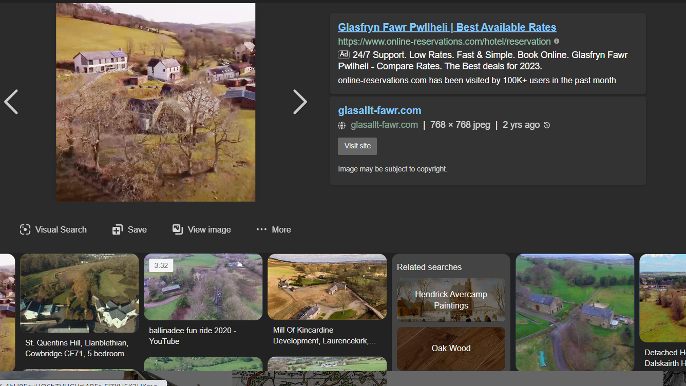

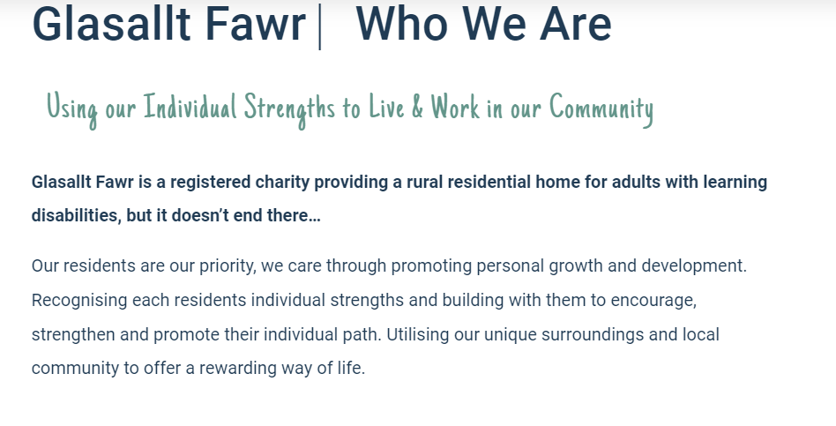
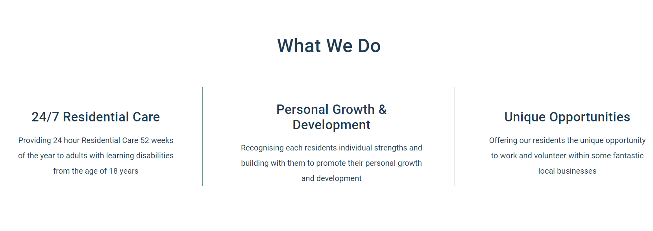

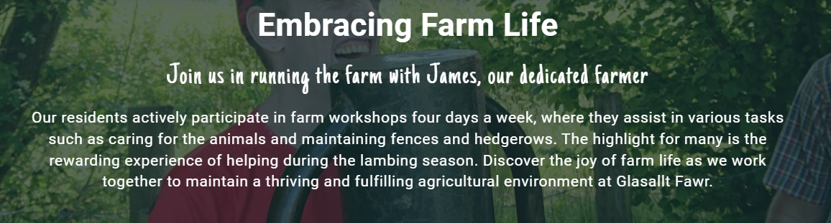

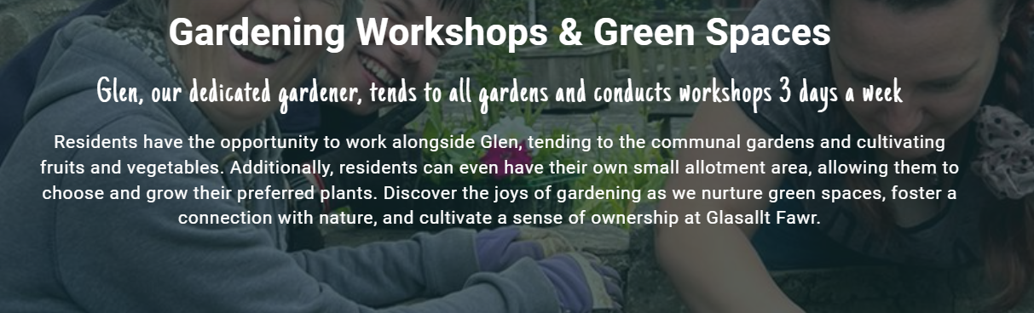

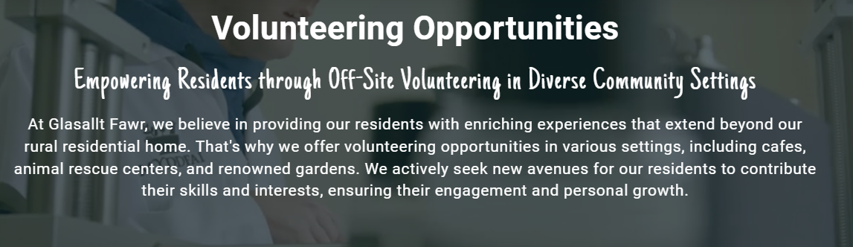

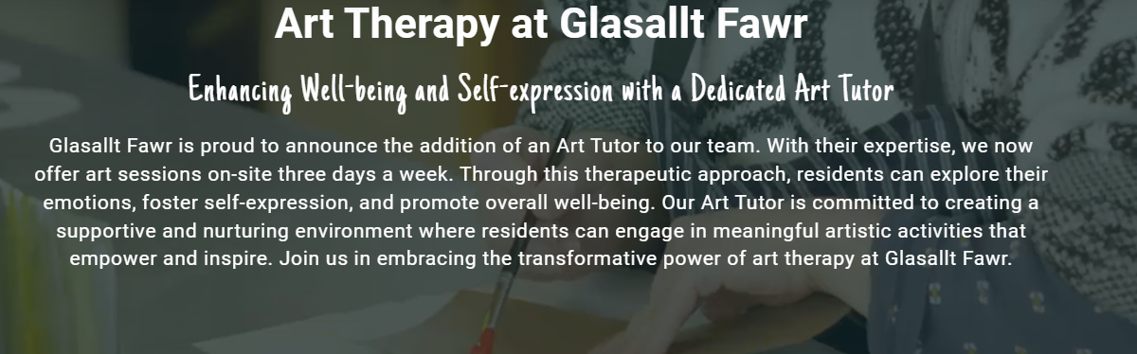

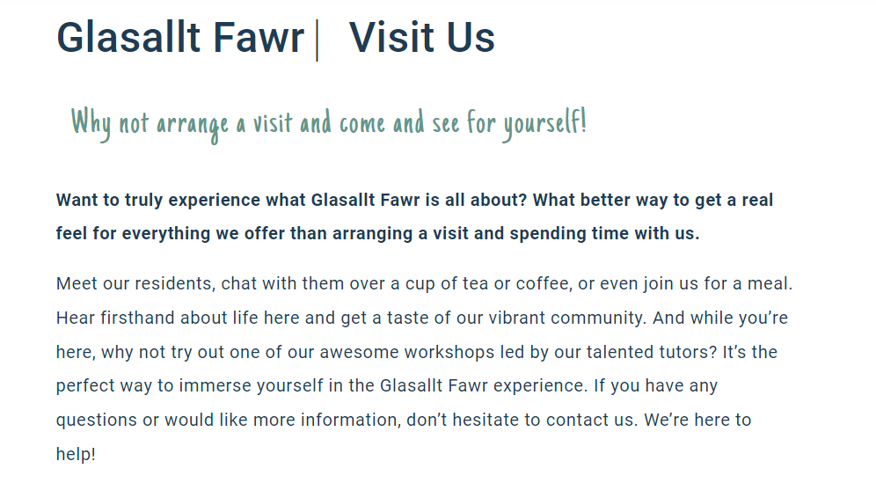

Mission Statement

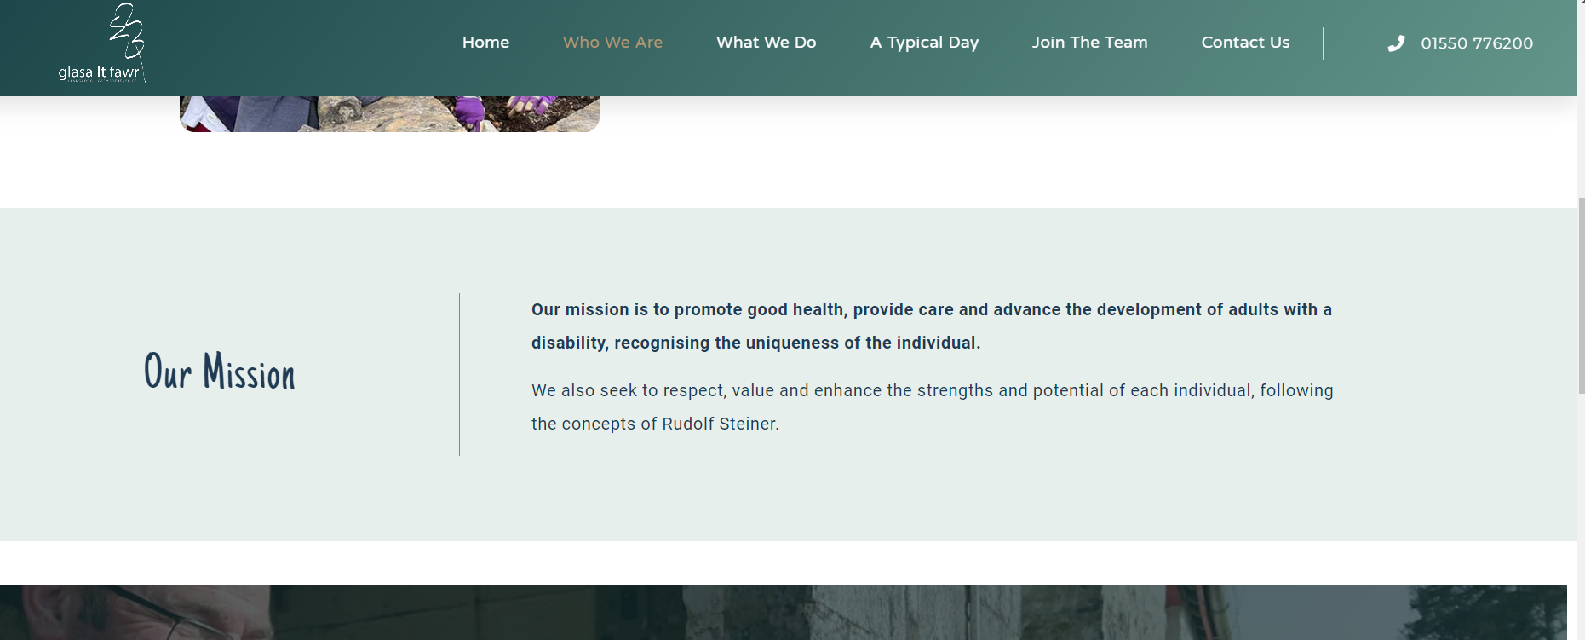
Job Description

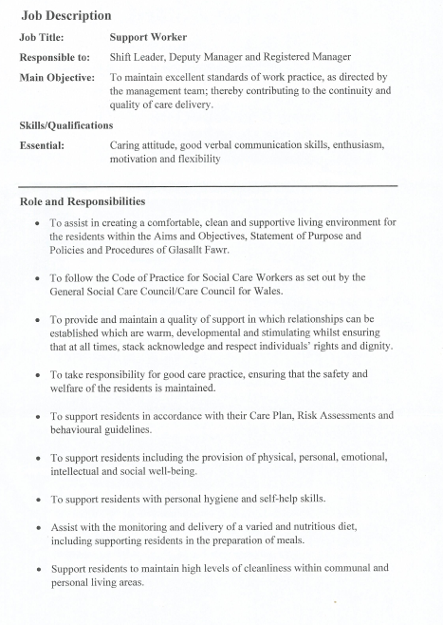
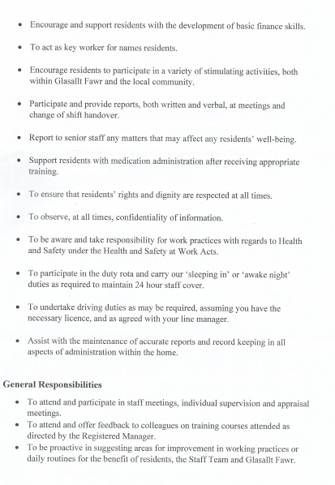

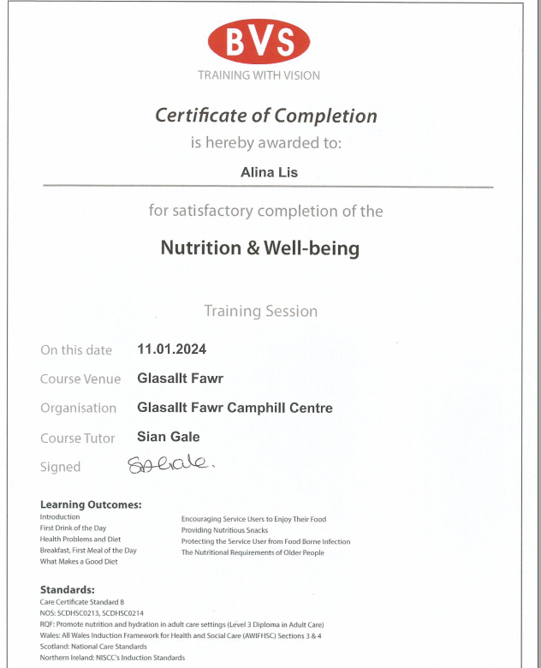

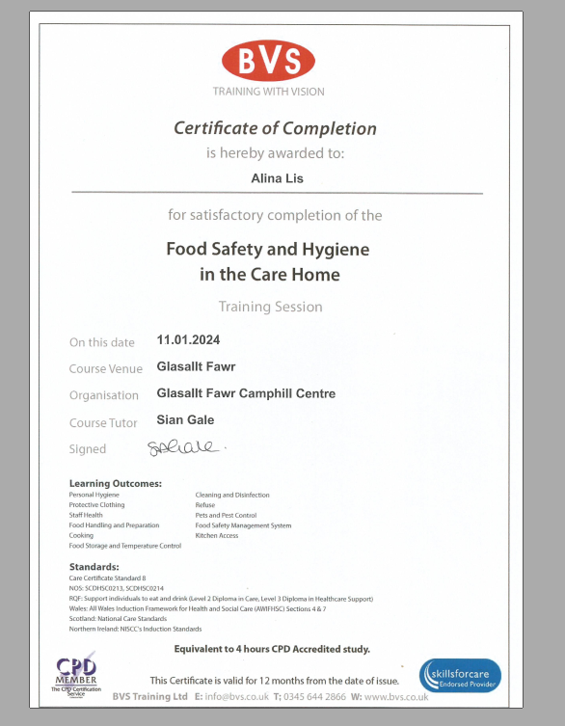

Supervision

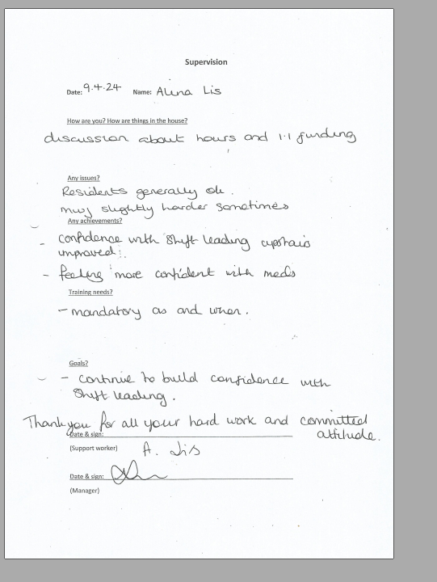

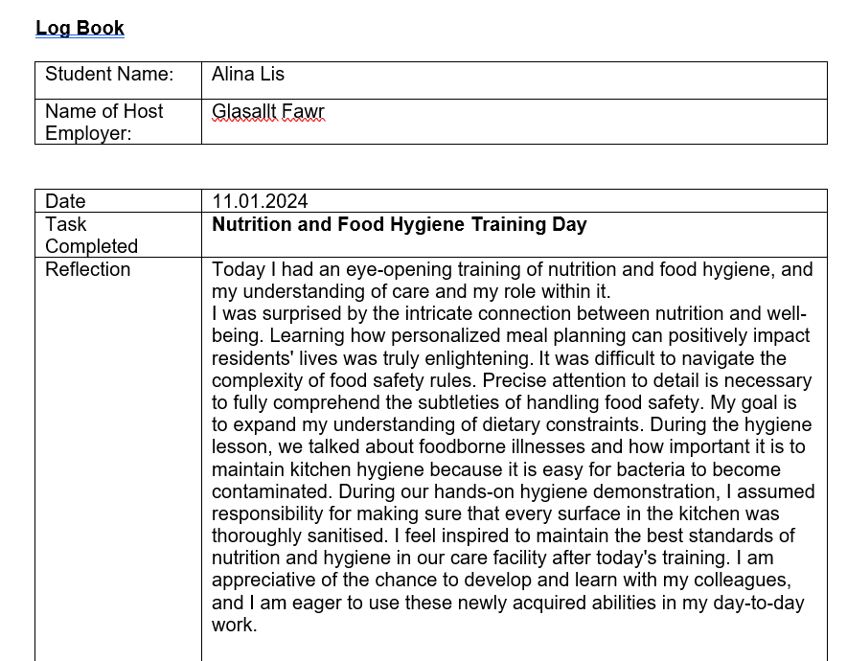
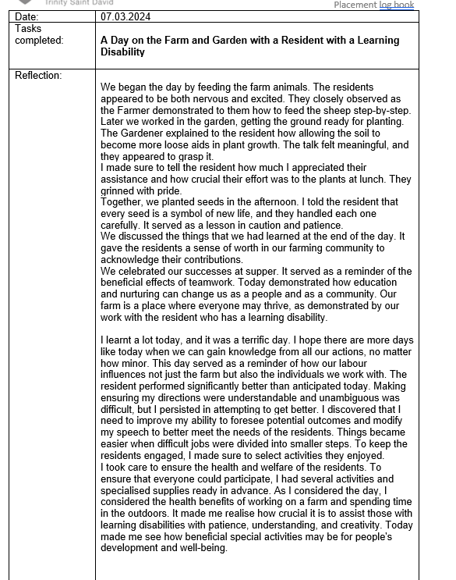

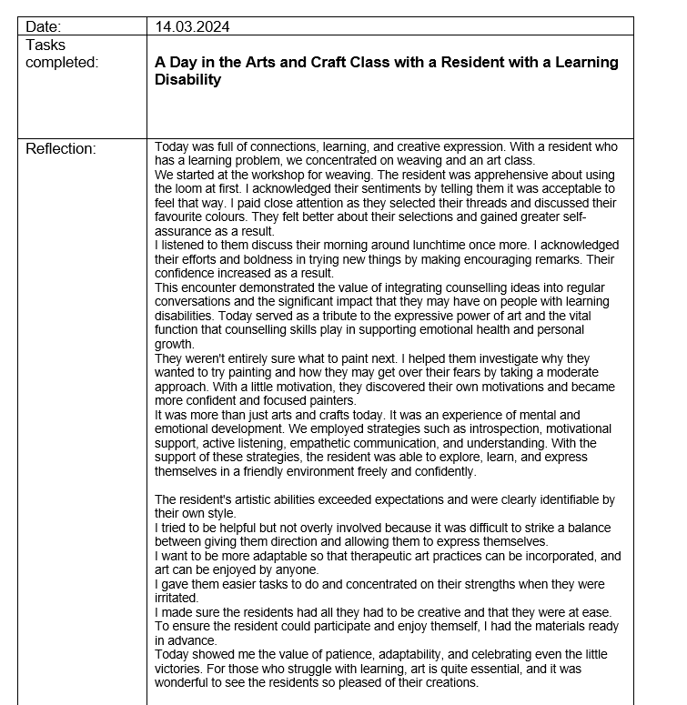

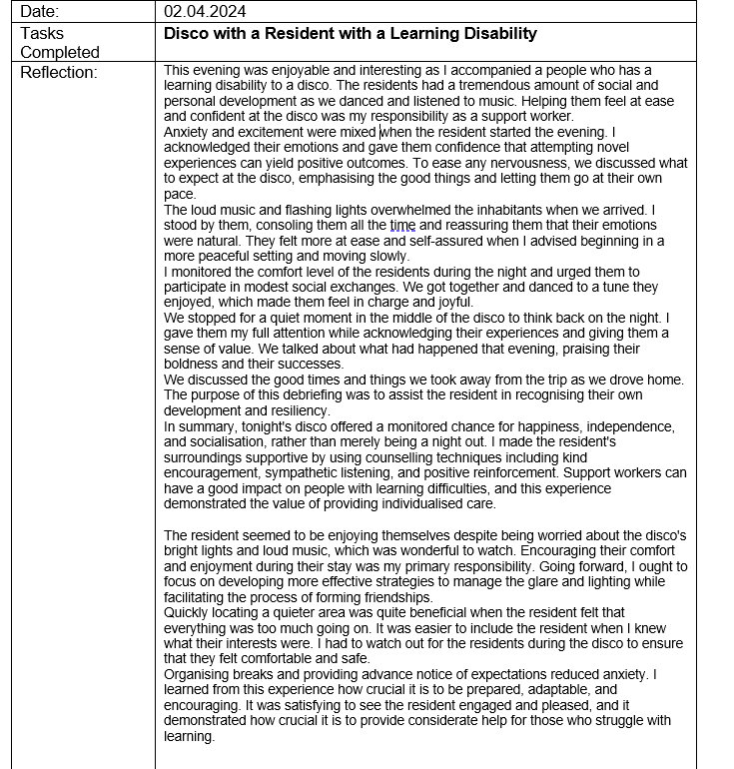

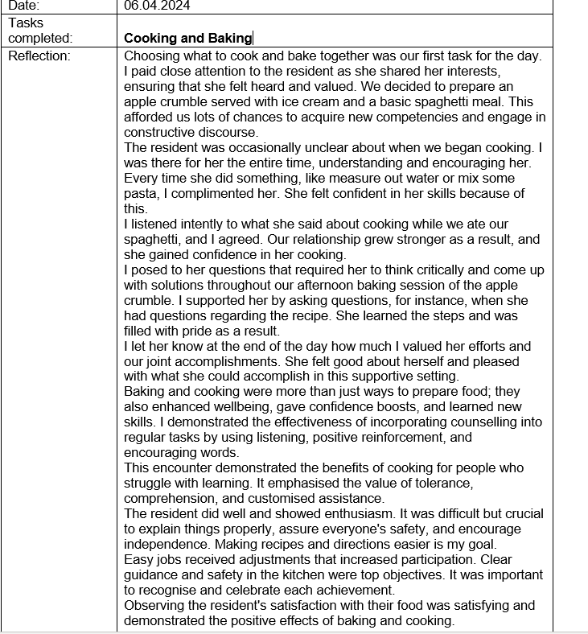

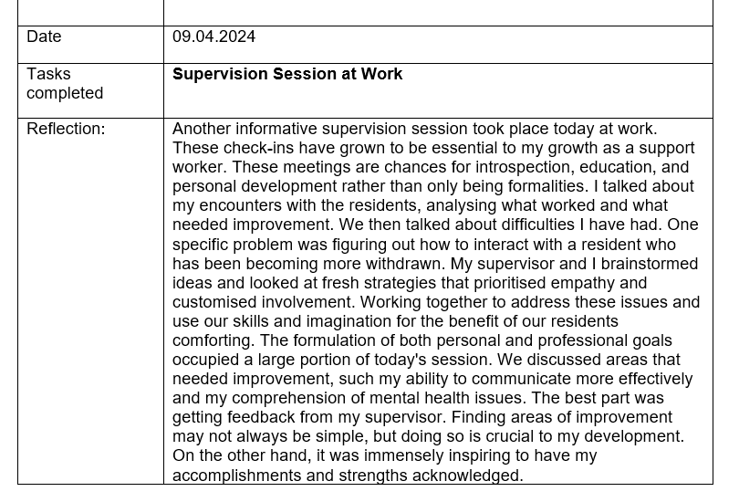

Email to Module Lead about Placement

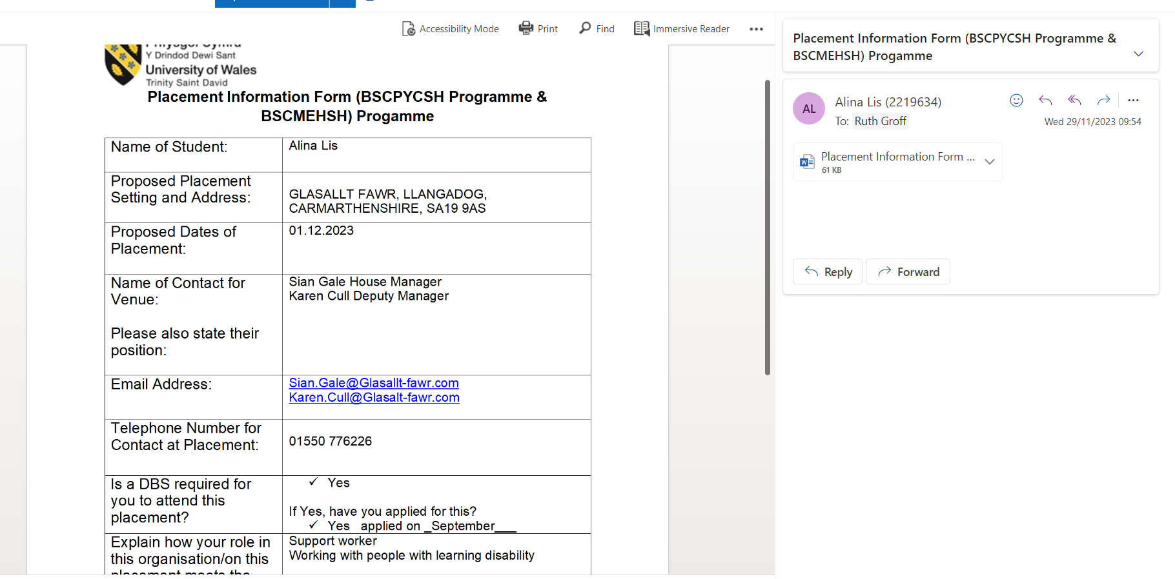

Placement information form
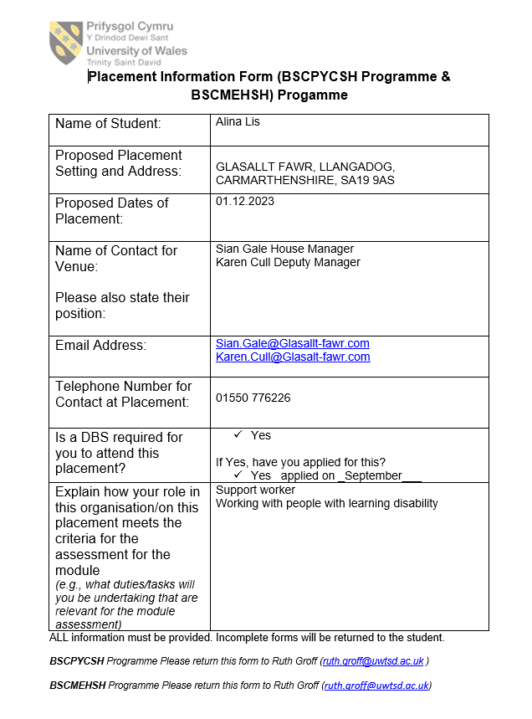

Record of hours
Dates of volunteering | Hours of volunteering
11.01.2024 | 6
07.03.2024 | 12
14.03.2024 | 12
02.04.2024 | 12
06.04.2024 | 12
09.04.2024 | 12

Placement attendance form



