
Programme: MSc Public Health and Social Care in Practice
Module: Quality Assurance and Service Improvements
Module code: LCHS7006
Component 2: Service Improvement Report
Student Name: Fuaansha Pimpale
Student ID:2530082
Lecturer’s Note: Christopher Mafuva
Assignment Title: A Service Improvement Report on Neonatal Safety and Clinical Governance at Countess of Chester Hospital: Strengthening Staffing, Escalation and Organisational Response

Table of Contents
1. Introduction 3
1.1 Background and Organisation Context 3
1.2 Identified Quality Concern 3
1.3 Evidence and Significance of the problem 3
1.4 Report aim and Scope 4
2. Main Body 4
2.1 Quality Management and Service Improvement in Health and Social Care 4
2.2 Root-Cause Analysis: Fishbone Diagram 5
2.2.1 Application to the Selected Quality Concern 5
2.2.2 Application to the Selected Quality Concern 5
2.2.3 Communication and Multidisciplinary Working 6
2.2.4 Clinical Processes and Escalation 6
2.3 Evaluation Using the Donabedian Model 7
2.3.1 Rationale and Critical Evaluation of Donabedian's Model 7
2.3.2 Structure 7
2.3.3 Process 8
2.3.4 Outcomes 8
2.4 Strategic Analysis: SWOT 9
2.4.1 Rationale for SWOT Analysis 9
2.4.2 Application of SWOT 9
2.4.3 Critical Interpretation 10
2.5 Synthesis of Root Causes and Priority Improvement Areas 10
3. Recommendations 11
3.1 Evidence-Based Recommendations 11
3.2 Quality Improvement Approach: PDSA 12
3.3 Implementation, Monitoring and Sustainability 12
4. Conclusion 13
4.1 Summary of Key Findings 13
4.2 Overall Service-Improvement Implications 13
Reference list 15

1. Introduction

1.1 Background and Organisation Context
Countess of Chester Hospital NHS Foundation Trust is a large acute health care provider for Western Cheshire and the adjacent North Wales region. The Trust is made up of two hospitals: The Countess of Chester Hospital (CoCH) with 600 beds and Ellesmere Port Hospital with 70 beds (Coch.nhs.uk, 2018). It serves about 260,000 people in and around Chester, Ellesmere Port and Neston, as well as around 152,000 for the Deeside area of Flintshire. The size of the Trust's services and their importance within the region are reflected in the more than 425,000 patients seen each year.
This organisation had a specialist care Unit for premature and vulnerable babies in the neonatal unit as a Local Neonatal Unit. Component 1 highlighted neonatal care as a sector that needed to be reviewed in a systematic way due to the interplay of workforce capacity, clinical processes, escalation and governance issues. According to CoCH.NHS (2016), there were 468 neonatal admissions in 2015 and 496 in 2016. With this organisational context, neonatal mortality was considered an important safety signal during 2015-2016. The Trust's annual report recorded a rise in emergency and maternity work during 2015/16 with staffing under pressure (CoCH.NHS, 2016).

1.2 Identified Quality Concern
The quality concern analysed in this report is the missed escalation and poor response by neonatal clinical governance and safety systems to the abnormal pattern of neonatal deaths and unexpected collapses in 2015-2016 (CoCH.NHS, 2016). This is more specific than simply neonatal mortality as it focuses on the organisational structure, or mechanism, designed to identify and mitigate new hazards to patient safety. During this period, internal review of neonatal death was carried out; however, the fact that serious incidents remained ongoing highlights the need to consider how neonatal mortality surveillance, staffing, escalation and multidisciplinary communication were working together and the management response. It was also found that Component 1 identified problems related to these interrelated safety barriers.

1.3 Evidence and Significance of the problem
Both the volume and constant nature of the signal of death constitute a major quality of care issue. Inquiry evidence suggests 18 neonatal deaths could be associated with CoCH during 2015 and 2016, of which 13 were on the neonatal unit (The Thirlwall Inquiry, 2025). Component 1 also brought to light system weaknesses related to limited staffing, limited access to specialist neonatal care, communication deficits, delayed recognition of deterioration and limited analysis of unusual patterns of clinical variation. All of these deficits are important because neonates rely on prompt identification, escalation and coordinated specialist response.

1.4 Report aim and Scope
This Report aims to review and critically evaluate the governance and service-system failures that led to unsafe neonatal care at CoCH in the period 2015–2016. The Fishbone and Donabedian Model will be used to analyse the root causes, and SWOT analysis will reveal the strategic improvement context. The findings will be used to develop recommendations that are put into action and tested in the PDSA quality-improvement cycle.

2. Main Body

2.1 Quality Management and Service Improvement in Health and Social Care
In health and social care, quality management is the term used for systematic service design, monitoring and improvement to ensure safe, person-centred, effective and timely services (Seelbach and Brannan, 2023). WHO (2020) suggests 7 dimensions of quality: effectiveness, safety, people-centredness, timeliness, equity, integration and efficiency, and NHS IMPACT focuses on enabling organisational conditions for continuous improvement and better health outcomes in all patients (NHS England, 2023). In neonatal care, it is imperative to adhere to these principles, since things can go wrong quickly, and failures in surveillance and communication or failure to escalate quickly may result in serious harm (Medscape, 2019).
Several deficits in the overall quality management systems within CoC came to light during the neonatal death and unexpected collapse in 2015–16. In Component 1, the interrelated gaps were noted relating to staffing, clinical escalation, communication, governance and monitoring and not a single clinical issue. This shows an inadequacy in the broader quality system, since good quality management should have linked mortality monitoring and reporting to prompt action by management, sufficient capacity of the workforce and learning within an organisation.

2.2 Root-Cause Analysis: Fishbone Diagram
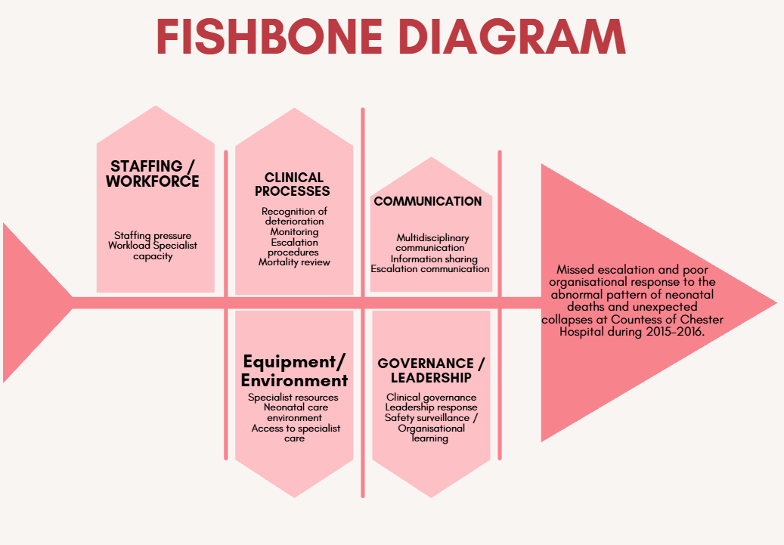
Figure 1: Fishbone diagram
(Source: Self-developed)

2.2.1 Application to the Selected Quality Concern
Fishbone Diagram affects the failure to escalate and/or inadequate organisational response to abnormal neonatal deaths and unexpected collapses in 2015-2016. It classifies causes and not individuals (Ishikawa, 1990). This is fitting since there are clear signs of interacting staffing, governance, communication, escalation and surveillance deficiencies, and therefore that it was a systems failure.

2.2.2 Application to the Selected Quality Concern
Gaps of capacity are identified by the People and staffing branch. Staff working levels were found to be insufficient when using indicators of activity and acuity. However, CQC evidence indicated that an additional number of shift workers, including bank and agency staff, were used. This can suggest that a listed staffing level may not appropriately show the level of risk that workload is presenting. The Fishbone importantly illustrates the difference between headcount and capacity, and relates workforce resilience to consistent recognition and response (Ito et al. 2022).

2.2.3 Communication and Multidisciplinary working
The second causal pathway was labelled communication and multidisciplinary working. Professional review of the service revealed a lack of liaison with the clinicians and inconsistent routes to surgical advice from the transport team. It also identified no formal mechanism for review of joint deaths/morbidity of the transferred child. The results indicate that communication of information was fragmented and this resulted in a lower level of shared situated awareness. However, structures were in place across all disciplines but not sufficiently intertwined to transform concerns into integrated and coordinated action on an inter-organisational level.

2.2.4 Clinical Processes and Escalation
Escalation to tertiary units for advice or transport was sometimes delayed, and a consideration of lowering the threshold for escalation and discussion was recommended. In addition, it identified a variety of referral pathways for surgery, which were confusing. Focusing on individual judgement, at the expense of embedded pathways, was a critical issue in escalation. Process reliability was key to identifying patterns and driving specialist review, as 13 neonates died on the neonatal unit.

2.3 Evaluation Using the Donabedian Model
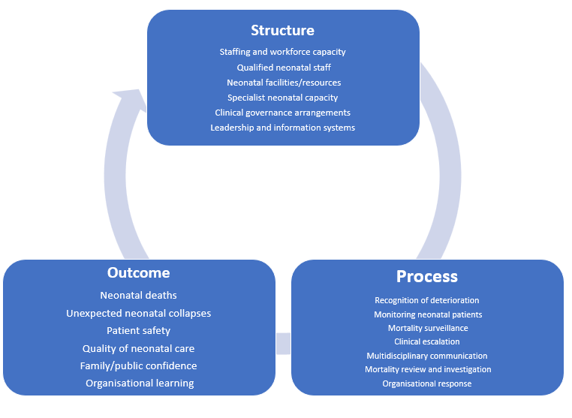
Figure 2: Donabedian Model
(Source: Self-developed)

2.3.1 Rationale and Critical Evaluation of Donabedian's Model
Donabedian's model of Structure-Process-Outcome (SPO) is suitable because the neonatal safety issue was the result of multiple, interdependent organisational and clinical errors, not just a single one (Moore et al. 2015). It looks at the process, which is reliable care, and the safe consequences in relation to resources and governance (structure). Among 386 hospital departments in Sweden, strong associations between structure and process (r=0.72) and structure and outcome (r=0.60) were seen, as well as weaker associations between process and outcome (r=0.20) (Kunkel et al. 2007). It can be helpful to CoCH, but it depends on acuity and case mix.

2.3.2 Structure
Structure refers to the capacity in which neonatal care is provided, such as staff, expertise, facilities, as well as governance and information systems. This puts capacity restrictions in the spotlight at CoCH. The CQC noted that in December 2015, the number of staff on duty met the RCN standard only six times; 11 times the number of staff on duty fell one short of the standard and 14 times staffing required was two or more above the standard, when taking into account occupancy and acuity. The neonatal unit also failed to staff according to the BAPM level, and 81.3% of neonatal staff had qualified in speciality (QIS) status (BAPM, 2020). The importance of the above-identified weaknesses lies in the fact that skilled staff are required for neonatal deterioration. But structure in itself would not prove causation since too few resources might be used.

2.3.3 Process
Process focuses on action and what staff and organisations actually do, and is pertinent to missed deterioration, delayed escalation and fragmented communication. Review revealed a lack of timely referral or escalation to tertiary services, confusion over surgical referral pathways, and a lack of multidisciplinary liaison. Therefore, it was found that merely having policies or staff did not ensure that it was likely to be put into practice. Multidisciplinary review should have been instituted because of surveillance of unusual mortality. The NNAP also provides for measurement of processes and staffing for neonatal care, to aid in monitoring (Ismail et al. 2022). But process measurements can promote adherence without necessarily showing that clinical judgement was correct in complicated cases.

2.3.4 Outcomes
Outcomes reflect the impact of care provision and are a good indicator for investigation. The report includes 18 neonatal deaths related to CoCH in 2015-16, of which 13 were in the neonatal unit. While collapses and patient-safety issues need to be investigated, not all deaths are preventable. Gestation age, birthweight and severity of illness have an impact on death. NNAP national data indicate that rates of neonatal deaths vary, ranging from 4 to 8% in the various networks in 2021. The Donabedian is used to link adverse outcomes to potentially modifiable structures and processes, however, and its use should be used in conjunction with clinical review and contextual evidence and not as a primary measure of quality 3, rather than as a primary measure of mortality alone.

2.4 Strategic Analysis: SWOT

2.4.1 Rationale for SWOT Analysis
SWOT analysis is an addition to the Donabedian model, which takes the diagnosis of the system to a prioritisation of strategies. Donabedian identifies structural weaknesses, process weaknesses, and outcome weaknesses, while SWOT identifies improvement pressures and capabilities that are inside the organisation. For CoCH, SWOT is not about neonatal mortality alone being viewed as a clinical issue but organisational weaknesses against external threats.

2.4.2 Application of SWOT
Strengths | Weakness
- Dedicated staff, incident reporting and feedback systems with daily safety briefings.  - Independent checks by the CQC ensured high standards in cleanliness and infection control practices, and facilities enabled parents to remain with babies.  - Registered neonatal nurses were trained in Newborn Life Support, and additional training was planned. | - 11 episodes with acuity and staffing breaches in the BAPM parameters between Jan 2015 and Jan 2016, and the unit was closed to admissions 7 times during the same period.  - Staffing risk  - Inadequate resources.
Opportunities | Threats
- External inspections, neonatal-network collaboration and targeted training that provided opportunities for improvement.  - Planned training and management awareness of risks identified by the CQC. | - High activity levels; acuity levels; shortage of staff and temporary staff might lower care reliability.  - The Thirlwall Inquiry (2025) reflects other governance, escalation and accountability issues at CoCH.
Table 1: SWOT analysis
(Source: Self-developed)

2.4.3 Critical Interpretation
The SWOT offered the insight that CoCH had clearly identified risks but was unable to translate them into actions. Incident reporting systems and briefings about safety were happening alongside continuous staffing incidents, pointing to gaps in information causing a failure to trigger organisational escalation (Kumah et al. 2024). So, the focus of improvement should be the link between risk intelligence, accountability of directors and swift interdisciplinary response. However, SWOT is subjective and cannot find causality; triangulation with CQC evidence, mortality review and Donabedian analysis should be undertaken.

2.5 Synthesis of Root Causes and Priority Improvement Areas
Intersections of structural and workforce issues: The evidence suggests that the confluence of structural problems rather than a shortage of staff is what led to this neonatal safety issue. CQC discovered that the staffing in the neonatal unit did not comply with the standards within the BAPM (2020) from January 2015 to January 2016, with patient acuity and staffing breaches occurring 11 times, and the unit closing to admission 7 times. Since 2010, staffing risk had also been identified in the divisional risk register.
Unreliable Escalation and Communication: CQC (2025) noted weaknesses in staffing arrangements for neonates, around the handover and escalation process and the circuit of care used by the service, which involved a pre-recorded handover for nursing, reducing opportunities for staff to ask questions or clarify information. This leaves a process vulnerability, as information was transferred without any guarantee of shared understanding of the clinical need.
Governance and risk-recognition failure: The greatest service-wide concern was the disconnect between the identification of risks and action by the organisation. Staffing risk was identified as an issue for several years and continued to impact service capacity. However, CQC (2025) also identified weaknesses in the general aspects of governance and oversight for the Trust, as this did not always translate to a reduction in risk.
Priority Improvement Focus: An integrated neonatal safety escalation system of staffing and acuity surveillance, structured communication, mortality review and board-level accountability should all be in place. This deals with the structure, process and outcomes of the Donabedian Model, and thus looks at a relationship rather than making stand-alone interventions. Importantly, these findings illustrate vulnerabilities in the various systems, but they do not necessarily indicate that failure of staffing or governance is the direct cause of individual fatalities.

3. Recommendations

3.1 Evidence-Based Recommendations
Staffing failed to meet BAPM standards: CQC indicates that staffing of neonatal services failed to meet BAPM standards, with 11 incidents related to patient acuity and staffing shortage, and seven admissions closures between 29 January 2015 and 26 January 2016. This staffing risk was also present on the divisional risk register since 2010.
Implement staff capacity escalation: Adoption of a daily neonatal staffing dashboard to compare nurse skill mix, patient dependency, cot occupancy and medical cover to BAPM requirements should be implemented by CoCH. A three-level escalation should be agreed: Green for level of staffing compliant; Amber for problem areas being identified and possible redeployment; Red for unsafe staffing, senior staffing review of this, restriction of admission or network support (this is for immediate senior review). BAPM (2020) guidance dictates that staffing and the number of cots should be based on activity and demand.
Stop passive transition, and have organised communication with others: CQC noted that nursing handover was pre-recorded, allowing staff no opportunity to make enquiries or seek clarifications during the formal handover. CoCH should implement a formalised face-to-face handover utilising a consistent structure of current acuity, deterioration risks, any outstanding investigations, escalation status and contingency plans. For high-risk patients or unresolved concerns, these matters should be followed up by a Senior Neonatal Nurse before the end of each shift.
Enhance deterioration and mortality escalation: The service should implement compulsory review criteria if a baby collapses out of the blue, deteriorates repeatedly, escalation is delayed or if neonatal deaths are unusual. Newborn Early Warning Trigger and Track should be included in a transparent pathway of recognition/response/escalation with clear thresholds for Consultant Review and Tertiary discussion (BAPM, 2015). NHS England (2019) recognises ways which improve the safety of babies born into the world, such as NEWTT2 and PIER as effective deterioration pathways.
Risk-Register to Accountable Action: Each high-risk neonatal situation should have an Executive Owner and deadline, measurable outcome and monthly Governance review.

3.2 Quality Improvement Approach: PDSA
PDSA is a process of testing a change, a way of learning the impact of the change, and a way of identifying an intervention before being used in future stages (IHI, 2025).
Plan | Set up a neonatal improvement team, consisting of the following members: Neonatal clinical lead, Senior neonatal nurse, Ward manager, Governance lead, Data analyst and patient/family representative. The priority should be to increase the uniformity of adherence to agreed staffing and escalation plans and minimise delays in the identification and escalation of deterioration.
Do | Carry out structured handover and test acuity dashboard for four weeks, on one neonatal shift pattern. All Amber/Red staffing triggers and all escalation episodes should be documented. It is best not to make a number of unrelated changes at once as this will make it hard to identify them.
Study | Analyse, weekly/regularly, the staffing compliance and escalation response times in relation to completeness of handover and balancing, including workload of staff and unnecessary escalation. Using outcome, process and balancing measures to decide whether the tested change produces real improvement is an IHI (2025) priority.
Act | If the test is reliable and not manually burdensome or raising the alarms unnecessarily, consider rollout to all neonatal shifts. If performance is not as consistent, make changes to the escalation thresholds, dashboard process, handover process and repeat a PDSA cycle.
Table 2: PDSA
(Source: Self-developed)

3.3 Implementation, Monitoring and Sustainability
The implementation will be in three steps. CoCH should set up the improvement team, agree staffing limits, draw up the dashboard, standardise handovers and train the staff involved in escalation procedures, months 1-2. In the neonatal unit, the intervention should be PDSA tested months 3- 4. Positive changes must be integrated into ongoing governance, staffing and neonatal safety audits from month 5.
Monitoring should be a mix of structure, process and outcome indicator(s). Compliance with the agreed nurse skill mix and availability of adequate medical cover should be included. Process measures should be provided of structure of handovers completed, escalation decision made and documented, time from deterioration to senior review and completion of mortality reviews. Indicators of outcome should be taken as unexpected collapses in the neonates, trend of neonatal mortality and unplanned admission closure.
The interventions need to be normalised, and not viewed as a project only, in order to be sustainable. The clinical governance committee should review the neonatal dashboard each month and any unresolved red-risk child staffing issues raised to the executive team. The learning from incidents should be applied to further cycles of improvement. This complies with PSIRF - Safety actions must be properly resourced, monitored and assigned to named individuals.

4. Conclusion

4.1 Summary of Key Findings
The analysis reveals that the error period about neonatal safety at CoCH was a failure of system: a set of interacting workforce, communication, escalation, and governance failures: not an isolated clinical error. The Fishbone analysis revealed that the following issues related to each other: lack of staffing capacity, lack of multidisciplinary communication, delay in escalation and delay in organisational response. Additionally, Donabedian's model illustrated how flaws in structure impacted the process of care, and consequently, the safety outcomes. This is aligned with the NHS England's existing approach to patient safety, focusing on the fact that harm usually starts with multiple factors of people, tasks, technologies, environments and organisations that interact. The SWOT analysis also revealed that CoCH had in place governance processes, trained staff and safety mechanisms, but identified risks were not always translated into action that brings about correction.

4.2 Overall Service-Improvement Implications
Acuity-based staffing escalation, a multidisciplinary hand-over system with a clear structure, explicit deterioration pathways, systematic mortality review and clear executive accountability. These should be piloted through PDSA cycles and should be assessed using structure, process and outcome measures. It is crucial, however, that safety learning is integrated into standard governance for sustainability to happen. NHS England's PSIRF asks organisations to do system-based learning to draw out safety actions, and find out whether those actions tackle the system issues being reported. This is especially true of CoCH, as only repeated staffing or escalating concerns could potentially be identified as insufficient without taking clear corrective action. Overall, the report finds that successful neonatal QI requires translating safety knowledge into immediate and actionable steps that address measurable accountability. A robust CoCH service should thus keep providing a linkage of staffing capacity, clinical processes, incident learning and governance oversight.

Reference list
BAPM (2015). Newborn early warning trigger & track (NEWTT) - A framework for practice (2015) | British Association of Perinatal Medicine. [online] www.bapm.org. Available at: https://www.bapm.org/resources/38-newborn-early-warning-trigger-track-newtt-a-framework-for-practice-2015 [Accessed 12 Aug. 2026].
BAPM (2020). BAPM issue statement in response to GIRFT workforce report. [online] British Association of Perinatal Medicine. Available at: https://www.bapm.org/articles/261-bapm-issue-statement-in-response-to-girft-workforce-report [Accessed 12 Aug. 2026].
CoCH.NHS (2016). ANNUAL REPORT 2015/16. [online] Available at: https://www.coch.nhs.uk/media/133225/abdb_3091_coch-annual-report-2015-16-min-1-.pdf [Accessed 12 Aug. 2026].
Coch.nhs.uk (2018). Who we are and what we do | Countess of Chester Hospital. [online] Coch.nhs.uk. Available at: https://www.coch.nhs.uk/corporate-information/about-us/publication-scheme/who-we-are-and-what-we-do.aspx [Accessed 12 Aug. 2026].
CQC (2025). CQC takes action to protect people using maternity and neonatal services at Leeds Teaching Hospitals NHS Trust - Care Quality Commission. [online] Cqc.org.uk. Available at: https://www.cqc.org.uk/press-release/cqc-takes-action-protect-people-using-maternity-and-neonatal-services-leeds-teaching [Accessed 12 Aug. 2026].
IHI (2025). How to improve: Model for improvement: Testing changes. [online] Ihi.org. Available at: https://www.ihi.org/library/model-for-improvement/testing-changes [Accessed 12 Aug. 2026].
Ishikawa, K. (1990). Ishikawa, K. (1990). Introduction to quality control, 3A Corporation, Tokyo. - References - Scientific Research Publishing. [online] www.scirp.org. Available at: https://www.scirp.org/reference/referencespapers?referenceid=1272669 [Accessed 12 Aug. 2026].
Ismail, A.-Q.T., Boyle, E.M., Oddie, S. and Pillay, T. (2022). Exploring variation in quality of care and clinical outcomes between neonatal units: A novel use for the UK national neonatal audit programme (NNAP). BMJ Open Quality, 11(4), p.e002017. doi:10.1136/bmjoq-2022-002017.
Ito, A., Hagström, M., Bokrantz, J., Skoogh, A., Nawcki, M., Gandhi, K., Bergsjö, D. and Bärring, M. (2022). Improved root cause analysis supporting resilient production systems. Journal of Manufacturing Systems, 64, pp.468–478. doi:10.1016/j.jmsy.2022.07.015.
Kumah, A., Zon, J., Obot, E., Yaw, T.K., Nketsiah, E. and Bobie, S.A. (2024). Using incident reporting systems to improve patient safety and quality of care. Global Journal on Quality and Safety in Healthcare, [online] 7(4). doi:10.36401/jqsh-23-39.
Kunkel, S., Rosenqvist, U. and Westerling, R. (2007). The structure of quality systems is important to the process and outcome: an empirical study of 386 hospital departments in Sweden. BMC Health Services Research, [online] 7, p.104. doi:10.1186/1472-6963-7-104.
Medscape (2019). Ethical issues in neonatal care: Overview, ethical questions, goals of neonatal intensive care. [online] Medscape.com. Available at: https://emedicine.medscape.com/article/978997-overview [Accessed 12 Aug. 2026].
Moore, L., Lavoie, A., Bourgeois, G. and Lapointe, J. (2015). Donabedian’s structure-process-outcome quality of care model: Validation in an integrated trauma system. The Journal of Trauma and Acute Care Surgery, 78(6), pp.1168–75. doi:10.1097/TA.0000000000000663.
NHS England (2019). NHS England » maternity and neonatal safety improvement programme. [online] www.england.nhs.uk. Available at: https://www.england.nhs.uk/mat-transformation/maternal-and-neonatal-safety-collaborative/ [Accessed 12 Aug. 2026].
NHS England (2023). NHS England » NHS impact. [online] www.england.nhs.uk. Available at: https://www.england.nhs.uk/nhsimpact/ [Accessed 12 Aug. 2026].
Seelbach, C.L. and Brannan, G.D. (2023). Quality management. [online] PubMed. Treasure Island (FL): StatPearls Publishing. Available at: https://www.ncbi.nlm.nih.gov/books/NBK557505/ [Accessed 12 Aug. 2026].
The Thirlwall Inquiry (2025). Countess of Chester Hospital. [online] Available at: https://thirlwall.public-inquiry.uk/wp-content/uploads/thirlwall-evidence/INQ0001888.pdf [Accessed 12 Aug. 2026].
WHO (2020). Quality of care. [online] Who.int. World Health Organisation: WHO. Available at: https://www.who.int/health-topics/quality-of-care [Accessed 12 Aug. 2026].

