Student Name: Llion Langford
Student P Number: 1702732
Module Title: Reflection on Academic and Employability Skills
Assignment Title: Organisation Design and IT Management
Lecturer’s Name: Mr James Williams

Section 1: Introduction Page 3
Section 2: Business Strategy & Pest Analysis Pages 4-5
- Business Strategy
- PEST Analysis
Section 3: Organisational Structure Pages 6-8
- Organisational Structure
Section 4: e-Business Information Systems Pages 9-11
- e-Business Solutions
- Testing
Section 5 Conclusions & Recommendations Page 12
- Conclusions
- Recommendations

Section 1: Introduction
The purpose of this report is for me to display an understanding of Business strategy & environment, structure & culture and, e-Business information systems. This report will cover many aspects of a business and will be broken down into 5 main sections with sub sections

Section 2: Business Strategy & Pest Analysis
Business Strategy
The definition of business strategy is a long term plan that is designed to achieve a particular goal or goals. This in-turn will include strategic planning which is a process in which the organisations leaders will determine their vison for the future, their goals and objectives for the organisation, as well as the creating the sequence in which those goals should fall so that the organisation is ultimately enabled to reach its vision.

PEST Analysis

Political
Many political factors effect employment one would be that if the EU made changes to working hours’ directive with employment laws implemented about the number of hours an individual may work it would force Tesco to employ more people as Tesco is a 24-hour store this could increase their number of employees as it would be illegal to work over a certain number of hours. But this may lead to them hiring younger people as they are more flexible with their working hours and they are fitter meaning they can work longer hours and they can work later hours. But this could make the company look like they are discriminating against old people so the company are required to find the perfect balance. Also these older people may want to work past retirement and another factor that supports this would be the increase in the age of retirement. But like my previous point a younger generation provides a fitter more enthusiastic work force with them brining new ideas to Tesco but if there are too many young people working in Tesco people may see that as Tesco being discriminative towards the older generation. Also with the current addition of Brexit trading with the EU could be dramatically affected. This could lead to a higher expense for Britain and Tesco to do trade with the EU which will results in a price increase in store.
Economical
Increased income tax affects consumers’ disposable income and would decrease the demand of luxury goods and services. And because of this factor Tesco will making less profit which in turn reduces their staff budget will decrease, resulting in people being made redundant one way to combat this would be to recruit people under 18 as they have a smaller minimum wage other way would be to increase staff’s hours and then to lay off more staff. But both of these methods could result in Tesco being scrutinised by breaching the EU’s working hours’ directive. And by primarily hiring young staff not only will they lack a large amount of experience but it would also be viewed as discriminative towards old people. Since the horsemeat scandal there has been a decrease in consumer non-grocery items as well as frozen and chilled food isles this gives Tesco a terrible reputation resulting in. Profits have fallen- Show figures and explain how this will affect with the recruitment process in Tesco. Also as the UK economy recovers from the recent financial crisis it has begun to see a growth. This growth can be seen as a positive sign by Tesco as it will result in growth in the supermarket industry.

Social
A social aspect that effect employment for Tesco is the increase in the number of single parent families or an increase in the number of people aged 65 and over who are looking for employment. An example would be single parents who are looking for a job to provide for their family. They have limited working hours as they would need to drop their kids off at school and pick them up after school this is particularly aimed towards people with younger kids as they cannot be in the house unattended. This effects employment because employees at Tesco usually work short shifts but they are required to be flexible and if you are in the situation where you are a single parent you cannot be flexible but Tesco do not want to look like they are victimizing single parents. Also over 65s are now looking for a job as they still need to provide for their family. Another reason for them seeking employment could be the fact that they are finding retirement boring which spurs them on to look for jobs. And like previously mentioned the public may see this as Tesco trying to contradistinguish against over 65s.
Impact on age, welfare, demographics and diversity can impact the number and quality of potential employees which the business may need. Tesco require a significant amount of diversity to look good in the public’s eye, this diversification is everything from religion, age, ethnicity, and social background but this diversification need to be carefully balanced with the employees potential. This requires them to be very specific in the people they hire and for them to ask the candidate a lot of questions. This is implemented into Tesco employment strategies to display their diversification and for them not to be persecuted by the public.
Technological
Technology can effect recruitment dramatically because as technology develops there’s less demand for personal such as people who may monitor stock levels or people who operate the checkouts as technology such as electronic re-ordering systems can re order any stock when it drops below a certain number. Also self-checkouts lower the demand for people operating the checkouts but increase the demand for more tech savvy staff as they must now be able to understand and operate the self-scan checkout if there was a problem with it. Also due to the increasing demand of online shopping Tesco have now developed “Dark Stores” which consist of large warehouses for staff to collect online orders. This means not only new staff will be needed to operate the vans and the warehouses but they must possess different qualities from traditional operational staff which results in an increase in employment.

Section 3: Organisational Structure
An organisational structure is the hierarchical arrangement of the lines of authority, the flow of communication as well as the rights and responsibilities of an organisation an organisational structure can be tall or flat. A tall structure results in a longer flow of communication which can result in a slower workforce but it can also keep the employees happy and motivated as there is a place in the company to improve too. A taller structure is typical of a larger organisation as they usually have a large number of employees which ultimately results in a lessened span of control. While a flat structure has a shorter has a smaller scalar chain which results in a smaller flow of communication but an increased span of control which is typical of smaller business’.
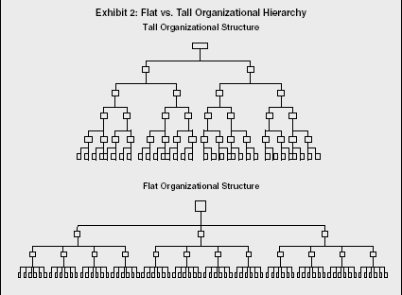 [1]
There are four structure styles and they are a Mechanistic structure, an organic structure, a matrix structure and, finally a virtual structure. A mechanistic structure is very similar to a tall structure in which there are more formal lines of communication with the power being centralized very high up the structure. This results in a lack of communication going up the structure as the primary flow of communication is downwards in the form of orders. There are also more levels to the organisation. But due to the rigidity of the structure and the fact the flow of communication is primarily downwards the organisation is usually very organised but it sacrificed speed of communication.
An Organic Structure is then very similar to a flat structured organisation in the way that it has more flexibility and a relaxed flow of communication. This can allow employees to become more independent and have greater influence over their roles and more responsibilities. This kind of structure can boost moral within employees as previously mentioned they have more responsibility it can also impact the organisation positively by allowing their employees to be more innovative and there is a higher chance that they will implement their innovations in an organic structure.
Yet there can also be negative impacts on both employee and organisation. For the employee they could be unmotivated to work there due to there being less places to be promoted to. As a direct result of this the organisation could see a high turnover of staff which would lead to higher costs due to the training of new staff. Another negative impact on the business is that due to the more relaxed flow of communication the flow of communication can become blurred and in times of crisis it is essential to have a string and direct flow of communication
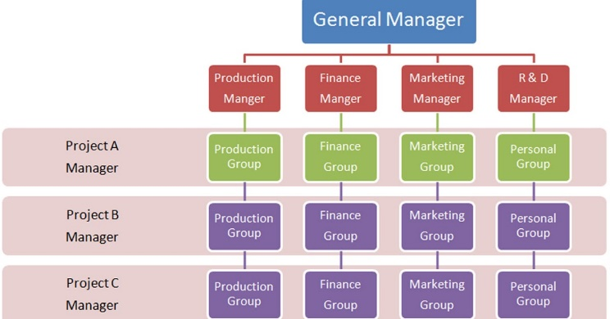
A matrix structure is ultimately an amalgamation of a traditional structure e.g. mechanistic or organic and a product structure. A product structure divides departments by the project they are working on instead of their function yet all teams still report to their functional managers as well as their project managers. This style of structure is typically found in a creative business where a product or service needs to be developed for example, creating a computer game or developing new car. The Matrix style can result in high tension and conflict due to the fact that staff answer to two managers who have different objectives to fulfil.

[2]
Finally, there is a Virtual Structure which is unlike any of the structures previously listed. It works in a network of external alliances which used cloud based technology to work on projects by using the internet. This is a relatively new and revolutionary way of structuring a business and allows the organisation to be small while working on a global scale. An example of this would be Apple. At the core of apple was Steve Jobs; he then had his executive team as well as a head of department such as HR, advertising, engineering etc. who would all report to him while his executive team had people reporting to them.
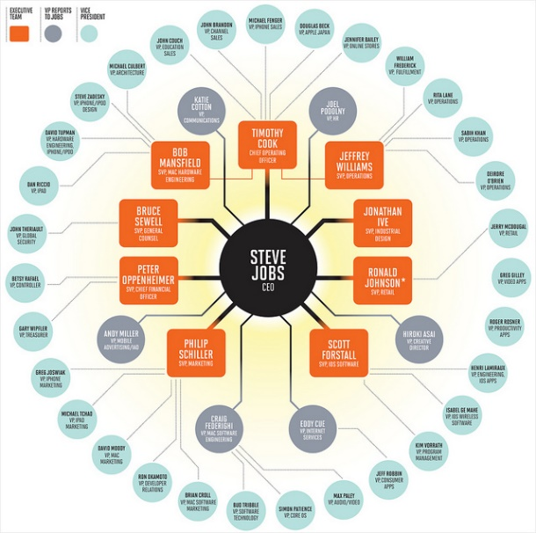
[3]

There are 5 primary departments within an organisation, they are listed below with their function within an organisation
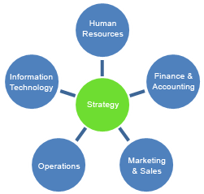
Human Resources
- Recruitment
- Job Satisfaction
- Training Staff
- Health and safety
- Redundancy
Finance & Accounting
- Cash flow
- Monitoring income
- Monitoring expenses
- profit and loss
- Raising finances
Marketing & Sales
- Customer Trend research
- Promotion
- Website & Social Media Management
- Sales strategies
Operations
- Sourcing and purchasing materials
- Stock control
- Production method
- Monitoring efficiency & productivity
- Quality control

Information Technology
- Technology installation and maintenance
- User training & support
- Testing and reviewing potential new systems

Section 4: e-Business Information Systems
In order for a business to run smoothly I believe organisation is essential therefore I believe that the implementation of an EPR system paired with an e-commerce system is essential to an organisations’ success. An Enterprise resource planning (ERP) is a process which allows an organisation to integrate the important parts of its organisation. This usually includes planning, purchasing, inventory, sales, marketing, finance and human resources and it is all updated in real time.
While being similar to an EPR system an e-Commerce system is more front end base and interacts with the customer and it allows the buying and selling of goods and or services that the organisation provides. It can also allow the user within the organisation manage the organisations social media, manage promotions, view their orders, view their shipping status, as well as view the products they sell, and view their customers that are saved onto a database. Ultimately, I believe that by pairing an e-commerce and an EPR system an organisation can run at an optimum level. To find out which were the best EPR and e-Commerce systems I decided to conduct extensive research as well as test the products where I can. Sage seems to be one of the most popular, and most equipped EPR systems available to purchase unfortunately there was no way of testing the system without purchasing it but from reviews it stated that
“Sage 100 ERP is an easy-to-use and comprehensive enterprise planning system whose implementation is highly-modularized, and allows companies to purchase or deploy only the functionalities they need. The pricing scheme is also adjusted to this concept, meaning that you will be charged only for features you’ve specifically requested.” [4]
Another EPR system I found was called EPRnext. This system did have a dem available and it was one of the best layed out dashboards I’ve seen. The dashboard was clear and concice and there was a large amount of information I could store and edit on the EPR system some beingProject, which allowed me to create and develop new Items, manage my staff and see which employees were in work, as well as accounts, and stock levels.
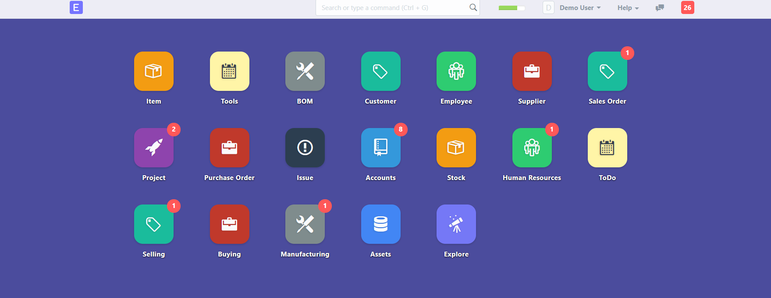
I believe that the decision on which between the two EPR systems is best is relative to your business needs but out of the two I would go for Sage as despite not being able to test them they are a well trusted brand with years of experience.
I tried to find a suitable e-commerce system to pair with the EPR system I found. Shopify looks to be an excellent and well trusted system with great reviews. It is used by a wide variety of organisations but unfortunately I was unable to test the system out despite thee being a free trial as I had problems creating an account. But I managed to test different e-commerce software it being CS-Cart. CS cart was easy to use for both the customer and the organisation and allowed me to manage sales, customers, all social media, as well as marketing, and what products that can be sold. The customer interface looked very professional and had an inviting and simple layout which was easy to use. Out of the two I believe the Shopify system is the best as they are a more trusted company with great experience and reviews and both are a monthly subscription.

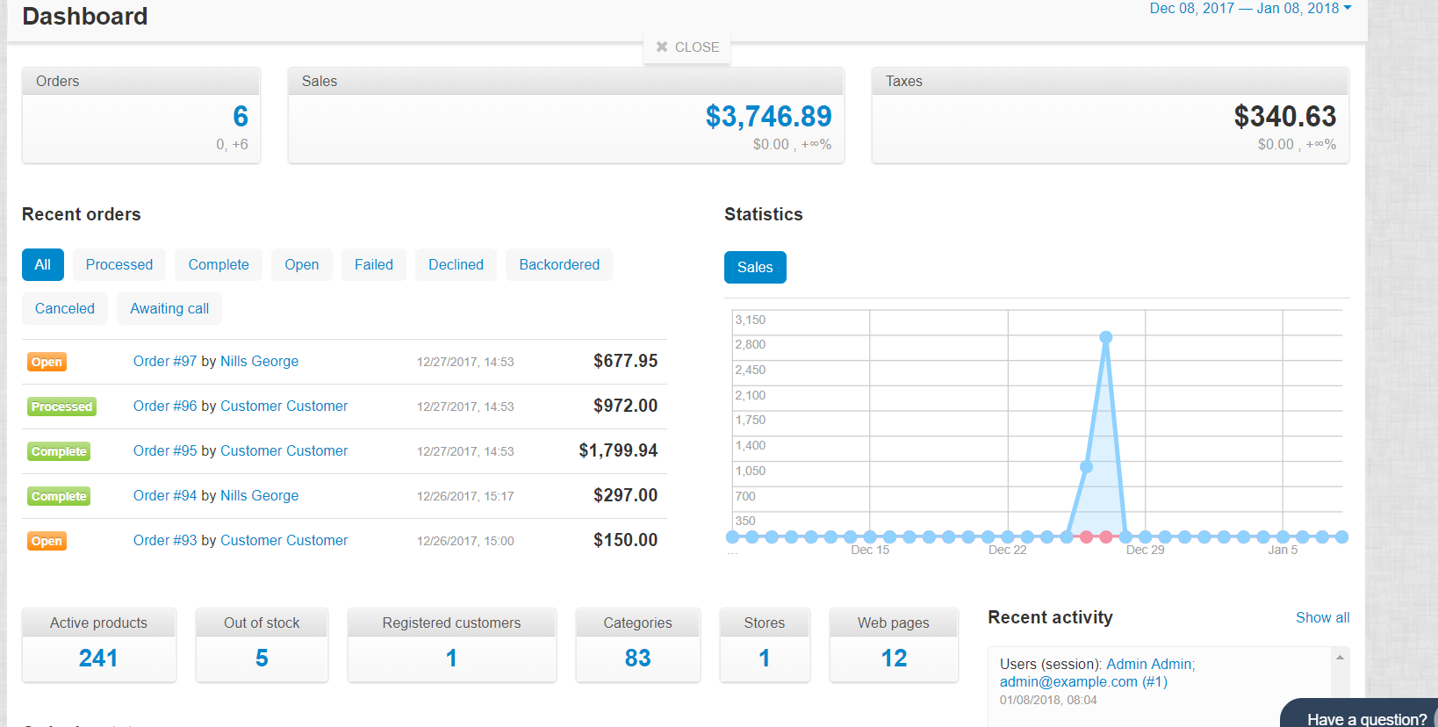
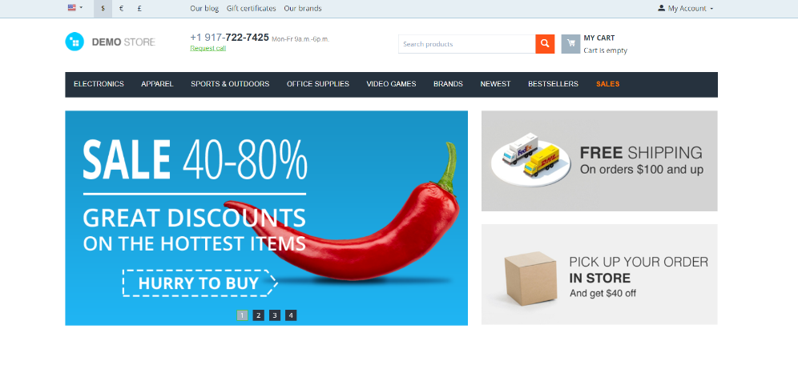

Section 5 Conclusions & Recommendations
From this report I understood the importance of business structure and how all aspects of the PEST analysis can have a great affect on a business. I now have a deeper understanding of the types of organisational structures and understand the importance that an e-business system can have on a business. And to ensure that a business is successful I believe it is essential for the business to have a structure that is well suited to their business, clear goals and objectives to work towards and that they have a clear EPR and e-commerce system in place to help control the business

References

[1] | [Online]. Available: https://jasbedi.wordpress.com/2011/06/28/tall-vs-flat-organization/.
[2] | [Online]. Available: http://analysisproject.blogspot.co.uk/2015/07/matrix-organization-structure.html.
[3] | [Online]. Available: https://infograph.venngage.com/p/235481/applecollaboration.
[4] | [Online]. Available: https://reviews.financesonline.com/p/sage-100-erp/.

