Module: Managing People
Module Number: LCBB5004
Tutor Name: Tanja Nathan
Student Name: Irena Dimitrova
Student Number: 1914044
2021

Contents
Introduction 3
Background of the organisation 3
Briefing statement evaluating the scope of human resource in reference to CIPD Profession Map 3
Organisational objectives within resourcing activities 5
Planning 5
Diagram illustration of the various steps of human resource planning 6
Evolution of human resource planning at Royal Mail 6
Recruitment 7
Evolution of recruitment process at Royal Mail 7
Royal Mail’s current recruitment process 8
Selection 9
Evolution of the selection process at Royal Mail 9
Funnel Diagram showing hiring and selection process 10
Conclusion 11
References 12

Introduction
Human resources are no doubt the key drivers to the attainment of success of any given organisation. However, they are the easiest yet the most difficult to manage hence giving relevance to human resource management which is a multi-faced discipline that encompasses of and not limited to all policies and matters concerning organisational manpower (Storey, 2016). This report will not only coherently investigate the scope of human resource professionalism in relation to the Chartered Institute of Personnel and Development (CIPD) Professional Map but will equally discuss the organisational objectives within resourcing activities and analyse their evolvement in the organisation.

Background of the organisation
Royal mail Group Plc. is a public limited British company that specialises in postal and courier services such as mail collection and parcel delivery within the United Kingdom (UK). The multinational organisation was founded in 1516 as a division of the English government and has its headquarters at London, England in UK. It is mainly characterised by letters and parcels from brands such as Royal Mail letters and Parcelforce Worldwide. According to the company’s CEO, Simon Thompson, the organisation has a total of 162,263 employees hence boosting its (Royal Mail, 2020) annual revenue to approximately £10,840 million with a net income of £161 million as of 2020. He strongly believes that the value and future of the company lies in the hands of its human resources.

Briefing statement evaluating the scope of human resource in reference to CIPD Profession Map
The Chartered Institute of Personnel and Development (CIPD) is an instrumental body that benchmarks and shapes the career development of people in different professions. As defined by the institute, human resource management (HRM) is the strategic system of acquiring, utilising and investing in employees at all levels of an organisation in order to achieve desirable goals (CIPD, 2016). It revolves around work related issues such as performance management, employee safety, compensation and workplace culture. A human resource (HR) professional is therefore denoted as the administrator responsible for coordinating all functions related to HRM in an organisation. The CIPD Professional map not only streamlines the HR profession but also aligns the HR function with the set objectives of a given organisation. It further ascertains that members are trustworthy through adherence of the set standards of conduct as well as ethical competence (CIPD, 2016). In this regard, a HR professional should have an internal and an external identity where the former identifies with himself/herself through a community while the latter projects through professional trust, knowledge and integrity.
The CIPD map emphasises that the main role of a HR professional is to oversee organisational objectives by recruiting suitable personnel for every position, developing skills and managing employee performance. These roles, on the other, hand should be executed through the four functions of HRM which are planning, directing, organising and controlling. While planning calls for the HR to match employees with their areas of specialisation as well as managing manpower shortages or surpluses; directing involves guiding, instructing and motivating staff to attain desired goals (Vithana, et al., 2019). Organising, on the other hand, is the function where HR professionals group and assign tasks to individuals and departments as they also allocate resources in the organisation. Finally, the CIPD professional map requires HRs to control all these functions in accordance with the formulated procedures and processes to evaluate each. It also involves tools such as appraisals, auditing and statistics to correct any deviations in all operative functions.
In conjunction with the Labour Management Institute of England, CIPD rubberstamps that professional HRs should perform their duties in line with the following principles of personnel management.
Principle of scientific selection: In order to increase work efficiency, HRs should select potential employees based on merit and qualification hence acquiring the right people for the job (Michael, 2019).
Principle of high morale: A HR professional should be creative in inculcating purpose and motivation to taskforces in an organisation through intrinsic and extrinsic efforts (Michael, 2019).
Principle of joint management: HRs are expected to integrate the idea of industrial democracy with labour partnerships and business agreements that favour the future of an organisation (Michael, 2019).
Principle of team spirit: It is the obligation of all HRs to inculcate unity, cooperation and mutual trust among employees in order to seamlessly execute the intended goals (Michael, 2019).
Principle of dignity of labour: It is upon HR professionals to safeguard employees’ rights and sentiments as stipulated by the national labour laws as well as the organisational employment contract (Michael, 2019).

Organisational objectives within resourcing activities
According to Ahammad (2017), HRM is a subsidiary of personnel management. While personnel management focused on ordinary employee management, HRM’s primary objective is to nurture taskforces into being valued assets in an organisation. In this regard, the department is established to serve the growth and sustainability of an organisation. Since industrial evolution began, the organisational objectives of HRM have transitioned from just hiring and firing employees to other complex objectives. Modern HRM which is also Royal Mail’s current human capital strategy presents the department with organisational objectives such as establishing effective communication amongst the corporate community, staffing and developing skills through ideal frameworks (DeCenzo, et al., 2016). Despite looking forward to developing optimal structures that boost productivity in the organisation, this functional unit also purposes to utilize talent among human resources and integrate employees’ personal goals with the overall organisational goals. When all these objectives are knitted together, HRM’s organisational objectives narrow down to three resourcing activities as suggested by George Elton Mayo, the father of modern HRM. These are planning, recruitment and selection.

Planning
Human resource planning (HRP) which is also referred to as workforce planning is a systematic continuous process of reviewing, forecasting and analysing the requirements of an organisation’s manpower in order to utilise existing human resources as well as reduce employee shortages and surpluses (Bernik, 2017). It is a sub-discipline of HRM that has evolved since the 19th century when scholars such as Frederick Winslow and Niklas Luhmann conceptualised scientific management and the system theory respectively. This process is facilitated by five main steps which include analysing organisational objectives, integrating HR objectives with corporate objectives, forecasting requirements for human resource, assessing the current supply of taskforces in the organisation and finally matching the job demands with the available pool of talent (Bernik, 2017).

Diagram illustration of the various steps of human resource planning
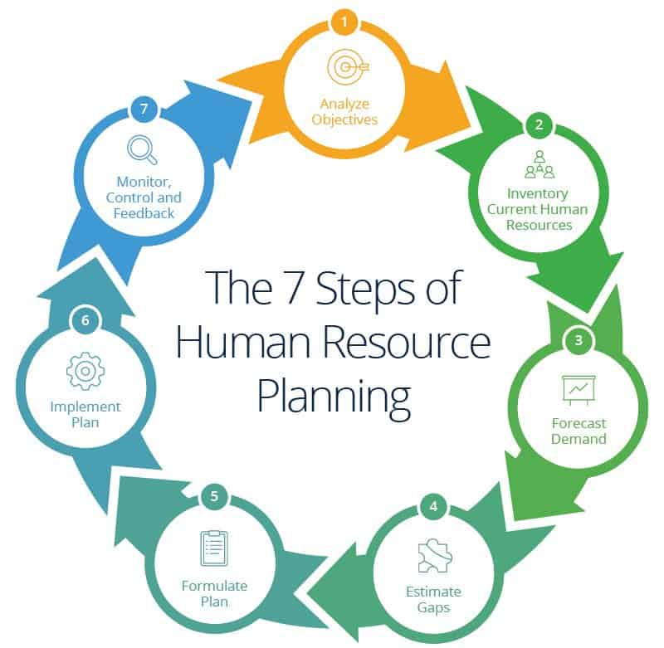
(Bernik, 2017)

Evolution of human resource planning at Royal Mail
As evidenced by Bernik (2017), HRP is an essential strategy for every business as it not only increases a business’ competitive advantage but also maximises its lucrativeness. Royal mail is one successful company that has leveraged on this strategy hence enabling the management to maintain a skilled taskforce and also balance its estimated labour demand with available manpower. When the company was founded, the management incorporated HRP as a strategy to plan the current and future demand for employees in both the short and long term. While this helped reduce the cost of resources, it was important for the administration to make careful considerations on how to identify and address gaps for certain positions. It is in the mid-70s that Royal Mail’s acting HR developed a workforce plan that pinpointed departmental loopholes, noted the training requirements for every position and laid out policies that would streamline training, recruitment and employee welfare (Royal Mail Group, 2020). The process was further reorganised to evaluate labour demand within the organisation. This involved assessment of organisational historical data such as employee turnover rate and the average length of service for each personnel. This evolution has led to creation of ideal frameworks that enhance capital intensity and increased flexibility of employees. Currently, Royal Mail has fully incorporated HRP to compute the number of employees needed to efficiently perform certain tasks and to calculate the natural wastage of employees that is influenced by retirement and transfers. The workforce plan is also automated to counter impeding factors such as net birth rate, mobility of labour and limited morale at work.

Recruitment
Recruitment is the process through which companies find ideal candidates suited for a certain job position (Hamza, et al., 2021). It encompasses of activities such as collection and sorting of applicant resumes, conducting job interviews and prepping interviewees of what is expected of them if they are entrusted with the position. Scholars perceive it to be a product of World War II since it was fostered by war lords’ efforts to fill gaps of fallen soldiers as well as the need to find administrators of new workstations in conquered states. This gradually led to the emergence of staffing agencies that developed the resume shortlisting method after receiving too many applications from even unskilled individuals. As stipulated by CIPD (2016), HRs are involved in five main recruitment stages. They include recruitment planning, strategy development, searching for job seekers, screening and evaluation of potential candidates. Today, HRs can either conduct internal recruitment which involves shortlisting of candidates from the existing organisation’s pool of labour or external recruitment which involves filling of vacancies with applicants from outside.

Evolution of recruitment process at Royal Mail
Over the years, the recruitment process at Royal Mail has transformed as a result of the changing organisational demands, increased technologies and demographics among other contributing factors. Initially, the management practiced internal recruitment where talented employees were transferred or promoted to emerging positions (Royal Mail Group, 2020). While this method reduced cost and on-boarding times, the management realised it is fostering inflexible culture and creating more gaps in some departments. Such limitations prompted the administration to maximise external recruitment which not only enhances diversity and generation of ideas in the organisation but also facilitates proper matching of careers with qualified individuals. Decades ago, the company relied on referrals from employees or publicised job vacancies in newspapers to attract applications. However, this initiative only reached a small audience hence limiting its pool of applicants. The management therefore began taking advantage of radio adverts, job fairs and college recruitment which partially increased the number of applicants to fill certain positions. In the recent years, technology has rampantly influenced the staffing process. Royal Mail has now digitalised their recruitment process through email, social media platforms as well as a company website where the HR can materialise recruitment planning by customising comprehensive job specifications for the vacant positions then publicises them to the public who can also use the same channels to apply (Royal Mail, 2020). In conjunction with the information technology (IT) team, the current HR has equally developed different software as a strategy to make job application, reviewing of resumes and virtual interviews a lot easier. With the company’s operations increasing by the day, Royal Mail is also partnering with recruitment agencies to help it search, do background checks to verify applicants’ credentials and ultimately conduct interviews. On such occasions, the HR is only left with the responsibility to evaluate and control the recruitment process by computing the human capital return on investment (ROI), the cost per hire and job tenure (Hamza, et al., 2021). Below is an illustration diagram of the current recruitment process at Royal Mail.

Royal Mail’s current recruitment process
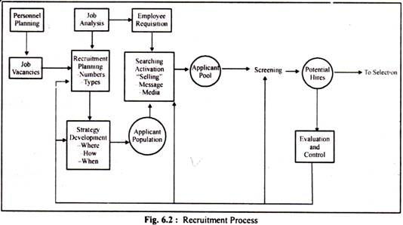
(Hamza, et al., 2021)

Selection
Although selection is often mistaken with the recruitment process, it is the final process that succeeds successful recruitment. It is denoted as the process of choosing, hiring or issuing employment contracts to shortlisted individuals in the recruitment process (Hamza, et al., 2021). Although this process varies from one industry to another, the constant factor is that every candidate must be exhaustively examined by a special organisational panel to prove he/she is fit for the job in question. Its evolution resembles that of the recruitment process since both HR activities are interdependent. The process was therefore established to ensure that organisations appoint and employ competent and loyal labourers that will propel a business to its intended direction through their input. According to Storey 2016), the selection process is a series of steps that play a pivotal role in identifying the required skills and talents which are the foundation to effective performance management in any given organisation. The process of selection is systematic and involves various essential steps among them being; reception, screening interview, application blank, selection tests, selection interviews, medical examinations, reference check, hiring decision and placement.

Evolution of the selection process at Royal Mail
At Royal Mail, the selection process always comes in handy in delivering an appealing candidate experience since time memorial. While this process begins with a job opening that has clearly delineated functions, specified educational backgrounds and work experience in respective fields; the current management depicts it as a funnel analysis that optimises the application process using certain monitoring tools and key performance indicators (KPIs) as illustrated in the diagram below (Royal Mail, 2020).

Funnel Diagram showing hiring and selection process
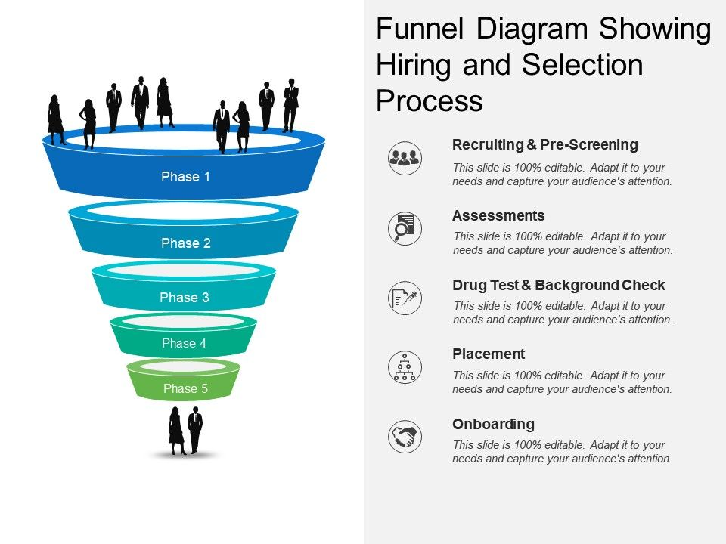
(Hamza, et al., 2021)
When the company was in its budding stages, its first step of selection was reception. In this phase, it branded itself with an appealing image that would create a favourable image to new recruits. Today, the organisation has furthered this agenda by presenting all employment opportunities transparently and eliminating candidates through honest and candid criteria (Royal Mail, 2020). The screening interview is still a major stage in the selection process although not given as much emphasis as back then. Unlike decades ago, when junior executives screened shortlisted candidates against factors such as age, remuneration expectations and aptitude among other determinants; nowadays the HR uses recruitment agencies to issue certain forms upon shortlisting favourable candidates whereby their responses qualify them to attend the final selection interview. These forms help the HR collect essential information that may impact his/her effectiveness at work. Information gathered through these forms includes personal upbringing, marital status and employment background among other aspects. The third stage which has barely changed overtime is selection testing. The HR analyses the behaviour, intellect, emotional intelligence and problem-solving capacities of shortlisted candidates. This analysis is done through administration of relevant tests such as polygraph test, simulation test, personality test and integrity test among others (DeCenzo, et al., 2016). According to Simon Thompson, this stage helps the assessing panel to avoid bias and prepares employees mentally, emotionally and psychologically to handle challenging situations at work. For instance, the organisation has capitalised on the Stanford Benet test and PIP (projective, interest and preference) test over the years and have proven to be useful in shortlisting the very best for critical positions especially in management. Finally, the organisation summarises the selection process with selection interviews and hiring decision. In the past, Royal Mail subjected finalists to just directive interviews and the HR was ready to decide. Today, finalists go through both directive and non-directive interviews before the HR’s panel does a reference check for the ideal candidate in order to give him/her a job offer and most importantly, an appointment letter (Royal Mail Group, 2020). Upon completion of all these formalities, the lucky candidate is usually placed on the job on a probationary basis of 6 months before a permanent job contract review.

Conclusion
In a nutshell, human resource management is a vast field that is dynamic in nature. However, the CIPD has made maximum attempts to streamline the human resource profession by ensuring HRs in an organisation hire the right people at the convenient time and for the right positions. Following these guidelines, HRs at Royal Mail not only create conducive work environments but also promote employee development and ultimately fulfil the overall organisation’s goals.

References
Ahammad, T., (2017). Personnel management to human resource management (HRM. Journal of Modern Accounting and Auditing, 3(18), pp. 412-420.
Bernik, M., (2017). Strategic Human Resource Planning. 4 ed. London: Palgrave.
CIPD, (2016). Profession Map—Our Professional Standards. Chartered Institute of Personnel and Development, 3(1), pp. 12-19.
DeCenzo, D., Stephen, R. and Susan, V., (2016). Fundamentals of human resource management. 2 ed. Hoboken: John Wiley & Sons.
Hamza, P. A. et al., (2021). Recruitment and Selection:The Relationship between Recruitment and Selection with Organizational Performance. International Journal of Engineering, Business and Management, 3(5), pp. 1-13.
Michael, A., (2019). A handbook of human resource management practice. 3 ed. London: Pearson.
Royal Mail Group, (2020). Welcome to Royal Mail Group
Available at: https://www.royalmailgroup.com/en
Royal Mail, (2020). Royal Mail Group Ltd
Available at: https://www.royalmail.com/
Storey, J., (2016). Human resource management. 2 ed. Camberley: Edward Elgar Publishing Limited.
Vithana, K., Teerooven, S. and Collins, N., (2019). Human resource disclosures in UK corporate annual reports: To what extent do these reflect organisational priorities towards labour?. Journal of Business Ethics, 3(1), pp. 1-23.

