Application Development
Application Development (ACCA5012)
December 10, 2018
Matthew Lewington
BSc Software engineering
UWTSD School of Applied Computing
Contents
1. Introduction 1
2. Application Development Concepts 1
2.1 Design Principles 1
2.1.1 Aesthetics and Content 1
2.2 Usability and User Experience (UX) 4
2.2.1 Functionality 4
2.2.2 Accessibility 5
2.2.3 Performance 5
3. Requirements 6
3.1 Requirements Specification 6
3.1.1 Avalanche Boards Design 7
4. Design 8
4.1 Colours 8
4.2 Images 9
4.3 Content Organisation 9
5. Implementation 9
5.1 Scripts 9
5.1.1 Index.html 10
5.1.2 Equipment.html and Clothing.html 10
5.1.3 Productinfo.html 10
5.1.4 Gallery.html 10
5.1.5 Contact-us.html 10
5.2 Screenshots of Avalanche Boards - Desktop 11
5.2.1 Index.html 11
5.2.2 Equipment.html 12
5.2.3 Clothing.html 13
5.2.4 Productinfo.html 14
5.2.5 Gallery.html 15
5.2.6 Stores.html 16
5.2.7 Contact-us.html 16
5.3 Screenshots of Avalanche Boards – Mobile 17
5.3.1 Index.html 17
5.3.2 Equipment.html 18
5.3.3 Clothing.html 19
5.3.4 Productinfo.html 20
5.3.5 Gallery.html 21
5.3.6 Stores.html 22
5.3.7 Contact-us.html 23
6. Evaluation 23
7. Conclusion and Future Improvements 25
8. References 26

1. Introduction
This report has been produced to provide an overview of the research conducted into development concepts of websites and web applications, along with the specification, design and implementation of Avalanche Boards – a website produced to fulfil the requirement task of the Application Development module.

2. Application Development Concepts
This section will discuss the importance of application development concepts for website design principles and usability and user experience (UX).

2.1 Design Principles
When designing a website, careful thinking and planning is required. As a designer the end goal is to find balance between a site that is aesthetically pleasing and has artistic value, and one that is usable, focussing on the functionality, presentation of information and efficiency [1, p. 5].

2.1.1 Aesthetics and Content
The end goal is not solely the way that the website looks, it is also the way that the content will be used by visitors – how useful it may be, or how easily they can interact with the content as said by Niederst Robbins [2, p. 5].
Following this, key points to be aware of for web design aesthetics and content would be:
- Content organisation,
- F-Pattern,
- Grid based layout,
- A single focal point,
- Typography
- Images,
- Colour

2.1.1.1 Content Organisation
It is important that the designer knows the purpose of the website [3, p. 11] such as why it is being created, whether it will be professional, educational, informative, etc… Or whether it will sell products or services.
Each page of a website has to have a clear purpose and needs to fulfil a requirement for the users in the most appropriate and effective way [4].
If a visitor is unable to find what they are looking for when they first use the site, or if it looks unorganised or unprofessional they may leave or go to another site [3, p. 163] [1, p. 9].

2.1.1.2 F-Pattern
A design pattern to follow for content organisation could be the “F-Pattern” [5]–[7]. As can be seen in Fig. 2-1, this is the way a typical user scans a website for information (further backed up by studies from Nielsen, et al. [8], [9]). By visualising where the user is more likely to look on a page, designers can see where important content should be placed.

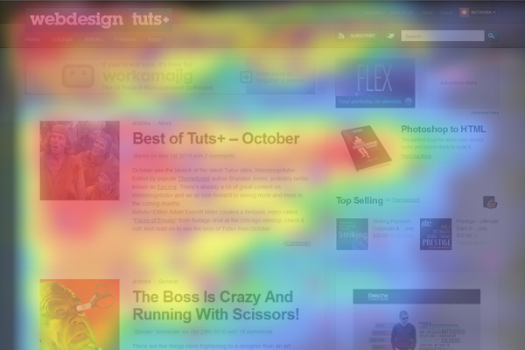
Figure 2-1 – “F-Pattern” Heatmap [10]

2.1.1.3 Grid Based Layout
Content placement needs to be uniform to keep a website looking professional. “Using a grid is more than just about making elements on the page be square and line up: it’s about proportion as well.” – Beaird [1, p. 10]
Grid based layouts have the benefit of being able to arrange content into sections, rows and columns - the designer can then easily build the look of a site. A popular framework for this is Bootstrap [11], breaking a page up into 12 columns, with each row or section spanning ‘x’ amount of columns [Fig 2-2].
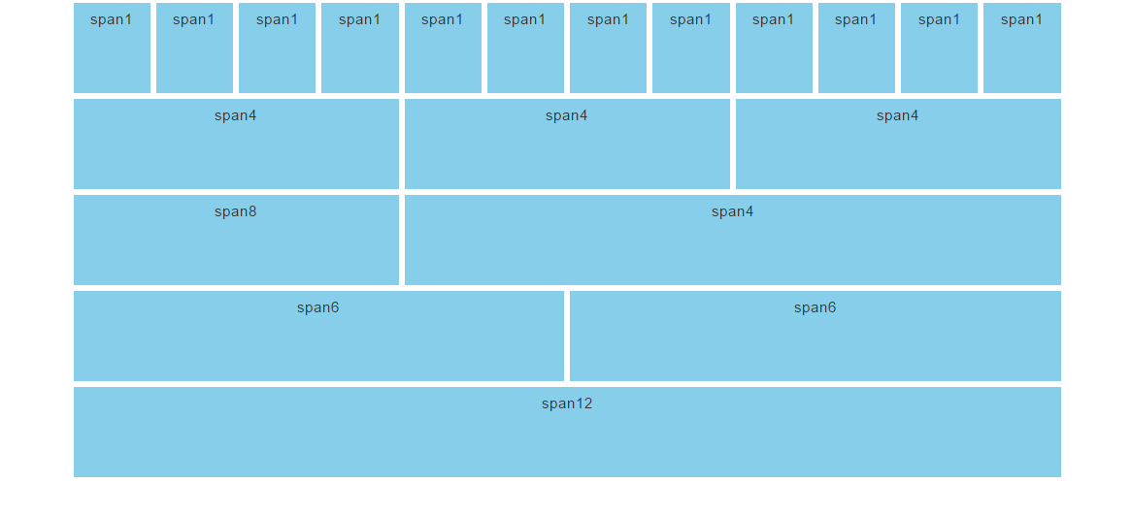
Figure 2-2 Bootstrap grid [12]

2.1.1.4 Single Focal Point
Another point is to keep main content as the focal point of a design. This way, visitors can scan the page for the information they have visited the website for [1, p. 9] easily.

2.1.1.5 Typography
Typically two or three fonts are chosen from the sans-serif family (no extra stroke or curves at the ends of the letters) [1, p. 136] as they are practical for any purpose.
The font size can have an impact on the design and readability of a web page [13, p. 312]. If the user is to easily attain the desired information, the font size cannot be too small. On the other hand, if the font size is too large the page may look cluttered and unprofessional.
Text alignment correctly aligns the text for the visitor and can assist with readability.

2.1.1.6 Images
When using images, there must be some type of benefit such as; does the image show a product or service? Is it related to the brand? It should help the user understand a point that is trying to be made. Images should:
- Be relevant [1, p. 154], i.e. if the site is being designed for a clothing company, the images should be of clothing items, not cars.
- Be good quality - not blurry or pixelated.
- Be close to text that is referring to it.
- Have an alternative text version. This way, search engines and screen readers have relevant information about the images.

2.1.1.7 Colour
While choosing the colour, a designer should keep in mind the business type. The look and feel of the website should be in sync with the colour scheme. Too many colours on a website can look unprofessional, so it is better to limit the number of colours used.
When deciding a colour palette for the site, the designer must keep in mind the readability to all users, of which there may be visually impaired users.
There are tools available online to assist with picking a relevant colour scheme [1, p. 72], [14], [15].

2.2 Usability and User Experience (UX)
Usability focuses on functionality, effective presentation of information, and efficiency. User experience is how the user feels when they use the website:
- What do they feel when they use the website?
- What do they do when they visit the website?

UX is the role of enhancing usability and user satisfaction by improving the accessibility and performance of a website in an effective and efficient manner [16].

2.2.1 Functionality
The website must be functional – it should work and display correctly across all types of devices.
Users can access websites on many devices with both varying screen sizes and resolutions, ranging from hand held devices (smartphones and tablets) through to high resolution computer screens and televisions [17, p. 2].
There has been a surge over the past decade with hand held devices. As shown in a recent Ofcom survey [18, p. 27] - 78% of UK adults (16+) have a smartphone and 58% have a tablet. Furthermore, a study by Deloitte [19, p. 5] shows over 80% of the world population has access to a smartphone.
37% of the time spent online at home is on a smartphone versus 22% on a laptop/desktop, showing smartphones are the preferred device [18, p. 15].
From this research it is obvious that when creating a website, smart devices are taken into consideration - a main technique is to design for the mobile version first (mobile-first design).

2.1.1.1 Mobile-First Design
Mobile-first design is to concentrate on the mobile browsing experience first, and then progress to a PC view website.
As said by Moreto et al [20], “…If you make a desktop version of the web page (responsive design or mobile last) first and then adjust the website for mobile, it has a 99 percent probability of breaking the layout at some point”, and further backed by Niederst Robbins [2, p. 450] stating a best practice is to adopt this mobile-first mentality.
The user is provided the best possible experience no matter which device they are then using this way, rather than using a watered down PC version [21].

2.2.2 Accessibility
Web accessibility means that people with disabilities can use the web. Specifically, people with disabilities can perceive, understand, navigate and interact with the web [22, p. 2]. While access to users with disabilities is the primary objective, it can also benefit people without disabilities as the websites are flexible to be able to meet different users’ needs [22, p. 3]. This allows everyone to use a website in a way that suits their preferences.

2.2.3 Performance
A key part of UX is the performance and load time of a website. As the speed of service and technology advancement has improved, with Moore’s law still being relevant [23]–[25], users are used to the speed of which data can now be attained.
If a user must wait a long time for a page to load, it is likely that they will leave the page. Some rules as outlined by Google [26] to decrease page load times to be followed are:
- Avoid landing page redirects
- Enable compression
- Improve server response time
- Minify resources
- Optimize images
- Optimize CSS
- Prioritize visible content

3. Requirements

3.1 Requirements Specification
Requirements should be clear, unambiguous, easy to understand, complete and consistent as per Sommerville [27, p. 120]. As shown in table 1, a basic requirement specification has been built.

Table 1 – SRS
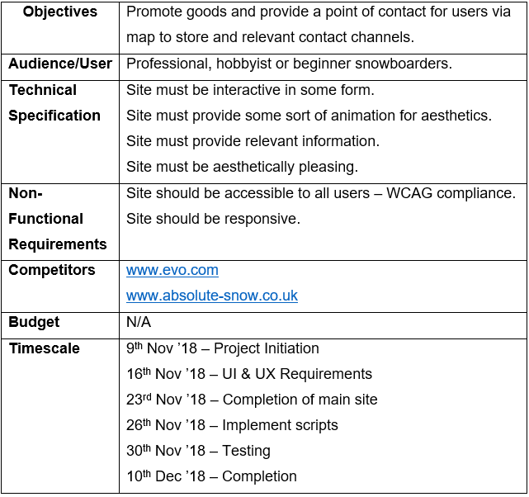

3.1.1 Avalanche Boards Design
Avalanche Boards was produced to provide an outlet for users (beginner and professional snowboarders) to see information on various types of snowboard equipment and clothing. The user can contact the staff via the page, and they are able to find a store.
The site has been developed to work with small, medium and large screens. As advised in section 2.1.1.1 – Mobile First Design, this approach was taken to be sure the website displayed correctly on smaller devices, then scaling up to medium and above.
As part of the site design, the following has been implemented:
- Product information displayed,
- Sort products by gender and brand,
- Map of stores,
- Contact information

4. Design

4.1 Colours
Avalanche boards has been designed to be a simple website, with a basic but appropriate colour scheme for the company and product type. Originally lighter colours were chosen, but after analysis [Fig 4-1] with the WAVE [28] evaluation tool, a darker foreground colour was selected and added into the bootstrap CSS class for content, to work toward WCAG compliance [29], each page now has 0 contrast errors [Fig 4-2].

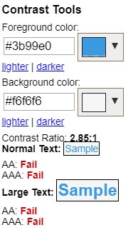
Figure 4-1 – Contrast Fail

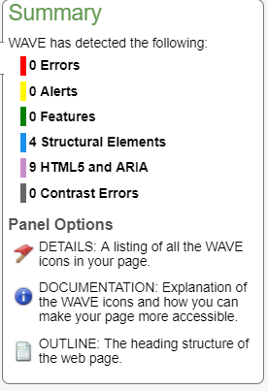
Figure 4-2 –Re-evaluation

4.2 Images
The colour contrast from images on the white or grey background allows them to stand out and draw attention, and images are relevant to the site’s needs. Each image has an alt tag [Fig 4-1] in compliance with WCAG [30].
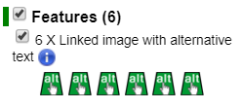
Figure 4-3 – WAVE evaluation of gallery.html

4.3 Content Organisation
Content has been organised into relevant pages/categories, has been split accordingly, and a grid-based layout (Bootstrap) has been used [Fig. 4-4].

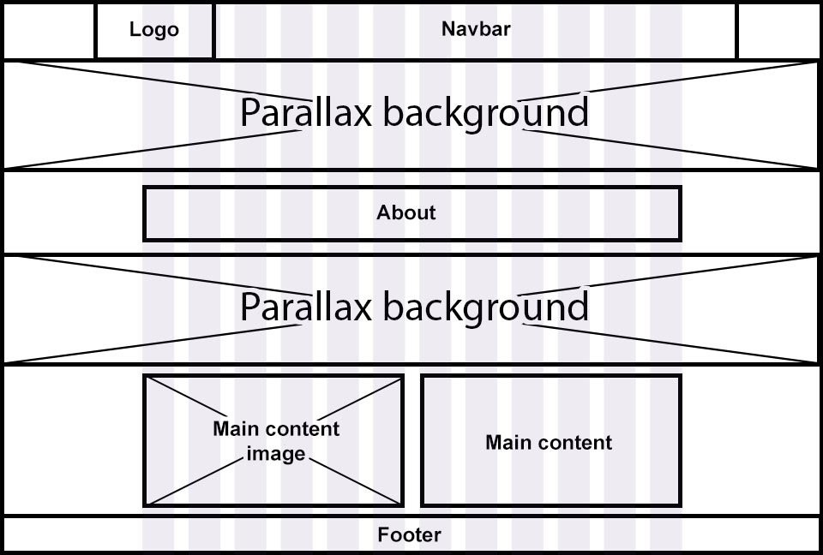
Figure 4-4 Wireframe of Avalanche Boards

5. Implementation

5.1 Scripts
As part of the implementation, several JavaScript functions were created, as well as some third party resources [11], [31]–[33] being used for layout or animation.
Each page has the footer being added via a JavaScript function, and the navbar has a slide-in animation from AOS [33].

5.1.1 Index.html
For index.html, scripts implemented were third party animation scripts; fade in. At the bottom of the page, a function was created to randomise an array that is loaded from a .JSON file and another function is used to display their properties with links to equipment.html. AOS was used to fade the products in.

5.1.2 Equipment.html and Clothing.html
For these, a function was produced to read products from the relevant .JSON files for each and display each product – this would loop until the last product is reached.
When a user clicks the ‘More Info’ button, a function has been implemented to append the product ID to the URL, passing this through to productinfo.html.
On page load, the ‘All’ checkboxes are automatically checked for Gender and Brands to automatically display all the content. Depending on what the user selects, the relevant products will be shown.
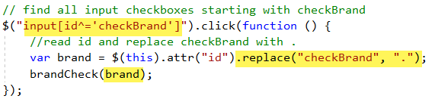

5.1.3 Productinfo.html
For productinfo.html a function was built to retrieve the ID from the URL passed from the previous page, this loads the product from the relevant .JSON file depending on the ID number (2 separate .JSON files. 100 – 199 for snowboards and 200 – 299 for clothing was used).
The previous URL is also passed through so when the user clicks the ‘Back’ button it takes them back to whichever page they came from – either products.html or clothing.html.

5.1.4 Gallery.html
Third party scripts were used for gallery animation.

5.1.5 Contact-us.html
Ideally a script would be implemented to POST user details, but as that involves a server, the user details are only logged to the console for proof of concept.

5.2 Screenshots of Avalanche Boards - Desktop

5.2.1 Index.html
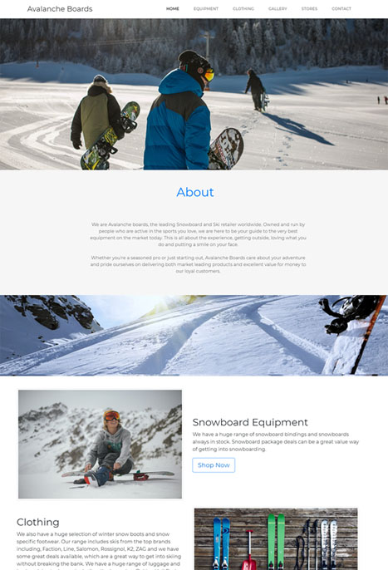
Figure 5-1 – index.html

5.2.2 Equipment.html
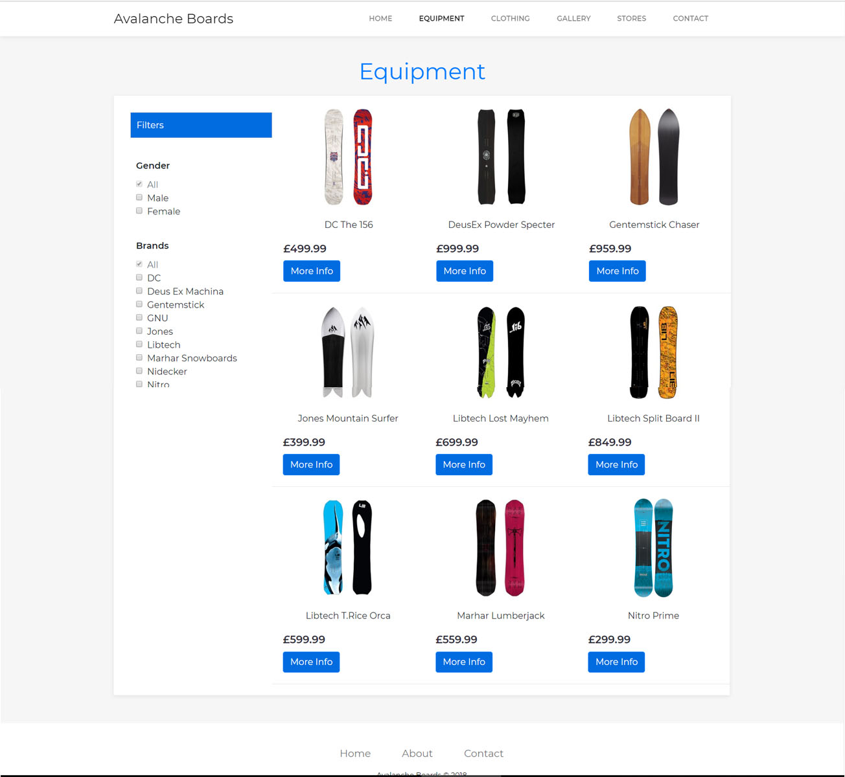
Figure 5-2 – equipment.html

5.2.3 Clothing.html
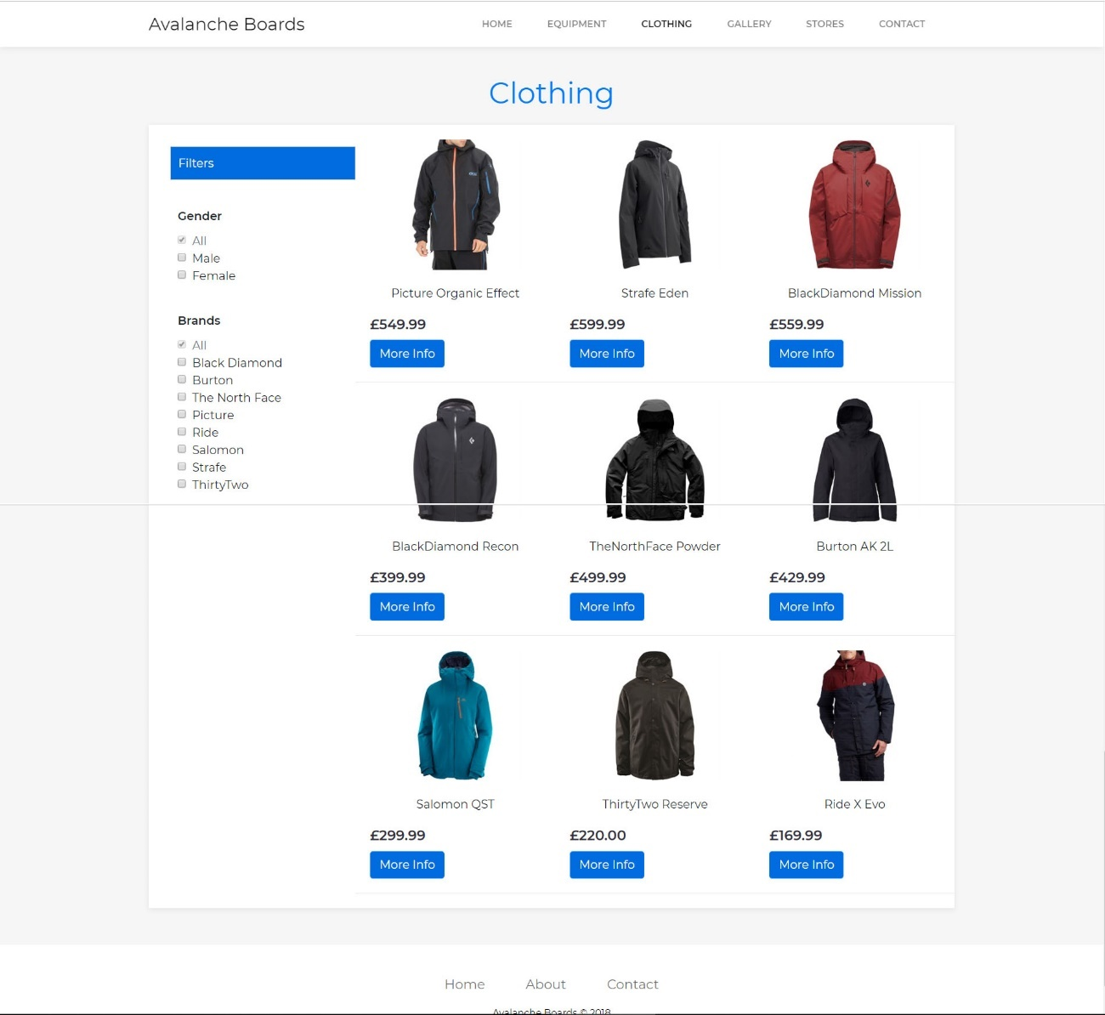
Figure 5-3 – clothing.html

5.2.4 Productinfo.html
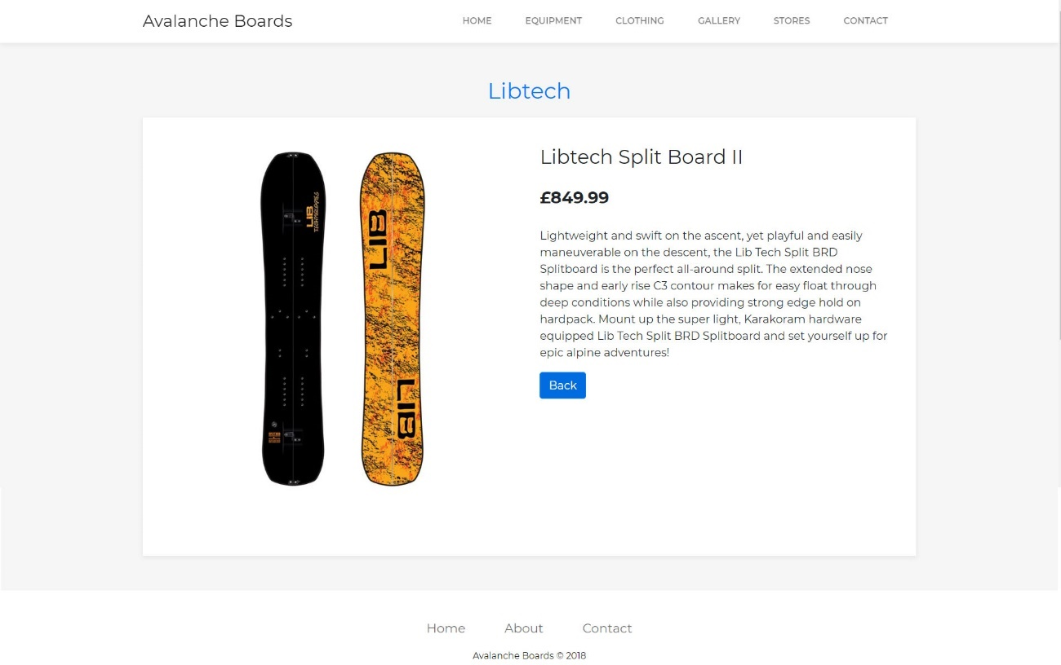
Figure 5-4 – productinfo.html

5.2.5 Gallery.html
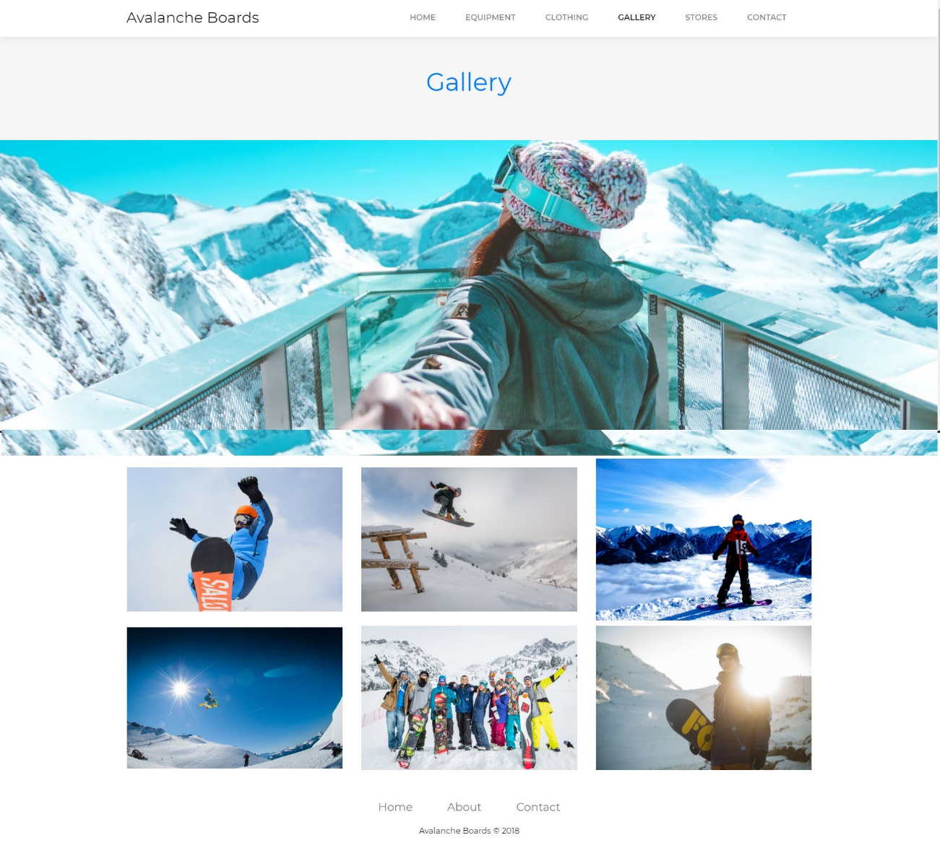
Figure 5-5 – gallery.html

5.2.6 Stores.html
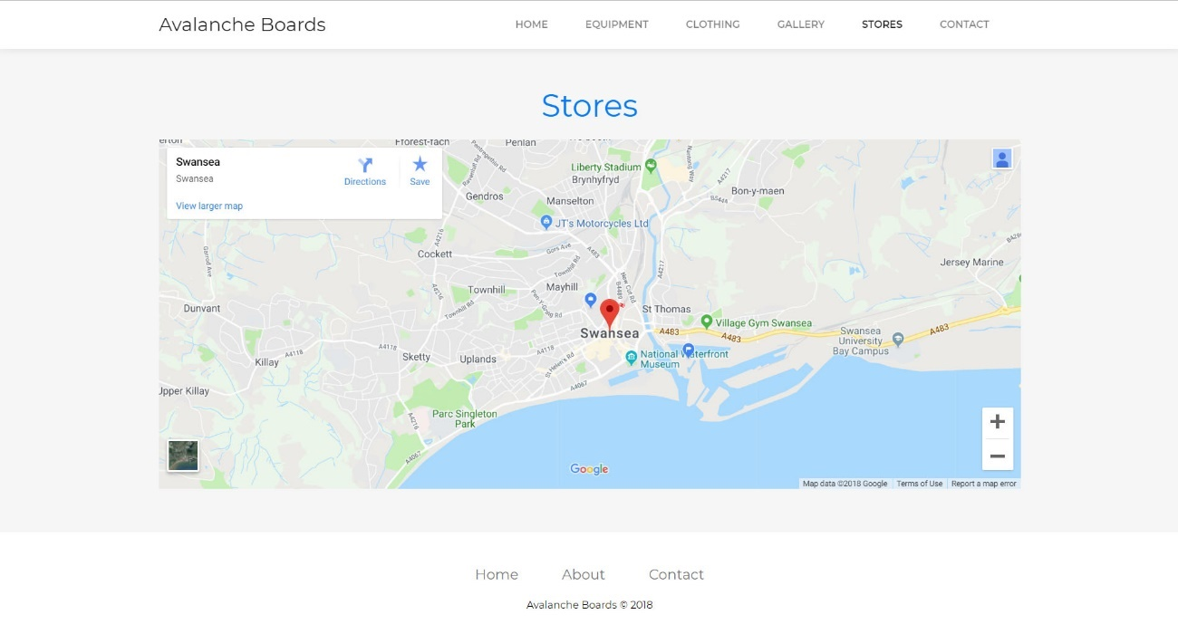
Figure 5-6 – stores.html

5.2.7 Contact-us.html
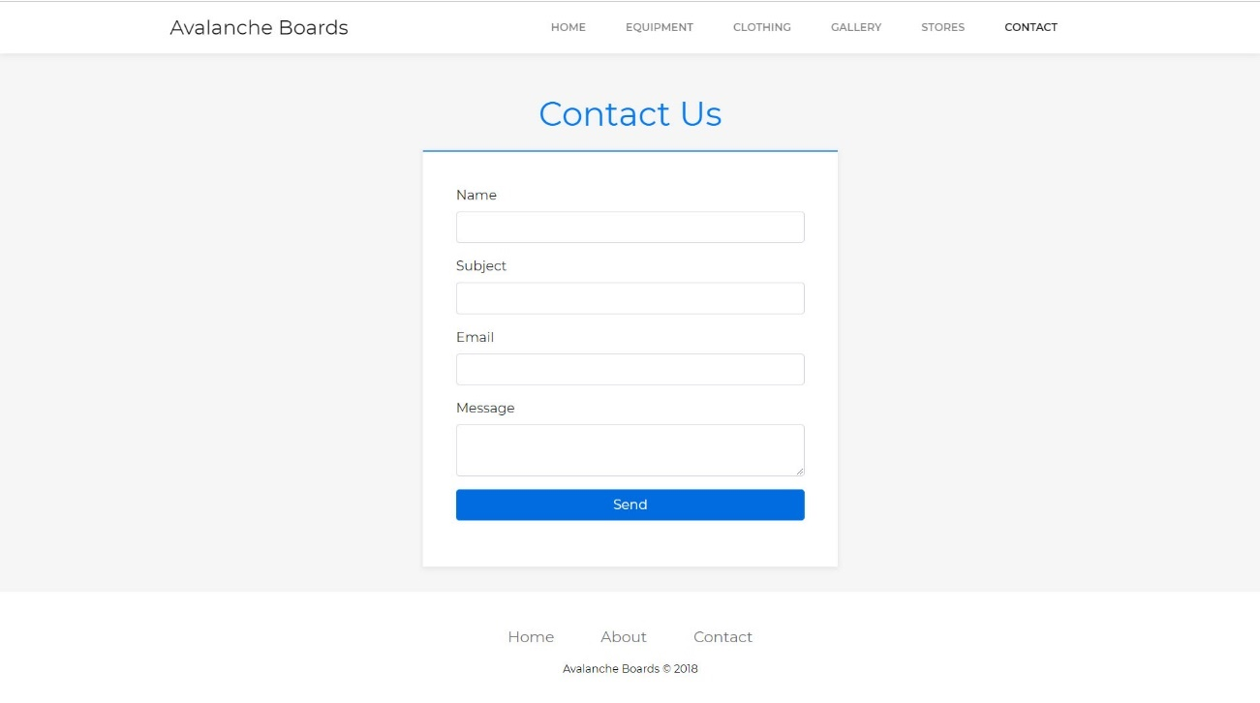
Figure 5-7 – contact-us.html

5.3 Screenshots of Avalanche Boards – Mobile

5.3.1 Index.html
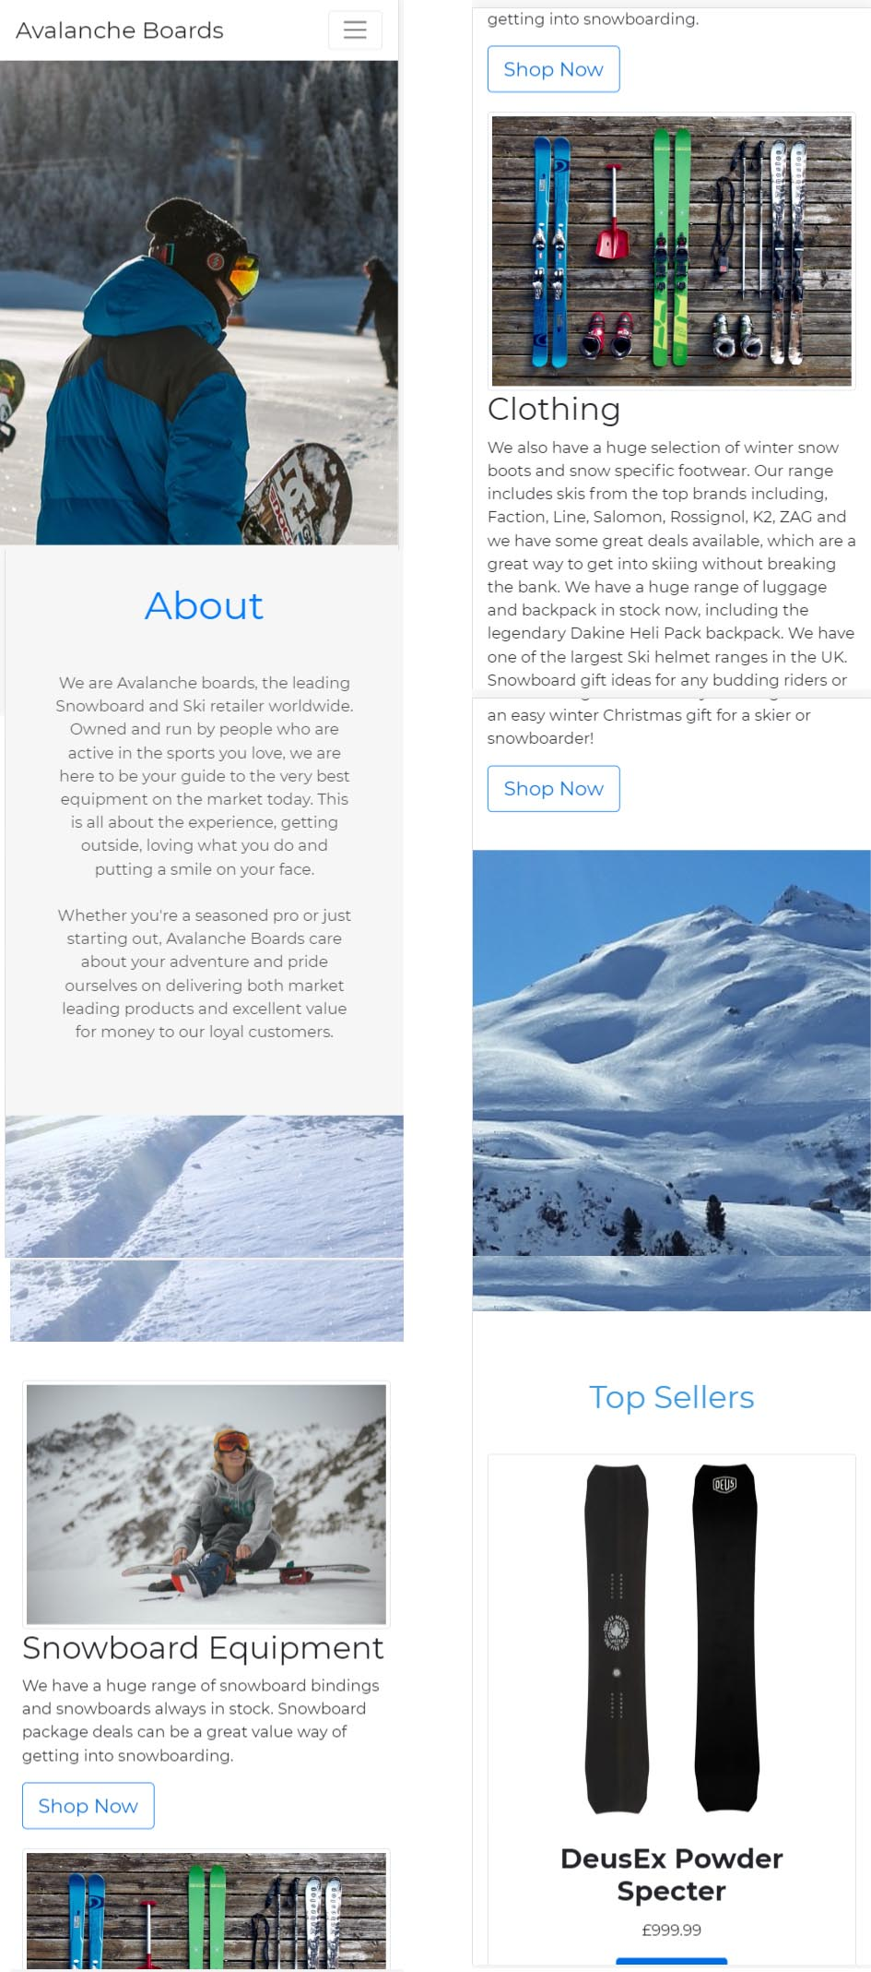
Figure 5-8 – index.html mobile

5.3.2 Equipment.html
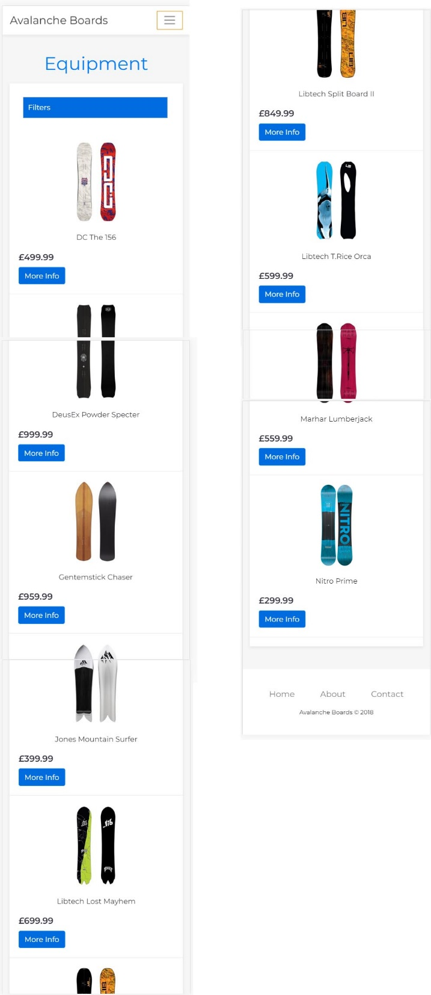
Figure 5-9 – equipment.html mobile

5.3.3 Clothing.html
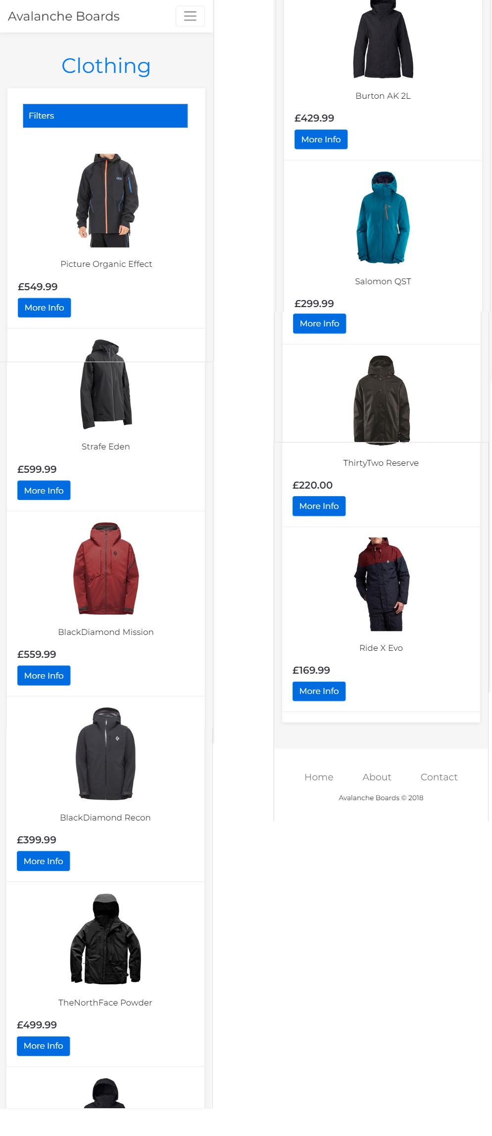
Figure 5-10 – clothing.html mobile

5.3.4 Productinfo.html
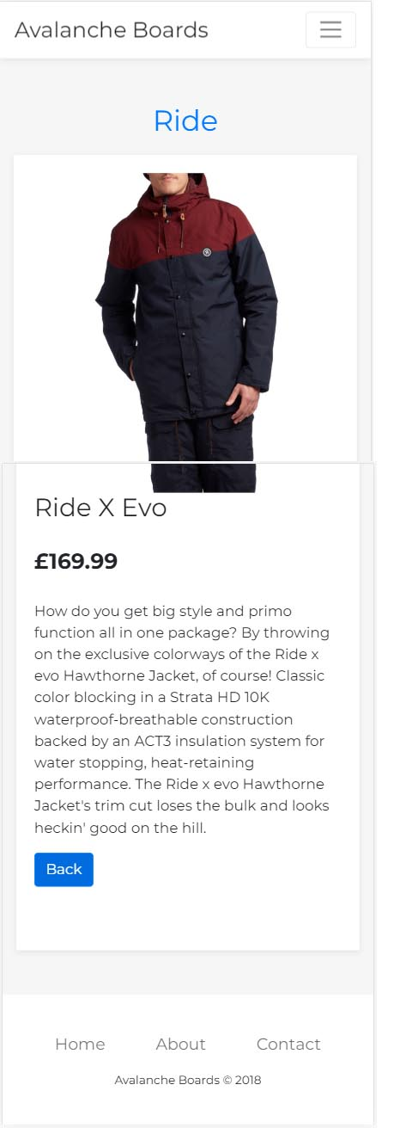
Figure 5-11 – productinfo.html mobile

5.3.5 Gallery.html
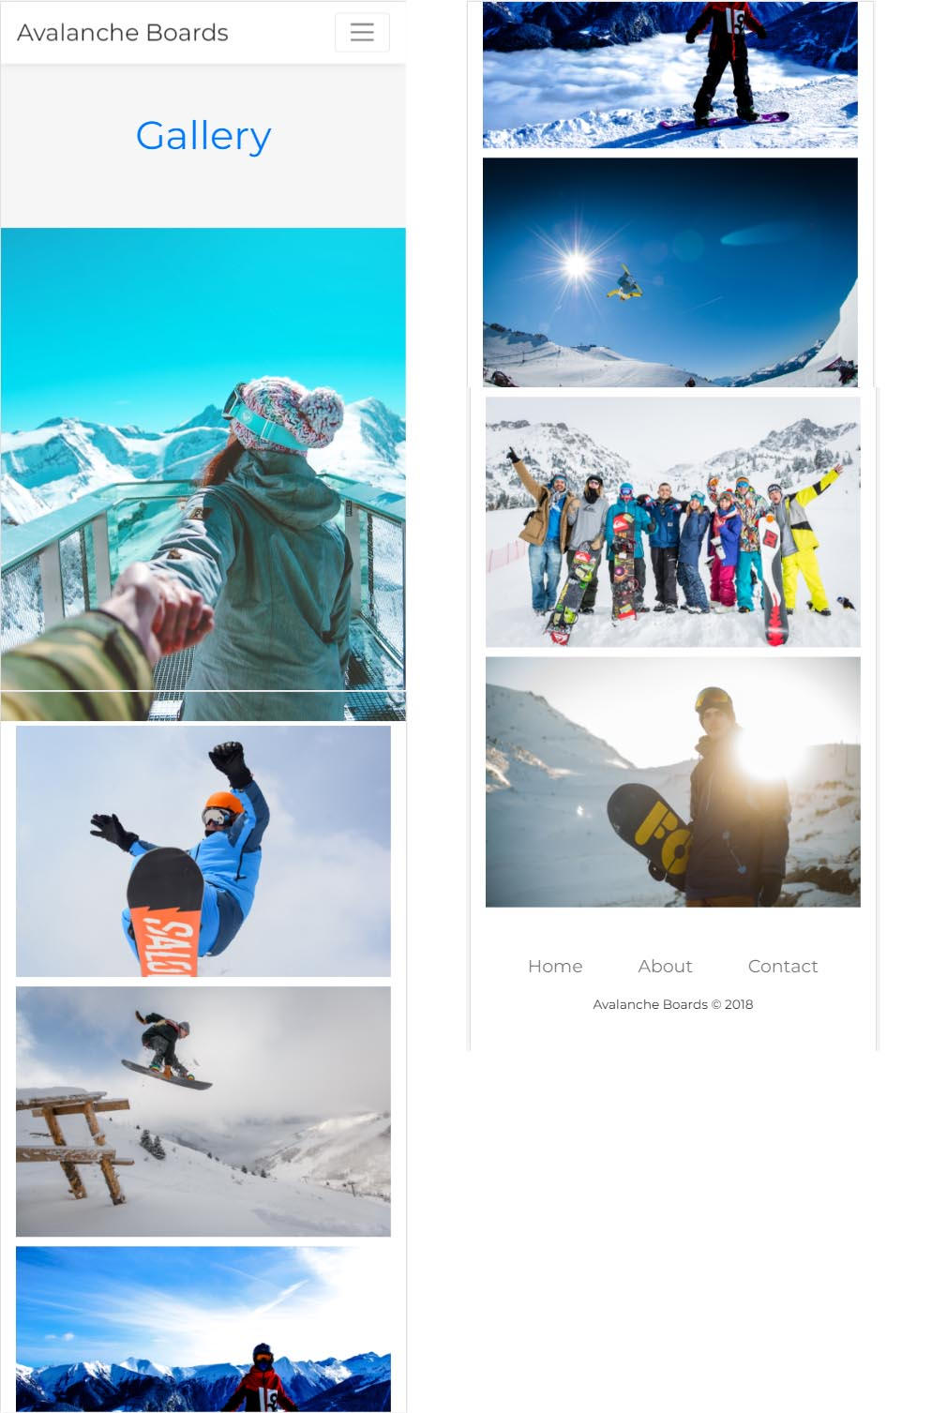
Figure 5-12 – gallery.html mobile

5.3.6 Stores.html
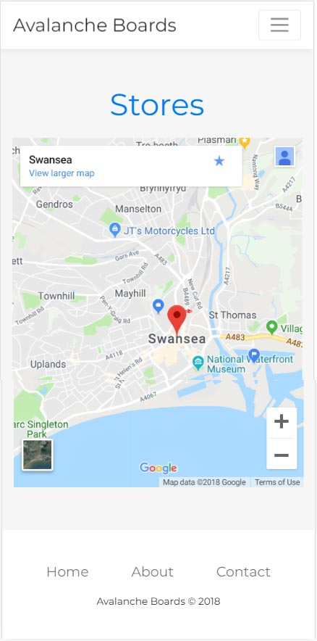
Figure 5-13 – stores.html mobile

5.3.7 Contact-us.html
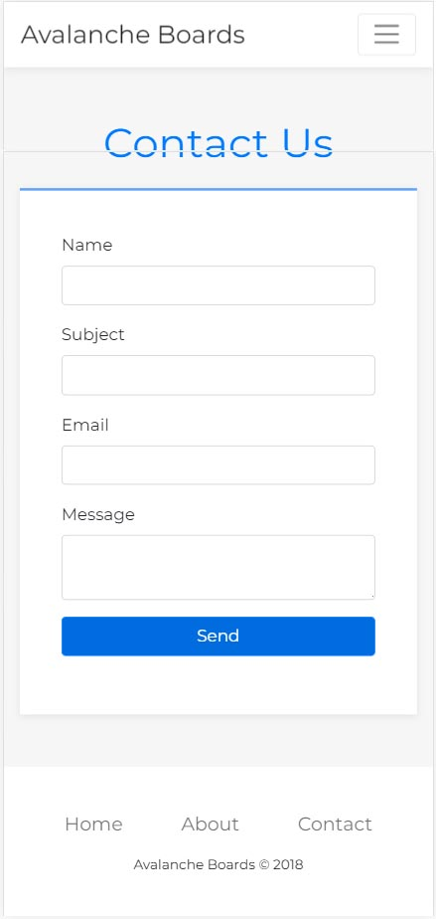
Figure 5-14 – contact-us.html mobile

6. Evaluation
As part of the evaluation of Avalanche Boards, code was put through validators [34], [35] to check W3 compliance. Any errors were corrected. For example, when trying to implement an anchor within index.html [Fig 6-1] a legacy attribute was used. This has now been updated and validation is successful [Fig 6-2]. The CSS file was validated as level 3 + SVG [Fig 6-3].

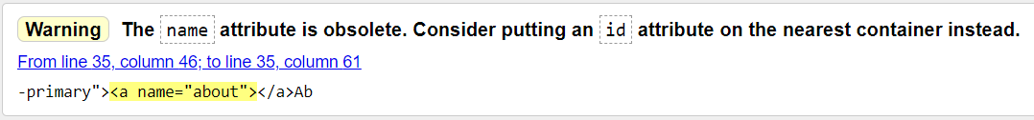
Figure 6-1 – W3 HTML Validator [34]


Figure 6-2 – W3 HTML Validator [34]


Figure 6-3 – W3 CSS Validator [35]

As outlined within section 4, design, accessibility was evaluated, and any errors were corrected – alt tags, page language and colour contrast.
All content on Avalanche boards is relevant to the company, brand, and user requirements.
The site displayed correctly across Google Chrome, Mozilla Firefox and Microsoft Edge [Fig 6-4 – Fig 6-6].

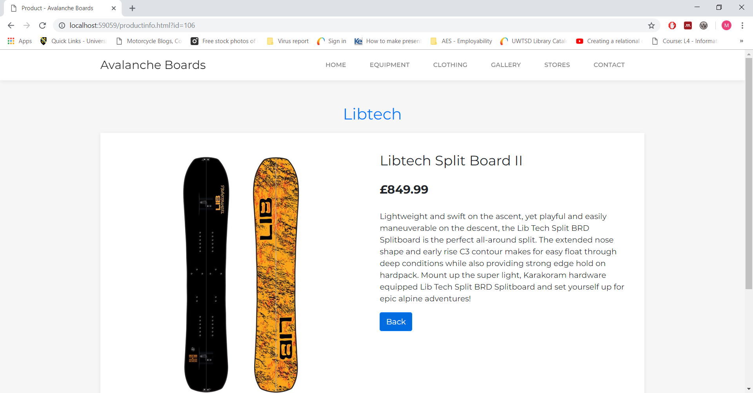
Figure 6-4 – Chrome test
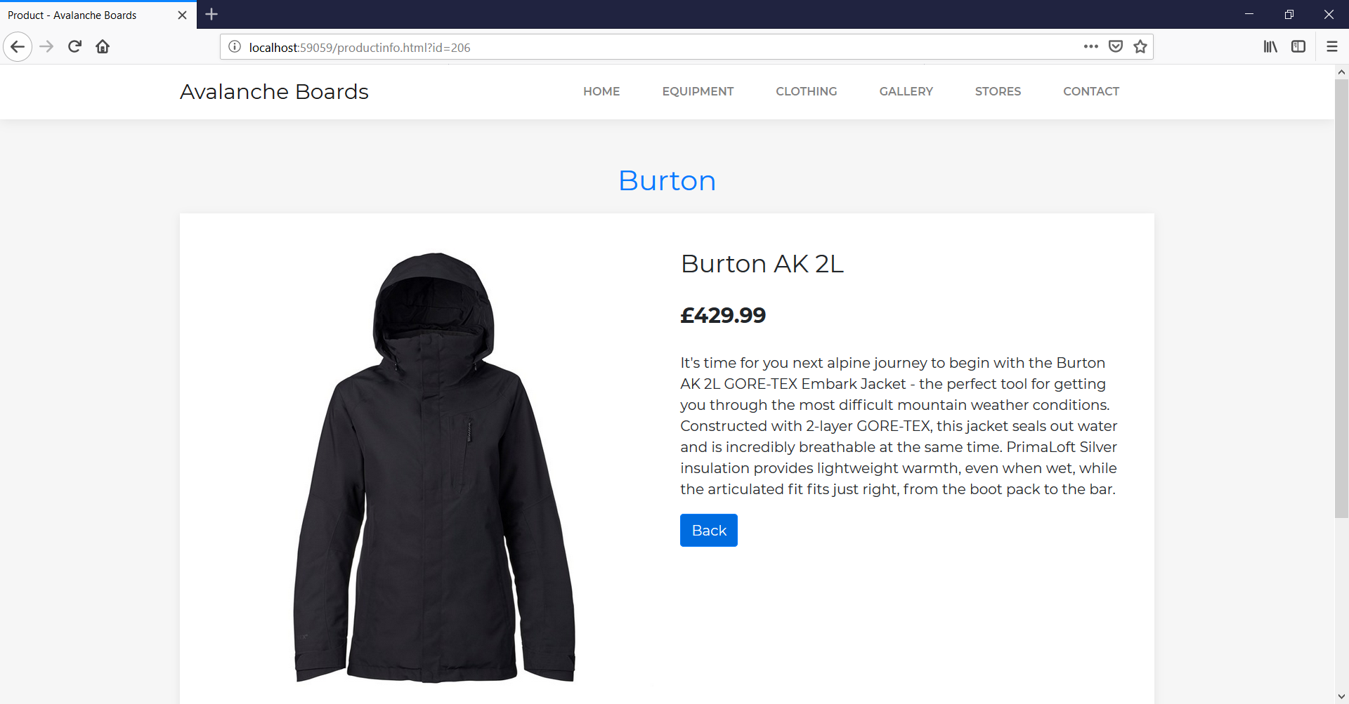
Figure 6-5 – Firefox test

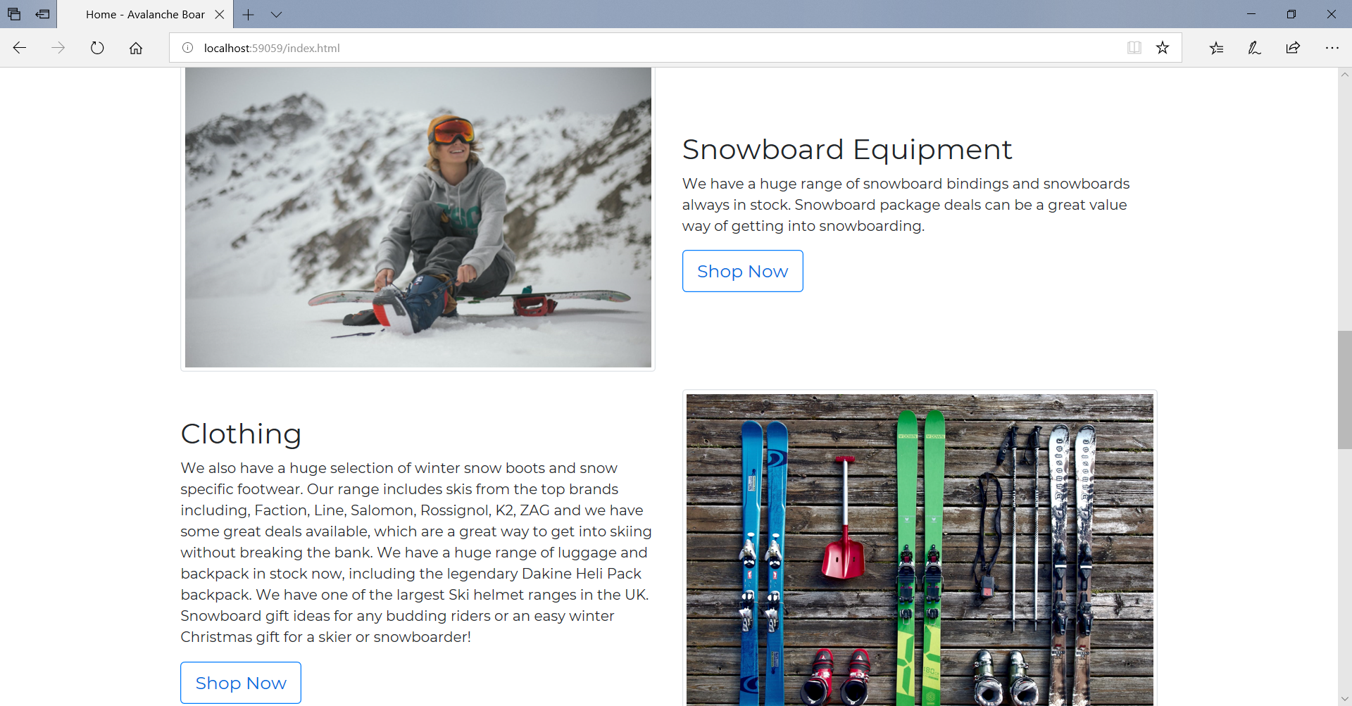
Figure 6-6 – Edge test

7. Conclusion and Future Improvements
The concepts and techniques of web scripting have been implemented and shown a basic range of usability and interaction that a website can provide.
If more was known about server-side scripting, implementation of a contact form properly would be useful for the site. Perhaps creating a carousel of objects or pagination for the product pages, so the user can load more into the pages would be good for future development.

8. References
[1] J. Beaird, The Principles of Beautiful Web Design. SitePoint Pty Ltd, 2010.
[2] J. Niederst Robbins, Learning Web Design: A Beginner’s Guide to HTML, CSS, JavaScript, and Web Graphics. O’Reilly, 2012.
[3] S. Jenkins, Web Design All-in-One For Dummies: . For Dummies, 2012.
[4] “10 Top Principles of Effective Web Design | Shortie Designs.” [Online]. Available: https://shortiedesigns.com/2014/03/10-top-principles-effective-web-design/. [Accessed: 13-Nov-2018].
[5] S. Mialki, “What is the F-Pattern and How to Use It for Increased Conversions.” [Online]. Available: https://instapage.com/blog/f-pattern-layout. [Accessed: 14-Nov-2018].
[6] K. Pernice, “F-Shaped Pattern of Reading on the Web: Misunderstood, But Still Relevant (Even on Mobile).” [Online]. Available: https://www.nngroup.com/articles/f-shaped-pattern-reading-web-content/. [Accessed: 14-Nov-2018].
[7] S. Moyers, “The F Pattern: Understanding How Users Scan Content | UX Magazine.” [Online]. Available: https://uxmag.com/articles/the-f-pattern-understanding-how-users-scan-content. [Accessed: 14-Nov-2018].
[8] K. Pernice, K. Whitenton, J. Nielsen, and N. N. Group, How People Read on the Web: The Eyetracking Evidence. Nielsen Norman Group, 2014.
[9] K. Pernice and J. Nielsen, “How to Conduct Eyetracking Studies.”
[10] B. Jones, “Understanding the F-Layout in Web Design.” [Online]. Available: https://webdesign.tutsplus.com/articles/understanding-the-f-layout-in-web-design--webdesign-687. [Accessed: 14-Nov-2018].
[11] “Bootstrap · The most popular HTML, CSS, and JS library in the world.” [Online]. Available: https://getbootstrap.com/. [Accessed: 14-Nov-2018].
[12] “Bootstrap Grid | FormGet.” [Online]. Available: https://www.formget.com/bootstrap-grid/. [Accessed: 14-Nov-2018].
[13] E. Robson and E. Freeman, Head First HTML and CSS, 2nd ed. O’Reilly, 2012.
[14] “Adobe Color Wheel.” [Online]. Available: https://color.adobe.com/create/color-wheel/.
[15] “Paletton - The Color Scheme Designer.” [Online]. Available: http://paletton.com/#uid=1000u0kllllaFw0g0qFqFg0w0aF. [Accessed: 14-Nov-2018].
[16] O. Sohaib, W. Hussain, and M. Badini, “User Experience (UX) and the Web Accessibility Standards,” Int. J. Comput. Sci. Issues, vol. 8, no. 3, pp. 584–587, 2011.
[17] E. Pettersson and T. Thai, “Design Principles In Mobile Web Usability,” 2016.
[18] “Ofcom Communications Market Report 2018,” 2018.
[19] “Global Mobile Consumer Trends,” 2017.
[20] S. Moreto, M. Lambert, B. Jakobus, and J. Marah, Bootstrap 4 - Responsive Web Design. Packt.
[21] M. Gioja, “Mobile-First Design: A user-first HR technology experience,” Core HR, HRIS Payr. Excell. Essentials, 2016.
[22] J. Thatcher et al., Web Accessibility Web Standards and Regulatory Compliance. Friendsof, 2006.
[23] “Moore’s law.” [Online]. Available: http://www.oxfordreference.com/view/10.1093/acref/9780199233991.001.0001/acref-9780199233991-e-3702.
[24] G. Moore, “Cramming More Components Onto Integrated Circuits,” 1965.
[25] M. Roser and H. Ritchie, “Technological Progress - Our World in Data.” [Online]. Available: https://ourworldindata.org/technological-progress. [Accessed: 14-Nov-2018].
[26] “PageSpeed Insights Rules | PageSpeed Insights | Google Developers.” [Online]. Available: https://developers.google.com/speed/docs/insights/rules. [Accessed: 14-Nov-2018].
[27] I. Sommerville, Software engineering, Tenth edit. Harlow: Harlow, Essex, England : Pearson, 2016.
[28] “WAVE Chrome &amp; Firefox Extensions.” [Online]. Available: https://wave.webaim.org/extension/. [Accessed: 03-Jan-2018].
[29] “Understanding Success Criterion 1.4.3 | Understanding WCAG 2.0.” [Online]. Available: https://www.w3.org/TR/UNDERSTANDING-WCAG20/visual-audio-contrast-contrast.html. [Accessed: 22-Nov-2018].
[30] “H37: Using alt attributes on img elements | Techniques for WCAG 2.0.” [Online]. Available: https://www.w3.org/TR/WCAG20-TECHS/H37.html. [Accessed: 22-Nov-2018].
[31] “jQuery.” [Online]. Available: https://jquery.com/. [Accessed: 22-Nov-2018].
[32] “fancyBox - Fancy jQuery Lightbox Alternative.” [Online]. Available: http://fancyapps.com/fancybox/. [Accessed: 22-Nov-2018].
[33] “AOS - Animate on scroll library.” [Online]. Available: https://michalsnik.github.io/aos/. [Accessed: 22-Nov-2018].
[34] “The W3C Markup Validation Service.” [Online]. Available: https://validator.w3.org/. [Accessed: 23-Nov-2018].
[35] “The W3C CSS Validation Service.” [Online]. Available: https://jigsaw.w3.org/css-validator/. [Accessed: 23-Nov-2018].
[36] “evo | Mountain, Street &amp; Water | Community, Culture &amp; Giving Back | evo.” [Online]. Available: https://www.evo.com/. [Accessed: 10-Dec-2018].
[37] “Free stock photos · Pexels.” [Online]. Available: https://www.pexels.com/. [Accessed: 10-Dec-2018].

marking criteria and Student FEEDBACK

This section details the extent to which the assessment criteria are demonstrated by you, which in turn determines your mark. The marks available for each category of skill are shown. Lecturers will use the space provided to comment on the achievement of the task(s), including those areas in which you have performed well and areas that would benefit from development/improvement.

Common Assessment Criteria Applied (Assignment 1) | Marks available | Marks  awarded
1. Engagement with Literature Skills

A wide range of appropriate reference sources have been consulted. (Grade mark: 90.00%) | 5 | 4.5
2. Knowledge and Understanding Skills

Excellent discussion of the application concepts demonstrating a detailed knowledge and critical understanding of the concepts. (Grade mark: 80.00%) | 25 | 20
3. Cognitive and Intellectual Skills

An excellent evaluation of the implemented website has been provided. The documentary evidence of testing could be improved beyond screenshots to further demonstrate test cases for the interactive functionality. (Grade mark: 65.00%) | 20 | 13
4. Practical Application Skills

An excellent attempt featuring a professional-looking website with well-thought-out content and interactivity functionality. The implemented website demonstrates a very good understanding of RWD and how JS can be used to add relevant functionality and interactivity. The main area for improvement is learning how to refactor repetitive code into reusable functions with parameters to pass in what varies. See your report for a few minor comments and suggested improvements. (Grade mark: 88.89%) | 45 | 40
5. Transferable Skills for Life and Professional Practice

The report is very well written and presented. (Grade mark: 90.00%) | 5 | 4.5

Assignment Mark (Assessment marks are subject to ratification at the Exam Board. These comments and marks are to give feedback on module work and are for guidance only until they are confirmed. ) | Late Submission Penalties (tick if appropriate) |  | 82%
 | Up to 1 week late (40% Max) |  | 82%
 | Over 1 week late (0%) |  | 82%

