The Recognition of Faces Following a Distractor Task.
Demi Easter
University of Wales Trinity Saint David

Abstract
This report had an aim to explore the idea of whether there was an existence of an ‘own-race bias’ which has been found by other researchers. The study in this report has explored whether white faces were more easily recognised than black faces. A Within subject paired samples t-test was carried out to test the hypothesis. It was found in this study that black faces were more easily recognised than white. All participants in this study were all of one ethnic race. Due to the findings of this study, it can be questioned whether the existence of this ‘own race bias’ is real or whether it has been created to cover up any racial discrimination.

Introduction
In this report it will be questioned whether people will recognise people in their own ethnic group more easily than people of a different ethnic group. This has been an area of research which is a highly debated topic. Research into this area could raise a multitude of social implications such as issues with racism, the validity and credibility of eye witness account and a range of other implications. There has been extensive research into whether an ‘Own-race’ bias is present when recognising faces and Meisser and Brigham (2001) study this bias in memory when people recall faces and debate whether there is a racial prejudice in play. They use eyewitness accounts to emphasise their points. This meta-analysis study uses 91 independent samples with almost 5,000 participants to support their findings. In the studies multiple eyewitness accounts are used and the researchers found strong evidence supporting the presence of and ‘own-race bias’. They found that this bias accounts for 15% of discrimination in eyewitness accounts and have also found that participants in the studies were 2.2 times more likely to correctly identify faces of their own race compared to faces of another race. In a report by Valentine (1991) there is evidence that age plays a role in how accurately faces are recalled. Its states that adults can generally recognise someone from their own ethnic group much more easily than someone of a different ethnic group. On the other hand, children can recognise face of their own race and faces from a different race just as easily as one another (Goldstein & Chance, 1980; Chance, Turner & Goldstein, 1975). Researchers Goldstein and Chance (1980) suggested that people have a ‘face schema’ that can impact on how easily we recognise faces from other ethnicities. They argue that as children age this face schema becomes more effective and later in life people should have a good face recognition performance. In another report by Chiroro and Valentine (1995) researchers Brigham and Malpass (1985) identified four hypotheses that they proposed had an impact on facial recognition. The first of which is that faces of another race may be more difficult to recognise. This has not been supported with any evidence according to Goldstein (1979). The main focus of this report is the fact that people may have not been exposed many people of another race and they may only have difficulty identifying face of another race because they have had limited contact with them. This study found that both White and Black participants could correctly identify, and be confident in their answers, faces of their own race. The researchers also concluded that the own race bias was present in both race. In a study by Malpass & Kravitz (1969) found that white persons and black persons both recognised white faces more easily than black faces. They concluded that this was due to media exposure and both races had more exposure to white faces after a social experiment. In summary, based on the literature reviewed it is clear that there is sufficient evidence that people should recall people of their own race more easily than people of another. The finding to this study should show some evidence of the ‘own-race bias’. Based on previous research such as above the hypothesis for this study will be, Participants will recall faces of their own ethnicity more easily than faces of another ethnicity.

Method
In this study there were 29 participants, consisting of seven males and 22 females. These participants were an opportunity sample and were recruited from a Research Methods module lecture. The age range of participants in this study was from 18 to 60. All participants in this study had an ethnicity of British White.
The Design of this study was a Within subject design. The test used a paired samples t-test. The Independent variable for this study was the Race/Ethnicity of the faces and was split into the categories of White faces and Black faces. The Dependant variable was the number of faces recalled correctly.
The Materials used in this study consist of PowerPoint Presentation which was used to create the study presentation. Instructions for the participants were shown on the first slide of the presentation. 12 faces were shown in part one of the study for two seconds each. They were presented one at a time with one face on an individual slide. There were six white faces and six black faces presented. Part two of the presentation showed the participants 36 faces altogether. There were six pages each consisting of six faces. The participants were shown each slide for 12 seconds, which provided two seconds to look at each face. A recall/response sheet (See Appendix A) with clear demographics were given with space for the participants to record their responses.
The Procedure for this study started with participants being provided with a consent form (See Appendix B). They were instructed to watch the PowerPoint presentation on the screens in the room. Additional instructions were then presented on the presentations slides. Participants were instructed to remain silent, as in a group setting, to allow for them to concentrate. A countdown, e.g. 3, 2, 1, was shown just before the beginning of part one of the presentation. Then the presentation showed the initial 12 faces. There was then a distraction in the form of a lecturer introducing information for one minute. Participants were instructed to look at the screen again for part two of the presentation. Additional instructions were again presented on screen. Participants were asked to remain silent again. The presentation with the 36 faces was shown and participants to record in the response sheet the 12 faces they has seen in part one of the presentation. After all participants had completed the response sheet, debrief information was presented on the screen, due to a group setting, and a debrief form was also handed out to all participants individually (See Appendix C).
Results
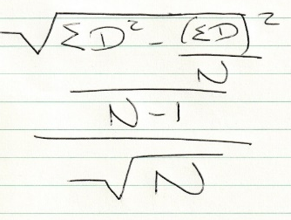
This study used a paired-samples t-test to determine whether participants could recall more white faces than black faces after a small distraction period. The results show that participant recalled a significant amount more black faces (M = 3.34, SD = 2.42) than white faces (M = 2.62, SD = 1.97); t (28) = 3.12, p<.05. The original hypothesis of this study was that participants would recall more white faces than black faces, so it must be rejected.

Discussion
Based on the outcomes of this study the original hypothesis must be rejected. Previous research has supported the theory that people would recognise more faces of their own ethnic group compared to other ethnic groups. This study did not support the results of the literature reviewed previously, instead the finding of the study contradict the evidence presented. The implications of the findings can relate to eyewitness accounts. Evidence such as in this study may discredit the reliability of eyewitness accounts and could possibly stop using them as a form of identification in the future. Some limitations of this study could be the fact that only one ethnic group took part in this study. To improve this multiple ethnic groups would need to take part in this study. There was also a limited number of participants and this could cause a problem with non-generalisability. For studies in the future, to solve this more participants would need to take part in the study. A limitation could also be the size difference in images on the PowerPoint presentation. On the screen part one had larger pictures than part two of the presentation and this may cause problems as people would not be able to see the faces clearly and make mistakes. To overcome the problems that this may cause, it should be made sure of that all pictures in both parts of the presentation are the same size so that participants can see all faces equally as clear.

References:
- Chiroro, P., & Valentine, T. (1995). An Investigation of the Contact Hypothesis of the Own-race Bias in Face Recognition. The Quarterly Journal of Experimental Psychology. 879-894.
- Malpass, R.S., & Kravitz, J. (1969). Recognition for Faces of Own and Other Race. Journal of Personality and Social Psychology. Vol. 13, No.4, 330-334.
- Meissner, C.A., & Brigham, J.C. (2001). Thirty Years of Investigating the Own-race Bias in Memory for Faces. A Meta-Analytic Review. Psychology, Public Policy, and Law, Vol, 7, No. 1, 3-35. DOI: 10.1037//1076-8971.7.1.3
- Valentine, T. (1991). A Unified Account of the Effects of Distinctiveness, Inversion, and Race in Face Recognition. The Quarterly Journal of Experimental Psychology. 161-204.

Appendices:
t-test Calculation
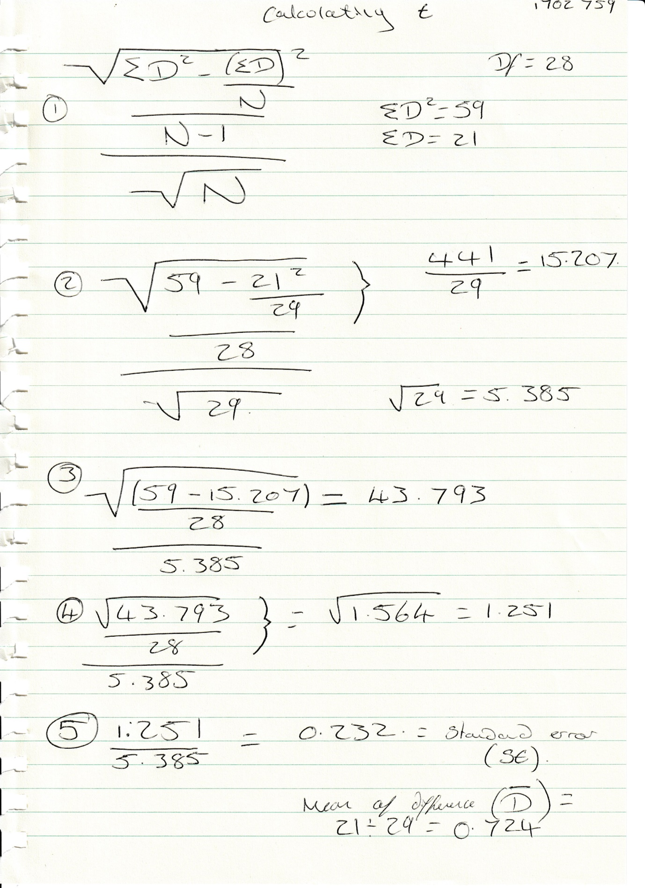

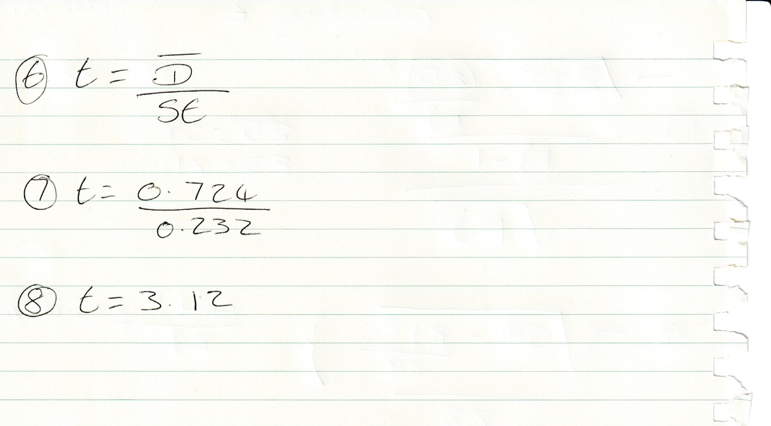
Appendix A
Appendix B

School of Psychology
Townhill Campus
Swansea

Study Consent Form

I understand that taking part in this research study will involve me viewing a number of faces and attempting to recall the faces I have already seen.
I understand that this study consists of two parts. Part one will take approximately two minutes and will consists of me viewing a number of faces. For part two, I understand that I need to pay attention to the faces being presented and record which faces were shown in part one.
I understand that participation in this study is entirely voluntary and I am free to withdraw at any time without giving a reason. I am aware that if I have concerns about the study I can discuss these concerns with the researcher at any time during or after the study.
I understand that the information provided by me will be used for the purpose of providing data for analysis, but that this data will be held confidentially and anonymously, with a code assigned in place of my name. These data will be stored in accordance with the Data Protection Act.
I also understand that at the end of the study I will be provided with a debrief form and the opportunity to discuss any issues with the researcher.

I, ___________________________________( NAME) consent to participate in the study conducted by Stacey Coleman, School of Psychology, University of Wales Trinity Saint David, Swansea.

Participant Signature:________________________________________________

Date:___________________

Name and signature of researcher taking consent:
Stacey Coleman

Appendix C

