Introduction

Steel
‘The Gherkin’, London

Listed as 30 St. Mary Axe, ‘The Gherkin’, is the second largest building in London. Situated in the heart of the city, it was designed architecturally, socially and spatially with the city’s environment, as well as sustainability in mind.

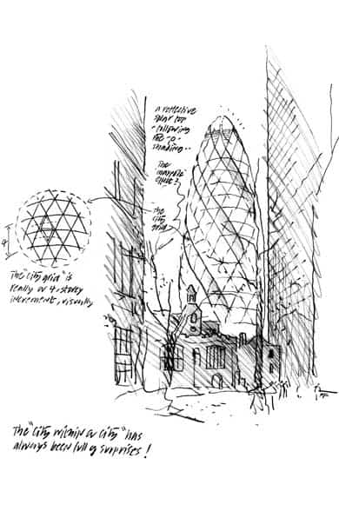
Figure 1- The architect’s original concept.

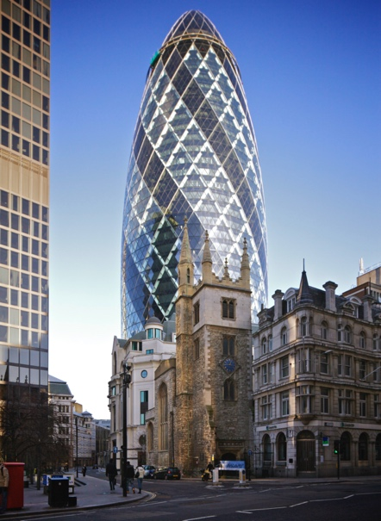
Figure 2- The Gherkin, when finished

‘The Gherkin’ was designed as a diagrid steel frame. The frame is formed from diagonal columns creating the visible diamond effect, which is one of the building’s most defining features.

Typical steel frames, provide stiffness through braced bays or moment connections, designed to withstand and resist lateral forces, whereas, a diagrid frame is designed with diagonally intersecting framework, which provides the required strength that a typical steel frame would, but also requiring less steel. Not only does this positively impact the sustainability of the building, through less materials being produced and transported, but it also results in lower costs (in materials and labour) and provides greater opportunities for more space and natural light to be let into the building, through its design.

A diagrid frame can be quickly erected and is designed to resist both gravity and lateral loads. The floor beams span from a central core to the external diagrid frame; it’s this external frame, combined with the internal core, that supports the gravity load, as well as resisting the lateral wind loads. This means that fewer columns are required, internally, resulting in a larger and more open space being available for use. This increases the social and commercial benefits that the building has to offer.

The structural steel elements forming the diagrid frame are fabricated offsite and transported when ready for construction; this provides a fast construction time for the main frame.

The building is circular on plan, and at ground level, the building is much slimmer; this was designed to provide maximum space for the public and street use. The circumference of the building on plan, increases from the ground level, as you go up towards the mid-height of the building. It then begins to taper towards the top, with a glass domed roof; this is what gave this structure the nickname, ‘The Gherkin’.

The Gherkin was built with various sustainability features, all designed with its carbon footprint in mind. The design and aerodynamic shape of the Gherkin allows it to reduce wind deflections, while the shape of the lower part of the building, allows for the wind to wrap around it, helping to minimise wind loads. The building utilises its 6 cores for passive solar heating, by allowing cool air to circulate through the building during summer, and recirculating the hot air, through winter, helping with the building’s natural ventilation system.

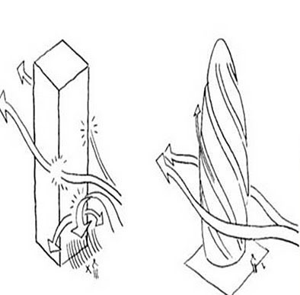

Figure 3- Wind deflection shown for The Gherkin, compared to conventional shaped tower.

The total time taken to build “The Gherkin’, was two years.

Concrete
The Clement Canopy, Singapore

The Clement Canopy is a residential high-rise development, consisting of two 40 storey apartment blocks. It includes communal facilities, a swimming pool, tenant car park, and a combined total of 505 residential units.

Both towers are 140m high and are said to be the tallest modular buildings in the world. They were constructed using prefabricated concrete modules, which were all built off site, before being transported and assembled on site. These structures are also the first in Singapore to use an all-concrete version of PPVC.

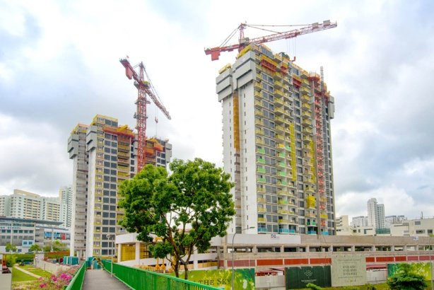
Figure 4- Clement Canopy being stacked and assembled

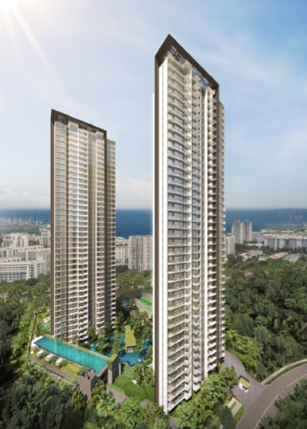
Figure 5- The Clement Canopy, when finished

The modules were cast in Malaysia, before being transported to Singapore for internal finishing and finally, were delivered to site for construction.

By building each module, off site, the site and surrounding environment would have suffered from much less disturbance; including disturbance and pollution from machinery travelling to and from site, for an extended period, as well as the additional disturbance that would’ve been created by the large team of people required to be on site, throughout the build.

Being built off site, would also mean that each module would’ve been cast and constructed in a factory-controlled environment, meaning, in turn, less materials would’ve been wasted, while the build time would’ve been significantly reduced, compared to if it had been cast in-situ.

These factors would’ve reduced the project’s carbon footprint, while also reducing the project’s costs, through improved wastage controls (both off site and on site), lower labour costs and time.

The core of Clement Canopy is made of cast in-situ concrete. This core was built at the same time as the modules were stacked and assembled.

The total time of the build, for both towers, was a little over one year.

Discussion

The Gherkin is situated in a city environment, so is not exposed to any extreme or coastal conditions. However, the building is fully glazed and there would be some potential issues surrounding condensation with the steel work, as well as thermal bridging.

Typically, all structural steel is primed with a protective coating to ensure a basic form of corrosion protection is provided. The Gherkin has glazing and would’ve had a sophisticated ventilation system in place to reduce the potential for condensation, however it is likely that an enhanced corrosion protection would’ve been applied to the steelwork. An alternative to protective coatings is weathering steel, which could have been specified, however, this is costly and would’ve affected the aesthetics of the steelwork. To reduce condensation, thermal breaks may have been installed at the interfaces between the glazing frameworks and the main structural steelwork, aiding in the reduction of heat loss and also the reduction of condensation.

Concrete climate resistance is provided by concrete cover; this is the protective layer of concrete provided to the steel reinforcement. The concrete cover can be increased or reduced, based on the expected corrosion, such as carbonation in marine environments.

Concrete is a porous material, which water can penetrate. Singapore is humid and is subjected to regular and extreme rain fall events, which need to be considered during the specification of the concrete and the cover required. To counter this, the Portland Cement content of the concrete could be increased, and the concrete could be air entrained to enhance its durability and resistance to climatic effects.

Singapore is typically a hot country, which means the possibility of early on thermal cracking occurring, during the hydration process is high. Additives to regulate these temperatures may be required to ensure the concretes design strength isn’t compromised, thus keeping thermal cracking to a minimum. Additives can be used to reduce thermal temperatures during curing.

The structural steel that was used to construct the frame of The Gherkin, would’ve been created through the hot rolling method. “Hot-rolling is a primary shaping process in which massive red-hot billets of steel are rolled between several sets of profiled rollers.” (MacDonald, 2019, pp. 52).

Structural steel has a large carbon footprint due to the intense mining and refining processes of its raw materials. Typically, iron ore is mined or quarried. Once the raw materials have been extracted, they then need to be smelted, removing any impurities. Following this, other alloys such as nickel, for example, are added and then formed into steel billets. These billets can then be hot rolled into a variety of other structural steel section sizes.

As described in Mining of Iron Ore (The World Counts, 2021), the mining of iron ore comes at a high cost to the environment. Many gases are produced and are released into the atmosphere, including carbon dioxide, carbon monoxide, nitrous oxide and sulphur dioxide. These are all created from the large equipment and machinery used for the extraction and mining process. Some mining also causes excess acids to be released from the mines into the surrounding watercourses, resulting in water pollution. In addition to this, the mining and quarrying process destroys the natural environments for flora and fauna, as well as changing the natural landscape.

One of the main bi products from making structural steel is blast furnace slag. There is an approximate recovery rate of 80% for steelmaking slag, to up to 100% for iron making slag.

Depending on its form (categorised by how it is cooled), there are various new uses for slag to be re-purposed. Some of it is reused in the steelmaking plant, while some is reused in other construction projects. One notable example is that it is often used as a sustainable alternative in concrete, to reduce the Portland Cement content.

The typical process for making concrete, consists of combining cement with water, aggregates and admixtures. Each type of build or structure requires a different type of mix, each varying in strength and workability. Each project will have its own requirements for the concrete, to meet its design brief for the build, and in addition to this, the mix chosen will also be dependent on the immediate surrounding environment.

The main component of concrete is Portland Cement. Portland Cement is the most used type of cement, mainly because its core ingredients are natural materials that are readily available and in large quantities, in most places around the world.

To create Portland Cement, limestone is passed through a kiln and heated to 1900 degrees, to burn off carbon dioxide. This process turns the limestone in to calcium oxide, also referred to as ‘quick lime’. Additives, such as silica, alumina and iron are incorporated and together, they form ‘clinker’. The clinker is ground accordingly, and has gypsum added to it.

The concrete that was used to build The Clement Canopy, was pre-cast and created off site. Although this meant that the site in question would have suffered far less disturbance, compared to a project that used cast in-situ, the modules still used concrete, but were formed somewhere else and transported, which would have resulted in other emissions being emitted.

The chemical process in making cement, is what makes it particularly harmful to environment. According to Dezem (2019), it’s estimated that around 66% of the polluting gases created during the cement making process, originates from the burning of limestone. The carbon dioxide that is burned off, is what is released into the atmosphere.

Bloomberg states that “Manufacturing the stone-like building material is responsible for 7 per cent of global carbon dioxide emissions, more than what comes from all the trucks in the world.” (Dezem, 2019). Dezem also states that “A ton of cement yields at least half a ton of CO2”, which she claims is confirmed by the European Cement Association.

In comparison to this, Hoffman, Van Hoey and Zeumer (2020) claim that” Every ton of steel produced in 2018 emitted on average 1.85 tons of carbon dioxide, equating to about 8 percent of global carbon dioxide emissions.”

This data shows that even though both materials would have had a notable negative impact on their respective environments at point of manufacture, the manufacture of steel, at least allows for the bi products to be reused, in other parts of the steel making process. Steel is also fully recyclable and reusable, so can be repurposed in future structures, thus reducing the need for the full amount to be remade from scratch, each time. Concrete, however, is far less adaptable and cannot be recycled.

Although The Gherkin looks like it would have been difficult to build, due to its complex looking design, shape and height, it likely would have been much easier to have built this, than it would have been to build something of a similar size out of concrete, particularly in such a built up and busy area as central London.

One of the benefits of a steel frame, is that it is all made to measure, off site and with great precision. Structural steel can also be made in to varying curves and shapes, creating endless design opportunities.

As steel is so easy to assemble, it also results in a much shorter build time and lower labour costs. As The Gherkin was built in the centre of London, where there’d be very little room or access for huge machinery or materials to be on site, in large quantities or for long durations, a steel frame building was an ideal solution, as materials could be delivered to site and erected, immediately, without the need for excess materials, workmen or equipment. Whenever the steel provided was erected, the next batch could be delivered to site, when required, to go through the same process.

Steel can also be easily dismantled and reassembled. As the primary connections are either made with bolts or welding, it can be taken apart with relative ease, allowing it to be adapted into new shapes or designs. Depending on its condition at the end of its use in its original structure, it can also be reused in other projects, or be recycled by being re-smelted to a new batch of steel that is created, in the blast furnace. Steel can also be used to adapt, alter and modify existing concrete, timber and masonry structures, making it extremely versatile, adding to its sustainable advantages over other materials.

A typical concrete building would not have the same advantages as steel, when it comes to ease of assembly. The building of a concrete frame is not only a more complex process, due to the erection of the formwork, the setting and curing requirements and the large amounts of materials and machinery needed, but also it is a much lengthier process.

The Clement Canopy however, was an exception to the typical concrete frame build, because the majority of it was cast off site, leaving only the assembly of the pre-fabricated modules to be conducted on-site. This would have allowed for the build to have been completed in a fraction of the time that it would have taken, if it had been cast on site, through usual methods.

Concrete, is hard (and sometimes dangerous) to dismantle, making it difficult to be adapted or recycled. Although it’s not impossible, its ability to be adapted is very complex and in most cases, it isn’t an option. While not being suitable for adaptation, concrete is almost useless, once it’s demolished.

Unlike steel, that can be recycled, completely, concrete has far fewer alternative uses. Concrete can be reused to make recycled aggregate, for future concrete mixes, but often, it ends up in landfill.

In contrast, each modular unit that was used to build The Clement Canopy, should be able to live out a longer life cycle, than a typical concrete framed structure. As each module was cast separately and stacked, to assemble the final build, this means that each unit should also be able to be removed, once by one, and potentially serve out a new purpose, in its modular form. While this is a better alternative to usual concrete frames, the modular units, will at some point meet the end of their life cycle, and may ultimately end up in landfill, albeit after (hopefully) serving a longer life span, beforehand.

To summarise, I have listed the main pros and cons of using structural steel and concrete, for easy and visual comparison-

Comparison of Pros and Cons
Structural steel |  | Prefabricated concrete modules
Pros | Cons | Pros | Cons
Easier to erect | More expensive | Is cheaper than other framing materials | Non- recyclable
100% re-useable or recyclable | Needs protection from corrosion and fire | Has potential for reuse (unlike typical concrete structures) | Has limited ability for re-use and recycling
Adaptable | Intense mining process has a large carbon footprint | Erection is quicker than casting and forming on site (and in this instance, was quicker than the erection of “The Gherkin’) | Curing process is time consuming
Easily dismantled | Transport of the product, leaves a carbon footprint | Cast off site in a quality-controlled environment | Needs reinforcement to create larger spans
Diverse architectural shapes |  | Modules come pre-finished and ready for use, including services | Has a large carbon footprint
Made with precision |  |  | Transport of the product, leaves a carbon footprint
Production is quality controlled, off site
Bi products can be reused
Can create large spans
Table 1 - Showing the pros and cons of the two construction methods discussed above.

As the above table shows, there are more benefits of using steel, than there are, for using the modular concrete framing, that has been discussed in this report.

Although there are more benefits to using the concrete modules, than there would be in using typical concrete, for framing a structure, the use of steel still offers a wider selection of advantages and has less disadvantages than other forms of concrete and concrete construction methods, discussed.

Despite the large carbon footprint that they both leave, during manufacture, steel, at least, can be mostly recycled, repurposed and adapted. In addition to this, its bi products can also be fully reused for something else, instead of only causing damage to the environment.

This may not make up for the negative impact made at point of manufacture, but it does mean that if used for as much as it can possibly give, for its full lifecycle, it does its best to counteract this damage, and makes itself more advantageous than using concrete.

Reference List

Figure 1- https://www.buildingthegherkin.com/pictures/hires/City-Norman_Foster.jpg

Figure 2- https://www.timeout.com/london/attractions/the-gherkin

Figure 3- https://brandondonnelly.com/2013/11/24/who-knew-gherkins-were-so-aerodynamic/

Figure 4- http://dragages.com.sg/projects-post/the-clement-canopy/

Figure 5- https://www1.bca.gov.sg/buildsg/productivity/design-for-manufacturing-and-assembly-dfma/prefabricated-prefinished-volumetric-construction-ppvc/prefabricated-prefinished-volumetric-construction-case-study-the-clement-canopy

Angus J. MacDonald (2019). Structure and Architecture. 3rd ed. New York: Routledge. 52.

The World Counts (2021) Mining of Iron Ore. Available at: https://www.theworldcounts.com/challenges/planet-earth/mining/environmental-impact-of-steel-production/story (Accessed: 21 November 2021).

Dezem, V. (2019) Cement produces more pollution than all the trucks in the world. Available at: https://www.bnnbloomberg.ca/cement-produces-more-pollution-than-all-the-trucks-in-the-world-1.1277216 (Accessed 21 November 2021).

Hoffman, C, Van Hoey, M, Zeumer, B. (2020). Decarbonization challenge for steel. Available at: https://www.mckinsey.com/industries/metals-and-mining/our-insights/decarbonization-challenge-for-steel (Accessed 21 November 2021).

