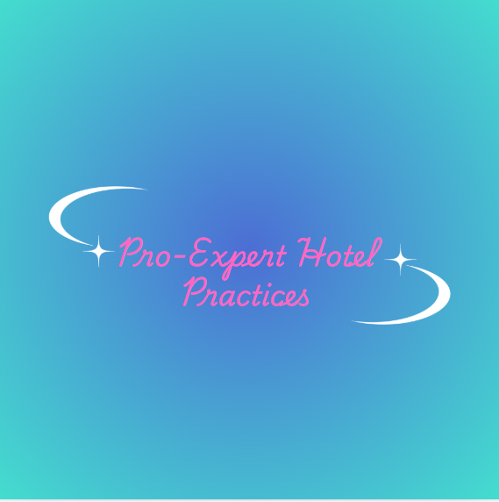
BMIH6005 Organisational Consultancy- LEVEL 6
Consultancy Report for Saman Boutique Hotel – The Housekeeping and Maintenance Department
Consultancy company name: Pro-Expert Hotel Practices
March 4, 2025
Lecturer: Jaliya De-Silva
Flor Yasmin Perez Paula 2226712
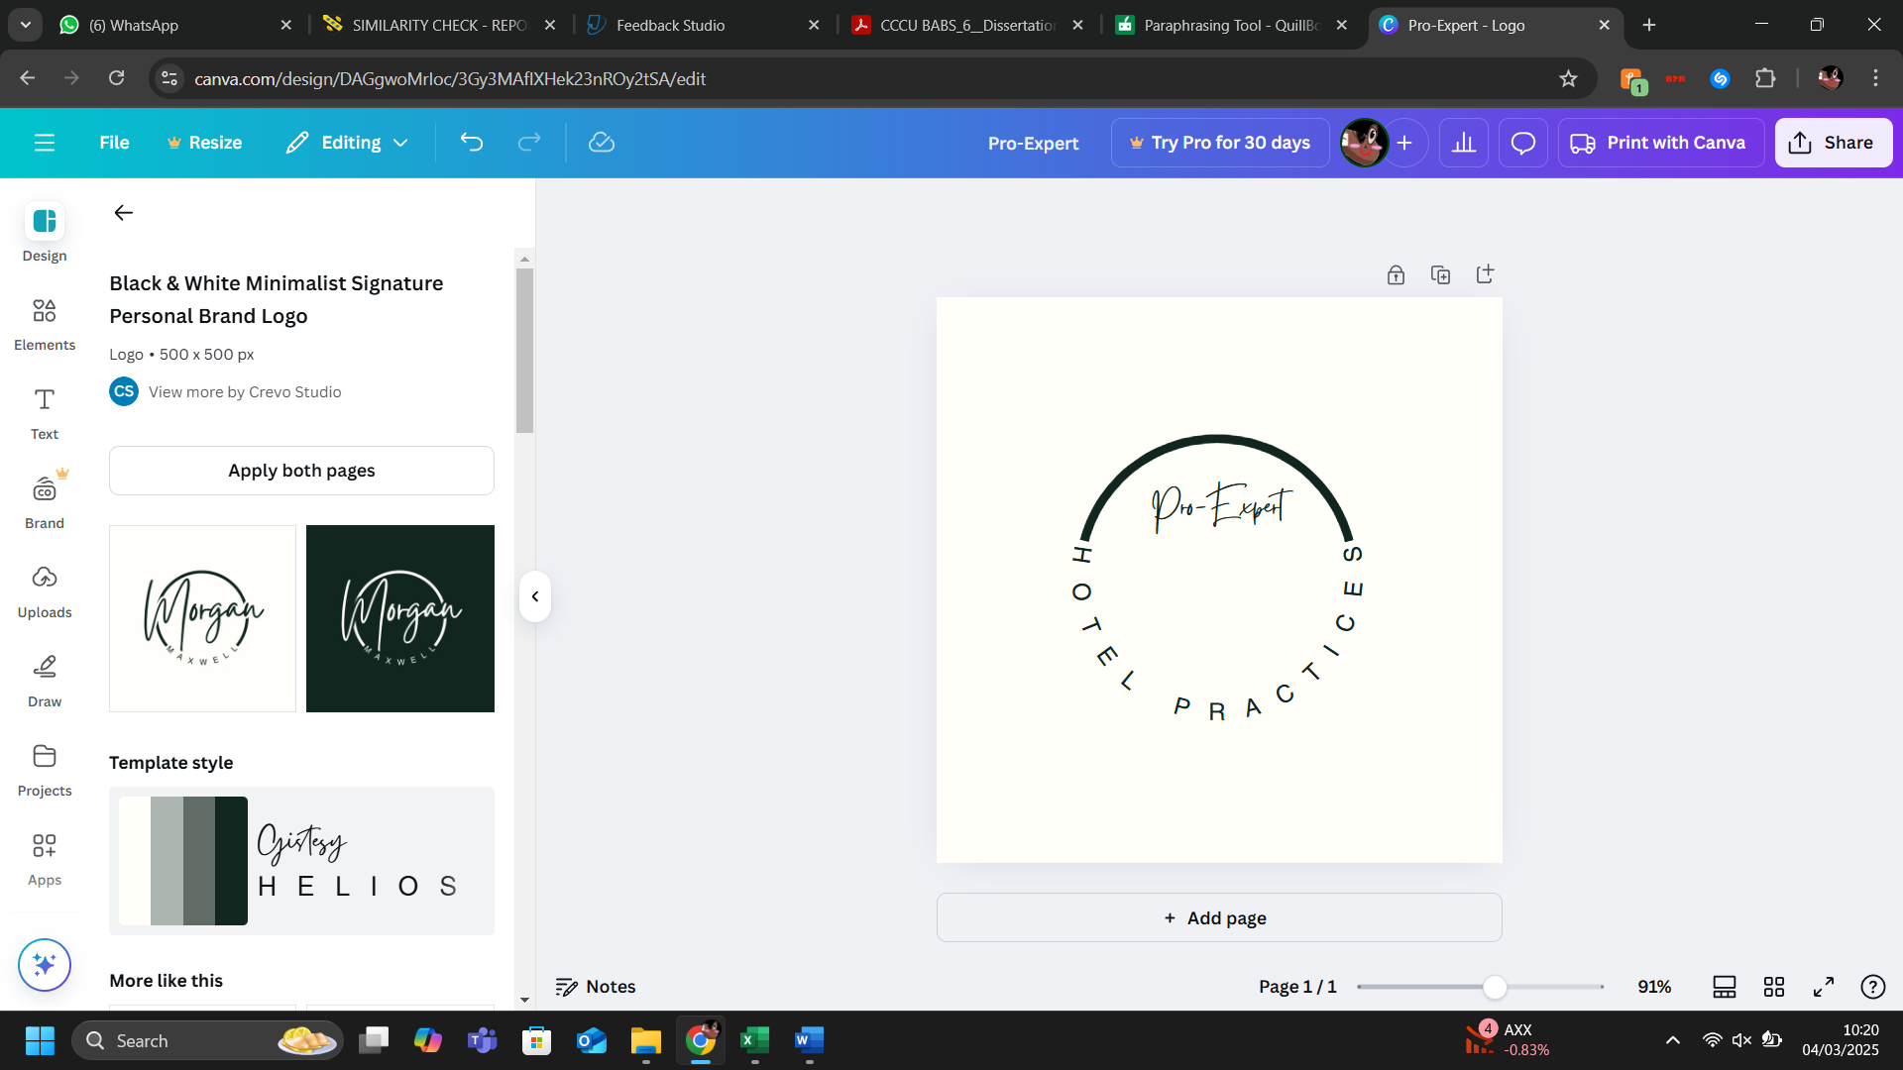
Table of Contents
Executive Summary 3
1. Introduction 3
1.1. Background of Saman Boutique Hotel ​ 3
1.2. Background of the Consultancy Firm ​ 9
1.3. Theories and Frameworks ​ 9
1.4. Objectives of the Report 10
2. Analysis 10
2.1. Identified Issues and Their Impact ​ 11
2.1.1. Room Conditions and Maintenance 11
2.1.2. Noise Disturbances ​ 12
2.1.3. Customer Services 12
2.2. Causes of the Issues ​ 13
2.2.1. Inadequate Maintenance and Upkeep ​ 13
2.2.2. Poor Soundproofing and Location ​ 13
2.2.3. Inadequate Training and Management of Staff ​ 13
2.2.4. Impact on Hotel Performance ​ 15
2.3. Analysis Using Strategic Frameworks ​ 15
2.3.1. STEEPLED Analysis ​ 15
2.3.2. SOAR Analysis 17
2.3.3. TOWS Analysis ​ 18
3. Recommendations and Change Management 19
3.1. Recommendations 19
3.2. Implementation 20
3.3. Measurement 21
3.4. Costs 22
4. Action Plan 22
5. Conclusion 24
Reference List 24

Figure 1. Brand logo 6
Figure 2. Hotel location 7
Figure 3. Deluxe room 7
Figure 4. Deluxe terrace room 8
Figure 5. Junior suite 8
Figure 6. Suite 9
Figure 7. Restaurant 9
Figure 8. Rooftop bar 10
Figure 9. Pool area 11
Figure 10. Saman Boutique Hotel 11

Table 1. STEEPLED Analysis 18
Table 2. SOAR Analysis 19
Table 3. TOWS Analysis 21
Table 4. Action Plan 25

Executive Summary
This consultancy report, prepared by Pro-Expert Hotel Practices, addresses the operational challenges faced by Saman Boutique Hotel in Las Terrenas, Dominican Republic, specifically focusing on the housekeeping and maintenance department. The report aims to deliver a thorough analysis of the issues, evaluate their impact on the hotel's performance and guest satisfaction, and offer practical recommendations to enhance operational efficiency and ensure sustainable growth.
Saman Boutique Hotel, a three-star boutique hotel with 24 rooms, is located in one of the most attractive communities in the Samana Peninsula. The hotel is an ideal destination for travellers who are seeking a serene and comfortable stay, as it offers a distinctive combination of contemporary amenities and natural beauty. The hotel's overall performance and guest satisfaction have been adversely affected by a number of operational challenges, despite its numerous positive aspects, such as a beautiful design, a friendly staff, and high ratings for cleanliness and room quality.
The primary issues identified include room conditions and maintenance, noise disturbances, and customer service. Guests have reported problems such as fluctuating shower temperatures, malfunctioning air conditioning, musty odours in rooms, and inconsistent hot water supply. Additionally, noise disturbances due to the hotel's location near busy roads and poor soundproofing have negatively impacted the guest experience. Customer service issues, including inconsistent room assignments, mishandling of reservations, and poor responsiveness to complaints, have further marred the hotel's reputation.
The root causes of these problems include inadequate maintenance and upkeep, poor soundproofing, and insufficient training and management of staff. The recurring nature of these issues suggests a need for more rigorous maintenance protocols, better management practices, and comprehensive training programs to ensure that all facilities are in proper working order and that staff are equipped to provide excellent customer service.
To address these challenges, the report utilises several strategic frameworks, including STEEPLED, SOAR, and TOWS. The STEEPLED analysis highlights the external factors affecting the hotel, such as the increasing demand for budget-friendly accommodations, technological advancements, economic conditions, environmental considerations, political and legal regulations, ethical standards, and demographic shifts. Addressing these factors through upgrades and better maintenance practices can significantly enhance guest satisfaction and overall hotel performance.
The SOAR analysis focuses on the hotel's internal strengths and opportunities, as well as its aspirations and desired results. The hotel's strengths include its strategic location, range of amenities, spacious and clean rooms, and high ratings for cleanliness and service. Opportunities for improvement include investing in regular maintenance, enhancing customer service training, and implementing soundproofing measures. The hotel's aspirations include enhancing guest satisfaction, maintaining high standards of cleanliness, and offering unique, sustainably designed accommodations. The desired results include increased occupancy rates, positive guest reviews, and a strong reputation in the hospitality market.
The TOWS analysis builds on the findings from the STEEPLED and SOAR analyses to develop strategic recommendations for Saman Boutique Hotel. By addressing the identified weaknesses and threats, such as inadequate maintenance, poor soundproofing, and untrained staff, the hotel can capitalise on its strengths and achieve its desired results.
The report provides several key recommendations to address the identified issues and improve the guest experience. These include upgrading room amenities, implementing rigorous cleaning protocols, installing soundproofing materials, providing comprehensive training to staff, developing a regular maintenance schedule, and ensuring transparent pricing. Additionally, the report outlines effective change management strategies, including developing a comprehensive communication plan, engaging with key stakeholders, implementing the recommendations in phases, and developing training programs to equip staff with the necessary skills and knowledge.
The success of the implemented strategies can be measured through several methods, such as Key Performance Indicators (KPIs), customer feedback, operational metrics, financial performance, employee feedback and performance, benchmarking, and implementation reviews. Monitoring these metrics regularly will help ensure that the changes are effective and sustainable, driving continuous improvement and maintaining high standards.
The report also includes a detailed budget plan to cover the costs associated with the recommended changes. The budget considers costs of approximately 8,000–15,000 per room for upgrades and $1,295 per person for training expenses. A comprehensive action plan outlines the key problems, proposed solutions, desired outcomes, time scales, completion dates, and planned budgets to address the identified operational challenges.
In conclusion, this consultancy report provides a comprehensive analysis of the issues faced by Saman Boutique Hotel and offers practical recommendations to enhance its operational efficiency, improve guest satisfaction, and ensure sustainable growth. By implementing the proposed strategies and change management practices, Saman Boutique Hotel can address its current challenges, capitalise on its strengths, and achieve long-term success in the competitive hospitality market.

Introduction

Background of Saman Boutique Hotel ​
Saman Boutique Hotel Located in Las Terrenas, one of the Samana Peninsula's most attractive and genuine communities in the Dominican Republic. It is a three star boutique hotel with 24 rooms and entertaining common areas near the beach (Saman Boutique Hotel, 2025a). The hotel is named after the Saman tree, also known as the rain tree, whose leaves behave differently after heavy rains. The hotel is an ideal destination for travellers who are seeking a serene and comfortable stay, as it provides a distinctive combination of contemporary amenities and natural beauty (Saman Boutique Hotel, 2025a). Notably, it is part of Mint Hotels & Residences (2025), which encompasses five different hotels located in Samana, Puerto Plata, and La Romana, three of the most attractive places in the Dominican Republic.


Figure 1. Brand logo
Source: Saman Boutique Hotel, 2025a

Saman Boutique Hotel is located in Abra Grande Avenue 7, Las Terrenas, Samaná, Dominican Republic. Please see the picture below for an illustration.
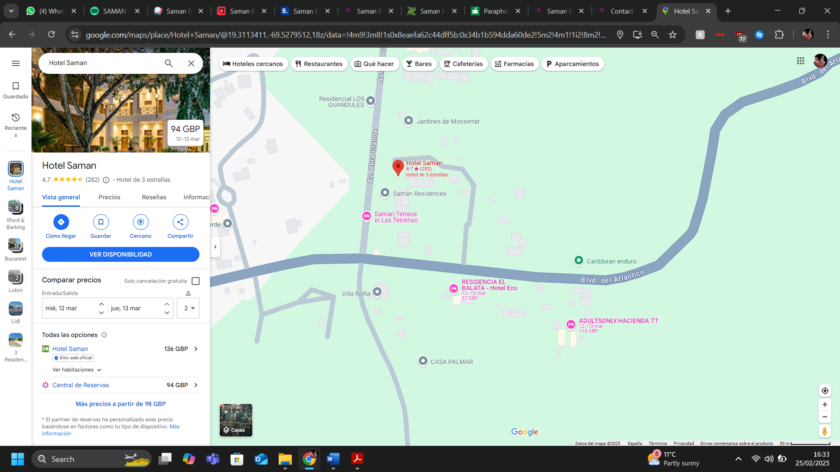
Figure 2. Hotel location
Source: Saman Boutique Hotel, 2025a
According to Tripadvisor (2025), the price range is between $117 and $195, based on average rates for a standard room. Additionally, the Nearby Attractions include Playa El Portillo (1.2 miles), Playa Bonita (3.0 miles), and Playa Las Ballenas (1.8 miles), as per Tripadvisor (2025). Amenities include free WiFi, available throughout the property; free breakfast, included with the stay; access to a pool; on-site restaurant and lounge, offering a variety of food and drink options; free parking; airport transportation only with a call ahead to confirm details; wheelchair access for disabled guests (Tripadvisor, 2025). Moreover, the room features include air conditioning, room service, safe, non-smoking rooms, suites, and smoking rooms (Tripadvisor, 2025).
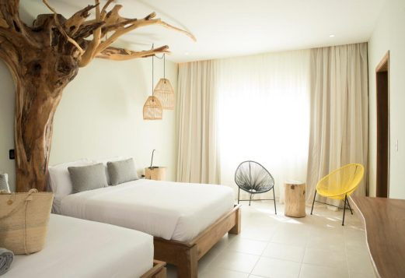
Figure 3. Deluxe room
Source: Saman Boutique Hotel, 2025b

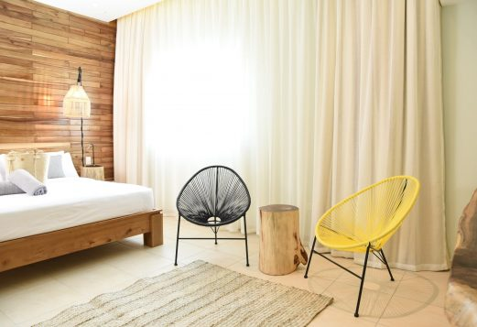
Figure 4. Deluxe terrace room
Source: Source: Saman Boutique Hotel, 2025b

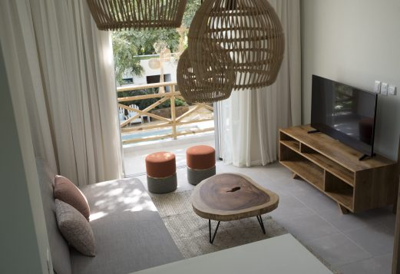
Figure 5. Junior suite
Source: Saman Boutique Hotel, 2025b

Figure 6. Suite
Source: Saman Boutique Hotel, 2025b

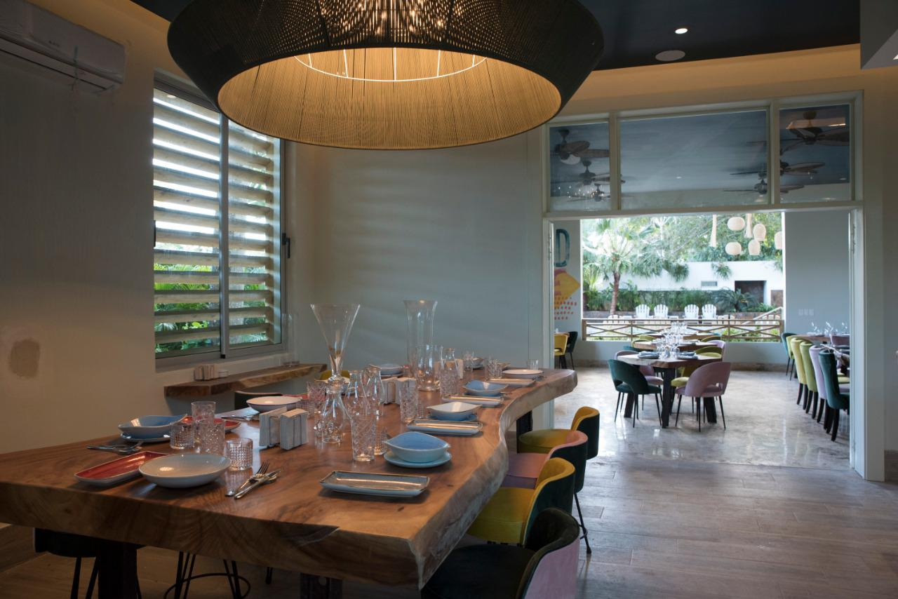
Figure 7. Restaurant
Source: Saman Boutique Hotel, 2025c
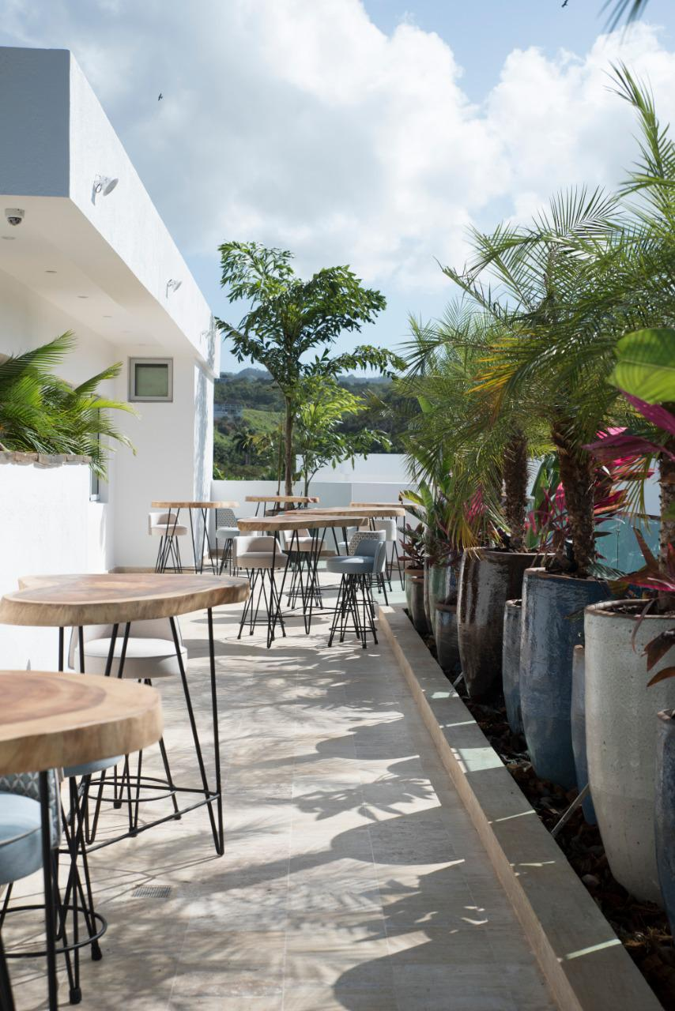
Figure 8. Rooftop bar
Source: Saman Boutique Hotel, 2025c
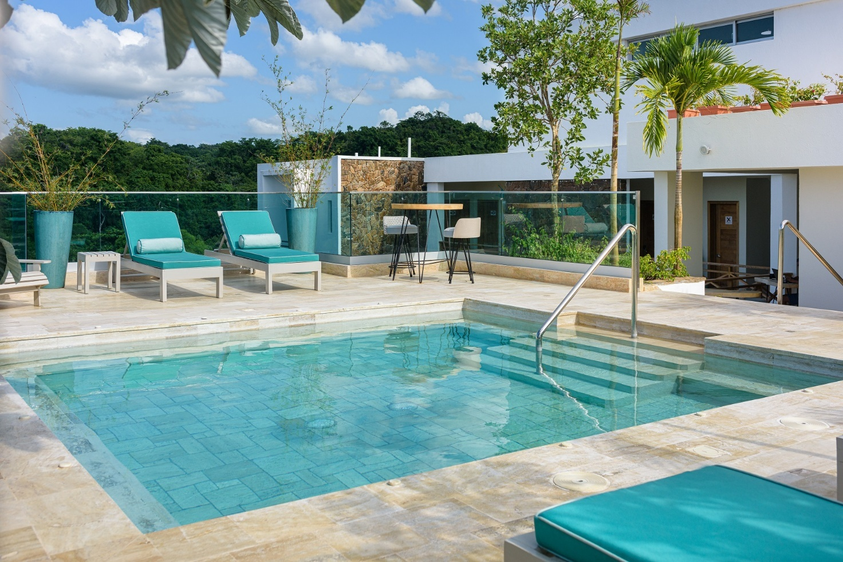
Figure 9. Pool area
Source: Saman Boutique Hotel, 2025c
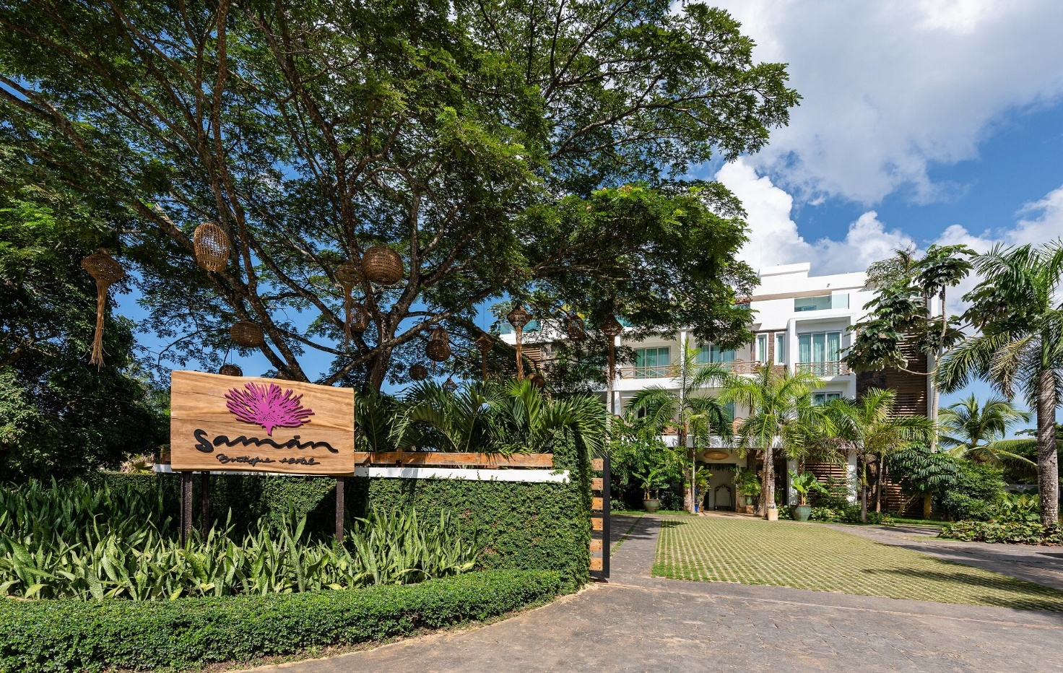
Figure 10. Saman Boutique Hotel
Source: Saman Boutique Hotel, 2025c

Background of the Consultancy Firm ​
Pro-Expert Hotel Practices specialises in providing strategic consultancy services to the hospitality industry (Sharifovich, 2021). Our firm is dedicated to helping hotels enhance their operational efficiency, improve guest satisfaction, and achieve sustainable growth (Sharifovich, 2021; Ibrahim and Rasheed, 2024). With a team of experienced consultants, we employ a range of analytical frameworks and methodologies to deliver actionable insights and recommendations tailored to the unique needs of each client (Florido-Benítez, 2024; Santarsiero et al., 2024). ​ Our expertise spans various aspects of hotel management, including operations, customer service, marketing, and financial performance (Putra and Law, 2024; Sharma et al., 2024).

1.3. Theories and Frameworks ​
To analyse and address these issues, this report will utilize several strategic frameworks, including STEEPLED (Social, Technological, Economic, Environmental, Political, Legal, Ethical, and Demographic analysis), SOAR (Strengths, Opportunities, Aspirations, and Results analysis), and TOWS (Threats, Opportunities, Weaknesses, and Strengths analysis).
The STEEPLED analysis will provide a comprehensive overview of the external factors (Saidova and Muminjonova, 2022) that may be influencing Saman Boutique Hotel’s operations. This includes examining social trends, technological factors, economic situation, environmental considerations, political and legal regulations, ethical standards, and demographic shifts. By understanding these external influences, the hotel can better adapt to changes and mitigate potential risks (George, 2021; Ramely et al., 2023). ​
The SOAR analysis will focus on the hotel's internal strengths and opportunities, as well as its aspirations and desired results (Andriansyah and Buhairi, 2023; Elgahwash, Ahmed and Al-Magarbi, 2023). This framework will help identify what the hotel is doing well and where there are opportunities for growth and improvement (Vardopoulos et al., 2023). ​ Additionally, it will highlight the hotel's long-term goals and the steps needed to achieve them.
The TOWS analysis will build on the findings from the STEEPLED and SOAR analyses to develop strategic recommendations (Saidmamatov et al., 2021) for Saman Boutique Hotel. This framework will help convert identified threats and weaknesses into opportunities and strengths. Thus, by addressing the hotel's challenges in a strategic manner, the TOWS analysis will provide actionable solutions that can enhance the hotel's performance and guest satisfaction (Elgahwash, Ahmed and Al-Magarbi, 2023).

1.4. Objectives of the Report
This report aims to deliver a thorough analysis of the issues faced by Saman Boutique Hotel and offer practical recommendations to enhance its operational efficiency, improve guest satisfaction, and ensure sustainable growth (Sharifovich, 2021; Ibrahim and Rasheed, 2024). The objectives of the report are as follows:
- To identify and analyse the key operational challenges faced by Saman Boutique Hotel. ​
- To evaluate the impact of these challenges on the hotel's performance and guest satisfaction. ​
- To develop strategic recommendations for addressing the identified challenges. ​
- To provide an action plan for implementing the recommended strategies. ​
- To outline the potential benefits of implementing the recommended strategies. ​
This consultancy report will assist Saman Boutique Hotel in enhancing guest satisfaction, enhancing operations, and attaining long-term success in the competitive hospitality market by achieving these objectives (Sharifovich, 2021; Ibrahim and Rasheed, 2024).

Analysis
While the hotel has many positive attributes, including its beautiful design and friendly staff, there are areas for improvement, particularly in maintenance, food quality, and customer service. As per Tripadvisor (2025), the guest review overall rating is 4.5 out of 5 (Very Good). Location is rated at 4, rooms at 4.9, value at 4.8, cleanliness at 5, service at 4.7, and sleep quality at 4.8.
In general, the analysis of the reviews on Booking.com (2025), Hotels.com (2025), Tripadvisor (2025) and Zen Hotels (2025) show that guests have praised the hotel for its beautiful design, cleanliness, and spacious rooms. The staff is generally described as friendly and accommodating, although there have been some issues with specific staff members and room assignments. On the other hand, some guests have reported maintenance issues, such as fluctuating shower temperatures, malfunctioning air conditioning, and cleanliness concerns in certain areas like the rooftop jacuzzi. Moreover, the food quality and variety have received mixed reviews, with some guests experiencing food poisoning and others finding the menu limited and not up to their expectations. Additionally, noise disturbances due to poor soundproofing and the hotel's location near busy roads have been mentioned by some guests. These challenges are not only affecting the hotel's current performance but also its long-term competitiveness in the hospitality market (Luo, Huang and Wang, 2021; Borowski, Zwolińska and Czerwiński, 2022; Huang, Liang and Choi, 2022; Hsueh and Hsu, 2024; Jeong and Lee, 2024).
The following analysis aims to identify the root causes of these difficulties, assess their impact on the hotel's performance, and provide a thorough interpretation of the issues at hand. ​

2.1. Identified Issues and Their Impact ​

2.1.1. Room Conditions and Maintenance
Saman Boutique Hotel in Las Terrenas, Dominican Republic, has faced several issues related to room conditions and maintenance that have significantly impacted its performance and guest satisfaction (Booking.com, 2025).​ Numerous reviews highlight problems such as fluctuating shower temperatures, malfunctioning air conditioning, and musty odours in rooms (Tripadvisor, 2025). Moreover, guests have reported that fixtures in the showers are falling off, and there have been instances where the hot water supply was inconsistent or entirely unavailable (Booking.com, 2025).​ Additionally, the rooftop jacuzzi has been noted to be dirty and not operational at times, with bird droppings on the chairs (Booking.com, 2025).​ These maintenance issues have led to discomfort and inconvenience for guests, detracting from their overall experience hazard (Borowski, Zwolińska and Czerwiński, 2022). For example, one guest mentioned being downgraded to a room in poor condition after their original room's hot water system broke, resulting in a negative impact on their stay (Booking.com, 2025).​ Such problems not only diminish the hotel's reputation but also lead to negative reviews and lower ratings on platforms like TripAdvisor and Booking.com. These issues indicate a lack of proper maintenance and upkeep (Shen et al., 2021; Zhang et al., 2023), which can significantly impact guest satisfaction and the hotel's overall reputation (Dasandara, Dissanayake and Fernando, 2022). ​​The recurring nature of these issues suggests a need for more rigorous maintenance protocols and better management practices to ensure that all facilities are in proper working order, thereby enhancing guest satisfaction and hotel performance.

2.1.2. Noise Disturbances ​
Noise disturbances at Saman Boutique Hotel have been a recurring issue that has negatively impacted guest experiences and overall satisfaction. Several reviews highlight that the hotel's location near busy roads results in constant noise, which disrupts the tranquillity that guests expect.​ For instance, one guest mentioned that the rooms overlooking the road were noisy 24 hours a day, making it difficult to rest (Tripadvisor, 2025). Additionally, the lack of soundproofing in the rooms exacerbates the problem, as guests can hear noise from adjacent rooms and the outside environment (Booking.com, 2025). This issue is particularly problematic for guests who are light sleepers or those who require a quiet environment to rest (Ding et al., 2024). ​ Another review pointed out that the noise from cars and motorcycles outside was clearly audible, further diminishing the quality of the stay (Booking.com, 2025). The hotel's management has not effectively addressed these concerns, leading to repeated complaints and lower ratings (Booking.com, 2025; Tripadvisor, 2025). The inability to provide a quiet environment has led some guests to leave the hotel earlier than planned, as they were unable to get adequate rest. In general, this inability to provide a peaceful and quiet stay leads to negative reviews and a decline in repeat business (Ding et al., 2024; Rezaei et al., 2024). ​​As a result, addressing these noise disturbances is crucial for improving guest satisfaction and maintaining the hotel's reputation.

2.1.3. Customer Services
Customer service at Saman Boutique Hotel in Las Terrenas, Dominican Republic, has been a mixed experience for guests, with both positive and negative aspects impacting overall satisfaction. On the positive side, many reviews commend the friendliness and helpfulness of the staff, with specific mentions of individuals like Mary and Elisa, who provided exceptional service (Booking.com, 2025). Guests appreciated the accommodating nature of the staff, especially in terms of language barriers and general hospitality (Tripadvisor, 2025). However, there have been significant issues that have marred the customer service experience for some guests. For instance, one review highlighted a negative encounter with the reception head, Ana, who attempted to charge extra for a room upgrade despite the hotel being nearly empty (Tripadvisor, 2025). Another guest faced disappointment when their pre-booked suite was given to someone else, and although they received a refund and a perk, it did not compensate for the inconvenience (Tripadvisor, 2025). Additionally, there have been reports of poor handling of maintenance issues, such as downgrading guests to inferior rooms when problems arose, and a lack of responsiveness to complaints about amenities like the rooftop jacuzzi and hot water supply (Booking.com, 2025). These inconsistencies in customer service and the provided incidents reflect poorly on the hotel's management and can deter potential guests from choosing Saman Boutique Hotel in Las Terrenas for their stay (Ali et al., 2021; Afaq, Gaur and Singh, 2023).

2.2. Causes of the Issues ​

2.2.1. Inadequate Maintenance and Upkeep ​
The recurring problems with room conditions and maintenance can be attributed to inadequate upkeep and a lack of regular maintenance schedules (Erbiyik, 2023; Getz, 2025). The issues with fluctuating shower temperatures, malfunctioning air conditioning, musty odours in rooms (Tripadvisor, 2025), fixtures in the showers falling off, inconsistent or entirely unavailable hot water supply, and dirty and not operational at times rooftop jacuzzi (Booking,com, 2025) suggest that the hotel does not have a robust maintenance plan in place.​ Regular inspections and timely repairs are essential to ensure that the hotel's facilities are in good working condition and that guests have a comfortable stay (Were and Maranga, 2022; Matey, 2024).

2.2.2. Poor Soundproofing and Location ​
The noise disturbances experienced by guests are primarily due to the hotel's location near busy roads results in constant noise, which disrupts the tranquillity that guests expect.​ Additionally, the lack of soundproofing in the rooms exacerbates the problem (Mago et al., 2024), as guests can hear noise from adjacent rooms and the outside environment (Booking.com, 2025). This issue is particularly problematic for guests who are light sleepers or those who require a quiet environment to rest (Ding et al., 2024). ​ The problem is that the hotel's management has not effectively addressed these concerns, leading to repeated complaints and lower ratings, which, in general, leads to a decline in repeat business (Ding et al., 2024; Rezaei et al., 2024).

2.2.3. Inadequate Training and Management of Staff ​
In summary, the customer service issues at Saman Boutique Hotel stem from inconsistent room assignments and upgrades, mishandling of reservations, maintenance and housekeeping problems, poor food and beverage service, lack of communication and responsiveness, general management and staff attitude issues. The problems with customer service can be traced back to inadequate training and poor management of the hotel staff (Ali et al., 2021). The incidents of rude and unhelpful behaviours suggest that the staff may not have received proper training in customer service and conflict resolution (Auh et al., 2024).​ Additionally, they indicate a need for better management practices and clear guidelines for the staff to follow (Waaje et al., 2025).
A guest reported that despite the hotel being nearly empty, the reception head, Ana, attempted to charge extra for a room upgrade that was initially requested during the reservation (Tripadvisor, 2025).​ This indicates a lack of flexibility and poor decision-making by management, which could have been resolved with better training on customer satisfaction and retention strategies. ​
Another guest experienced a situation where their pre-booked suite was given to someone else, and although they received a refund and a perk, it did not compensate for the inconvenience (Tripadvisor, 2025).​ This points to poor management practices and a lack of proper training in handling reservations and ensuring guest satisfaction. ​
Several reviews mentioned problems with room maintenance, such as fluctuating shower temperatures, non-functional hot water, and unclean facilities like the rooftop jacuzzi (Tripadvisor, 2025). ​ One guest noted that the hotel downgraded them to an inferior room when maintenance issues arose (Booking.com, 2025), which reflects inadequate training in problem resolution and guest accommodation.
Another guest reported that the cleaning staff stole money from their room, and the management's response was unsatisfactory (Tripadvisor, 2025), indicating a lack of proper training in security and guest relations.
Moreover, multiple guests complained about the quality and variety of food, with some noting that the menu was limited and the food lacked flavour (Tripadvisor, 2025).​ One guest specifically mentioned that the breakfast options were poor and not as described (Tripadvisor, 2025).​ This suggests that the kitchen and service staff may not be adequately trained in food preparation and presentation.
Furthermore, guests reported that the staff was not responsive to complaints and did not take timely action to resolve issues (Booking.com, 2025).​ For example, a guest mentioned that the rooftop jacuzzi was not turned on despite requests, and another noted that the staff did not restock the fridge and coffee capsules daily (Tripadvisor, 2025), indicating a lack of proper training in communication and responsiveness to guest needs. ​
Lastly, the reviews highlighted that while some staff members were friendly and helpful, others, particularly in management positions, were not accommodating. For instance, the reception head's behaviour and the mishandling of room issues (Tripadvisor, 2025) reflect poor management practices and a lack of training in customer service excellence.
Addressing these issues requires comprehensive training programs focused on customer service, problem resolution, communication, and management practices to ensure a consistently positive guest experience.

2.2.4. Impact on Hotel Performance ​
The identified issues have a major impact on the hotel's performance and reputation. ​ Negative guest reviews can deter potential customers from booking a stay at Saman Boutique Hotel in Las Terrenas, Dominican Republic, leading to a decline in occupancy rates and revenue (Mahadevan and Bilgihan, 2024).​ Additionally, the recurring problems with room conditions, noise disturbances, and customer service can result in a high turnover rate of guests, with many choosing not to return for future stays (Luo, Huang and Wang, 2021; Borowski, Zwolińska and Czerwiński, 2022; Huang, Liang and Choi, 2022; Hsueh and Hsu, 2024; Jeong and Lee, 2024). Additionally, this can further affect the hotel's long-term competitiveness in the hospitality market.

2.3. Analysis Using Strategic Frameworks ​

2.3.1. STEEPLED Analysis ​
According to Saidova and Muminjonova (2022) STEEPLED assessment can provide a comprehensive overview of the external factors that may be influencing Saman Boutique Hotel 's operations, including the examination of social aspects, technological factors, economic circumstances, environmental considerations, political and legal regulations, ethical standards, and demographic shifts.
Please see the following table encompassing the STEEPLED analysis.
Table 1. STEEPLED Analysis
Social | Technological | Economic | Environmental | Political and Legal | Ethical | Demographic
The increasing demand for budget-friendly accommodations in the Dominican Republic (BudgetYourTrip, 2025) presents an opportunity for the hotel to attract cost-conscious tourists. However, the negative reviews and poor guest experiences can hinder the hotel's ability to capitalise on this trend (Ali et al., 2021; Afaq, Gaur and Singh, 2023).​​ | Guests have reported non-functional televisions, including smart TVs, weak Wi-Fi signals, fluctuating shower temperatures, issues with air conditioning units that turn off frequently due to motion sensors, non-functional hot water and broken fixtures in the shower, problems with booking and reservation systems, maintenance and upkeep etc. Addressing these technological factors through upgrades and better maintenance practices can significantly enhance guest satisfaction and overall hotel performance. | The economic conditions in the country, including the cost of living and disposable income levels, can influence the hotel's pricing strategy (Sampaio, Rodrigues and Hernández-Mogollón, 2021). In general, offering competitive rates while maintaining high-quality services can attract more guests and improve occupancy rates, as per Al Fahmawee and Jawabreh (2022), Candra, Mahaputra and Mahaputra (2023), and Santa, Rodríguez Victoria and Tegethoff (2025). | The hotel's location near a busy road contributes to noise pollution, which can negatively impact guest experiences (Ding et al., 2024; Rezaei et al., 2024). ​​Implementing soundproofing measures (Mago et al., 2024) and investing in environmentally friendly technologies can mitigate this issue (Prakash et al., 2023). | Compliance with local regulations and standards is essential for maintaining the hotel's operational license (Oh, 2022). Ensuring that the hotel meets health and safety standards, including proper maintenance of facilities, can prevent legal issues and enhance guest satisfaction (Were and Maranga, 2022; Matey, 2024). | Ethical considerations such as providing a safe and comfortable environment for guests, are crucial for maintaining a positive reputation (Were and Maranga, 2022; Matey, 2024). Hence, addressing the issues with room conditions and customer service can demonstrate the hotel's commitment to ethical practices. Moreover, implementing sustainable practices, the hotel can appeal to eco-conscious travellers (Kuo, Fang and LePage, 2022; Gui and Abdullah, 2024; Murtaza, Khan, and Mustafa, 2024). | According to Diwyarthi et al. (2024), understanding the demographics of the hotel's target market, including age, income levels, and travel preferences, can help tailor services and amenities to meet guest needs. For example, according to Siwek et al. (2022) and Naudé-Potgieter (2023), offering family-friendly accommodations and amenities can attract more families traveling to the Dominica Republic.

2.3.2. SOAR Analysis

A SOAR analysis focuses on the hotel's internal strengths and opportunities, as well as its aspirations and desired results (Andriansyah and Buhairi, 2023; Elgahwash, Ahmed and Al-Magarbi, 2023). Please see the following table encompassing the SOAR analysis.
Table 2. SOAR Analysis
Strengths | Opportunities | Aspirations | Results
• Location: Proximity to popular attractions like Playa El Portillo, Playa Bonita, and Playa Las Ballenas.  • Amenities: Free Wi-Fi, free breakfast, pool, on-site restaurant, lounge, and free parking.  • Room Quality: Spacious, clean rooms with air conditioning, room service, and safes.  • Accessibility: Wheelchair access and facilities for disabled guests.  • Guest Experience: High ratings for cleanliness, service, and sleep quality.  • Unique Design: Sustainably designed rooms with natural elements.  • Airport Transportation: Available for guests. | - Investing in regular maintenance and technological upgrades, enhancing customer service training, and implementing soundproofing measures can address the identified issues and improve guest experiences (Ali et al., 2021; Prakash et al., 2023; Mago et al., 2024).  - Moreover, implementing sustainable practices, the hotel can appeal to eco-conscious travellers (Kuo, Fang and LePage, 2022; Gui and Abdullah, 2024; Murtaza, Khan, and Mustafa, 2024). | - The Saman Boutique Hotel aspires to enhance guest satisfaction by improving customer service, maintaining high standards of cleanliness, and offering unique, sustainably designed accommodations.  - They aim to leverage their prime location near popular attractions to attract more visitors.​  - The hotel seeks to address technological and maintenance issues, improve food quality, and expand menu options.  - Additionally, they aspire to enhance their reputation by resolving booking and reservation issues, ensuring a consistent hot water supply, and providing better in-room amenities.  - These aspirations align with their goal of achieving and sustaining a competitive advantage through effective change management and innovation.​ | - The desired results include increased occupancy rates, positive guest reviews, and a strong reputation in the hospitality market.​  - Achieving these results can lead to long-term success and competitiveness for the hotel (Candra, Mahaputra and Mahaputra, 2023; Bhowmik, Hasan and Nafi, 2024).

2.3.3. TOWS Analysis ​
According to Saidmamatov et al. (2021) and Elgahwash, Ahmed and Al-Magarbi (2023), a TOWS analysis builds on the findings from the STEEPLED and SOAR analyses to develop strategic recommendations for Hotel Sir Orhideea. ​ Please see the following table encompassing the TOWS analysis.
Table 3. TOWS Analysis
Threats | Opportunities | Weaknesses | Strengths
• Location: Distance from the beach and restaurants, requiring transportation.  • Noise: Proximity to noisy roads affecting guest experience.  • Competition: Nearby hotels offering better amenities or services (Booking.com, 2025; Tripadvisor, 2025). | - Addressing the identified issues presents an opportunity for the hotel to improve guest satisfaction and attract more customers.  - Implementing regular maintenance schedules, investing in technological upgrades, and enhancing customer service training can mitigate the threats and leverage the hotel's strengths. | - The hotel's weaknesses include inadequate maintenance, poor soundproofing, and untrained staff.  - Addressing these weaknesses through targeted strategies can enhance the hotel's overall performance. | - Leveraging the hotel's strategic location and range of amenities can attract more guests and improve occupancy rates.  - By addressing the identified weaknesses and threats, the hotel can capitalise on its strengths and achieve its desired results.

Recommendations and Change Management

Guest satisfaction and overall performance have been adversely affected by the numerous operational challenges that Saman Boutique Hotel is confronted with. This chapter aims to address these issues and improve the guest experience, by proposing a series of recommendations and change management strategies. These proposals focus on enhancing room conditions, improving customer service, addressing maintenance issues, and ensuring better value for money. Additionally, effective change management strategies are outlined to facilitate the implementation of these recommendations and ensure a smooth transition. ​

3.1. Recommendations
The first recommendation is to upgrade room amenities, by replacing outdated and malfunctioning amenities. Ensuring that all rooms are equipped with functional and modern appliances will enhance guest comfort (Shen et al., 2021; Borowski, Zwolińska and Czerwiński, 2022; Dasandara, Dissanayake and Fernando, 2022; Zhang et al., 2023). Furthermore, improving cleanliness standards is crucial (Roncally, Susila and Wulandari, 2024; Singgalen, 2024). Hence, it is essential to employ a rigorous cleaning practice to ensure that all rooms are completely cleaned and sanitised, including regular pest control measures (Siddiqi, 2023; Barry, 2024). Moreover, providing training to housekeeping staff to maintain high standards of cleanliness (Kumar, Ghosh, and Mondal, 2021; Evryastuti et al., 2022) will further support this initiative. Furthermore, enhancing room furnishings will also contribute to a more comfortable stay for guests (Ali, Nurin, and Mohi, 2023).
Installing soundproofing materials in the walls and windows will address noise disturbances by reducing noise from neighbouring rooms and external sources (Ding et al., 2024; Rezaei et al., 2024). ​​As a result, a quieter and more restful environment for guests will be created.
Improving customer service is another key recommendation. Hence, a comprehensive training to all staff members on customer service best practices will highlight the importance of responsiveness, professionalism, and courtesy in all interactions with guests (Roncally, Susila and Wulandari, 2024; Singgalen, 2024). Moreover, streamlining the check-in and check-out procedures to ensure a smooth experience for guests is also important (Waaje et al., 2025). Lastly, according to Vinod (2022), a new system for better room assignment and management will help avoid overbooking and room changes.
Addressing maintenance and facilities issues is critical; hence, a regular maintenance schedule will ensure that all maintenance tasks are completed promptly and efficiently, as per Shen et al. (2021) and Zhang et al. (2023). The investment in upgrading the hotel's facilities will ensure that these are well-maintained and meet the needs of guests.
Lastly, ensuring better value for money (Luo, Huang, and Wang, 2021) is another important recommendation. Transparent pricing should be ensured, with all pricing information clearly communicated to guests. Moreover, avoiding overcharging and ensuring that guests are aware of all costs associated with their stay is essential. Lastly, according to Soifer, Choi, and Lee (2021), the enhancement of the guest experience by providing additional amenities and services, such as complimentary breakfast, free WiFi, and access to recreational facilities, will also contribute to better value for money.

3.2. Implementation
According to Radwan (2022), one of the most influential change management models that can be used by a hotel is Kurt Lewin's 1950 change management model. This model outlines three steps for change implementation: Unfreeze, Change, and Refreeze. The first step involves emphasising the need for change to motivate staff to accept it. Hence, effective communication is essential to improve employee comprehension and support for suggested changes (Radwan, 2022). Second, change involves learning new concepts, beliefs, attitudes, ideas, and practices. Lastly, the refreezing stage consists of applying what was learnt into practice.
Overall, effective communication and stakeholder engagement are crucial for successful change management. As a result, developing a comprehensive communication plan to keep all stakeholders informed about the changes being implemented is essential, encompassing regular updates to staff, guests, and management (Radwan, 2022). Engaging with key stakeholders, including staff and guests, in the change process by seeking their feedback and input will ensure that the changes meet their needs and expectations, as per (Radwan, 2022).
Furthermore, implementing the recommendations in phases will minimise disruptions to hotel operations, while allocating the necessary resources, including budget and personnel, will ensure the successful implementation of the recommendations. Thus, prioritising the most critical issues and addressing them first, followed by less urgent improvements, will ensure a smooth transition.​ Moreover, allocating the necessary resources, including budget and personnel, will ensure the successful implementation of the recommendations. Ensuring that all staff members are aware of their roles and responsibilities in the change process is also important (Radwan, 2022).
Developing and implementing training programs to equip staff with the skills and knowledge needed to adapt to the changes is essential (Ali et al., 2021; Auh et al., 2024; Waaje et al., 2025), including training on new cleaning protocols, customer service best practices, and maintenance procedures. Additionally, encouraging a culture of continuous improvement by regularly reviewing and updating training programs and providing opportunities for staff to develop their skills and advance their careers will further support the change management process (Radwan, 2022).
Additionally, according to Uddin et al. (2021), the establishment of key performance indicators (KPIs) to monitor the success of the implemented changes is important. This includes metrics such as guest satisfaction scores, room occupancy rates, and maintenance response times (Kolodiziev et al., 2024). Moreover, conducting regular reviews to assess the effectiveness of the changes and identify areas for further improvement will help maintain high standards and drive continuous improvement, while using guest feedback and performance data to make informed decisions and adjustments will ensure that the changes are effective and sustainable.
Lastly, developing a detailed budget plan to cover the costs associated with the recommended changes is essential. Ensuring that the budget is realistic and considering all necessary expenses will support the successful implementation of the recommendations. ​Additionally, conducting a cost-benefit analysis to evaluate the potential return on investment for each recommendation will help prioritise changes that offer the greatest benefits relative to their costs.

3.3. Measurement
The success of the strategies can be measured through several methods, such as Key Performance Indicators (KPIs), customer feedback, operational metrics, financial performance, employee feedback and performance, benchmarking, and implementation reviews to make informed decisions to drive continuous improvement. Hence, specific KPIs relevant to the hotel's operations, such as occupancy rates, customer satisfaction scores, and revenue growth (Kolodiziev et al., 2024), must be monitored regularly. ​Additionally, guest reviews and feedback from platforms such as Booking.com, Tripadvisor, Zen Hotel etc and direct surveys can be collected and investigated, with a focus on changes in customer satisfaction ratings. Furthermore, the improvements in operational efficiency, such as reduced maintenance issues, faster and better check-in/check-out services, and better housekeeping performance, can also be measured (Waaje et al., 2025). Additionally, financial metrics, including average daily rate (ADR), revenue per available room (RevPAR), and overall profitability, can be analysed and compared before and after strategy implementation (Kolodiziev et al., 2024). Furthermore, feedback from staff regarding the changes and their impact on work processes and morale can be gathered, and as a result, improvements in employee performance and engagement could be assessed (Radwan, 2022). Lastly, the hotel's performance can be compared against industry standards and competitors to evaluate relative success, while periodic reviews of the implementation process will be conducted to ensure strategies are being executed as planned, with adjustments made as needed based on ongoing assessments and feedback (Radwan, 2022).

3.4. Costs
As mentioned above, a detailed budget plan can be developed to cover the costs associated with the recommended changes is essential. The budget must consider costs of approximatively $8,000–$15,000 per room (Operto, 2024), and $1,295/person as expenses with the training (The Knowledge Academy, 2025).

Action Plan

Please see below the action plan for Saman Boutique Hotel in Las Terrenas, Dominican Republic, considering 50 members of staff.
Table 4. Action Plan
Number | Problem | Solution | Desired Outcome | Time Scale | Completion Date | Planned Budget
1 | Poor room conditions and maintenance ​ | Upgrade room amenities, replace outdated and malfunctioning appliances, implement rigorous cleaning protocols, and provide training to housekeeping staff ​ | Enhanced guest comfort and satisfaction, improved cleanliness standards ​ | 3 months | 31 May 2025 | $240,000 (24 rooms * $10,000 per room)
2 | Noise disturbances | Install soundproofing materials in walls and windows, upgrade air conditioning systems to quieter units ​ | Quieter and more restful environment for guests ​ | 2 months | 30 April 2025 | $24,000 (24 rooms * $1,000 per room)
3 | Inadequate customer service ​ | Provide comprehensive training to all staff on customer service best practices, streamline check-in and check-out procedures ​ | Improved guest interactions, reduced wait times, and smoother check-in/check-out experience ​ | 1 month | 31 March 2025 | $64,750 (50 staff * $1,295 per person) ​
4 | Maintenance and facilities issues ​ | Develop a regular maintenance schedule. | Timely and efficient maintenance, well-maintained facilities ​ | 4 months | 30 June 2025 | $500 (estimated)
5 | Value for money ​ | Ensure transparent pricing, avoid overcharging, enhance guest experience with additional amenities and services | Better value for money, increased guest satisfaction ​ | 2 months | 30 April 2025 | $500 (estimated)
This action plan outlines the key problems, proposed solutions, desired outcomes, time scales, completion dates, and planned budgets to address the identified operational challenges.

Conclusion

The consultancy report for Saman Boutique Hotel in Las Terrenas, Dominican Republic, has provided a thorough analysis of their operational challenges, particularly in the housekeeping and maintenance department. The report has identified key issues, including room conditions and maintenance, noise disturbances, and customer service, which have significantly impacted guest satisfaction and overall hotel performance.
The analysis revealed that inadequate maintenance and upkeep, poor soundproofing, and insufficient training and management of staff are the primary causes of these issues. These problems have led to negative guest experiences, resulting in lower ratings and reviews on platforms such as Booking.com, Tripadvisor, and Zen Hotels. The recurring nature of these issues suggests a need for more rigorous maintenance protocols, better management practices, and comprehensive training programs to ensure that all facilities are in proper working order and that staff are equipped to provide excellent customer service.
The report implemented numerous strategic frameworks, such as STEEPLED, SOAR, and TOWS analyses, to confront these obstacles. The STEEPLED analysis emphasised the external factors that influence the hotel, including economic conditions, environmental considerations, technological advancements, social trends, political and legal regulations, ethical standards, and demographic shifts. Addressing these factors through upgrades and better maintenance practices can significantly enhance guest satisfaction and overall hotel performance. Moreover, the SOAR analysis focused on the hotel's internal strengths and opportunities, as well as its aspirations and desired results. The hotel's strengths include its strategic location, range of amenities, spacious and clean rooms, and high ratings for cleanliness and service. Opportunities for improvement include investing in regular maintenance, enhancing customer service training, and implementing soundproofing measures. The hotel's aspirations include enhancing guest satisfaction, maintaining high standards of cleanliness, and offering unique, sustainably designed accommodations. The desired results include increased occupancy rates, positive guest reviews, and a strong reputation in the hospitality market. Furthermore, the TOWS analysis built on the findings from the STEEPLED and SOAR analyses to develop strategic recommendations for Saman Boutique Hotel. By addressing the identified weaknesses and threats, such as inadequate maintenance, poor soundproofing, and untrained staff, the hotel can capitalise on its strengths and achieve its desired results.
The report provided several key recommendations to address the identified issues and improve the guest experience. These include upgrading room amenities, implementing rigorous cleaning protocols, installing soundproofing materials, providing comprehensive training to staff, developing a regular maintenance schedule, and ensuring transparent pricing. Additionally, the report outlined effective change management strategies, including developing a comprehensive communication plan, engaging with key stakeholders, implementing the recommendations in phases, and developing training programs to equip staff with the necessary skills and knowledge.
The success of the implemented strategies can be measured through several methods, such as Key Performance Indicators (KPIs), customer feedback, operational metrics, financial performance, employee feedback and performance, benchmarking, and implementation reviews. Monitoring these metrics regularly will help ensure that the changes are effective and sustainable, driving continuous improvement and maintaining high standards.
The report also included a detailed budget plan to cover the costs associated with the recommended changes. The budget considers costs of approximately 8,000–15,000 per room for upgrades and $1,295 per person for training expenses. A comprehensive action plan outlines the key problems, proposed solutions, desired outcomes, time scales, completion dates, and planned budgets to address the identified operational challenges.
In summary, this consultancy report provides a comprehensive analysis of the issues faced by Saman Boutique Hotel and offers practical recommendations to enhance its operational efficiency, improve guest satisfaction, and ensure sustainable growth. By implementing the proposed strategies and change management practices, Saman Boutique Hotel can address its current challenges, capitalise on its strengths, and achieve long-term success in the competitive hospitality market.

Reference List
Afaq, A., Gaur, L. and Singh, G. (2023). ‘Social CRM: linking the dots of customer service and customer loyalty during COVID-19 in the hotel industry’. International Journal of Contemporary Hospitality Management, 35(3), pp. 992-1009. Available at: https://doi.org/10.1108/IJCHM-04-2022-0428
Al Fahmawee, E.A.D. and Jawabreh, O.A. (2022). ‘A study architectural and intangible environment affecting occupancy rate of five stars business hotel in Amman’. Journal of Environmental Management & Tourism, 13(2), pp. 530-545. Available at: https://doi.org/10.14505/jemt
Ali, A.S.M., Nurin, S.S. and Mohi, Z. (2023). ‘Room guest satisfaction towards guestroom physical environment quality in the theme hotel’. Journal of Tourism, Culinary, and Entrepreneurship (JTCE), 3(2). Available at: https://doi.org/10.37715/jtce.v3i2.3966
Ali, B.J., Gardi, B., Othman, B.J., Ahmed, S.A., Ismael, N.B., Hamza, P.A., Aziz, H.M., Sabir, B.Y., Sorguli, S. and Anwar, G. (2021). ‘Hotel service quality: The impact of service quality on customer satisfaction in hospitality’. International Journal of Engineering, Business and Management, 5(3), pp. 14-28. Available at: DOI: 10.22161/ijebm.5.3.2
Andriansyah, A. and Buhairi, B. (2023, November). ‘Service Quality Strategy On Tourist Satisfaction: The Case of Gili Iyang’. In Proceeding International Conference on Economy, Management, and Business, Vol. 1, No. 1, pp. 416-433. Available at: E-ISSN: 3026-0965
Auh, S., Menguc, B., Thompson, F.M. and Uslu, A. (2024). ‘Conflict-solving as a mediator between customer incivility and service performance’ . The Service Industries Journal, 44(5-6), pp. 342-377. Available at: https://doi.org/10.1080/02642069.2022.2094916
Barry, K. (2024) ‘Like yelling bomb in an airport’: bed bugs and more-than-human geographies of migrant farm worker hostels. Social & Cultural Geography, 25(7), pp. 1006-1024. Available at: https://doi.org/10.1080/14649365.2023.2257660
Bhowmik, D., Hasan, S. and Nafi, S.M. (2024). ‘Guest Insight Regarding Service Quality in Hotels: An Empirical Study from Bangladesh’. Journal of Digital Marketing and Communication, 4(1), pp. 46-61. Available at: https://doi.org/10.53623/jdmc.v4i1.454
Booking.com (2025) Saman Boutique Hotel By Mint. Available at: https://www.booking.com/hotel/do/saman-resort.en-gb.html (Accessed 2 February 2025)
Borowski, M., Zwolińska, K. and Czerwiński, M. (2022). ‘An experimental study of thermal comfort and indoor air quality—a case study of a hotel building’. Energies, 15(6), p. 2026. Available at: https://doi.org/10.3390/en15062026
BudgetYourTrip (2025) Dominican Republic. Available at: https://www.budgetyourtrip.com/dominican-republic (Accessed 20 February 2025)
Candra, P., Mahaputra, M.R. and Mahaputra, M.R. (2023). ‘Service Quality and Customer Satisfaction Have an Impact on Increasing Hotel Room Occupancy Ratio: Literature Review Study’. Greenation International Journal of Tourism and Management, 1(4), pp. 400-412. Available at: https://doi.org/10.38035/gijtm.v1i4.127
Dasandara, M., Dissanayake, P. and Fernando, D.J. (2022). ‘Key performance indicators for measuring performance of facilities management services in hotel buildings: a study from Sri Lanka’. Facilities, 40(5/6), pp. 316-332. Available at: https://doi.org/10.1108/F-02-2021-0009
Ding, K., Gong, X.Y., Huang, T. and Choo, W.C. (2024). ‘Recommend or not: A comparative analysis of customer reviews to uncover factors influencing explicit online recommendation behavior in peer-to-peer accommodation’. European Research on Management and Business Economics, 30(1), p. 100236. Available at: https://doi.org/10.1016/j.iedeen.2023.100236
Diwyarthi, N.D.M.S., Pratama, I.W.A., Jata, I.W., Wiartha, N.G.M. and Darmiati, M. (2024). ‘Analyzing the Influence of Demographic Factors on Consumer Preferences in the Tourism Industry in Bali’. West Science Social and Humanities Studies, 2(02), pp. 295-304. Available at: e-ISSN 3025-3764
Elgahwash, F.O., Ahmed, K. and Al-Magarbi, A.O. (2023). ‘Strengthening Libyan Hospitality: A SOAR Analysis of Digital Marketing Strategies and Practices in the Tourism and Hospitality Sector’. Journal of Economics, Management and Trade, 29(12), pp. 144-159. Available at: https://doi.org/10.9734/jemt/2023/v29i121181
Erbiyik, H. (2023) ‘Definition of Maintenance and Maintenance Types with Due Care on Preventive Maintenance’. Maintenance Management - Current Challenges, New Developments, and Future Directions. IntechOpen. Available at: http://dx.doi.org/10.5772/intechopen.106346.
Evryastuti, N.K.A., Komala, I.G.A.M.K., Suarja, I.K., Suja, I.K. and Sudarmini, N.M. (2022). ‘Cleanliness, Health, Safety, and Environment Sustainability (CHSE) Implementation in Housekeeping Department’. International Journal of Travel, Hospitality and Events, 1(1), pp. 37-53. Available at: https://doi.org/10.56743/ijothe.v1i1.6
Florido-Benítez, L. (2024). ‘Generative artificial intelligence: a proactive and creative tool to achieve hyper-segmentation and hyper-personalization in the tourism industry’. International Journal of Tourism Cities. Vol. ahead-of-print No. ahead-of-print. Available at: https://doi.org/10.1108/IJTC-05-2024-0111
George, R. (2021). ‘The Tourism and Hospitality Marketing Environment’. In Marketing Tourism and Hospitality: Concepts and Cases (pp. 183-219). Cham: Springer International Publishing. Available at: https://doi.org/10.1007/978-3-030-64111-5_6
Getz, D. (2025). ‘Festival and event tourism’. In Encyclopedia of tourism (pp. 391-395). Cham: Springer Nature Switzerland. Available at: https://doi.org/10.1007/978-3-030-74923-1_84
Gui, Q. and Abdullah, A.R. (2024). ‘Empirical Review of Attitude towards Eco-Friendly Hotels’. International Journal of Global Economics and Management, 3(1), pp. 105-115. Available at: https://doi.org/10.62051/IJGEM.v3n1.13
Hotels.com (2025) Saman Boutique Hotel. Available at: https://uk.hotels.com/ho1467135296/saman-boutique-hotel-las-terrenas-dominican-republic (Accessed 2 February 2025)
Hsueh, J.T. and Hsu, S.H. (2024). ‘Turning negative reviews into operational insights: ABSS-GPT’s role in informing hotel decisions’. Journal of Decision Systems, pp. 1-16. Available at: https://doi.org/10.1080/12460125.2024.2428977
Huang, S., Liang, L.J. and Choi, H.C. (2022) ‘How we failed in context: A text-mining approach to understanding hotel service failures. Sustainability, 14(5), p. 2675. Available at: https://doi.org/10.3390/su14052675
Ibrahim, M. and Rasheed, A. (2024). ‘Exploring the Link Between Customer Relationship Management and Hotel Performance’. Journal of Policy Options, 7(1), pp. 1-10. Available at: https://resdojournals.com/index.php/jpo/article/view/348 (Accessed 12 February 2025).
Jeong, N. and Lee, J. (2024). ‘An Aspect-Based Review Analysis Using ChatGPT for the Exploration of Hotel Service Failures’. Sustainability, 16(4), p. 1640. Available at: https://doi.org/10.3390/su16041640
Kolodiziev, O., Dorokhov, O., Shcherbak, V., Dorokhova, L., Ismailov, A. and Figueiredo, R. (2024). ‘Resilience Benchmarking: How Small Hotels Can Ensure Their Survival and Growth during Global Disruptions’. Journal of Risk and Financial Management, 17(7), p. 281. Available at: https://doi.org/10.3390/jrfm17070281
Kumar, S., Ghosh, S. and Mondal, B. (2021). ‘Training-up during COVID-19 in hotel housekeeping operations in selected hotels of Kolkata’. Indian Journal of Hospitality Management, 3(1), pp. 89-95.
Kuo, F.I., Fang, W.T. and LePage, B.A. (2022). ‘Proactive environmental strategies in the hotel industry: Eco-innovation, green competitive advantage, and green core competence’. Journal of Sustainable Tourism, 30(6), pp. 1240-1261. Available at: https://doi.org/10.1080/09669582.2021.1931254
Luo, J., Huang, S. and Wang, R. (2021). ‘A fine-grained sentiment analysis of online guest reviews of economy hotels in China’. Journal of Hospitality Marketing & Management, 30(1), pp. 71-95. Available at: https://doi.org/10.1080/19368623.2020.1772163
Mago, J., Sunali, Negi, A., Bolton, J.S. and Fatima, S. (2024). ‘Sound Insulation: Key Concepts and Technologies’. Handbook of Vibroacoustics, Noise and Harshness, pp. 1-44. Available at: https://doi.org/10.1007/978-981-99-4638-9_27-1
Mahadevan, D. and Bilgihan, A. (2024). ‘Great remains great, weak becomes weaker? Examining the influence of platform’s signaling cues on provider performance’. International Journal of Hospitality Management, 122, p. 103877. Available at: https://doi.org/10.1016/j.ijhm.2024.103877
Matey, D. (2024). ‘Service Etiquette, the Guest, the Provider and the Experience’. International Journal of Research in Engineering, Science and Management, 7(1), pp. 26-32. Available at: https://journal.ijresm.com/index.php/ijresm/article/view/2915
Mint Hotels & Residences (2025) Dominican Republic – About us. Available at: https://www.minthotelsresidences.com/home.html (Accessed 2 February 2025)
Murtaza, S.H., Khan, A. and Mustafa, S.M. (2024). ‘Eco‐centric success: Stakeholder approaches to sustainable performance via green improvisation behavior and environmental orientation in the hotel industry’. Business Strategy and the Environment, 33(7), pp. 7273-7286. Available at: https://doi.org/10.1002/bse.3860
Naudé-Potgieter, R. (2023, August). ‘A Needs Analysis of Mothers Travelling with Their Families in South Africa’. In International Conference of the International Association of Cultural and Digital Tourism (pp. 445-454). Cham: Springer Nature Switzerland. Available at: https://doi.org/10.1007/978-3-031-54342-5_27
Oh, S.Y. (2022). ‘Effect of ethical climate in hotel companies on organizational trust and organizational citizenship behavior’. Sustainability, 14(13), p. 7886. Available at: https://doi.org/10.3390/su14137886
Operto (2024) Hotel Renovation Cost Per Room: 2025 Comprehensive Budgeting Guide. Available at: https://operto.com/blog/hotel-renovation-costs-per-room/ (Accessed 24 February 2025)
Prakash, S., Sharma, V.P., Singh, R. and Vijayvargy, L. (2023). ‘Adopting green and sustainable practices in the hotel industry operations-an analysis of critical performance indicators for improved environmental quality’. Management of Environmental Quality: An International Journal, 34(4), pp. 1057-1076. Available at: https://doi.org/10.1108/MEQ-03-2022-0090
Putra, F.K.K. and Law, R. (2024). ‘Critical success factors for virtual hotel operator partnership with small-and medium-sized hotels: perspectives of owners and operators’. Journal of Hospitality and Tourism Insights, 7(3), pp. 1391-1411. Available at: https://doi.org/10.1108/JHTI-06-2022-0244
Radwan, H.R.I. (2022). ‘Factors influencing the implementation of organizational change management in large Egyptian hotels: Mediating effects of employee engagement’. The International Journal of Tourism and Hospitality Studies, 3(2), pp. 77-103. Available at: https://ijthsx.journals.ekb.eg/
Ramely, A., Ab Talib, M.F., Ahmad, R. and Yusof, N.A.M. (2023). ‘Examining PESTEL Analysis of Event Businesses in Malaysia’. Journal of Event, Tourism and Hospitality Studies, 3, pp. 57-79. Available at: https://doi.org/10.32890/jeth2023.3.4
Rezaei, F., Raeesi Vanani, I., Jafari, A. and Kakavand, S. (2024). ‘Identification of influential factors and improvement of hotel online user-generated scores: a prescriptive analytics approach’. Journal of Quality Assurance in Hospitality & Tourism, 25(4), pp. 1070-1109. Available at: https://doi.org/10.1080/1528008X.2022.2146620
Roncally, F.M.D., Susila, I.M.G.D. and Wulandari, P.P. (2024). ‘Strategic Approaches for Elevating Room Service Quality at Hotel Asa Larantuka, East Flores Regency’. Bali Journal of Hospitality, Tourism and Culture Research, 2(1), pp. 67-85. Available at: https://doi.org/10.5281/zenodo.14602789
Saidmamatov, O., Matyakubov, U., Khodjaniyazov, E., Day, J., Ibadullaev, E., Chuponov, S., Bekjanov, D., Matniyozov, M. and Matyusupov, B. (2021). ‘TOWS analysis for sustainable ecotourism development and state support during the pandemic: The Aral Sea region of Uzbekistan’. Turyzm/Tourism, 31(1), pp. 47-56. Available at: https://doi.org/10.18778/0867-5856.31.1.16
Saidova, M.X. and Muminjonova, E.K. (2022, February). ‘Using STEEPLE analysis in business process (in case of Uzbekistan)’. In International Scientific and Current Research Conferences, pp. 48-60. Available at: https://www.orientalpublication.com/index.php/iscrc/article/view/396 (Accessed 12 February 2025).
Saman Boutique Hotel (2025a) A Relaxed Place in Las Terrenas. Available at: https://hotelsamanrd.com/ (Accessed 2 February 2025)
Saman Boutique Hotel (2025b) Accommodation. Available at: https://hotelsamanrd.com/habitaciones/ (Accessed 2 February 2025)
Saman Boutique Hotel (2025c) Gallery. Available at: https://hotelsamanrd.com/galeria/ (Accessed 2 February 2025)
Sampaio, C.A., Rodrigues, R.G. and Hernández-Mogollón, J.M. (2021). ‘Price strategy, market orientation, and business performance in the hotel industry’. Journal of Global Information Management (JGIM), 29(1), pp. 85-102. Available at: DOI: 10.4018/JGIM.2021010105
Santa, R., Rodríguez Victoria, O.E. and Tegethoff, T. (2025). ‘The role of quality in the hotel sector: the interplay between strategy, innovation and outsourcing to achieve performance’. The TQM Journal, 37(1), pp. 199-221. Available at: https://doi.org/10.1108/TQM-01-2023-0016
Santarsiero, F., Carlucci, D., Lerro, A. and Schiuma, G. (2024). ‘Navigating digital transformation and business model innovation in the tourism sector: challenges opportunities, and leadership styles’. Measuring Business Excellence, 28(3/4), pp. 426-438. Available at: https://doi.org/10.1108/MBE-09-2023-0137
Sharifovich, Y.K. (2021). ‘Ways to improve information and consulting services in the field of tourism’. International Journal of Business, Technology and Organizational Behavior (IJBTOB), 1(2), pp. 98-104. Available at: ISSN: 2775-4936
Sharma, G.D., Taheri, B., Cichon, D., Parihar, J.S. and Kharbanda, A. (2024). ‘Using innovation and entrepreneurship for creating edge in service firms: A review research of tourism and hospitality industry’. Journal of Innovation & Knowledge, 9(4), p. 100572. Available at: https://doi.org/10.1016/j.jik.2024.100572
Shen, Z., Yang, X., Liu, C. and Li, J. (2021). ‘Assessment of indoor environmental quality in budget hotels using text-mining method: case study of top five brands in China’. Sustainability, 13(8), p. 4490. Available at: https://doi.org/10.3390/su13084490
Siddiqi, Z. (2023). ‘A review of advances in pest control products and services in urban pest management’. Urban Pest Management: An Environmental Perspective, pp. 50-61. Available at: https://doi.org/10.1079/9781800622944.0004
Singgalen, Y.A. (2024). ‘Hotel Customer Satisfaction: A Comprehensive Analysis of Perceived Cleanliness, Location, Service, and Value’. Journal of Business and Economics Research (JBE), 5(3), pp. 352-369. Available at: DOI: 10.47065/jbe.v5i3.6016
Siwek, M., Kolasińska, A., Wrześniewski, K. and Zmuda Palka, M. (2022). ‘Services and amenities offered by city hotels within family tourism as one of the factors guaranteeing satisfactory leisure time’. International Journal of Environmental Research and Public Health, 19(14), p. 8321. Available at: https://doi.org/10.3390/ijerph19148321
Soifer, I., Choi, E.K. and Lee, E. (2021). ‘Do hotel attributes and amenities affect online user ratings differently across hotel star ratings?’. Journal of Quality Assurance in Hospitality & Tourism, 22(5), pp. 539-560. Available at: https://doi.org/10.1080/1528008X.2020.1814935
The Knowledge Academy (2025) Effective Communication Skills - Dominican Republic. Available at: https://www.theknowledgeacademy.com/do/courses/communication-skills-training/effective-communication/ (Accessed 23 February 2025)
Tripadvisor (2025) Saman Boutique Hotel. Available at: https://www.tripadvisor.com/Hotel_Review-g259440-d19981007-Reviews-Saman_Boutique_Hotel-Las_Terrenas_Samana_Province_Dominican_Republic.html (Accessed 2 February 2025)
Uddin, S., Popesko, B., Papadaki, Š. and Wagner, J. (2021). ‘Performance measurement in a transitional economy: unfolding a case of KPIs’. Accounting, Auditing & Accountability Journal, 34(2), pp. 370-396. Available at: https://doi.org/10.1108/AAAJ-11-2019-4231
Vardopoulos, I., Giannopoulos, K., Papaefthymiou, E., Temponera, E., Chatzithanasis, G., Goussia-Rizou, M., Karymbalis, E., Michalakelis, C., Tsartas, P. and Sdrali, D. (2023). ‘Urban buildings sustainable adaptive reuse into tourism accommodation establishments: a SOAR analysis’. Discover Sustainability, 4(1), p. 50. Available at: https://doi.org/10.1007/s43621-023-00166-2
Vinod, B. (2022). ‘Revenue Management of Room Rates’. In Revenue Management in the Lodging Industry: Origins to the Last Frontier (pp. 105-188). Cham: Springer International Publishing. Available at: https://doi.org/10.1007/978-3-031-14302-1_4
Waaje, A., Karim, R., Roshid, M.M. and Meem, T.N. (2025). ‘Minimizing Waste in the Hospitality Industry: The Opportunities and Challenges of Lean Tourism’. Sustainable Waste Management in the Tourism and Hospitality Sectors, pp. 125-166. Available at: DOI: 10.4018/979-8-3693-6110-8.ch006
Were, S.O. and Maranga, V.N. (2022). ‘Hotel facilities’ management practices and employee performance in Kenya’. Research in Hospitality Management, 12(2), pp. 125-131. Available at: https://doi.org/10.1080/22243534.2022.2133069
Zen Hotels (2025) Saman Boutique Hotel & Residences. Available at: https://www.zenhotels.com/hotel/dominican_republic/las_terrenas/mid9901004/saman_boutique_hotel (Accessed 2 February 2025)
Zhang, F., Seshadri, K., Pattupogula, V.P.D., Badrinath, C. and Liu, S. (2023). ‘Visitors’ satisfaction towards indoor environmental quality in Australian hotels and serviced apartments’. Building and Environment, 244, p. 110819. Available at: https://doi.org/10.1016/j.buildenv.2023.110819

