

Assignment 2 – Individual report

External analysis and Evaluation- Marks & Spencer
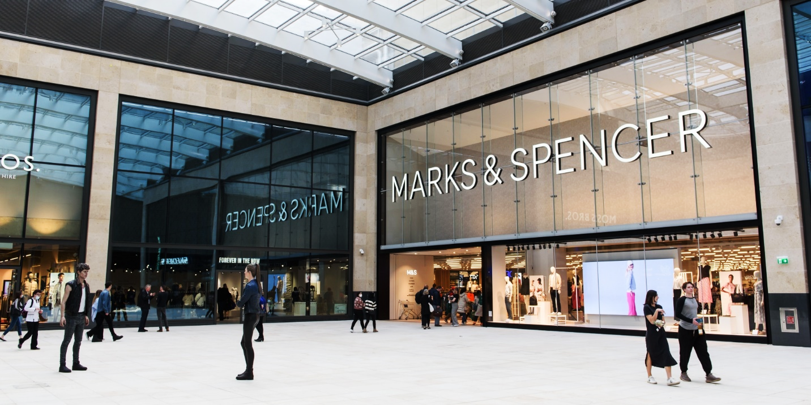
Student Name: Linda Roze
Student ID: 2219027
Marketing Fundamentals (LCBB4004)
Lecturer: Piyumika Gamage
Table of Contents
1. Introduction 3
2. Overview, objectives and control of Marks & Spencer 4
3. External Analysis 6
3.1 PESTLE Analysis 6
3.2 Porter’s Five Forces 9
3.3 SWOT Analysis 11
3.4 Analysis of Growth Strategies with Ansoff Matrix 12
4. Current Strategies & Recommendations 15
4.1 Current Strategies Used by Marks & Spencer 15
4.2 Recommendation 17
5. Conclusion 19
References 20

1. Introduction
In this modern era, many economies depend on businesses to improve, which has not only created a huge number of businesses but also has led the world into a competitive age. In these competitive times, it is essential for businesses to have continuous improvements. This report is based on company named Marks & Spencer, which was founded in the late 1800s and is in business for more than 130 years. The report is based on not only providing the company with recommendations to improve its operations to have an advantage in the market but also providing them with the reasoning behind the recommendations.
The following diagram shows the structure of the report:
Introduction

Objectives and overview
External Analysis

PESTLE Analysis
Ansoff Matrix

SWOT Analysis
Porter’s Five Forces

Recommendations

Conclusion

2. Overview, objectives and control of Marks & Spencer
Marks & Spencer (M&S), a British multinational retailer headquartered in London, UK, was founded in 1884 by Michael Marks and Thomas Spencer (Marks and Spencer, 2023). The company has since burgeoned to become one of the most pre-eminent retailers in the UK, with more than 400 stores across the globe and over 100 websites (Marks & Spencer, 2023). M&S's extensive inventory encompasses clothing, home goods, food and drink, and beauty products. Renowned for its superior quality goods, exceptional customer service, and robust brand reputation, M&S has managed to develop a devoted customer base and establish itself as a trusted brand in the UK.
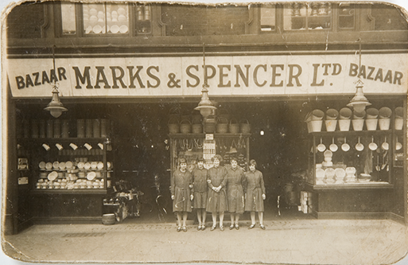
Figure 1: Marks & Spencer First Shop
(Source: Marks & Spencer, 2023)
Despite its successes, the company has been confronted with various predicaments in recent years, most notably dwindling sales and profits which is apparent in Figure 2. Nevertheless, M&S has taken proactive measures to bolster its performance, which includes shuttering underperforming stores, expanding its digital footprint, and introducing novel products and services. Additionally, M&S has shown a steadfast commitment to sustainability, manifesting in a host of initiatives that aim to mitigate its environmental impact, including the usage of sustainable materials and curbing waste. The company has also unveiled a comprehensive sustainability program that includes a pledge to become a zero-waste enterprise by 2040 (Marks & Spencer, 2023).
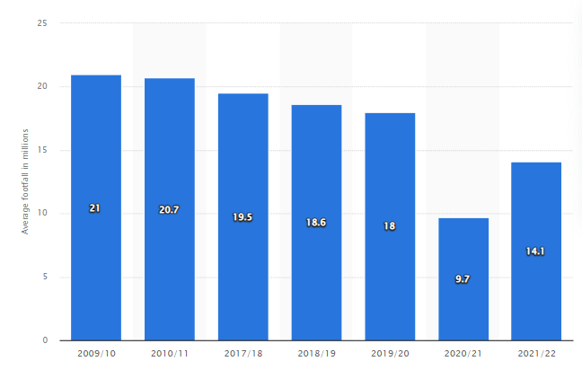
“Figure 2: Average weekly footfall in Marks & Spencer stores in the United Kingdom (UK) from 2009/10 to 2021/22”
(Source: Smith, 2022)

3. External Analysis

3.1 PESTLE Analysis
PESTLE Analysis of Marks & Spencer
Political | Marks & Spencer conducts its business in various nations, and the political milieu in these nations holds the power to substantially impact its operations (Soliman, 2021; Marks & Spencer, 2023b). As an example, Brexit has precipitated uncertainty in the United Kingdom, where Marks & Spencer has its base, and this has culminated in the hindrance of the company's supply chain and its operations overall. Moreover, any modifications in taxation policies and regulations, trade agreements, and governmental stability in the operational countries can considerably influence the enterprise's activities.
Economic | The company's economic operations are gravely affected by the economic circumstances in the countries where it is functional. As an illustration, modifications in interest rates, inflation rates, and exchange rates hold the power to exert a significant impact on the enterprise's profitability. Furthermore, the economic depression and the COVID-19 pandemic have impinged upon the firm's activities and profit margin (Smith, 2022).
Social | Social factors, such as alterations in consumer conduct, cultural differences, and demographic transitions, have the power to exert a significant impact on Marks & Spencer's operations. The company's activities are also influenced by fashion trends, and changes in the buyers' preferences for sustainable and ethical fashion can significantly affect the company's sales (Nyame-Asiamah, 2020).
Technological | Technological advancements have significantly influenced Marks & Spencer's activities, particularly in e-commerce and supply chain management. The company has infused resources in technology to augment its online presence, and this has resulted in a surge in online sales (Retail4Growth Bureau, 2023). In addition to this, technology has also facilitated the firm to streamline its supply chain management, resulting in a considerable surge in the efficiency of its operations.
Legal | Several legal factors, including intellectual property laws, employment laws, and product safety regulations, hold the power to influence Marks & Spencer's operations. The company must conform to the regulations in the countries where it operates. For instance, the General Data Protection Regulation (GDPR) of the European Union has substantially affected the enterprise's activities in the EU (Yuan, 2019).
Environmental | The Plan A program (Marks & Spencer, 2023) is an initiative that the company has undertaken to diminish its environmental impact. The company has set several targets to curb its carbon footprint, waste, and water consumption. The company's efforts to promote sustainable and ethical fashion have also enabled it to mitigate its environmental impact.
Table 1: PESTLE Analysis of Marks & Spencer
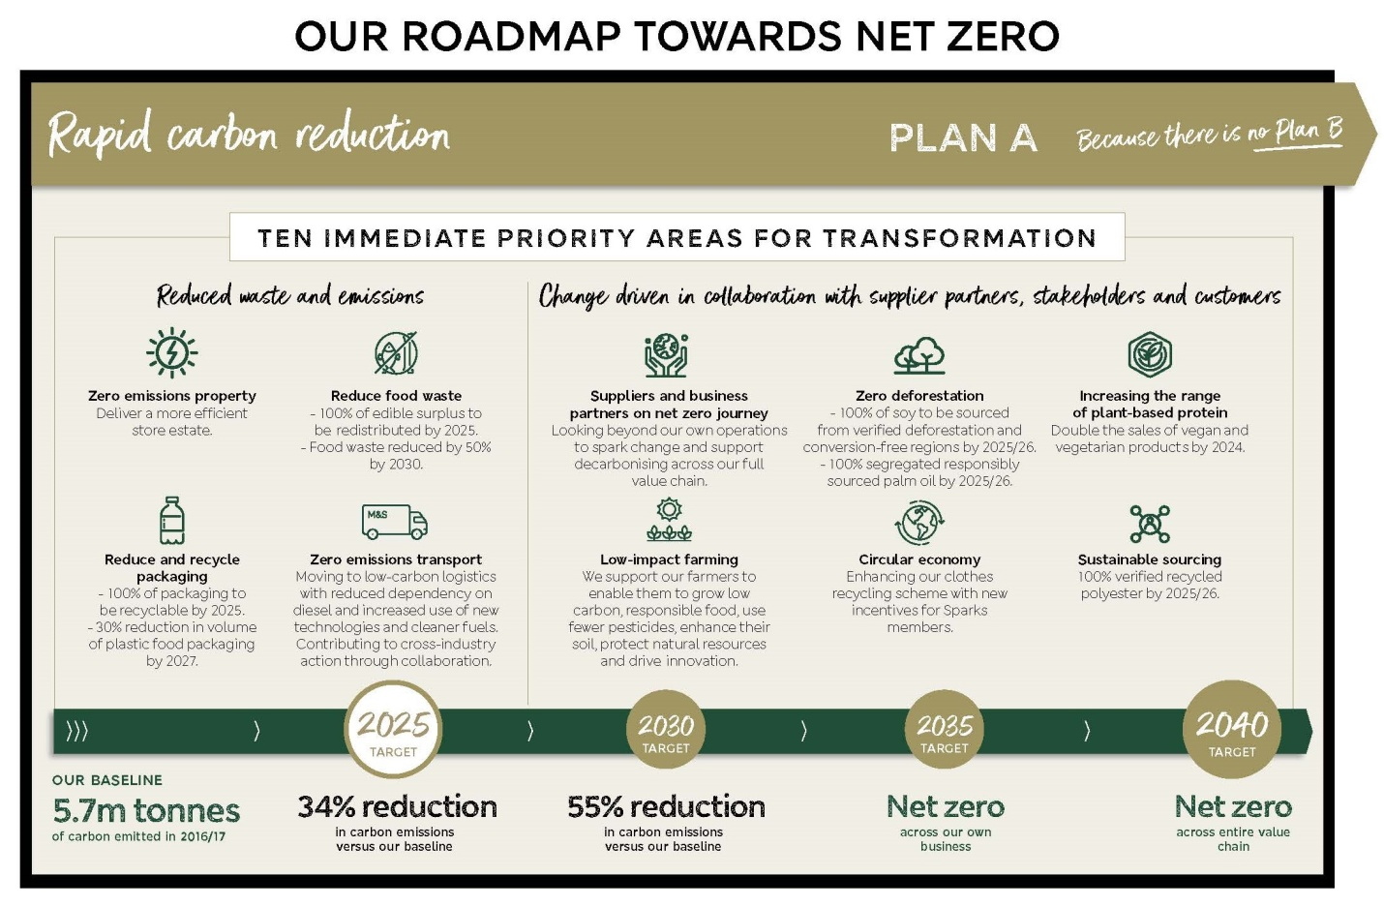
Figure 3: Marks & Spencer’s Pledge Towards Net Zero Carbon
(Source: Marks & Spencer, 2023)

3.2 Porter’s Five Forces
The Threat of New Entrants
Marks & Spencer encounters a meagre risk of fresh contenders in the UK retail trade. This is owing to the towering hindrances to entry into the marketplace. To illustrate, the enterprise's entrenched brand identity, scales of economies, and comprehensive allocation system impart a momentous competitive edge over novel contenders. Furthermore, the expenditure of mounting physical stores and online platforms is exorbitant, and the regulations and policies that monitor the retail trade engender an arduous milieu for inexperienced entrants (Alves et al., 2021). Additionally, M&S's firm rapport with purveyors and its proficiency to barter profitable deals enable it to maintain low prices, rendering it arduous for fresh contenders to vie.
Bargaining Power of Suppliers
The bargaining authority of suppliers in the UK retail trade is primarily low, but it can fluctuate contingent on the merchandise (Tingey, Webb and van der Horst, 2021). For instance, purveyors of idiosyncratic and high-quality commodities can have more bargaining authority equated to purveyors of conventional products. Concerning M&S, it has a firm rapport with purveyors due to its prolonged standing presence in the marketplace, bequeathing it more control over the supply chain (Landau et al., 2020). Moreover, the enterprise's voluminous order extents and eminence as a reliable customer enable it to barter favourable terms with purveyors. However, the recent transition towards environmentally sustainable and ethical sourcing has rendered it more strenuous for M&S to locate suitable purveyors, which could augment the bargaining authority of purveyors in this domain.
Bargaining Power of Customers
The bargaining authority of consumers in the UK retail trade is preponderant, particularly for low-priced products. M&S dispenses an array of commodities across divergent price points, which could impact the bargaining authority of buyers (Marks & Spencer, 2023). Nevertheless, the enterprise's robust brand identity and customer loyalty bestow it an advantage concerning customer retention. Furthermore, M&S's extensive spectrum of commodities and amenities, along with its emphasis on quality, affords consumers with more alternatives, which can decrease their bargaining authority. Nonetheless, the burgeoning vogue of online marketplaces and the upsurge of reduced-price retailers have rendered it more strenuous for M&S to sustain its position in the marketplace.
The Threat of Substitutes
The peril of substitutes within the United Kingdom's retail industry is considerable owing to the profusion of alternative products and services. Specifically, in the instance of M&S, patrons have an array of substitutes to choose from, including online vendors, bargain retailers, and supermarkets. Nevertheless, M&S's established brand reputation and client fidelity confer it an edge in terms of retaining customers. Moreover, the company's commitment to excellence and originality can render it more arduous for customers to identify suitable alternatives (Marks & Spencer, 2023b). Nevertheless, the burgeoning demand for eco-friendly and ethically acquired commodities has spawned an opening for M&S to distinguish itself from its competitors and decrease the risk of substitutes.
Competitive Rivalry
The level of competition amid rivals within the United Kingdom's retail industry is intense, and M&S is confronted with severe rivalry from a variety of competitors, encompassing supermarkets, discount retailers, and online vendors (Wilson, 2022). The degree of competition varies based on the product category, with clothing and food being fiercely competitive areas. However, M&S's widespread distribution network and online presence enable it to reach a broader audience and remain competitive. Additionally, the corporation boasts a competitive advantage over its adversaries owing to its firmly established brand reputation, unwavering client loyalty, and unwavering emphasis on superiority and distinctiveness. Nevertheless, the emerging inclination towards sustainability and ethical sourcing has paved the way for fresh and current competitors to achieve market supremacy.

3.3 SWOT Analysis
Strengths
Marks & Spencer offers an extensive assortment of commodities spanning diverse segments encompassing grocery, fashion, and interior design. This diversity permits Marks & Spencer to cater to a wide demographic of clients. Furthermore, the company's e-commerce platform is firmly established, and it possesses a robust supply chain network.The organisation boasts a formidable brand reputation within the United Kingdom market (Marks & Spencer, 2023). Its notoriety stems from its adherence to ethical business practices and the provision of high-quality products.
Weaknesses
Regrettably, Marks & Spencer's traditionalistic approach to clothing design and its reluctance to innovate leaves the company vulnerable to market trends and these factors contribute to a significant dip in sales. Additionally, the company's pricing strategy has elicited criticism from the public, as it is difficult to compete with other, cheaper retailers (Smith, 2022).
Opportunities
Marks & Spencer has a plethora of prospects to seize for advancement. To start with, the organisation can broaden its merchandise assortment by introducing innovative commodities and amenities (Marks & Spencer, 2023). In addition, the enterprise can delve into novel markets, both domestically and globally, to accumulate a broader consumer base and the corporation can even espouse virtuous principles that endorse sustainability to allure consumers who hold environmental apprehensions in high regard.
Threats
Marks & Spencer contends with formidable competition from other retailers in the UK market. Moreover, the Brexit negotiations have led to ambiguity in the market, potentially impacting the company's sales and supply chain (Hobolt, 2020).

3.4 Analysis of Growth Strategies with Ansoff Matrix
Market Penetration
Market infiltration tactics are the intricate procedures undertaken by an organisation to heighten its portion of the existing market share while sticking to its current product line. A plethora of market infiltration strategies are available for Marks & Spencer to embrace in its quest for greater market share. The initial approach is to give precedence to increasing its brand recognition and loyalty by investing in efficient marketing and advertising drives (Muniesa and Giménez, 2020). This will allure novel customers while retaining existing ones. Secondly, Marks & Spencer can entice price-sensitive customers by providing novel sales promotions and discounts. Customer loyalty programmes can be instituted to retain existing clients while motivating them to purchase more (Kim, Steinhoff and Palmatier, 2021). Through competitive pricing, the company can amplify its sales and market share. Thirdly, the establishment can improve its product line by adding innovative products and services to address fluctuating customer preferences. This can help you retain existing consumers while also attracting new ones.
Product Development
Marks & Spencer has an extensive scope to pursue numerous options for their product development endeavours. This encompasses the introduction of new fashion lines, diversification of their food and home categories, and the expansion into the beauty and wellness product lines. The possibility of collaborating with designers and influencers presents a thrilling prospect for infusing the company's existing product range with fresh ideas and designs, thereby catering to both the new and existing clientele (Wilson and Tewdwr-Jones, 2021). Such development initiatives can also assist the company in sustaining its market relevance, especially in a continually shifting retail landscape. By introducing innovative products or enhancing the existing ones, Marks & Spencer can distinguish itself from its competitors and offer a unique value proposition to its consumers. The conglomerate is obligated to ensure that each fresh offering is in line with its brand character and caters to the preferences of its loyal clientele. In order to execute this scheme properly, Marks & Spencer must allocate funds towards extensive research and development, design, and advertising. It is crucial for the entity to conduct comprehensive market analyses to pinpoint deficiencies in its merchandise range and comprehend the evolving requests of its intended patronage. Furthermore, the firm must prioritise the development of a competent design team in order to guarantee that its new goods are in line with the newest fashion and design trends (Güemes-Castorena, 2020).
Market Development
Market expansion is a strategy that entails bringing a current product or service into previously untouched areas. For example, Marks & Spencer might increase their global awareness by expanding into new markets. While they have made significant progress in this area, there is still room for improvement. As a result, one plausible strategy for Marks & Spencer would be to focus on emerging economies such as India, where the middle-class population is growing, and their spending power is expanding (Marks & Spencer, 2023). By tailoring their products and services to align with the unique tastes and preferences of local consumers, Marks & Spencer could potentially dominate a substantial segment of these markets. Besides, online sales offer a feasible path to expanding their market reach. Given the current pandemic situation, the prevalence of online shopping has skyrocketed and is expected to persist. Consequently, Marks & Spencer could utilize their online platform to expand their market penetration, thereby reaching out to new customers in novel markets. Additionally, Marks & Spencer could also establish partnerships with local retailers in international markets to establish a foothold in those markets. Such alliances would be pivotal in providing Marks & Spencer with an in-depth comprehension of the local market, aiding them in customising their products and services to cater to local preferences and reach out to customers more effectively.
Diversification
Marks & Spencer has a fortuitous opening to delve into a diversification strategy, thereby broadening its horizons by introducing novel wares in unexplored markets. The prospective new product lines may encompass household paraphernalia, electronic gadgets, and furniture (Chiu, 2022). The company could also contemplate venturing into geographical locations where it currently lacks a presence. Such a manoeuvre would enable the corporation to reduce its dependence on the apparel and grocery sectors, hence curtailing jeopardy and ensuring prolonged expansion. Nevertheless, diversification also harbours certain hazards, such as entering unfamiliar markets and launching goods that are beyond the corporation's fundamental skills. It is incumbent on Marks & Spencer to undertake meticulous research and scrutinise potential markets and products to effectuate a diversification strategy successfully. The corporation must evaluate the risks and prospects of each potential market and product. Additionally, it will necessitate procuring fresh abilities and expertise to guarantee triumph in these novel markets.

4. Current Strategies & Recommendations

4.1 Current Strategies Used by Marks & Spencer
The company aims is to follow the most important models of marketing such as The Product Life Cycle which refer the four stages every product should go including, introduction, growth, maturity and decline. This model helps companies to understand how to manage their products throughout their life cycle to maximize profits (Kotler, 2012). Another important model to follow is the STP. Model which suggests that companies should first segment their market into smaller groups with similar need and characteristics, than select one or more segments to target, and develop unique position in the minds of the customers (Kotler, 2012).
Marks and Spencer (M&S) have placed its primary focus on expanding its market presence and developing its range of products. The company has taken various initiatives to increase the sales of its existing products, including expanding its food offering and engaging in online sales. the M&S has created an ingenious reward scheme to entice new customers and push them to spend more (Spanke, 2020). Furthermore, the company is investing in product development by launching new product lines and improving the quality of its present items. M&S has notably launched a new range of vegan products to meet the burgeoning demand for plant-based foods. Additionally, the firm is striving to improve the quality of its clothing line by utilising sustainable materials.
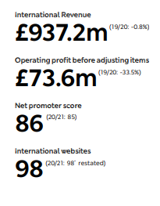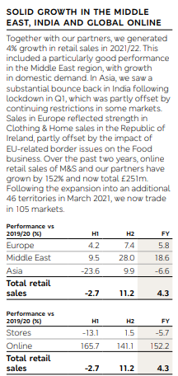
Figure 4: International Growth of Marks & Spencer
(Source: Marks & Spencer, 2023d)
M&S has used market development tactics to enter new areas in addition to its focus on market penetration and product development. The company has extended its business operations into foreign markets, such as India, which has enabled it to reach new customers and broaden its revenue streams (Marks & Spencer, 2023d). However, M&S has not devoted significant attention to diversification strategies, and it has not yet ventured into entirely novel markets or product categories. This could be attributed to the fact that the firm is currently concentrating on refining its existing operations and sustaining its market position.

4.2 Recommendation
Enhance E-commerce Platform
One key area of focus for M&S should be the improvement of its website's user interface, product display, and checkout process, with the ultimate goal of creating a more customer-centric platform that offers maximum convenience and accessibility (Martín-Peña, 2023). Marks & Spencer (M&S) is currently experiencing a rapid shift towards online shopping, and it is therefore recommended that the company enhance its e-commerce platform to provide a seamless and immersive shopping experience to its customers.
Expand Internationally
Another area of opportunity for M&S lies in expanding its international presence, which aligns with the data from Figure 4 and to do so, the company should focus on regions that demonstrate high potential for growth, and tailor its products and marketing strategies to local cultures and preferences. This would not only enable M&S to capitalise on new sources of revenue but also increase its brand visibility and awareness on a global scale.
Diversify Product Line
M&S should broaden its product line in order to cater to a broader spectrum of clients and minimise its dependency on the shrinking clothes sector (Rana and Shankar, 2020). This might include expanding into new product categories or collaborating with other brands to offer a more diversified variety of items, which can help the firm acquire new income streams and remain competitive in a fast-changing retail market.
Focus on Customer Experience
M&S should focus on customer experience to increase customer loyalty and satisfaction and by cultivating long-term connections with its customers, M&S can strengthen its brand reputation and position itself as a market leader. Offering customised shopping experiences, delivering great customer care, and communicating with consumers through numerous channels, including social media, might all fall under this category.
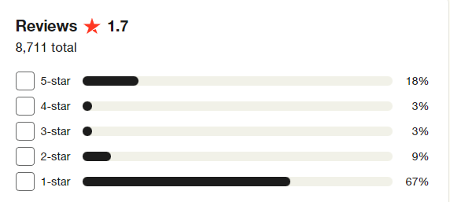Customer Reviews of Marks & Spencer

Figure 5: Total Reviews of Marks & Spencer
(Source: Trustpilot, Inc, 2023)

5. Conclusion
The aim of the report was to analyse the present condition of the company and provide recommendations for future improvement. After analysis of Marks & Spencer, the PESTLE analysis found that the company is in an overall good state, however, it needs to pay attention to the legal factors. Porter's Five Forces analysis suggests that Marks & Spencer faces a low threat of new entrants, primarily low bargaining power of suppliers, high bargaining power of customers, considerable threat of substitutes, and intense competitive rivalry in the retail industry in the UK. In terms of SWOT analysis, the company's strengths include its extensive range of products, e-commerce platform, and supply chain network, while its weaknesses are its traditionalistic approach to clothing design, pricing strategy, and susceptibility to market trends. The opportunities for the company include broadening its product range and entering new markets, while the threats include competition and the impact of Brexit. The current strategies of the company focus on expanding its market presence, developing its range of products, launching new product lines, improving the quality of present items, and investing in online sales and loyalty programs.

References
Alves, J.B., Marques, B., Dias, P. and Santos, B.S., 2021. Using augmented reality for industrial quality assurance: a shop floor user study. The International Journal of Advanced Manufacturing Technology, 115(1-2), pp.105-116.
Chiu, T.P., 2022, June. The Integrated Study of Cross-cultural Differences in Visual Merchandising Design and Consumer’s Visual Perception on E-Commerce Platform. In Cross-Cultural Design. Interaction Design Across Cultures: 14th International Conference, CCD 2022, Held as Part of the 24th HCI International Conference, HCII 2022, Virtual Event, June 26–July 1, 2022, Proceedings, Part I (pp. 342-356). Cham: Springer International Publishing.
Güemes-Castorena, D. and Ruiz-Monroy, B.C., 2020. Ambidexterity in the supply chain: studying the apparel industry. International Journal of Agile Systems and Management, 13(2), pp.130-158.
Hobolt, S.B. and Rodon, T., 2020. Cross-cutting issues and electoral choice. EU issue voting in the aftermath of the Brexit referendum. Journal of European Public Policy, 27(2), pp.227-245.
Kotler, P., & Armstrong, G. (2012). Principles of marketing. Pearson.
Kim, J.J., Steinhoff, L. and Palmatier, R.W., 2021. An emerging theory of loyalty program dynamics. Journal of the Academy of Marketing Science, 49, pp.71-95.
Landau, A., Rochell, J., Klein, C. and Zwergel, B., 2020. Integrated reporting of environmental, social, and governance and financial data: Does the market value integrated reports?. Business Strategy and the Environment, 29(4), pp.1750-1763.
Marks & Spencer, 2023a. Our History. [Online] Available at: https://corporate.marksandspencer.com/about-us/our-history [Accessed on: 26 April 2023]
Marks & Spencer, 2023b. About Us. [Online] Available at: https://corporate.marksandspencer.com/about-us [Accessed on: 26 April 2023]
Marks & Spencer, 2023c. Plan A: Our Planet. [Online] Available at: https://corporate.marksandspencer.com/sustainability/plan-a-our-planet [Accessed on: 26 April 2023]
Marks & Spencer, 2023d. Shaping the FUTURE. [Online] Available at: https://corporate.marksandspencer.com/sites/marksandspencer/files/marks-spencer/m-and-s-ar22-full-ar-report.pdf [Accessed on: 26 April 2023]
Martín-Peña, M.L., García-Magro, C. and Sánchez-López, J.M., 2023. Service design through the emotional mechanics of gamification and value co-creation: a user experience analysis. Behaviour & Information Technology, pp.1-21.
Muniesa, R.L. and Giménez, C.G., 2020. The importance of the loyalty of fashion brands through digital marketing. Journal of Spatial and Organizational Dynamics, 8(3), pp.230-243.
Nyame-Asiamah, F. and Ghulam, S., 2020. The relationship between CSR activity and sales growth in the UK retailing sector. Social Responsibility Journal, 16(3), pp.387-401.
Rana, A. and Shankar, R., 2020. Crisis or opportunity: Marks and Spencer’s tryst with Indian retail. The CASE Journal, 16(6), pp.671-690.
Retail4Growth Bureau, 2023. Marks & Spenser to focus on tech led growth with TCS partnership. [Online] Available at: https://www.retail4growth.com/news/marks-spenser-to-focus-on-tech-led-growth-with-tcs-partnership-6272 [Accessed on: 26 April 2023]
Smith, P., 2022. Marks & Spencer: average weekly footfall in the United Kingdom (UK) 2009-2022. [Online] Available at: https://www.statista.com/statistics/413515/marks-and-spencer-mands-average-weekly-footfall-united-kingdom-uk/ [Accessed on: 26 April 2023]
Soliman, A.M., 2021. State Power, Society, Economy, and Urban Informality. In Urban Informality: Experiences and Urban Sustainability Transitions in Middle East Cities (pp. 157-188). Cham: Springer International Publishing.
Spanke, M., 2020. Retail isn't dead: Innovative strategies for brick and mortar retail success. Springer Nature.
Tingey, M., Webb, J. and van der Horst, D., 2021. Housing retrofit: six types of local authority energy service models. Buildings and Cities, 2(1).
Trustpilot, Inc, 2023. Marks and Spencer. [Online] Available at: https://www.trustpilot.com/review/www.marksandspencer.com [Accessed on: 26 April 2023]
Wilson, A. and Tewdwr-Jones, M., 2021. Digital participatory planning: Citizen engagement, democracy, and design. Routledge.
Wilson, D., 2022. A Study on Customer Satisfaction towards Max Fashion Brand.
Yuan, B. and Li, J., 2019. The policy effect of the general data protection regulation (GDPR) on the digital public health sector in the european union: an empirical investigation. International journal of environmental research and public health, 16(6), p.1070.

