Cameron Rees

Assignment 2

This is my customer table where I can type in the MemberID, Title, Forename, Surname, Address1, Postcode, Telephone, Email, DataOfBirth, Gender.
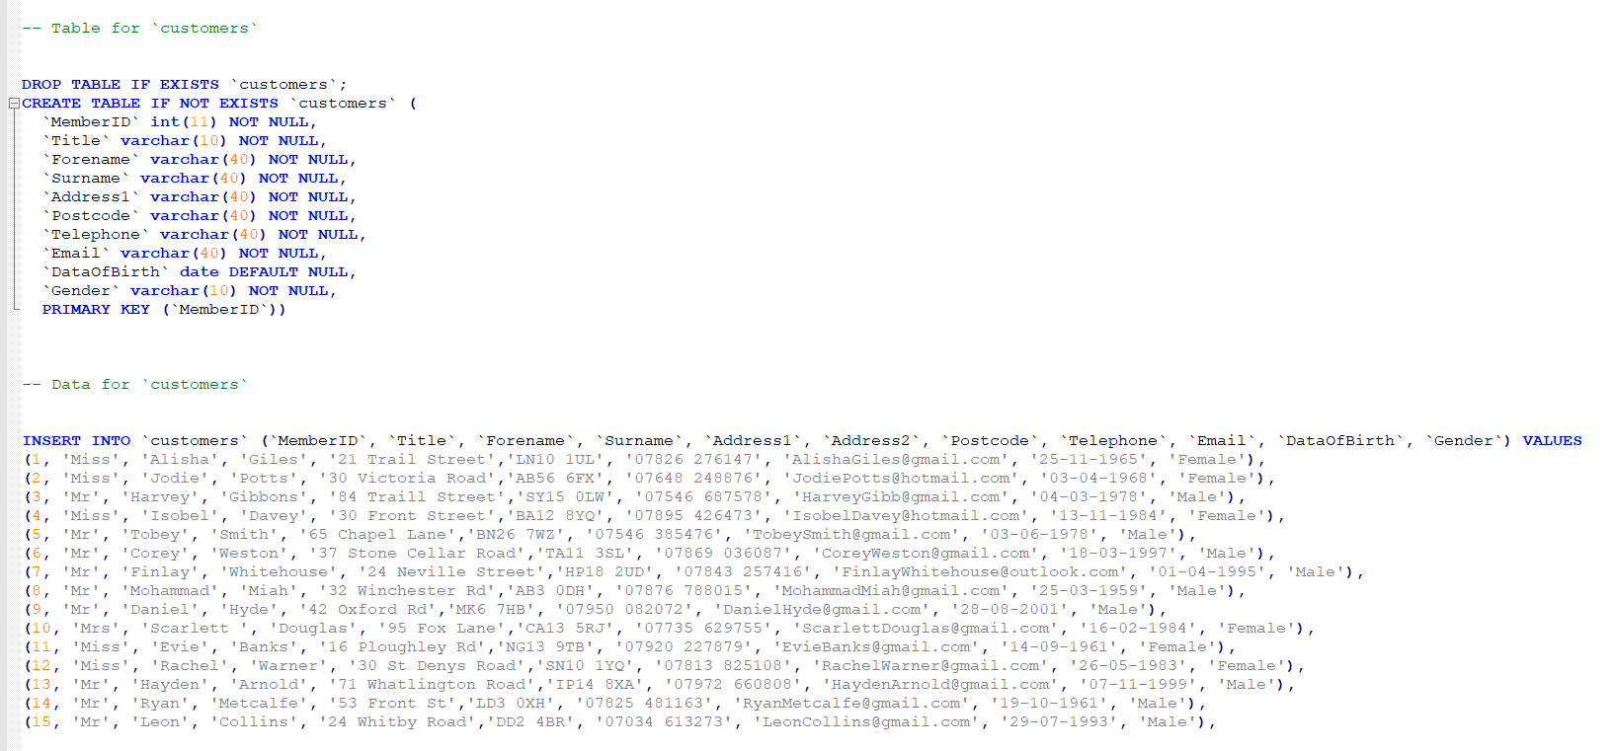

This is the table where you can see what phones are able to be rented and I have PhonesID, SupplierID, Publisher, Released
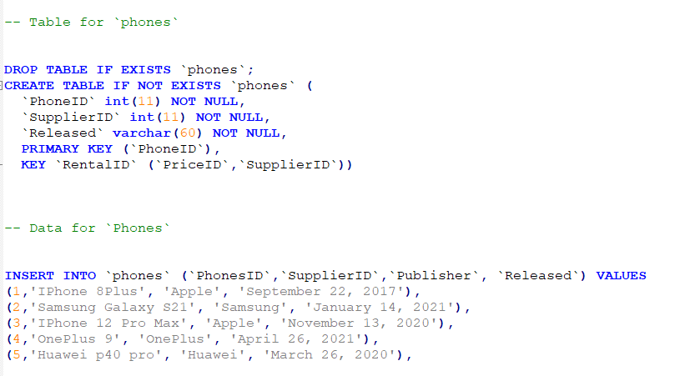

This is my price table where the prices are stored for the phones
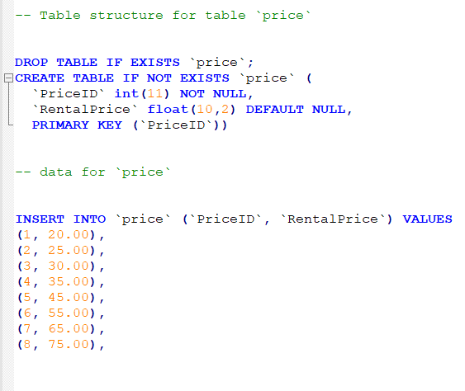

This is the table of rentals which shows you when the phone is rented and when its meant to be returned and you can see if any phones are overdue
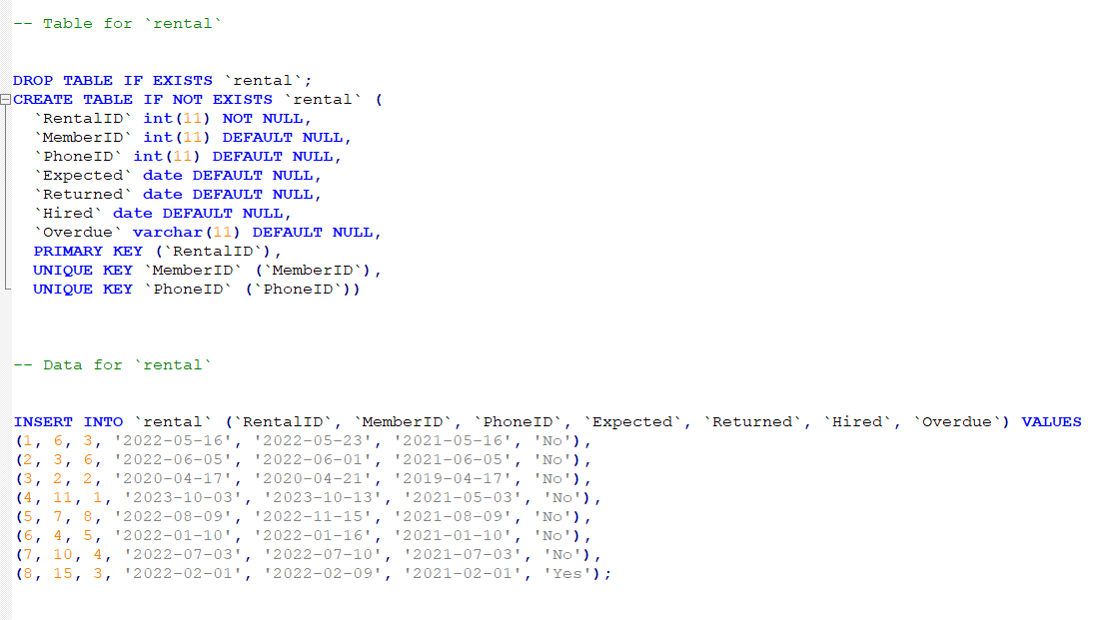

This is the table which shows the supplier will the table being set SupplierID, Suppliername, Address1, Postcode, Telephone, Email


