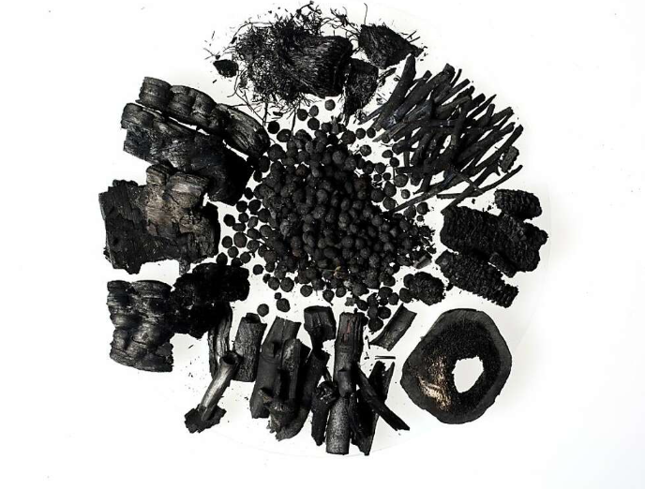
Reducing net CO2 emissions in steelmaking using Biochar
Jamie Waters
Jamie Waters (1551425) | 7/29/22 | Lean & Agile Operations

Abstract
50ish words - summarise contents of report
The purpose of this report is – include findings and conclusion.
The executive summery is not included in word count.

Declaration
This thesis is the result of the author’s personal research and conducted work. It has been composed by the author with all relevant research cited and has not been previously submitted for examination for the award of an honour’s degree. Confirmation of work:
Signed:
Date:



Acknowledgements
Table of Contents
Abstract 1
Declaration 2
Acknowledgements 3
Table of Figures 6
Glossary 7
Introduction 8
Background 8
Research aim 12
Theory 13
Biomass 13
Raw Biomass structure 13
The problem with Raw Biomass 15
Biomass Pre-treatment 16
Biomass utilisation in the iron and steel industry 18
Injection of Biomass into blast furnaces 19
Potential for biomass in metallurgical coke making 21
Potential for biomass in the sintering process 23
Biomass supply and availability 25
Method 28
Biochar characterisation 28
Proximate analysis 28
Ultimate analysis 31
Calorific value 32
Major Elemental Analysis 32
Minor elemental analysis 33
Particle size distribution 33
Assessing biochar substitution in pulverised coal injection (PCI) 34
Drop tube furnace 34
Assessing biochar substitution in coke making 36
Pilot scale coke oven 36
1/5th Micum – Mechanical Strength 39
Coke strength after reaction and Coke reactivity index (CSR/CRI) 40
Assessing biochar substitution in sinter making 42
Sinter pot 42
Determination of low-temperature reduction disintegration indices 44
Tumble and Abrasion indices 45
Quality Control 46
Results 47
Biochar substitution in pulverised coal injection (PCI) 47
Properties of charcoal compared to pulverized coal 48
Chemical Composition 49
Combustibility 51
Biochar substitution into coke making 53
Conclusion 54
Recommendations 55
Reference list 56
Appendix 57

Table of Figures
Figure 1 The response of some climate variables to global warming (Arias et al. 2021). 8
Figure 2 World Steel Production 1950 - 2021 (Worldsteel. 2021) 9
Figure 3 CO₂ emissions in an integrated steelworks (BF - BOS route) (Suopajärvi et al. 2018) 10
Figure 4 Pathways for cutting emissions in the Iron and Steel industry (Mousa et al. 2016) 10
Figure 5 Major constituents of a woody biomass (Basu 2013) 13
Figure 6 Structure of primary cell wall of plant cell (Nhuchhen et al. 2014). 14
Figure 7 Van Krevelen diagram of thermochemical conversion products from woody biomass. With additional data of raw biomass (non-filled symbols), torrefied biomass (red symbols), HTC biomass (blue symbols), and charcoal (black symbols) (Suopajärvi et al. 2018) 15
Figure 8 Biomass upgrading technologies according to product type (Mousa et al. 2016). 16
Figure 9 Influence of pre-treatment temperature on key variables (Liu and Shen 2021) 18
Figure 10 Opportunities for Biomass in iron & steelmaking (Mandova et al. 2018) 19
Figure 11 Illustration of PCA injection into PCI into the blast furnace. 20
Figure 12 Diagram of a typical by-product coke plant (Hilding 2005) 22
Figure 13 Diagram of a sintering machine (Chen et al. 2016). 24
Figure 14 Sinter indices under the influence of biochar substitution for coke breeze (Mousa et al. 2015). 25
Figure 15 a) The spatial distribution of woody biomass and waste in the EU b) Comparison of the woody-biomass supply and the existing woody-biomass demand, per country) (Mandova et al. 2018). 27
Figure 16 The cost of charcoal production (Suopajärvi and Fabritius 2013) 27
Figure 17 Calculated VUI's for BF injectants and consequent CO2 emissions from the BF (Mathieson et al. 2011) 28
Figure 18 Rotary kiln pilot-scale pyrolysis unit used to make biochar 1 (Mašek et al. 2018) 28
Figure 19 The components of coal (Backus 2022) 29
Figure 20 Illustrating x-ray fluorescence (Blondel 2020) 33
Figure 21 Excitation of an atom by a plasma (Thermo Fisher Scientific 2022) 34
Figure 22 Particle size distribution by sieves (Particle Technology Labs 2022) 34
Figure 23 A picture and schematic (Steer et al. 2021) of the drop tube furnace. 35
Figure 24 The Pilot scale coke oven at Tatasteel 36
Figure 25 An illustration of the 25Kg pilot scale coke oven at Port Talbot, made by the author 37
Figure 26 Preparing the coal charge 38
Figure 27 The coal density calculation 39
Figure 28 The motion of coke in a micum test (Geerdes et al. 2009). 40
Figure 29 Diagram of the CSR/CRI test 41
Figure 30 A photograph and a schematic diagram of the sinter pot (Zandi et al. 2010) 42
Figure 31 RDI test equipment apparatus (British Standards Institute 2015b) 44
Figure 32 The drum specifications for the tumble and abrasion test (British Standards Institute 2015a) 45
Figure 33 The lower zone of the BF (Ahmed 2018). 51
Figure 34 Graph showing the burnout efficiency of T-coal and biochar 52

Glossary

Introduction

Background
Climate change is a problem the world cannot ignore, shifting weather patterns threaten food production and rising sea levels can lead to catastrophic flooding. Climate change has been directly linked to the concentration of greenhouse gases (GHG) in the earth’s atmosphere and that the role of human influence on climate change is undisputed. The choices made today will have a significant effect on the climate that future generations will experience. Reducing emissions rapidly will limit further changes but if current trends continue then some climate changes could persist for thousands of years, figure 1 illustrates the possible long term effects of climate change (Arias et al. 2021).
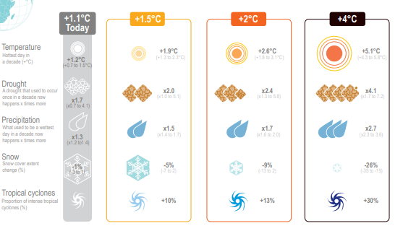
Figure 1 The response of some climate variables to global warming (Arias et al. 2021).
According to (Holappa 2020) GHG emissions have doubled since 1970 and Carbon Dioxide (CO₂) the most important GHG has increased from 300ppm to 410 ppm (atmospheric content) since 1950. At the conference of parties Paris (COP21) in 2015 an agreement to prevent a global rise in temperature of over 2 ◦C was achieved, this target was later reduced to 1.5 ◦C at the COP 24 meeting in 2018. To meet the 2 ◦C target a 50% reduction in emissions by 2050 is required and an 80% reduction is required to meet the 1.5 ◦C target respectively.
The Iron and steel industry (ISI) is one of the world’s most important manufacturing sectors with a significant impact on the global economy. Steel is a highly cost-effective material which can be recycled endlessly and has a vast array of applications, steel is going to be crucial for the low carbon transition as it is required in in the manufacture of solar panels, wind turbines, dams, and electric vehicles. Recent steel demand and production has increased sharply (Figure 2), there are predictions of growth range from 3000 MT by 2050 to a more conservative prediction of 2500 MT (Holappa 2020).
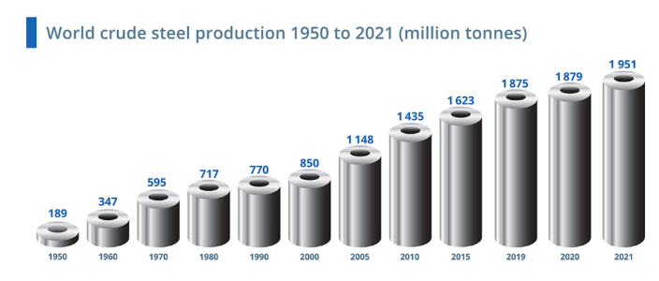
Figure 2 World Steel Production 1950 - 2021 (Worldsteel. 2021)
The ISI is the 2nd largest consumer of energy consuming ~22% of industrial energy and ~ 8% of the total energy produced worldwide. The ISI is also the 2nd largest emitter of CO₂ and is accountable for ~25% of industrial CO₂ emissions and ~9% total CO₂ emissions producing 3.2 GT CO₂ equivalent in 2019 (IEA.org 2020). For every tonne of steel produced there is 1.89 tonne of CO₂ emitted (WorldSteel. 2021).
The Kyoto protocol 1997 persuaded the worlds industrialised countries to adopt policies that would limit and reduce GHG’s to agreed targets (UNFCCC 2022). As a result, a Carbon trading market was created, the European Union Emissions trading system (EUETS) being the first and largest, the UK has since created its own trading system. Carbon trading allows governments and countries to trade permits and credits to emit CO₂ into the atmosphere. It is designed to punish those who over pollute and reward those who reduce their emissions. The “cap and trade” is the most widely used scheme, governments set a legal limit on emissions over a specific time period and companies are allocated allowances. The UK has set a legal minimum price of £22 a ton of CO₂. A company that has used all its credits but is still emitting CO₂ would need to buy carbon credits from a company that has emitted less pollution and has credits saved (Carbonaro 2021).
The UK government has set a target for a 68% reduction in greenhouse gases by 2030 (compared to levels in 1990) with further ambitious targets of 78% reduction by 2035 and net zero GHG emissions by 2050 (Gov.UK. 2021). To facilitate the targets set by the UK government the industry’s CO₂ usage needs to decrease by 1.9% annually until 2030 (de Souza and Pacca 2021).
The ISI has already reduced its energy consumption, and therefore GHG emissions by 60% in the last 50 years and is continuously researching ways to further reduce its emission output. There are improvements that can be implemented immediately to reduce CO₂ emissions but to get to the target levels set for 2050, changes in the technologies used to produce steel are required (WorldSteel, 2021). An integrated steelworks consists of coke making, sintering, iron making (blast furnace), basic oxygen steelmaking (BOS), hot and cold rolling. Figure 3 shows the CO₂ output of each process in an integrated steelworks (Suopajärvi et al. 2018).
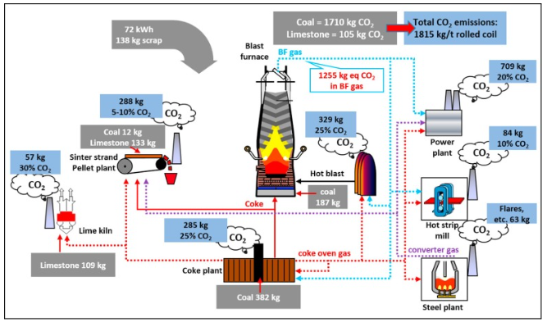
Figure 3 CO₂ emissions in an integrated steelworks (BF - BOS route) (Suopajärvi et al. 2018)
There are many pathways towards meeting these targets and the ISI must take them all collectively. In the medium to long term new technologies such as carbon capture, and a fuel shift away from fossil fuels towards hydrogen, natural gas and renewable energy and an increase in the utilisation of electric arc furnace (EAF) steel production capacity, will yield the greatest results. In the short-term, significant improvements in process reliability, steel demand reduction through material efficiency and minimising waste through energy efficiency are mitigations that need to be actioned immediately (Aaskov 2022).
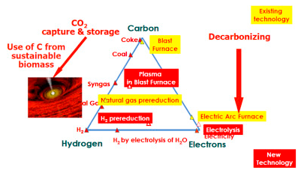
Figure 4 Pathways for cutting emissions in the Iron and Steel industry (Mousa et al. 2016)
(Suopajärvi et al. 2018) investigated one short term opportunity for reducing CO₂ emissions in the ISI, using biofuels as a partial replacement for the fossil fuels used in the industry as its primary source of energy, see figure 4. A biofuel is an energy source derived from renewable biomass. Biomass is deemed to be carbon neutral as it absorbs CO₂ from the atmosphere while the plants grow and then the CO₂ is returned when it is burned. New biomass is then planted and a continuous cycle with zero net CO₂ is maintained.
Using biomass can be considered a transitional strategy for the reduction of CO₂ emissions from the ISI over the next 30 – 40 years, until new net zero emission iron and steelmaking processes can be developed and adopted, with potential for up to 50% net emission reductions (Mathieson et al. 2011). The dominant route for Iron production is through the blast furnace (BF) and it accounts for 70% of world crude steel production. The energy source of the BF comes from coal and coke.
The technological feasibility of using biomass in BF has been studied by several authors (Suopajärvi et al. 2013; Fick et al. 2014; Mousa et al. 2016; Ye et al. 2019). According to these studies, there is true potential to utilise renewable biomass in the BF processes in significant quantities thereby offsetting net CO₂ emissions in the industry. These studies have mainly concentrated on the use of charcoal although torrefied wood pellet has also been considered. Despite the few studies where biomass has been introduced in ironmaking, there is a need for more detailed considerations of material and energy balances, CO2 reduction potential and environmental burden.
There are limitations to using biomass in iron and steelmaking, biomass in its raw form is not suitable for the ironmaking processes because of its high moisture and oxygen content and low calorific value (Strezov 2006; Montiano et al. 2014b). Pre-treatment processes such as torrefaction, pyrolysis, gasification, liquefaction, and hydrogenation can enhance the properties of biomass for use in industry. Slow pyrolysis results in a char, the properties of charcoal are comparable to the bituminous coals used in ironmaking although at reduced yields due to a lower bulk density.
(Conte et al. 2021) defines biochar as:
“Biochar is a porous, carbonaceous material that is produced by pyrolysis of plant biomasses and is applied in such a way that the contained carbon remains stored as a long-term C sink or replaces fossil carbon in industrial manufacturing. It is not made to be burnt for energy generation”
Biomasses that can be used for biochar production need to be obtained from fast growing plants, plant residues from certified forestry management, agricultural residues, and organic wastes from urban areas.

Research aim
Biomass represents an opportunity to enable the ISI industry to reduce its net CO₂ output and help the UK meet the GHG reduction targets set out by the government. The most suitable type of biomass for use in the ISI is biochar produced from woody feedstocks (Suopajärvi et al. 2013; Wei et al. 2017).
Research on the effect of biomass in the ISI is limited and sometimes conflicting. Each steel plant uses different sources for its raw materials and uses them in various concentrations and therefore the effect of biochar on each individual steel plant could vary.
The aim of this report is to assess a wood industry waste hardwood biochar and a pelletised softwood biochar for use in three ironmaking processes and the raw materials used in them at Port Talbot steelworks. The biochar will be assessed as partial replacement for the coal used in coke and iron making and coke breeze used in sinter making. The biochar will be assessed using:
- A lab scale pilot coke oven as partial replacement of coal
- A sinter make simulation called the sinter pot as partial replacement of coke breeze.
- Several tests required for assessing a potential fuel replacement in the blast furnace.
Once an approximate optimum biochar replacement value for each process is obtained then the potential CO₂ saving gained for each process will be calculated.

Theory

Biomass
Biomass refers to organic materials produced by plants, animals, and microorganisms. It can be split into four categories:
- Wood and forestry residues – Sawdust, woodchip, bark, lump wood etc.
- Agriculture residues – Straw, corn stalks, bagasse, willow, and nut hulls.
- Organic industry waste – Papermill sludge and food processing wastes.
- Urban wastes – Sewage, common waste manure and compost.
(Mousa et al. 2016)
These products all have very different origins, and their physical and chemical properties will therefore differ significantly. The coal, sinter and iron making processes are complex and their raw materials have specific requirements. Therefore, not all the biomass fuels listed above would be considered suitable for use in these processes, there is also usually some form of thermal pre-treatment required (Fick et al. 2014).

Raw Biomass structure
The structure of biomass can be lignocellulosic or non-lignocellulosic. The lignocellulosic material is the fibrous part of the plant that consists of cellulose, hemicellulose, and lignin (figure 5). The non-lignocellulosic material is non-cellulosic organic material which is used for nutritional purposes such as Sugar, protein, fat and starch. Lignocellulosic material can be described as woody and is not easily digestible by humans (Basu 2013). In a thorough assessment of many different types of biomass (Tao et al. 2012) found that woody materials were considered a higher quality for use in a BF, while herbaceous biomass such as straw and fruit residues were considered low quality fuels. The reasons the wood-based biomasses are favourable is because they have low ash and sulphur content and the level of harmful elements such as sodium (Na) and potassium (K) found in wood ash, are at acceptable levels.
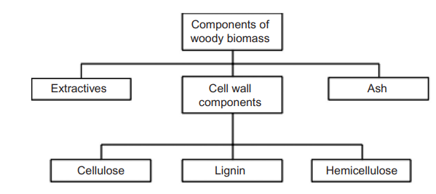
Figure 5 Major constituents of a woody biomass (Basu 2013)
Cellulose (C₆H₁₀O₅)_{n} is the most common organic compound on earth and is the primary structural component of cell walls in biomass. Cellulose is a long chain polymer; its crystalline structure gives it a high strength and forms most biomass skeletal structure. It is the largest component of wood making up to 44% of dry weight (Basu 2013). Cellulose is hygroscopic and is responsible for the hygroscopic behaviour of biomass (Nhuchhen et al. 2014). Hemicellulose (C₅H₈O₄)_{n} is also a constituent of the biomass cell wall although unlike cellulose it has an amorphous structure with little strength. The composition and structure vary significantly among different biomasses. It constitutes approx. 20-30% of the dry weight of most wood (Basu 2013). Hemicellulose groups release CO₂ & CO upon low temperature thermal treatment and has a significant effect on the mass yield in a thermal pre-treatment process (Nhuchhen et al. 2014). Lignin is an integral part of the secondary cell wall of plants, it acts as the cementing agent for cellulose fibres, holding adjacent cells together. It is one of the most abundant organic polymers on earth (exceeded only by cellulose). It accounts for between 18 – 35% of the dry weight of wood (Basu 2013). Lignin is thermally stable over a wide range of temperatures, thus in the thermal pre-treatment process, lignin remains less modified and a biomass with higher lignin content yields a more solid product (Nhuchhen et al. 2014). Figure 6 illustrates these components in a typical plant cell wall.
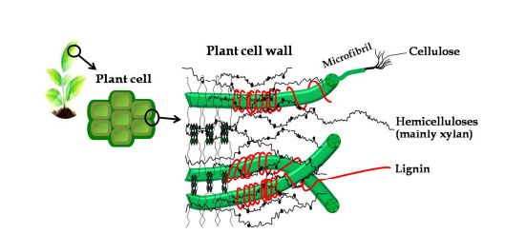
Figure 6 Structure of primary cell wall of plant cell (Nhuchhen et al. 2014).
Biomass mainly comprises of carbon (C), hydrogen (H), oxygen(O), nitrogen (N) and sulphur (S). A Van Krevelen diagram illustrates the O:C and H:C ratios for various solid fuels as shown in figure 7. The highest rank fuel is anthracite coal with the lowest O:C and H:C ratios. When compared to fossil fuels, biomass has the highest O:C and H:C ratios. The higher proportion of oxygen and hydrogen compared to carbon reduces the calorific value (CV) of the fuel because the C-O and C-H bonds have lower energy than the C-C bond (Suopajärvi et al. 2013)
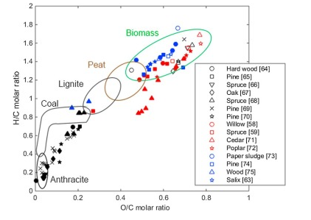
Figure 7 Van Krevelen diagram of thermochemical conversion products from woody biomass. With additional data of raw biomass (non-filled symbols), torrefied biomass (red symbols), HTC biomass (blue symbols), and charcoal (black symbols) (Suopajärvi et al. 2018)

The problem with Raw Biomass
Biomass in its raw form is not suitable for an energy source in industry as compared with fuels such as coal. Biomass compared with coal as a fuel:
- Higher oxygen content – reduces the heating value, results in a higher volume of flue gas during combustion.
- Lower carbon content – Required as a fuel and reducing agent.
- Low bulk density – High transportation and storage costs, also influences process conversion efficiency.
- Higher moisture content 45 – 60% - Higher thermal energy is required to combust, higher tar formation, lower density, greater tendency to decompose.
- Low net calorific value (NCV) – Low product yields, more biomass required to compensate.
- Low heating value (LHV)
- Hygroscopic – Can draw moisture in, even after drying.
- Fibrous – The fibrous nature of biomass increases the difficulty in pulverising it into a powder ready for processing. Thus, increased processing costs.
- Higher organic volatile mater – Burnt off in BF processes, lower product yields, can interfere with processes.
- Higher concentration of Alkali metals (Na, K, Zn) – Can foul BF refractory, increase coke consumption, and can be released into atmosphere upon combustion.
(Tumuluru et al. 2012; Suopajärvi et al. 2013)

Biomass Pre-treatment
Biomass pre-treatment methods can be classified into five categories:
- Chemical – Removes the lignin and hemicellulose improving biodegradability of cellulose. Includes Steam explosion, acid, alkaline, ammonia and freeze explosion treatments.
- Mechanical – Only brings about a physical change, Milling, extrusion, and grinding are the main methods.
- Biological – Uses microorganisms to modify the chemical composition and structure of lignocellulose to make it suitable for enzymatic digestion. Environmentally friendly and consumes less energy than other treatments but requires a large, controlled environment and is costly and slow.
- Thermal – Modifies the physical, structural, and chemical properties of biomass. Volatiles are driven off producing a more brittle and less fibrous product.
- Hydrothermal – A thermochemical conversion process in which biomass and water is subjected to high pressure at moderate temperatures. Can be used for wet biomass such as animal manures, human waste, and sewage. Produces an energy dense product.
(Nhuchhen et al. 2014)
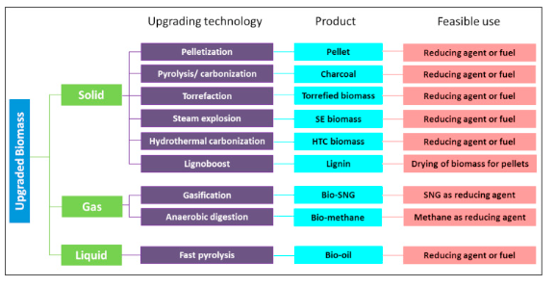
Figure 8 Biomass upgrading technologies according to product type (Mousa et al. 2016).
Figure 8 illustrates some of the available biomass upgrading technologies
Biomass must be dried before any thermochemical conversion processes. The moisture content needs to be reduced from 50 – 60% to 10% to avoid thermal ballast and affecting the yield of the charcoal. The most common technology used for biomass are rotary dryers although there are several other technologies available.
Thermal pre-treatments include torrefaction, carbonisation, fast pyrolysis, hydrothermal carbonisation, and gasification, they are classified based on their operating conditions, mainly temperature and reaction time and they produce heat, syngas (H₂+CO), or bio-oil and char. However, the solid product from some of these processes is not regarded as suitable for use in the ISI. (Suopajärvi et al. 2018) provides a summary of the available pre-treatments as follows (product yields from (Kambo and Dutta 2015):
Slow Pyrolysis – Slow heated to 300 - 600⁰C without air, residence time can vary from 15 – 30 min to several hours. Produces a highly carbonated solid residue (50 – 95% fixed carbon) called charcoal or Biochar with a large particle size. Gas and bio-oil produced as by-products. The product yields for carbonisation are 20 -30% liquid, 25 - 35% char and 25 - 35% gas.
Torrefaction – Temperature range is 200 - 300⁰C in the absence of air with 15 – 30 min residence time. Produces carbonised solid residue 14 – 48% fixed carbon. The product yields for torrefaction are 60 - 80% char and 20 - 40% gas.
Hydrothermal Carbonisation (HTC) – Mixed with saturated water-steam at 150 – 250⁰C form a few minutes to a few hours. Produces a slightly carbonated solid residue called HTC biomass with similar properties to torrefied biomass. Suitable for wet biomass. Eliminates the need for pre-drying. The product yields for HTC are 45 – 70% char, 5 – 25% liquid, and 2 – 5% gas.
Fast Pyrolysis - Heated to 400 - 600⁰C for a few seconds without the presence of air. Produces bio-oil. The product yields for fast pyrolysis are 75% liquid, 12% char and 13% gas.
Gasification – Operating conditions are 600 – 1400 ⁰C, mixed with 30 – 50% oxygen or air. Syngas is produced. The product yields of gasification are 5% liquid, 10% char and 85% gas.
Some char is produced as a by-product in both fast pyrolysis and gasification but is not considered biochar does not have the required properties.
The most suitable biomass state for use in industry as a source of energy is solid biomass, followed by biogas. The solid biofuels are represented by charcoal and torrefied wood pellets, and these are the most appropriate fuels for industrial use as an energy source. Biochar has the highest fixed carbon and calorific value and the lowest volatile matter among the bio products (Suopajärvi et al. 2018).
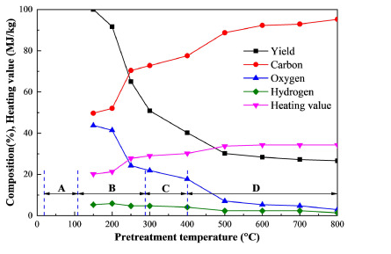
Figure 9 Influence of pre-treatment temperature on key variables (Liu and Shen 2021)
Figure 9 illustrates that during thermal pre-treatment the carbon mass increases relative to the oxygen and hydrogen content, as a result the heating value and CV increases by about 9 – 12%. Figure 10 shows another Van Krevelen diagram based on the molar ratio of O/C and H/C of various biomass and biochar material, it demonstrates that carbonised woody biomass has the highest rank in terms of calorific value and that it has similar fuel properties with coal meaning biochar from slow pyrolysis at high temperature has the potential to replace a high proportion of fossil coal in the ISI (Kambo and Dutta 2015; Mousa et al. 2016; Suopajärvi et al. 2018).

Biomass utilisation in the iron and steel industry
The BF – BOS steelmaking process accounts for 70% of global steel production. The BF process involves charging agglomerated iron ore and /or sinter into the BF at 1600 -2000⁰C. Metallurgical coke is the primary source of energy and the reducing agent. Fluxes such as limestone and dolomite are added to remove impurities such as sulphur. Pulverised coal injection (PCI) and oxygen are injected into the furnace to increase productivity and reduce coke demand (Geerdes et al. 2009).
The three processes with most potential for CO₂ savings in the ISI, displayed in figure 10, are:
- As a replacement for coal in PCI at the BF tuyeres.
- Partial replacement of coal in the coke making process for charging into the BF.
- Biomass in iron ore sintering for charging into BF.
(Liu and Shen 2021a)
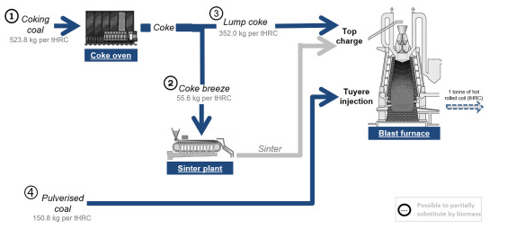
Figure 10 Opportunities for Biomass in iron & steelmaking (Mandova et al. 2018)
Other potential options for CO₂ savings in the ISI include:
- Biomass briquette charged directly into the BF (partial coke replacement).
- Iron ore pellets produced using biomass
- BF nut coke replacement
This report will focus on the first three options.

Injection of Biomass into blast furnaces
A blast furnace is charged through the top with iron bearing materials such as iron ore and sinter, metallurgical coke and fluxes or slag formers. The iron bearing materials are charged along with the fluxes in alternating layers with the coke. Preheated air (blast) and coal is injected near the bottom through tuyeres (water cooled copper pipes), the hot blast ignites and consumes the coal and coke producing a very hot flame (up to 2300°C). The hot gases produced rise up the furnace melting and reducing the iron ore. As oxygen in the burden is removed it reacts with the coke and produces carbon monoxide (CO), further fuelling the reduction of the iron ore in the burden. The voids caused by the burned coal and coke allows the burden in the furnace to descend. The fluxes react with impurities and produce a slag which along with the liquid iron seeps through the porous coke and is eventually tapped from the bottom, as the slag is less dense than the iron, they do not mix (Lundgren 2010).
(Haapakangas 2016) states that in the throat of the furnace any moisture present in the charged materials is driven off by the rising hot gas, as temperatures rise to 500 - 600°C the iron ore in the form of Hematite (Fe₂O₃) is reduced to Magnetite (Fe₃O₄). Descending a bit further as temperatures now rise to 700 - 900°C Magnetite reduces to Wustite (FeO), as the burden reaches the cohesive zone the Wustite is reduced to metallic iron which starts to soften and melt at 1100 - 1400°C. Below the cohesive zone coke is the only solid raw material as temperatures raise over 1500°C. The active zone is a semi fluidised region in which liquids drip through voids between lumps of coke. The deadman is a stable region of coke through which liquid iron drips and the final stage of reduction takes place. By the time the burden reaches the bosh it is fully melted and reduced. The molten iron and slag collect at the hearth where it is cast via the tap hole.
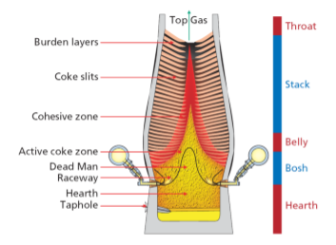
Figure 11 The Blast furnace (Geerdes et al. 2009).
(Mathieson et al. 2011) reports that the use of biomass in the blast furnace could reduce 22 - 32% of CO₂ emissions. Biomass can be injected into the BF in three forms; Biochar, bio-oils and bio syngas (Suopajärvi et al. 2013) although most studies have focused on biochar, as it has comparable properties to the coals used in PCI (Matsumura et al. 2008; Babich et al. 2010; Mathieson et al. 2011; Suopajärvi et al. 2013; Bazaluk et al. 2022). Coke is irreplaceable as the fuel in the BF and cannot be directly replaced by biochar due to its insufficient strength (Mathieson et al. 2011). PCI is used worldwide as a method to enhance BF profitability and efficiency. The injection of coal into the BF (illustrated in figure 13) has various economic and operation benefits including a) lower consumption of coke (which is significantly more expensive that coal) b) Coke oven life extension c) higher BF productivity d) improved hot metal quality e) BF operation flexibility f) lower CO₂ emission.
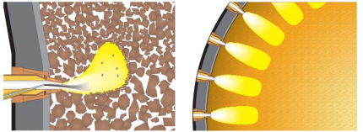
Figure 11 Illustration of PCA injection into PCI into the blast furnace.
(Matsumura et al. 2008) state that the important characteristics for PCI are devolatilization, gasification and combustion characteristics, as they affect the heating value and the raceway adiabatic flame temperature (RAFT). They demonstrated that that biomass possess higher reactivity and higher combustion levels when compared to pulverized coal. (Wang et al. 2014; Wang et al. 2015a) investigated various types of biomasses for replacement of coal in PCI, they found that 155 kg/tHM (Kg per tonne of hot metal) of pulverised coal (PC) could be replaced by 166.7 kg/tHM of biochar, This equates to an 22.8% replacement rate of PC with biochar, they found that increasing the biochar injection rate any further required further oxygen enrichment and might lead to a decrease in the RAFT temperature and an increase in the top gas temperature (TGT), which is undesirable. (Mousa et al. 2022) observed that CO₂ emissions could be reduced by 34% by full replacement of PC with biochar in the BF. They state that 100% PC - biochar replacement is achievable without negatively affecting RAFT and TGT. (Babich et al. 2010; Mathieson et al. 2011; Mousa et al. 2022) conclude that a good quality charcoal out preforms PC, the low ash and high basicity (CaO content) of the charcoal results in a decrease in slag volume and blast volume which results in a reduced coke rate and improvement in BF productivity. The drawbacks of charcoals include poor grindability, achieving the correct particle size may be problematic, that and the low density of charcoal means high injection rates may be difficult to realise without modifications to the PCI plant. (Ng et al. 2018) add that the production of biochar’s with low O/C ratios (high CV) may result in the increase of phosphorus and alkali metals which would lead to BF operational challenges.

Potential for biomass in metallurgical coke making
Coke performs many functions inside the blast furnace: it supports the burden as it descends the furnace, provides gas permeability, permits the decent of the liquid iron, acts as reducing agent, carburising of the hot metal and a fuel source. Coke is the only material capable of carrying out all these functions making it irreplaceable for BF operation. Coke is made by heating a blend of coals of specific rank to 1000 - 1100⁰C in the absence of air (pyrolysis) (Dı́ez et al. 2002). An example of a typical by-product coke oven is shown in figure 12. High quality coke allows the BF to achieve low coke consumption and high PCI rate and therefore high productivity. Metallurgical coke needs to be resistant to degradation, abrasion and chemical attack, be of a certain size, have a specific chemical composition and mechanical strength (Geerdes et al. 2009).
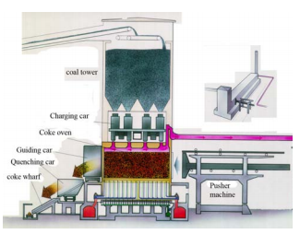
Figure 12 Diagram of a typical by-product coke plant (Hilding 2005)
Coking coal goes through several chemical and physical changes during the coking process, in order these are softening, swelling, contraction, evolution of volatile matter and then re-solidification. The thermoplastic properties of the coals are critical to the quality of the final coke (Loison et al. 1989).
Studies have shown that biomass can be added into the blend in several forms, raw biomasses, torrefied biomasses and pyrolyzed biomass. The addition of any of these seems to have a negative effect on the fluidity of the coal blend (MacPhee et al. 2009). (Diez et al. 2012) added untreated saw dust to the coal blend, they found that the inert nature of the sawdust negatively affected fluidity development, it does not soften and melt and does not bind the components of the plasticised coal. (Solar et al. 2021) added charcoal to the coking blend and found that it reduced the thermoplastic properties, an effect which increased as more char was added.
The mechanical strength and reactivity of coke are important parameters when measuring coke quality. These can be measured using ISO standard 1889-4 : CSR (coke strength after reaction) / CRI (coke reactivity index), the CSR and CRI measures are inversely proportional, when the CSR measure is high the CRI measure will be low (Dı́ez et al. 2002).
The particle size of the biochar can have a significant effect on the CSR/CRI values (MacPhee et al. 2009; Ng et al. 2011; Suopajärvi et al. 2017; Ng et al. 2018) biochar was introduced into the coal blend at 2 – 5% (Ng et al. 2011; Ng et al. 2018), 2 – 10 (MacPhee et al. 2009), 3 - 8% (Flores et al. 2017), and 5 – 25% (Yustanti et al. 2021). They found that coke reactivity (CRI) increased with the addition of biochar, the CRI increase is more pronounced when the charcoal is fine, this is due to the dispersion of calcium oxide (CaO) within the blend, which acts as a catalyst, promoting the carbon and CO₂ reaction. This reaction is less defined as the particle size of charcoal used increased. Reactive coke is favourable in the BF, as it improves the combustion process in the BF raceway and can equal or improve on the performance of coal (Babich et al. 2010; Mathieson et al. 2011), however, too high reactivity can mean a decrease in the CSR, this can lead to the generation of fines, which can result in BF permeability issues. The addition of course charcoal also led to the impairment of the biocoke’s cold mechanical strength, this measure relates to the behaviour of the coke during handling on its way to and during charging into the BF. Low cold strength could lead to fracture of the coke and the creation of fines. Course biochar affected the cold strength considerably, while the effect was far less pronounced when fine biochar was added (MacPhee et al. 2009; Ng et al. 2011; Flores et al. 2017; Suopajärvi et al. 2017). According to (Nomura and Kato 2006) the lower limit of biomass size was found to be 3 – 10mm.
Due to the negative effects of biomass addition into the coking coal blend, the amount that can be added is limited to 5% wt., while still maintaining acceptable coke quality (Suopajärvi et al. 2018). (Montiano et al. 2014a) found that by briquetting biomass that additions of 10 – 15% can be included in coking blends.

Potential for biomass in the sintering process
The materials available for the ferrous input into a blast furnace are pelletised iron ore, iron ore lump or sinter. Iron ore pellets are formed by agglomerating iron ore fines, that are not suitable for direct charge into the BF. A good blast furnace burden consists of sinter and/or pellets. Lump ores are becoming increasingly scarce and their properties are generally poorer than the alternatives, and so are mainly only used as a cheap replacement for pellets (Geerdes et al. 2009).
Iron ore sintering is the process of heating iron ore fines, coke fines and other materials to produce a semi molten mass that solidifies into a porous piece of sinter. Sinter must be of a certain size and strength to be suitable for use in the BF. The main steps in the sintering process are proportioning, mixing and sintering. Raw materials such as iron ore fines, reverts - iron and steelmaking by-products that contain iron and fluxes are added together to form what is called a raw mix. The raw mix is mixed with water to form granules. The granules are then fed onto a moving grate to form the sintering bed. The bed is ignited by gas burners near the ignition hood at the face of the bed. As the coke in the bed burns it creates a high temperature combustion zone at temperatures 1200⁰ – 1400⁰C. Air is drawn through the bed creating a narrow self-propagating flame front, further promoting combustion. Some of the materials melt and as the flame front moves the material cools and resolidifies. This partial melting and diffusion within the materials forms an agglomerated porous sinter cake, this is illustrated in figure 13. The process produces sinter with the required chemical composition, permeability and strength for use in the BF (Chen et al. 2016).
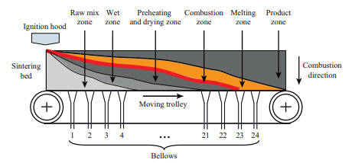
Figure 13 Diagram of a sintering machine (Chen et al. 2016).
The best fuel for use in the sintering process is coke breeze, undersized coke screened from the coke produced at the coke ovens. The sintering process contributes up to 12% of the CO₂ emissions produced at a typical integrated steel plant. The CO₂ in this case is mainly generated from the combustion of the coke breeze and decomposition of flux additives. The combustion of coke breeze in the sintering process is also responsible for the emission of various types of GHG such as sulphur dioxide (SO₂), nitrogen oxides (NO_{x}), carbon monoxide (CO), methane (CH₄), dioxins and fine dust. The concentration of these emissions is correlated with operational conditions, quality of the fuel and raw materials used (Abreu et al. 2015).
Biochar can be used as an alternative fuel instead of coke breeze, the primary differences between coke breeze and biochar that affect the sintering process and sinter quality is higher reactivity (Gan et al. 2015) due to higher surface area and porosity (Lovel et al. 2009). (Lu et al. 2013) found that partial replacement of coke breeze with biochar resulted in higher concentration of CO_{x} but lower concentrations of SO_{x} and NO_{x} in the off gas. (Abreu et al. 2015) conclude that a 50% biochar/coke breeze blend fuel mix was operationally feasible and that a 50% reduction in GHG emissions was observed, although dust concentration and methane concentrations rose significantly. (Mathieson et al. 2011) states that partially replacing coke breeze with biochar can reduce net CO₂ emission by 5 – 15%. They also found that as charcoal is highly porous, sinter granulation is negatively affected. The moisture saturation of charcoal is 48% compared to 25% for coke breeze. Therefore a higher percentage of water needs to be added to the sinter mixture (~8.5%) while coke breeze requires (~7.1%). (Mousa et al. 2015) studied biochar substitution for coke breeze at 0 - 100%, they found that that the lower crushing strength of biochar when compared to coke breeze resulted in its destruction during mixing, as a result the bed permeability is negatively affected, and the vertical sintering speed is decreased. Sinter yield was unaffected, but sinter quality (measured by the tumbler index) and product yield sharply decreased when the biochar substitution for coke breeze surpassed 25%. (Lovel et al. 2007; Kawaguchi and Hara 2013; Wei et al. 2017) demonstrated that biomass addition to sinter making has a negative effect on the sinters yield and ability to resist impact and friction (measured by the tumble index) while at this point fuel consumption increases as illustrated in figure 14. Although (Kawaguchi and Hara 2013) found that by using biochar with high fixed carbon (>90%) and larger particle size (1-5mm), the sinter yield and product yield was comparable to that of coke breeze and by adjusting the sintering process, sinter produced from biomass can meet BF requirements.
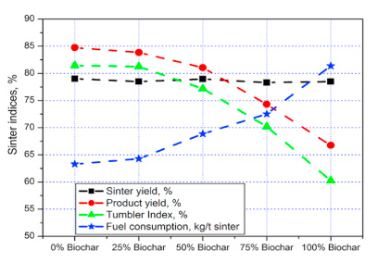
Figure 14 Sinter indices under the influence of biochar substitution for coke breeze (Mousa et al. 2015).
(Ooi et al. 2011) suggest that up to 20% of coke breeze can be replaced with charcoal, they discovered that both sinter yield and productivity was improved. (Gan et al. 2014; Gan et al. 2015) report that up to 40% biochar replacement could be reached. As the substitution rate increased, the combustion efficiency deteriorated due to variation in the flame front speed and heat front speed. They found if the PSD in the 1 - 5mm range is increased the sinter quality indices improved. The parameters that need to be considered and controlled when optimising the substitution rate of biochar, include particle size, strength, reactivity, and chemical composition (fixed carbon, volatile matter, alkalis, and moisture) of the biomass products.

Biomass supply and availability
There are barriers to implementing biochar in the ISI. At present there are no supply chains in place for the supply of biochar to the ISI (Suopajärvi et al. 2018). The UK also currently lacks the facilities to produce the amount of biochar that would be required for the ISI (Lamers et al. 2016). For biochar to be sustainable as a green technology there is a need to ensure that the feedstocks are sourced from sustainably managed lands. Biochar needs to be both environmentally and economically viable (Jahanshahi et al. 2014). Charcoal production technology needs to be developed that can produce charcoal at a significantly lower cost (Norgate et al. 2012)
Life cycle assessments (LCA) assess the potential environmental impacts associated with a product, or process during its entire life cycle, from extraction of raw materials through to the production and use of the end product. LCA’s on biochar carried out by (Norgate and Langberg 2009; Norgate et al. 2012; Feliciano-Bruzual and Mathews 2013; Suopajärvi and Fabritius 2013; Fick et al. 2014) found that net CO₂ and GHG levels were reduced between 3.4 to 12.9 CO₂/MJ or 31 – 57% CO₂ emission reduction when assessing biochar usage.
Approximately 800Kt of charcoal is consumed yearly in Europe, mostly by the barbecue market, 70% of which is imported from Africa. Substituting 5% of the fossil fuels used by a small European size steelmaking plant BOS – BF with a production output of 3 million tonnes of crude steel per annum would require roughly 120kt of charcoal. The question needs to be asked whether the countries such as the UK has the resources to meet the demand. (Mandova et al. 2018) demonstrated that forestry growth in the EU is 36% bigger than EU sourced wood consumption (see figure 15 b) and sufficient biomass resources exist to meet demand by all steel plants in Europe, however counties such as Great Britain, Germany, Italy, Spain, Belgium, and the Netherlands would be highly reliant on cross border trading, as shown in figure 15 a). Similar resource studies were also carried out for Finland (Suopajärvi and Fabritius 2013), Sweden (Wang et al. 2015a) and France (Fick et al. 2014) indicating that these nations natural resources are capable of supplying biomass to their iron and steel plants.
a)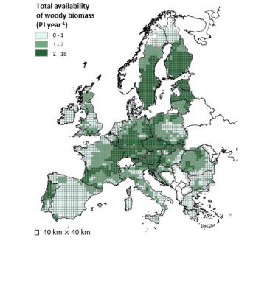 b)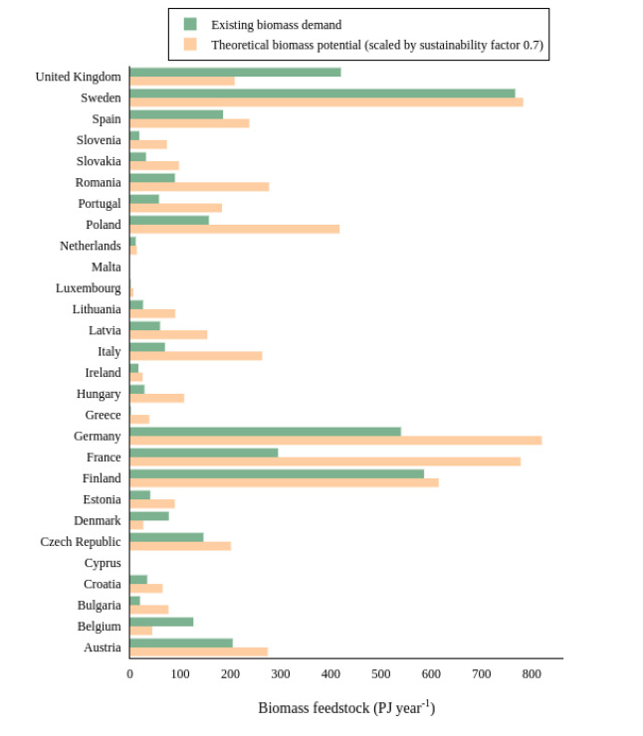
Figure 15 a) The spatial distribution of woody biomass and waste in the EU b) Comparison of the woody-biomass supply and the existing woody-biomass demand, per country) (Mandova et al. 2018).
Biomass raw materials are low in energy density and require treatment in order to make them suitable for use in iron making processes. A significant amount of energy costs are associated with cultivating, transporting and pre-treating and handing them, as illustrated in figure 16. As such biochar productions costs are significantly in excess of the fossil fuels they are meant to replace. Charcoal cannot compete with fossil fuels on price without the introduction of high carbon taxes (Mousa et al. 2016).
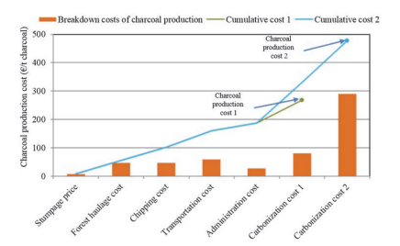
Figure 16 The cost of charcoal production (Suopajärvi and Fabritius 2013)
Charcoal production costs range from €268/t to €478/t, for logging residues. Raw material costs account for between 54% - 65.4% and transportation costs make up 21% - 34%. Investment in Charcoal production plants near to the steel plants would help to reduce costs significantly. CO2 mitigation costs were €33–69/tCO2 (Suopajärvi 2014).
(Mathieson et al. 2011) illustrated the value in use (VUI) of various charcoal types compared with coal types for BF tuyere injection at 140kg/t-HM shown in figure 17. Three charcoal samples had calculated values 50% greater than the reference bituminous coal. The reason for this is the predicted lower BF coke rates and improved hot metal composition.
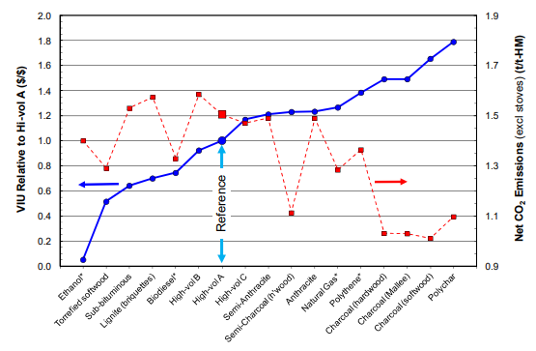
Figure 17 Calculated VUI's for BF injectants and consequent CO2 emissions from the BF (Mathieson et al. 2011)

Method
Two biochar samples were considered for assessment. The first sample (biochar 1) is a softwood pellet biochar that has been pyrolysed at 650⁰c in a rotary kiln (Mašek et al. 2018) as shown below in figure 18.
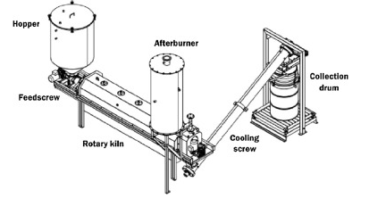
Figure 18 Rotary kiln pilot-scale pyrolysis unit used to make biochar 1 (Mašek et al. 2018)
The second sample (biochar 2) is a mixed hardwood sample sourced from industry waste. For which the process parameters and specifications were unavailable.
Before these materials can be assessed for use in the iron making processes it is necessary to fully understand their chemical and physical properties to ensure they are suitable for the processes they are being assessed in. These can then be compared with the fossil fuels they are replacing.

Biochar characterisation

Proximate analysis
Proximate analysis is widely accepted as the basis for coal characterisation in connection with the utilisation of coal. Proximate analysis is a means of determining the products obtained when a coal sample is heated under specific conditions. The proximate analysis of coal separates these products into four groups (Speight 2015), see figure 19.
- Moisture - Water content
- Volatile matter – the gases and vapours driven off during pyrolysis
- Ash – The inorganic residue remaining after combustion
- Fixed carbon – The non-volatile fraction of coal
- Free swell index – The swelling properties of the coal
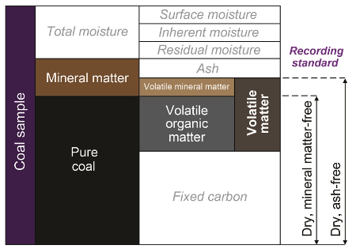
Figure 19 The components of coal (Backus 2022)

Moisture
There are several types of moisture values reported for coal. The surface moisture is water adhering to the outside of the coal sample or particle, inherent moisture is held by capillary action in the microscopic structure of the coal, residual moisture is water that remains in the coal after air drying and/or minor heating to 10 -15⁰C. The moisture value that will be used in this report is the total moisture – All moisture in and on a coal sample that can be removed through heating (Backus 2015).
The method used to determine moisture is taken from the British standard BS 1016-1: 1973, 1 Kg of sample is heated in an air oven at 105⁰to 100⁰C for approx. 4 – 5 hours, the sample and container is then weighed and returned to the oven. This is repeated until a constant mass is achieved. The Moisture is calculated from the loss in mass of the sample.
If m1 = Mass of container plus sample as received (g),
m2 = Mass of empty tray (g),
m3 = Mass of tray plus sample after heating (g),
m4 = Mass of dry empty container (g),
M = Percentage of moisture in the sample analysed,
then $M=\frac{\left(m_{1}- m_{4}\right)-(m_{3}- m_{2)}}{\left( m_{1}- m_{4}\right)}*100$
(British Standards Institute 1999)

Volatile matter
Volatile matter (VM) refers to the components of coal, excluding moisture, that are liberated at high temperature in the absence of air. Coals are ranked by the amount of carbon present in them and therefore their energy content. Measuring VM is an important parameter used to help identify a coals rank. VM decreases as the coal rank increases see table 1 (Speight 2015). Most VM comes from the organic components in coal, but some elements from minerals combine to form volatile oxides. The most common VM in coal is water, carbon dioxide, and sulphur dioxide (Backus 2015).
Table 1 Decrease of VM in bituminous coals in response to increasing coal rank (Osbourne 2013)
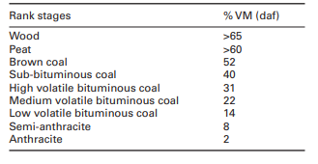
VM is determined by measuring 1g of sample into a lidded silica crucible (preventing air ingress), the crucible is placed in a furnace at 900⁰C for 7 minutes. VM is calculated from the loss in mass of the sample after adjusting for moisture.
VM is given by $V=\frac{100\left(m_{2}-m_{3}\right)}{m_{2}-m_{1}}- ω_{H_{2}O}$
Where m1 is the mass, expressed in grams, of the empty crucible and lid.
m2 is the mass, expressed in grams, of the crucible and lid and test portion before heating; m3 is the mass, expressed in grams, of the crucible and lid and contents after heating.
^{ω}H₂O is the moisture, expressed as a percentage mass fraction,
(British Standards Institute 2010a)

Ash
Ash is the non-combustible residue left after coal is burned and represents the bulk mineral matter after carbon, sulphur and water has been driven off during combustion. The ash is composed primarily of oxides and sulphides and can be considered to be an approximation for the mineral content but does not equal the original mineral content as some of the mineral phases are altered when the coal is combusted e.g., CO₂ is removed from carbonates and SO₃ is removed from the sulphides (Speight 2015). Ash is determined by measuring 1g of sample into a silica dish, the dish is placed into a furnace at 815⁰C for 60 minutes. The ash is calculated as the mass remaining in the dish as a fraction of the original sample weight.
The ash is expressed as a percentage mass fraction:
$$A=\frac{m_{3}- m_{1}}{m_{2}- m_{1} } ×100$$
where:
m1 is the mass, expressed in grams, of the empty dish.
m2 is the mass, expressed in grams, of dish plus test portion.
m3 is the mass, expressed in grams, of dish plus ash.
(British Standards Institute 2010b)

Fixed carbon
Fixed carbon is the solid combustible residue remaining after removal of moisture, ash and volatile materials. Fixed carbon is calculated by subtracting the percentage moisture, ash and VM from 100%.
$$FC=100-\left(M+A+V\right)$$
where:
M = Moisture content expressed as a percentage
A = Ash content expressed as a percentage
V= Volatile matter content expressed as a percentage
(Loison et al. 1989)

Ultimate analysis
The organic components of coal are composed of carbon, hydrogen, nitrogen, oxygen and sulphur, these components make up 99% of the organic portion of coal. Analysis performed using an instrument called an ultimate analyser, carbon, hydrogen and nitrogen are determined by combusting the sample, the elements carbon, hydrogen and nitrogen are converted into CO₂, H₂0, N₂ and NO_{X}. These gases are then passed through infrared cells to determine carbon and hydrogen content, and a thermal conductivity cell to determine nitrogen. The raw hydrogen analysis result is moisture corrected. The total oxygen is calculated from the other values (Osbourne 2013).
Total oxygen weight % = 100 – (total carbon weight % + total hydrogen weight % + total nitrogen weight % + total sulphur weight % + total ash weight%).
Sulphur can be determined using a combustion analyser, a sample is placed in the sulphur analyser. The sample is combusted at a temperature of 1,370°C in an oxygen atmosphere. The oxygen reacts with sulphur to form sulphur dioxide gas. The gas passes through an infrared absorption detector in the analyser, which measures the concentration of sulphur (Backus 2015).

Calorific value
The calorific value is a measure of the energy content of the coal. It is the amount of energy produced when a known quantity of sample is combusted in oxygen. The instrument used to measure this is called a bomb calorimeter. The sample is combusted in a steel container placed in water. The change in water temperature is used to determine the calorific value of the sample. Calorific value is measured in kilojoules/kg or megajoules/kg (Backus 2015).

Major Elemental Analysis
Coals can contain a variety of elements, major elements make up more than 1%, they are determined by X-ray fluorescence (XRF), the coal is combusted, and the remaining ash is fused with a flux material before being analysed on the XRF. The XRF works as follows: Photons from the x-ray tube strike the sample with enough energy to expel the electrons out of the element’s innermost orbital, the atoms become unstable. To regain stability electrons in the outer orbitals move into the newly vacant inner orbitals. When an electron transitions from an outer orbital to an inner orbital it emits energy known as x-ray fluorescence, each element has a specific energy signature which is picked up by the detector, see figure 20 below (Blondel 2020).
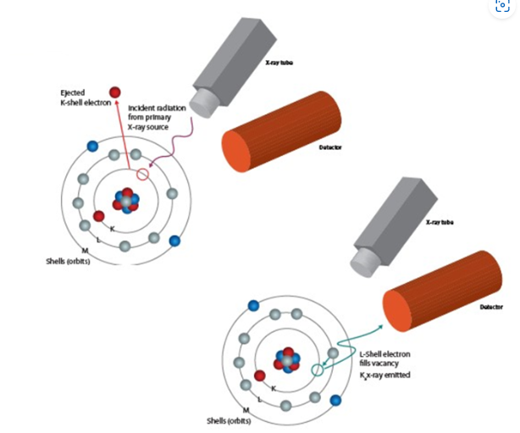
Figure 20 Illustrating x-ray fluorescence (Blondel 2020)
Results are presented on an oxides basis, such as SiO₂, Al₂O₃, Fe₂O₃, CaO, MgO, Na₂O, K₂O, TiO₂, Mn₃O₄, SO₃, P₂O_{5.}

Minor elemental analysis
Minor elements make up less than 1% of the sample by weight. They are determined by using an inductively coupled plasma optical emission spectrometer (ICP-OES). A plasma is formed by applying a high frequency electric current to argon gas. The electromagnetic field created by the current ionises the argon gas and a plasma is created. The analyte in the form of atoms is introduced to the plasma which then becomes ionised. When an atom or ion is excited within the plasma, its electrons move from a lower energy level to a higher energy level (see figure 21). When the electrons then return to their initial state, energy is emitted in the form of photons which a picked up by a detector. These photons possess wavelengths that are unique to their respective elements (Thermo Fisher Scientific 2022).
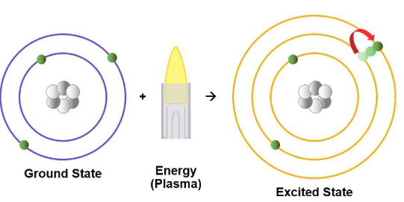
Figure 21 Excitation of an atom by a plasma (Thermo Fisher Scientific 2022)

Particle size distribution
The particle size distribution (PSD) of a material can be of critical importance to the performance of the material in its use. A PSD indicates the percentages of particles of certain size fractions of a granular material. It is determined by allowing a representative sample of the material to pass through a series of sieves (typically woven wire or punched plate for larger particle sizes) of decreasing opening size (see figure 22). The sieves are placed on a mechanical shaker which shakes them for a set period to allow the material to fall through the sieve openings. PSD results are reported as the weight percent retained on each sieve as well as the cumulative weight percent less than the sieve size.
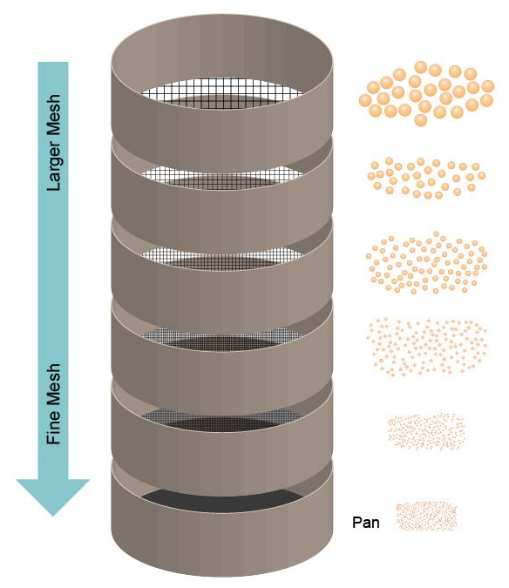
Figure 22 Particle size distribution by sieves (Particle Technology Labs 2022)

Assessing biochar substitution in pulverised coal injection (PCI)

Drop tube furnace
A drop tube furnace (DTF) is designed to study the high temperature combustion and devolatilasation of materials such as pulverised coal. The DTF is designed to achieve rapid particle heating rates (up to 1450⁰C) using different gas compositions (inert or oxidising) and residence times ranging from 30ms to 700ms. The DTF can replicate conditions similar to those found in the BF raceway.
The DTF (shown in figure 23) consists of a vertically mounted alumina work tube which is heated by four main and two trim silicon carbide heating elements. The temperature is monitored by three thermocouples spaced evenly along the length of the tube. The gas has a laminar flow, such that particles delivered into the DTF drop at a constant velocity, enabling accurate residence times. Samples are fed through a water-cooled stainless-steel tube at the top of the DTF. A water-cooled stainless steel collection probe is positioned within the lower half of the work tube. The residence time is varied by adjusting the length of the probe inside the tube.
The biochar samples were dried to a constant mass and then crushed in a hammermill. 15g of each sample, sieved to 100% < 1mm and 50% < 200μm, were fed via a vibrating hopper at a rate of 15g/hour into the DTF, this sample particle size is representative of the coal that would be injected into the BF after being crushed and processed through the PCI plant at Port Talbot. The sample travels through the work tube in the main gas stream and the residue is collected in a cyclone trap. The residence time of the samples can be controlled by adjusting the length of the collection probe. Coals injected into the furnace have residency times of approx. 35ms, therefore the biochar samples were tested at this residency time to assess burnout characteristics, as the DTF has a lower temperature, a longer residency time of 700ms was also assessed.
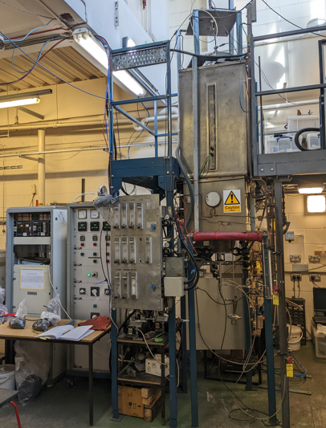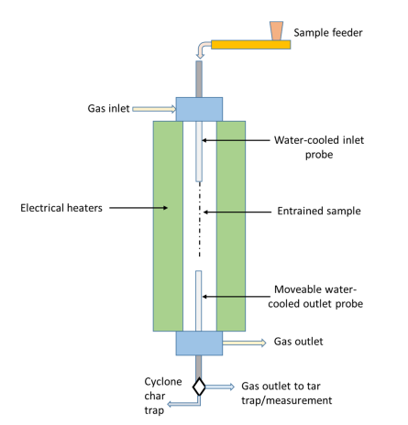
Figure 23 A picture and schematic (Steer et al. 2021) of the drop tube furnace.

The ash tracer method was then used to calculate the burnout of the coals, sometimes referred to as the combustion efficiency. The burnout (%) is calculated from the ash balance of the initial content of ash in the coal (A₀) and the ash content of the residue collected post DTF (A₁).
$$Burnout \%= \frac{{10}^{4}(A_{1}-A_{0})}{A_{1}(100- A_{0})}$$
(Steer et al. 2021)
The biochar samples will be compared with a coal often used at Port Talbot for PCI called T-coal.

Assessing biochar substitution in coke making

Pilot scale coke oven
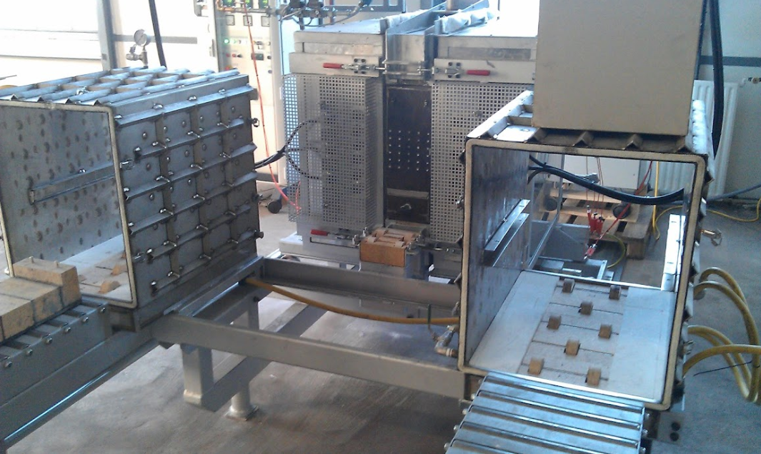
Figure 24 The Pilot scale coke oven at Tatasteel
Pilot scale coke ovens (PSCO’s) are widely used to produce coke samples for characterisation and to assess the coking behaviour of coal blend. This allows the business to optimise the value in use of the coals available to them. The purpose of pilot scale testing is to determine the suitability of the produced coke for use in the blast furnace and to assess the pressure generated at the oven walls during coking. The 25Kg PSCO at Tata steel is pictured above in figure 24.
The oven uses a silicon carbide plate in the refractory walls to heat the oven. The electrical heating elements are situated inside the refractory wall and behind the silicon carbide plate. The walls of the oven can both move horizontally. A refractory C-section sits in the middle. An illustration of the PSCO is shown in figure 25. The 25 Kg packed coal bed is charged into the furnace in a rectangular cardboard box which sits inside a refractory cassette. The cassette is charged through the front of the furnace via movable cooling jackets. The walls are then closed, a stainless-steel gasket keeps the oven sealed. The furnace is charged at 900⁰C and left for 3 hours to allow the furnace to stabilise, the temperature is then ramped up to 1000⁰C and held at temperature for 5 hours before ramping back down. The ramp ensures full carbonisation of the coke by driving off any excess volatiles. All exhaust gases are vented into a local exhaust ventilation system. The charge stays in the furnace for 18 hours, once the coal is fully coked, the cassette is placed into a water-cooled jacket and left to cool.
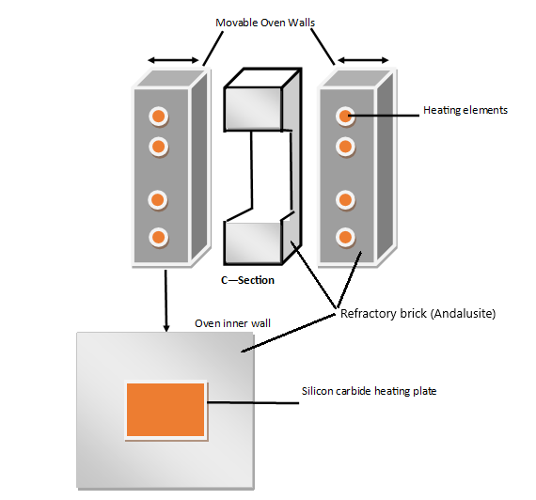
Figure 25 An illustration of the 25Kg pilot scale coke oven at Port Talbot, made by the author
The biochar will be assessed against a coal used at Port Talbot steelworks called Riverside. Riverside is a high-quality Australian coking coal. Each biochar will be blended with Riverside in increments of 3%, 5% and 7.5% addition.
Riverside coal was sampled from a stockpile, 50 shovel loads of material were collected from around the stockpile at evenly spaced points. The heights of the sample points were varied to try avoid material size bias. This type of sampling is not recommended by the ISO standard however there are no coal autosamplers or belt sampling points onsite.
To mimic the coal charged into the Morfa coke ovens at Port Talbot, the Riverside coal and the biochar samples will be passed through a hammer mill, set to crush the materials to 80% > 3.175mm and 40% > 0.5mm and the bulk density will be 750Kg/m³ dry.
The Riverside coal and Biochar blends were tested in duplicate 2x 25Kg charges, to calculate the biochar additions the total blend weight the following calculation was applied.
$$Biochar addition=Tw*(\frac{B\%}{100})$$
Where: Tw is the total weight of the duplicate charge = 50Kg
B% is the biochar addition in Kg.
An example would be for a biochar addition of $x= 50*(\frac{3}{100})$ which equals 1.5Kg of Biochar. The blend would consist of 48.5 Kg of Riverside coal and 1.5 Kg of biochar.
The moisture of the charges will be set at 9.5%, this is to reduce variation across tests. The coal charge moisture is assessed. In all cases for this project the moisture was measured >9.5 %, meaning water needed to be added to the charge. The calculation used to assess the required water addition was:
$$Wa=\left(\frac{9.5-M\%}{100}\right)*Tw$$
Where: Wa is the water addition required in Litres
M5 is the measured moisture percentage
Tw is the total charge weight in Kg
An example would be for a charge measuring 8.4% moisture = $Wa=\left(\frac{9.5-8.4}{100}\right)*50 Kg$ which equals 0.55 L of water addition to the charge.
The riverside coal is weighed out and charged into a cement mixer, the biochar is then weighed out and added into the mixer, while the materials are mixing the water is sprayed onto the material in the cement mixer.
A cardboard box placed inside the refractory cassette to contain the coal. Lines are drawn inside the cardboard box using a template, see figure 26. A known mass of coal is then compacted into the known volume of space inside the box which results in the required coal density (figure 27).
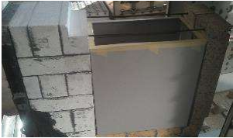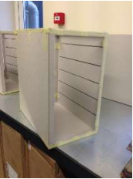
Figure 26 Preparing the coal charge
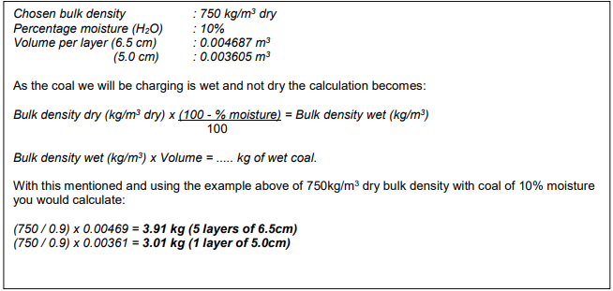
Figure 27 The coal density calculation
The cassette is then charged into the PO and left for 18 hours. After which the cassette is discharged into a steel water-cooled jacket and left to cool.
The coke produced in the PSCO was then assessed for its quality using the tests described below.

1/5th Micum – Mechanical Strength
During its transportation from the coke ovens to the BF, the coke will be handled several times, through conveyors, stockpiles and bunkers before finally being charged through the top of the BF. This handling will result in some degradation due to abrasion and shock. The resistance to this degradation is measured using a test called the micum test.
The coke sample is screened, and a composite sample is made up of the representative size distribution of coke +40 mm. This composite sample is then subjected to 100 revolutions inside a drum at 25 rpm, containing paddle lifters, as shown in figure 28. The coke is essentially subjected to a 100 m drop. The coke is then rescreened and the percentage of coke left over 40 mm is called the M₄₀ fracture index and the percentage of coke under 10 mm is called the M₁₀ abrasion index (Geerdes et al. 2009).
As the coke produced in a PSCO weighs only ~15Kg the ISO 556-2020 standard does not apply, the standard states a full micum sample weight of 50 Kg or a half micum weight of 25Kg. For the purposes of the PSCO, a 1/5 micum has been adapted from the standard. For this test, the sample weight is ratioed at 10Kg and the drum width is 1m x 1m to 1m x 0.2m. All other specifications remain the same in both tests.
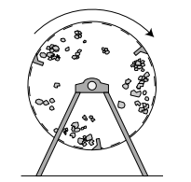
Figure 28 The motion of coke in a micum test (Geerdes et al. 2009).
The M₁₀ is calculated as follows:
$$M_{10}=\frac{\left(m_{1}+m_{2}\right)}{m_{3}}x100$$
Where:
m₁= is the mass of coke (after rotation in the drum) passing the sieve of aperture size10mm
m₂= is the mass of material lost during determination
m₃= is the mass of the test portion
The M₄₀ is calculated as follows:
$$M_{40}= \frac{m_{4}}{m_{3}} x 100$$
Where:
m₃= is the mass of the test portion
m₄= Is the cumulative mass of coke (after rotation in the drum) retained on all sieves of aperture size equal to or greater than 40mm.
(International Standards Association 2020)

Coke strength after reaction and Coke reactivity index (CSR/CRI)
The CSR/CRI test replicates some of the conditions coke is exposed to in a blast furnace. A high CSR is believed to indicate that the coke will resist breaking down, improve the permeability of gas and liquid iron, increase productivity and reduce coke consumption in the BF (Li et al. 2014). A good quality coke should have a low CRI and high CSR. The CRI measures the solution loss reaction of coke by CO₂ at 1100⁰C for 2 hours under standardised gas flow rate conditions, see figure 29. For the CSR, the coke is tumbled post reaction and re-screened to calculate the strength index (Dı́ez et al. 2002).
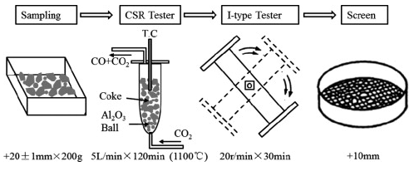
Figure 29 Diagram of the CSR/CRI test
The CRI is expressed as a percentage by mass and is given by the formula
$$CRI=100× \frac{m₀-m₁}{m₀}$$
Where:
m₀ is the mass in grams of the sample before reaction
m₁ is the mass, in grams, of the sample after reaction
The CSR is expressed as a percentage by mass, is given by the formula
$$CSR=100×\frac{m₂}{m₁}$$
Where:
m₁ is the mass, in grams, of the sample after reaction
m₂ is the mass, in grams, of the fraction of the sample >9,5 mm after tumbling
(British Standards Institute 2018)

Assessing biochar substitution in sinter making

Sinter pot
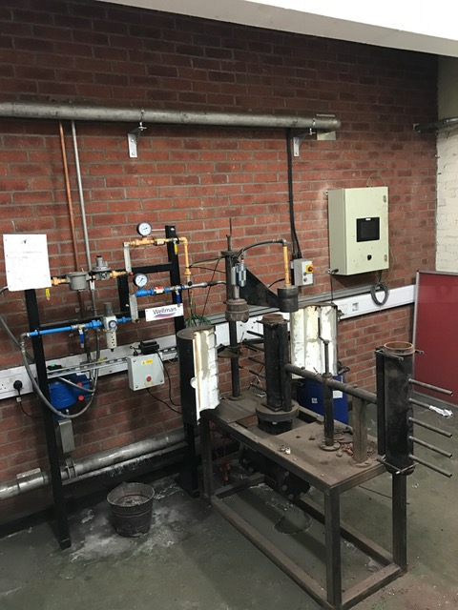
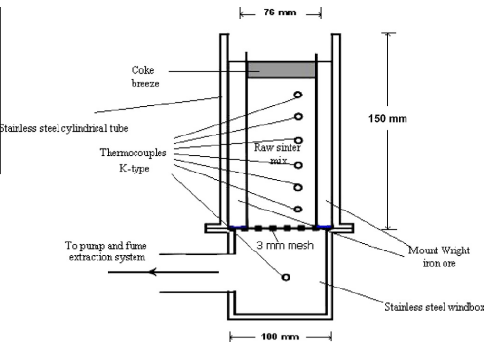
Figure 30 A photograph (author) and a schematic diagram of the sinter pot (Zandi et al. 2010)
The sinter pot is a laboratory scale sintering furnace. It is capable of producing iron ore sinter in 10kg batches. The furnace is filled iron ores, coke breeze and limestone. The top is ignited, and air is then drawn through the bottom of the furnace, drawing the flame front downwards. This allows combustion to occur throughout the mixture, finishing the agglomeration process. The sinter pot is connected to a computer system, where the process parameters can be monitored via flowmeters, thermocouples, and pressure gauges. The sinter pot and computer system are connected to a butterfly valve where the user can adjust the pressure drop accordingly. Overall, the sinter pot essentially mimics the process conditions of the sinter plant at a laboratory scale in order to investigate and optimize the process (Mousa et al. 2015). The sinter pot is demonstrated in figure 30.
The Biochar will be assessed against a base sinter blend, made up of a blend of iron ores fluxes and fuel, similar to that used at the Port Talbot steelworks sinter plant. A blend model excel sheet was used to calculate a base blend with the required chemistry to give a strong sinter with high quality characteristics, see table 2. The base blend can then be used to assess the impact of biochar addition on sinter quality.

Table 2 Sinter blend components
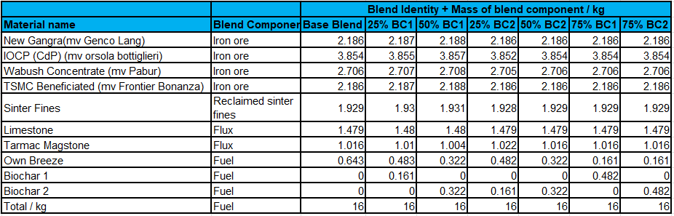
The calculated fuel percentage in this blend was 4% coke breeze. The coke breeze will be replaced by biochar in increments of 25%, 50% and 75%. The resulting sinter will be assessed using the quality measures discussed below. The emissions during these tests will also be monitored for their GHG concentration.
The iron ore samples are collected during discharge of the vessel, the ore is loaded onto a conveyor belt and transported to the stockyard. An iron ore stacker discharges the iron ore from the conveyor belt into large stockpiles. Every 5000 Kt the stacker, diverts the material away from the main stockpile and creates a small pile for sampling. The practice of sampling from the main stockpile has been discontinued at Port Talbot for safety reasons, large stockpiles of iron ore fines have been known to slip, rainfall can cause the fines to liquefy, large amounts of the ore can slip away from the stockpile. The ISO recommended sampling method is to use an autosampler, which is not available at Port Talbot, the next best recommendation is to stop the conveyor belt and take cuts from across the belt. This practice has also been stopped as it caused operational issues when discharging iron ore, the weight of the ore on the belt can strain the conveyor belt when it has been stopped, discharging of the vessel is slowed down which incurs a cost, and discharge chutes can become blocked. The small sample stockpiles method was developed at Port Talbot laboratories to try obtain as representative sample as possible given the constraints put in place. 50 increments are taken from around the small pile and bagged up to create 25Kg samples for every 5000Kt. These samples are mixed and spilt down into more manageable sample sizes. A composite was then created to obtain a representative sample of the vessel cargo. As it is not to ISO standard some bias may exist in this sampling method. The fluxes and coke breeze were sampled from conveyor belts as they discharge into the process. They are sampled using ISO standard methods.
The materials were then dried in an oven at 105⁰C until constant mass was achieved. The ores were screened through a 5mm sieve, any oversize was discarded. This was done to mimic plant conditions, a uniform particle size ensures air flow uniformity (Cheng et al. 2016). Fuels are sieved to <3mm.
The Materials were weighed out according to the weights shown in table 2. The blend was thoroughly mixed together in a cement mixer before being charged into a granulation drum and mixed with 6.5% water to form micro pellets, granulation helps create a porous and permeable mixture and the moisture helps the particles adhere to one another. Next the furnace is filled with a layer of sinter 10-15mm called the hearth layer, this layer ensures good permeability and protects the base from thermal attack. The granulated raw mix is now added to the furnace and thermocouples fixed into place.
A flowmeter is fixed above the furnace, air is drawn through the furnace to measure the raw mixture permeability. To ignite the mixture a burner is placed above the furnace and left for 1 minute, the flow meter is returned to the top of the furnace and the furnace is left to sinter.

Determination of low-temperature reduction disintegration indices
Inside the BF, sinter material is degraded due to mechanical wear and reduction. The reduction wear mechanism results from the crystal structure change from hematite (Fe₂O₃) to magnetite (Fe₃O₄). This structural change occurs in the low temperature region of the furnace and therefore is known as low temperature degradation. This degradation is measured by the reduction disintegration index (RDI) (Jiao et al. 2021). Figure 31 illustrates the RDI equipment requirements.
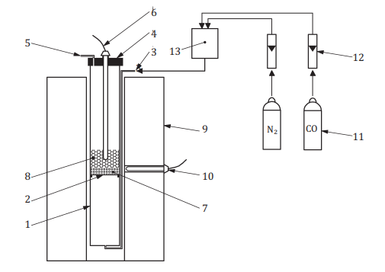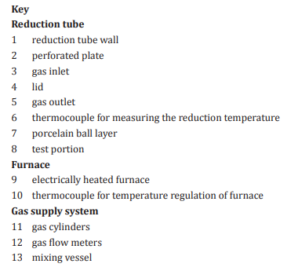
Figure 31 RDI test equipment apparatus (British Standards Institute 2015b)
The test portion is reduced by heated to 550⁰C and a reducing gas consisting of a 70/30 % mix of N₂ and CO is passed through the sample for 30 minutes. The reduced sample portion is then tumbled in a small drum for 900 revolutions before being sieved through a 2.8mm sieve. The RDI is calculated as the mass percentage of material less than 2.8mm.
$${RDI}_{-2.8mm} = 100- \frac{m_{1}}{m_{0}}* 100$$
Where;
m₀ is the mass, in grams, of the test portion after reduction and before tumbling.
m₁ is the mass, in grams, of the fraction retained on the 2,8 mm sieve.
(British Standards Institute 2015b)

Tumble and Abrasion indices
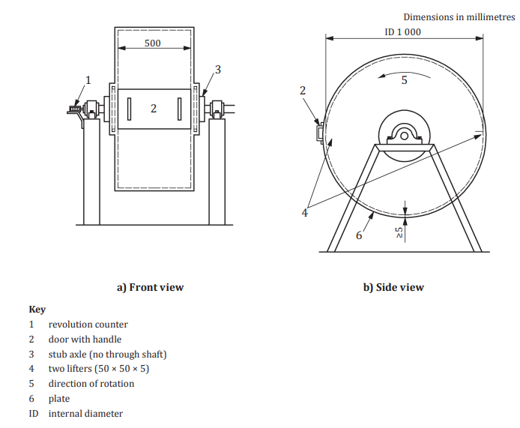
Figure 32 The drum specifications for the tumble and abrasion test (British Standards Institute 2015a)
It is very important for the BF to reduce the quantity of fines within it as much as possible. Fines produced during charging of the burden can accumulate at the point of impact on the burden surface. A high concentration of fines will impede gas flow and result in operational instability. Cold strength is characterised by the tumbler test (Geerdes et al. 2009).
The sinter sample is sieved through 25mm, 16mm and 10mm sieves, normally a 15Kg sample is made up from proportionate amount of material from each of these size fractions. As the sinter pot only produces a 10 Kg sample, a modified version of this test will be carried out using 5Kg of the sinter pot produced sinter, sieved to 10mm, 16mm, 25mm.
The sample is tumbled in a drum for 200 revolutions at 25 rpm and then sieved again over 6.3mm and 500μm sieves. The drum requirements are displayed in figure 32.
The tumble index is calculated by:
$$Ti= \frac{m_{1}}{m_{0}}*100$$
The abrasion index is calculated by:
$$Ai= \frac{m_{0-( m_{1}* m_{2})}}{m_{0}}*100$$
Where:
m₀ is the mass, in kilograms, of the test portion as weighed out and placed in the tumble drum.
m₁ is the mass, in kilograms, of +6,30 mm fraction of the tumbled test portion;
m₂ is the mass, in kilograms, of −6,30 mm + 500 μm fraction of the tumbled test portion.
(British Standards Institute 2015a)

Quality Control
All the analysis in the report was carried out at the Port Talbot steelworks laboratories apart from the CV, ultimate and drop tube testing, as the laboratories lacked the facilities to provide this analysis. For CV and ultimate analysis, the samples were sent to Socotec laboratories which has United Kingdom accredited services (UKAS) accreditation (Solid Biofuels. [no date]). The drop tube tests were carried out by the author at Cardiff university engineering department under the supervision of Dr J. Steer.
In line with the laboratory standard ISO 17025, all the equipment used in these tests such as drying ovens, furnaces, thermocouples, XRF’s and ICP’s are calibrated, serviced, and certified annually by independent and accredited companies. Quality checks are also carried out and recorded daily. Equipment such as the XRF and ICP require that certified reference materials (CRM’s) are run and meet control limits before any analysis can be carried out. The CSR/CRI & RDI equipment has a weekly standard made up of internally validated bulk coke material.
All analysis has been carried out in duplicate and meets the repeatability control limits set out the relevant ISO standard.

Results

Biochar substitution in pulverised coal injection (PCI)
PCI is a well establish technique used to reduce coke consumption in the BF. Coal is pulverised and carried pneumatically through a lance and injected into the BF tuyeres. These water-cooled nozzles direct the hot blast of air into the BF, forming a balloon like void known as the raceway. PCI can replace up to 50% of the coke required, many furnaces achieve PCI rates of 200 kg/t hot metal. Variations in the process, such as temperature and pressure can cause issues such as localised hot/cold spots which can cause damage to the lining of the furnace or result in over consumption of raw materials. BF process stability is very important to ensure consistent iron production and to prolong the life of the furnace (Steer et al. 2021).
(Liu and Shen 2021) advise that when assessing biochar as a BF fuel, there are several criteria you should consider, namely:
- Calorific value (CV)
- Chemical composition
- Combustion characteristics
- Carbon gasification reactivity
- Grinding characteristics and fluidisation properties
- Softening and melting characteristics of the ash
Of these six characteristics the first three have been tested on two biochar samples and a PCI coal, for this report. Results from tests published in literature, on similar materials will be discussed for the remaining characteristics, as the facilities for testing them were not available for this report.

Properties of charcoal compared to pulverized coal

Replacement ratio
The Ultimate analysis and proximate analysis results for the PCI coal and two biochar’s can be found below in table 3.
Table 3 The properties of pulverised coal and biochar (Proximate and Ultimate analysis).
(%) db. | T - Coal | Biochar 1 | Biochar 2
C | 83.2 | 90.2 | 83
H | 3.2 | 1.83 | 2.02
N | 1.84 | 0.09 | 0.47
S | 0.34 | <0.02 | 0.005
O | 2 | 6.02 | 7.33
Vm | 12.3 | 6.7 | 15.6
Ash | 9.4 | 1.89 | 6

According to (Geerdes et al. 2009) the most important property of a fuel injected into the BF is the replacement ratio (RR) of coke. The coke RR is defined as the mass, in kilograms, of coke replaced per kilogram of coal. The composition and moisture content of the fuel determines the amount of coke that can be replaced by the fuel. To determine the RR, the carbon percentage, hydrogen percentage, ash content, moisture content and the heat required to crack the coal chemical structure have to be considered. The formular for the RR (for coke with 87.5% carbon) is:
$$RR ≈ 2xC\% + 2.5xH\% -2xH2Oinj - 86 + 0.9xash\%$$
The moisture figure used was 1.5% as this is the moisture that PCI coals are dried to for injection at Port Talbot steelwork.

Table 4 The replacement ratios for T-coal and two biochar’s are compared.
% | T - Coal | Biochar 1 | Biochar 2
RR | 93.86 | 97.676 | 87.45

The aim is for a high RR without affecting furnace productivity and hot metal quality. The RR aim of PCI coals should be 85% (Geerdes et al. 2009). The RR is correlated with the calorific value and volatile matter of the fuel. RR increases with CV value. The CV values of T-coal and the biochar can be seen in table 5. Typical RR values for PCI coals range from 70% for high VM coals to 99% for low VM coal such as anthracite (Carpenter 2010). The carbon content is also correlated with the CV value, high values for both are desirable.
Table 5 The Calorific values of potential PCI fuels
MJ/Kg | T - Coal | Biochar 1 | Biochar 2
CV (Gross) | 31.06 | 33.26 | 28.07
CV (Net) | 30.89 | 32.80 | 27.54

T-coal is used in PCI at Port Talbot BFs on its own and in a blend, its RR is 93.86 T-coal has a reasonably high carbon content and CV.
Biochar 2 has lower carbon, hydrogen and ash that the T-coal and so the RR is lower, however it is still above the aim.
Biochar 1 has a high RR, carbon content and CV. It could replace more coke and it would provide more energy into the furnace if used. Biochar with similar properties could outperform PCI coals using these measures.

Volatile Matter
The volatile matter released during coal pyrolysis consists of combustible gases such as H₂, CH₄ and CO, incombustible gases (steam and CO₂) and tar. The high volume of gas generated when coal is injected into the raceway creates a greater blast momentum and increases the raceway depth. The coal volatile content can affect char formation and coke fines generation in the raceway. Low volatile coals have higher RR values and therefore lower coke rates and they have less of a cooling effect on the furnace. They produce less off gas with a lower CV, less H₂ (for Iron ore reduction). They have a higher RAFT and lower combustion efficiency than high volatile coals. High volatile coals have superior combustion performance, a lower ignition temperature and produce more reactive chars. They also contribute more H₂. The higher gas volume can lead to back pressure issues at the tuyere. Mid volatile coals are often perceived as the optimal solution or a blend of low and high coals (Carpenter 2010).
Low volatile coals - <14%, medium volatile coals – 14% – 31%, high volatile coals >31%.
T-coal and biochar 2 would be considered low volatile while biochar 1 is has a very low volatile, comparable with anthracite.

Chemical Composition

Ash content
The constituents of the coal can influence BF operation and the quality of the hot metal. An ash content of < 10% is preferred. Low ash results in lower slag volumes and therefore less flux requirements. High levels of ash can block the PCI lances. There needs to be a limit of undesirable constituents as they can negatively influence BF performance (Carpenter 2010).
The most significant elements affecting BF process defined by (Suopajärvi et al. 2018) are:
Zinc (Zn) – Attacks the BF lining and negatively impacts coke CSR/CRI.
Potassium (K) & sodium (Na) – Alkalis metals reduce coke and iron ore pellet strength and can promote scaffold formation.
Phosphorus (P) – Phos content in iron hot metal should be kept to a minimum as it undesirable in steelmaking.
Sulphur (S) – Sulphur is detrimental to steel properties. Removal from the hot metal is an expensive process.
Table 6 The chemical compositions of T-coal and biochar ash
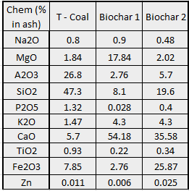
At 1.89% biochar 1 has a low ash content which would be beneficial for PCI use. Biochar 2 has an ash content well within 10% and is lower than the T-coal, both the biochar’s are significantly lower in sulphur content (table 3) when compared with the T-coal.
The T-coal has a high SiO₂ and Al₂O₃ content, this would indicate an acidic character of the coal ash. The biochar 1 & 2 both have a high CaO level which would indicate a basic ash character. Using biochar would mean less lime would be needed to adjust the basicity in the BF which in turn would reduce the slag generation rate (Wang et al. 2015b).
Table 7 shows the chemical composition by weight. The sodium and phosphorus levels were lower in the biochar. There is higher potassium content in the biochar ash 2 but not overly so and this amount would not be a concern. There is also less sulphur in the biochar than in the coal.
The chemical analysis of the biochar demonstrates that there would be no significant increase in harmful elements introduced into the BF as a result of using biochar as a fuel infectant.
Table 7 - T-coal and biochar chemical composition by weight %
Chem (wt. %) | T - Coal | Biochar 1 | Biochar 2
Na2O | 0.08 | 0.02 | 0.03
MgO | 0.17 | 0.34 | 0.12
A2O3 | 2.52 | 0.05 | 0.34
SiO2 | 4.45 | 0.15 | 1.18
P2O5 | 0.12 | 0.001 | 0.02
K2O | 0.14 | 0.08 | 0.26
CaO | 0.54 | 1.02 | 2.13
TiO2 | 0.09 | 0.00 | 0.02
Fe2O3 | 0.74 | 0.05 | 1.55
Zn | 0.0010 | 0.0001 | 0.0015

Combustibility
For optimal BF operation using PCI, it is crucial that all the injected coal is gasified as soon as possible. The residence time of the injected coal particles in the raceway is only approx. 20 – 30 ms, this short residence time can mean that the pulverised coal is not completely combusted in the raceway and a considerable amount of char (unburnt coal) can escape from the raceway region into the active coke zone as shown in figure 33. This fine char can block coke bed voidage and consequently result in reduced gas flow, a drop in BF pressure, reduced permeability, and decreased furnace productivity (Ahmed 2018).
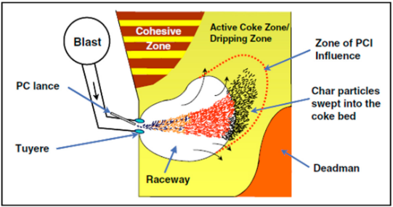
Figure 33 The lower zone of the BF (Ahmed 2018).
The DTF can be used to characterise burnout behaviour of fuel injected into the BF as the environment in the DTF closely resembles the BF raceway (Steer et al. 2015). The burnout or combustion efficiency for the biochar samples and T-coal are:
Table 8 The burnout efficiency of T-coal and the biochar
Burnout (%) | T - Coal | Biochar 1 | Biochar 2
35ms | 13.3 | 46.09 | 71.97
700ms | 58.7 | 86.01 | 91.47

Figure 34 Graph showing the burnout efficiency of T-coal and biochar
It can be seen from table 8 and figure 34 that the burnout efficiency of the biochar is higher than that of the T-coal. This would mean less char would escape the raceway into the active coke zone and benefit BF productivity. (Babich et al. 2010; Ng et al. 2011) propose that this may be due to the higher specific surface areas of charcoals compared with PCI coals.
However, it is inevitable that when using PCI, that some char will escape from the raceway into the coke active zone, because of the short residence time and high injection rates.
The char reactions in the raceway are A) devolatisation and B) char combustion which can be written as:
- Biochar→^{Rr}VM+Char
- Char+O2→^{Rr}CO+CO2
- Char+CO2→2CO
The char in the active zone is reactive, more so for biochar, see the reverse Boudouard reaction (solution loss reaction) C) shown above. The BF contains a large amount of C0₂, which reacts with the coke in the furnace, reducing its strength, which can weaken the coke scaffold function. Under high PCI injection rates, any unburnt carbon powder (char) with high reactivity will react with the CO₂ in preference with coke, this sacrificial reaction can protect the coke leaving it strong, which is beneficial for the operation of the furnace (Ning et al. 2022). However (Steer et al. 2021) states that the reverse Boudouard reaction is endothermic, so more reactive chars could result in a larger cooling effect on the thermal reserve temperature of the BF and that localised char retention could result in BF instability.
Table 9 T-coal and biochar reactivity
Reactivity | T - Coal | Biochar 1 | Biochar 2
Ti ⁰C | 492 | 368 | 380
Tm 0^{C}(Er/Kj/mol) | 636 | 515 | 512
Tb ⁰C | 816 | 537 | 581
Ti – Ignition temperature, Tm – temperature of the maximum weight loss rate, Tb – burnout temperature
Table 9 contains the TGA analysis, blast furnace heating rates are in the order of 10⁴ – 10⁵ ⁰C/s, the heating rates of a TGA (10 ⁰C/min) are considerably lower, with small sample masses ~20mg. However the technique is fast and reliable (Steer et al. 2015).
The results show that the biochars ignite at lower temperatures, reach maximum rate of combustion at lower temperatures and burnout at lower temperatures when compared with the T-coal.
When considering combustibility and burnout it can be seen that the biochar samples have the potential to at least partially replace coal in PCI, plant trials would be required to see how much of it could be substituted in.

Biochar substitution into coke making

Conclusion

Recommendations

Reference list

Appendix
Supporting documentation

