Christopher Davis (1712446)
Emergent Leadership BMSW6101
what makes elon musk a great leader.

Introduction
For our module of Emergent Leadership our lecturer Brynach has tasked us with writing an essay and a 15-minute presentation on What makes a great leader? The essay will be split into 2 parts with part 1 identifying what makes a good leader, and part 2 focusing on my leadership styles.
Leadership can be defined many ways however Adrian Gilpin says, “The impact you have on yourself and the impact you have on people around you.” This allows us to focus on why leadership is so important in motivating ourselves and others.
‘Leadership is the most influential factor in shaping organisational culture, so ensuring the necessary leadership behaviours, strategies and qualities are developed is fundamental. There is clear evidence of the link between leadership and a range of important outcomes within health services, including patient satisfaction, patient mortality, organisational financial performance, staff well-being, engagement, turnover and absenteeism, and overall quality of care.’
For part 1 of this essay, I have decided to base my work around South African entrepreneur Elon Musk and using the various management style theories of John Adair, Kurt Lewin and MacGregors Theory X-Y.

Introduction
Who is Elon Musk?
“Just like other visionaries before him such as Steve Jobs, Mark Zuckerberg and Larry Page, Musk is changing the world through following his passion, pursuing his big dreams, having laser-like focus on advancing technology to help humanity.” (Elon Musk's Leadership Style: Top 3 Leadership Qualities of Tesla and SpaceX Entrepreneur, 2020)

Most people are aware of Elon Musk as he is most famously known for his creation in Tesla Motors however to show that he is a good leader we need to start at the beginning.
Early Years
Elon was born on June 28, 1971, in Pretoria South Africa to Maye and Errol. Maye is a Canadian model whilst Errol is a wealthy South African engineer. Growing up in South Africa was tough for Elon and his siblings Kimbal and Tosca and up until his parents’ divorce when Elon was 10 his mother would be constantly out working to support her family and at one stage was holding down 5 jobs. (Elon Musk, 2020)
Growing up Elon faced a difficult childhood and due to his constant daydreaming about inventions his parents and doctors were concerned that he may have been deaf. He grew up short, introverted and very much into books which made him the target of school bullies until he learned to defend himself with karate and boxing when he was 15. (Elon Musk | Biography & Facts, 2020)
His love for computers started at a young age and helped him get through his parent’s divorce, he was so clever that by the age of 12 he sold his first software game Blastar.
Education
In 1989 aged 17 Elon made the decision to leave South Africa and avoid doing mandatory service in the army and headed to Canada to study in Queens University. 3 years later Elon was on the move again and went on to get 2 bachelors’ in physics and Business& Physics from the university of Pennsylvania. These degrees were the start of something big and after leaving Penn Elon moved across country to study a PHD at Stanford, California in energy physics. Within 2 days of enrolling in Stanford and the internet boom Elon dropped out of school and launched his first company Zip2 Corporation in 1995.
Companies
Zip2 was launched with his brother Kimbal and was an online city guide. Within 4 years Elon and Kimball sold Zip2 to Compaq Computer Corporation for $307 million cash and $34 million stock options. With the funds from their sale Elon and Kimball founded X.com which resulted in PayPal within a tear following an acquisition and gave Elon his first billion when eBay purchased PayPal in 2002.
That same year Elon founded his 3rd company SpaceX which made history in 2012 when they launched Falcon 9 rocket into space and today has over 100 satellites out in orbit. (SpaceX, 2020)
2003 was to see Elon become a co-founder of Tesla which premiered its first electric sedan in the summer of 2008.
Private Life
Elon has been married and divorced twice and has 6 sons 1 of whom sadly died at 10 weeks old from SIDS. Since May 2018 Elon has been in a relationship with musician Grimes and in 2020 welcomed another son into the world. (Sewell, 2020)
Elon also believes in giving back and in 2019 Elon donated $1million to the #TeamsTrees campaign and has also founded the Musk Foundation which is dedicated to the discovery of renewable and clean energy sources. (Musk Foundation, 2020)

Part 1
“Through his unique life circumstances, Musk has developed the important leadership qualities of being (1) a proactive learner, (2) a hard worker, (3) a bold visionary, and (4) an unwavering optimist, which still influence his success today” (2020)
Whilst Musk has found success, he is first to admit that this success was a result of the work of his designers, marketers and team of engineers who all contributed towards this success but who needed his leadership along the way.
“Transformational leadership is a leadership style that can inspire positive changes in those who follow.” (How Do Transformational Leaders Inspire and Motivate Followers? 2020)
There are many layers and roles of a leader and by possessing these qualities will ensure that Musk is not only recognised as a great leader but also earn him the respect and motivation of his peers and employees. It is important that Musk can:
Demonstrate confidence and knowledge when leading and motivating others.
Listen, support, and help others.
Monitor the progress.
Empower people.
Create a shared value and vision.
It is important that Musk is a good leader as his traits and characteristics will help to eliminate staff dissatisfaction and help to develop teamwork whilst boosting staff morale. It is also important for a leader to effectively delegate and to help with managing change at a time when the environment is constantly changing.
By researching Elon Musk and his various styles and traits it is evident to see that he possesses many of the traits that Burns, and Bass referred to as Transformational Traits.
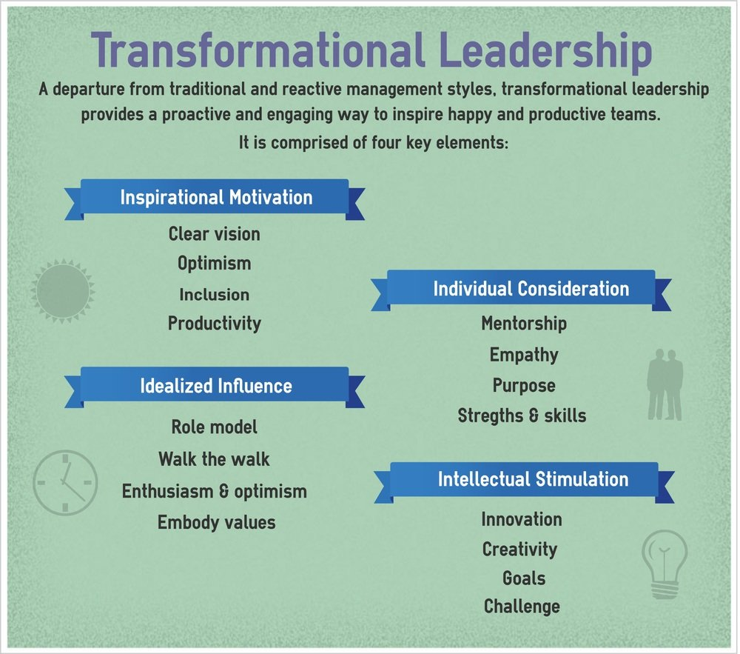 (Shkurina, 2020)

It is easy to identify Elon Musk as a Transformational Leader as his characteristics mirror the 4 key elements.
- Inspirational Motivation
- Individual Consideration
- Idealized Influence
- Intellectual Stimulation
Elon was not lucky enough to be born a leader but instead he became one through trial and error and as some believe he also acquired these skills from his teachers whilst studying in Pennsylvania.
Musk has a clear vision of what he wants to achieve and is willing to take small steps to achieve this however he believes that all feedback from his team will help the company succeed. He is so interested in receiving this feedback that he has dedicated set times where he will make himself available for team leaders to keep him informed of their progress and has made it clear to all staff that both positive and negative feedback is needed to succeed. He is so passionate about his work and ideas that when he starts talking about his plans you cannot help but feel inspired and motivated to help achieve these goals even if some of his ideas are simply outrageous and seem so farfetched. An example of this is when Musk travelled to Russia to find a shuttle for SpaceX which was against the advice of others and also at a personal financial cost to himself as he needed to make the journey 3 times and using the last of his financial resources it finally orbited on its fourth flight. This belief in his vision is what drives and motivates himself and others. (Motivation Madness, 2020)

If Kurt Lewins theory is to be believed then people everywhere would believe that Elon Musk is the perfect leader as he has all the traits that make for one including Autocratic, Democratic and Laissez-faire.
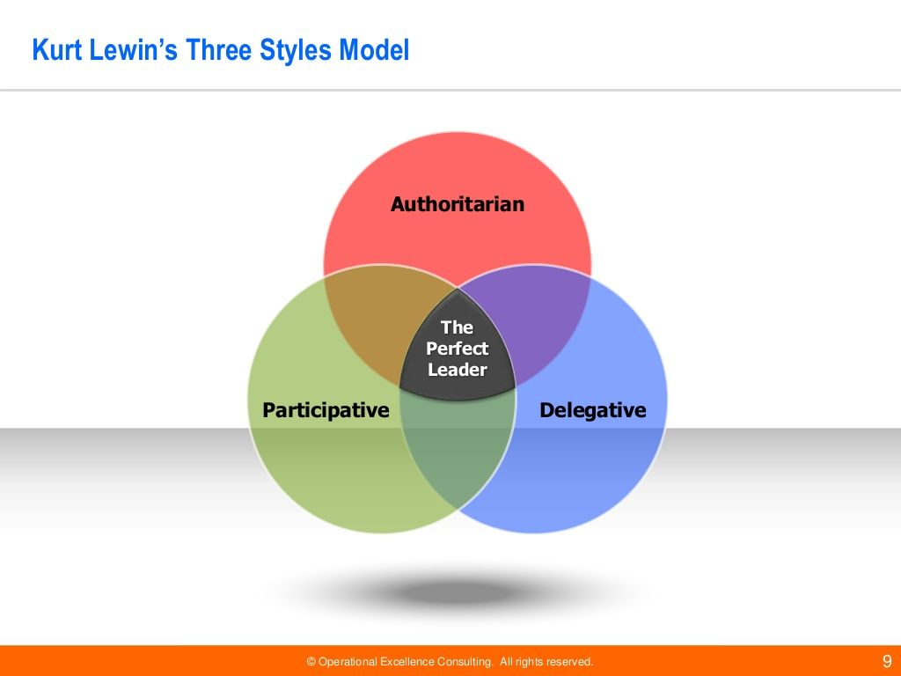(Kurt lewin leadership style - Bing, 2020)
Musk possesses the following Autocratic traits.
Aggressive, demanding management approach.
- Quick decision-making and fail fast method in project management.
- Strong ability to visualise the outcomes, inspire the shared vision and bring best people on board.
- Successful leading by example approach
- High stress endurance and clear decision making under stress.
- Blunt and confrontational style of communication
- Egocentrism prevails in day-to-day communications.
(Elon behind Iron-man&#39; s Mask: Analysing Leadership Style of Elon Musk, 2020)
Musk also can be linked with a few Democratic traits as he does always listen to other opinions, and due to the time, he sets aside for feedback he is promoting two way communication these traits along with his Laissez-faire traits which includes his numerous deliberations and discussions he can be easily portrayed as the Perfect Leader.
Musk is a great leader who has 3 qualities that he continues to stay true to throughout his career. These 3 qualities are:
- Let your vision guide you - As a young man, Musk discovered that he was keenly interested in a few fields that he thought would have an impact on the world: “the internet; sustainable energy; space exploration, in particular the permanent extension of life beyond Earth; artificial intelligence; and reprogramming the human genetic code.”
- Set the standard in your industry- Musk is not content with doing what everyone else is doing; he seeks solutions for important, large-scale issues that will change the way we live. Whether it was PayPal where he championed the idea of an online banking institution, or SpaceX which has become the first private company to successfully launch a rocket and dock at the International Space Station, or SolarCity which promotes the use of solar energy as a sustainable energy source, Musk is disrupting large industries by setting a new standard.
- Use a feedback loop constructively- “I think it’s very important to have a feedback loop, where you’re constantly thinking about what you’ve done and how you could be doing it better. I think that’s the single best piece of advice: constantly think about how you could be doing things better and questioning yourself.” (Elon Musk's Leadership Style: Top 3 Leadership Qualities of Tesla and SpaceX Entrepreneur, 2020)
Musk’s leadership and management styles also fit well within MacGregors Theory X-Y (1960) where is characteristics will place him within theory Y which also interlinks with Kurt Lewins theory as he has a participative management style.
“If you believe that your people take pride in their work and see it as a challenge, then you'll more likely adopt a participative management style. Managers who use this approach trust their people to take ownership of their work and do it effectively by themselves. McGregor called this Theory Y.” (Theory X and Theory Y: Understanding People's Motivations, 2020)
Throughout his career Musk has displayed many various traits and characteristics of the different Leadership style theories and models but at no time in his life could anyone call him an Authoritarian Manager as he displays none of MacGregors Theory X characteristics.
(Theory X and Y (L02), 2020)
It is also very easy to link Musk’s style with that of John Adair’s Action Centred Leadership theory. This theory sees Musk put great emphasis on 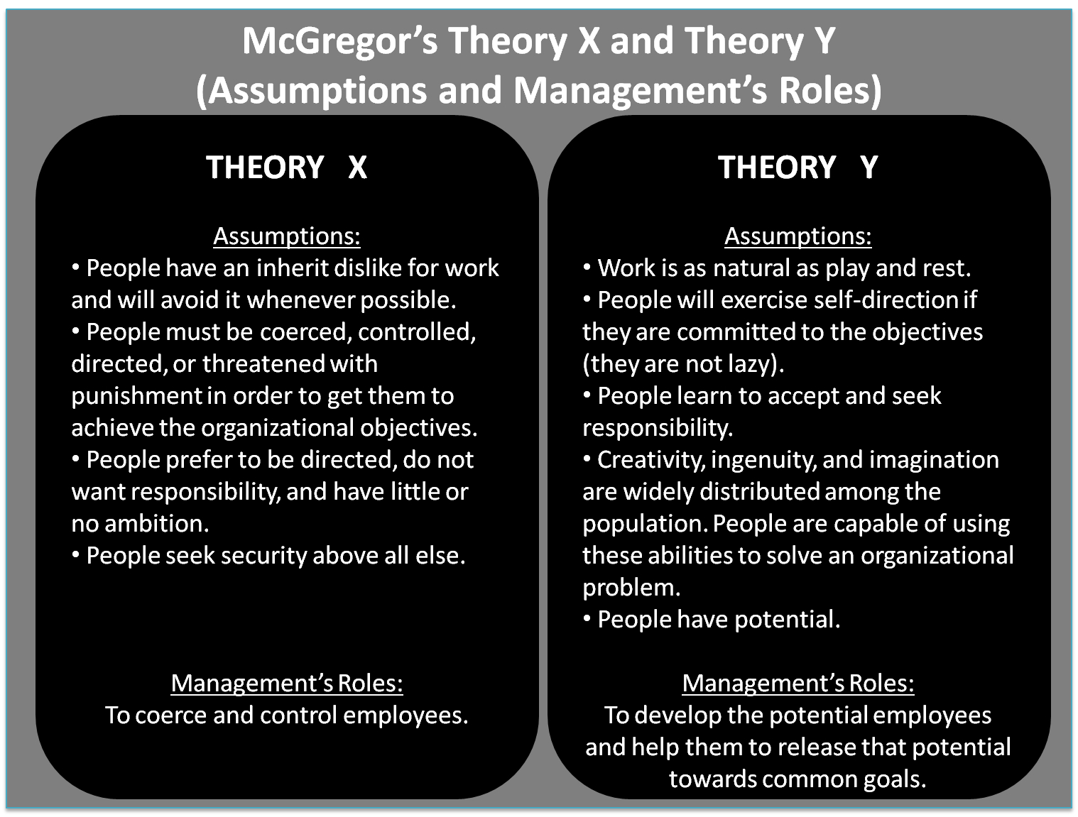
- Planning - seeking information, defining tasks, setting aims
- Initiating - briefing, task allocation, setting standards
- Controlling - maintaining standards, ensuring progress, ongoing decision-making
- Supporting - individuals' contributions, encouraging, team spirit, reconciling, morale
- Informing - clarifying tasks and plans, updating, receiving feedback and interpreting
- Evaluating - feasibility of ideas, performance, enabling self-assessment (John Adair's Action–Centred Leadership Model – BusinessBalls.com, 2020)

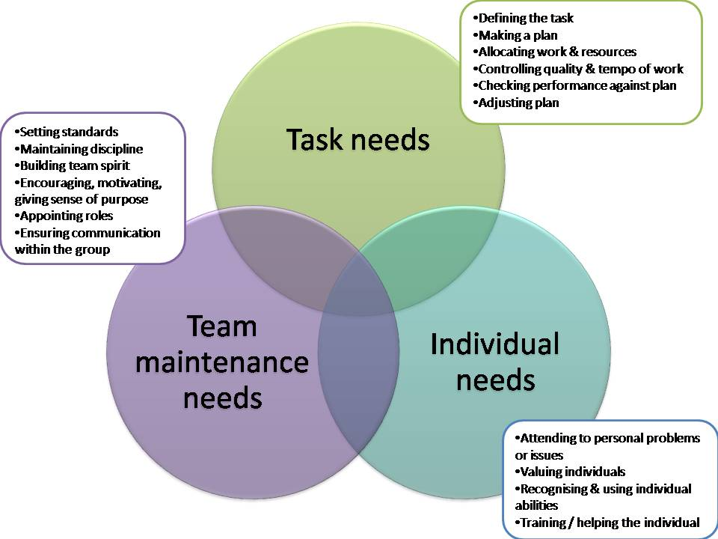
(John Adair's Action–Centred Leadership Model – BusinessBalls.com, 2020)

Looking at Musk’s leadership style it is evident that he is motivating his staff and is showing actions that link back to the Vrooms Expectancy Theory. This theory is based od Musk motivating his staff and rewarding and recognising their performances. He is also quick to praise others for their input and good ideas as he believes that feedback is what will hemp realise his visions and goals.
Organisations often consider financial bonuses to be the best way to motivate employees, even though the Expectancy Theory shows that this is by no means always the most important factor to employees. (What is Vroom's Expectancy Theory? Definition, application | tools hero, 2020)

We are currently in worrying times but through all of this Musk is remaining true to his vision and has every faith that Tesla and SpaceX will perform well and reach all goals and visions. Musk is aware that he can not reach these visions without well motivated and inspired staff.
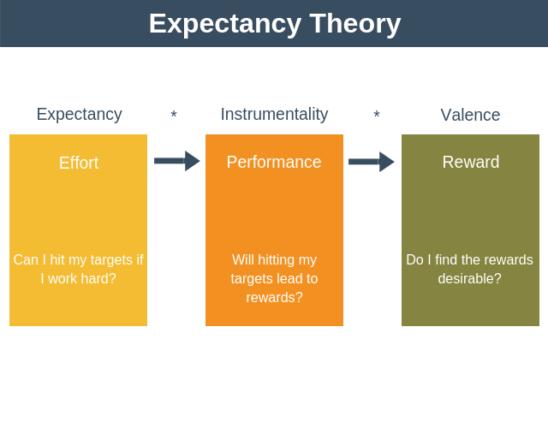(Expert Program Management, 2020)

Part 2
For this section of the essay, I will be looking at my own personal leadership styles and I go about leading and motivating others in my workplace.
To identify my style of leadership I decided to take a leadership style questionnaire (appendix 1). The results of this questionnaire will help me understand my leadership more in depth. These results will also help me understand other styles of leadership and how they relate to mine. I will also be taking a second questionnaire (Appendix 2) based on conceptualizing leadership to identify how I view leadership and to show how I perceive the different aspects of leadership. I have included an example from my Army career of a time when I was put in a Leadership position.
Whilst serving in the British Army I was stationed in Kenya and on a rare occasion myself and the squadron were given a r&r day to do some team building exercises. My Corporal decided on a map reading exercise and as I was second in command, he tasked with ensuring all soldiers had the correct kit, equipment, and enough fluids to see the task through. I delegated various tasks to the soldiers and compiled a checklist to ensure that all kit and water bottles etc were accounted for before informing the Corporal that we were good to go.
I gave all the soldiers a brief on what to expect from local wildlife to their actions if we should get lost, I had the rifle with 20 rounds of live ammunition should we need to use as a backup precaution. Then we set off with a map and compass water supply and survival kit into the local area. The Corporal would then change each person’s map-reading from point to point on the map which he double checked to ensure we were going the right way. It was a red-hot day and water was being drunk much quicker than anticipated, due to this factor I told Corporal maybe we should head back as the midday heat and the low water supply was slowing us down, but the Corporal ignored me, so we carried on.

During this time, we got chased by baboons as we came into their area, I had to control members of the team as their adrenaline was high at this point, but I was fortunate I did not have to use my rifle or shoot anything. I then emphasised to the team that we should go back as we only had a few litres of water left and by looking at the map we were going to take hours to get back. The team wanted to carry on, but I noticed that the points on the map did not add up we were lost, nobody in the team believed me and by now the Corporal was suffering from dehydration. At this point we all heard a noise so I then had an idea and asked if me and another soldier could go and see what it was. It was a music warrior and a herd of goats. I pointed to the map, but we did not speak in the language and he did not understand English he just smiled and walked away. At this point we made our way back to the team I then said we were here on the map but the truth was I did was a recession on a map picking out points and moving to the next point when we got back to the team I lied and said I was shown on the map where I was but the man had to go it is my actions and previous training that got us back to the camp exhausted even though the rest of the team didn’t agree with me my actions prevented us from getting lost but should I have got it wrong we could’ve been in a lot more trouble. After that I gained respect even though I went against the grain my actions paid off even though we had to go on IV drip, so we got back the exhibition was a success.
What I learnt when things are not going as planned and you know you are right you live by your sword. Things could have been worse, but I managed to keep morale up even when people were having negative attitudes and to trying to bring the team morale down. A lot more gets done by being positive and drilling that into the team you and the team can achieve a lot by this means.
After taking the 2 leadership style questionnaires I was shocked by my results as they had me come out as an Autocratic leader. An autocratic leader is a leader who is
- Detached
- All decisions must go through them.
- Believes groups are not responsible for their actions.
- Does not encourage their staff to think for themselves.
- Makes decisions quickly.
- Emphasises quality more than quantity.
- All decisions are made upon an individual’s opinions.
I do not feel I have these characteristics as I feel that I am a follower more than a leader. I am however good dealing with problems when under pressure and I find it easy to find a solution and think fast on my feet which is evident from my “monkey walk”. Like Musk I am not a born leader but have acquired the various styles and traits throughout my career especially when in the British Army as they put me on various courses to enhance my military career and allow me to climb the ranks whilst taking on more leadership responsibilities.
I feel that I can relate to Laissez -faire as I too am like a grey man in a team and am much more comfortable to sit back, and observe the others before I make a decision as I would like to think that the best decisions can only be made once we have all the facts and figures.
I have learned through my results that I have many qualities and depending on the situation there are different traits of leadership that can be shown.
From attending lectures and observing others I have found that our culture and background gives us our starting point in leadership, and these can be enhanced and improved on through our life experiences and cognitive knowledge.
It is important to be kind to others and to lead by example. A good leader will always hold themselves accountable for their actions and decisions and will always be transparent in what they do while staying committed to their values and beliefs.
After writing this essay and researching Elon Musk I have no doubt in my mind that future generations will be looking back at Elon Musk as one of the greatest leaders of all times. I believe that he will go down in history with the likes of Bill Gates, Margaret Thatcher, Moses, Gandhi, and Mother Teresa.

References.
Encyclopaedia Britannica. 2020. Elon Musk | Biography & Facts. [online] Available at: <https://www.britannica.com/biography/Elon-Musk> [Accessed 20 November 2020].
West, M., Armit, K., Loewenthal, L., Eckert, R., West, T. and Lee, A. (2015) Leadership and Leadership Development in Healthcare: The Evidence Base. London, Faculty of Medical Leadership and Management P.25
Edge.sagepub.com. 2020. Introduction to Leadership: Concepts and Practice | Online Resources. [online] Available at: <https://edge.sagepub.com/northouseintro4e> [Accessed 20 November 2020].
Leadership Geeks. 2020. Elon Musk's Leadership Style: Top 3 Leadership Qualities of Tesla And SpaceX Entrepreneur. [online] Available at: <https://www.leadershipgeeks.com/elon-musk-leadership-style/> [Accessed 1 December 2020].
Biography. 2020. Elon Musk. [online] Available at: <https://www.biography.com/business-figure/elon-musk> [Accessed 20 November 2020].
Sewell, K., 2020. Elon Musk Wife: Is Elon Musk Married? How Many Children Does Elon Musk Have? [online] Express.co.uk. Available at: <https://www.express.co.uk/celebrity-news/1289218/elon-musk-wife-Grimes-married-children> [Accessed 20 November 2020].
SpaceX. 2020. SpaceX. [online] Available at: <https://www.spacex.com/> [Accessed 20 November 2020].
Very well Mind. 2020. How Do Transformational Leaders Inspire and Motivate Followers? [online] Available at: <https://www.verywellmind.com/what-is-transformational-leadership-2795313> [Accessed 1 December 2020].
Shkurina, E., 2020. School Leadership Styles - Which One Are You? [online] Blog.youragora.com. Available at: <https://blog.youragora.com/school-leadership-styles-which-one-are-you> [Accessed 1 December 2020].
Financhill. 2020. Elon Musk Leadership Style - Financhill. [online] Available at: <https://financhill.com/blog/investing/elon-musk-leadership-style> [Accessed 1 December 2020].
Leadership Geeks. 2020. Elon Musk's Leadership Style: Top 3 Leadership Qualities Of Tesla And SpaceX Entrepreneur. [online] Available at: <https://www.leadershipgeeks.com/elon-musk-leadership-style/> [Accessed 1 December 2020].
Influencewatch.org. 2020. Musk Foundation. [online] Available at: <https://www.influencewatch.org/non-profit/musk-foundation/#:~:text=Musk%20Foundation%20The%20Musk%20Foundation%20is%20a%20private,Kimbal%20Musk%20is%20secretary%2C%20treasurer%2C%20and%20board%20director.> [Accessed 1 December 2020].
Mindtools.com. 2020. Theory X and Theory Y: Understanding People's Motivations. [online] Available at: <https://www.mindtools.com/pages/article/newLDR_74.htm> [Accessed 1 December 2020].
Nitieim19pomb133.blogspot.com. 2020. Theory X and Y (L02). [online] Available at: <http://nitieim19pomb133.blogspot.com/2012/07/theory-x-and-y-l02.html> [Accessed 1 December 2020].
Businessballs.com. 2020. John Adair's Action–Centred Leadership Model – Businessballs.Com. [online] Available at: <https://www.businessballs.com/leadership-models/action-centred-leadership-john-adair/#:~:text=%20John%20Adair%27s%20Action-Centred%20Leadership%20model%20is%20represented,team%20or%20group%203%20Managing%20individuals%20More%20> [Accessed 1 December 2020].
Yauney, Ryan H. (2018) "Leadership Development: A Study of Elon Musk," Marriott Student Review: Vol.: Iss. 2, Article 4.
Scholarsarchive.byu.edu. 2020. [online] Available at: <https://scholarsarchive.byu.edu/cgi/viewcontent.cgi?article=1084&context=marriottstudentreview> [Accessed 1 December 2020].
Motivation Madness, 2020. Elon Musk Life Advice Will Change Your Life (Must Watch ). [video] Available at: <https://eur01.safelinks.protection.outlook.com/?url=https%3A%2F%2Fm.youtube.com%2Fwatch%3Fv%3Dje2VkvTmml8&amp;data=04%7C01%7C%7C43e82412e8c943a8a23508d89857e54f%7C4e0f11f9046e45059cb8db2152311e21%7C0%7C1%7C637426850558857225%7CUnknown%7CTWFpbGZsb3d8eyJWIjoiMC4wLjAwMDAiLCJQIjoiV2luMzIiLCJBTiI6Ik1haWwiLCJXVCI6Mn0%3D%7C3000&amp;sdata=9PQse6RIzCoDLPk2FIC1I0zsJ6EYuTLqss%2BMLRvDI5U%3D&amp;reserved=0> [Accessed 1 December 2020].
Vroom, V. H. (1964). Work and motivation. Oxford, England: Wiley
Expert Program Management. 2020. Expert Program Management. [online] Available at: <https://expertprogrammanagement.com/2018/10/expectancy-theory/> [Accessed 1 December 2020].
Isaac, R. G., Zerbe, W. J., & Pitt, D. C. (2001). Leadership and motivation: The effective application of expectancy theory. Journal of managerial issues, 212-226.
toolshero. 2020. What Is Vroom's Expectancy Theory? Definition, Application | Toolshero. [online] Available at: <https://www.toolshero.com/psychology/vrooms-expectancy-theory/> [Accessed 1 December 2020].

Appendices
edge.sagepub.com/northouseintro4e

