

Student Name:Galla Prasith

Student ID:2543438

Module Name: Financial Management

Module Code: LCMB7002

Lecturer’s Name:Ghulam Mujtaba

Work Count: 5077

Term 1

Table of Contents
1. Introduction 4
1.1 Company Background 4
1.2 Purpose of the Report 4
1.3 Sources of Data and Method 4
2. Financial Health Check 5
2.1 Five-Year Financial Performance Overview 5
2.2 Profitability Ratio Analysis 8
2.3 Liquidity Ratio Analysis 9
2.4 Efficiency Ratio Analysis 10
2.5 Gearing Ratio Analysis 11
2.6 Investment Ratio Analysis 12
2.7 Cash Flow Ratio Analysis 13
3. Working Capital Management Analysis 14
3.1 Cash Operating Cycle Assessment 14
3.2 Working Capital Improvement Strategies 15
3.3 Short-term vs Long-term Financing 16
4. Strategic Financial Restructuring Plan 16
4.1 Current Financial Challenges 16
4.2 Recommended Financial Restructuring 17
4.3 Impact Assessment 18
4.4 International and Ethical Considerations 18
5. Investment Appraisal and Capital Budgeting 19
5.1 Introduction to Investment Appraisal 19
5.2 Project Information 19
5.3 Payback Period (PBP) 19
5.4 Accounting Rate of Return (ARR) 20
5.5 Net Present Value (NPV) 21
5.6 Profitability Index (PI) 23
5.7 Internal Rate of Return (IRR) 24
5.8 Recommendation of Best Project 25
5.9 Capital Rationing (£100 Million Limit) 25
6. Critical Reflection on AI Usage 26
6.1 Tool Disclosure 26
6.2 Critical Evaluation of AI Output 26
6.3 Contribution Analysis 26
6.4 Professional and Ethical Reflection 27
7. Conclusion 27
Reference List 28

1. Introduction

1.1 Company Background
Marriott international is a large hospitality enterprise in the world, with a total of over 9,900 properties operating in over 30 hotel brands in 146 countries and regions. The company was founded in 1927 by J. Willard Marriott and Alice Marriott and has evolved into an asset-light business model, which deals with hotel management, franchising and licensing. Marriott caters to a wide range of markets, such as luxury, premium, select-service, extended-stay and timeshare hotels, allowing it to cover a wide market worldwide. With its growing Forward strategy and Serve 360 sustainability platform, Marriott strives to create long-term value by achieving operational excellence, responsible business practices and continuous global growth (Marriott International, 2025).

1.2 Purpose of the Report
This report assesses the financial performance of Marriott International in the last five years in terms of ratio and trend. It evaluates liquidity, management of working capital, financial restructuring plans and methods of investment appraisal to propose financially sustainable decisions to maximize shareholder value and long-term corporate performance.

1.3 Sources of Data and Method
The analysis will be conducted using Annual Reports of Marriott International (2021-2025), and background information provided in secondary sources (Yahoo Finance, Statista and reports on the hospitality industry). Ratio analysis of profitability, liquidity, efficiency, gearing, investment and cash flow is used to assess financial performance. Trend analysis is used to determine performance trends within a period of five years and liquidity ratios are compared with the industry standards. To analyze capital investment options and aid strategic financial decision making, investment appraisal methods, such as Payback Period, ARR, NPV, PI and IRR are used.

2. Financial Health Check

2.1 Five-Year Financial Performance Overview
Income Statement Analysis
The income statement of Marriott International indicates a high degree of improvement in the overall financial performance of the company from 2021 to 2025. Total income for the firm grew from $13.857 billion in 2021 to $26.186 billion in 2025, indicating an improvement in franchise fees income, management fees income, income from owned and leased property as well as cost reimbursement income. The company’s operating income increased from $1.750 billion in 2021 to $4.141 billion in 2025, but the company experienced a drop from $3.864 billion in 2023 to $3.767 billion in 2024. Net income grew from $1.099 billion in 2021 to $3.083 billion in 2023 and then fell to $2.375 billion in 2024, and later increased to $2.601 billion in 2025.(Income statement 2021-2025)
Income Statement Item | 2021 | 2022 | 2023 | 2024 | 2025
REVENUES
Franchise fees | 1,790 | 2,505 | 2,831 | 3,113 | 3,325
Base management fees | 669 | 1,044 | 1,238 | 1,288 | 1,322
Incentive management fees | 235 | 529 | 755 | 769 | 791
Gross fee revenues | 2,694 | 4,078 | 4,824 | 5,170 | 5,438
Contract investment amortization | (75) | (89) | (88) | (103) | (135)
Net fee revenues | 2,619 | 3,989 | 4,736 | 5,067 | 5,303
Owned, leased, and other revenue | 796 | 1,367 | 1,564 | 1,551 | 1,679
Cost reimbursement revenue | 10,442 | 15,417 | 17,413 | 18,482 | 19,204
Total Revenues | 13,857 | 20,773 | 23,713 | 25,100 | 26,186
OPERATING COSTS AND EXPENSES
Owned, leased, and other – direct/expense | 734 | 1,074 | 1,309* | 1,329 | 1,461
Depreciation, amortization, and other | 220 | 193 | 189 | 183 | 213
General & administrative | 823 | 891 | 867* | 945 | 870
Restructuring & merger-related charges/other | 8 | 12 | 60 | 77 | 77
Reimbursed expenses | 10,322 | 15,141 | 17,424 | 18,799 | 19,503
Total Operating Costs & Expenses | 12,107 | 17,311 | 19,849 | 21,333 | 22,045
Operating Income | 1,750 | 3,462 | 3,864 | 3,767 | 4,141
Gains and other income, net | 10 | 11 | 40 | 31 | 9
Interest expense | (420) | (403) | (565) | (695) | (809)
Interest income | 28 | 26 | 30 | 40 | 42
Equity in earnings/(losses) | (24) | 18 | 9 | 8 | 11
Income Before Income Taxes | 1,180 | 3,114 | 3,378 | 3,151 | 3,394
Provision for income taxes | (81) | (756) | (295) | (776) | (793)
NET INCOME | 1,099 | 2,358 | 3,083 | 2,375 | 2,601
EPS – Basic ($) | 3.36 | 7.27 | 10.23 | 8.36 | 9.53
EPS – Diluted ($) | 3.34 | 7.24 | 10.18 | 8.33 | 9.51
Figure 1: Income statement
Source: Income statement

Balance Sheet Analysis
Balance Sheet of Marriott International reveals the trend of expansion in the company’s assets throughout the period under consideration. From $25.553 billion in 2021, the total assets grew to $27.540 billion in 2025 with only one exception – a temporary reduction in 2022 when the company’s total assets were $24.815 billion. The company’s current assets have been steady and were equal to $3.626 billion in 2021 and grew to $3.584 billion in 2025. Also, the company had substantial amounts of intangible assets which include brands, contract acquisition costs, and goodwill which comprised an essential part of the company’s total assets. As for the company’s liabilities, the current liabilities rose from $6.407 billion in 2021 to $8.398 billion in 2025, and the long-term debt went up from $9.333 billion to $14.995 billion during the same period. On the other hand, stockholders’ equity fell from $1.414 billion in 2021 to negative $3.771 billion in 2025 owing mostly to the sharp increase in treasury stock.(Income statement 2021-2025)
Balance Sheet Item | 2021 | 2022 | 2023 | 2024 | 2025
ASSETS
Current Assets | 3,626 | 3,313 | 3,311 | 3,485 | 3,584
Cash and equivalents | 1,393 | 507 | 338 | 396 | 358
Accounts and notes receivable, net | 1,982 | 2,571 | 2,712 | 2,795 | 2,909
Prepaid expenses and other | 251 | 235 | 261 | 294 | 317
Property and equipment, net | 1,503 | 1,585 | 1,581 | 1,833 | 1,954
Brands | 5,979 | 5,812 | 5,907 | 5,770 | 6,207
Contract acquisition costs and other | 2,947 | 2,935 | 3,283 | 3,718 | 4,129
Goodwill | 9,073 | 8,872 | 8,886 | 8,731 | 8,907
Total Intangible Assets | 17,999 | 17,619 | 18,076 | 18,219 | 19,243
Equity method investments | 387 | 335 | 308 | 298 | 298
Notes receivable, net | 144 | 152 | 138 | 136 | 151
Deferred tax assets | 228 | 240 | 673 | 650 | 570
Operating lease assets | 1,062 | 987 | 929 | 845 | 941
Other noncurrent assets | 604 | 584 | 658 | 716 | 799
TOTAL ASSETS | 25,553 | 24,815 | 25,674 | 26,182 | 27,540
LIABILITIES & STOCKHOLDERS' EQUITY
Current Liabilities | 6,407 | 7,339 | 7,762 | 8,649 | 8,398
Current portion of long-term debt | 805 | 684 | 553 | 1,309 | 1,209
Accounts payable | 726 | 746 | 738 | 763 | 814
Accrued payroll and benefits | 1,187 | 1,299 | 1,390 | 1,449 | 1,438
Liability for guest loyalty program | 2,522 | 3,314 | 3,328 | 3,487 | 3,497
Accrued expenses and other | 1,167 | 1,296 | 1,753 | 1,641 | 1,440
Long-term debt | 9,333 | 9,380 | 11,320 | 13,138 | 14,995
Noncurrent guest loyalty program liability | 3,949 | 3,280 | 3,678 | 4,032 | 4,495
Deferred tax liabilities | 169 | 313 | 209 | 81 | 79
Deferred revenue | 1,181 | 1,059 | 1,018 | 1,103 | 1,200
Operating lease liabilities | 1,098 | 1,034 | 887 | 794 | 879
Other noncurrent liabilities | 2,002 | 1,842 | 1,482 | 1,377 | 1,265
Stockholders' Equity / (Deficit) | 1,414 | 568 | (682) | (2,992) | (3,771)
Class A Common Stock | 5 | 5 | 5 | 5 | 5
Additional paid-in-capital | 5,892 | 5,965 | 6,051 | 6,179 | 6,352
Retained earnings | 10,305 | 12,342 | 14,838 | 16,531 | 18,414
Treasury stock, at cost | (14,446) | (17,015) | (20,929) | (24,644) | (27,900)

Figure 2: Balance sheet
Source: Income statement

2.2 Profitability Ratio Analysis
Profitability ratios assess the capacity of a firm to transform revenue into earnings and are valuable ratios in determining the future growth in profits (Widiasmara et al., 2022). Marriott has also seen a substantial improvement in Net Profit Margin in 2023, as it has increased to 13.00% in 2023, and then fell to 9.46% in 2024 and back to 9.93% in 2025. Except for 2021, the company consistently outperformed the hospitality industry average of 8.50%, reflecting successful recovery from the COVID-19 pandemic and effective cost control. Similarly, the Operating Profit Margin increased from 12.63% in 2021 to 16.67% in 2022, remaining close to the industry benchmark of 16% thereafter. The latter temporary decrease was primarily caused by increased operating and financing expenses in 2024. The asset-light business model of Marriott, where the company focuses on management and franchise agreements, as opposed to hotel ownership, has minimised capital intensity and enhanced operating profitability. Lee (2023) points out that the operating performance is greatly boosted by efficient cost management and operational efficiency, which underlies the stable margins of Marriott. In general, profitability dynamics show stable earnings production and effective post-pandemic recovery, but increasing interest costs are putting a strain on net profitability.Calculation in the appendix.

Figure 3: Profitability ratios
(Self-developed)

2.3 Liquidity Ratio Analysis
Liquidity ratios assess the capacity of a company to address the immediate liabilities (Lee, 2023). The Current Ratio of Marriott decreased to 0.40 in 2024 and then slightly increased to 0.43 in 2025, which is very low compared to the industry average of 1.05. Similarly, its Cash Ratio dropped to 0.04, compared to 0.22 a major decline in comparison with the industry average of 0.45, which implies that it has less readily available cash to pay off its current debts. The implications of these findings are that Marriott depends heavily on consistent operating cash flows and effective working capital management as opposed to having high current asset balances. The relatively low liquidity ratios indicate the asset-light business model and high dependence on short-term liabilities of the company. Even though a high level of operating cash generation lowers the immediate solvency risk, long-term liquidity is below industry levels which puts Marriott at risk of refinancing and economic risks in the season of market uncertainty. Therefore, building up short-term liquidity must be a financial priority.Calculation in the appendix.

Figure 4: Liquidity ratios
(Self-developed)

2.4 Efficiency Ratio Analysis
Efficiency ratios determine the effectiveness of the company in using its assets to produce revenue (Iazzolino et al., 2023). The Accounts Receivable Turnover of Marriott increased to 9.18 times in 2025 compared to 7.39 times in 2021, which means that it collected its customers faster. It was, nevertheless, significantly lower than the industry average rate of 15 times, which indicates the possibilities of improving the receivables management. Total Asset Turnover, on the other hand, rose considerably; it was 0.55 and then 0.97, which was above the industry average of 0.60 in 2022 and 2023, respectively. This shows good use of assets to make revenue, which has been greatly aided by asset-light operating model of Marriott, in which franchised and managed hotels do not need as much capital investment. Iazzolino et al. (2023) argue that better operational efficiency will lead to improved financial results and competitive advantage in the long term. In general, the asset utilisation in Marriott is highly efficient, but the receivables collection can be further enhanced to enhance operational performance and cash conversion.Calculation in the appendix.

Figure 5: Efficiency ratios
(Self-developed)

2.5 Gearing Ratio Analysis
Gearing ratios are used to show the degree to which a company has funded its operations using debt, hence, financial risk (Aldo, 2022). In the five-year period, Marriott has experienced a significant gain in its gearing ratio due to the growth of total debt and a negative value of the shareholders equity due to large share buybacks. The total debt as of 2025 amounted to US$17.08 billion, which was way beyond the industry gearing of 140. This high gearing capital structure is more sensitive to interest rate changes and risks of refinance, especially when the economy is in an uncertain state. Marriott however has been able to keep its operating profitability and cash generation at strong levels thus being able to service its debt commitments. The asset-light approach of the company lowers the capital expenditure requirements to some extent compensating the high leverage risks. Though the gearing is high, which increases the financial risk, the gearing has helped in supporting the value of the shareholders by distributing capital and expanding the company strategically. Further debt management is crucial to maintain financial flexibility and long-term sustainability.Calculation in the appendix.

Figure 6: Gearing ratios
(Self-developed)

2.6 Investment Ratio Analysis
Investment ratios evaluate shareholder returns and market confidence (Ferniawan et al., 2024). Earnings per Share (EPS) at Marriott was boosted to 10.18 in 2023, after which it has been fluctuating between US3.33 in 2021 and 2025. During 2022-2025, EPS was considerably higher than the industry average is US3.80, which is evidence of high profitability and efficient value creation to shareholders. The Price-to-Earnings (P/E) Ratio declined from 44.49 in 2021 to 18.43 in 2023 before increasing to 31.41 in 2025, exceeding the industry average of 27.50. The premium is attributed to the fact that the investors believe that Marriott can generate more earnings in future due to its strong global brand recognition and a robust business model. Ferniawan et al. (2024) note that increasing EPS and P/E ratios have a positive impact on investor confidence and stock returns. On balance, Marriott is highly marketable despite the variations in earnings and multiples of valuation.

Figure 7: Investor ratios
(Self-developed)

2.7 Cash Flow Ratio Analysis
Cash flow ratios offer a more holistic identification on financial health compared with traditional accounting ratios since they assess the financial capacity of a company to produce cash to fulfill financial obligations (Seretidou et al., 2025). The Operating Cash Flow Ratio of Marriott has increased to 0.41 in 2023, then it became consistent at 0.38 in 2025. This is evidence of higher operating cash generation after the pandemic, but the ratio of 0.26 was less than the industry average of 0.60, which reflects relatively weaker short-term cash coverage. Equally, the Free Cash Flow Ratio ranged between 0.07 and 0.11, which was marginally lower than the industry average that was 0.12 over the period. These relatively low ratios notwithstanding, Marriott has produced continuous positive cash flows to support debt servicing, share buybacks and shareholder dividends. Seretidou et al. (2025) believe that cash flow, with a combination of traditional financial ratios, will offer a more accurate measure of financial stability. All in all, the cash generation of Marriott is healthy but can be enhanced to enhance financial strength and liquidity.

Figure 7: Cash flow ratios
(Self-developed)

3. Working Capital Management Analysis

3.1 Cash Operating Cycle Assessment
The Cash Conversion Cycle (CCC) is used to determine how many days it takes to turn the cash invested in operations into cash received by customers and is calculated as:
Cash Conversion Cycle = Inventory Days + Receivable Days − Payable Days
Marriott is a business model that mainly deals with assets but with less inventory as it is an asset light business model that is founded on hotel management and franchising. As a result, its CCC is highly affected by the management of receivable and payable which generates rather short or negative cash conversion cycle, typical of major hospitality companies. There was no significant fluctuation in the accounts receivable turnover because it was 7.39 times in 2021, and 9.18 times in 2025, which means the company collected the receivables efficiently and facilitated quicker cash flows. Meanwhile, the company has favourable payment terms with suppliers enabling it to put the cash outflows on hold as it earns revenue through hotel operations.
The growing turnover of receivables throughout the five years indicates a higher working capital efficiency after the recovery after the pandemic. Marriot working capital structure is in line with service-based business in which customers pay prior to suppliers being paid as compared to the hospitality industry where the working capital structure is often short or negative due to the characteristics of clients who often settle their bills before suppliers. According to Stavropoulos and Zounta (2025), service companies, such as hotels, tend to have negative cash conversion cycles, enhancing liquidity management and profitability. Hence, the high cash generation is supported by the efficient operating cycle of cash, lower financing needs and operational resilience of Marriott.

3.2 Working Capital Improvement Strategies
Proper working capital management enhances liquidity as well as long-term profitability (Soda et al., 2022). Despite the good cash generation by Marriot, there are a number of areas, which can be improved to make its working capital more solid.
To reduce food, beverage and operating inventory in managed hotels, first, the management of inventory must still use demand forecasting and automated procurement system. Second, by promoting faster payment of corporate customers and travel intermediaries with tighter credit policies and incentives based on early payment, one can improve the receivable management. Third, Marriott needs to keep on supplier negotiations to obtain longer payment terms without influencing supplier relationships, positively impacting operating cash flow.
Moreover, the extensions of digital payment systems, such as mobile payments, and contactless transactions can speed up the cash collections and make the customer experience more convenient. Khando, Islam and Gao (2022) emphasize the fact that despite the challenges in the implementation, digital payment technologies enhance the efficiency of payments and contribute to sustainable financial management. Revenue management should also be reinforced by Marriott to ensure that it optimises the occupancy of the rooms and maximises cash inflows at various occasions of demand. Lastly, the advanced cash forecasting systems would enhance better liquidity planning as they would help predict the seasonal cash requirements and financing needs. All these would collectively reduce cash conversion cycle, enhance liquidity, decrease the dependence on outside financing and increase shareholder value.

3.3 Short-term vs Long-term Financing
Marriott can fund its operations either in short term or long-term sources, which have various benefits and risks. Bank overdrafts, commercial paper and trade credit, are short-term sources of finance, which are flexible and offer reduced initial interest rates in satisfying seasonal working capital needs. Nevertheless, these facilities put the company at risk of refinancing and varying interest rates. Kaya (2022) discovered that in times of economic decline, financial institutions will decrease overdraft provision, which would add liquidity risk to companies that were dependent on short-term credit.
Conversely, long-term financing, which includes corporate bonds, equity financing and long-term loans, is a more stable source of funding strategic growth and capital investments. The cost of financing is usually higher in long-term financing, but the risks of refinancing are minimized and financial stability is increased. Hu et al. (2022) emphasise that long-term loans play an important role in supporting sustainable business growth by providing longer maturity financing. Taking into account that Marriott is highly leveraged and its operations are worldwide, long-term financing with corporate bonds and long-term loans which are well controlled is the best option. This is a strategy that matches financing with long-term investments, enhances financial flexibility and less liquidity strains and helps the company achieve its global expansion goals.

4. Strategic Financial Restructuring Plan

4.1 Current Financial Challenges
Marriott International has a number of financial issues in spite of its good operating performance. In the years 2022 and 2025, the total debt of the company rose to US11.10 billion and US17.08 billion respectively and therefore, the capital structure of the company is highly leveraged and the shareholders of the company have negative equity. The growing debt has pushed the interest expense as well, increasing the net income US$403 million in 2022 as it will be US$809 million in 2025, which is a negative impact on net income and a decrease in financial flexibility. According to Matuzevičiūtė et al. (2023), the high debt level can lead to long-term financial burdens, raising financing expenses and restricting future fiscal resources. Marriott also has a presence in over 140 countries, which puts the business at risk of economic unpredictability and cycling travel demand factors, geopolitical risk and foreign exchange risk, which can impact the revenue, operating expenses and profitability. As a result, enhancing the capital structure without compromising operational resiliency has emerged as a strategic priority.

4.2 Recommended Financial Restructuring
A set of financial restructuring efforts would enhance the long-term financial status of Marriott as well as promote sustainable development.
Option 1: Debt refinancing is a preference where short-term and higher-interest borrowings should be replaced with longer-term debt with better interest rates. Friewald, Nagler and Wagner (2022) assert that the longer the debt maturity, the lower the refinancing risk and the higher financial stability. Reduced financing cost would also enhance net profitability and cash flow.
Option 2: Selective divestiture entails selling of poor-performing or non-core assets but retaining management and franchise operations that are performing. This would bring in more cash to pay off debt without impacting on the business model of Marriott.
Option 3: Equity financing would help to boost the balance sheet through enhancing equity of the shareholders and decreasing leverage. Even though equity financing can dilute the current ownership, Svetek (2022) advises that in cases of promoting the long-term strategic growth and financial stability, equity financing can send positive signals to the market.
Option 4: Asset-light expansion should remain Marriott's primary long-term strategy by expanding management and franchise contracts instead of owning hotel properties. Chen et al. (2026) exhibit that asset-light operations enhance financial flexibility, and decrease the capital requirement and capital exposure to policy related uncertainty.
All in all, a combination of debt refinancing, selective divestiture and further expansion that is asset-light is the most suitable restructuring approach, and equity financing should be limited to instances where the company needs more capital to make significant strategic investments.

4.3 Impact Assessment
The suggested reorganization plan would help Marriott in a number of ways to better its financial stance. Refinancing of debt and selective divestiture would lower financing costs, build up the debt structure and enhance interest coverage, which would add to a better credit profile. Further expansion on the asset-light would decrease the capital expenditure and enhance the flexibility of operations and sustainability of international expansion. The reduced cost of borrowing and the increase in the efficiency of operations would increase profitability and support the future cash flows. Hall (2023) states that shareholder value growth through effective financial strategies will also lead to the long-term organisational growth. These actions together will likely boost investor confidence, enhance shareholder value, and minimize financial risk and give Marriott more ability to react to the evolving global market dynamics.

4.4 International and Ethical Considerations
Marriott being a global hospitality company, it should take into account international financial and ethical risks in adopting restructuring strategies. The fluctuations in exchange rates may have a drastic impact on foreign revenues, operational expenses and debt repayments, especially in times of economic uncertainty (Ferrara and Yapi, 2022). The escalating inflation can also add more labour, construction and operating, costs in the international markets. Marriott should also consider adhering to the international taxation laws to reduce the tax risks and at the same time have a transparent financial reporting. Ethically, restructuring decisions must be in line with the ESG commitments and CSR initiatives of the company such as responsible environmental practices, employee welfare and community development. Incorporation of sustainable finance concepts in future investment choices would create greater resilience over the long run, improve the corporate image and exceed the expectations of increasing investor requirements on responsible business operations.

5. Investment Appraisal and Capital Budgeting

5.1 Introduction to Investment Appraisal
Investment appraisal is a capital budgeting method that is basic in analyzing the financial feasibility of investments with long-term investment projects. It helps managers to efficiently allocate scarce financial resources by comparing anticipated costs, returns and risk thus helping with value maximising investment decisions and maximizing long-term wealth of shareholders.

5.2 Project Information
Marriott International is debating three investment projects which are mutually exclusive that will need a starting investment of £50 million and which have various anticipated cash inflows in the next five years. Payback Period (PBP), Accounting Rate of Return (ARR), Net Present Value (NPV), Profitability Index (PI) and Internal Rate of Return (IRR) are all used to evaluate the project and this is on the assumption of the 8% discount rate and straight-line depreciation to zero.

5.3 Payback Period (PBP)
The Payback Period (PBP) is an indicator of the time needed to break even on the initial investment and is popular due to its simplicity and focus on liquidity (Dai et al., 2022). Project C has the shortest payback period of 3 years and 7.2 months, followed by Project A at 4 years and 6 months and Project B at 4 years and 6.5 months. The lower payback of Project C can be attributed to the fact that there are much more cash inflows in Years 3 and 4, which will allow the cash to be recovered within a shorter period of time. As Marriott is already having a rather low liquidity and high leverage, lower payback period would lower the risk of investments and enhance cash recovery. Thus, considering the PBP criterion only, Project C is the most desirable investment.
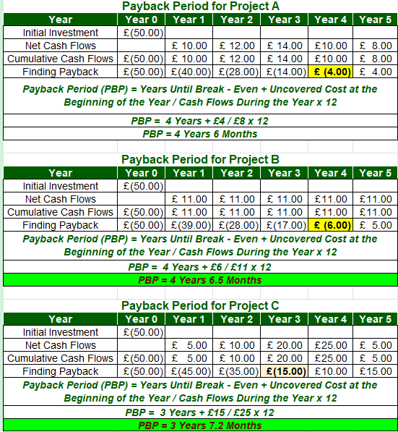
Figure 8: Payback Period (PBP)
(Self-developed)

5.4 Accounting Rate of Return (ARR)
Accounting Rate of Return (ARR) is used to assess the average accounting profit in comparison to average investment. According to straight-line depreciation, Project A will yield an ARR of 3.2, Project B will yield an ARR of 4.0 and Project C will yield an ARR of 12.0. Project C has the largest average annual profit (£3 million), which is way higher than the returns made by Projects A and B. Though time value of money is not considered in ARR, it is still applicable in the comparison of accounting profitability of projects. Project C is more profitable and better utilises the invested capital, due to its substantially higher ARR. Therefore, project C is the best investment when it is considered on the basis of accounting rate of return.
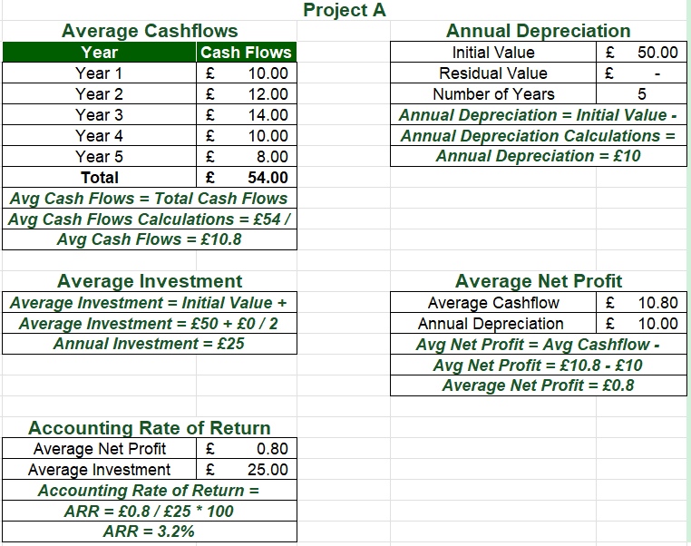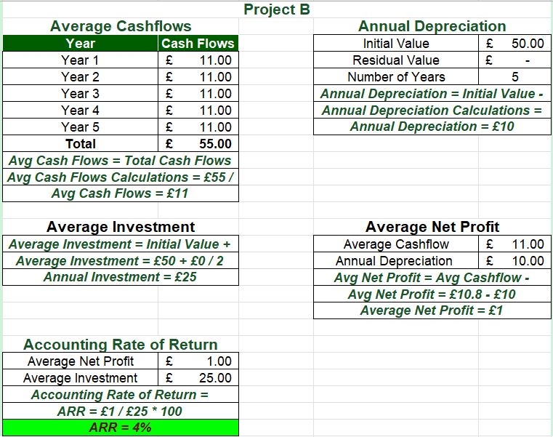
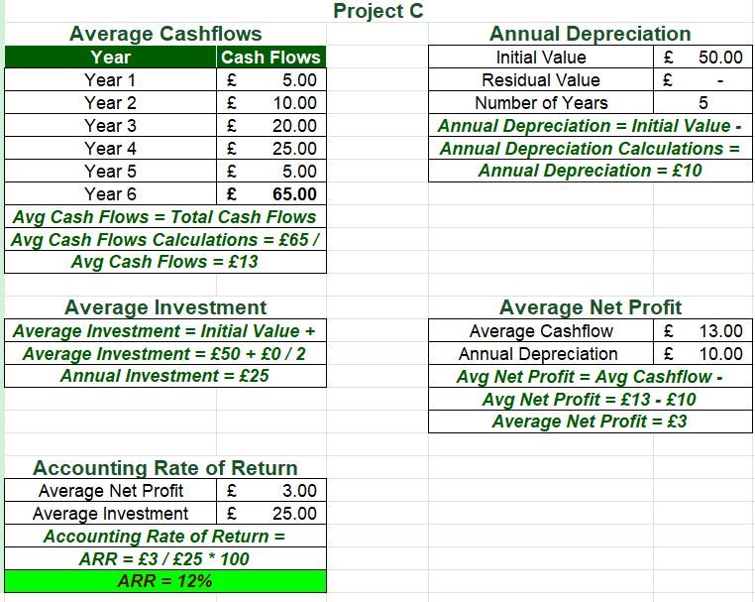
Figure 9: Accounting Rate of Return (ARR)
(Self-developed)

5.5 Net Present Value (NPV)
The Net Present Value (NPV) technique uses the time value of money as it discounts the future cash inflows at the necessary rate of return. One of the most credible methods of investment appraisal, according to Dai et al. (2022), is NPV as it quantifies the direct contribution of a project to the shareholders wealth. Using an 8% discount rate, Project A generates an NPV of –£6.57 million, while Project B produces –£6.11 million, indicating that both projects fail to recover their cost of capital. However, Project C has a positive NPV of 0.83 million, indicating that the discounted cash inflows are higher than the initial investment. Since the only project that generates positive economic value is Project C, then it is the only project acceptable on the NPV criterion on a financial basis.
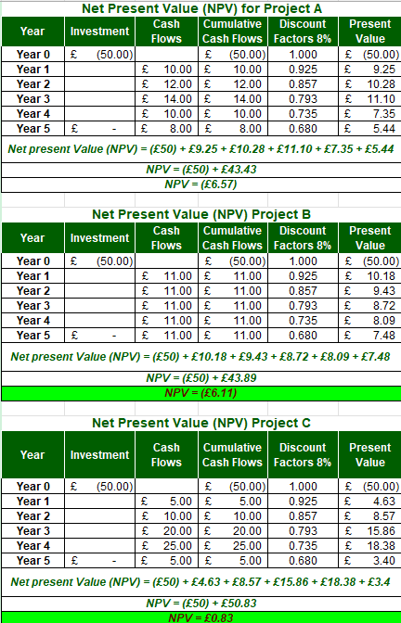
Figure 10: Net Present Value (NPV)

5.6 Profitability Index (PI)
Profitability Index (PI) is used to determine the present value of cash inflows that will be received in the future on a pound of investment. Project A measures PI of 0.87, and Project B measures PI of 0.88, which are less than the acceptance value of 1.0, a sign of value destruction. On the other hand, Project C yields PI of 1.02, i.e. each pound invested in the project will result in present value benefits of 1.02. Project C is the best investment to give the maximum efficiency due to the fact that it is the only project with the minimum requirement of the acceptance criterion and the best opportunity of generating shareholder value. Thus, the PI analysis also confirms the choice of Project C.
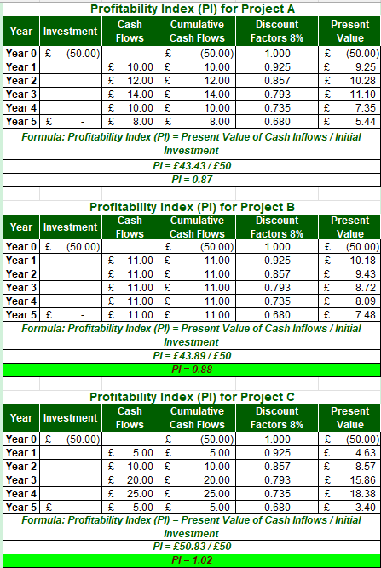
Figure 11: Profitability Index (PI)
(Self-developed)

5.7 Internal Rate of Return (IRR)
The Internal rate of Return (IRR) is defined as the discount rate at which NPV of a project is equal to zero and is commonly applied in conjunction with NPV to assess the attractiveness of an investment (Dai et al., 2022). Project A records an IRR of approximately –3.16%, while Project B generates –7.55%, both substantially below the required discount rate of 8%, indicating financial unacceptability. Conversely, Project C generates an IRR of around 7.58%, which is much higher than that of the other two projects and is close to the required rate of return. The IRR of Project C is slightly lower than the cost of capital of the company when the model is based on the interpolation approach, but still, it is the most prosperous project since it also produces the single positive NPV. On the whole, IRR and NPV rankings indicate that Project C is always the most appealing investment in terms of its financial aspects.
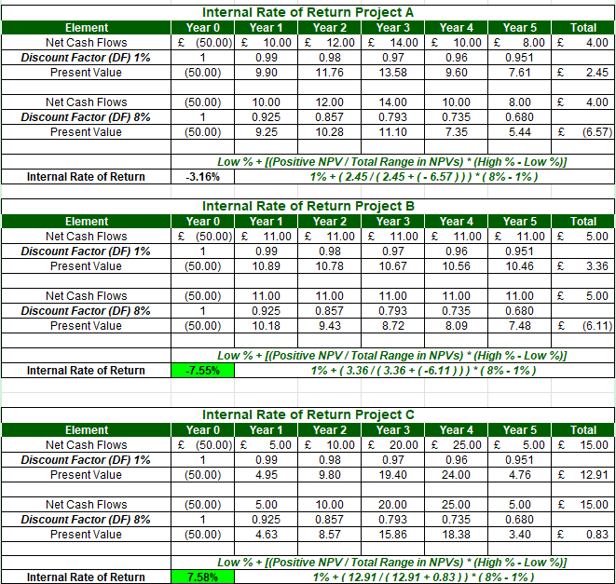
Figure 12: Internal Rate of Return (IRR)
(Self-developed)

5.8 Recommendation of Best Project
According to the overall investment appraisal outcomes, Project C ought to be chosen. It captures the lowest payback (3 years and 7.2 months), and highest ARR (12%), the sole positive NPV (£0.83 million) and highest PI (1.02) and the best IRR of the three options. Such outcomes show high profitability and value creation in the long term. The recommendation is also in line with the financial position of Marriott. Since the company is relatively highly leveraged and its liquidity ratios are below the industry, the faster cash recovery of Project C would enhance the operating cash flows and decrease the burden on financing. Moreover, the project seems to be more appropriate to assist Marriott in its global expansion strategy by addressing the rising demand of customers in high-quality hospitality services and reducing the risk of long-term investment payback. Political uncertainty and macroeconomic risks still exist; however, the international diversification of Marriott lowers concentration risk. Also, the choice of the project with the best financial payoff contributes to the further investment in ESG projects and sustainable operations, which enhances the global brand image and sustainable shareholder value of Marriott.

5.9 Capital Rationing (£100 Million Limit)
Marriott has a maximum investment budget of up to £100 million allowing it to pursue any two projects. According to the NPV, the alternatives are ranked in the following way:
Combination | Total NPV (£m) | Ranking
B + C | –5.28 | 1
A + C | –5.74 | 2
A + B | –12.68 | 3
All the combinations result in a negative total NPV since Projects A and B cause a loss of value but Project B and Project C offers the highest aggregated NPV and reduced total value loss. But strategically, Marriott can only invest in Project C when capital allocation can be adjusted because it is the only project that will generate a positive value to the shareholders. With the need to spend the entire budget of £100 million, Projects B and C are the most financially acceptable combination without compromising on risk profile and greater strategic fit than the other options.

6. Critical Reflection on AI Usage

6.1 Tool Disclosure
There were no specific Artificial Intelligence (AI) tools that were utilized in the preparation of this report. In its place, Microsoft Excel has been used as the main analytical tool to structure financial data, ratios, investment appraisal methods and to present financial data in a structured format. Data sets were organised in Excel, tables were edited, financial data were summarised, ratios were analysed using formulas of Payback Period (PBP), Accounting Rate of Return (ARR), Net Present Value (NPV), Profitability Index (PI) and Internal rate of Return (IRR). As Elmakaty (2024) notes, Microsoft Excel offers a convenient means of arranging quantitative data and underpinning sound financial analysis with properly structured calculations and clear data display.

6.2 Critical Evaluation of AI Output
Even though no specific AI program was involved in creating financial analysis, it was necessary to ensure that data accuracy is maintained throughout the report. The numbers were all taken out of the annual reports of Marriott International and compared with published financial statements and other reliable secondary sources then analyzed. The calculation of ratios, investment appraisal outcomes and interpretation of financial outcomes were checked independently through Microsoft Excel formula to reduce the error in calculation. In cases where secondary sources had financial information, cross-checking was made with formal disclosures to ascertain similarity. Pang et al. (2025) stress that systematic numerical cross-checking is a key to ensuring credibility and minimisation of inconsistencies in financial reporting. A special emphasis was made in validating the numerical relationship among income statements, balance sheets and cash flow statements so that calculations were true to the financial performance of Marriott. This check-up minimized the chance of factual errors, logical fallacies and unjustified financial findings.

6.3 Contribution Analysis
The technicalities of this report were mostly aided by Microsoft Excel, which helped in organising financial data, creation of tables, use of formulas and presentation of financial information in a clear and uniform format. It enabled calculation of financial ratios and investment appraisal measures as well. But the analytical material was still the product of independent analysis. Thus, although the Excel facilitated data processing and presentation, all the strategic analysis, financial interpretation and recommendations are the independent work of the author.

6.4 Professional and Ethical Reflection
Transparency, academic integrity and professional judgement are needed in the responsible use of technology in financial analysis. Any financial data utilized in this report was acquired publicly and therefore the information will remain confidential and will be in accordance with ethical research practices. Proper referencing has been adhered to in all the cases in order to give credit to all sources of information. Though spreadsheet software enhances efficiency in analysis, and removes errors in manual calculations, financial decisions must never be based on automated calculations. Human judgment is still required in the interpretation of financial performance, assessing business risks and formulating strategic advice. Over dependence on technology without critical assessment can lead to incorrect conclusions and bad managerial judgments. Professional accountants are therefore advised to apply analytical tools carefully by balancing technology efficiency with professional skills, ethical judgment and critical analysis.

7. Conclusion
Marriott International has shown good financial recovery within the five-year period due to the steady growth in revenues, a rising operating profitability and a lean asset-based business model. Nevertheless, the company remains challenged due to the high debt rates, rising interest costs and liquidity ratios lower than industry standards, which points to the necessity of greater financial flexibility. Increasing liquidity and decreasing financing pressures would be achieved by improving working capital by improving receivable management, supplier negotiations, digital payment systems and correct cash forecasting. A debt refinancing-based reorganization strategy, selective divestiture and ongoing asset-light growth would enhance the capital structure and sustain international growth. Investment appraisal results indicate that Project C is the most financially attractive option, as it generates the highest profitability, the shortest payback period and the only positive Net Present Value. In general, the above financial and strategic recommendations would enhance Marriott long-term financial sustainability, shareholder value, and competitive ability in the international hospitality sector.

Reference List
Aldo, M. (2022). The Effect of Gearing, Price Earnings Ratio, Interest Rate, Risk on Abnormal Return. Indonesian Interdisciplinary Journal of Sharia Economics (IIJSE), [online] 5(2), pp.752–768. Available at: http://e-journal.uac.ac.id/index.php/iijse/article/view/2195.
Chen, M., Liu, Y., lei, X., Zhang, W. and Xu, T. (2026). Climate policy risk and corporate asset structure upgrading: The rise of asset-light operations. International Review of Economics & Finance, 107, p.105103. https://doi.org/10.1016/j.iref.2026.105103.
Dai, H., Li, N., Wang, Y. and Zhao, X. (2022). The analysis of three main investment criteria: NPV IRR and payback period. [online] Atlantis Press, pp.185–189. https://doi.org/10.2991/aebmr.k.220307.028.
Elmakaty, I. (2024). Mastering meta‐analysis in Microsoft Excel with MetaXL add‐in: A comprehensive tutorial and guide to meta‐analysis. Journal of Evaluation in Clinical Practice. https://doi.org/10.1111/jep.14138.
Ferniawan, M.F., Kusumawati, A. and Madein, A. (2024). The Influence of Earnings Per Share (EPS), Price Earnings Ratio (PER), Price to Book Value (PBV), And Debt Equity Ratio (DER) On The Stock Return. Akrual: Jurnal Bisnis dan Akuntansi Kontemporer, pp.114–130. https://doi.org/10.26487/akrual.v17i01.32073.
Ferrara, L. and Yapi, J. (2022). Measuring exchange rate risks during periods of uncertainty. International Economics. https://doi.org/10.1016/j.inteco.2022.04.001.
Friewald, N., Nagler, F. and Wagner, C. (2022). Debt refinancing and equity returns. The Journal of Finance, 77(4). https://doi.org/10.1111/jofi.13162.
Hall, J.H. (2023). Corporate shareholder value creation as contributor to economic growth. Studies in Economics and Finance, 41(1). https://doi.org/10.1108/SEF-06-2021-0255.
Hu, B., Schclarek, A., Xu, J. and Yan, J. (2022). Long-term finance provision: National development banks vs commercial banks. World Development, 158, p.105973. https://doi.org/10.1016/j.worlddev.2022.105973.
Iazzolino, G., Bruni, M.E., Veltri, S., Morea, D. and Baldissarro, G. (2023). The impact of ESG factors on financial efficiency: An empirical analysis for the selection of sustainable firm portfolios. Corporate Social Responsibility and Environmental Management, 30(4). https://doi.org/10.1002/csr.2463.
Kaya, H.D. (2022). The impact of the 2008-2009 global crisis on manufacturing firms’ bank accounts, overdraft facilities, and loans. Financial Markets, Institutions and Risks, 6(3), pp.64–70. http://doi.org/10.21272/fmir.6(3).64-70.2022.
Khando, K., Islam, M.S. and Gao, S. (2022). The emerging technologies of digital payments and associated challenges: A systematic literature review. Future Internet, 15(1), p.21. https://doi.org/10.3390/fi15010021.
Lee, C.-C. (2023). Analyses of the operating performance of information service companies based on indicators of financial statements. Asia Pacific Management Review, 28(4). https://doi.org/10.1016/j.apmrv.2023.01.002.
Marriott International (2025). About Marriott International | Corporate Information. [online] marriott. Marriott International. Available at: https://www.marriott.com/marriott/aboutmarriott.mi [Accessed 1 Aug. 2026].
Matuzevičiūtė, K., Mironikovaitė, I., Garšvienė, L. and Ruplienė, D. (2023). Threshold effects of public debt on the tax burden: Evidence from EU member states. Intelektinė ekonomika, [online] 17(2), pp.292–307. Available at: https://www.ceeol.com/search/article-detail?id=1210751 [Accessed 3 Aug. 2026].
Pang, C., Cao, Y., Zhou, G., Li, H. and Luo, P. (2025). Document-level tabular numerical cross-checking: A coarse-to-fine approach. [online] arXiv.org. Available at: https://arxiv.org/abs/2506.13328 [Accessed 3 Aug. 2026].
Seretidou, D., Billios, D. and Stavropoulos, A. (2025). Integrative analysis of traditional and cash flow financial ratios: insights from a systematic comparative review. Risks, [online] 13(4), pp.62–62. Available at: https://www.mdpi.com/2227-9091/13/4/62.
Soda, M.Z., Hassan Makhlouf, M., Oroud, Y. and Al Omari, R. (2022). Is firms’ profitability affected by working capital management? Novel market-based evidence in Jordan. Cogent Business & Management, 9(1). https://doi.org/10.1080/23311975.2022.2049671.
Stavropoulos, A.-S. and Zounta, S. (2025). Cash conversion cycle and profitability: Evidence from Greek service firms. Journal of Risk and Financial Management, 18(4), p.208. https://doi.org/10.3390/jrfm18040208.
Svetek, M. (2022). Signaling in the context of early-stage equity financing: Review and directions. Venture Capital, 24(1), pp.1–34. https://doi.org/10.1080/13691066.2022.2063092.
Widiasmara, A., Kusherawati, A., Cahyaningati, R. and Paramita, R.W.D. (2022). The effect of current ratio, debt to equity ratio, return on assets, and net profit margin on profit growth. Assets: Jurnal Ilmiah Ilmu Akuntansi, Keuangan dan Pajak, 6(1), pp.8–15. https://doi.org/10.30741/assets.v6i1.831.
Yahoo Finance (2026). Marriott International (MAR) Income Statement - Yahoo Finance. [online] finance.yahoo.com. Available at: https://finance.yahoo.com/quote/MAR/financials/ [Accessed 1 Aug. 2026].

Appendix
Ratio Analysis for Marriott International Inc
Particulars | Formula | 2021 |  | 2022 |  | 2023 |  | 2024 |  | 2025 |  | Industry Standard
Profitability Ratios
Net Profit Margin | Net Profit / Total Revenue * 100 | $1099 / $13857 * 100 = 7.93% | 7.93% | $2358 / $20773 * 100 = 11.35% | 11.35% | $3083 / $23713 * 100 = 13% | 13.00% | $2375 / $25100 * 100 = 9.46% | 9.46% | $2601 / $26186 * 100 = 9.93% | 9.93% | 8.50%
Net Profit | Net Profit / Total Revenue * 100 | $1099 / $13857 * 100 = 7.93% | $1,099.00 | $2358 / $20773 * 100 = 11.35% | $2,358.00 | $3083 / $23713 * 100 = 13% | $3,083.00 | $2375 / $25100 * 100 = 9.46% | $2,375.00 | $2601 / $26186 * 100 = 9.93% | $2,601.00
Total Revenue | Net Profit / Total Revenue * 100 | $1099 / $13857 * 100 = 7.93% | $13,857.00 | $2358 / $20773 * 100 = 11.35% | $20,773.00 | $3083 / $23713 * 100 = 13% | $23,713.00 | $2375 / $25100 * 100 = 9.46% | $25,100.00 | $2601 / $26186 * 100 = 9.93% | $26,186.00
Operating Profit Margin | Operating Profit / Total Revenue * 100 | $1750 / $13857 8 100 = 12.63% | 12.63% | $3462 / $20773 * 100 = 16.67% | 16.67% | $3864 / $23713 * 100 = 16.29% | 16.29% | $3767 / $25100 * 100 = 15.01% | 15.01% | $4141 / $26186 * 100 = 15.81% | 15.81% | 16%
Operating Profit | Operating Profit / Total Revenue * 100 | $1750 / $13857 8 100 = 12.63% | $1,750.00 | $3462 / $20773 * 100 = 16.67% | $3,462.00 | $3864 / $23713 * 100 = 16.29% | $3,864.00 | $3767 / $25100 * 100 = 15.01% | $3,767.00 | $4141 / $26186 * 100 = 15.81% | $4,141.00
Total Revenue | Operating Profit / Total Revenue * 100 | $1750 / $13857 8 100 = 12.63% | $13,857.00 | $3462 / $20773 * 100 = 16.67% | $20,773.00 | $3864 / $23713 * 100 = 16.29% | $23,713.00 | $3767 / $25100 * 100 = 15.01% | $25,100.00 | $4141 / $26186 * 100 = 15.81% | $26,186.00
Asset Efficiency Ratio
Accounts Receivable Turnover | Trade Revenue / Average Accounts Receivable | $13857 / $1875 = 7.39 Times | 7.39 | $20773 / $2277 = 9.12 Times | 9.12 | $23713 / $2642 = 8.98 Times | 8.98 | $25100 / $2754 = 9.11 Times | 9.11 | $26186 / $2852 = 9.18 Times | 9.18 | 15 Times
Total Revenue | Trade Revenue / Average Accounts Receivable | $13857 / $1875 = 7.39 Times | $13,857.00 | $20773 / $2277 = 9.12 Times | $20,773.00 | $23713 / $2642 = 8.98 Times | $23,713.00 | $25100 / $2754 = 9.11 Times | $25,100.00 | $26186 / $2852 = 9.18 Times | $26,186.00
Average Accounts Receivable | Trade Revenue / Average Accounts Receivable | $13857 / $1875 = 7.39 Times | $1,875.00 | $20773 / $2277 = 9.12 Times | $2,277.00 | $23713 / $2642 = 8.98 Times | $2,642.00 | $25100 / $2754 = 9.11 Times | $2,754.00 | $26186 / $2852 = 9.18 Times | $2,852.00
Total Asset Turnover | Total Revenue / Average Total Assets | $13857 / $25127 = 0.55 times | 0.55 | $20773 / $25184 = 0.82 Times | 0.82 | $23713 / $25244 = 0.94 Times | 0.94 | $25100 / $25928 = 0.97 Times | 0.97 | $26186 / $26861 = 0.97 Times | 0.97 | 0.60 Times
Total Revenue | Total Revenue / Average Total Assets | $13857 / $25127 = 0.55 times | $13,857.00 | $20773 / $25184 = 0.82 Times | $20,773.00 | $23713 / $25244 = 0.94 Times | $23,713.00 | $25100 / $25928 = 0.97 Times | $25,100.00 | $26186 / $26861 = 0.97 Times | $26,186.00
Average Total Assets | Total Revenue / Average Total Assets | $13857 / $25127 = 0.55 times | $25,127.00 | $20773 / $25184 = 0.82 Times | $25,184.00 | $23713 / $25244 = 0.94 Times | $25,244.50 | $25100 / $25928 = 0.97 Times | $25,928.00 | $26186 / $26861 = 0.97 Times | $26,861.00
Liquidity Ratios
Current Ratio | Current Assets / Current Liabilities | $3626 / $6407 = 0.57 Times | 0.57 | $3313 / $7339 = 0.45 Times | 0.45 | $3311 / $7762 = 0.43 Times | 0.43 | $3485 / $8649 = 0.40 Times | 0.40 | $3584 / $8398 = 0.43 Times | 0.43 | 1.05 Times
Current Assets | Current Assets / Current Liabilities | $3626 / $6407 = 0.57 Times | $3,626.00 | $3313 / $7339 = 0.45 Times | $3,313.00 | $3311 / $7762 = 0.43 Times | $3,311.00 | $3485 / $8649 = 0.40 Times | $3,485.00 | $3584 / $8398 = 0.43 Times | $3,584.00
Current Liabilities | Current Assets / Current Liabilities | $3626 / $6407 = 0.57 Times | $6,407.00 | $3313 / $7339 = 0.45 Times | $7,339.00 | $3311 / $7762 = 0.43 Times | $7,762.00 | $3485 / $8649 = 0.40 Times | $8,649.00 | $3584 / $8398 = 0.43 Times | $8,398.00
Cash Ratio | Cash & Cash Equivalent / Current Liabilities | $1393 / $6407 = 0.22 Times | 0.22 | $507 / $7339 = 0.07 Times | 0.07 | $338 / $7762 = 0.04 Times | 0.04 | $396 / $8649 = 0.05 Times | 0.05 | $358 / $8398 = 0.04 Times | 0.04 | 0.45 Times
Cash & Cash Equivalent | Cash & Cash Equivalent / Current Liabilities | $1393 / $6407 = 0.22 Times | $1,393.00 | $507 / $7339 = 0.07 Times | $507.00 | $338 / $7762 = 0.04 Times | $338.00 | $396 / $8649 = 0.05 Times | $396.00 | $358 / $8398 = 0.04 Times | $358.00
Current Liabilities | Cash & Cash Equivalent / Current Liabilities | $1393 / $6407 = 0.22 Times | $6,407.00 | $507 / $7339 = 0.07 Times | $7,339.00 | $338 / $7762 = 0.04 Times | $7,762.00 | $396 / $8649 = 0.05 Times | $8,649.00 | $358 / $8398 = 0.04 Times | $8,398.00
Investor Ratio
Earning Per Share (EPS) | (Profit Attributable to Ordinary Shareholders / Weighted Average Number of Ordinary Shares) | $1099 / $329 = 3.33 Times | 3.33 | $2358 / $325.80 = 7.24 Times | 7.24 | $3083 / $302.90 = 10.18 Times | 10.18 | $2375 / $285.20 = 8.33 Times | 8.33 | $2601 / $273.60 = 9.51 Times | 9.51 | $3.80
Profit Attributable to Ordinary Shareholders |  | $1099 / $329 = 3.33 Times | $1,099.00 | $2358 / $325.80 = 7.24 Times | $2,358.00 | $3083 / $302.90 = 10.18 Times | $3,083.00 | $2375 / $285.20 = 8.33 Times | $2,375.00 | $2601 / $273.60 = 9.51 Times | $2,601.00
Weighted Average Number of Ordinary Shares |  | $1099 / $329 = 3.33 Times | 329.80 | $2358 / $325.80 = 7.24 Times | 325.80 | $3083 / $302.90 = 10.18 Times | 302.90 | $2375 / $285.20 = 8.33 Times | 285.20 | $2601 / $273.60 = 9.51 Times | 273.60
Price-to-Earnings (P/E) Ratio | Market Price Per Share / EPS | $148.26 / $3.33 = 44.49 Times | 44.49 | $159.55 / $7.24 = 22.04 Times | 22.04 | $187.55 / $10.18 = 18.43 Times | 18.43 | $252.21 / $8.33 = 30.29 Times | 30.29 | $298.64 / $9.51 = 31.41 Times | 31.41 | 27.50 Times
Market Price Per Share | Market Price Per Share / EPS | $148.26 / $3.33 = 44.49 Times | $148.26 | $159.55 / $7.24 = 22.04 Times | $159.55 | $187.55 / $10.18 = 18.43 Times | $187.55 | $252.21 / $8.33 = 30.29 Times | $252.21 | $298.64 / $9.51 = 31.41 Times | $298.64
Earning Per Share (EPS) | Market Price Per Share / EPS | $148.26 / $3.33 = 44.49 Times | $3.33 | $159.55 / $7.24 = 22.04 Times | $7.24 | $187.55 / $10.18 = 18.43 Times | $10.18 | $252.21 / $8.33 = 30.29 Times | $8.33 | $298.64 / $9.51 = 31.41 Times | $9.51
Cash Flow
Operating cash Flow Ratio | Cash Flow from Operating Activities / Current Liabilities | $1177 / $6407 = 0.18 Times | 0.18 | $2363 / $7339 = 0.32 Times | 0.32 | $3170 / $7762 = 0.41 Times | 0.41 | $2749 / $8649 = 0.32 Times | 0.32 | $3212 / $8398 = 0.38 Times | 0.38 | 0.60 Times
Cash Flow from Operating Activities | Cash Flow from Operating Activities / Current Liabilities | $1177 / $6407 = 0.18 Times | $1,177.00 | $2363 / $7339 = 0.32 Times | $2,363.00 | $3170 / $7762 = 0.41 Times | $3,170.00 | $2749 / $8649 = 0.32 Times | $2,749.00 | $3212 / $8398 = 0.38 Times | $3,212.00
Current Liabilities | Cash Flow from Operating Activities / Current Liabilities | $1177 / $6407 = 0.18 Times | 6,407.00 | $2363 / $7339 = 0.32 Times | 7,339.00 | $3170 / $7762 = 0.41 Times | 7,762.00 | $2749 / $8649 = 0.32 Times | 8,649.00 | $3212 / $8398 = 0.38 Times | 8,398.00
Free Cash Flow Ratio | Free Cash Flow (Operating Cash Flow - capital Expenditure) / Total Revenue | $994 / $13857 = 0.07 Times | 0.07 | $2031 / $20773 = 0.10 Times | 0.10 | $2718 / $23713 = 0.11 Times | 0.11 | $1999 / $25100 = 0.08 Times | 0.08 | $2608 / $26186 = 0.10 Times | 0.10 | 0.12 Times
Free Cash Flow |  | $994 / $13857 = 0.07 Times | $994.00 | $2031 / $20773 = 0.10 Times | $2,031.00 | $2718 / $23713 = 0.11 Times | $2,718.00 | $1999 / $25100 = 0.08 Times | $1,999.00 | $2608 / $26186 = 0.10 Times | $2,608.00
Total Revenue |  | $994 / $13857 = 0.07 Times | $13,857.00 | $2031 / $20773 = 0.10 Times | $20,773.00 | $2718 / $23713 = 0.11 Times | $23,713.00 | $1999 / $25100 = 0.08 Times | $25,100.00 | $2608 / $26186 = 0.10 Times | $26,186.00
Gearing Ratio | Total Debt / Total Shareholders Equity * 100 | $10138 / $1414 * 100 = 717% | 717% | $10064 / $568 * 100 = 1772% | 1772% | $11873 / $682 (Deficit) * 100 = -1741% | 1741% | $14447 / $2992 (Deficit) * 100 = - 483% | 483% | $16204 / $3771 * 100 = - 430% (Deficit) | 430% | 140%
Total Debt | Total Debt / Total Shareholders Equity * 100 | $10138 / $1414 * 100 = 717% | $10,138.00 | $10064 / $568 * 100 = 1772% | $10,064.00 | $11873 / $682 (Deficit) * 100 = -1741% | $11,873.00 | $14447 / $2992 (Deficit) * 100 = - 483% | $14,447.00 | $16204 / $3771 * 100 = - 430% (Deficit) | $16,204.00
Total Shareholders Equity | Total Debt / Total Shareholders Equity * 100 | $10138 / $1414 * 100 = 717% | 1,414.00 | $10064 / $568 * 100 = 1772% | 568.00 | $11873 / $682 (Deficit) * 100 = -1741% | 682.00 | $14447 / $2992 (Deficit) * 100 = - 483% | 2,992.00 | $16204 / $3771 * 100 = - 430% (Deficit) | 3,771.00

