

Fitness within Police:
Are the current fitness standards up to modern-day policing?

Student Name: Amy Shaw
Student Number: 2134315
Subject: BSc (Hons) Professional Police Practice

Acknowledgements:
Firstly, I would like to extend the deepest thanks my partner Christian, for his continued, unwavering support and encouragement whilst I have been completing the degree in Professional Police Practice. He has demonstrated understanding and patience when I have leaned on him to take care of the things in our life that could not be left, whilst I have had to prioritise giving time to study and research.

Secondly, I wish to also express thanks to my parents, Maxine and Steven, who have given me the ultimate belief that I can achieve anything, whilst showing compassion and understanding whilst I have been committed to working and studying.

I would also like to extend my thanks to those who gave their time to participating in my research. Without this participation, my dissertation would not have been achievable.

Finally, I wish to express my thanks to those at University of Wales Trinity Saint David for the provisions of knowledge and information over the last 3 years to help me work towards a degree that I had never imagined possible.

Declaration
This work has not previously been accepted in substance for any degree and is not being concurrently submitted in candidature for any degree.
Signed: Date: 03rd April 2025

STATEMENT 1
This dissertation is being submitted in partial fulfilment of the requirements for the degree of BA.
Signed: Date: 03rd April 2025

STATEMENT 2
This dissertation is the result of my own independent work/investigation, except where otherwise stated.
Other sources are acknowledged by footnotes giving explicit references. A bibliography is appended.
Signed: Date: 03rd April 2025

STATEMENT 3
I hereby give consent for my dissertation, if accepted, to be available for photocopying and for interlibrary loan, and for the title and summary to be made available to outside organisations.
Signed: Date: 03rd April 2025

STATEMENT 4
I hereby give consent for my dissertation, if accepted, to be available on the university’s IT system to those who have consent to use the system.
Signed: Date: 03rd April 2025

Abstract
The following research investigates the appropriacy of the current standards of fitness set by the College of Policing for police forces across England and Wales. The study investigates whether the outlined fitness levels are cohesive to the demands of modern-day policing in the UK, in an ever-changing and evolving climate. Assessing whether current fitness standards sufficiently equip police officers for the physical demands of their everyday tasks is the primary goal of this study. The study specifically looks at how officers' performance and fitness levels relate to one other as well as how practical the standard is to their role. The research consists of a qualitative data collection method, with the results of 25 contributing front line officers in the role of constable and sergeant participating. To evaluate the relationship between job performance and fitness levels, a statistical study was performed.
The study overwhelmingly found that officers felt their police force didn’t support their fitness, that there were other more accurate measures of fitness – such as strength and endurance – and that the current fitness test was not an accurate reflection of the day to day demands of the role.
The results imply that in order to better reflect the physical demands of police, the current fitness standards may need to be updated to incorporate more thorough tests of strength and agility. The study concludes that cardiovascular fitness alone does not adequately reflect contemporary policing.

Table of Contents

Chapter One – Introduction

Chapter Two – Literature Review
2.1 Introduction to the Literature Review
2.2 Fitness Standards in Policing: A Historical Overview
2.3 Current Fitness Standards in Policing
2.4 The Relationship between Fitness and Police Performance
  - Challenges in Modern Policing and the Need for Evolving Fitness Standards

Chapter Three – Methodology
3.1 Research Design
3.2 Participants and Sampling
3.3 Data Collection Methods
3.4 Data Analysis
3.5 Ethical Considerations
3.6 Study Limitations

Chapter Four - Analysis of results
4.1 Introduction
4.2 Summary of Key Findings
4.3 Comparison with Existing Standards
4.4 Alignment with Modern Policing Demands
4.5 Implications and Challenges
4.6 Conclusion

Chapter Five – Findings and Conclusion (1000 words)
5.1 Introduction
5.2 Findings
5.3 Discussion and Interpretation
5.4 Conclusion

Chapter Six – Recommendations

Chapter Seven – Bibliography

Chapter Eight - Appendix

Chapter One – Introduction
Being physically active has long been seen as crucial to policing because officers must respond to high-pressure circumstances that call for strength, stamina, and agility, though it is becoming more widely acknowledged that these instances are becoming less frequent as crime types evolve. The capacity to do physically demanding jobs is still seen as essential for maintaining both officer and public safety, from detaining individuals, managing violent physical encounters and pursuing criminals on foot.
Many law enforcement organisations have fitness requirements that officers must fulfil during the recruitment process to maintain a standard minimum level of physical preparedness. This standard is evaluated once a year and for appointment in role in the UK using the Job-Related Fitness Test (JRFT). It has been questioned, therefore, if these standards really represent the difficulties facing policing in the modern-day. Given the evolution of crime patterns, improvements in policing strategies and tactical options, and a growing emphasis on equality, it is vital to assess if the fitness standards in place are still appropriate.
Critics counter that this test might not adequately reflect actual police situations, with research finding that police personnel frequently encounter extreme pressures outside the range of typical human experience. Police officers may be required to attend incidents that pose a threat to their bodily well-being, the physical well-being of other officers, or the general public at any point throughout their shifts (Anderson, Litzenberger, & Plecas, 2002) and when executing a sequence of consecutive job duties that are representative of those an officer could encounter on duty, muscular fitness, particularly lower-body muscular endurance and power, is fundamental (Canetti, et al., 2024). Furthermore, some officers may pass the initial entry fitness test but eventually lose their physical capabilities. This begs the question of whether current standards sufficiently equip officers for the long-term physical demand.
The goal of this dissertation is to critically assess whether the requirements of contemporary policing are met by the present fitness standards for constables. In addition to examining how these requirements affect overall performance, the study will investigate whether current tests accurately gauge the physical skills required for frontline duties. To identify possible areas for improvement, it will also examine if police fitness requirements have changed over time and contrast them with norms seen in other countries, like the United States and in some areas of the European continent.
To accomplish these goals, this dissertation is organised as follows: A review of research on police fitness standards is provided in Chapter Two, looking at the current measure of fitness and the demands of frontline policing, as well as a brief history. The research approach used to evaluate the applicability of existing fitness requirements is described in Chapter Three, along with the specified data collection techniques; a survey of current police officers and sergeants. The results are covered in Chapter Four, which examines whether the fitness measures used today accurately represent the realities of modern policing. Chapter Five concludes by making suggestions for possible revisions of the current policies.
This study intends to add to continuing conversations on training officers for the physical demands of their job by critically analysing police fitness standards. The results may have important ramifications for organisations looking to improve officer effectiveness and public safety by refining their fitness standards to meet modern day demands.
549 words

Chapter Two – Literature Review

2.1 - Introduction to the Literature Review
This literature review aims to investigate how fitness standards in policing have changed over time, with a particular emphasis on whether the demands of modern-day policing are met by the physical fitness standards now in place. Officers' physical preparedness and health must change along with the constable role, and the review will also seek to find whether police forces in the UK are making the necessary changes to accommodate the way the role is continually evolving. Research on physical fitness requirements, modifications to policing practices, and the relationship between officer performance and fitness standards will all be covered within the text. The literature will seek to provide evidence for or arguments against the importance of physical health within the role and its role in ensuring police officers’ safety, performance, and ability to respond to challenges in a variety of policing environments.

2.2 - Fitness Standards in Policing: A Historical Overview
The "most thorough review of police pay and conditions in more than 30 years" was announced by Home Secretary Theresa May in October 2010. Tom Winsor led the independent review that covered Wales and England (Jarrett, 2011). Winsor was requested to offer suggestions on how to use pay and terms of service to maximise the number of officers and staff who are deployed to frontline positions where their abilities and skills were needed, to offer pay and terms of service that are equitable and reasonable for the public taxpayer as well as police officers and staff, and facilitate contemporary management techniques that are consistent with those used in other public sectors and the larger economy (Home Office, 2013).
Whilst the review into police remunerations itself focussed on a value for money agenda on behalf of the UK Government, Winsor’s report outlined a responsibility of chief constables to make sure that their officers and personnel on the front lines are adequately equipped to handle the potential threats to both their own and the public's safety. The report found that the number of officers restricted from front line operational duties had increased by 3838, from 2003 to 2011, where the overall number of non-operational officers totalled 6137. Additionally, the report also found that aside from the entry level fitness testing, post-appointment, there was no national policy in relation to repeat fitness testing, with only some of the forces requiring annual testing. As such, in relation to fitness of officers, Winsor recommended “a new annual fitness test should be undertaken by all officers who may be deployed on the frontline”. (Winsor, 2012).

2.3 - Current Fitness Standards in Policing
Following the Winsor reviews final report in 2012, the College of Policing (CoP) developed a nationalised framework for fitness testing for police forces in England and Wales named the Job-Related Fitness Test (JRFT). The 15-meter multi-stage fitness test, also known as a beep test, is based on the physiological requirements of personal safety training and is an aerobic test (College of Policing, 2021). The minimum required standard for officers is level 5.4, which consists of 3 minutes and 35 seconds of shuttle runs (College of Policing, 2021a), though literature confirms that this minimum standard has been in place since 2004 for recruitment of new constables, with the standard being applied to existing constables in 2014 following the recommendations made by Windsor (National Police Chiefs Council, 2023a).
Though the test is described as a physiological test, the CoP also highlight that in 2016, the push/pull test, which measures upper body strength, was removed from the JRFT (College of Policing, 2021b). There is currently no standard strength assessment utilised in the measure of fitness for duty within the 43 police forces across England and Wales.
Research into the current fitness standard requirements has found that a new, lower level test should be introduced to the JRFT. A twelve-month trial project, by Professor Brewer, to assess standards for the new PPST curriculum began using officers from Avon and Somerset police in September 2021. Using the same methodology for Police Fitness standards in 2004 and 2009, he evaluated data from 125 constables who were enrolled in the new PPST courses piloted by the force as well as the 15-meter MSFT. The result of the research found that the JRFT requirement would have to be lowered by 11% from the current level of 5.4, if it were based on peak heart rate to match the minimum standard to the aerobic needs of PPST, meaning a minimum level of 3.7 for the bleep test (National Police Chiefs Council, 2023b).
This evidences a clear need to reassess the measure of police officer fitness, as the standards currently in place, up to Brewers recent research, have not been changed in some twenty years, despite clear changes in the types of crimes being dealt with, and the resources deployed to respond to live crimes.
In comparison, the United States doesn’t operate using a standardised framework, with the available literature showing that law enforcement agencies utilize different assessment methods, though they are largely similar. Though the JRFT is aerobically measured, the U.S. tests largely measure overall physical performance.
For example, U.S. Immigration and Customs Enforcement (ICE) use the Physical Fitness Test (PFT). Four timed events make up the PFT. Stringent protocols see that applicants must complete thirty-two sit-ups in one minute or under, 22 push-ups in under a minute, 47.73 seconds or less for a 220-yard sprint and 14 minutes and 25 seconds or less for a 1.5-mile run. To pass this test, the criteria for each event must be met or surpassed. These tests evaluate cardiovascular endurance, anaerobic and aerobic power, and muscle strength and endurance (U.S. Immigration and Customs Enforcement, 2025). Although passing a physical fitness test is a requirement for police academy training in many places in the US, officers are not required to maintain the same physical standards once they graduate (Frick, et al., 2024).
One study sought to determine and examine the most popular physical fitness exams for law enforcement personnel, finding that the handgrip test, which measures muscle strength, push-ups, sit-ups, and vertical jump, as well as the 12-minute Cooper test, which involves timed 1.5 mile, 2.4 mile, and 20-meter shuttle runs to gauge aerobic capacity and sit-and-reach exercises to gauge flexibility, are the most frequently used tests worldwide. Data comparing the physical activity levels of Portuguese police officers to those of other police officers throughout the world showed that they were moderately active, also stating that the research found that over time, a police officer's level of physical fitness generally deteriorates (Massuça, Santos, & Monteiro, 2022).

2.4 - The Relationship between Fitness and Police Performance
Police officers are expected by the communities that they serve, to be physically healthy, whilst strength and endurance are logically assumed to be essential job needs. In actuality, the sedentary nature of police work raises questions regarding officers' fitness and health (Bissett, Bissett, & Snell, 2012). However, research has shown just a small percentage of policing entails police officers doing a range of brief, high-intensity actions, such as running, jumping, and physically detaining suspects, whereas the majority of the work is often low-intensity, being conducting foot or mobile vehicle patrols (Manser, 2019).
Male law enforcement officers from the United States participated in research, where they were randomised to either a “training” group, which followed a circuit weight training program over 16 weeks, training 3 times weekly or the no-exercise control group, which did not engage in any physical activity. Over the duration of the program, the training participants' level of fitness grew as anticipated, whereas the no exercise group's level did not. Additionally, for the officers grouped into the training program, job satisfaction significantly increased in tandem with the gain in fitness. Officers who did not take part in the fitness program, however, did not report feeling more satisfied with their jobs (Boni, 2004).
Whilst this does offer some evidence that there is a positive link between physical fitness and increased officer role satisfaction it does not fully explore or evidence an increase in job related performance. It also does not offer a broad or inclusive result as there were no female officer participants included in the research.
Research has shown that the development of physical fitness is a crucial aspect of initial training for police applicants. The majority of initial training courses use physical training as a standard practice to acquire the fundamental physical skills required for the position. Increased fitness has been linked to improved performance on job-related tasks unique to policing, therefore finding fitness development to be essential (Lockie, et al., 2020).
According to other studies, the selection procedures used to hire constables are very important because of the high demands of the job and the public's increased scrutiny of policing. The sedentary nature of the job may lead police forces to undervalue the importance of physical readiness. Even though they may not occur often, it's important to recognise that incidents involving physical skills within the role are often necessary within the circumstances, drawing the inference that in order to ensure that officers maintain their physical fitness throughout their careers, more work needs to be done by the regulatory and advisory bodies within policing. However, this particular research was completed with in-post officers, with the results showing a considerable preference for requiring new hires, but not incumbents, to meet physical agility and fitness standards. This was despite the physical tasks used within the research not being frequently employed on the job, with up to 27% of already-employed officers acknowledging that they were unable to pass a basic physical agility test (Bissett, Bissett, & Snell, 2012).
Further research conducted (Lockie, Orr, & Dawes, 2022) stated that those who work as police officers may be at a higher risk of developing cardiovascular disease (CVD). Stress, shift work, a decrease in physical activity, a reduction in sleep duration, and poor nutrition choices are some of the factors that increase this risk. Numerous studies have shown that officers' fitness tends to decline after initial training, in part because of a decrease in physical activity, such as engaging in primarily sedentary activities, like sitting in a patrol car during a shift. Shift work can also have a negative effect on an officer's sleep patterns, and irregular shift patterns lead to officers making poor dietary choices. Officers may experience stress as a result of their duties in the policing environment.
This provides evidence that the profession in itself can have an overall detrimental impact on the health and wellbeing of those participating in the role and would give good cause to arguments in support of maintaining physical fitness. This would be further supported by police organisations implementing more targeted fitness regimes, as opposed to one annual test, requiring little preparation.

2.5 - Challenges in Modern Policing and the Need for Evolving Fitness Standards
Since the introduction of the JRFT in 2014, police forces have increasingly been using new technologies to respond to and investigate incidents. Policing in the UK has seen the use of new mobility methods, such as during a frontline deployment and for other sophisticated evidence collection, autonomous vehicles—in particular, a mix of drones and fixed-wing Unmanned Aerial Vehicles—offer a quicker, safer, more affordable, and more environmentally friendly option. This is in addition to the retrieval and use of CCTV and Automatic Number Plate Recognition (ANPR) to develop investigations, with the provision to frontline resources of less lethal weapons to ensure operational safety. All of these methods, though not limited to, look to increase the performance of police (Taylor, 2024).
Though there are potential advantages to implementing new technologies that have been identified by the government, police departments, and other sector stakeholders, including enhanced performance in areas like crime prevention and detection, the use of facial recognition technology (FRT) to identify criminals, or accelerated court proceedings; increased efficiency by freeing up police time and capacity for higher priority work; simpler communication and interaction between the police and the public; and support for transparency, accountability, and trust, such as the use of body-worn cameras (Low, 2024).
There are however some notable challenges with policing using new technologies, notably in September 2019, where South Wales Police were subject to judicial review proceedings following the use of a facial recognition surveillance scheme by the force. The ruling found that insufficient work had been done by the force to comply with Article 8 European Convention on Human Rights, as well as the Equality Act 2010 and Data Protection Act 2018 (Simmons and Simmons, 2020). Despite the success of the challenge, South Wales Police published data that prior to the judgement, sixty one persons were arrested as a result of live face recognition deployments for offences such as theft, robbery, violent crime and noncompliance with court orders (South Wales Police, 2023).
Other challenges within Modern Day policing are the number of assaults committed on emergency workers. Police in England and Wales reported 45,907 assaults on officers in the year that ended in March 2024, this data comprised of injury and non-injury assaults, with a 15.5% rise of assaults without injury being recorded from the year prior (GOV.UK, 2025). This evidences an increased risk whilst undertaking the role, however there is a dearth of research on the causes and effects of assaults on police officers. Some research suggests that there were five important characteristics of those who committed the categorised assaults being "employment status, shared residence with an abuse victim, alcohol consumption, property damage, and hostile demeanour towards officers". Most studies that have examined police violence have concentrated on police use of force rather than the police as victims of violence (den Hayer, 2024). This should be investigated further to establish whether there is a link to the current measure of fitness for the role and its demands.
Shift work also poses a challenge to fitness. A pattern consisting of a mixture of day, afternoon and night shifts is typically what those in frontline roles and middle office roles, such as police dispatchers and call handlers, will regularly work. The Home Office recommends the 2x2x2 pattern (Police Federation, n.d.).
In general, shift working reduces opportunities for sports involvement and physical activity. While snacking is more common during the night shift, meal frequency is typically decreased. These results can be explained by a lack of time, a decreased want for eating at night, and the unavailability of preferential foods at work. Sleep and circadian rhythm disturbances brought on by shift employment also affect the metabolic reactions to food (Atkinson, Fullick, Grindey, & Maclaren, 2008). Additionally, research found that insomnia, exhaustion, poorer work performance, a higher risk of accidents, and a lower quality of life are all consequences of Shift Work Disorder (SWD). Furthermore, SWD is linked to higher economic costs and worse productivity (Jang, 2021).
These issues question the legitimacy of the level required within the JRFT and whether there should be alternative measures of job-related fitness, given new technology and how the role affects fitness due to its very nature of irregularity. With the use of artificial intelligence, such as CCTV or FRT, incidents can be investigated at a slower pace, detaining suspects with an orchestrated plan, thus reducing the immediate risk to the wider public.
2491 words

Chapter Three – Methodology

3.1 - Research Design
Saunders' Research Onion (Saunders, Lewis, & Thornhill, 2007) framework is used in this study to methodically plan the research process. The whole strategy is guided by positivism, focussing on fact and neutrality, as the research philosophy. To determine if the UK police force's current fitness standard meets the modern-day demands of the role, an inductive technique is used. The study employs a mono-method research design and uses a survey to gather quantitative data. Because of the time frame limits, a cross-sectional time horizon is chosen. Finally, suitable methods for gathering and analysing data are used to guarantee the authenticity and dependability of the results.

3.2 - Participants and Sampling
The targeted respondents for the survey are constables employed by South Wales Police, within an active role, with the inclusion criteria being that they have passed the JRFT in the 12 months prior to responses being requested. Responses will also be accepted from officers who are restricted due to pregnancy or short-term injury. These roles will include response officers, neighbourhood policing team officers, roads policing constables and any other relevant team or department.
Constables on sick leave, retired officers and student constables still within their initial six-month training period will be excluded from the research to ensure that only current standards are represented. Officers above the rank of Sergeant, being Inspector and above, will also not be included. These exclusions are necessary to ensure that relevant job-related experience is also considered by participants within the responses to the survey questions presented.

3.3 - Data Collection Methods
The primary data collection method for this research will be through the use of a Survey to obtain responses. The survey will consist of 10 closed ended questions, offering only yes or no responses. Standardising the response options is to ensure that the opinions of participants in the survey are clearly understood and easily measurable and can be statistically analysed accurately. The survey will take between 1 to 3 minutes to complete.
The objective of this survey is to establish whether operational and front line officers feel that the current fitness testing in place, recommended by the CoP, meets modern day requirements of the role by those who are performing it, whether they feel the standards set are sufficient, whether they feel supported by their organisation and whether fitness upkeep could be encouraged by random testing and additional health education.

3.4 - Data Analysis
By utilising quantitative data, achieved by employing the use of a survey, measurable and comparable responses will become numerical data that will be collated and transformed for analysis to identify and outline any patterns that either support outlined objectives or affirm current standards of fitness being sufficient. The retrieved numerical data will be displayed in an easily readable format, like graphs or pie charts.
The data will be obtained with a series of questions, sent to prospective respondents using online website “Survey Monkey”, where there is an analytical tool provided.

3.5 - Ethical Considerations
To ensure that this research falls within ethical research guidelines, all participants will be made aware of the reason for the research, what method of research is being used and why and how the data they provide will be used in analysis, prior to their participation. No personal information will be sought from respondents to ensure the integrity in confidentiality and anonymity, with responses being kept in a password protected folder to additionally support data protection is met.
All participants will be informed of their right to withdraw from the survey and the relevant methods to do so, however, this is likely to reveal their identity to the researcher. Any retractions will be treated confidentially and stored in a secure folder.
This study, though formally proposed with an alternative title, has been approved by the Ethics Committee at University of Wales Trinity Saint David, prior to any data being collected.

3.6 - Study Limitations
There are several potential limitations within the research topic. Firstly, the survey provided to participants offers closed questions, with “yes” or “no” as the only response options. There is no option for participants to elaborate on their response choices or to offer any suggestions or recommendations.
Secondly, the target participants are constables employed by South Wales Police and as such renders the scope of the research to be narrow and not representative of all 43 (this figure includes the specified sample) police forces within England and Wales.
Though the survey is being made available to all warranted police officers within South Wales Police, of which there are almost 3000, via the force intranet, there are only expected to be a much smaller pool of respondents. The pool reduces significantly because of the aforementioned exclusions but also as a result of cost limitations. There is no available budget to extend the research, and the survey developer will only allow a maximum of 25 responses to be analysed within their free creator tool.
Another limitation to the research is that there is a time restriction on the length of time the study, meaning that it cannot be carried out over a number of years where comparison can be made to evolving policing issues.
Additionally, the respondents to the survey will be expected to act with honesty and integrity when participating, due to the exclusions provided. Due to the questions posed being necessary to answer the named objectives, combined with no financial support, questions directed at specific roles have not been included and therefore no filtering can take place.
The final limitation is that no practical testing of alternative fitness test options will be carried out. This means that respondents will be providing responses based on their perceived personal preferences, potentially providing a bias or narrow opinion, without having the ability to attempt other fitness testing methods that they would consider “ideal”.
944 words

Chapter Four - Analysis of results

4.1 - Introduction
The aim of the study is to establish whether the current framework for standards of fitness required within UK policing meets the demands of modern-day policing. To retrieve the relevant data, a survey consisting of ten targeted closed-ended questions about the current standards, provisions of support and other opinions about policing fitness, was created and advertised for responses via an internal force intranet blog post within South Wales Police. A specified sample of police constables and sergeants, who have undertaken a JRFT within 12 months of the date of the study, were encouraged to respond.
This chapter will analyse the number of responses received, as well as the answers provided by respondents, turning them into simple numerical data that will be compared to research and literature outlined in the second chapter of this study. The outcome of the research data and its comparison to existing research will be summarized, where the information will be reviewed to establish its alignment with modern-day policing needs.

4.2 - Summary of Key Findings
There was a total of 84 responses to the survey within a 12-hour period. Due to limitations within budget affecting the accessible and usable responses, the sample size further decreased to 25 respondents whose answers were randomly selected by the survey tool for analysis.
The most significant and conclusive result from the survey found that 100 percent of respondents felt that the organisation did not do enough to support them maintaining their fitness (Figure 7). Ninety two percent of respondents also felt that the force could provide more access to gym and training equipment (Figure 8), with the same percentage also stating that they thought there were better measures of fitness than just cardiovascular testing (Figure 3).
The majority of participants, 72 percent, also said they felt that the current JRFT did not meet the demands of their role (Figure 10), whilst there was a relatively even split when responding to questions about their fitness levels decreasing since joining the role (Figure 2) or whether their fitness levels would be better assessed wearing all of their personal protective equipment (PPE) (Figure 5).

4.3 - Comparison with Existing Standards
The results of the survey demonstrate that officers feel there are other measures of fitness that could be utilised, as opposed to the current standard in the UK, and this is reflective of the standards seen in literature from enforcement agencies within the United States.
Officers who responded, however, have indicated by a minor margin of 4% that they feel their fitness has decreased since joining their police force (Figure 2). This does reflect research that has shown fitness levels decrease in incumbent officers, with a survey showing that almost a third of officers who participated stating they felt they wouldn’t meet the minimum level in a fitness test.

4.4 - Alignment with Modern Policing Demands
The literature provided within this study has emphasised that the public are increasingly scrutinising police and it is important to consider that fitness of officers is important to the public, for whom the police are responsible for protecting.
Overall, the research finds that officers are somewhat evenly split between whether their fitness should be assessed whilst wearing all of their PPE (Figure 5). Due to the data obtained being qualitative, there are no additional notes from the respondents to explain their choices. Force policies define that officers should wear all of their PPE and despite the relatively even split, the majority belonged to respondents believing their fitness would be more accurately assessed wearing this equipment, reaffirming the data suggesting that officers do not currently feel the fitness test reflects their role (Figure 10) or is sufficient to their role (Figure 1).
The stated literature has evidenced a need for physical strength in the pursuit of detaining suspects, however, 92% (Figure 3) of respondents felt their physical strength should be tested.

4.5 - Implications and Challenges
When analysing responses as to whether the JRFT is sufficient for the role being performed (Figure 1) by respondents and whether those requirements are reflective of their day-to-day role demands (Figure 10), the outcome was similarly split. This result would suggest that the lack of comparison, when participating in annual testing, to the daily demands could leave officers susceptible to injury or open to inaccurate lower ratings on physical performance during end of year reviews based on a measure of fitness not reflective of their role.
Of those surveyed, one hundred percent stated that their force did not do enough to support their fitness (Figure 7), with a further 80% of respondents stating they felt the force could do more on training days around health, fitness and nutrition (Figure 9). These figures suggest that though there is an expectation to maintain a level of fitness, this isn’t being prioritised by decision makers within policing. This could see poorer overall results of the current standards if analysed compared to if the force were to supply the provisions for improved fitness. Lack of fitness culture within the force, and already existing research that demonstrates overall performance is lowered by shift workers, means it is unlikely that officers are performing to their best standards.
This research suggests fitness testing should be revised to reflect the role requirements, as well as the provision to forces of a package for health and wellness education and support. Challenges for implementing this change would be the development of a new fitness package, as well as the overall cost associated with disseminating this to the 43 forces in England and Wales.

4.6 - Conclusion
Though a wider survey should be undertaken to improve the accuracy of the analysis of officers and sergeants within South Wales Police and broaden the scope to the remaining 42 forces in England and Wales, the analysed data shows that the sole measure of cardiovascular fitness measured by the JFRT is not thought to be suitable or accurate and subsequently adds weight to literature that the current standards should be revised entirely or subject to ongoing assessment to ensure that the test is reflective of the role and optimising job-related performance and safety.
990 words

Chapter Five – Findings and Conclusion (1000 words)
5.1 Introduction
The aim of this research is to establish whether the current fitness standards are representative of modern-day policing demands, as well as establishing whether there should be a revision in those standards to better meet the evolving crime and other present-day issues faced by policing. The chapter will cover the findings of a survey submitted for completion by officers and sergeants in a front-line role employed by South Wales Police. The chapter will be drawn to a close with a conclusion of the findings.
The findings outlined in this chapter evidence that the current standards in place are not accurately reflective of the duties performed by those in front line roles and respondents felt there were other better measures of fitness, as well as how the force could support a better standard. The results go some way in supporting the need for a revision of the current guidance across England and Wales.

5.2 Findings
Within this section of the chapter, the results will be set out in graph format due to the qualitative method of obtainable data.

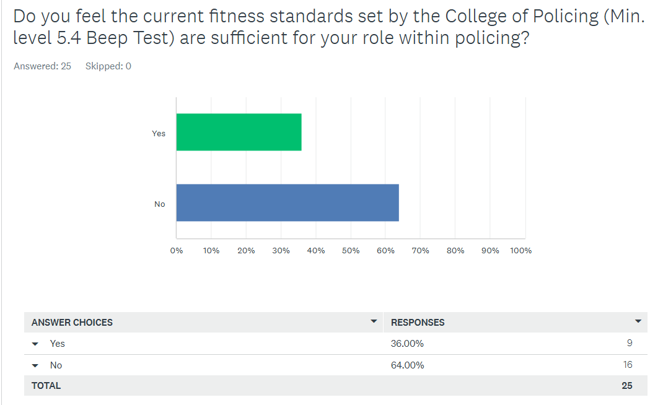
This data shows that 16 of 25 respondents, totalling 64%, felt that the current level of 5.4 on the beep test was not sufficient for their role.
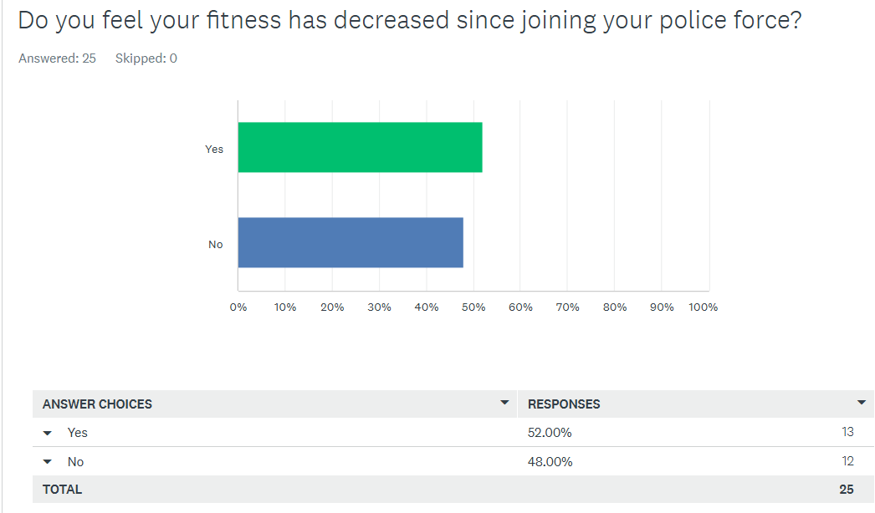
Only 52% of respondents felt that their fitness had decreased since joining their police force.
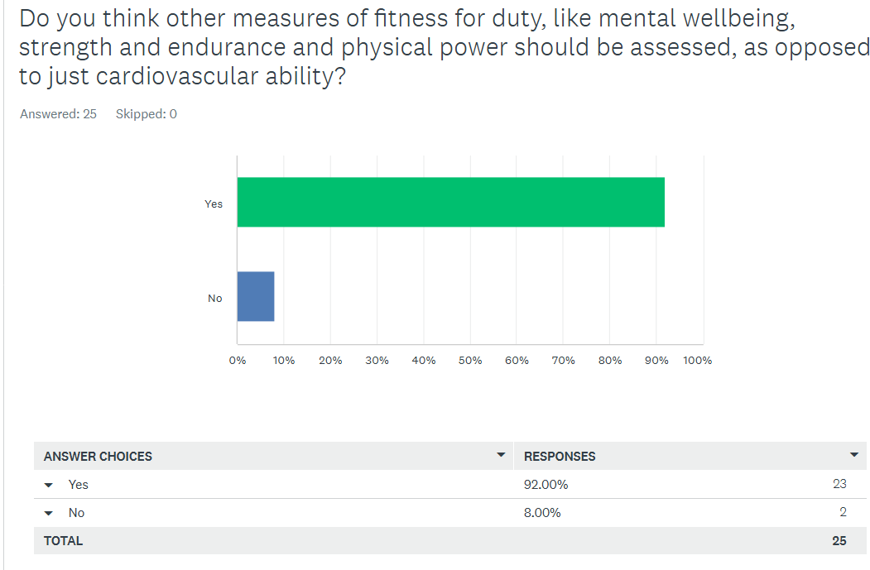
This survey result shows that 92% of participants thought that other measures of fitness, such as mental wellbeing, strength and endurance and physical power should be assessed, instead of just cardiovascular ability.

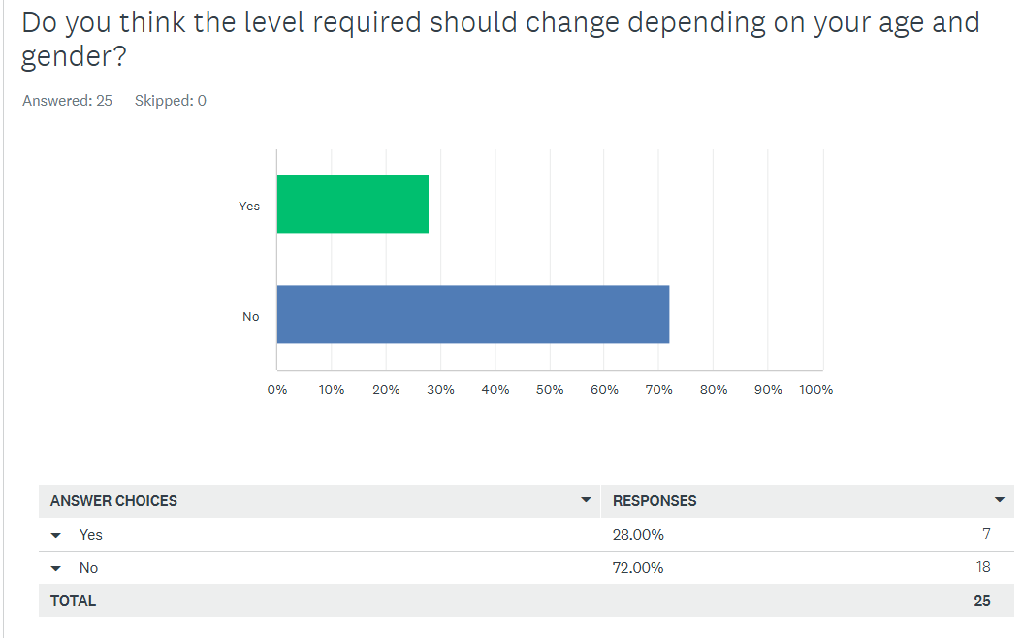
72% of respondents for this survey question felt that the level should not change based on age or gender.

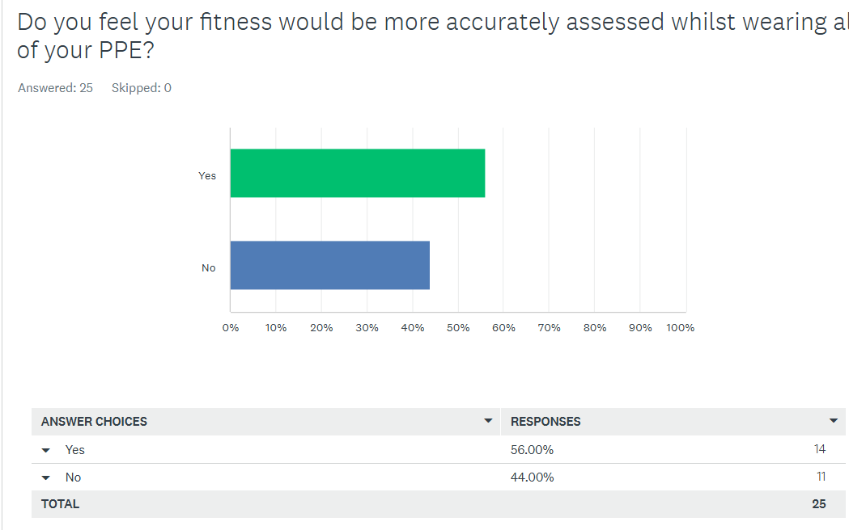This result shows that 56% of participants felt their fitness standards would be more accurately assessed whilst wearing all of their PPE.
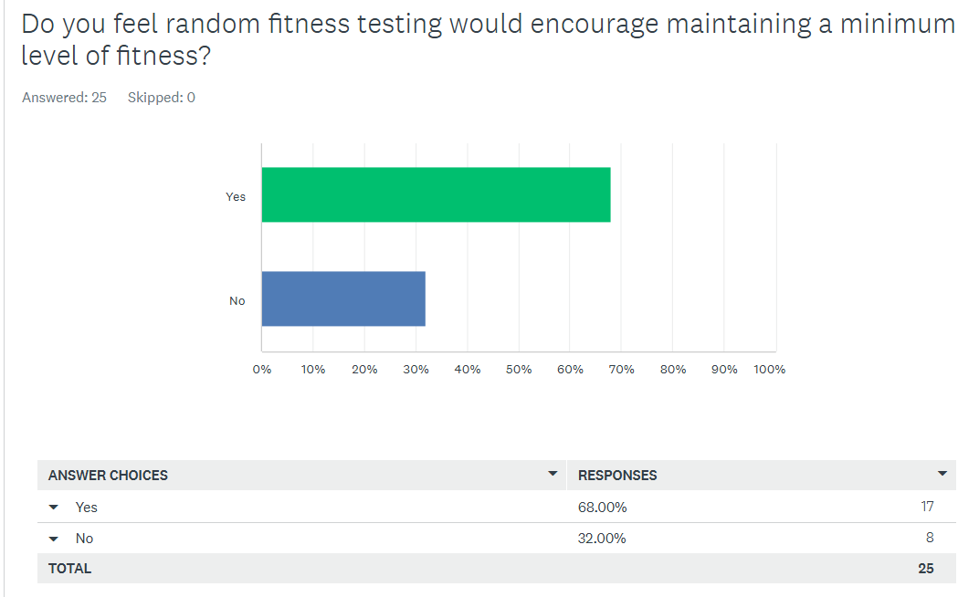
Sixty-eight percent of participants felt that random fitness testing would encourage maintaining a minimum level of fitness.

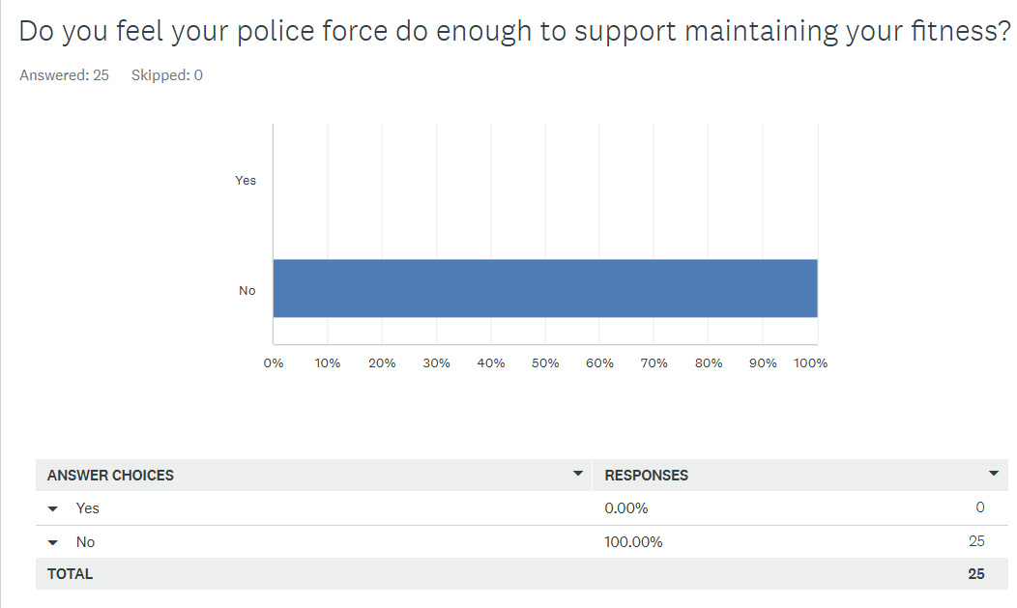
100% of respondents felt their police force do not do enough to support maintaining their fitness.

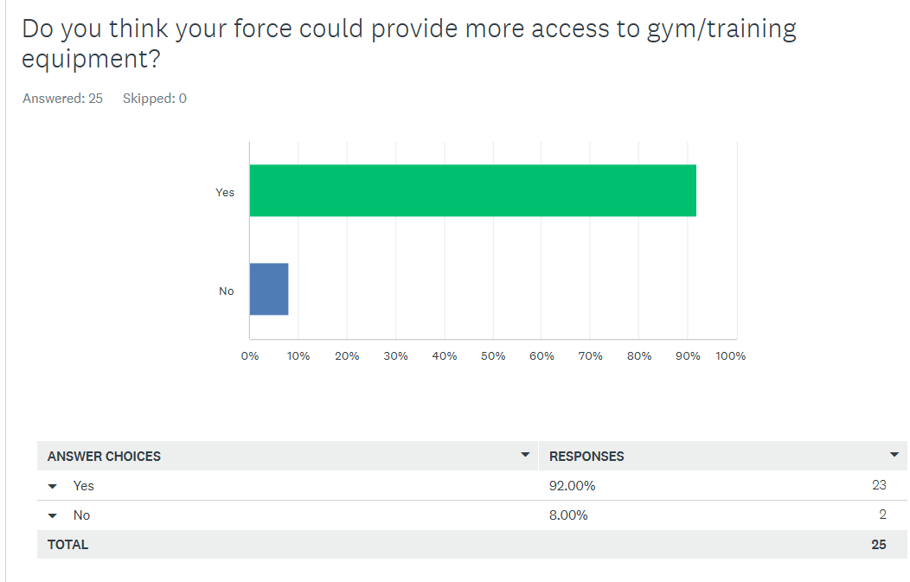
92% of participants thought that their police force could provide more access to gym and training equipment.

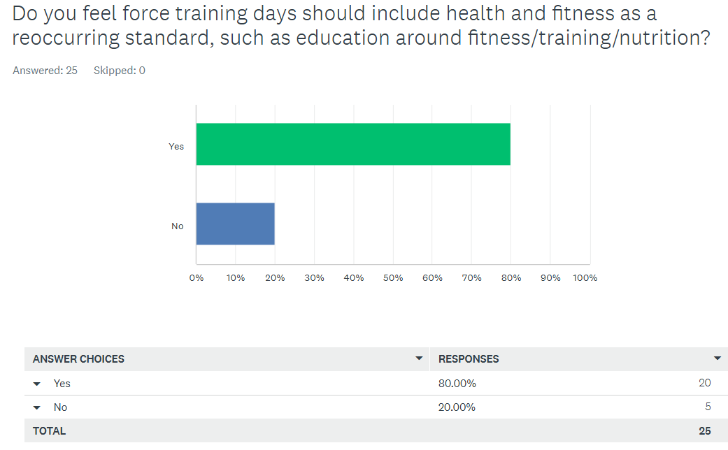

The survey result shows 80% of respondents felt that force training days should include health and fitness as a reoccurring standard, where education around fitness, training and nutrition is provided.

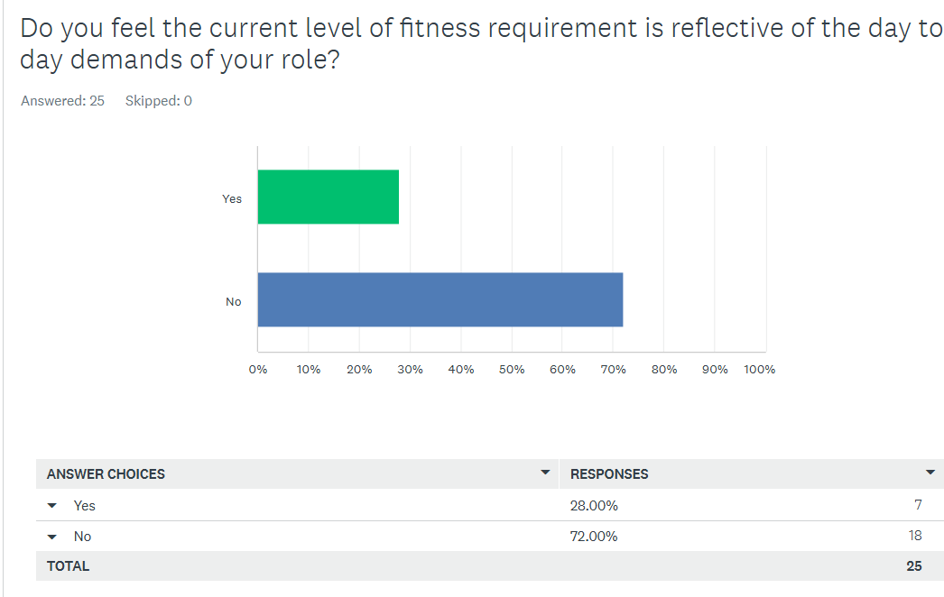
Seventy-two percent of respondents felt the current requirement for fitness standards was not reflective of their day-to-day role demands.

5.3 Discussion and Interpretation
Within the research, respondents were asked whether they felt their fitness had deceased since joining the force. Despite the literature from one study showing that only 27% of incumbent officers felt they would pass the same fitness test as upon recruitment, the result of the survey question surrounding a decrease in fitness showed a largely even split, with 52% making up the majority that felt their fitness had in fact decreased. This is almost double the figure established in the existing research.
The most unexpected finding of the survey is in relation to the 72% of officers who felt that age and gender should not change the minimum level of fitness. Though not directly addressed within this body of research, further research should be conducted to establish whether those opinions would change when presented with supplementary information about menstruation, pregnancy, menopause, and other age-related illnesses such as osteoporosis. This result suggests that respondents expect a one-size minimum standard, regardless of circumstances faced by individuals in-post.
In addition, despite the literature showing that modern-day policing is utilising new technologies, the findings of the research support that officers still feel they need to maintain a high degree of fitness, and this could be seen as making the testing more difficult, by adding more levels of competence. This could potentially offer a more professional perception of policing from the public, who literature shows are more likely to be scrutinising the profession.
Overall, the research findings show an emerging theme that constables and sergeants do not feel that there is an accurate reflection within the testing, nor is there enough support around their fitness, whether that be in the format of education or physical training activities and facilities. Each of the survey questions posed to participants strongly favoured that the force should do more to support the standards that are being expected from officers.

5.4 Conclusion
In summary the research, the data has shown that officers and sergeants based in South Wales Police think that the fitness test standards currently in place do not reflect the day to day demands of their job, nor are they reflective of the role. The research supports that there should be a review of the current fitness testing, with a view to overhauling the current test for something more real-world reflective, where all PPE is used, as well as including evaluations of strength, mental fortitude and physical power. In addition, amendments should be made to the policy to provide enough practical support and education around fitness and nutrition to ensure officers feel supported and are able to provide a professional appearance to the public for who they serve.
The implications of the research are that there has been no physical testing undertaken to further prove the findings and as such, this would provide some weakness to the argument that fitness is not up to current standards. This also means that due to financial restrictions on the research and a time limit, there is no comparison between the revisions being suggested and those currently in place to accurately assess the viability and likelihood of increased all-round officer performance. To conclude, there would be a significant cost implication to testing and implementation of new policy, and this would be at a cost to government budgets within policing.
934 words

Chapter Six – Recommendations
The research's conclusions, which emphasise that current police fitness standards might not adequately meet the physical demands of contemporary policing, are the basis for the recommendations made in this chapter. The suggestions are meant to improve officer performance and adjust the current fitness test.
Though it is acknowledged that completion of JFRT allows officers to participate in PPST, where engaging in mock physical confrontations will occur, the first recommendation within the chapter is that fitness standards should be updated to include more functional fitness tests that mimic real-world policing scenarios, such as carrying weights and engaging in strength-based activities like lifting or dragging, given the findings that current fitness assessments primarily focus on cardiovascular endurance. This would ensure that officers are physically fit enough to participate in PPST practice scenarios and allow the profession to be more equipped to handle the range of physical difficulties that may arise while doing their duties, such as restraint of suspects or handling of medical crises seen within major incidents. Organisations could then ensure that officers are prepared for the entire range of duties outlined in their job descriptions by expanding the scope of fitness evaluations, which will enhance public safety and officer safety.
The next recommendation would be that police forces and the relevant managing bodies adopt continuous fitness monitoring standards for officers throughout their careers in addition to updating initial fitness evaluations. Officers would maintain a baseline level of fitness and manage any potential reductions over time with the use of wellness support programs and regular fitness testing. Officers may then be encouraged to maintain their physical fitness throughout their employment by offering wellness incentives, fitness classes and workshops, or access to personal trainers and nutritional information. This preventive strategy lowers the chance of injury and improves long-term officer performance in addition to improving the general health of the police force.
The final recommendation would be that the relevant governing bodies embark upon research across the forty-three forces in England and Wales, interviewing and then discussing the opinions of those in front line roles about their expectations and needs for future fitness standards, to allow for accurate implementation of restructured guidance. Allowing for open dialogue should ensure that those in post are able to support adequately preparing new recruits for the realities of the role, in line with evolving policing techniques. These results should then be compared to standards set in other first world countries for refining and development, to meet or exceed the fitness expectations of the public to which officers serve.
To sum up, enhancing the general efficacy and wellbeing of police officers requires updating fitness standards to take into account actual policing situations, and putting in place continuous fitness monitoring. By implementing these suggestions, police organisations can create a more supportive and healthy work atmosphere while better preparing their officers for the physical demands of their jobs.
478 words

6386 words
Chapter Seven – Bibliography

Anderson, G., Litzenberger, R., & Plecas, D. (2002). Physical Evidence of Police Officer Stress. Policing An International Journal, 399-420.
Atkinson, G., Fullick, S., Grindey, C., & Maclaren, D. (2008). Exercise, energy balance and the shift worker. Sports Med.
Bissett, D., Bissett, J., & Snell, C. (2012). Physical agility tests and fitness standards: Perceptions of law enforcement officers. Police Practice & Research: An International Journal, 208-223.
Bissett, D., Bissett, J., & Snell, C. (2012). Physical agility tests and fitness standards: perceptions of law enforcement officers. Police Practice & Research, 208-223.
Boni, N. (2004). Exercise and physical fitness: The impact on work outcomes, cognition, and psychological well-being for police. Australasian Centre for Policing Research.
Canetti, E., Orr, R., Brown, W., Schram, B., Lockie, R., & Dawes, J. (2024). The Use of Musculoskeletal Fitness Measures as Indicators of Performance in Police Occupational Tasks. Internation Journal of Exercise Science, 819-830.
College of Policing. (2021, August). Implementation guidance for fitness testing. Retrieved from assets.college.police.uk: https://assets.college.police.uk/s3fs-public/2021-08/jrft-implmentation-guidance-2021.pdf
College of Policing. (2021a, January 18). Job-related fitness standards. Retrieved from www.college.police.uk: https://www.college.police.uk/support-forces/health-safety-welfare/job-related-fitness-standards
College of Policing. (2021b, January 18). Job-related fitness standards. Retrieved from www.college.police.uk: https://www.college.police.uk/support-forces/health-safety-welfare/job-related-fitness-standards#:~:text=Completion%20of%20the%20JRFT%20is,as%20part%20of%20their%20role.
den Hayer, G. (2024). Assaults on police officers: A comparison between England and Wales and New Zealand from 2015 to 2022. International Journal of Police Science & Management, 211-225.
Frick, K., Agostinelli, P., Swinford, J., Harris, M., Mobley, C., & Sefton, J. (2024). Age-Related Declines in Health and Fitness among Law Enforcement Officers Compared to Population Norms. Healthcare, Article 12(7).
GOV.UK. (2025, March 19). Police workforce, England and Wales: 31 March 2024. Retrieved from www.gov.uk/: https://www.gov.uk/government/statistics/police-workforce-england-and-wales-31-march-2024/police-workforce-england-and-wales-31-march-2024
Home Office. (2013, March 26). Police pay: Winsor review. Retrieved from www.gov.uk: https://www.gov.uk/guidance/police-pay-winsor-review#:~:text=Tom%20Winsor%20was%20asked%20to,powers%20and%20skills%20are%20required
Jang, T.-W. (2021). Work-Fitness Evaluation for Shift Work Disorder. Int J Environ Res Public Health.
Jarrett, T. (2011, December 05). Police pay and conditions: Winsor Review. Retrieved from commonslibrary.parliament.uk: https://commonslibrary.parliament.uk/research-briefings/sn06148/
Lockie, R., Dawes, J., Maclean, N., Pope, R., Holmes, R., Kornhauser, C., & Orr, R. (2020). The Impact of Formal Strength and Conditioning on the Fitness of Law Enforcement Recruits: A Retrospective Cohort Study. Internation Journal of Exercise Science , 1615–1629.
Lockie, R., Orr, R., & Dawes, J. (2022). Fit (and Healthy) for Duty: Blood Lipid Profiles and Physical Fitness Test Relationships from Police Officers in a Health and Wellness Program. Internation Journal of Environmental Research and Public Health, Article 19.
Low, N. (2024, October 25). Use of digital, scientific and other technologies by the police and wider criminal justice system. Retrieved from post.parliament.uk: https://post.parliament.uk/use-of-digital-scientific-and-other-technologies-by-the-police-and-wider-criminal-justice-system/#:~:text=crime%20prevention%2C%20for%20example%20predictive,HS56%20Cyber%20Crime%20and%20Harm).
Manser, A. (2019). Physiological responses during performance of the 15-metre Multistage Shuttle Run Test (15mMSFT), with reference to the Police Fitness Standards (Master's dissertation). Chester : University of Chester .
Massuça, L., Santos, V., & Monteiro, L. (2022). Identifying the Physical Fitness and Health Evaluations for Police Officers: Brief Systematic Review with an Emphasis on the Portuguese Research. Biology.
National Police Chiefs Council. (2023a). Fitness Testing Working Group – JRFT Results and Recommendation. Retrieved from www.npcc.police.uk: https://www.npcc.police.uk/SysSiteAssets/media/downloads/publications/disclosure-logs/npcc-central-office/2023/228-2023-session-02-jrft-app-a.pdf
National Police Chiefs Council. (2023b). Fitness Testing Working Group – JRFT Results and Recommendation. Retrieved from www.npcc.police.uk: https://www.npcc.police.uk/SysSiteAssets/media/downloads/publications/disclosure-logs/npcc-central-office/2023/228-2023-session-02-jrft-app-a.pdf
Police Federation. (n.d.). Shift Rota Management. Retrieved from www.polfed.org: https://www.polfed.org/support/fatigue/responsibilities/shift-rota-management/
Saunders, M., Lewis, P., & Thornhill, A. (2007). Research Methods for Business Students. In M. Saunders, P. Lewis, & A. Thornhill, Research Methods for Business Students (pp. 130-160). Harlow: Pearson Education Limited.
Simmons and Simmons. (2020, September 02). UK Court of Appeal finds facial recognition technology unlawful. Retrieved from www.simmons-simmons.com: https://www.simmons-simmons.com/en/publications/ckelg1z7p8kjt09008l0bet7c/uk-court-of-appeal-finds-facial-recognition-technology-unlawful
South Wales Police. (2023, April 05). Commitment to facial recognition technology reaffirmed as report finds tech does not breach equality requirements. Retrieved from www.south-wales.police.uk: https://www.south-wales.police.uk/news/south-wales/news/2023/ebr-apr/commitment-facial-recognition-technology-reaffirmed-report-tech-does-not-breach-equality-requirements/
Taylor, P. J. (2024). Policing Areas of Research Interest. Retrieved from science.police.uk: https://science.police.uk/site/assets/files/4138/npcc_policing_aris_report-1.pdf
U.S. Immigration and Customs Enforcement. (2025, February 06). Physical Fitness Test. Retrieved from www.ice.gov: https://www.ice.gov/careers/how-apply/physical-fitness-test#:~:text=PFT%20Requirements%20and%20Standards,minutes%2025%20seconds%20or%20less
Winsor, T. P. (2012). Independent Review of Police Officer and Staff Remuneration and Conditions. Norwich: TSO (The Stationery Office).

Chapter Eight – Appendices

Appendix 1 - Survey Questions
Do you feel the current fitness standards set by the College of Policing (Min. level 5.4 Beep Test) are sufficient for your role within policing?

Do you feel your fitness has decreased since joining your police force?

Do you think other measures of fitness for duty, like mental wellbeing, strength and endurance and physical power should be assessed, as opposed to just cardiovascular ability?

Do you think the level required should change depending on your age and gender?

Do you feel your fitness would be more accurately assessed whilst wearing all of your PPE?

Do you feel random fitness testing would encourage maintaining a minimum level of fitness?

Do you feel your police force do enough to support maintaining your fitness?

Do you think your force could provide more access to gym/training equipment?

Do you feel force training days should include health and fitness as a reoccurring standard, such as education around fitness/training/nutrition?

Do you feel the current level of fitness requirement is reflective of the day to day demands of your role?

Appendix 2 - Survey Response Graphs

Figure 1

Figure 2

Figure 3

Figure 4

Figure 5

Figure 6

Figure 7

Figure 8

Figure 9

Figure 10

