DS 1 Template

My Screenshots/Photos
- Please add 4–6 screenshots or photos of your digital life.
- You can use your phone or laptop.
- For each screenshot, write one or two sentences explaining what it shows.

Screenshot/Photo 1
[Insert Photo/Screenshot below]
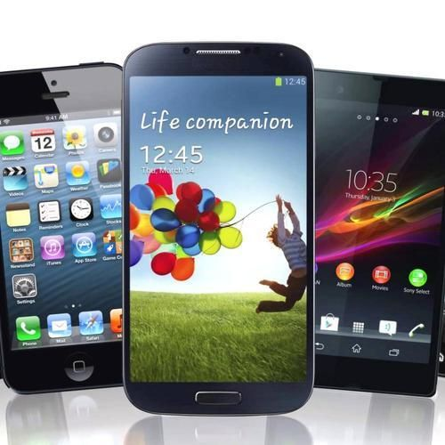
[Write what this shows of your digital life] mobile phone it make life easier and faster.
Make calls and send text messages
Use social media and messaging apps.
Take and share photo and videos.
Check emails and join online meetings.

Screenshot/Photo 2
[Insert Photo/Screenshot below]
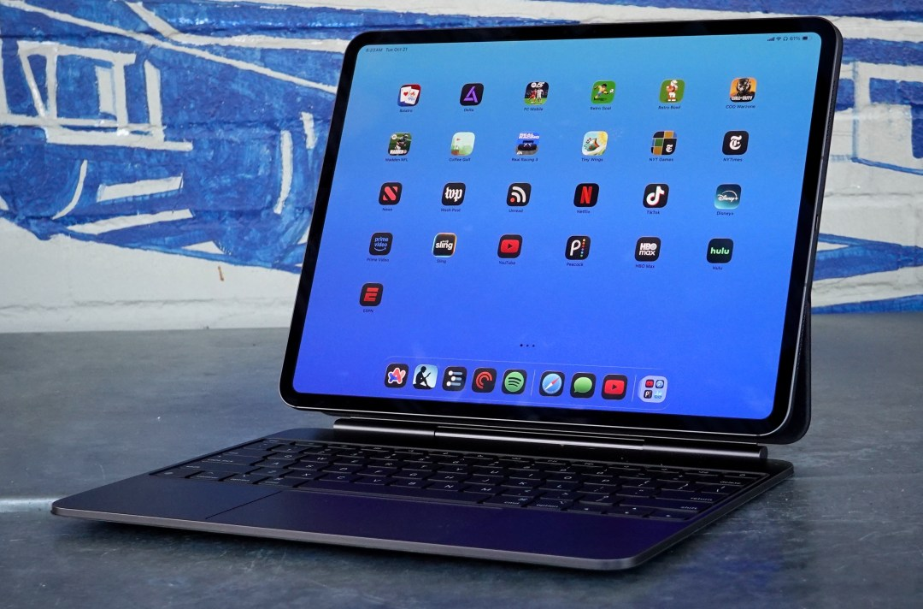
[Write what this shows of your digital life] I use apps for learning, creativity and productivity.
Attend online classes or virtual meetings

Screenshot/Photo 3
[Insert Photo/Screenshot below]

[Write what this shows of your digital life] and the Internet help us talk to people far away.

Screenshot/Photo 4
[Insert Photo/Screenshot below]
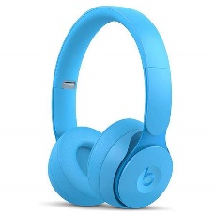
[Write what this shows of your digital life] listen to music podcasts, and audiobooks.
Join online classes meetings, or video calls.

Screenshot/Photo 5
[Insert Photo/Screenshot below]
[Write what this shows of your digital life]

Screenshot/Photo 6
[Insert Photo/Screenshot below]
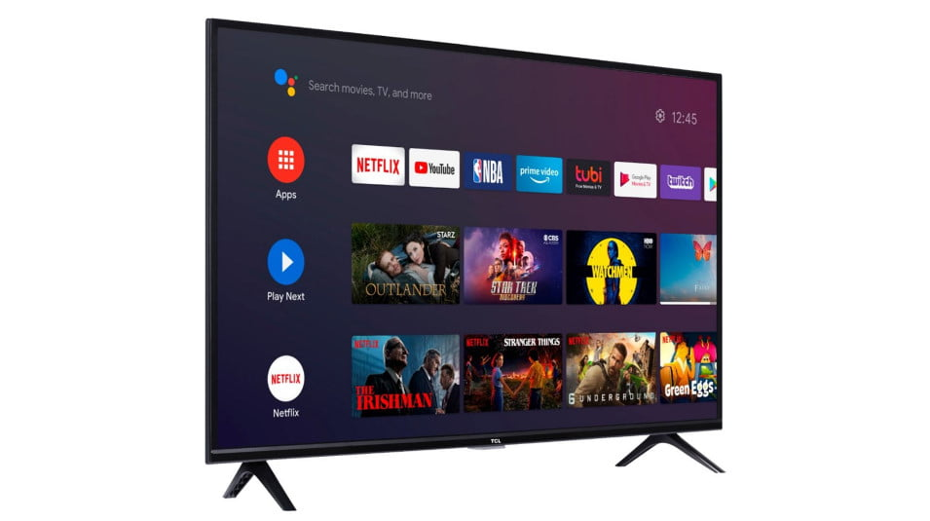
Connect with other smart devices in my home.
Access social media and online
I use voice commands for control the tv

My Short Reflection
- Write 5–8 simple sentences about your digital life.
- You can use the sentence starters below if helpful.
digital life has make many part of my life easier.
Mobile phone, laptop, smart tv, and earbuds help me communicate, learn, work, and enjoy entertainment. They allow me to stay connected with other people and quickly access information.

Sentence starters
- I use digital tools to …
- I feel confident when I …
- I want to improve …
- I often use these tools: …
- I sometimes feel nervous about …
- I hope this module will help me …
- Digital skills are important for me because …
You can write more if you want.

Submission Checklist
Before you submit, please check:
​​​ ☐ I added 4–6 screenshots
☐ I wrote short sentences for each screenshot
☐ I wrote my short reflection
☐ My work is my own
☐ My file opens correctly
​​☐ My file opens correctly

