MODULE CODE: BMIH5007
MODULE: FINANCIAL MANAGEMENT FOR THE HOTEL INDUSTRY

Assignment 1: Business Report -
Comparison of Two
Hospitality Organisations

Student Name:Ana Ivascu
Student ID number :2239390
Lecturer’s name :Tristan Hawkins

Table of Contents

Assessment 1 2
1.0 Introduction 2
2.0 Analysis and comparison of total Revenue generated by Shangri-La and Premier Inn 3
3.0 Comparative analysis of market positions of Shangri-La and Premier Inn 5
4.0 Comparative evaluation of growth potential of Shangri-La and Premier Inn 7
5.0 A comparison of financial commitment to CSR of Shangri-La and Premier Inn 8
6.0 Recommendation 9
7.0 Conclusion 9
References 10

Assessment 1
1.0 Introduction
Financial management is important in the hospitality industry as it directly affects operational efficiency, profitability, and sustainability. Effective financial strategies enable hotels to optimise resource allocations, and management costs and enhance revenue generation, ultimately contributing to long-term success (Seal, 2019). The study will differentiate between Shangri-La and Premier Inn within the hospitality sectors. Shangri-La operates in the luxury market, focusing on high-quality service and premium pricing, appealing to affluent travellers. On the other hand, Premier In targets the budget segment, emphasising affordability and value for money to attract cost-conscious guests. The study will compare their financial management strategies and practices.
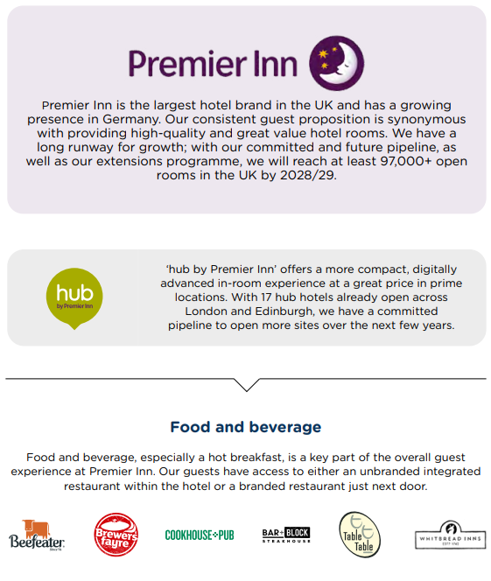  Figure 1: Premier Inn  (Source: Whitbread Plc, 2024) | 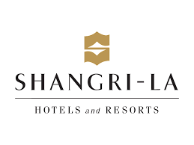  Figure 2: Shangri-La  (Source: Martinroll, 2018)

2.0 Analysis and comparison of total Revenue generated by Shangri-La and Premier Inn
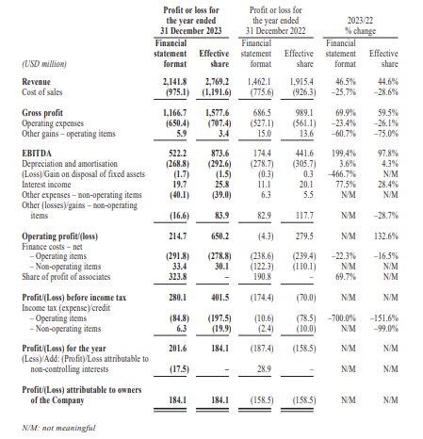
Figure 3: Consolidated statement of profit and loss of Shangri-La
(Source: Shangri-La Group, 2023)
In order to analyse and compare the total revenue generated by both hospitality firms., the first figure of the study depicts the financial statement of Shangri-La. In this figure, it has been illustrating that the revenue of Shangri-la has seen a monumental rise in FY23, in comparison to the revenue generated in FY22. To be specific, the revenue generated on 31 December 2022 was $1,462.1 million, which rose to $2,141.8 million on 31 December 2023.
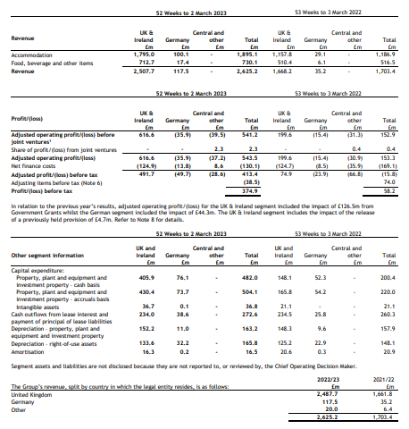
Figure 4: Consolidated financial statements of Premier Inn
(Source: Whitbread, 2023)
In comparison to the revenue generated by Shangri-la for the FY of 2022 and FY203, the revenue generated by Premier Inn shows a decline in revenue. Specifically, the revenue of Premier Inn UK as of 3rd March 2022 was £2,625.2 million, which on 2nd March 2023, has dipped to £2,507.7 million. In a comparison of the revenue generated by both firms, it can be noted that Shangri-La experienced a profit jump from $1,462.1 million in 2022 to $2,141.8 million in 2023. As per the article of Oh (2024), it has been noted that the main revenue source for Shangri-La is through the operations in the hotels and hospitality sector. As the travelling trends across Asia, and globally are changing, this has led the firm to widen their product offerable as well as holistically serve the guests.
On the contrary side, the revenue stream of Premier Inn is mainly through offering a range of hospitality products and services to its global consumer bases. The main revenue source of Premier Inn is accommodation services, along with the offers of food, beverages and other hospitality services. However, despite having a global presence and a wide spectrum of product offerings, the financial performance of Premier Inn dipped. The company saw a revenue decline from £2,625.2 million in 2022 to £2,507.7 million in 2023. However, over the current financial performance, Premier Inn has planned to increase its number of rooms by 25% by 2030 (O’Neill, 2024). The parent firm of Premier Inn, Whitebread has planned to fast forward the company’s growth plan in the UK, and Germany. In order to aid the growth plan, the leadership of Whitebread stated that it will convert around 112 restaurants which are not optimally performing, and make stays which can accommodate customers. This as a result will add around 3,500 new rooms in the network of Premier Inn.
3.0 Comparative analysis of market positions of Shangri-La and Premier Inn
Market position refers to the ability of the company to influence consumer perception regarding a brand and product relative to competitors. Associating a brand with specific attributes and benefits is crucial for differentiation in a competitive marketplace (CFI, 2024). Shangri-La and Premier Inn Hotels use unique product characteristics to align their offerings with customer expectations. Shangri-La Hotel emphasises luxury, elegance, and personalised services, appealing to high-end travellers seeking an exclusive experience, whereas the Premier Inn focuses on value and convenience, associating its brand with affordability and practicality. The hotel offers comfortable, clean, and well-equipped rooms at competitive prices, appealing to budget-conscious travellers.
Market share: In 2023 the Shangri-La has a notable market share in the luxury hotel sector, with over 100 properties across Asia, Europe, and the Middle East. The brand has been recognised for its distinctive blend of Asian hospitality and modern luxury that has differentiated it from competitors like Hilton (Martinroll, 2018). In contrast, Premier Inn operates in the budget segment and holds a significant market in the UK.
Brand perception: Premier Innis perceived it as a reliable and affordable option for budget-conscious travellers. The commitment of the brand is in providing value without compromising quality served to the customers (Whitbread Plc, 2024). Conversely, Shangri-La Hotels is perceived as a premium brand synonymous with luxury, elegance, and exceptional services.
Product or service price plays a significant role in brand perception. The position of the Shangri-La Hotels is at a premium point price, reflecting high-quality offerings and luxurious experiences (Shangri-La, 2023). However, Premier Inn adopts a competitive pricing strategy, ensuring affordability without compromising on quality. The brand offers promotions and discounts to attract price-sensitive customers.
Product quality: Shangri-La hotels provide luxurious facilities and top-notch dining experience. Whereas Premier Inn provides consistent quality across its location ensuring that customers receive a reliable and comfortable experience (Whitbread Plc, 2024).
Customer demographics: Shangri-La primarily attracts affluent travellers, including business executives, luxury vacationers, and high-net-worth individuals (Shangri-La, 2023). Premier Inn's target audience is diverse, encompassing families, business travellers, and budget-conscious individuals.
Both brands effectively position themselves against competitors. Shangri-La emphasises its luxurious offerings and personalised service to distinguish itself from other luxury brands, while Premier Inn highlights its affordability and value compared to other budget hotels.
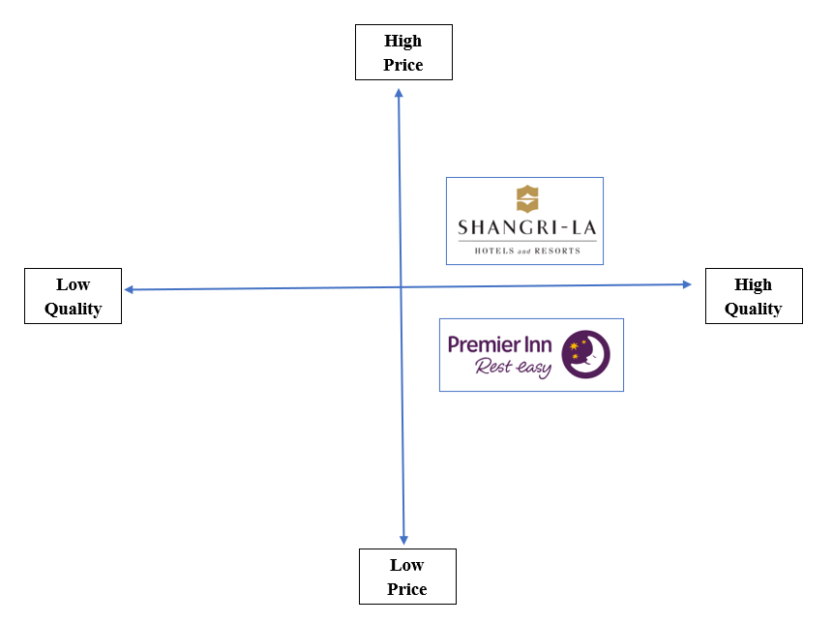
Figure 5: Market Positioning
(Source: Created by Learner)
4.0 Comparative evaluation of growth potential of Shangri-La and Premier Inn
Premier Inn is owned by Whitbread Plc. and it functions on a vertically integrated business model. This means that Premier Inn relies on ownership of property, hotel operations, and inventory distribution for expansion and growth (Whitbread, 2024). The expansion strategy of Premier Inn, however, does not involve franchising as seen by key competitors like Marriott International. Premier Inn operates over 850 hotels across different locations in the UK (Statista, 2024). However, the hotel chain has a scarce presence outside the UK. In 2016 and 2019 Premier established its presence in Frankfurt and Munich respectively (Premier Inn, 2024). Nevertheless, the expansion strategy of Premier Inn has remained largely confined to Germany and the UK. In comparison, Shangri-La, a premium hotel chain owned by Kuok Group, has explored over 22 countries, focusing on the Asia Pacific region (Shangri La, 2024). Unlike Premier Inn, Shangri-La has not stayed confined to a particular continent and has tapped into a wide variety of regions, such as the Middle East, Europe, North America, Africa, and Oceania. Comparing the expansion strategies of the two hotels, it can be said that Shangri-La has adopted a more rigorous approach towards international expansion while Premier Inn has preferred penetrating deeper into its domestic market.
As far as the market opportunities of Premier Inn are concerned, it can be said that the hotel chain can consider exploring the international market using franchising opportunities. Another striking contrast between the growth strategy of Shangri-La and Premier Inn is their difference in branding. For instance, Shangri-La has diversified its properties into four hotel brands namely “Shangri-La, Kerry Hotels, Jen by Shangri-La, and Traders” (Shangri La, 2024). Each of these brands represents different personalities, for example, Jen by Shangri La focuses on upholding the Asian cultures to its guests while Traders caters mainly to the business travellers. On the contrary, the Premier Inn hotel brand solely stands on its brand message “Good Night Guarantee” (Premier Inn, 2024). Despite these differences, it can be seen that the occupancy rate of Premier Inn has stayed well above 80% across its 800 properties over the past few years (Statista, 2024). On the contrary, the average occupancy rate of Shangri-La stood at a mere 60% across 100 hotels (Shangri La, 2023). The low occupancy rate can be considered as a potential barrier to further growth in the case of Shangri La.
As per a report published by Financial Times, the owner of Premier Inn mentioned that the ongoing labour shortages and inflation are two potential barriers to growth (Barnes, 2023). On the other hand, Shangri-La, which is focused on the Asia Pacific group, can face competition from other industry leaders like Hilton. According to Burgos (2022), Hilton has adopted a vigorous expansion strategy to the Asia Pacific region, planning to double its footprint in the region over the next few years. This means that the competition in this region is expected to increase which is deemed to be a potential barrier to Shangri-La’s growth.
5.0 A comparison of financial commitment to CSR of Shangri-La and Premier Inn
Premier Inn has developed a comprehensive corporate social responsibility (CSR) strategy, namely the “Force for Good” (Premier Inn, 2024). Under this strategy, the company has allocated a good amount of funds to different CSR initiatives. For instance, Premier Inn has spent £504 million to issue green bonds under its sustainability strategy (Whitbread, 2023). The green bond is meant to support green development, operation and procurement. Furthermore, Premier Inn has also allocated £234 million for the purpose of green construction which, in turn, has helped the company curb nearly 64,810 tonnes of greenhouse gas emissions (Whitbread, 2023). In addition to Premier Inn’s commitment to environmental sustainability, the company is also committed to philanthropy. Premier Inn has been a partner of the GOSH charity since 2012 and has donated a total of £23 million to the charity so far (Premier Inn, 2024). On the other hand, Shangri-La has developed a “Sanctuary” through which Shangri-La aims to preserve the valuable habitats of exotic species (Shangri-La, 2024). For this purpose, Shangri-La donated a total of 1.6-hectare land to promote conservation of Pandas. Moreover, the company has allocated a significant amount of budget to implement its “Triple S” sustainability policy. The company has mobilised a budget to establish sustainable properties, ensure sustainable procurement and organise community development programmes. Therefore, it can be seen that the financial commitments of Shangri-La are quite wholesome, touching upon different aspects of sustainability, such as people, planet, and profit. On the other hand, the CSR strategies of Premier Inn mainly focus on philanthropy and curtailing the environmental footprint on the company. Both the companies are committed to achieve “Net Zero” status 2050 which means both companies would have to commit a fair share of its budget to curtailing carbon emissions.
6.0 Recommendation
After analysing the different aspects of Shangri-La and Premier Inn, the following recommendations can be framed to boost growth.
- International Expansion: Premier Inn has already developed a strong foothold in the UK hotel industry. However, as far as globalisation is concerned, Premier Inn has confined itself to the UK and Germany. Therefore, Premier Inn can consider tapping to the potential international market using strategies like franchising and licensing. Franchising is a mode of international expansion whereby a franchisor sells the rights to use their brand name, business model, and services to a franchisee (Alon et al., 2021). Franchising is a proven strategy for international expansion which has facilitated key hospitality companies like Marriott International to expand globally. Furthermore, according to Alon et al. (2021), franchising involves less risks as compared to other modes of international expansion. Therefore, Premier Inn can consider tapping into the potential of the international market through franchising.
- Dynamic Pricing Strategies: Dynamic pricing strategy refers to the process of adjusting room rents with changing demands, competitor pricing, and other market conditions. From the above discussion, it has been found that Shangri-La emphasises on providing its guests with a luxurious and personalised stay experience. In contrast, Premier Inn is perceived as a reliable and affordable hotel chain. As a result, the average occupancy rate of Shangri-La stands at a mere 60% whereas that of Premier Inn is above 80%/. In order to raise the average occupancy rate, Shangri-La can consider adopting a dynamic pricing strategy like Premier Inn.
7.0 Conclusion
In conclusion to the aforementioned section of the study, it can be summarised that the brand portfolio of Premier Inn and a limited presence in the UK and Germany have led the firm to tap a limited number of customers. Contrarily, the financial performance of Shangri-La has seen a significant incline, mainly due to the operations in the hospitality sector and offering properties for sale and more. This gives a widened scope for Shangri-La to enhance its profit revenue.

References
Part A
Alon, I., Apriliyanti, I.D. and Henríquez Parodi, M.C., (2021). A systematic review of international franchising. Multinational Business Review, 29(1), pp.43-69.
Barnes, O. (2023). Premier Inn owner says inflation and labour shortages offer ‘growth opportunities’. [online]. Available at: <https://www.ft.com/content/e4c6f668-cfeb-466a-8db9-3e68d49612f5> [Accessed on: 15th October 2024].
Burgos, J. (2022). Hotel Chains From Hilton To Shangri-La Are Expanding Across Asia On Post-Pandemic Recovery Hopes. [online]. Available at: <https://www.forbes.com/sites/jonathanburgos/2022/04/18/hotel-chains-from-hilton-to-shangri-la-are-expanding-across-asia-on-post-pandemic-recovery-hopes/> [Accessed on: 15th October 2024].
CFI, (2024). Market Positioning [Online]. Available at: <https://corporatefinanceinstitute.com/resources/management/market-positioning/> [Accessed on: 15 October 2024]
Martinroll, (2018). Shangri-La Hotels and Resorts – Bringing Asian Hospitality To The World [Online]. Available at: <https://martinroll.com/resources/articles/asia/shangri-la-hotels-resorts-bringing-asian-hospitality-to-the-world/> [Accessed on: 15 October 2024]
O’Neill, S. (2024). Premier Inn to Grow Hotel Room Count by 25% Before 2030. [online] Available at: https://finance.yahoo.com/news/premier-inn-grow-hotel-room-181728239.html?guccounter=1&guce_referrer=aHR0cHM6Ly93d3cuZ29vZ2xlLmNvbS8&guce_referrer_sig=AQAAAEweTBk9ZGscKeMHIyAyXnGnrDc4AKMLFPdHt2207BWR0MNcpebQe-VR2vJjl0qQLMDftxhlgHL7ZWjaXxqbeXAzvwhrdwmOjtTqAfGCGsvK7TpMAJ8afIautIIgNeD_i83ypeWSE80N96cslPzKme-QgmA0barnrOEy68_p1OTQ. [Accessed on: 15th October 2024].
Oh, T. (2024). Shangri-La Asia returns to black in FY2023 with US$184.1 million net profit. [online] The Business Times. Available at: https://www.businesstimes.com.sg/companies-markets/shangri-la-asia-returns-black-fy2023-us-184.1-million-net-profit. [Accessed on: 15th October 2024].
Premierinn, (2024). Good Night Guarantee| Sleep. [online]. Available at: <https://www.premierinn.com/gb/en/sleep/good-night-guarantee.html> [Accessed on: 15th October 2024].
Premierinn, (2024). International Development. [online]. Available at: https://www.premierinn.com/gb/en/business/international-development.html [Accessed on: 15th October 2024].
Premierinn, (2024). Supporting Great Ormond Street Hospital Children’s Charity. [online]. Available at: <https://www.premierinn.com/gb/en/why/gosh-childrens-charity.html> [Accessed on: 15th October 2024].
Seal W (2019) (6th Ed) Management Accounting, London, McGraw Hill.
Shangri-La Group (2023). 2023 FINAL RESULTS ANNOUNCEMENT. [online] Available at: https://sitecore-cd.shangri-la.com/-/media/Project/Shangri-La-Group/Investor/Files/Public-Disclosures/Latest-Top-Publications/2024-03-22-Final-Results-Announcement_E.pdf. [Accessed on: 15th October 2024].
Shangri-la, (2023). Shangri-La Group Releases 2023 Interim Results. [online]. Available at: <https://www.shangri-la.com/group/media/media_post?post=Aug30_2023InterimResults> [Accessed on: 15th October 2024].
Shangri-la, (2024). About Shangri-La. [online]. Available at: <https://www.shangri-la.com/group/our-story/about-shangri-la> [Accessed on: 15th October 2024].
Shangri-La, (2023). Annual report 2023 [Online]. Available at: <https://sitecore-cd.shangri-la.com/-/media/Project/Shangri-La-Group/Investor/Files/Public-Disclosures/Latest-Top-Publications/2023_Annual_Report_E.pdf> [Accessed on: 15 October 2024]
Statista, (2024). Premier Inn hotel room occupancy rates in the UK and Ireland 2011-2024. [online]. Available at: <https://www.statista.com/statistics/739831/premier-inn-hotel-occupancy-rates/> [Accessed on: 15th October 2024].
Whitbread (2023). FY23 Results Premier Inn UK drives significant profit uplift versus FY22 and FY20 Strength of operating model underpins long-term growth opportunities in UK and Germany Increased dividend plus £300m share buy-back in H1 FY24. Available at: https://cdn.whitbread.co.uk/media/2023/04/Final-FY23-RNS-Final-Combined.pdf. [Accessed on: 15th October 2024].
Whitbread Plc, (2024). Results, reports and presentations [Online]. Available at: <https://www.whitbread.co.uk/investors/results-reports-and-presentations/> [Accessed on: 15 October 2024]
Whitbread Plc, (2024). Whitbread PLC Annual Report and Accounts 2023/24 [Online]. Available at: <https://cdn.whitbread.co.uk/media/2024/05/Whitbread-PLC-Annual-Report-and-Accounts-2023_Single_pages-1.pdf> [Accessed on: 15 October 2024]
Whitbread, (2023). Environmental, Social and Governance Report 2022/23. [online]. Available at: <https://cdn.whitbread.co.uk/media/2023/07/Whitbread_ESG_Report_2022.pdf> [Accessed on: 15th October 2024].
WhiteboardPlc, (2024). Our business model and strategy. [online]. Available at: <https://www.whitbread.co.uk/about-us/our-business-model/> [Accessed on: 15th October 2024].
Declaration
I confirm that I have not used any AI tools in the research and creation of this
assignment. I confirm that I have not presented any AI generated materials as my own
work. I confirm I have copies of my drafts, notes, and other resources I used, which I
may be asked to provide in evidence. However, I have used Grammarly to correct the grammatical mistakes in the study.

