

A Comprehensive Guide to Virtual Private Networks (VPNs)

by
Scott Marshall Jones

Supervisor: Kapilan Radhakrishnan

Project submitted as part of the requirements for the award of
BSc (Hons) Computer Networks and Cybersecurity

April 2021

DECLARATION

I, Scott Marshall Jones declare that I am the sole author of this Project; that all references cited have been consulted; that I have conducted all work of which this is a record, and that the finished work lies within the prescribed word limits.

This work has not previously been accepted as part of any other degree submission.

Date: Thursday 22nd April 2021

FORM OF CONSENT

I, Scott Marshall Jones hereby consent that my Project, submitted in candidature for the B.Sc.(Hons) Computing (stream) degree, if successful, may be made available for inter-library loan or photocopying (subject to the law of copyright), and that the title and abstract may be made available to outside organisations.

Date: Thursday 22nd April 2021

DECLARATION 2
FORM OF CONSENT 2
Chapter 1 – Introduction 5
1.1 Introduction 5
1.2 Aim 6
1.3 Objectives 7
1.4 Project Structure 7
Chapter 2 – Research and Review of Literature 8
2.1 Introduction 8
What is a Virtual Private Network? 8
Types of VPN 8
Advantages of Using a VPN 9
Issues Related to VPN 9
Layout 11
Related Work 15
The research of VPN on WLAN – W. Huang, F. Kong [10] 15
Study on the Application of VPN Technology Based on IPSec in the Modern Universities – J. Lu, C. Dong [11] 16
A Comparative Research on SSL VPN and IPSec VPN – H. Mao, L. Zhu, H. Qin [12] 17
Literature Comparisons 18
2.6 Conclusion 18
Chapter 3 – Research Methodology 19
3.1 Introduction 19
3.2 Research Overview 19
3.2.1 Research Process 20
3.2.2 Research Philosophy 21
3.2.3 Research Methodologies 21
3.2.4 Data Collection 22
3.3 Research Design 23
3.3.1 Research Deliverables 23
3.3.2 Project Management 23
3.5 Conclusion 27
Chapter 4 – Design and Implementation 28
4.1 Introduction 28
4.2 Problem Formulation 28
4.3 Design 29
4.4 Implementation 32
4.5 Conclusion 32
Chapter 5 – Testing and Evaluation 33
Introduction 33
Connections and Speeds 34
Test 1 – The Netherlands 34
Test 2 – Japan 38
Test 3 – USA 42
Average Speed Results 46
Complications 47
VPN Recommendations 48
Chapter 6 – Conclusions and Recommendations 49
6.1 Conclusion 49
6.3 Recommendations for Further Research 50
Chapter 7 – Reflections 51
Chapter 8 – References 52

Chapter 1 – Introduction

Introduction
In a world where technology is constantly getting more advanced, and the internet is virtually everywhere, online security is something that most users take for granted. It is almost as if it is expected when browsing the internet, but the truth is it is very easy for your average user to be exploited if they are not being careful in what they are doing. Virtual Private Networks (VPNs) are used to create secure connections to the internet. They ensure security and privacy whilst being connected to the internet, or at least they advertise themselves that way. There are many different VPNs available for people to use, they come at different costs and each have their own advantages and disadvantages. This report will take some of the most popular VPN services available to the public, compare their prices and features.
It is important to understand that there is not really a way you can be 100% secure on the internet. Somewhere out there, there is someone who has the knowledge and resources that enables them to find out the identity of the user. That is why it is key for the VPN to protect that identity should somebody be targeted. Obviously, this could be used in a bad way as well, since people using VPNs are hard to trace, this could increase the likelihood of cybercrime occurring as people may believe there is smaller chance, they would get caught.
The whole idea of VPNs revolves around security on the internet, and there are lot of VPNs available in different shapes and sizes (features and prices). Will the more expensive VPNs be faster than the cheaper ones? That is just one of the questions that will be answered.
In order to measure the speed (estimated), each test must be connected to the same server for each VPN. For example, if the first VPN is connected to Istanbul, the second one must be connected to the closest server to Istanbul. Different VPNs offer different servers so there would need to be matching servers in each test otherwise it would be greatly unfair. The further away the server is to the user, the slower the connection would be. It would be best to test the internet before connecting to the VPN to get a base speed and then connect to see what the difference is and work it out as a percentage. These percentages would then be compared across different VPNs at different price points to see if the more expensive ones are faster or slower. It may be that the more expensive ones are slightly slower but have greater security since security and privacy is promised the most when advertised.
It would also be a good idea to test the VPN in different locations instead of just the one. For example, if the first test were in Istanbul, it would be good to test servers that are further away like Tokyo to see what the speed decrease is for each different VPN. Doing 4-5 different locations for each VPN would be a good place to start.
There are a few ways a user can test the security of the VPN they are using. The most common leaks from VPNs are an IP Leak, DNS Leak and WebRTC Leak [1]. The most basic test is to find your original IP address without being connected to the VPN, then connect and perform the same test to ensure you get a different IP address. This would show if the VPN were working or not. If you get the same IP address twice, then the VPN is either not configured properly or is leaking the IP address (which is the exact opposite of what it is supposed to do.

Most VPNs offer a free service where the user can use the VPN for very limited time each day just to get a feel for what they pay for. Also, the speed of the VPN is essential for everyday users. It is s common for webpages to load up within the first second or two seconds of the link being clicked; and people have gotten so used to this that it is always expected. VPNs essentially slow the internet connection down to be able to connect it to the secure server. When using the VPN, you are connected to a remote server via an encrypted tunnel which secures the data [2] making it very difficult to find the original source IP address.

Aim
The aim of this project is to compare different features at different price points and determining whether people are receiving the service that has been advertised by each company providing the VPN.

Objectives
The main objectives of this project are to test different VPN speeds and security. The objectives are as follows.
- Comparative Study on Existing VPNs to better understand how internet speeds are affected.
- Explore Strengths and Weakness Within the VPNs to find if the price point is worth it.
- Analyse VPN Connections (and what to test) and
- Analyse the Test Results and Compare them
- Come to a Conclusion.
- Review Other Studies and compare them to each other.
- The Authors Recommendations on what is the best VPN for a new user (of those tested).

Project Structure
This report is structured in different sections. The first chapter is the Introduction. This chapter sums up the entire report and gives the reader a brief understanding on what to expect the report to cover. The introduction also covers the aims and objectives off the report. The next chapter is the Literature Research section. The section is to compare literature or similar research and review it. This reviewed literature will then be compared with each other, checking sources and trying to find anything that could be done to maybe improve the research.
Chapter 3 talks about different types of research, including methodology, design and a handful of others. The next chapter uses the information gathered in the literature review section for the design and implementation of the report. Chapter 5 is for testing and evaluation where any test results will be analysed and talked about. The final chapter covers the main conclusion and any recommendations the writer has in the specific area covered in the report.

Chapter 2 – Research and Review of Literature

2.1 Introduction
The beginning of this chapter will go in-depth about Virtual Private Networks (VPNs). This includes what they are exactly, how they can be obtained, any advantages and disadvantages that are included and different types of VPNs.
When conducting research, it is important to look at the work of various authors covering similar topics. It is interesting to see what others have discovered whilst carrying out their own research. It is also important to ensure that when you are carrying out your own research, that you are not getting the exact same results as somebody else who has also researched the chosen topic. In this chapter, the writer compares literature available to the public and reviews it, giving their own opinion and what they believe could be changed. There will also be a comparison section where the writer compares different research pieces with each other, to see the different methods used by the authors of each report. There are multiple advantages of doing this, the main one being able to identify the different research methods to incorporate into your own work.

What is a Virtual Private Network?
A Virtual Private Network provides privacy and anonymity when using the internet by creating a private network from a public network connection [3]. There are multiple different types of VPNs and Protocols that can be used, each having their own advantages and disadvantages. It is important you use a protocol that best suits the user. Most VPNs don’t allow the users to change the protocol that the VPN uses, this is usually only an option for somebody that configures their own VPN.

Types of VPN
Protocols aside, VPNs have three main types:
- Remote Access
- Intranet Based
- Extranet Based
The average user using a VPN in their home would use a Remote Access VPN whilst most businesses would implement their own Intranet or Extranet VPN [4].

The most popular type of VPN is the Remote Access. This is what most home users would use if they would like to browse the internet safely. A remote access VPN would connect the user to a secure server anywhere in the world (that the VPN allows) and encrypts the data so it cannot be accessed by a third party.
The Intranet and Extranet based VPNs are like each other, just for different types of networks. These allow multiple users to access each other’s resources by connecting them to the same network [4]. These are mainly used in big businesses.

Advantages of Using a VPN
The biggest advantage of using a VPN is the privacy and security. When a VPN is advertised, the main feature that is being advertised in 99% of cases is the security. Since the data is encrypted, even if somebody manages to gain your information it would be completely useless to them. Although this is the biggest advantage, there are many more that are not usually talked about as much.
A VPN allows you to essentially change the location of the user’s device and connection. There are some websites and media outlets that only allow the user to view specific data if they are in a specific location, they can also blacklist countries from seeing things. This is where a VPN can become even more useful. If you cannot access the data from the United Kingdom but you can from France for example, you are able to VPN into a server in France and suddenly the data becomes available. Since your data is being routed through a server in France, the website believes that that is where the user is located.

Issues Related to VPN
A VPN seems essential if people would like to ensure safety whilst using the internet, however there are a handful of disadvantages as well. Even though security and anonymity are an advantage, it could also be a disadvantage. Since it can be difficult to find someone’s identity if they are using a VPN, this means that this feature can also be exploited by users with malicious intentions. Another big downside of using a VPN is the loss of internet speed. Mainly when a user uses a Remote VPN, they will see a drop in their internet speed. This happens because the data gets encrypted for protection purposes. This is one of the many ways that the internet can slow down [5]. Another big factor is what server the user is connected to. It seems that the further away the server is from the user, the slow the internet speed would be. The increased distance always increases the ping, or the signal that is sent from the host machine.
Alongside with a reduction on internet speed, the internet in general can sometimes not be as reliable when connected to a VPN. The user may occur sudden connection drops where they are temporarily disconnected from the server, thus revealing their real IP-address. This is a major disadvantage. A smaller disadvantage is the subscription cost. Most users that are aware of how important cyber security is would not mind paying a small fee every month in order to stay protected online. However, a less experienced person could argue against it believing the likelihood of them falling victim of a cyber-attack is so low that there is no need for them to subscribe to a VPN. Yet these are always better targets for any users with malicious intents. Another disadvantage is that sometimes popular browsers can stop the user from browsing the internet since it is detecting unusual traffic from that network. This requires human authentication to be allowed to search, this can be annoying if it happens every time the user wants to search something.

Layout
A good table to compare VPN connections would look as followed.
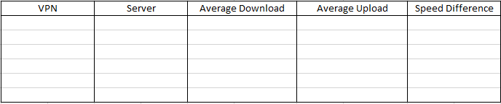
VPN | Server | Avg. Download  (Mbps) | Avg. Upload  (Mbps) | Speed Difference  (Download)
No VPN | N/A | 61.35 | 37.42 | N/A
VPN No.1 | Japan | 48.93 | 15.85 | -12.42
VPN No.2 | Japan | 45.53 | 13.90 | -15.82
VPN No.3 | Japan | 47.61 | 12.45 | -13.74

This table shows the VPN name, which server it is connected to, and the speed that the VPN gives on that specific server. By organising the table like this, it shows the reader all the data they need to see about the connection’s speeds on specific VPNs. It is also a very basic table but includes almost everything the average user would need to know before being able to choose. Different servers would also have different speeds, and it is important to establish which server the VPN is connected to so there are no unfair results. It would be important that there are a couple of different tests for each VPN and server so the table would contain the average result from the tests. The reason for this is to avoid anomalies. For example, if you ran only one test, and for that test a family member was using a lot of internet elsewhere in the house, then it could significantly slow down the internet connection leading to an unfair result. Internet essentially comes in two different parts, upload and download. Download is how fast you can download any form of data from a web server, whilst upload is how fast you can send information to said server [6] (measured in megabits per second (mbps)).
The author personally uses NordVPN, although there are many different VPNs that some people would argue are better. NordVPN is amongst the most popular VPN services. Below is a table showing different VPN connection speeds gathered by a Cyber Security researcher [5]. This table is specific to NordVPN.
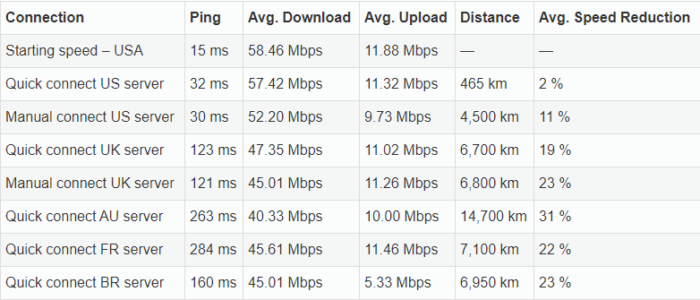
Elly Hancock – Cybersecurity Researcher [7]
This table is set out well, it also includes ping and distance over the authors generic table earlier. This table also includes either a quick connect or a manual connect to the server. For those who do not know, using a VPN connects to a different server in different parts of the world. When the VPN is open, it gives the user a chance to either manually choose the server they connect to or give them another option called ‘Quick Connect’. For this the VPN tries to decide which server would be best for the user to connect to, and automatically connect to that server. It is also useful to display the ping, or latency, in the table. This is essentially how long it takes for a data packet to go from the device to the server and back to the device. Generally, the lower the ping, the faster the internet speed.

As previously mentioned, figures and graphs provide an easy to read visual on specific data captured in a table. Although tables are good themselves, a graph would always be easier to read and understand (if that graph is well made). A web article containing results from multiple different speed tests has a comprehensive tool that allows users to check different VPN speeds and have a table/graph comparing them made in an instant. The webpage allows you to select different VPN providers, select the to/from servers and instantly gives you a table with percentage differences for upload and download speeds, along with a graph for visual representation [8].
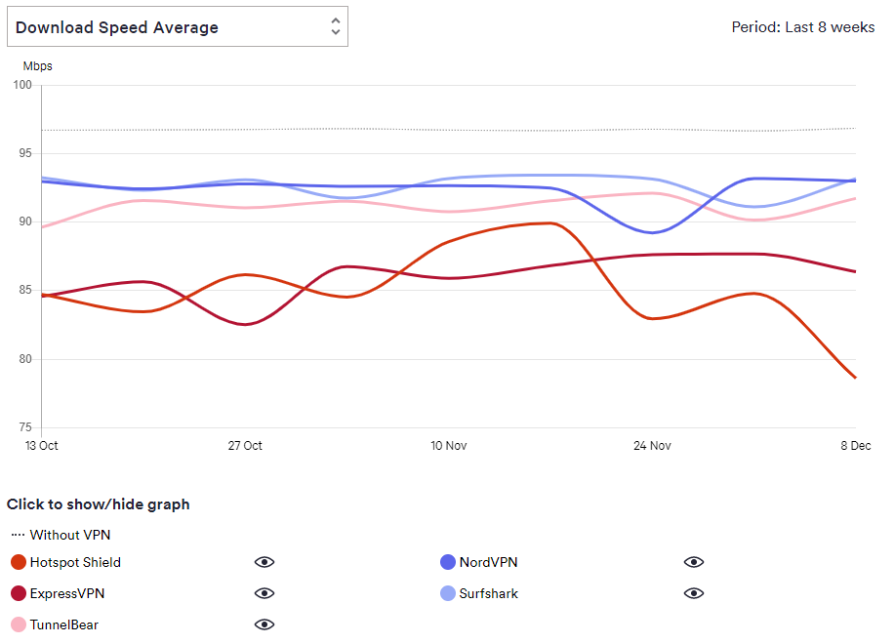
Taken from Webpage, Authored by JP Jones & Callum Tennent [8]
This is one of the graphs using the tool that is found on the webpage, it allows you to choose which VPN speeds you want to compare and compares them. There is no way to really judge the accuracy of these graphs, yet for the average user to wants to know which VPN provides the best performance, this tool would be more than enough.
The servers include:
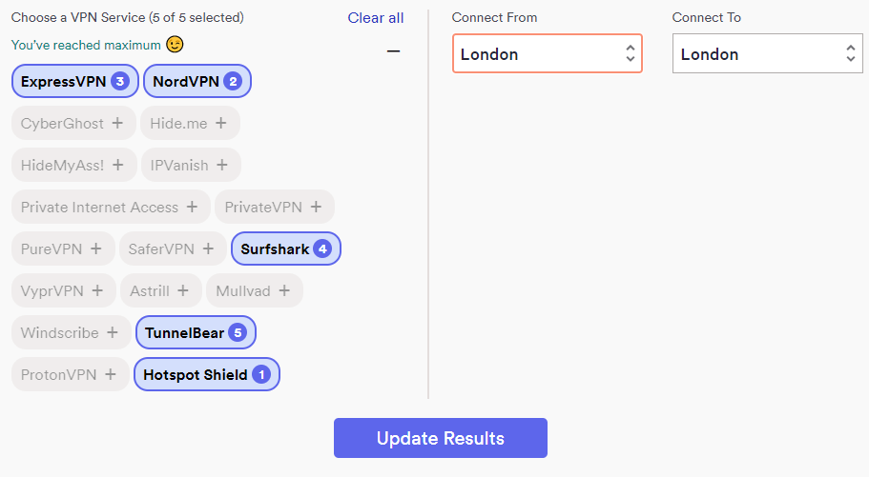
- Amsterdam
- Frankfurt
- London
- New York
- Paris
- San Francisco
- Singapore
- Sydney
- Tokyo
- Toronto
- Vancouver
Taken from Webpage, Authored by JP Jones & Callum Tennent [8]
It is unknown to the author at the current time who created this tool, that knowledge may help to understand the accuracy of it. Although, the 2 authors of the webpage are well credited, JP Jones having over 25 years in Software Engineering, and Callum Tennent being a member of IAPP featuring in Forbes and the Internet Society. More about the authors can be found at the top of the webpage.
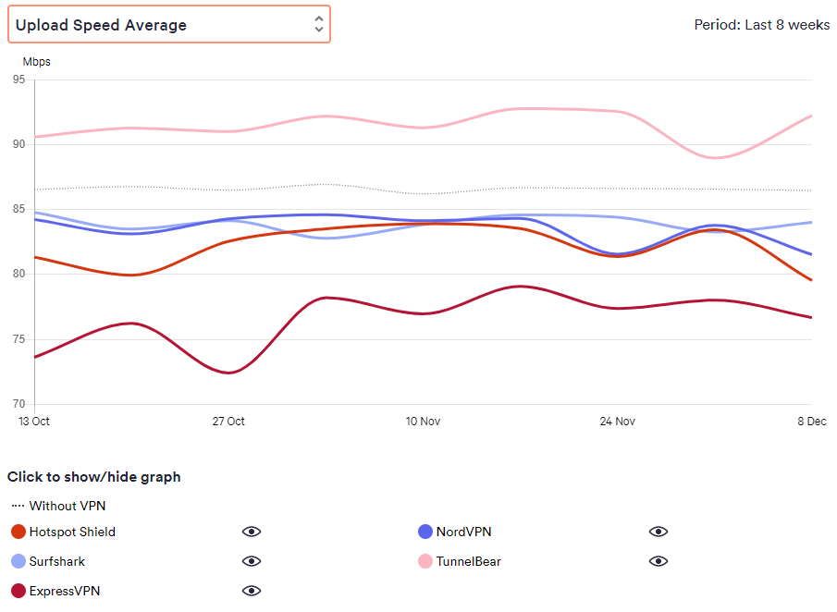
Taken from Webpage, Authored by JP Jones & Callum Tennent [8]
The image above is another type of graph created by the website’s VPN test tool. The internet neds an upload and download connection to function, and generally the upload speed is significantly slower than the download speed. It is useful to know how much a VPN slows down upload speed since the average upload speed of around 14Mpbs, according to a study by Ofcom [9].

Related Work
This section is aimed to compare different literature reviews that all cover a similar topic, VPNs and their protocols. Below are three different papers by different authors, all talking about VPNs and their different users. The author will talk about these papers, mention the structure and features of each paper, and then discuss any similarities and differences between them. Each paper having its own heading ensures that relative credit is given to the author and makes it easier for the reader to understand which paper is being talked about that the time.

The research of VPN on WLAN – W. Huang, F. Kong [10]
The first paper the author will be reviewing is by two students from the Hebei University of Engineering. The title of the paper is “The research of VPN on WLAN”, and it essentially compares two different types of VPN protocols. It compares IP Security (IPSec) and Security Socket Layer (SSL) [10]. The authors, W. Huang and F. Kong begin the report with a short abstract and an introduction briefly explaining what a VPN is and the two main types of WLAN VPN protocols. The paper includes multiple different figures and tables explaining how these protocols are structured and applied in practice. The bulk of the report talks about different advantages and disadvantages of using the different protocols. The information included is structured in a clean format, using figures and short lists to give some space in between large chunks of text, allowing for an easier read. This section ends with a table comparing different ‘options’ with IPSec and SSL, talking about how each protocol handles said option. This is followed by a short conclusion summing up this section.
There are a couple changes that could be made to improve the report. One improvement would be to include more advantages and disadvantages off each protocol. There are a few included, but there is only a couple of advantages for SSL compared to there being five for IPSec. Also, the disadvantages feel minimal for both protocols. Each protocol has a lot of advantages and disadvantages and the author feels there could be a few more to give the reader a better understanding. In addition, the conclusion that finishes the report feels slightly rushed. There are only a couple lines for the conclusion, an improvement would be to spend a little more time and research to sum up the entire paper.
This paper talks about the advantages and disadvantages of SSL and IPSec for a WLAN network, whilst the third paper is not oriented around WLAN networks.

Study on the Application of VPN Technology Based on IPSec in the Modern Universities – J. Lu, C. Dong [11]
In the second paper covers the IPSec VPN protocol exclusively in modern universities. The paper is structured well throughout and is an easy read. Similarly, to the first paper the author talked about [10], this paper uses figures to space out the text so there are no big chunks of text, giving the paper some breathing space. Considering this section is only three pages long, there is an excellent amount of information within these pages. Included is an abstract along with an introduction, a few chapters on the topic in hand, a guide on how the topic is setup, and a summary section to round the paper off. The paper is very well described throughout and does not over complicate anything that is talked about. On the topic of VPNs and protocols, it would be very easy to confuse the reader (especially somebody who has just been introduced to networks and VPNs), yet the writers have done a great job explaining everything that has been mentioned.
This paper talks about how VPNs can be used for the same features as your typical wide area network but mentions that VPNs would allow a more cost-effective method, whilst adding more security and other features with minimal disadvantages. The VPN protocol that is discussed in this paper is IPSec. There is a section within the paper that talks about what makes up the protocol, and briefly goes over what each feature is.

A Comparative Research on SSL VPN and IPSec VPN – H. Mao, L. Zhu, H. Qin [12]
Much like the first piece of literature reviewed [10], this piece from three students at the Wenzhou University and the Yangtze in China exclusively compare two different types of VPN protocols. This paper also compares Security Socket Layer (SSL) protocol and IP Security (IPSec) protocol. This paper is very similar to the first reviewed, they both follow a similar format, both containing mainly advantages and disadvantages of each protocol. This paper has a substantial amount more references than the first considering each of the two papers hold roughly the same amount of information. With leaders the author to believe a lot more research was done for the third piece. Obviously, the first piece reviewed was not based around these two protocols as the third one is, although it does mainly talk about the two since they are well suited for WLAN networks.
This paper begins with an abstract followed by an introduction. The two sections are short yet very informative. The abstract tells the reader exactly what they can expect to see within the paper, and the introduction provides a little more detail on the two protocols researched, giving slight comparisons between each one and what they do.

Literature Comparisons
Each piece of literature that was reviewed covers a specific area over a shared topic. In this case, a couple of VPN protocols are viewed in-depth. Each piece has its own goal, to identify exactly how VPNs work in different environments and scenarios. To a less experienced user, VPNs may not seem necessary for everyday use.
There are multiple reasons that someone may want to study VPN connections. A good reason would be if they had been using a VPN themselves and discovered a drop in performance, whereas some could just be curios into how VPNs work exactly. Throughout each of the 3 projects discussed, the chosen topic shared is about VPN protocols, and what would be the best one to use in specific scenarios.
The first [10] and third [12] are very similar, both talking about IPSec and SSL VPN Protocols. The first is more specific to a chosen scenario, whereas the latter is more summarised for the general features and how each protocol works. The second piece [11] only covers IPSec protocol but refers to how a University would go about using it through their campuses. This talks about the advantages and disadvantage of using VPNs for students and employees.

2.6 Conclusion
Research is one of the most important factors for any project or experiment. It can grant the Author the knowledge to proceed in their project. With no base research, there may be unexpected results which cannot be explained. Also, research can help with predictions in what is going to happen in an experiment. If the predicted does not happen, the Author can start to discover how come the prediction was not accurate and why anything unexpected happened. It may prove difficult to spot anomalies in results if there is no knowledge on what to expect.

Chapter 3 – Research Methodology

3.1 Introduction
This section aims to discuss different methods of research, including the different methodologies, processes and philosophies. Most research is split into two sections, qualitative and quantitative. Qualitative research is usually expressed in words, this can include interviews and literature reviews etc. Quantitative research is numbers and graphs etc. Methods of quantitative research include tests and experiments, and surveys [13]. The topic of research for this paper is VPNs, and the main research would be the speeds of different VPNs connected to different servers. Since VPNs tend to slow internet down when connected to different servers, the research covers the percentage loss of internet speed.

3.2 Research Overview
The research overview essentially discusses every section of research that needs to be completed throughout the project.
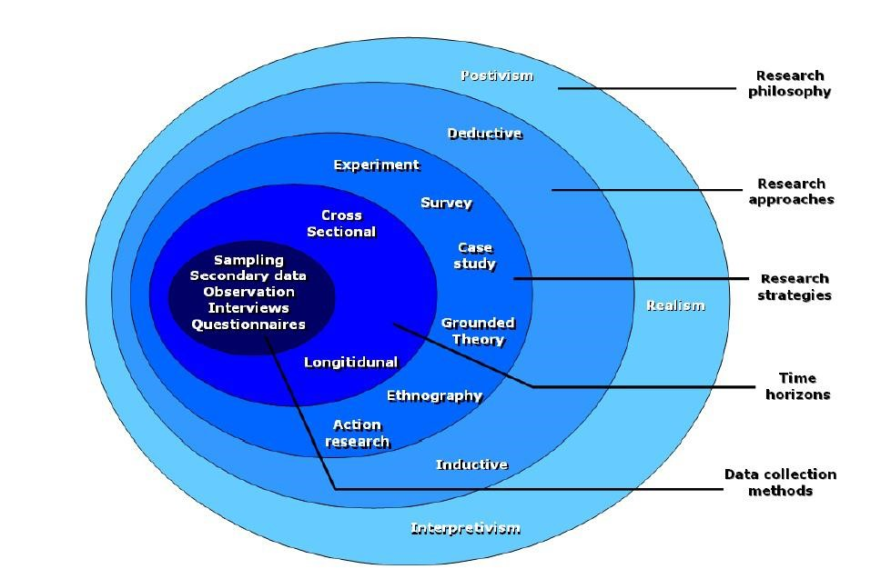
Analysis of Saunders Research Onion – ThesisMind [14]
The figure above shows the Saunders Research Onion. The research onion illustrates the different stages that are involved in research development [14]. It allows for a more effective method of gathering research. Each of the stages should be discussed and implanted into the research of a project, the Research Onion describes each stage and what should be included.
The stages of the research onion are:
- Research Philosophy
- Research Approach
- Research Strategies
- Research Time Horizon
- Data Collection Methods

3.2.1 Research Process
This research aims to provide an in-depth understanding of how VPNs effect the user’s internet speed and security. The research process of this project consists of understanding different types of research methods and data collection and talking about why these types are better to use for this type of project. A big section of the research process is to review other literature sources that cover a similar topic to gain a better understanding of what is being researched. This research is typically conducted after coming up with what is hoped to be achieved from the research. This can be any questions that would be answered or developing a hypothesis. After the preliminary research, the researcher would need to select the different methods of data collection. This part would be understanding different advantages and disadvantages of data collection methods and what would work best for the chosen objectives. Next, the research would analyse the data that has been collected in the previous step and try to understand the data. The last step in the research process is to come to a conclusion about the project. Here the author would talk about how they think the aims of the project have been achieved. Deductive research would be better for the experiment, since it is already known that VPNs can slow down internet speeds. Deductive research essentially tests and existing theory whereas inductive is developing a theory.

3.2.2 Research Philosophy
There are four main type of research philosophies: Pragmatism, Positivism, Realism and Interpretivism. Each philosophy has popular data collection methods, and it’s important to choose the right philosophy whilst conducting the research. There is also Qualitative and Quantitative research. Quantitative research would be used in these projects since the experiment mainly deals with numbers and statistics, primarily being the internet speeds.

3.2.3 Research Methodologies
There are many different methods that somebody could use to gather information for their research project. Research Methodologies are the processes that are used to gather information. To expand on this, a good way of gathering information would be through a survey. Surveys can be held for any topic, and nowadays it would not be too difficult to get a certain number of people to answer a couple of questions on the chosen topic. Similarly, an interview could be held to gain a greater understanding of what is being researched. When selecting a research methodology, the researcher needs to select the ones that best suite their topic. Some projects would require and experiment, for others it could be more beneficial to use a survey. Another method of gathering information would be to have a look at case studies. This is not really based on what project is being done, no matter what the topic is there is a high chance that a case study has already been completed following a similar topic. A case study could fit alongside some of the other methodologies for a bit of extra research.
The main method of collecting research for this project is an experiment. It is also useful to look at existing case studies to gain a better understanding. An experiment would give the author a tested/verified result. This would allow for a definitive un-biased result for a fair experiment. The reason that this project is an experiment is to be able to get an exact answer, A survey or questionnaire would not really suit this type of project since the results are numerical. The project is testing internet speeds with and without a VPN connection. It is possible to do a survey on whether users feel that their internet speeds are slowed down when they are using a VPN. However, this would involve asking the low percentage of users that use VPNs regularly. Even then, it would essentially be a yes or no answer, which would not be very useful in this project. An experiment however would give the exact results and using these the author is able to compare results side by side in the form of a graph or table. These results would also

3.2.4 Data Collection
After selecting the right method, you can begin collecting the data. There are numerous different ways somebody can collect data. Just a few of them are Questionnaires/surveys, Interviews, Reviewing Documents, and general observations [15].
Research can be split into primary and secondary research. Primary research is data that is collected from the source directly, whilst secondary research is collected by somebody else for others to use [16]. Primary and secondary both have their own advantages and disadvantages, depending on what type of project is being studied. Primary research is usually conducted to make some new discoveries on the topic, which needs to be credible. Secondary research is useful for gaining some information and support your own arguments with similar research [17].

3.3 Research Design

3.3.1 Research Deliverables
Once the experiment has concluded, there would be a few things to be discussed. Aside from the results from the experiment, the author would need to answer a few questions. An example question could be how much the internet speed was affected whilst connected to the VPN, another one could be how much percentage loss was there and compare each VPN against each other.
The project report itself is also a big part of the project. The report covers all the details that are not discussed within the experiment itself, along with research and recommendations etcetera. Towards the end of the project, the authors recommendations will be discussed. This recommendation will be based around all the information that has been discovered during the project, whether this be the primary or secondary research. Any other questions that may be asked during the project will be answered and explained alongside evidence that backs up the answer.

3.3.2 Project Management
One big limitation of the project could be the availability of certain VPNs. In order to make the test fair, multiple different VPNs would need to be tested to obtain and accurate result. The issue is there are often limitations whilst using a free trial of a VPN. Obviously, a free trial cannot be as good as the full product, and some VPNs offer more in their free trial. Most VPN free trials offer a data limit so the user can only be connected to the VPN for a certain number of minutes, usually per day/week. Unfortunately, the author has not got the resources to temporarily subscribe to each VPN that is to be test, so the trial version would need to be used. These trial versions will be inspected and checked to see if there is an internet speed limit for the trial. If this is the case, it would be unfair to test that specific VPN. If needs be, there are online tools that can aid in comparing VPN speeds against each other. However, it is not known how accurate or outdated these online tools can be.
It would be unfair to test some VPNs manually and then turn to online tools to test the ones that the author could not. These could give very different results based on factors such as base internet speed and many others. The manual tests would not be conducted in a perfect environment, only the typical environment for the average user. This environment could be other people sharing the same internet connection and houses in the surrounding area using the same channel. This would provide a more realistic result.
The following Gantt Charts have the date format Month/Day/Year - So ‘11/5/20’ is 5th November 2020.

Gantt - Research
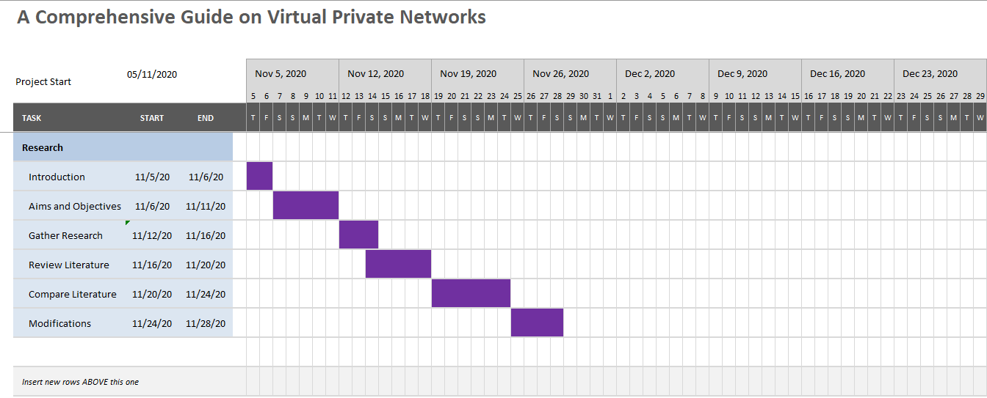
Above is a Gantt Chart showing what the original plan was before the project had begun. This Gantt Chart only covers the research section of the project. However, other work commitments and the amount of research quickly made this plan inaccurate. Some days there was no progress made due to external factors. There is a more accurate Gantt Chart below.
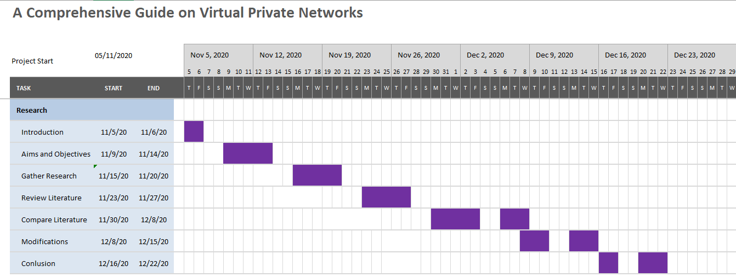
As shown, the first couple of sections took longer than originally planned.

Gantt – Research Methodology
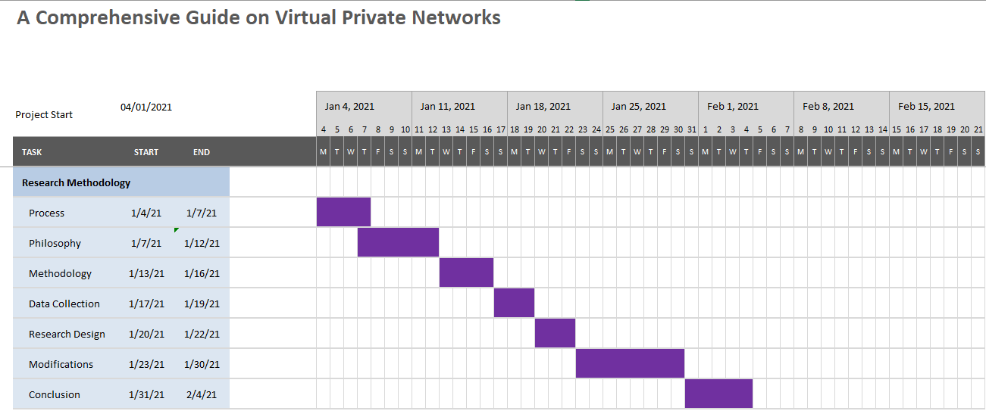
The goal was to finish the Research Methodology section by the end of January to be able to focus on the Design and Testing as early as possible. However, gaining a better understanding on how important research is, this also took longer than expected. The original Gantt chart does not take rest days and other work commitment days into account.
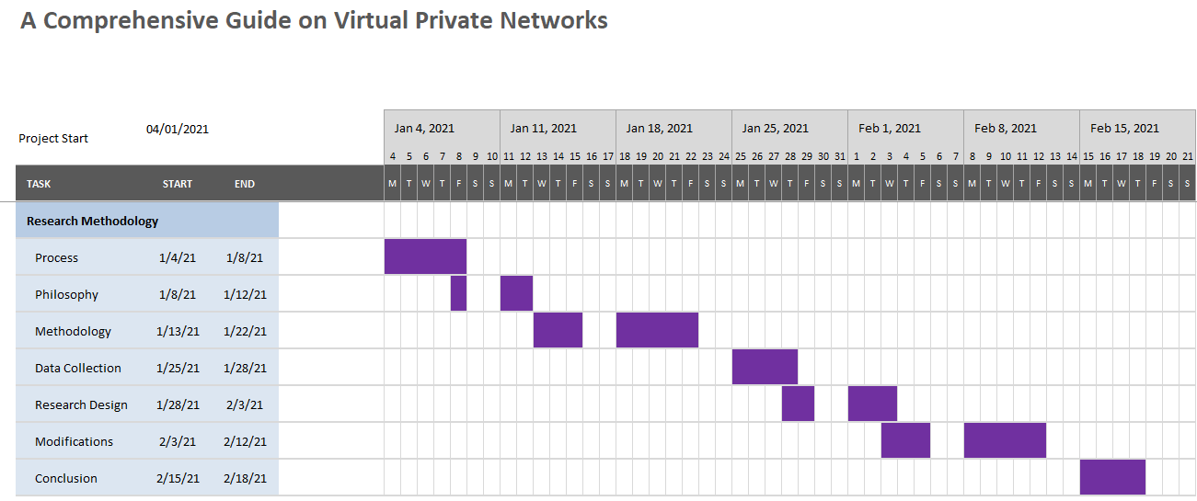
Here is the finalised Gantt Chart for this section.

Gantt – Design / Implementation
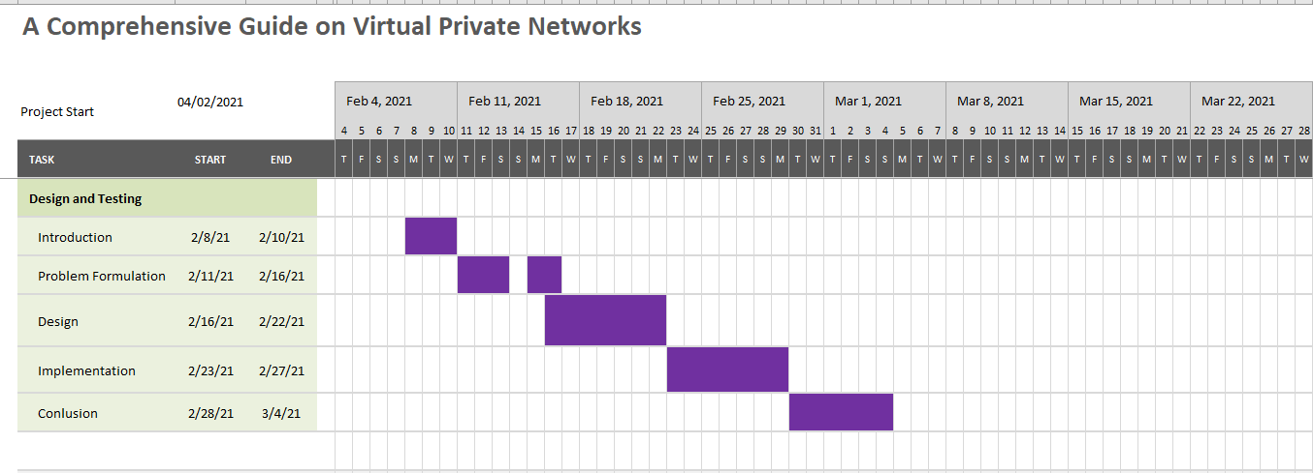
Since the initial goal was to finish the Research Methodology towards the start of February, this is when the plan to start the Design and Implementation section. Since this was not the case, the Gantt chart quickly became inaccurate.
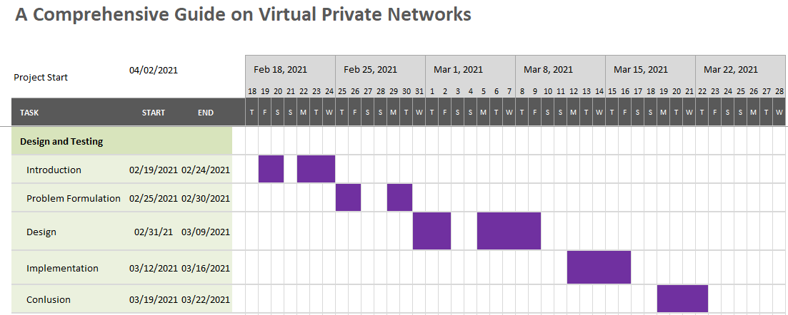
Here is the finalised Gantt Chart for this section.

3.5 Conclusion
To sum up everything that has been said in this chapter, research is very important and plays a big part of any type of project. Anything that is discovered during primary research can essentially be verified by existing information. Unfortunately, not everything on the internet is true even when it claims to be. For this reason, it is always useful to do some primary research. When conducting research, the Saunders Research Onion is always useful to refer to when going through each stage. Understanding how the Onion works can have substantial benefits when conducting research. It is important to select the right research methodology based on what type of research is being conducted. It would be difficult if this section of the project is skipped or rushed in any way. The Gantt Charts towards the end of the chapter show how much the project plan has changed since the start of the project. There are multiple factors that could cause these changes to happen. In any case, it is always useful to have some sort of plan to try and stick to.

Chapter 4 – Design and Implementation

4.1 Introduction
This chapter covers how the author will go about completing the experiment. This includes the design, implementation and any problems that could occur during the tests. The main body of the project is the experiment, where the author will test internets speeds whilst being connected to different servers via VPNs. These VPN speeds will then be compared against each other to arrive at a conclusion based on the results gathered. If the experiment is not well designed, then there could be several anomalies that are encountered during the experiment that give unfair results. This needs to be carefully evaluated to be as fair as possible.

4.2 Problem Formulation
The whole idea of the project is to get a better understanding on how a VPN effects internet speed. The project involves an experiment where the author runs multiple internet speed tests whilst connected to different VPNs and servers. These tests include using a popular website by Ookla that is well known for giving accurate internet results and is probably the most used internet speed test to date. As for evidence that the VPN is working, the IP address displayed on the website should be different for every server and VPN.
The idea for the project began when the author just started to use a VPN daily and noticing a huge drop in speed or connection all together. This is never constant, however occasionally it would be noticeable. This resulted in curiosity, wondering on how much speed is affected when it comes to a consistent use. Different VPNs offer different price points. The big question here is do some providers limit the internet speed of users unless they pay at a specific price? Virtual Private Networks play a monumental role in internet security, some will consider them to be essential if users take their data and privacy seriously. A lot of people already feel safe on the internet, without knowing how much of their data is kept and stored (some of which in a public database). If this were common knowledge, more users would use VPNs. It seems that people are thrown off by needing to pay for extra security, however it could be seen as like buying cameras for outside a home. Most of the time it is not needed, but if anything were to happen it would be much better to have this security.

4.3 Design
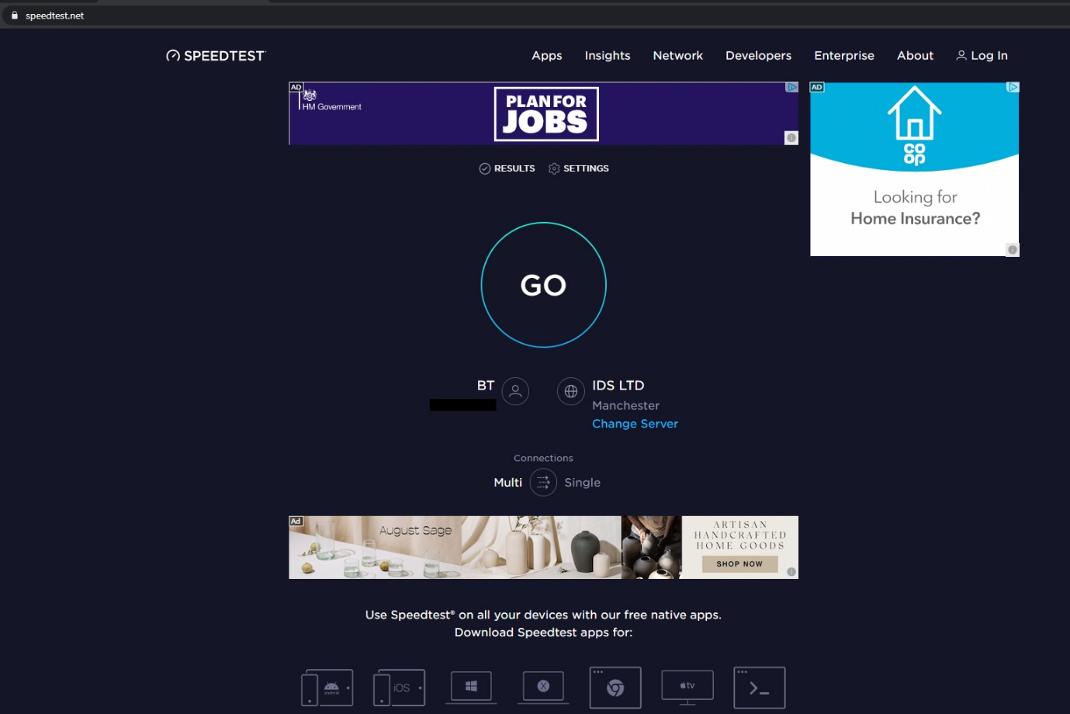
Speedtest by Ookla – speedtest.net
This is the main interface for the internet speed testing website by Ookla. As basic as it comes, this internet speed test is used every day by many users across the world and is seen as an accurate and respected speed tester. This is the website that will be used to test the speed of each VPN. The users IP address is also shown on the page. The authors own IP address, without being connected to a VPN) is being shown in this image, that is why it has been covered. When connected to the VPN, this IP address will change and be different for every test.
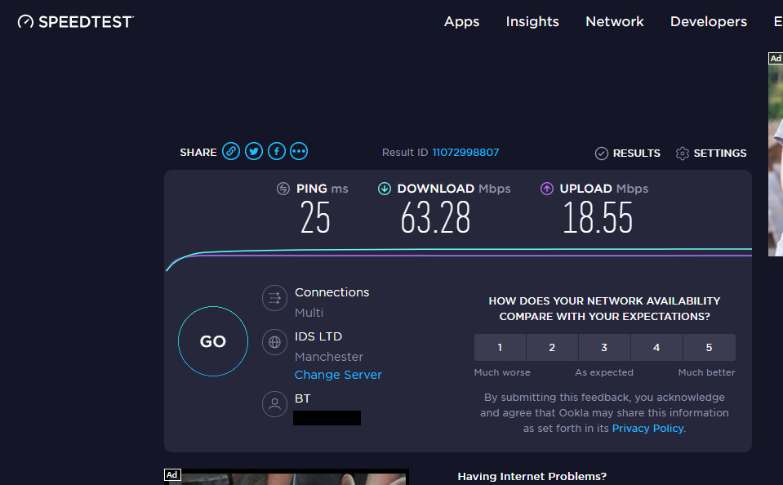
Here is the screen after the test has ran, it displays:
- Ping
- Download Speed (Mbps)
- Upload Speed (Mbps)
This is where the results are shown, these results will be shown at the end of every test for the VPN and Server. The higher these figures are, the faster the internet connection. So, it is expected for these numbers to drop whilst connected.
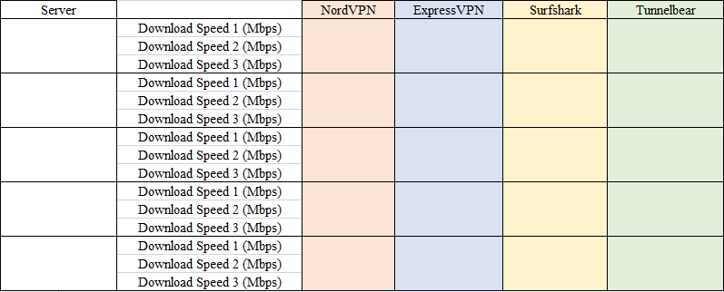
Above is an example on what the results table could look like. There are three tests on each server and the average is to be taken and used in the results.
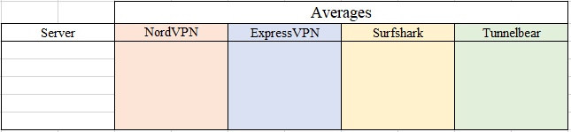All averages are to be stored and compared against each other. Creating this table using Microsoft Excels formula system to find the exact average of the other results can be very beneficial. Once these results are collected, it is incredibly simple to convert them into a graph to visualise the results. This can make understanding the results a lot easier for the reader.
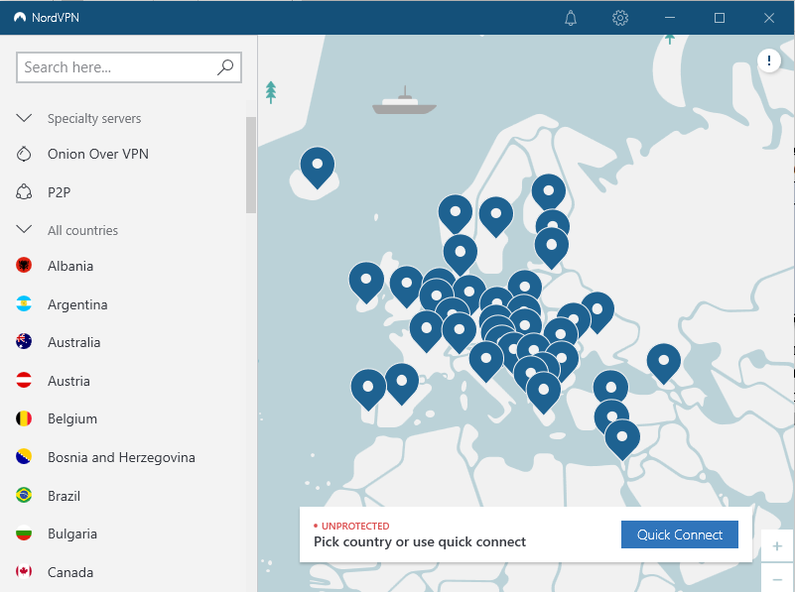
Above is a screenshot taken from the NordVPN windows application. It shows what a typical VPN interface looks like, simple and easy to use and navigate. Each blue pin represents a server in the country the pin is located on the map. There is also an option to search for whatever server best suits the user, or just look on the map itself. There is also a “Quick Connect” option that automatically connects the user to an optimal server. This is usually I the same country, but still provides the necessary protection.

4.4 Implementation
There are multiple different VPNs to test, each VPN is to be tested whilst being connected to different servers across the world. Most VPNs use similar servers, so the test would only be valid if the servers were in the same location throughout each VPN. For example, if the VPN server is in America, they would need to be in the same state to give a fair result. If for one VPN the server was in Florida, and the other VPN has a server in California, they would give different results. The speeds would be expected to be slower when connected to the California server since it is further away from the host location (United Kingdom). Each test would be held 3-5 times to avoid any anomalies. The average of these tests would be taken and used as the result. Each test would be held after doing an initial internet test without the VPN to ensure there is no connection drop in-between tests which would give an unfair result. Any anomalies are to be removed from the average but mentioned to ensure that nothing is left out.

4.5 Conclusion
The design of an experiment is the body of it. There cannot be an experiment without the design, ensuring a useful design is essential to get successful results. With the design comes the implementation, this is essentially how somebody uses the design and understanding how it works to have fair and accurate results. A good design can also greatly help the efficiency of the project/experiment. It can greatly improve workflow or decrease depending on how well it has been set up. Once the design has been set, the implementation is using that design. Without this, there would be no experiment, or if there was it may not be fair. As mentioned previously, there are certain aspects and requirements that need to be met in order to make it a fair test.

Chapter 5 – Testing and Evaluation

Introduction
Below is a screenshot of an Internet Speedtest without the Author being connected to a VPN, this is the average home internet speed. Not slow nor incredibly fast. The IP address of the connection is being displayed on the centre; however, it has been blurred for safety purposes. It starts with ’81.1’, this will be used to verify that the VPN connections are working. When the VPN is connected, this address should change.
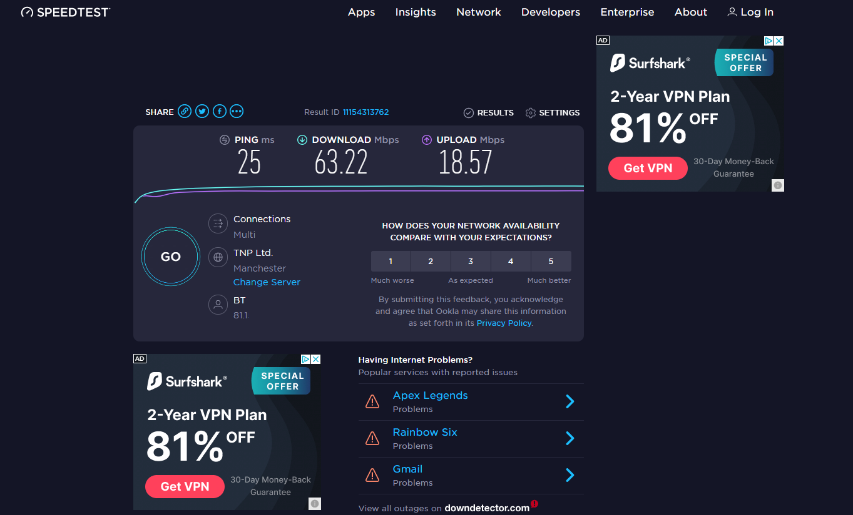
These internet speeds are what the VPN connection speeds will be compared to. The ping, download and upload are going to be documented throughout each test. In addition, each VPN connection is going to be tested three times each. The average of these 3 tests is going to be what is used in the results.
It is expected that the connection speed is going to decrease slightly with each test, the server’s location is going to be the biggest factor that would impact the internet speeds.

Connections and Speeds
The three servers that are going to be used are in The Netherlands, Japan and the USA. All the VPNs that are tested have servers in these regions.

Test 1 – The Netherlands

NordVPN

Test | Ping | Download (mbps) | Upload (mbps)
1 | 26 | 57.85 | 16.75
2 | 26 | 57.31 | 16.79
3 | 26 | 57.80 | 16.68
Average | 26 | 57.65 | 16.74

Above are the results from each test whilst connected with NordVPN. Below is a screenshot of the final speed test.
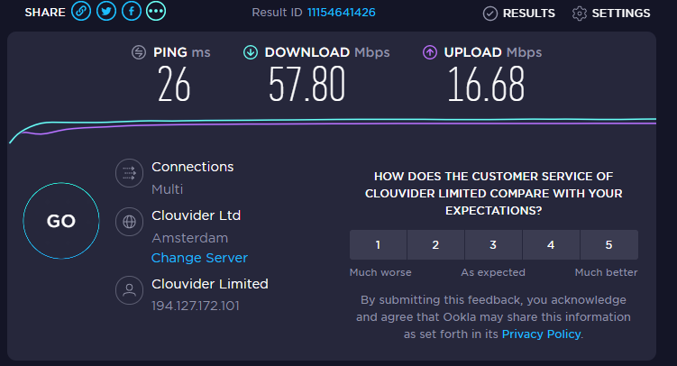

Surfshark
Test | Ping | Download (mbps) | Upload (mbps)
1 | 29 | 61.29 | 12.93
2 | 30 | 59.35 | 14.27
3 | 29 | 60.45 | 15.53
Average | 29 | 60.36 | 14.24

Above are the results from each test whilst connected with Surfshark. Below is a screenshot of the final speed test.
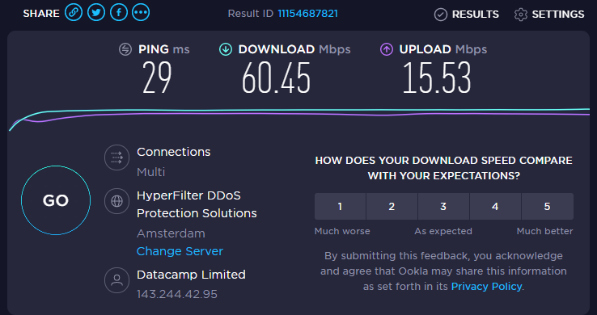

Tunnelbear

Test | Ping | Download (mbps) | Upload (mbps)
1 | 29 | 59.47 | 17.47
2 | 29 | 59.65 | 17.59
3 | 29 | 60.30 | 17.60
Average | 29 | 59.81 | 17.55

Above are the results from each test whilst connected with Tunnelbear. Below is a screenshot of the final speed test.
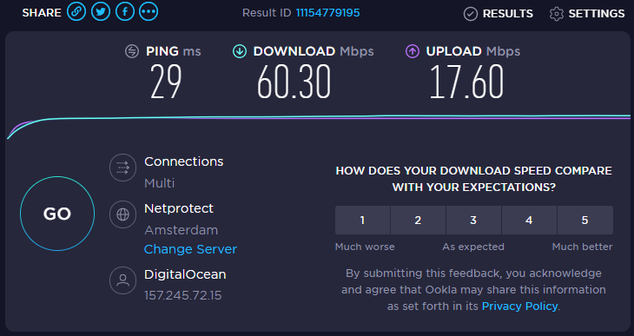

ProtonVPN

Test | Ping | Download (mbps) | Upload (mbps)
1 | 29 | 61.15 | 17.83
2 | 29 | 60.84 | 17.83
3 | 29 | 61.17 | 17.81
Average | 29 | 61.05 | 17.82

Above are the results from each test whilst connected with Tunnelbear. There is no screenshot of the result from the test. Instead, there is a video of the author doing running all three tests for this VPN and Server.

Test 2 – Japan

NordVPN

Test | Ping | Download (mbps) | Upload (mbps)
1 | 258 | 48.94 | 15.82
2 | 258 | 47.49 | 14.17
3 | 258 | 51.50 | 16.33
Average | 258 | 49.31 | 15.44

Above are the results from each test whilst connected with NordVPN. Below is a screenshot of the final speed test.
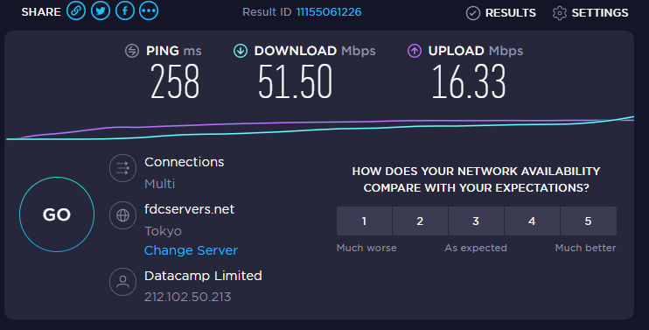

Surfshark

Test | Ping | Download (mbps) | Upload (mbps)
1 | 242 | 49.48 | 17.09
2 | 242 | 52.32 | 17.25
3 | 242 | 52.12 | 17.55
Average | 242 | 51.31 | 17.30

Above are the results from each test whilst connected with Surfshark. Below is a screenshot of the final speed test.
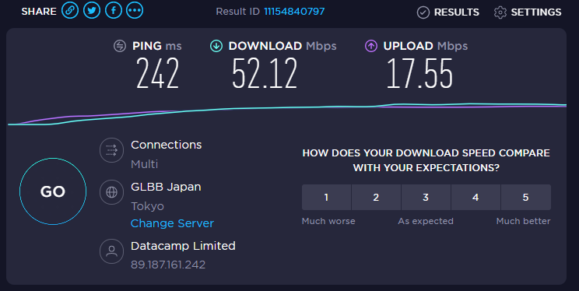

Tunnelbear

Test | Ping | Download (mbps) | Upload (mbps)
1 | 247 | 28.75 | 7.42
2 | 247 | 26.90 | 7.27
3 | 247 | 51.13 | 10.25
Average | 247 | 35.60 | 8.31

Above are the results from each test whilst connected with Tunnelbear. Below is a screenshot of the final speed test.
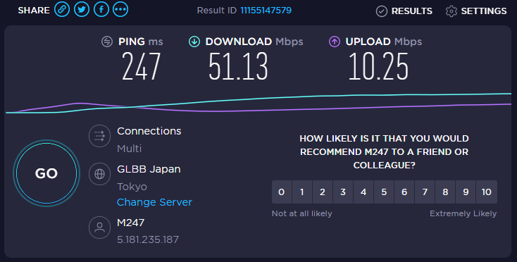

ProtonVPN

Test | Ping | Download (mbps) | Upload (mbps)
1 | 267 | 41.09 | 2.66
2 | 266 | 47.01 | 2.69
3 | 261 | 46.25 | 4.52
Average | 265 | 44.78 | 3.29

Above are the results from each test whilst connected with Tunnelbear. Below is a screenshot of the final speed test.
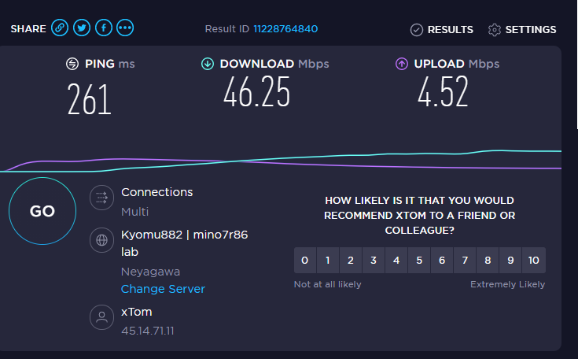

Test 3 – USA

NordVPN

Test | Ping | Download (mbps) | Upload (mbps)
1 | 99 | 55.59 | 16.17
2 | 100 | 56.37 | 16.67
3 | 99 | 56.88 | 16.78
Average | 99 | 56.28 | 16.54

Above are the results from each test whilst connected with NordVPN. Below is a screenshot of the final speed test.
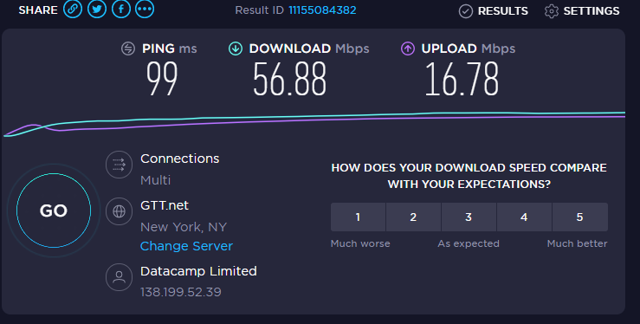

Surfshark

Test | Ping | Download (mbps) | Upload (mbps)
1 | 100 | 59.52 | 17.81
2 | 100 | 58.25 | 17.79
3 | 100 | 61.31 | 17.79
Average | 100 | 59.69 | 17.80

Above are the results from each test whilst connected with Surfshark. Below is a screenshot of the final speed test.
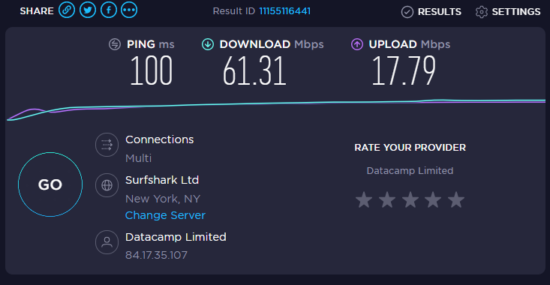

Tunnelbear

Test | Ping | Download (mbps) | Upload (mbps)
1 | 88 | 49.06 | 17.50
2 | 87 | 59.91 | 17.59
3 | 87 | 59.80 | 17.60
Average | 87 | 56.26 | 17.56

Above are the results from each test whilst connected with Tunnelbear. Below is a screenshot of the final speed test.
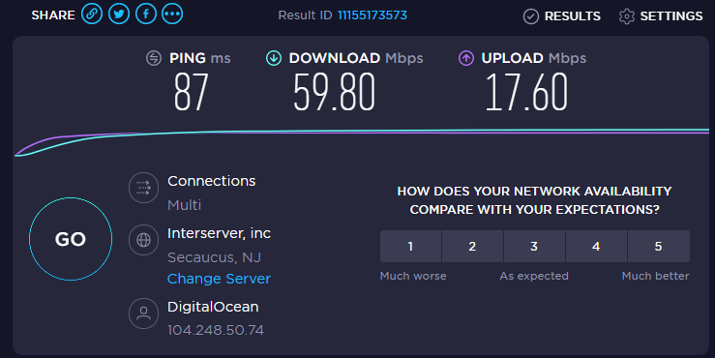

ProtonVPN

Test | Ping | Download (mbps) | Upload (mbps)
1 | 152 | 49.54 | 17.75
2 | 152 | 52.72 | 17.79
3 | 152 | 55.21 | 17.76
Average | 152 | 52.49 | 17.77

Above are the results from each test whilst connected with Tunnelbear. Below is a screenshot of the final speed test.
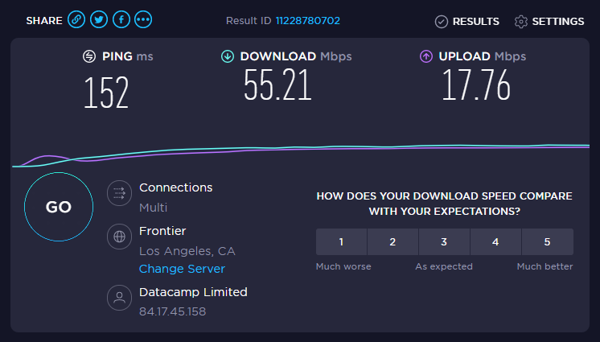
Mbps | NordVPN |  |  | Surfshark |  |  | Tunnelbear |  |  | ProtonVPN
Mbps | Download | Upload |  | Download | Upload |  | Download | Upload |  | Download | Upload
Netherlands | 57.65 | 16.74 |  | 60.36 | 14.24 |  | 59.81 | 17.55 |  | 61.05 | 17.82
Japan | 49.31 | 15.44 |  | 51.31 | 17.30 |  | 35.60 | 8.31 |  | 44.78 | 3.29
USA | 56.28 | 16.54 |  | 59.69 | 17.80 |  | 56.26 | 17.56 |  | 52.49 | 17.77

Average Speed Results

Base Speed
Download: 63.22Mbps
Upload: 18.57Mbps

Above is the table that contains all the average speeds taken across the speed tests. Here it is easy to see exactly how much the internet speeds were affected through the VPNs. Beneath that is the base speed from before the tests (the internet speed without being connected to a VPN.
Through the averages, we can see that the VPN that gave the fastest connection was Surfshark. In general, the VPNs that were bought instead of the free version produce faster speeds (as expected). However, considering Tunnelbear and ProtonVPN were free, they were not as bad as originally thought.
The results give some unexpected results. For the Netherlands server, ProtonVPN had the highest download and upload speed. However, had a bad upload speed when it was connected to the Japan server. Both free VPNs had trouble with the Japan server, assuming this is due to the distance between the host machine in the UK.

Complications
A few problems were encountered whilst both installing the VPNs and running the internet tests. The original VPNs that were going to be tested were NordVPN, ExpressVPN, Surfshark and Tunnelbear. However, this was short-lived once it was found out that ExpressVPN and Surfshark do not offer free trials with their services. Yet there is a 30-day money-back guarantee with each, providing that the right subscription is chosen. In the circumstances, the Author has purchased a two-year subscription to Surfshark and has decided to swap ExpressVPN with well-known ProtonVPN. Proton VPN offers multiple subscriptions, the cheapest being completely free but with a few limitations. The biggest limitation being the very limited servers that are available for the free version. There was originally going to be around five servers tested in different servers across the world, but the Proton VPN free version only offers three servers in The Netherlands, Japan and the USA.
Another issue that was met was an error regarding NordVPN own protocol, ‘NordLynx’. For a couple of weeks, the Author was unable to connect to any server whilst using NordVPN (despite not using a free trial). This put a small halt on the experiments, unfortunately it was not possible to switch this out for another VPN since it has already been purchased by the Author. This problem was fixed by manually changing the VPN protocol that NordVPN used.

VPN Recommendations
Out of the VPNs that were tested, it may be slightly unfair since a free version of Proton VPN and Tunnelbear were used. A free version of a VPN obviously has some limitations, mainly including speed which is what was tested. This is taken into consideration. Judging by the speed alone, Surfshark is the clear winner. This was one of the VPNs that has been paid for in full, the other being Nord VPN.
Out of the two free VPNs, the best for speed is Tunnelbear. These two VPN providers had different limitations for their free versions. Tunnelbear basically limited the user with how much data they could use over a certain time period, whereas Proton VPN has a minor speed cap, along with a very limited selection of available servers. Each free VPN are easy to use, setup and navigate, and are overall very user friendly. Anybody who is looking for a free VPN would most likely be impressed with each of these options. Although Tunnelbear is faster than Proton VPN (according to the speed tests) it does not necessarily mean that it is the better option. The data cap on Tunnelbear is around 2500MB a month (for the free version) which is not a lot when browsing the internet, especially if anything is being downloaded. This is where it could be more beneficial to use Proton VPN. There are some options on Tunnelbear that allow the user a free 1 GB of data, simply just by posting the VPN on a social media page. Overall, both free VPNs would be suitable for a user who is not willing to pay for better internet security and access.
Overall, if the user only cared about the internet speed, the best VPN to use would be Surfshark.

Chapter 6 – Conclusions and Recommendations

6.1 Conclusion
A Virtual Private Network is expected to slow down an internet connection, the amount of speed lost depends on a couple of factors:
- The VPN used
- The Server Connected
Some VPNs offer a speed cap (primarily for Free Versions). This is to try and get the user to buy the full product. The biggest factor that affects internet speed is the server that the user is connected to. A VPN can connect the user to any available server that they choose. These servers are in different parts of the world. In a previous section, three servers were selected for testing. The Netherlands, Japan and the USA. Each of these servers are in different parts of the world. The further away the server is from the users host machine, the slower the internet connection will be (in theory). These three servers were the only ones available for users that use the free version of ProtonVPN, and they were perfect for what was needed. All other VPNs tested also had servers in these countries.
At the beginning of the project, a main aim and a few objectives were discussed. Each of these have been met, and everything that was said to be completed has been complete. Throughout the project, there was not really any major issues. A couple of minor issues might have had an impact on workflow for a couple of weeks, but these were quickly resolved as soon as it was possible.

6.3 Recommendations for Further Research
The biggest thing that could be better if someone were to recreate this experiment is to do more background research into the VPN’s that are to be studied. For example, the author of this project had to change the original VPNs that were going to be studied, since there were no free versions of the VPNs. This caused a little delay and ended up costing the author a 2-year subscription to one of the VPNs that was originally talked about. The author did not want to change the project too much from what was stated at the beginning.
One thing that was important to keep consistent throughout was the testing environment. It would be more accurate to use a wired connection compared to a wireless connection, and to also try and get the same base internet speed before starting any tests. Anybody else in the household who may be using the internet can cause anomalies in the results. If someone were to be downloading a big file at the time of the internet test, there would be a high chance that the internet that is connected to the VPN would appear slower and seem as if the VPN were slowing it down. Throughout this project, the author ensured that nobody else was using the internet whilst the tests were being conducted.

Chapter 7 – Reflections
From the start of this project, I was adamant that a VPN connection greatly decreased the internet speed for the user. However, it was not as drastic as I originally thought. I started off with the basic knowledge of VPNs and how they operate, as well as knowing that the further away the server is located to the user then the slower the connection will be. Where there is obviously a little speed loss, it is noticeable but not annoying when just using the VPN for day-to-day use.
Throughout the project there is not really many things that went wrong. Aside from one of the VPNs not offering a free trial. For this I had to buy a 2-year subscription to the VPN, which luckily I was able to get a refund on shortly after I ran all the tests. There was also another small issue where I could not get NordVPN to work. I thought it was to do with the configurations and I could not find anything online to help me fix this. This put a little halt on the project since I could not access one of the main VPNs. I fixed this however by changing the protocol that the software used. One other issue that I had that is not related to the VPNs is my home machine. My PC keep randomly crashing for weeks, I had to ensure I was constantly saving my work. There was one point where I lost an hour work due to a crash. Towards the end of the project, I had fixed this,
The speed tests for the project went well, it was just a case of connecting to the VPN and running the speed test after making sure it was using the correct server. I noticed there is a small issue with one of the VPNs if there are multiple installed to the machine. It would never let me connect to a server if it were previously connected to a different VPN. I worked my way around this by doing all those tests for that VPN at once.
Once a week I had a meeting with my project supervisor, I would upload the work I have done throughout that week and gain feedback on if I were going in the right direction. I was also set a goal to reach by the following week, to ensure I was getting the work done. These meetings helped me to great extent, as I always felt the need to get a lot of work done by that time.

Chapter 8 – References
[1] | E. Green, “How to check if VPN is working,” NordVPN, 15 April 2019. [Online]. Available: https://nordvpn.com/blog/check-vpn-working/. [Accessed 11 November 2020].
[2] | M. Eddy, “What Is a VPN, and Why You Need One,” PC Mag, 1 July 2020. [Online]. Available: https://uk.pcmag.com/features/88655/what-is-a-vpn-and-why-you-need-one. [Accessed 10 November 2020].
[3] | S. Symanovich, “What is a VPN?,” Norton, 14 January 2021. [Online]. Available: https://us.norton.com/internetsecurity-privacy-what-is-a-vpn.html. [Accessed 2 March 2021].
[4] | R. Greenberg, “Different Types of VPNs and When to Use Them (Updated 2021),” VPN Mentor, 6 February 2021. [Online]. Available: https://www.vpnmentor.com/blog/different-types-of-vpns-and-when-to-use-them/. [Accessed 2 March 2021].
[5] | R. James, “Does VPN Slow Down Internet?,” HackerNoon, 18 May 2018. [Online]. Available: https://hackernoon.com/does-vpn-slow-down-internet-4ba14ae60e3. [Accessed 4 March 2021].
[6] | N. George, “Upload vs. download speed: What’s the difference?,” AllConnect, 18 August 2020. [Online]. Available: https://www.allconnect.com/blog/difference-between-download-upload-internet-speeds. [Accessed 3 December 2020].
[7] | E. Hancock, “10 Fastest VPNs in 2020 – Only These Passed Our Speed Tests,” VPNMentor, 1 December 2020. [Online]. Available: https://www.vpnmentor.com/blog/the-fastest-vpns-we-actually-tested-them/. [Accessed 3 December 2020].
[8] | C. T. JP Jones, “VPN Speed Test Tool: Compare the Speed of 18 Popular VPNs,” Top10VPN, 3 Decemeber 2020. [Online]. Available: https://www.top10vpn.com/vpn-speed-test/?to=lon&from=lon&period=8w&providers=direct,hotspot-shield,nordvpn,expressvpn,surfshark,tunnelbear&int=7&chart=dl_speed_avg. [Accessed 9 December 2020].
[9] | ISP Review, “Ofcom 2020 Study – Average UK Broadband ISP Speeds Hit 64Mb,” ISP Review, 13 May 2020. [Online]. Available: https://www.ispreview.co.uk/index.php/2020/05/ofcom-2020-study-average-uk-broadband-isp-speeds-hit-64mb.html. [Accessed 9 Decemeber 2020].
[10] | W. Huang and F. Kong, “The research of VPN on WLAN,” IEEE, Handan, China, 2010.
[11] | J. Lu and C. Dong, “Study on the Application of VPN Technology Based,” IEEE, Beigin, 2011.
[12] | H. MAO, L. ZHU and H. Qin, “A comparative research on SSL VPN and IPSec VPN,” IEE, Shanghai, 2012.
[13] | R. Streefkerk, “Qualitative vs. quantitative research,” Scribbr, 12 April 2019. [Online]. Available: https://www.scribbr.com/methodology/qualitative-quantitative-research/#:~:text=Quantitative%20research%20deals%20with%20numbers%20and%20statistics%2C%20while%20qualitative%20research,ideas%20and%20experiences%20in%20depth.. [Accessed 2 February 2021].
[14] | ThesisMind, “Analysis of Saunders Research Onion,” ThesisMind, 29 June 2019. [Online]. Available: https://thesismind.com/analysis-of-saunders-research-onion/. [Accessed 24 February 2021].
[15] | Q. Ainsworth, “Data Collection Methods,” JotForm, 1 June 2020. [Online]. Available: https://www.jotform.com/data-collection-methods/. [Accessed 15 February 2021].
[16] | Formplus Blog, “Primary vs Secondary Data:15 Key Differences & Similarities,” Formplus Blog, [Online]. Available: https://www.formpl.us/blog/primary-secondary-data#:~:text=Primary%20data%20sources%20include%3B%20Surveys,primary%20and%20secondary%20data%20sources.. [Accessed 25 February 2021].
[17] | R. Streefkerk, “Primary and secondary sources,” Scribbr, 20 June 2018. [Online]. Available: https://www.scribbr.com/citing-sources/primary-and-secondary-sources/. [Accessed 25 February 2021].

