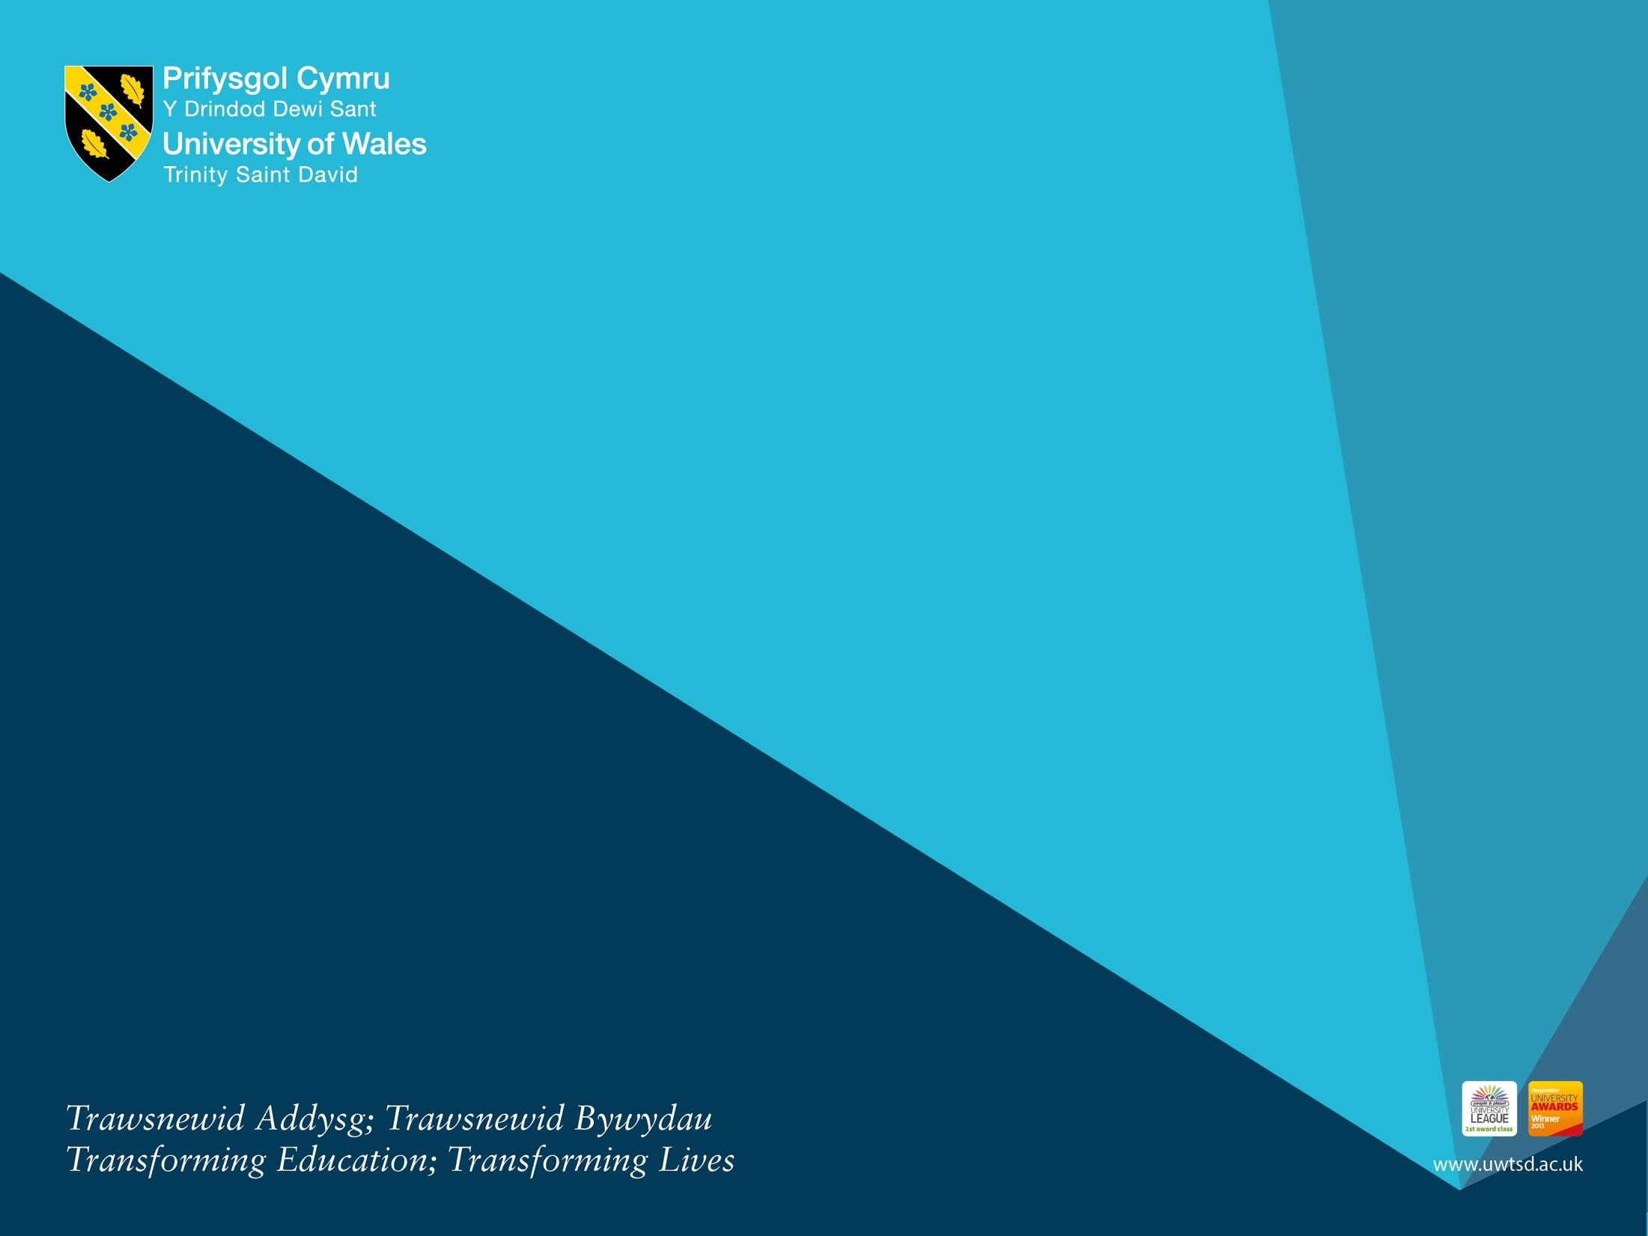

Introduction To Health And Social Care

Name: Mahmida Khan
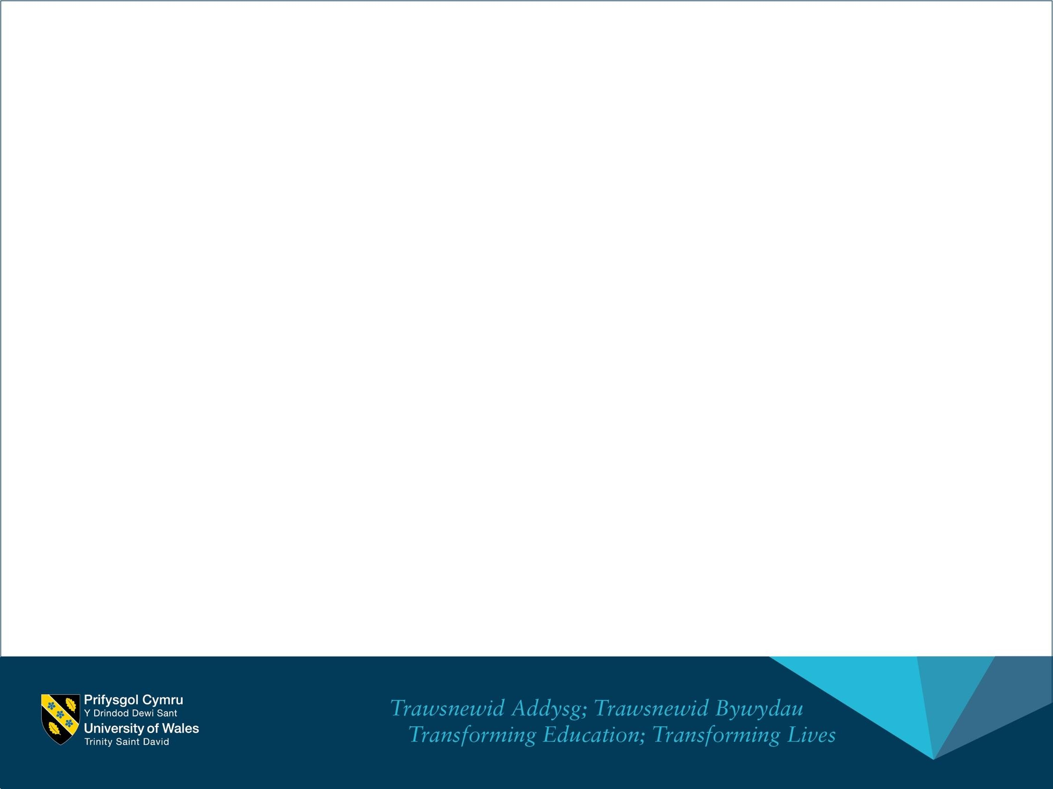
Student ID - 2512965
Lecturer: Azida Zainol
Module: LCHS4003_BIRM

Mr Ahmed’s Case Study

Introduction
Effective health and social care practice relies on strong communication, accurate administration, and collaborative working. These elements are essential for ensuring safe, person‑centred care, particularly for individuals with complex needs such as Mr Ahmed, a 68‑year‑old man recovering from a stroke. His care involves multiple professionals, including domiciliary carers, a district nurse, a GP, and a speech and language therapist, alongside the vital support of his wife. The recent missed home visit and delayed medication highlight the importance of robust systems and coordinated practice. This report examines three key aspects of professional practice within the context of Mr Ahmed’s situation: effective communication, good administrative and record‑keeping skills, and multi‑agency collaboration. Drawing on legislation such as the Equality Act 2010 and the Data Protection Act 2018, as well as sector‑specific frameworks, the report demonstrates how these principles underpin safe, lawful, and high‑quality care delivery.

1. Importance of Effective Communication
Communication is central to delivering safe, person‑centred care, particularly for individuals with communication barriers. In Mr Ahmed’s case, his limited English proficiency and the effects of his stroke mean that professionals must adapt their communication methods to ensure understanding, dignity, and involvement in decision‑making. Effective communication supports trust, reduces anxiety, and ensures that care is delivered in line with the individual’s needs and preferences.
The Equality Act 2010 requires services to make reasonable adjustments to avoid disadvantaging individuals based on protected characteristics, including disability and race. For Mr Ahmed, this means providing language‑appropriate communication, using interpreters when needed, and ensuring information is accessible. His wife currently acts as an informal interpreter, but best practice suggests that professionals should not rely solely on family members, especially for complex or sensitive information. Using professional interpreters or translated materials ensures accuracy and reduces the risk of misunderstandings.
One communication model relevant to this case is the SOLER model (Egan, 2010), which supports active listening and person‑centred engagement. SOLER encourages professionals to:
- Sit squarely to show attentiveness
- Open posture to convey acceptance
- Lean slightly forward to show interest
- Eye contact (adapted sensitively to cultural norms)
- Relax to reduce tension
Applying SOLER when interacting with Mr Ahmed helps create a supportive environment, especially when communication is already challenging. For example, maintaining a calm posture and giving him time to respond can reduce pressure and support his speech and language therapy goals.
Professionals should also use simple language, visual aids, gestures, and demonstrations to support understanding. Checking comprehension through techniques such as “teach‑back” ensures that Mr Ahmed and his wife fully understand medication instructions, care plans, and safety information.
Cultural sensitivity is also essential. Understanding Mr Ahmed’s cultural background, dietary preferences, and family dynamics helps build rapport and ensures care is respectful. The Health and Social Care Act 2012 emphasises person‑centred care, which includes recognising cultural and linguistic needs.
In summary, effective communication in Mr Ahmed’s care involves adapting methods, applying equality principles, and using structured communication models. This ensures that he remains involved in his care, reduces risks, and promotes dignity and respect.

2. Importance of Good Administrative Skills and Record Keeping
Accurate administration and record keeping are fundamental to safe practice in health and social care. In Mr Ahmed’s case, the missed home visit and delayed medication highlight how administrative failures can directly impact health outcomes. Good administrative skills ensure continuity of care, accountability, and compliance with legal and professional standards.
The Data Protection Act 2018 and the UK GDPR set out strict requirements for handling personal data. Health and social care records must be:
- Accurate and up to date
- Stored securely
- Used only for legitimate care purposes
- Shared appropriately and lawfully
Professionals must ensure that Mr Ahmed’s records—including medication administration records (MAR charts), visit logs, and clinical notes—are completed promptly and accurately. Any missed visits must be documented and escalated immediately, following organisational safeguarding and incident‑reporting procedures.
The Caldicott Principles also guide information governance in health and social care. These principles emphasise the need to justify the use of personal information, limit access to those who need it, and ensure that information is shared securely. For Mr Ahmed, this means that only relevant professionals—such as his GP, district nurse, and care workers—should access his records, and information should be shared on a need‑to‑know basis.
Administrative skills also include organising appointments, coordinating multi‑agency communication, and ensuring care plans are updated. The Care Quality Commission (CQC) requires providers to maintain clear, accurate, and contemporaneous records as part of its regulatory standards. Poor record keeping can lead to safeguarding concerns, medication errors, and breakdowns in communication between professionals.
In Mr Ahmed’s case, the missed visit incident should trigger a formal investigation, including reviewing rota systems, communication logs, and reporting procedures. This ensures learning and prevents recurrence. Good administrative practice also involves documenting Mr Ahmed’s communication needs, cultural preferences, and risk assessments, ensuring all staff are aware of how to support him effectively.
Overall, strong administrative skills and adherence to data protection legislation ensure safe, lawful, and high‑quality care, reducing risks and supporting coordinated practice.

3. Importance of Collaborative Working
Mr Ahmed’s care involves multiple professionals, making effective collaboration essential. Multi‑agency working ensures that his medical, communication, mobility, and personal care needs are addressed holistically. Collaboration reduces duplication, prevents errors, and supports continuity of care.
Approaches that foster effective collaboration include:
- Regular communication between the GP, district nurse, speech and language therapist, and care agency
- Shared care plans accessible to all professionals
- Clear role boundaries to avoid confusion
- Team meetings or case conferences to review progress
- Use of digital systems to share updates securely

The Care Act 2014 emphasises the importance of integrated working to promote wellbeing and prevent needs from escalating. For Mr Ahmed, this means ensuring that all professionals understand his communication needs, medication schedule, and rehabilitation goals.
Common challenges in multi‑agency working include communication breakdowns, unclear responsibilities, and delays in information sharing. Strategies to overcome these include:

- Establishing clear communication protocols
- Using structured tools such as SBAR (Situation, Background, Assessment, Recommendation)
- Ensuring timely documentation
- Encouraging a culture of mutual respect and shared responsibility
By addressing these challenges proactively, professionals can work together effectively to support Mr Ahmed’s recovery and independence.

Conclusion
Mr Ahmed’s case highlights the importance of effective communication, strong administrative skills, and collaborative working in delivering safe and person‑centred care. Adapting communication methods, applying equality principles, and using structured models ensure that Mr Ahmed remains involved in his care despite language and health barriers. Accurate record keeping and adherence to data protection legislation safeguard his rights and support continuity of care. Multi‑agency collaboration ensures that all aspects of his health and wellbeing are addressed holistically, reducing risks and improving outcomes. Together, these elements form the foundation of high‑quality practice in health and social care and are essential for supporting individuals with complex needs.

REFERENCES
1. Equality Act 2010. (2010) London: HMSO. Useful for your communication section, especially around reasonable adjustments and anti‑discrimination.
2. Data Protection Act 2018. (2018) London: HMSO. Essential for your record‑keeping and administrative skills section.
3. Care Act 2014. (2014) London: HMSO. Supports your discussion on multi‑agency collaboration and wellbeing principles.
4. Egan, G. (2010) The Skilled Helper: A Problem-Management and Opportunity-Development Approach to Helping. 9th ed. Belmont: Brooks/Cole. This is where the SOLER model originates — perfect for your communication section.
5. Royal College of Nursing (RCN). (2021) Record Keeping: Guidance for Nurses and Midwives. London: RCN. A strong professional reference for administrative skills and documentation standards.
6. Laver, K., George, S., Thomas, S., Deutsch, J. and Crotty, M. (2015) ‘Virtual reality for stroke rehabilitation’, Cochrane Database of Systematic Reviews, 2015(2). A high‑quality academic source relevant to stroke care, communication needs, and multidisciplinary rehabilitation.

7. Caldicott, F. (2013) Information: To Share or Not to Share? The Information Governance Review. London: Department of Health.
8. Health and Social Care Act 2012. (2012) London: HMSO.
9. Thompson, N. (2018) Effective Communication: A Guide for the People Professions. London: Red Globe Press.
10. Glasby, J. and Dickinson, H. (2014) Partnership Working in Health and Social Care. 2nd ed. Bristol: Policy Press.

