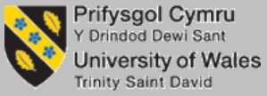

MARKETING ESSENTIALS - BMIH4005
A comparison of the marketing methods of two multinational hotel chains

Name of the Student: Mirel-Tiberiu Neagu
Student ID: 1918824

Lecturer: Neil Dyer

1. Introduction
The essay aims to discuss the marketing operations of Intercontinental hotel group (IGT) and Hyatt Hotel Corporation. Intercontinental hotel group is a British multinational hospitality brand working with 350,000 colleagues in more than 100 countries with the aim of delivering true hospitality for goods. Hyatt Hotel Corporation has successfully pursuing its business since 1957 with more than 1000 hotels in 68 countries. Both of these multinational hotel brands are very popular among their customers because of the services they offer and the marketing tactics. The researcher will discover their marketing choices. The current market position will be described followed by their current marketing strategies. The sustainable marketing considerations of these brands will be covered and the marketing messages they are using to regain the customers' confidence after the covid-19 situation will be described in the report.

2. Description
Intercontinental Hotel Group is famous for its services among its customers. Each and every property of this hotel group offers best in class services that come with spacious rooms with attached washrooms, temperature control, private bars and free Wi-Fi facilities (Ihgplc, 2021). On the other hand, Hyatt Hotel Corporation promises a luxurious and authentic hospitality experience with their well-furnished properties, bars, restaurants and gardens with a wide range of delicious cuisines. Intercontinental Hotel Group targets people from middle to high economic backgrounds and that's why they designed their price strategy accordingly. The room rate of the IHG hotel group is starting from £302 and then onwards. The Hyatt Hotel Corporation targets the people who enjoy a luxurious living and thus their pricing range is higher as compared to the IHG group of hotels. The price that the customer needs to pay to book a night stay in Hyatt hotels is £491 (Hyatt, 2021). Intercontinental Hotel Group has a presence in more than 100 countries that include London, Manchester, Glasgow and many other locations. The hotels choose prime locations for their hotels which are nearest to the airports and railways stations and that become the key to success for the IHG group of hotels (Ihg, 2021). Headquartered in Chicago, Hyatt group of hotels and resorts present in more than 68 countries with more than 1000 hotels in different locations of the world. Additionally, they have a central reservation system that helps Hyatt Group of Hotels to provide 24*7 services to their customers. Intercontinental Hotel Group uses multiple media platforms to promote their service that including both online and offline media platforms. The hotel group uses TV advertisements, website advertisements to make the costumes aware of their services. Additionally, their Facebook and Instagram pages have millions of followers because of their excellent services. Hyatt Hotel Corporation primarily uses offline media channels to promote its brand. The best in class service and the brand value provided by this hotel group turns visitors into the brand's advocate. Additionally, the loyalty rewards offered by the Hyatt Gold Passport are accepted in every location and fetches extra discounts to their regular customers (Hyatt, 2021). Additionally, this hotel group is engagingly using their YouTube and Instagram profiles to promote the brand.
The Intercontinental Hotel Group has 6031 hotels that are currently operating throughout the world which means they have a 3.00% market share globally. However other biggest hotel brands like Marriott, Hilton group of hotels also have significant market shares and are the main competitors of IHG hotels. Due to the recent pandemic situation, the revenue earned by the organisation is £992 million which is 52% reduced as compared to 2019 (Ihgplc, 2021). This UK-based popular hotel makes its business under different brands such as Crown pLaza, Hotel Holiday Inn Express, Hotel Holiday Inn, Hotel Indigo and Candlewood Suites. According to Macrotrends (2021), the net worth of the company as of now is £185 billion. In 2020, Hyatt Hotel Corporation have earned 2.7 billion US dollars which is 59% lower than the previous years. The Hilton hotels, Westin Company, Marriott group of hotels are the biggest competitors of this brand in the world. Hyatt Hotel Corporation operates under different brands namely Caption, Hyatt Regency, Alila, Thompson Hotels, Park Hyatt and many others throughout the world. In 2020, Hyatt group of hotels generate a brand value of 4.53 billion US dollars (Statista, 2021). Because of their service the customers in the world rate Hyatt 79 out of 100 which is greater than the average rating in the hotel industry. According to Macro trends (2021), as of now the net worth of Hyatt Hotel Corporation is 8.45 billion US dollars.
According to KHAN et al (2018, p.2020), their strategy is to deliver high quality, industry-leading services in order to ensure their future growth. In order to do that, an intercontinental group of hotels heavily invests in their services to enhance their guest experience and thus engage them with the hotel services. IHG in order to become more accessible to their customers heavily depending on the online platforms. Nowadays 75% of hotels searches have been done online thus using SEO marketing strategy to enhance brands visibility. The ratings and ranking matter a lot in this digital era. Intercontinental group of hotels gets maximum five-star ratings when it is compared with other hotel groups. In 2020 the Hotel Holiday Inn brand was awarded the best budget-friendly luxury hotels (Nozdreva and Churakova, 2021, p.20). The Intercontinental hotel group offers great facilities like best rates on booking, rewards points and free night stays with their loyalty program to keep their customers engaged. Hyatt hotel Corporation has been the first choice of the consumers for years because of their excellent services. This hotel group keeps their costumes at heart and thus always treat their guests exceptionally with their starters of the art facilities. The multinational hospitality company has ranked 9th in fortune 500 magazine (Bowie et al, 2016). Additionally, Hyatt has broken the monotony of hotel services with their loyalty programs and differentiating experience. Additionally, the hotel considers their human resources as their valuable assets thus they arrange a reward system in their hotels which make them more dedicated to their responsibilities. It also helps the hotel to become popular in the business market as the hotel is chosen among the 100 companies for the best place of work (Bowie et al, 2016).
Intercontinental hotel group aims to shape the future of the travel industry. IHG group hotels, with the support of the people, decide to make a positive change in the local community and to preserve the beauty of the plant at the same time (Wang et al, 2020). Intercontinental hotel groups with their thousands of colleagues influence the diverse culture in the organisation so that all their employees get equal treatment irrespective of their gender, race, or color (Ihgplc, 2021). The hotel with its expanding business supports the local communities by hiring local people, and local vendors. Additionally, the IHG group of hotels maximises the use of renewable energy and aims to entirely reduce their carbon footprint by 2030 (Ihgplc, 2021). The organisation already concentrates on reducing waste production and exchanging the single usable items in their hotels with reusable materials. Over more than 60 years Hyatt Hotel corporations have been working responsibly towards the plant (Hyatt, 2021). Hyatt group of hotels are focused on reducing greenhouse gas emission, improving the energy and water efficiency, and reducing waste production (Hyatt, 2021). The hotel group strongly supports the communities that strongly depend on tourism by providing them with proper education and job opportunities. Additionally, Hyatt committedly works with its suppliers to enhance the sourcing of responsible products.
The intercontinental hotel group manages the effect of covid-19 with their colleagues as a team. IHG hotel group is responding thoroughly and quickly to ensure their guests, hotel owners, colleagues and the local community from where they belong (Ihgplc, 2021). The hotel group ensures that their amazing hotels and services are ready to safely welcome their guests again. The hotel group reported that they will take great care of the guests with their proper cleanliness and minimum contact facilities. Hyatt continuously monitors the covid-19 situation and takes proper precautions to make their hotels the safest place for their guests. Additionally in the covid-19 situation, they help their guests by providing booking with confidence and travel flexibility facilities (Hyatt, 2021).

3. Conclusion
Marketing is a process, a set of instructions and activities that are used by different business organisations for communicating, delivering, creating and exchanging offers that have value for the clients, customers, partners and society. The researcher through this essay aims to discuss the feasibility of marketing for two famous multinational hospitality brands namely The Intercontinental hotel group and Hyatt Hotel Corporation. The researcher thus presented the current marketing choices of these hotel groups. The current marketing position has been discussed followed by their current marketing strategies. The responsibility of these hospitality brands towards the environment has been discussed in the essay and their response towards their customers in the Covid-19 situation has been added to the report.

References
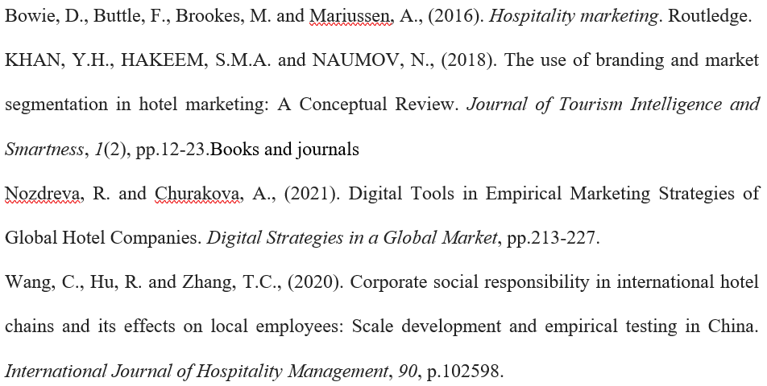

Websites
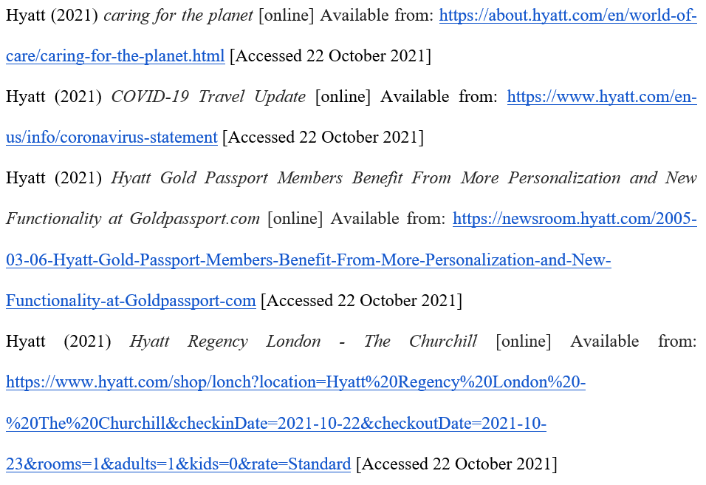Ihg (2021) Popular Destinations [online] Available from: https://www.ihg.com/destinations/gb/en/explore?scmisc=WEB-_-6C-_-GLO-_-QE-_-AE-_-RatesOffers-_-StayPage [Accessed 22 October 2021]
Ihgplc (2021) IHG PLC – Full Year Results to 31 December 2020 [online] Available from: https://www.ihgplc.com/-/media/2-ihg-plc-sea--23-feb-2021.pdf [Accessed 22 October 2021]
Ihgplc (2021) Our response to Covid-19 [online] Available from: https://www.ihgplc.com/en/about-us/our-response-to-covid-19 [Accessed 22 October 2021]
Ihgplc (2021) PLANT [online] Available from: https://www.ihgplc.com/en/responsible-business/our-planet [Accessed 22 October 2021]
Ihgplc (2021) True Hospitality for Good [online] Available from: https://www.ihgplc.com/ [Accessed 22 October 2021]
Macrotrends (2021) Hyatt Hotels Net Worth 2009-2021 | H [online] Available from: https://www.macrotrends.net/stocks/charts/H/hyatt-hotels/net-worth [Accessed 22 October 2021]
Macrotrends (2021) Intercontinental Hotels Group Net Worth 2006-2021 | IHG [online] Available from: https://www.macrotrends.net/stocks/charts/IHG/intercontinental-hotels-group/net-worth#:~:text=Intercontinental%20Hotels%20Group%20net%20worth%20as,15%2C%202021%20is%20%2412.87B. [Accessed 22 October 2021]
Statista (2021) Revenue of Hyatt Hotels Corporation 2008-2020 [online] Available from: https://www.statista.com/statistics/257362/revenue-of-the-hyatt-hotels-corporation/ [Accessed 22 October 2021]

