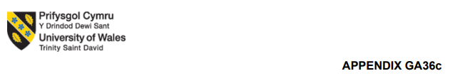

Programme: BA Leadership and Management Skills for the Workplace Module: Developing Emotional Intelligence Skills for the Workplace
Module code: BMSW6106
Contribution to Overall Module Assessment (%): 100%
Lecturer: Amare Desta (Prof)
Internal Verifier: M.D. Kalam
Student name :Dinyo Radev 2129750
TITLE: INVESTIGATING THE ROLE OF EMOTIONAL INTELLIGENCE (EI) IN THE WORKPLACE AND FAYE INC.
WORD: 3551

Table of Contents
1. Introduction 4
2. The Role of Emotional Intelligence (EI) in the Workplace 4
2.1. Definition of Emotional Intelligence 4
2.2. Importance of EI at FAYE Inc. 5
2.3. Challenges of Low EI in a Multicultural Workplace 6
3. Emotional Intelligence Models 6
3.1. Goleman’s Emotional Intelligence Model 7
3.2. Bar-On’s Emotional Intelligence Model 8
3.3. Analysis of EI Models 9
4. The Role of Culture in Understanding EI and Mindfulness 9
4.1. Cultural Awareness and Sensitivity 10
4.2. Cultural Intelligence (CQ) and Mindfulness 10
4.3. The Impact of Culture on EI and Workplace Performance 11
4.4. Cultural Awareness and Mindfulness for Enhancing EI 12
5. Strategies for Harnessing EI and Mindfulness at FAYE Inc. 12
5.1. Implementing EI Training Programs 12
5.2. Cultural Awareness Workshops as a way of promoting Inclusivity 12
5.3. Introducing Mindfulness Practices 13
5.4. Establishing Effective Feedback Systems 13
6. Conclusion 13
7. Recommendations 14
References 16
Appendix: Poster 18

List of Figures
Figure 1: Definition of Emotional Intelligence 5
Figure 2: Goleman’s Emotional Intelligence Model 7
Figure 3: Mindfulness And Emotional Intelligence 10
Figure 4: Impact of Emotional Intelligence on Organisational Performance 11

1. Introduction
This report seeks to evaluate Emotional Intelligence (EI) and Mindfulness in their role of improving and promoting workplace performance and inclusivity in the workplace at FAYE Inc. Today we live in a business world which is very globalised and organisations are very much diverse – people from different cultural social or language background. Therefore, Emotional Intelligence and mindfulness are two key productive tools that enable the creation of positive workplace relationships, better communication, and the existence of a respectful and productive work environment. This report will attempt to elucidate the correlation between superior leadership skills, employee satisfaction and overall organisation’s performance that can be developed by the improvement of EI and mindfulness.
Recently, FAYE Inc. hired new supervisor Clarke followed by migration from Texas previously working in the same type of organisation. However, his interaction style has met with employees’ concerns. Clarke said he felt comfortable using endearing phrases such as “my love”—some of his female employees thought it was too intimate considering his work culture from Texas. Its preference to use English names to address Chinese employees instead of their actual names indicates a lack of cultural sensitiveness by Clarke (Acosta-Prado, Zárate-Torres, and Tafur-Mendoza, 2022). This type of interaction has had employees become less loyal and concerned with inclusivity in their workplace. These concerns of Clarke are indicative of a need for further understanding of Emotional Intelligence and Mindfulness in dealing with workplace performance issues formed by the presence of these problems.
The body of this report will be divided into different sections. An examination of the role of Emotional Intelligence on the workplace and then discuss in more detail about the use of two EI models. Then, cultural awareness will be examined regarding the importance of it in understanding the nature of EI and facilitating mindfulness.

2. The Role of Emotional Intelligence (EI) in the Workplace

2.1. Definition of Emotional Intelligence
Emotional Intelligence (EI) is the ability to intelligently recognise, understand, and manage this own and other people’s emotions to skilfully steer the thinking, mediation, behaviour, and social relations. According to Goleman, a leading researcher in this field, EI comprises five elements: self-awareness, self-regulation, motivation, empathy and social skills. For example, Bar On (1997) defines EI as a particular set of emotional and social competencies that influence how individuals perceive and express themselves and behave towards others, as well as cope with daily problems.

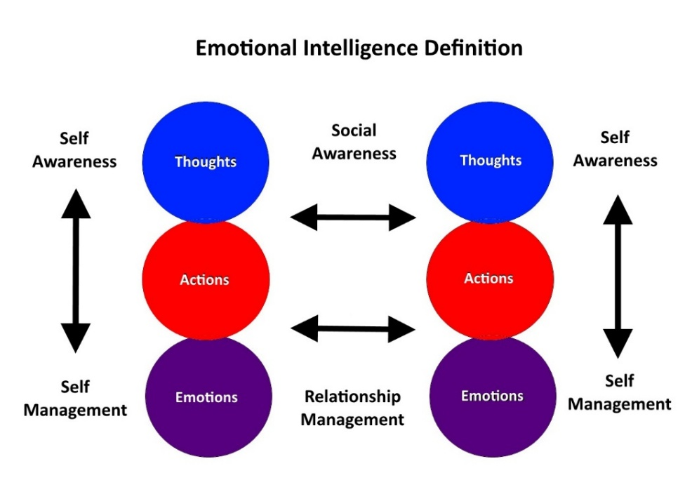

Figure 1: Definition of Emotional Intelligence
(Source: Adekiya et al., 2021)
For example, EI is an important skill in the workplace for effective leadership, communication, dealing with conflict and making better decisions. The leaders with high EI will be able to empathise to their employees, and communicate well, and foster a better work environment that makes people be productive and be inclusive (Adekiya et al., 2021). EI is also important to understand and navigate complex social interactions, manage stress and promote resilience. Especially when dealing with multicultural work environment in which people with various backgrounds, values and communication styles are all present. EI can help leaders develop their capacity to respond appropriately to different emotional cues to create team cohesion and increase organisational performance.

2.2. Importance of EI at FAYE Inc.
Clarke’s case at FAYE Inc. is illustrative of the impact that a deficit in my Emotional Intelligence can have on both relationships and communication at the workplace and also the morale of employees. Clarke’s positive approach to his female workers with expressions of love like ‘my love’ were seen as unprofessional and inappropriate. Also, Clarke didn’t show any cultural sensitivity and empathy when he preferred asking Chinese employees to wear English names rather than use their actual names (Cavaliere et al., 2021). Due to these actions, employees are becoming uncomfortable and may end up disengaging, not being motivated, and not performing as they have been in the past.
It is important for Clarke to be emotionally intelligent in managing a colourful workforce at FAYE Inc. Goleman’s EI model includes the skills of empathy as well as social awareness, essential for leaders to know and appreciate how cultural differences should be recognised and appreciated, how their words and actions could be seen by others and how to change their communication skills.
Results from research show that leaders with high EI are able to create a positive work environment, create a culture of inclusion, and create meaningful connexions with employees (Chakraborty et al., 2023). By improving his EI, Clarke would be able to respond well to feedback, show an interest in the employees' well-being and establish trust and good mutual respect. As a result, employee satisfaction, productivity, and harmony in the workplace at FAYE Inc would improve.

2.3. Challenges of Low EI in a Multicultural Workplace
Challenges from Clarke’s encounters with others at FAYE Inc. illustrate how low Emotional Intelligence is detrimental to the functioning of a multicultural workplace. While such informal terms as ‘my love’ may have been acceptable in Clarke’s previous work place in Texas, he did not appreciate the fact that they might not go down well with colleagues from other cultural backgrounds. In addition, Clarke assumed that Chinese employees should take English names to aid in communication — a clear lack of cultural sensitivity that appeared to be completely bent on cultural diversity.
Lowering the EI in the multicultural workforce will also have some negative consequences onto the employees in form of decreased morale, engagement, and productivity. Unless leaders are empathic and culturally aware employees may feel less valued, or not be understood, or even marginalised at the hands. Ching, Isa, and Manaf, (2025), studies show that leaders with low EI use communication styles that are perceived to be insensitive, disrespectful, or exclusionary. Consequently, such behaviour can lead to higher turnover on the job, lower job satisfaction, and also conflict in the workplace.

3. Emotional Intelligence Models
Emotional Intelligence (EI) models consist of structured how we can understand and improve emotional intelligence competencies. There are two of the most widely known models in the field, namely Goleman’s Emotional Intelligence Model and Bar-On’s Emotional Intelligence Model. This chapter attempts to show the value these models of EI offer in developing and applying these components to increase leadership effectiveness, workplace communication, and cultural sensitivity.

3.1. Goleman’s Emotional Intelligence Model
Daniel Goleman’s Emotional Intelligence Model (2005) is considered one of the most influential and referred to models of EI. Here, Goleman says that EI or emotional intelligence combines these five core components: self-awareness, self-awareness, motivation, empathy and social skills. All of the components help an individual to be able to recognise, understand and control emotions in themself and others.
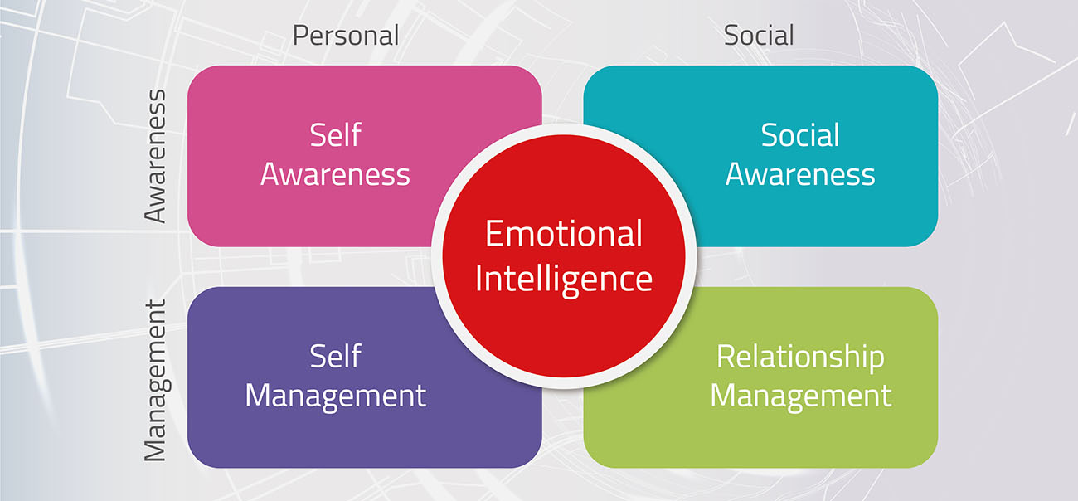

Figure 2: Goleman’s Emotional Intelligence Model
(Source: Cui and Li, 2021)
The meaning of self-awareness mentioned above is to recognise and understand the emotions, the strengths and weaknesses, the triggers, etc. for oneself. Clarke recognises its key to self-awareness so he can understand the ways in which his more informal ways of communicating such as using a context of endearing things such as “my love” might be considered unprofessional or not appropriate by his staff (Cui and Li, 2021). With self-awareness, Clarke will become aware of his words or actions to adjust himself to avoid causing discomfort.
It also includes the ability to control impulsive emotions and behaviours, being calm under stress, and being flexible in adapting to changing circumstances, and applying them appropriately in different situations. Clarke’s form of lack of regulation and adaptation: insistence on using English names of the Chinese employees under his command (Dott et al., 2022). This ability could be improved in order to receive more constructive feedback, change his communication style as needed, and be more culturally sensitive.
Motivation is the drive to achieve goals, maintain enthusiasm and keeping up with the tough times. Although Clarke seems to be really trying to succeed in the role of a supervisor, there’s a chance he might not be able to perceive the emotional needs of his employees while he’s trying to be so efficient and he has to follow very strict schedules (Hamizat, 2021). It enables him to develop intrinsic motivation of employee well-being and inclusivity which will better help to improve his overall leadership effectiveness.
One of the most important components of EI is Empathy, that is, the ability to recognise and understand the emotions, peripheries and the culture of the other. Essentially, Clarke sympathises with his employees being uncomfortable in some regard with the way he greeted them, and they do not like that he was calling them by Chinese names, but fails to empathise with their genuine discomfort being welcomed in that manner (Majova, 2022).

3.2. Bar-On’s Emotional Intelligence Model
Reuven Bar On by through the Bar On model of Emotional Intelligence emphasises a more general approach to EI concerning emotional, social, and cognitive skills. The emphasis of this model lies in the role of EI in dealing with the everyday demands and challenge. By bar-on, intrapersonal skills, interpersonal skills, adaptability, stress management and general mood were added five components of the EI (Nazaripour and Zakizadeh, 2025).
The intrapersonal skills refer to self-awareness, emotional expression, independence, self-confidence and so on. Lack of knowledge about what his communication style conveys to other people reflects a weakness in Clarke’s intrapersonal skills. Clarke’s enhancement of these skills will deepen his ability to understand his own emotions and strengths as well as weaknesses and enable him to interact better with employees.
Interpersonal skills are very important to build meaningful relationships, empathy and social responsibility. Importance of appreciating and understanding the emotions of others, especially in multicultural work place like FAYE Inc as this is what Bar On’s model suggests, however Clarke’s inability to empathise with employees who find his greeting style uncomfortable require further improvement in this area (Padhy, Das, and Panda, 2024).
Adaptability is one’s ability to deal with change, solve problems, and able to be flexible when faced with the challenge. Clarke is not flexible in culture and insists to call his Chinese employees by their English names. This will help him to be able to respond more effectively to a given diversity of culture and modify his leadership style accordingly.
Stress management refers to keeping stress in cheque and being able to withstand it. This particular part isn’t really visible in Clarke’s interactions but it is very important for Clarke to learn this skill before he can continue being composed when having issues of cultural sensitivity (Sanchez, 2022). Clarke will be more effective at being thoughtful in response to feedback or criticism rather than quick to react, if he’s good at stress management.
The Bar-On model offers a comprehensive holistic framework of the workplace performance which emphasises emotional, social and cognitive skills as means to enhance on workplace performance. This model can be applied to help Clarke learn the skills that would enable him to cope with cultural differences, communicate more effectively, develop better relationships with his employees.

3.3. Analysis of EI Models
Goleman’s and Bar-On’s models properly provide useful information about the way Emotional Intelligence can be developed and used in the workplace. Goleman’s model emphasises more on specific core competencies of leadership, social communicability and social interaction but the stride of Bar-On’s model is quite wide that in addition to emotional, social and cognitive ability it includes.
Through combining syntheses of the models, Clarke can optimise his EI capabilities and be an effective leader in FAY Corp (Sayegh, 2024). Likewise, culture-augmented EI development, can assist faculty member to acknowledge and pay attention to the various backgrounds of his workers.

4. The Role of Culture in Understanding EI and Mindfulness
Emotional Intelligence (EI) in the workplace places an emphasis on cultural awareness and sensitivity, more so in terms where employees from different backgrounds are present. The ability to understand and respect cultural differences is essential in the communication, conflict resolution and fostering an inclusive work environment. Clarke’s experiences with employees as she works at FAYE Inc. provide clear evidence that the culture is crucial for the development of EI and mindfulness.
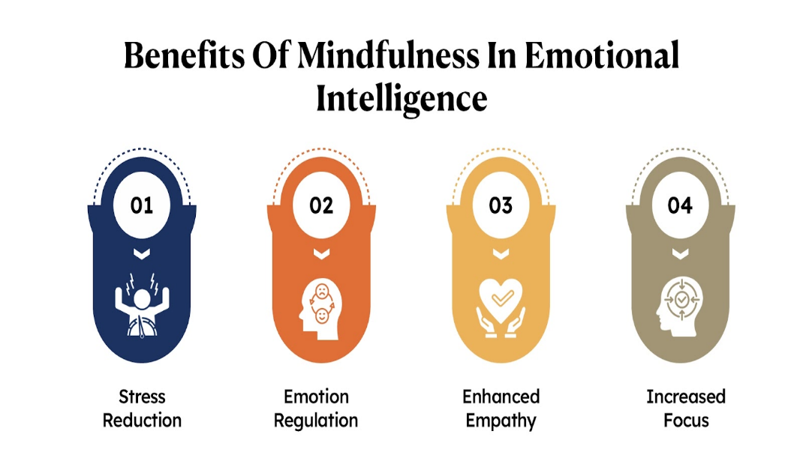

Figure 3: Mindfulness and Emotional Intelligence
(Source: Segers, 2023)

4.1. Cultural Awareness and Sensitivity
Cultural awareness consists of understanding and knowing how to deal with the differences among beliefs, values and communication styles in different cultures. Clarke acknowledges that if you are the leader, you need all the cultural awareness you can develop or else you may not act in a way that may be considered inappropriate or non-respectful. Given Clarke’s casual usage of my love and preference of English names over Chinese name, he shows a contriteness to respect of norms and expectation of culture.
Hofstede’s Cultural dimensions theory (1980) gives insight into cultural difference. One example is that the Chinese culture, which holds in high regard hierarchy, respect, and formal communication, may be put off by Clarke’s informal greetings. Moreover, cultural collectivism that is common in Chinese society emphasises group harmony and relationships; it is probable that Clarke’s rigid approach will be considered inconsiderate. Thus, by using Hofstede’s model, Clarke could take a step further in the understanding of how cultural values would influence the perceptions and interactions of employees, hence we ought to recall the concept of cross-cultural sensitivity, the importance of balancing uniqueness and uniformity of expectations in a given culture.

4.2. Cultural Intelligence (CQ) and Mindfulness
The cultural intelligence, CQ is that capability which is used for interacting and managing between different cultural settings. This includes knowing the differences in cultural, having the mindfulness and behavioural adaptation. For this context, mindfulness means being aware of one’s own emotions, thoughts, and biases when we are dealing with different culture individuals.
In order to develop CQ leaders have to be empathetic, adaptive and be willing to learn from his or her experience. It indicates a lack of CQ when Clarke refuses to bend to the desires of Chinese employees (Segers, 2023). Mindfulness can enable Clarke to notice his biases, reflect different perspectives and respond more superbly with regards to socially differed representatives. Previous research has suggested that leaders with high CQ are more fit to promote inclusivity, facilitate trust, and facilitate employee engagement.

4.3. The Impact of Culture on EI and Workplace Performance
Emotions are strongly influenced by culture in terms of how they are perceived, shown, and regulated. Employee engagement can be jeopardised if leaders do these things without grasping the cultural awareness and knowledge of their employees. The reason why Clarke ‘assumed’ that Chinese employees should adopt English names could their cultural identity and could lead to feeling excluded and frustrated.
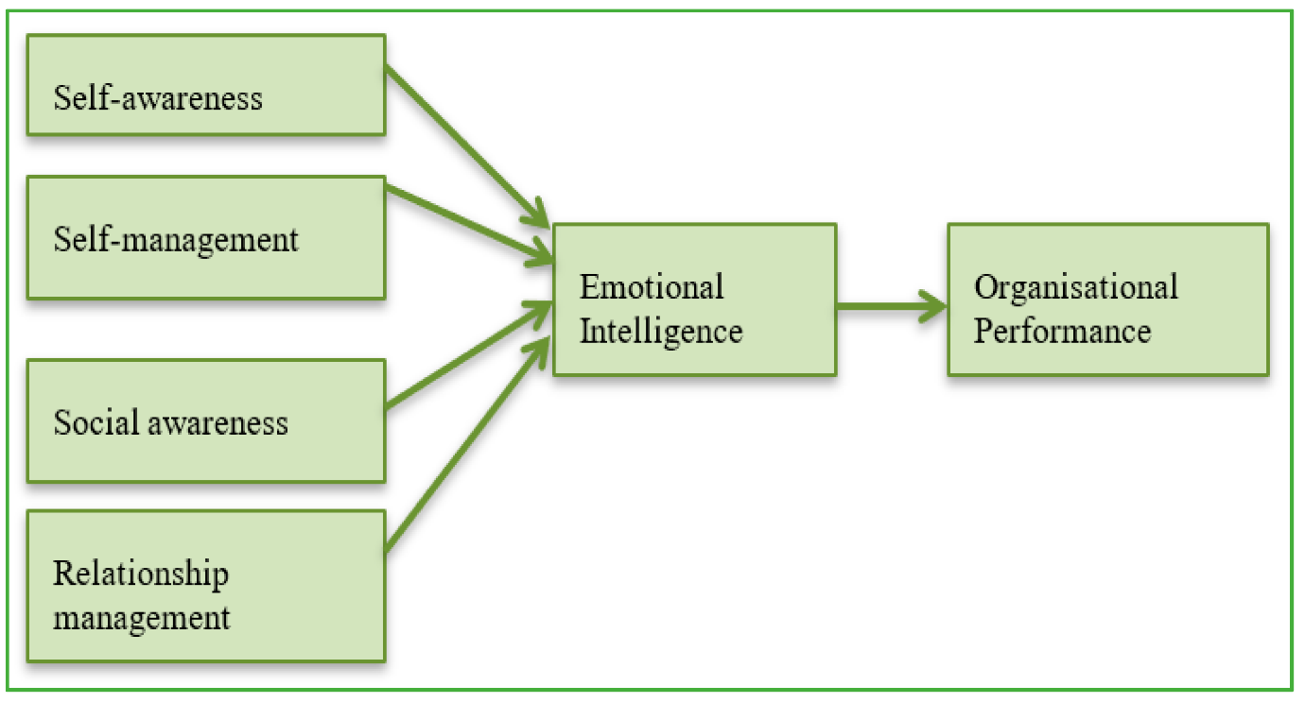

Figure 4: Impact of Emotional Intelligence on Organisational Performance
(Source: Suong and Tho, 2021)
This also relates to research which claims that if the cultural competence is not acquired, then empathy; one of the chief aspects of EI, cannot develop. This is a damning rejection of an employee’s desire to always be referred to by their actual name, primarily because Clarke can’t bear to put himself in their shoes. By developing empathy and increasing his cultural sensibility, Clarke can improve his skills with communication, strengthen his relationships and promote a more inclusive work culture at FAYE Inc.

4.4. Cultural Awareness and Mindfulness for Enhancing EI
In order to enhance his EI competencies, Clarke has to grow cultural awareness and mindfulness. This entails mastering the ability to listen actively to employees, understanding the culture of employees, and showing respect to different backgrounds. Clarke can also encourage employees to share their cultural experiences and perspectives, thus providing him an opportunity to build on an inclusive approach to leadership. In addition, adding in mindfulness practises like reflection and active listening will make it easier for Clarke to respond thoughtfully and appropriately to cultural differences.

5. Strategies for Harnessing EI and Mindfulness at FAYE Inc.
To help Clarke conquer the challenges he is faced with and to overall help FAYE Inc improves the workplace performance emotionally it is imperative to take advantage of strategies aimed at increasing Emotional Intelligence (EI) as well as mindfulness. FAYE Inc. is capable of creating more positive and productive work environment by fostering inclusive, empathetic, and adaptable culture. The following strategies are recommended.

5.1. Implementing EI Training Programs
Structured EI training programmes can help Clarke and other leaders at FAYE Inc to be better prepared in ordering to be able to manage emotions, communication and empathy. Such programmes should work to improve the following ‘EI’ (emotional intelligence) competencies: self-awareness, self-regulation, motivation, empathy, and social skills (Suong and Tho, 2021). Role playing, feedback sessions and case studies can be practicable exercises used to help leaders understand how their actions affect others. It should also train people to have an awareness of and adapt themselves to handling the diversity of workplace environments.

5.2. Cultural Awareness Workshops as a way of promoting Inclusivity
To meet Clarke’s cultural sensitivity deficiency, FAYE Inc. will need to educate employees about different cultural norms, values and communication styles through cultural awareness workshops. These workshops should discuss the need to respect employees’ cultural identities and preferences including using employees’ real names when addressing the Chinese employees. This will help Clarke to be able to empathise with employees coming from different cultures by encouraging open discussions of cultural differences and supporting mutual respect.

5.3. Introducing Mindfulness Practices
Some mindfulness practises like meditation, reflection sessions and active listening can assist Clarke in improving the EI and gaining a better understanding of how his words and actions are likely to be listened to by others. In particular practising mindfulness will allow leaders to be present, attentive, and empathetic when we are in contact with one another and is important in keeping workplace conflict and inclusivity at a minimum (Swetha et al., 2023). Clare's regular mindfulness workshops will also help increase his self-awareness and emotional regulation which will better prepare him to respond to feedback and criticism and also give him time to ration out his anger.

5.4. Establishing Effective Feedback Systems
To enhance EI and make it more inclusive, it is necessary to establish a strong feedback mechanism where employees feel free to convey their views without retaliation. Instead, Clarke should proactively give employees the chance to provide feedback and be willing to hear what is being said (Majova, 2022). This will feel like a relief to him since this approach will help him determine where to improve, the cultural awareness increase, and strengthen relationship with his team.
The application of these strategies will serve to improve Clarke’s EI, develop mindfulness and create an inclusive and harmonious work environment for FAYE Inc.

6. Conclusion
Thus, the case of Clarke at FAYE Inc. proves that the importance of Emotional Intelligence (EI) and mindfulness in performing well on the job, as well as in increasing inclusiveness and employee satisfaction and productivity are key. A lack of cultural awareness and sympathy on Clarke’s part has made employees feel uncomfortable and the general morale down. To address these challenges, however, a complete remedy needs to be prioritised, which means working to develop the most effective EI competencies — self-awareness, self-regulation, empathy, social skill, and adaptability.
Since both the Goleman’s Emotional Intelligence model and the Bar-On’s Emotional Intelligence model are useful in conceptualising and development EI in workplace, the above two emotional intelligence models can be used well. Clarke would benefit much from Goleman’s model of empathy, motivation and social skills. Although these are all important aspects, Bar On’s model employs adaptability, stress control and good attitude specifically, all which are essential to creating an environment less likely to foster disrespect.
Therefore, Clarke must introduce the use of structured EI training programmes, build cultural awareness and mindfulness practises, and establish good feedback mechanisms in order to enhance his emotional and cultural competencies. These strategies will continuously be evaluated and improved so that the Clarke will ultimately develop into a more effective leader and worked in an environment that promotes positivity and inclusiveness.

7. Recommendations
The following recommendations is based on the finding of a deficit of Emotional Intelligence (EI) at FAYE Inc and its cultural insensitivity in performing tasks at workplace.
Implement Comprehensive EI Training Programs:
Formal EI training should be afforded to Clarke and other leaders at FAYE Inc., aimed at enhancing specifically empathy, social skills, and adaptability. Practical exercises, such a role playing, feedback session and training in cultural sensitivity, should be included in the training.
Promote Cultural Awareness and Inclusivity:
Cultural awareness workshops – which educate leaders and workers on how their cultural norms, communication styles, and preferences – should be launched by FAYE Inc. The focus on employee names they prefer to be called and recognising cultural diversity can make the workplace more inclusive.
Introduce Regular Mindfulness Practices:
Clarke can boost self-awareness and emotional regulation through the incorporation of consciousness skills such as meditation, active listening and reflection in her routine. All employees should be made available regular mindfulness workshops to improve focus, resilience, and interpersonal interaction.
Establish Feedback Systems:
The presence of a transparent and supportive feedback mechanism will allow employees to voice their complaints and how they ought to be improved (Dott et al., 2022). Notably, he should be encouraged to take the initiative and actively seek for feedback while showing himself open to learn from his mistakes.
Continuous Monitoring and Evaluation:
Continue to survey and perform reviews of subsequent EI training programmes, cultural awareness initiatives and mindfulness practises. These strategies need to be tuned up accordingly to keep the efficiency improving continuously.

References
Acosta-Prado, J.C., Zárate-Torres, R.A. and Tafur-Mendoza, A.A., 2022. Psychometric properties of the Wong and Law emotional intelligence scale in a Colombian manager sample. Journal of Intelligence, 10(2), p.29.
Adekiya, A., Aliyu, M.S., Bello, G.B. and Kofar-Mata, B.A., 2021. Moderating influence of emotional intelligence in the relationship between domain-based self-efficacy and task performance: A study of employee in Nigerian banking industry. Ekonomia Międzynarodowa, (35), pp.146-174.
Cavaliere, L.P.L., Poddar, A., Poddar, S., Padma, S., Koti, K., Chakravarthi, M.K., Rajest, S.S. and Regin, R., 2021. Emotional Intelligence and Driving Change in Public Sector: The Mediating Role of Culture. Turkish Online Journal of Qualitative Inquiry, 12(7).
Chakraborty, R., Bhattacharjee, A., Mostafa, A. and Bhattacharjee, P.K., 2023. Study of Correlation between different fingerprint Patterns and Emotional intelligence in Medical Students. Journal of Chittagong Medical College Teachers' Association, 34(1), pp.90-94.
CHING, D.N.S., ISA, D.Z.M. and MANAF, D.M.R.B.A., 2025. Emotional Intelligence and Its Association With Working Environmental Factors and Spiritual Intelligence Among Doctors. Notion Press.
Cui, Z. and Li, Y., 2021. The relationship between proactive behavior and work-family conflict: A moderated mediation model. Frontiers in Psychology, 12, p.657863.
Dott, C., Mamarelis, G., Karam, E., Bhan, K. and Akhtar, K., 2022. Emotional intelligence and good medical practice: is there a relationship?. Cureus, 14(3).
Goleman, D., 2005. Emotional intelligence: Why it can matter more than IQ. Bantam.
Hamizat, N.H., 2021. The relationship between emotional intelligence and job performance: a case of O&G industry in Malaysia (Doctoral dissertation, Universiti Tun Hussein Onn Malaysia).
Majova, N., 2022. Counterproductive work behaviour, personality and trait based emotional intelligence: A South African personality inventory model profile analysis. University of Johannesburg (South Africa).
Nazaripour, M. and Zakizadeh, B., 2025. Moral intelligence, emotional intelligence, organizational commitment and job performance of accountants. Accounting Research Journal, 38(1), pp.19-34.
Padhy, T.P., Das, S. and Panda, L.P., 2024. Emotional intelligence and employee involvement: a study on the mediating effect of compassionate leadership. International Journal of Business Performance Management, 25(4), pp.565-588.
Sanchez, T., 2022. Saddling Up for Success: Rope or Wrangle? Comparing Experiential Learning Programs for Developing Emotional Intelligence in the Workplace.
Sayegh, F., 2024. Leveraging emotional intelligence to foster proactive climate change adaptation: A study of engineering decision-making. Journal of Environmental Management, 365, p.121669.
Segers, S.K., 2023. The perceived quality of interpersonal communication and the role it plays in emotional intelligence and workplace engagement. Keiser University.
Suong, H.T.T. and Tho, T.A., 2021. Emotional Intelligence, Work Stress, Job Satisfaction, and Employee Creativity: A Critical Study on Vietnamese Universities. Indian Journal of Economics and Business, 20(3).
Swetha, P., Ramesh, K.S.V., Vanguru, R., Sruthima, G.N., Rajashekaraiah, P.B. and Srinivas, S., 2023. Role of emotional intelligence in academic performance among dental students of South India: a cross-sectional study. Journal of Datta Meghe Institute of Medical Sciences University, 18(4), pp.698-702.

Appendix: Poster


