

Assignment Title: Portfolio of Evidence
Student Name-Gabriela Iuliana Giurgiu
Student ID-2240417
Module title: Business Skills BMIH4001
Lecturer’s name: Daniel Payne
Wordcount: 3184

Introduction
Understanding how we transmit information and making improvements to it are crucial in the dynamic world of contemporary communication. Investigating models that can improve our message transmission is a part of this journey. One such framework that offers important insights into the complex procedure of effective communication is the Shannon-Weaver Communication Model. In this investigation, I will go into this concept to reveal how it could improve my professional skills.

Task 1
Academic writing
I have found that being able to efficiently organise and outline my thoughts is one of my writing abilities. I can communicate my views clearly and logically thanks to this ability, which will help me succeed in my academic endeavours. Assignments with a clear framework are not only simpler for teachers to understand, but they additionally guarantee that difficult concepts are adequately conveyed.
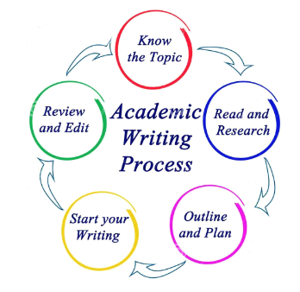
Figure: Academic writing skills
Source: (Cottrell, 2019)
However, I occasionally struggle to write in a formal tone that is consistent throughout. Since formality is important in academic writing, this might have an impact on my academic achievement. The institution offers helpful tools like Grammarly to help with this, which can help me improve the stiffness of my writing. I can also ask academics or the university's writing centre for advice on preserving a suitable tone (Cottrell, 2019).
Research skills
I have noticed that my research abilities are strong, especially my ability to find pertinent material from a variety of sources. My ability to obtain thorough and varied research resources for my tasks would greatly help my academic endeavours. I can focus on critical the process of analysis and synthesis while also saving time if I can sort information effectively.

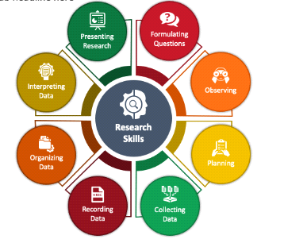
Figure: Research skills
Source: (Cottrell, 2019)
However, occasionally a flaw in analysing sources manifests itself. This flaw might affect how trustworthy my research is. The university provides resources, such as librarians in academia who can help me evaluate materials. This part of my research abilities can also be improved with access to college libraries and research seminars (Cottrell, 2019).
Skills in analysis
My capacity for analytical and critical thought is a strong suit. For a deeper understanding, the capacity to divide complex knowledge into digestible pieces and approach it from several aspects is essential. I can evaluate material objectively and arrive at wise decisions thanks to critical thinking.
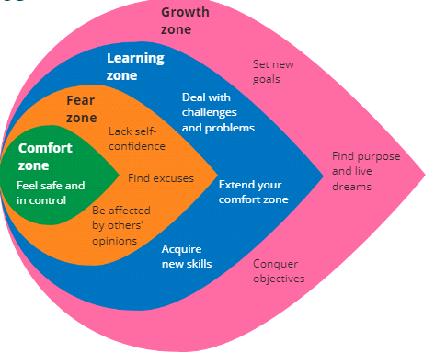
Figure: How to be relevant by critical thinking (The Comfort Zone)
Source: (Cottrell, 2019)
On the other hand, there are instances when I rush throughout the analytical process and draw rash judgements. I intend to spend more time carefully examining the data and taking many viewpoints into account before making judgements. I hope to take use of the university's workshops and resources aimed at improving critical thinking abilities.
My road to thrive in university studies begins with me realising my strengths and my weaknesses in writing for education, research, and analytical abilities. I am certain that I can improve my flaws and build on my strengths by actively seeking assistance from university resources like writing centres, academic librarians, and more and critical thinking workshops. The dedication to my own development and my use of the resources at my disposal will be crucial to my academic achievement (Cottrell, 2019).
Task 2
Harvard Referencing and its relevance
Harvard Referencing utilises both in-text citation and a reference list, in order to acknowledge and track sources in academic writing. Its importance rests in preserving academic integrity, honouring others' contributions, and enabling readers to confirm the accuracy of the content. It guarantees moral behaviour and maintains the ideas behind intellectual property. Harvard referencing is an essential tool for academic writing and research that raises the standard and reliability of scholarly work. I gained this knowledge from the classes provided by my university and the materials provided has strengthened my knowledge regarding the principles of Harvard referencing style.
My confidence level regarding the understanding of citation and referencing
I feel reasonably confident about my comprehension of citation and reference. Even though I am aware of the essential ideas and significance of appropriate citation, I realise that I can always do better. It can be difficult to navigate the nuances of different citation methods, especially when working with a variety of source types. However, in order to retain the highest levels of professionalism and honesty in my academic work, I am dedicated to always improving my talents in this area. The assistance and tools the institution offers, such as the tutorials, handbooks, as well as internet references, are encouraging and help me improve my citation and reference skills.
Support and resources that I can get for my poor level of knowledge
The university offers several helpful resources for assistance if I ever lose confidence in my comprehension of citation and reference. Some of them are tutorials, like the Cite Them Right instruction, which provides a thorough overview of numerous citation formats, including Harvard Referencing. Additionally, the institution's library materials are available, including the webpage for Cite Them Right and the Harvard Referencing Handbook. Additionally, academic staff members and librarians are constantly ready to assist with queries and provide advice. My ability to reference and cite sources correctly can be constantly improved thanks to a blend of these sources and my willingness to ask for help.
Task 3a
Techniques to Combat Perfectionism and Improve Time Management
I would like to talk about how being a perfectionist has been taking up too much of my time. Being a perfectionist, I frequently catch myself overthinking projects, aiming for perfection, and devoting unnecessary effort to every little detail. This propensity may result in inefficiency and low output. Therefore, to combat this, I intend to implement the following time management techniques in my quest of professional development:

Prioritisation
I will develop the ability to rank tasks according to their importance and completion dates. I can better manage my time if I concentrate on what matters most.

Set Achievable Goals
Instead of aiming for unreachable perfection, I will set reasonable goals for each activity or endeavour. This strategy will enable me to maintain the equilibrium between timeliness and quality.
Time Blocking
I will be able to give tasks a set amount of time to complete them by designing time blocks for particular activities. I will be able to maintain my discipline and avoid focusing too much on one task thanks to this.
Requesting Feedback
I am willing to hear what my mentors and peers have to say. This will raise the standard of my work and cut down on the number of unnecessary revisions.
Learning to Let Go
It is important to realise that not everything has to be flawless. Some duties might not require as much attention to detail, which would free up my time for more important professional development activities.
I want to improve my overall effectiveness, achieve my professional growth objectives, and preserve a better balance between work and personal life by confronting my perfectionist inclinations and implementing these time management techniques.
Suggestions for my fellow students
I would tell my fellow students who have trouble managing their time to prioritise their tasks, set realistic goals, and stay away from the dangers of perfectionism. Effective time management is a crucial ability that can greatly advance both a person's career and personal development.
Task 3b
Urgent/Important Matrix
Quadrant | Tasks
Quadrant 1 | Do first – Urgent and important
Quadrant 2 | Schedule – Important, Not Urgent
Quadrant 3 | Delegate – Urgent, Not Important
Quadrant 4 | Avoid – Neither Urgent, Nor Important

 | Urgent (Do first) | Not Urgent (Schedule)
Important (Do first) | - Vising library  - Meeting with professors  - Join classes and learning session | - Strategic planning  - Skill development
Not important (Schedule) | - Checking mails  - Minor administrative tasks | - Social media browse  - Non-essential meetings

Task 4
Industry Event
My recent business event was an exciting experience that made me feel both motivated and uneasy. It highlighted the field's innovative possibilities and difficulties due to quick change and ferocious competition. It emphasised the significance of consulting with seasoned experts and utilising academic resources to successfully navigate the market (Migdal et al.,2015).
My feeling
The incident brought up a complicated jumble of feelings in me. The potential and creativity of the sector excited and drove me. However, given the quick-paced nature of the industry, it also made me uneasy. All in all, it sparked a strong drive to study, develop, and seek advice in order to succeed in this fast-paced field.
Was the event inspirational?
This event was inspirational, without a doubt I can say. My resolve to excel in the area was strengthened by the industry leaders' insights, creative ideas, and success tales. It strengthened my conviction that there is room for improvement and success and inspired me to work even harder to achieve my objectives.
If so, how?
The event motivated me by displaying the industry's innovation and endless possibilities. It emphasised the value of networking and lifelong learning. I was inspired by successful professionals' knowledge and enthusiasm to accept change, be flexible, and pursue greatness in my professional endeavours.
Managing Mixed Emotions: Looking for Advice in the Sector
In fact, the experience left me with conflicted emotions and some trepidation regarding the difficulties facing the sector. I have a network of people I can lean on to help me with these issues. I can seek advice from seasoned mentors and business leaders I met during the event. My university also provides helpful tools like courses tailored to particular industries and career counselling services. These resources will aid in my development of the knowledge and abilities required to successfully navigate the market. My confidence and capacity to address industry changes will be further enhanced by staying updated through company publications, online discussion forums, as well as participating in webinars and workshops (Walker, 2021).
Task 5
Assessment of communication and interpersonal skills
I think I have a number of strengths that have helped me in terms of interpersonal and communication abilities, but I also see places where I can do better.
Strengths
My skills include adaptability, empathy, and active listening. I usually listen well, which enables me to comprehend other people's perspectives and reply wisely. My ability to empathise with people and put myself in their position naturally enables me to effectively communicate and cultivate great interpersonal relationships. I may also modify my communication style to meet the demands of various contexts and target audiences.
Weaknesses
I do recognise that there are some things that could be done better, though. I occasionally have trouble being forceful, especially in social situations. Although it might be viewed as a positive feature, I have a propensity to avoid disagreement, which occasionally makes it difficult for me to firmly convey my own thoughts. I am actively working to get better in this area (Cottrell, 2021).
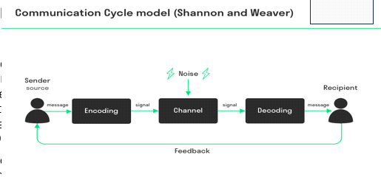
Figure: Communication model
Source: (McMillan et al., 2021)
Preparation for the group interview
I plan to concentrate on developing my assertiveness in order to succeed in future academic group interview without compromising my capacity to listen and empathise. I think using a balanced approach will enable me to participate more successfully in group conversations. Therefore, I would like to follow the communication model of Shannon and Weaver to improve my communication abilities. Additionally, I am eager to improve my public speaking abilities because being able to express myself clearly and confidently is crucial in professional as well as educational settings. I can improve these abilities and get helpful criticism from my classmates and professors during the academic group interview. I am hopeful that this opportunity will be a first step in developing my interpersonal and communication skills for success in school and in the future (McMillan et al., 2021).
Task 6
Communication and interpersonal skills
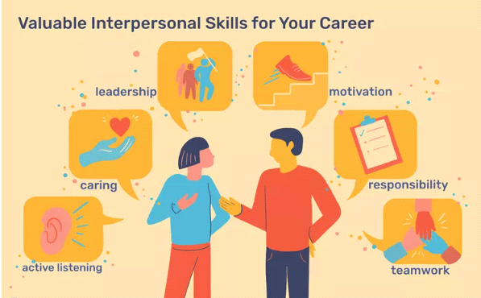
Figure: Valuable interpersonal skills
Sources: Analysis
In the workplace, interpersonal skills also known as soft abilities or emotional intelligence are crucial. They cover all aspects of how we converse, work together, and engage with people. These abilities include teamwork, empathy, leadership, listening, and negotiating. They also involve communication and conflict management. Whatever your line of work, having great interpersonal skills is essential. These abilities are highly regarded by employers when assessing candidates since they help to foster a positive work environment and achieve overall success. The capacity for good teamwork, active listening, and effective communication are particularly crucial. In interviews and on your resume, highlighting these abilities can greatly improve your job readiness and career prospects.
Time-management and productivity
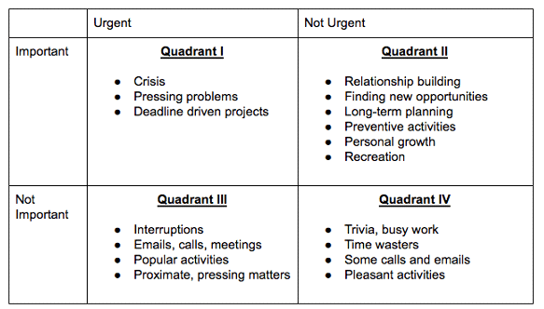
Figure: Time management chart
Source: Analysis
The 4 Quadrants of the Management of Time Matrix, a tool to aid people in task management and productivity improvement, are covered in the article. The classification of each activity into four quadrants—Urgent and Essential, Not Urgent yet Important, Urgent yet Not Essential, and Not Immediate and Not Important—highlights the significance of comprehending the critical nature and significance of each task. People can more effectively prioritise and take control of their workload by appropriately categorising their jobs. The article emphasises the advantages of stress reduction, productivity growth, and better work-life balance while offering a straightforward three-step process for job organisation within the matrix.

Academic skills and writing
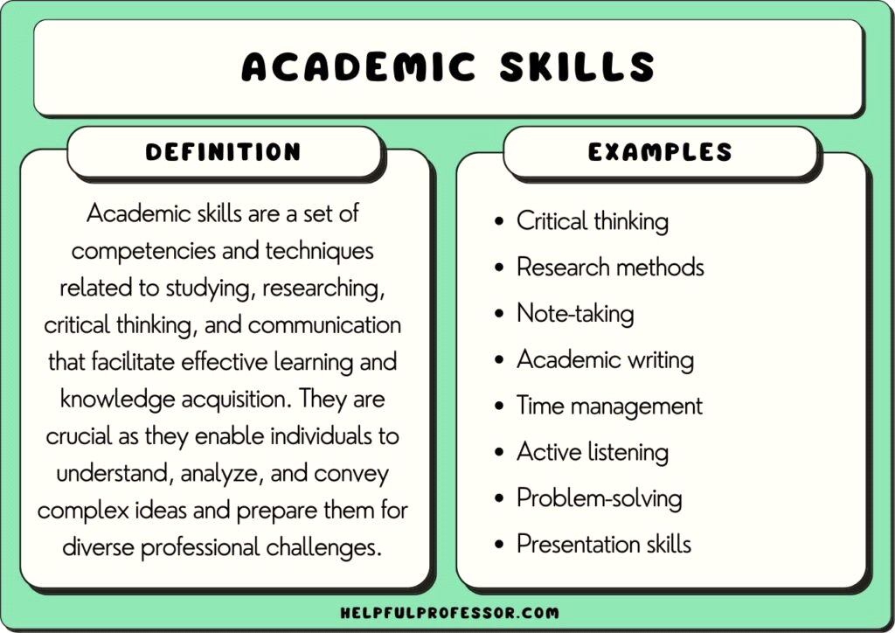
Figure: Academic skills
Source: Analysis
Academic talents cover a wide variety of skills necessary for success in the classroom and beyond. These abilities go beyond only cognitive ones and include soft skills like teamwork, organisation, and communication. Examples include the capacity for critical thought, time management, and research expertise. Academic abilities support academic success and translate into important employment competence. Therefore, to succeed in college, where they must manage challenging assignments, group projects, and a variety of learning opportunities, students must develop these abilities. In the end, these abilities enable people to develop into flexible, curious, and competent problem solvers, improving their chances of succeeding in academia and work.
Professional development
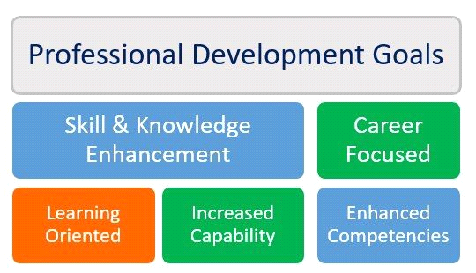
Figure: Professional development goals
Source: Analysis
The significance of developing a thorough professional development strategy is discussed in the article as a means of advancing one's career. It places a strong emphasis on proactive preparation and self-motivation, just as successful people in many different fields. The introduction of a Professional Growth Plan (PDP) as a tool for outlining both long- and short-term professional goals with a focus on self-management. Assessing your existing situation, formulating SMART goals (Specific, Measurable, Achievable, Realistic, and Time-bound), hiring a mentor, creating a calendar, and keeping a record of accomplishments are important elements in constructing this method. The article stresses the value of flexibility as well as the necessity of reviewing and modifying the plan as needed.
Industry Events and Experiences
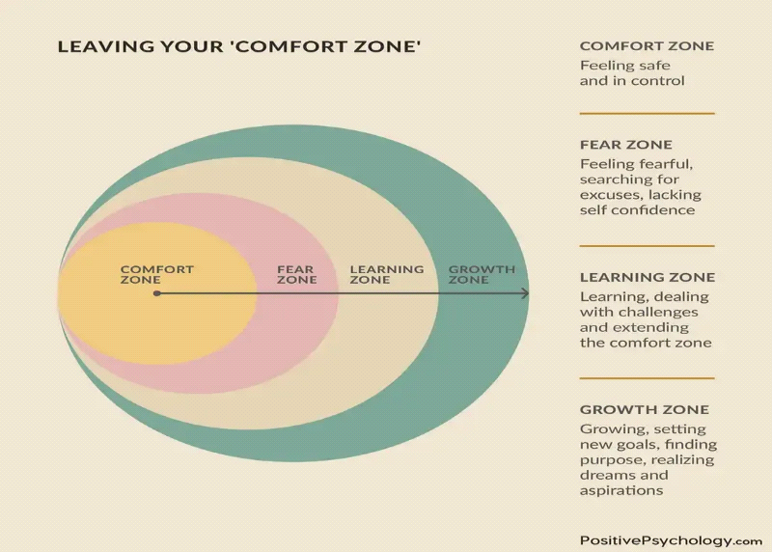
Figure: Comfort zone
Source: Analysis
The idea of stepping outside one's comfort zone and into one's "growth zone" for personal growth is explored in this article. It explores the psychology of comfort zones and places a strong emphasis on awareness of oneself and a growth mentality. Self-actualisation, the formation of a mindset of growth, resilience, and greater self-efficacy are among the advantages of moving beyond of one's comfort zone that are emphasised. The article offers useful advice to help readers break out of their comfort zones, including how to reframe stress, comprehend neuroplasticity, prioritise goals, and take baby steps. Additionally, it provides motivational sayings and links to additional resources. In the end, the piece promotes accepting discomfort as a means of development and self-discovery.

Harari’s theory

Figure: Newspaper Article of Harari’s theory
Source: Analysis
Artificial intelligence and biotechnology development have the potential to splinter society. A small elite might become "superhumans" as a result of these technologies, whilst a large underclass might experience economic and political marginalisation and become "useless." Social unrest as well as instability may result from this expanding inequality. Although AI and robots are capable of many tasks, they cannot take the place of humans' sophisticated creativity, mental abilities, and social awareness. The social, economic, and political ramifications of these technologies must be addressed in order to ensure that benefits are fairly dispersed throughout society and to mitigate this scenario.
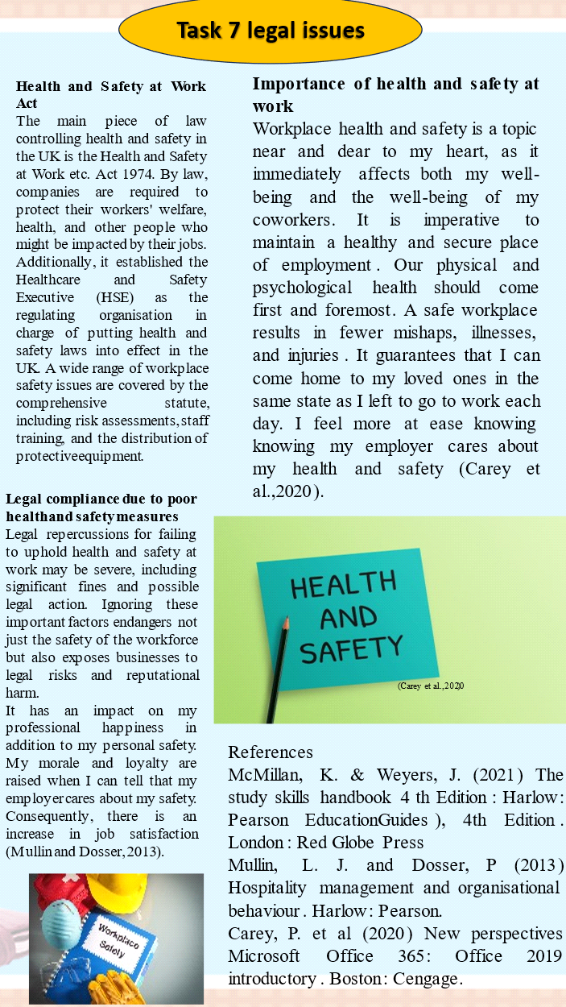

Health and Safety at Work Act
The main piece of law controlling health and safety in the UK is the Health and Safety at Work etc. Act 1974. By law, companies are required to protect their workers' welfare, health, and other people who might be impacted by their jobs. Additionally, it established the Healthcare and Safety Executive (HSE) as the regulating organisation in charge of putting health and safety laws into effect in the UK. A wide range of workplace safety issues are covered by the comprehensive statute, including risk assessments, staff training, and the distribution of protective equipment.
Importance of health and safety at work
Workplace health and safety is a topic near and dear to my heart, as it immediately affects both my well-being and the well-being of my coworkers. It is imperative to maintain a healthy and secure place of employment. Our physical and psychological health should come first and foremost. A safe workplace results in fewer mishaps, illnesses, and injuries. It guarantees that I can come home to my loved ones in the same state as I left to go to work each day. I feel more at ease knowing my employer cares about my health and safety (Carey et al.,2020).
Legal compliance due to poor health and safety measures
Legal repercussions for failing to uphold health and safety at work may be severe, including significant fines and possible legal action. Ignoring these important factors endangers not just the safety of the workforce but also exposes businesses to legal risks and reputational harm.
It has an impact on my professional happiness in addition to my personal safety. My morale and loyalty are raised when I can tell that my employer cares about my safety. Consequently, there is an increase in job satisfaction (Mullin and Dosser, 2013).

Conclusion
The Shannon-Weaver Communication Model is a useful resource for analysing the intricate nature of communication. It emphasises how crucial it is to accurately encode, transmit, and decode messages. People can improve their communication skills and encourage more direct and meaningful interactions in both the personal and professional spheres by putting the lessons learned from this model to use.

References
Baker, R., (2022). 4 Quadrants of Time Management Matrix. [Online] Available at: https://www.ntaskmanager.com/blog/quadrants-of-time-management-matrix/[Accessed 12 august 2023].
Carey, P. et al (2020) New perspectives Microsoft Office 365: Office 2019 introductory. Boston: Cengage.
Conn, R., (2020). HOW TO PLAN A COMPREHENSIVE PROFESSIONAL DEVELOPMENT STRATEGY. [Online] Available at: https://infobase.com/blog/how-to-plan-a-comprehensive-professional-development-strategy/[Accessed 17 august 2023].
Cottrell, S. (2019) Study skills handbook, 5th Edition., Palgrave Macmillan: Basingstoke
Cottrell, S. (2021) Skills for success: Personal development and employability Palgrave Study
Doyle, A., (2022). Top Interpersonal Skills That Employers Value. [Online] Available at: https://www.thebalancemoney.com/interpersonal-skills-list-2063724[Accessed 10 august 2023].
Drew, C., (2023). 106 Academic Skills Examples. [Online]Available at: https://helpfulprofessor.com/academic-skills-examples/[Accessed 16 august 2023].
Martins, J., (2022). 18 time management tips, strategies, and quick wins to get your best work done. [Online] Available at: https://asana.com/resources/time-management-tips[Accessed 14 august 2023].
McMillan, K. & Weyers, J. (2021) The study skills handbook 4 th Edition: Harlow: Pearson EducationGuides), 4th Edition. London: Red Globe Press
Migdal, N. Taylor & Francis (2015) Hotel law: Transactions, management and franchising, Abingdon: Routledge
MONAE, A., (2022). 9 Time Management Tips That Will Boost Your Productivity. [Online]Available at: https://www.entrepreneur.com/living/boost-your-productivity-with-these-9-time-management-tips/432430[Accessed 13 august 2023].
Mullin, L. J. and Dosser, P (2013) Hospitality management and organisational behaviour. Harlow: Pearson.
Page, O., (2020). How to Leave Your Comfort Zone and Enter Your ‘Growth Zone’. [Online]Available at: https://positivepsychology.com/comfort-zone/[Accessed 17 august 2023].
theguardian, (2023). Are we about to witness the most unequal societies in history?. [Online]Available at: https://www.theguardian.com/inequality/2017/may/24/are-we-about-to-witness-the-most-unequal-societies-in-history-yuval-noah-harari[Accessed 19 august 2023].
Walker, J. (2021) Introduction to hospitality 8 th Edition. Harlow: Pearson
Appendix

Figure: Academic writing skills

Figure: Research skills
Figure: How to be relevant by critical thinking (The Comfort Zone)
Figure: Communication model
Figure: Valuable interpersonal skills
Figure: Time management chart
Figure: Academic skills
Figure: Professional development goals
Figure: Comfort zone
Figure: Newspaper Article of Harari’s theory

