Student Name – Lauren Thomas
P number – 2302542
Programme of study – Graphic Design
Module – Research in context (ADAD5003/C)
Essay – Can Graphic Design save your life?
Word count – 2319

In this essay, I will be writing about the power of Graphic Design within the food industry. I will concentrate on the design aspects related to food allergies, including information graphics, packaging, and warning labels. Additionally, history of packaging designs and what makes good food packaging. My focus will also extend to addressing food waste by visual communication and examining various campaigns and advertising strategies that aim to reduce waste by altering consumer appreciation for food resources. Through this essay, I aim to demonstrate how graphics design serves as a powerful tool to boost functionality, safety, and sustainability within the food industry.

Food allergies information graphics is a powerful way to visually communicate key information about food allergies in a clear, concise, and engaging way. It can typically combine images, icons, and text to present data, making it easier for audiences to understand complex topics quickly and effectively. Allergens can lead to a numerous adverse effect on individuals, often stemming from various factors. One significant issue is consumers making unsuitable restaurant choices, due to the lack of effective allergen design and visibility. Addressing these issues requires improved design solutions to ensure food choices are more reliable. Re-designing allergen warning is essential to help customers make informed decisions. A questionnaire was conducted to gather customer preferences regarding colour and typography. Results from the online survey revealed that using coloured allergen symbols positively influences consumer decision making. Participants found these symbols to be more descriptive and easier to understand (Kara, 2019). Food labelling plays a huge role in helping consumers with allergies or intolerances by providing clear information about the ingredients in food products. While numerous foods can potentially cause allergic reactions, EU law demands specific allergen labelling for key substances or products. These allergenic ingredients, including those present in processing aids, additives, or solvents, must be clearly listed on food labels. These foods packaging’s include cereals containing gluten, crustaceans, eggs, fish, peanuts, milk, nuts, mustard, lupin and celery. These labelling requirements ensure that consumers can make safer, more informed food choices (Eufic 2013).

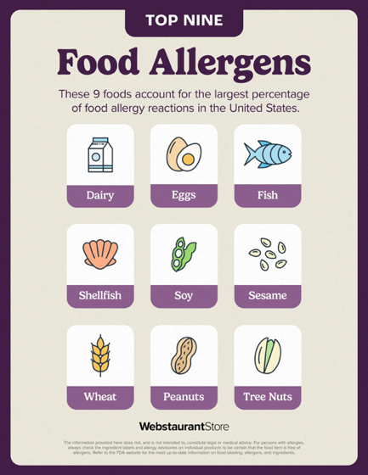

Fig. 1 :Webstaurant store (2024) Food allergen information graphic

Food hygiene ratings are assigned through a collaboration between the food standards agency and local authorities to assess a business’s hygiene practices during food service. These ratings are determined based on inspections evaluating specific hygiene standards. A rating of ‘5’, the highest possible score, signifies excellent hygiene practices and is represented by a green sticker. A rating of ‘0’, the lowest score, indicates serious hygiene deficiencies. Establishments receiving this rating face closure unless immediate corrective actions are put in place. These ratings help consumers make informed decisions about where to eat or purchase food (HSE, 2024). Food allergies have increasingly become a major public health issue globally, impacting many people. Proper identification and management of allergens in food products are vital to prevent harmful reactions and protect the safely of individuals with allergies. By enabling more accurate information and management of allergens, nano biosensor chemicals have the potential to greatly increase food safety for individuals with allergies, while also boosting consumer confidence in the quality and reliability of packaged food product (Sabaghi. and Jamali, 2024). Food packaging serves not only to protect the consumers from external damage but also to prevent items from being crushed, flattened, or punctured. Food products undergo various processes before reaching their destination. Without packaging, they risk losing their shape and texture during transportation and storage. High-quality food packaging ensure that products are transported and delivered without physical damage. It also minimizes the need for careful handing, making shipment and storage more efficient. Moreover, when food items consistently reach consumers in excellent condition, it boosts market demand and strengthens consumer trust. ‘30% of the food items get wasted in the supply chains’ (Select Equip, 2023). Allergens used as ingredients in prepacked food must be clearly declared in the ingredients list. You have the flexibility to choose the method of highlighting the allergens, such as using bold text, contrasting colours, or underlining, to make them easier to read and to stand out. ‘Choosing to include an allergy advice statement on the product label to clarify how allergens are highlighted in the ingredients list. Examples include “allergy advice: for allergens, see ingredients in bold” or allergy advice: for allergens, including cereals containing gluten, see Ingredients in red” (Food Standards Agency, 2015).

As mankind has moved forward, so have our consumer needs. Food packaging has advanced significantly from its early use as a basic container for storage and transport. Today, it serves a vital role in maintaining a products quality, freshness, and shelf life (Taylor. 2021). Paper was one of the first manufactured styles which we call today as “flexible packaging”. During the first and second century, Chinese people would use pieces of mulberry bark and wrap food up in it. Over time, papermaking methods were improved and expanding. This was brought to the Middle East, Europe, and lastly the United Kingdom in 1310. This paper method has evolved over time. Flax fibbers was what paper was first made from then moved onto recycled linen rags. In 1867, over 200 years later was the introduction of wood pulp. In the 1850s paper made an appearance and by the 1900, handcrafted wooden crates and boxes that would be used for trading were no longer the way as shipping cartons on paperboards replaced them. Coming up with the idea of using cereal cartons increased The Kellogg’s Brothers brand and they became trendsetters by using these in Battle Creek, Michigan and Sanatorium. Once “health food” was eventually promoted to the public. It was advertised as being not a well throughout design with a heat-sealed Waxtite bag wrapped around a plain box. The only text on the packaging was the brand name and advertising. Today, the only plastic content is the plastic liner in the cardboard box, this helps the cereals remain fresh. During the 20th century everyone was using paper and paper board packaging. However, during the late 1970s and early 1980s the use of paper-based products decreased. Recently, due to the high demand of environmentally friendly alternatives the use of these single use plastics has changed as consumers seek to use sustainable resources.
(Bond, 2017).
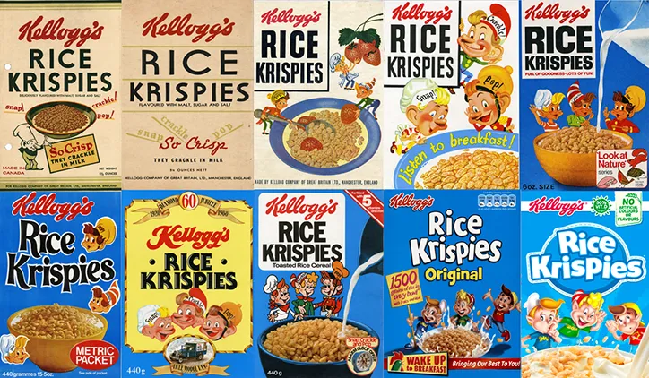

Fig.2: Baines. J (2018) Kellogg’s rice Krispie packaging throughout the years

In the early days, functionality was the top priority. The main goal of food packaging was to safeguard food from contamination, spoilage, and physical damage. Materials such as glass, metal, and wax-coated paper were widely used due to their excellent food preservation properties. The designs were straightforward, and the visuals were not a priority. Manufacturers began to understand the value of branding and packaging as a tool to differentiate their products on store shelves. This period gave rise to the iconic designs, such as the signature Coca-Cola bottle. Brands recognized that compelling selling points are built around stories. Consumers connect deeply with personal narratives or stories crafted for brands. Artistic illustrations, origin stories, and cultural references enhance the product, adding layers of depth and meaning (Foreman. 2023).

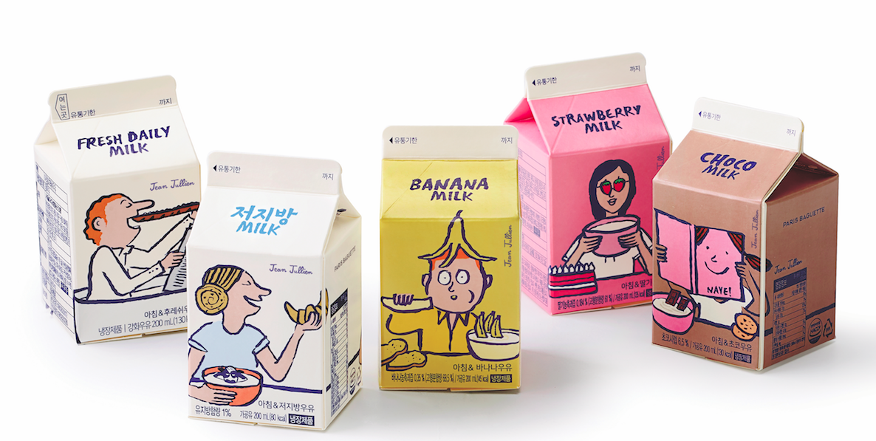
Fig. 3: Bonaccorsi. A (2022) packaging illustration

Before designing packaging, many food companies create a “brand style guide”. (Tymon, 2022). This outlines the guidelines for all branded materials to ensure consistency across the brand. Style guides typically include details like the exact colours to use and the typefaces for the product packaging. The more familiar a customer becomes with your brand, the more likely they are to trust it. Whilst building brand trust is very important, it is not the only factor to consider. Your products also need to be visually appealing and memorable. Keep in mind that your product will likely be placed next to many others, so you do not want it to be overlooked simply because your competitors have more attractive packaging. Packing windows allow the product to be displayed directly, making it an ideal choice if your food item looks appealing in its natural state. For products that require preparation, high-quality photography is more effective in showcasing what the fully prepared product will look like to the customer (Tymon, 2022). Before the retail revolution, food packaging in glass and cans was mainly used for preserving food, with labels containing information about the contents. In the twentieth century, supermarkets chains replaced family-owned grocery stores, making food packaging a major element of urban food culture. Over time, labels and packaging evolved into key tools for promoting food products. Before the 1930, illustrated painted imagery was commonly used in packaging design to represent the contents or brand identity, though it often did not provide a true or accurate description of the actual food product. Following this, photography became a main force in shaping modernism, enabling more visual representation. In the twentieth century, it continued to make a leading role in realistically capturing and reproducing impressions of the real product (Watkiss. 2013).

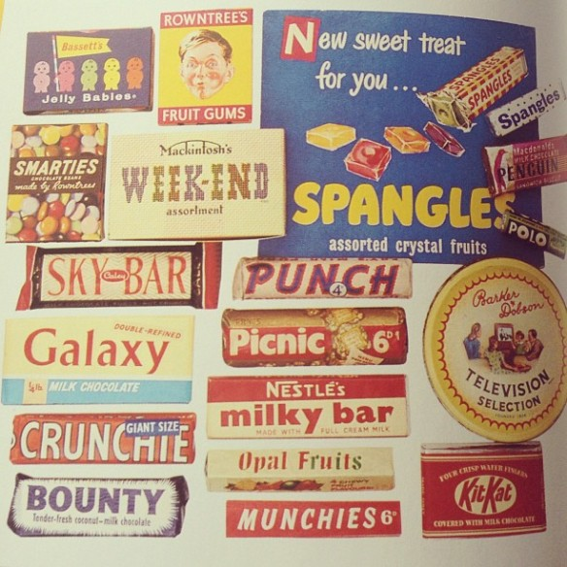
Fig. 4. Watkiss. (2013) Food Packaging History
‘The Waterloo Milk Company was founded in 1897 under the name Fountain Farmer’s Creamery Company. In 1908, the company changed its name to the M & O milk Company, as the diary was located just yards from the Mobile & Ohio Railroad tracks. When the company began condensing milk in 1918, it was renamed the Waterloo condensed Milk Company. Finally, in 1925, after incorporating, the business became The Waterloo Milk Company, Inc. The diary produced a wide range of products, including whole white milk, chocolate milk, whipped cream, orange juice, grade, ice cream, sherbet, cottage cheese, and butter. The company enjoyed success for many years, and by 1955, it was one of the largest businesses in Waterloo, with annual sales exceeding one million dollars. Nevertheless, in 1969, the company closed its door as it struggled to compete with larger regional brands that took a share of the market. (Waterloo Milk Company Cottage Cheese Packages, 2015) .’

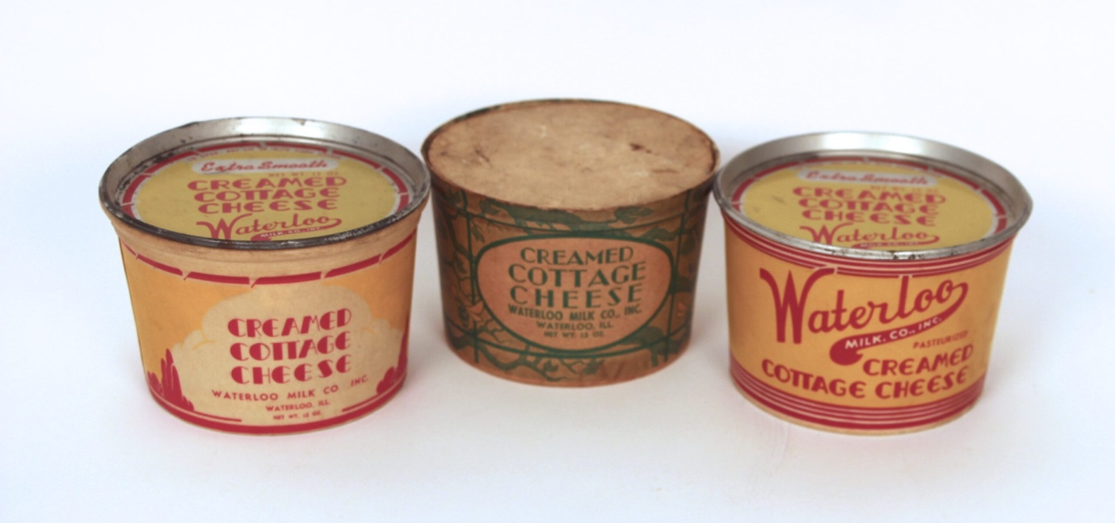
Fig. 5: The Antique Advertising Expert (2024) Waterloo Milk Company Cottle Cheese packages, 1950’s

Household food waste holds a key part of packaging, as it connects products to consumers by serving multiple functions. Industry research has focused on the environmental impact of specific packaging features, such as ease of resealing, re-closing, and providing food safety information, including waste frequency and mass. Social practice studies aim to uncover food-related habits and routines, focusing on how packaging influences these designs (Zeng, Durif , and Robino, 2021). Individuals are encouraged to recycle food waste instead of throwing it away as though it was rubbish. Understanding these changes can help industries, government, and non-profit organizations in developing people to reduce food waste. Given the differences in food cultures and regions across, further market research is essential to tailor campaign content effectively. This research will help messages and choose media formats that work with target audiences – particularly those who waste substantial amounts of food and are open to new habits to minimize waste. The effectiveness of such “downstream” behaviour change campaigns will be taken on bored when supported by “upstream” factors, including strong social networks, communities, and regulatory measures (Pearson. and Perera, 2018). Currently, few food waste interventions or campaigns use social media to integrate with their target audiences effectively. Many campaigns and interventions have raised consumer awareness about food waste, but long-term changes were neither measured nor documented. An approach that integrates social media with behaviour change strategies is recommended for reducing food waste (Jenkins, et al. 2022). There was research taken place by the ‘End Food Waste Cooperative Research Centre” to inspire the public to use less food waste. This was conducted through a text-based campaign. Behaviour change messages were initially created during workshops. There were 18 members who contributed to an online focus group. 11 experts were also taking part who focused in the food waste area. A survey took place in Australia with 1,000 households taking part and the top three messages that were carried out were ‘analysed using summative content analysis’. (Abos, et, al. 2024). Visual literacy and the history of food photography serve as a main framework for the case study, illustrating how viewers can actively play a role in both consumers and creators, contributing to greater representation of “ugly” food. A carefully selection of images from marketing campaigns, Instagram, and fine art is analysed, with the insights used to produce “ugly” food photographs. These photographs aim to challenge stigma, enhance consumer perceptions, and encourage a shift in values towards recognizing “ugly” food as equally valuable and consumable (Canose , 2021). Two approaches to reducing food waste through design are identified. The first involves innovations at the product and product-service level, such as advancements in packaging, labelling, fridge and freezer technology, mobile apps, subscription box services, and online grocery shopping platforms. The second approach requires a deeper reimagining and reconfiguration of food-related practices. This includes rethinking how we source food, when and where we consume it, and how and where it is stored (Hebrok, 2020).
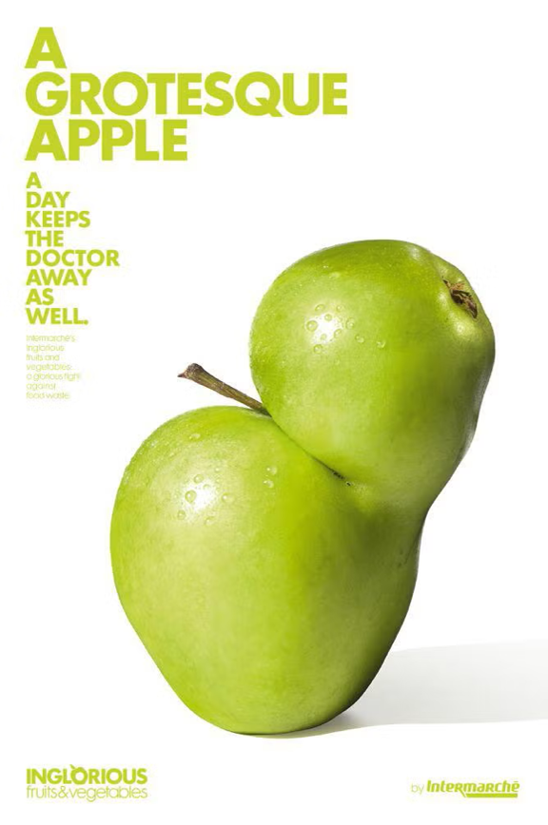
Fig. 6: Hohenade. K. (2015) Groceries often reject ugly carrots and grotesque apples campaign

In conclusion, food packaging plays a significant role in maintaining food safety and quality, while also addressing growing environmental concerns. Designers are at the forefront of creating packaging solutions that not only fulfil practical requirements but also respond to shifting consumer demands and sustainability goals. Designers are trained to develop knowledge from various disciplines, enabling them to balance food safety requirements with material manufacturing constraints, marketing needs, user demands, and environmental considerations (Barbera 2024). Graphic Design plays a significant role in saving lies within the food industry by ensuring that critical information is clearly communicated to consumers. Through well-designed food allergen labels, history of packaging designs and what makes good food packaging, guiding consumers to make safter choices. By making essential safety information easily accessible and understandable, Graphic Design not only improves food safety but also promotes public health. As the food industry continues to evolve, the importance of effective graphic design in protecting consumers and saving lives will only grow.

References

Abos, R.M, Taffe, S. Connory, Karunasena , G.G. and Pearson.D (2024). Reducing food waste through persuasive communication design. Available at: https://www.emerald.com/insight/content/doi/10.1108/jsocm-07-2023-0156/full/html (Accessed: 26th November 2024)

Barbera, M. (2024). Food packaging technology considerations for designers, available at: https://ift.onlinelibrary.wiley.com/doi/10.1111/1541-4337.70058?af=R (Accessed: 24th November 2024)

Bond, C. (2017). Paper and Paper Products, available at: https://ohioline.osu.edu/factsheet/cdfs-133 (accessed: 24th November 2024)

Canose.J .(2021). Designing the taste of food waste, available at: https://www.sciencedirect.com/science/article/abs/pii/B9780128178218000126 (Accessed: 26th November 2024)

Eufic (2013) Food allergen labelling, available at: https://www.eufic.org/en/healthy-living/article/food-allergens (Accessed: 21st November 2024)

Food Standards Agency, (2015) food packaging, available at: https://www.cambridge.gov.uk/media/1305/allergy-labelling-prepacked.pdf (accessed: 21st November 2024)

Foreman, L. (2023). The Evolution of Food Packaging Design, available at: https://www.toastfood.co.uk/the-evolution-of-food-packaging-design/ (accessed: 24th November 2024)

Hebrok, M. (2020). Food waste: a practice-oriented design for sustainability approach, available at: https://ntnuopen.ntnu.no/ntnu-xmlui/handle/11250/2676125 (accessed: 26th November 2024)

HSE Docs.com, (2024) Food hygiene ratings, available at: https://www.hsedocs.com/blog/what-are-the-food-hygiene-ratings--what-/#:~:text=These%20ratings%20are%20issued%20in,and%20warrants%20a%20green%20sticker. (accessed: 21st November 2024)

Jenkins, E.L. Brenna ,L, Molenaar. A. and McCaffrey. T.A . (2022).Exploring the application of social media in food waste campaigns and interventions. Available at: https://www.sciencedirect.com/science/article/pii/S0959652622016754 (Accessed: 26th November 2024)

Kara, B.N, (2019) Allergen warnings in menu design, available at: https://gcris.ieu.edu.tr/handle/20.500.14365/747 (Accessed: 21st November 2024)

Pearson. D. and Perera .A. (2018). Reducing food waste. Available at: https://journals.sagepub.com/doi/abs/10.1177/1524500417750830 (Accessed: 25th November 2024)

Sabaghi, M. and Jamali, S.N, (2024). Food packaging for allergen detection, available at: https://link.springer.com/article/10.1007/s11694-024-02416-x (Accessed: 21ts November 2024)

Select Equip, (2023) food packaging: is it important?, available at: https://selectequip.com.au/news-insights/why-food-packaging-important/#:~:text=Food%20packaging%20not%20just%20secures,getting%20to%20their%20final%20destination. (Accessed: 21ts November 2024)

Taylor, L. (2021). The History of Food Packaging, available at: https://www.nextdayflyers.com/the-evolution-of-food-packaging-a-timeline.html?srsltid=AfmBOooGUuxDfhJTLyILCIN_KD5D4iWzVF8LKLc3bF6i3STAVqEfBgAO (accessed: 24th November 2024)

Tymon, C. (2022). What makes effective packaging design, available at: https://www.toastfood.co.uk/effective-packaging-design/ (accessed: 24th November 2024)

Waterloo Milk Company Cottage Packages, 1950’s (2015) The Antique Advertising Expert. Available at: https://antiqueadvertisingexpert.com/project/waterloo-milk-company-cheese-packages-1950s/ (Accessed: 24 February 2025).

Watkis. N. (2013). Food Packaging History, available at: https://nicholawatkiss.wordpress.com/2013/04/20/food-packaging-history/ (Accessed: 24th November 2024)

Zeng, T. Durif. F. and Robinot, E. (2021). Can eco-design packaging reduce consumer food waste? Available at: https://www.sciencedirect.com/science/article/abs/pii/S0040162520311689 (Accessed: 25th November 2024)

List of illustrations

Figure 1: Baines. J (2018) Kellogg’s rice Krispie packaging throughout the years [online]. Available at: https://www.itsnicethat.com/news/rice-krispie-90-birthday-packaging-graphic-design-131118 ( Accessed :13 December 2024).

Figure 2:Bonaccorsi.A (2022) Packaging illustration [online]. Available at: https://www.pixartprinting.co.uk/blog/packaging-illustration/

Figure 3:Hohenadel.K (2015) Groceries often reject ugly carrots and grotesque apples campaign [online]. Available at: https://slate.com/human-interest/2015/05/inglorious-fruits-and-vegetables-is-a-clever-campaign-to-reduce-food-waste-by-making-ugly-produce-more-endearing.html

Figure 4:The Antique Advertising Expert (2024) Waterloo Milk Company Cottage Cheese Packages, 1950’s [online]. Available at: https://antiqueadvertisingexpert.com/project/waterloo-milk-company-cheese-packages-1950s/

Figure 5: Watkiss.N (2013) Food Packaging History [online]. Available at: https://nicholawatkiss.wordpress.com/2013/04/20/food-packaging-history/

Figure 6:Webstaurant store (2024) Food allergen information graphic [online]. Available at: https://www.webstaurantstore.com/article/22/food-allergy-overview.html

